Appendices

Ethics Form …………………………………………….………………………….… Page 2
Learners’ Interview Questions ……………......…...…………….……………….. Page 16
Learners’ Interview Responses ……………………..………….………………… Page 17
Staff Questionnaire Questions ……….……………………..…………….……… Page 24
Staff Questionnaire Responses …………………….…..…………………..….… Page 27
Parental Consent Form ……………………………………………..……….....…. Page 32
School Consent Form ……………………………………………..……….....…. Page 33

Ethics Form:

APPLICATION FOR ETHICAL APPROVAL

RESEARCH STUDENTS
This form is to be completed by the student within SIX months for full-time students and TWELVE months for part time students, after the commencement of the research degree or following progression to Part Two of your course.

Once complete, submit this form via the MyTSD Doctoral College Portal at (https://mytsd.uwtsd.ac.uk).

This document is also available in Welsh.

RESEARCH STAFF ONLY
All communications relating to this application during its processing must be in writing and emailed to pgresearch@uwtsd.ac.uk , with the title ‘Ethical Approval’ followed by your name.

STUDENTS ON UNDERGRADUATE OR TAUGHT MASTERS PROGRAMMES should submit this form (and receive the outcome) via systems explained to you by the supervisor/module leader.

In order for research to result in benefit and minimise risk of harm, it must be conducted ethically. A researcher may not be covered by the University’s insurance if ethical approval has not been obtained prior to commencement.

The University follows the OECD Frascati manual definition of research activity: “creative work undertaken on a systematic basis in order to increase the stock of knowledge, including knowledge of man, culture and society, and the use of this stock of knowledge to devise new applications”. As such this covers activities undertaken by members of staff, postgraduate research students, and both taught postgraduate and undergraduate students working on dissertations/projects.

The individual undertaking the research activity is known as the “principal researcher”.

Ethical approval is not required for routine audits, performance reviews, quality assurance studies, testing within normal educational requirements, and literary or artistic criticism.

Please read the notes for guidance before completing ALL sections of the form.

This form must be completed and approved prior to undertaking any research activity. Please see Checklist for details of process for different categories of application.

SECTION A: About You (Principal Researcher)
1 | Full Name: |  | Nia Colclough
2 | Tick all boxes that apply: |  | Member of staff: | ☐ | Honorary research fellow: | ☐
 | Undergraduate Student | ​​☒​ | Taught Postgraduate Student | ​​☐​ | Postgraduate Research Student | ​​☐​

3 | Institute/Academic Discipline/Centre: | Initial Teacher Education, Yr Athrofa
4 | Campus: | Carmarthen
5 | E-mail address: | 2100479@student.uwtsd.ac.uk
6 | Contact Telephone Number:
 | For students:
7 | Student Number: | 2100479
8 | Programme of Study: | BA Primary Education with QTS
9 | Director of Studies/Supervisor: | Dr Julia Holloway

SECTION B: Approval for Research Activity
1 | Has the research activity received approval in principle?  (please check the Guidance Notes as to the appropriate approval process for different levels of research by different categories of individual) |  | YES | ​​☒​ | NO | ​​☐​
 |  |  |  |  | Date
2 | If Yes, please indicate source of approval (and date where known): Approval in principle must be obtained from the relevant source prior to seeking ethical approval | Research Degrees Committee |  | ​​☐​
2 |  | Institute Research Committee |  | ​​☐​
2 |  | Other (write in) ECAD5010 Module lead: Dr Julia Holloway and Sioned V Hughes |  | ​​☐​ | 24.01.24

SECTION C: Internal and External Ethical Guidance Materials
 | Please list the core ethical guidance documents that have been referred to during the completion of this form (including any discipline-specific codes of research ethics, location-specific codes of research ethics, and also any specific ethical guidance relating to the proposed methodology). Please tick to confirm that your research proposal adheres to these codes and guidelines. You may add rows to this table if needed.
1 | UWTSD Research Ethics & Integrity Code of Practice | ​​☐​
2 | UWTSD Research Data Management Policy | ​​☐​
3 | BERA Guidelines (2018)  EWC Code of Professional Conduct and Practice for Registrants with the Education Workforce Council | ​​☐​

SECTION D: External Collaborative Research Activity
If there are external collaborators then you should gain consent from the contact persons to share their personal data with the university. If there are no external collaborators then leave this section blank and continue to section E.
1 | Institution
2 | Contact person name
3 | Contact person e-mail address
4 | Is your research externally funded? |  | YES | ​​☐​ | NO |  | ​​☐​
5 | Are you in receipt of a KESS scholarship? |  | YES | ​​☐​ | NO |  | ​​☐​
6 | Are you specifically employed to undertake this research in either a paid or voluntary capacity? | Voluntary | YES | ​​☐​ | NO | ​​☐​
7 |  | Employed | YES | ​​☐​ | NO | ​​☐​
8 | Is the research being undertaken within an existing UWTSD Athrofa Professional Learning Partnership (APLP)? | If YES then the permission question below does not need to be answered. | YES | ​​☒​ | NO |  | ​​☐​
9 | Has permission to undertake the research has been provided by the partner organisation? | (If YES attach copy)  If NO the application cannot continue | YES | ​​☒​ | NO |  | ​​☐​

Where research activity is carried out in collaboration with an external organisation
10 | Does this organisation have its own ethics approval system? | YES | ​​☒​ | NO | ​​☐​
 | If Yes, please attach a copy of any final approval (or interim approval) from the organisation (this may be a copy of an email if appropriate).

SECTION E: Details of Research Activity
1 | Indicative title: | What are staff and year 6 students’ perceptions on peer assessment within the classroom?
2 | Proposed start date: | 24.01.24 | Proposed end date: | 19.02.24
Introduction to the Research (maximum 300 words per section)
Ensure that you write for a Non-Specialist Audience when outlining your response to the points below:
- Purpose of Research Activity
- Proposed Research Question
- Aims of Research Activity
- Objectives of Research Activity
Demonstrate, briefly, how Existing Research has informed the proposed activity and explain
- What the research activity will add to the body of knowledge
- How it addresses an area of importance.
3 | Purpose of Research Activity  The purpose of undertaking this research is to explore and evaluate how assessment for learning, specifically peer assessment is implemented and valued within staff and year 6 students. It is also to develop research skills which will be done by trialling and evaluating different research tools in practice.  (this box should expand as you type)
4 | Research Question  What are staff and year 6 students’ perceptions on peer assessment within the classroom?  (this box should expand as you type)
5 | Aims of Research Activity  - To explore staff and learners’ perceptions of AFL strategy’s, specifically peer assessment.  - To critically evaluate different research tools used including interviews and questionnaires.  - To deepen and expand personal knowledge of AFL in order to improve professional practice.  (this box should expand as you type)
6 | Objectives of Research Activity  - To provide explore the AfL strategies and approaches used by staff to support and develop pupils’ learning using a questionnaire.  - To interview year 6 students to capture their views about peer assessment.  - To critically reflect on the process of using different research tools to collect data.  - To trial and use the mosaic approach in order to collect both quantitative and qualitative data.  (this box should expand as you type)2
Proposed methods (maximum 600 words)
Provide a brief summary of all the methods that may be used in the research activity, making it clear what specific techniques may be used. If methods other than those listed in this section are deemed appropriate later, additional ethical approval for those methods will be needed. You do not need to justify the methods here but should instead describe how you intend to collect the data necessary for you to complete your project.
7 | Interviews – Year 6 students will be involved in a semi-structured interview where they will be invited to respond to key questions. For example, do you know what peer assessment is? Do you find peer assessment helps you to improve your work? These interviews will be conducted in an informal setting, and I will make notes of and audio record their responses. The students will not be forced to participate, will be made aware that they do not have to answer any questions and that they can stop at any time. Students will be asked if they wish to be involved. I will regularly check in that students are comfortable in order to show that they are happy to continue. I will check on the student’s feelings regularly. No names will be recorded for anonymity. If interviews are unable to take place with students, I will conduct the interviews on members of staff.  Questionnaire – A questionnaire will be sent to members of staff within the school to gather their perceptions on the AFL strategy of peer assessment in order to gain an insight of whether practitioners find it effective. This will remain anonymous and no names will be motioned or recorded. Members of staff will be informed through the beginning of the questionnaire that it is an anonymous task, and they only need to participate if they are willing to. Staff will have the option to withdraw from the questionnaire at any time and will be made aware of the purpose of the questionnaire.  (this box should expand as you type)
Location of research activity
Identify all locations where research activity will take place.
8 | The research activity will take place in an urban school with approximately 250 pupils.  (this box should expand as you type)
Research activity outside of the UK
If research activity will take place overseas, you are responsible for ensuring that local ethical considerations are complied with and that the relevant permissions are sought. Specify any local guidelines (e.g. from local professional associations/learned societies/universities) that exist and whether these involve any ethical stipulations beyond those usual in the UK (provide details of any licenses or permissions required). Also specify whether there are any specific ethical issues raised by the local context in which the research activity is taking place, for example, particular cultural and/or legal sensitivities or vulnerabilities of participants. If you live in the country where you will do the research then please state this.
9 | N/A  (this box should expand as you type)

10 | Use of documentation not in the public domain: Are any documents NOT publicly available? | NO | ​​☒​
10 |  | YES | ​​☐​
11 | If Yes, please provide details here of how you will gain access to specific documentation that is not in the public domain and that this is in accordance with the current data protection law of the country in question and that of England and Wales.  (this box should expand as you type)

 | Does your research relate to one or more of the seven aims of the Well-being of Future Generations (Wales) Act 2015? | YES | NO
12 | A prosperous Wales | ​​☐​ | ​​☒​
13 | A resilient Wales | ​​☐​ | ​​☒​
14 | A healthier Wales | ​​☐​ | ​​☒​
15 | A more equal Wales | ​​☐​ | ​​☒​
16 | A Wales of cohesive communities | ​​☐​ | ​​☒​
17 | A Wales of vibrant culture and thriving Welsh language | ​​☐​ | ​​☒​
18 | A globally responsible Wales | ​​☐​ | ​​☒​
19 | If YES to any of the above, please give details:
 | (this box should expand as you type)

SECTION F: Scope of Research Activity
 | Will the research activity include: | YES | NO
1 | Use of a questionnaire or similar research instrument? | ​​☒​ | ​​☐​
2 | Use of interviews? | ​​☒​ | ​​☐​
3 | Use of focus groups? | ​​☒​ | ​​☐​
4 | Use of participant diaries? | ​​☐​ | ​​☒​
5 | Use of video or audio recording? | ​​☒​ | ​​☐​
6 | Use of computer-generated log files? | ​​☐​ | ​​☒​
7 | Participant observation with their knowledge? | ​​☐​ | ​​☒​
8 | Participant observation without their knowledge? | ​​☐​ | ​​☒​
9 | Access to personal or confidential information without the participants’ specific consent? | ​​☐​ | ​​☒​
10 | Administration of any questions, test stimuli, presentation that may be experienced as physically, mentally or emotionally harmful / offensive? | ​​☐​ | ​​☒​
11 | Performance of any acts which may cause embarrassment or affect self-esteem? | ​​☐​ | ​​☒​
12 | Investigation of participants involved in illegal activities? | ​​☐​ | ​​☒​
13 | Use of procedures that involve deception? | ​​☐​ | ​​☒​
14 | Administration of any substance, agent or placebo? | ​​☐​ | ​​☒​
15 | Working with live vertebrate animals? | ​​☐​ | ​​☒​
16 | Procedures that may have a negative impact on the environment? | ​​☐​ | ​​☒​
17 | Other primary data collection methods. Please indicate the type of data collection method(s) below. | ​​☐​ | ​​☒​
 | Details of any other primary data collection method:  (this box should expand as you type) | ​​☐​ | ​​☒​
If NO to every question, then the research activity is (ethically) low risk and may be exempt from some of the following sections (please refer to Guidance Notes).

If YES to any question, then no research activity should be undertaken until full ethical approval has been obtained.

SECTION G: Intended Participants
If there are no participants then do not complete this section, but go directly to section H.

 | Who are the intended participants: | YES | NO
1 | Students or staff at the University? | ​​☐​ | ​​☒​
2 | Adults (over the age of 18 and competent to give consent)? | ​​☒​ | ​​☐​
3 | Vulnerable adults? | ​​☐​ | ​​☒​
4 | Children and Young People under the age of 18? (Consent from Parent, Carer or Guardian will be required) | ​​☒​ | ​​☐​
5 | Prisoners? | ​​☐​ | ​​☒​
6 | Young offenders? | ​​☐​ | ​​☒​
7 | Those who could be considered to have a particularly dependent relationship with the investigator or a gatekeeper? | ​​☐​ | ​​☒​
8 | People engaged in illegal activities? | ​​☐​ | ​​☒​
9 | Others. Please indicate the participants below, and specifically any group who may be unable to give consent. | ​​☐​ | ​​☒​
 | Details of any other participant groups:  (this box should expand as you type) | ​​☐​ | ​​☒​

Participant numbers and source
Provide an estimate of the expected number of participants. How will you identify participants and how will they be recruited?
10 | How many participants are expected? | 15 participants  (this box should expand as you type)
11 | Who will the participants be? | Approx. 7 questionnaires..,  Focus group of 6 year 6 pupils aged 10-11  1 teacher  (this box should expand as you type)
12 | How will you identify the participants? | I will use a sample of stakeholder staff for data from a broad range of staff members.  I will use a random sample of students and identify them through support of the class teacher.

 | Information for participants: | YES | NO | N/A
13 | Will you describe the main research procedures to participants in advance, so that they are informed about what to expect? | ​​☒​ | ​​☐​ | ​​☐​
14 | Will you tell participants that their participation is voluntary? | ​​☒​ | ​​☐​ | ​​☐​
15 | Will you obtain written consent for participation? | ​​☐​ | ​​☐​ | ​​☒​
16 | Will you explain to participants that refusal to participate in the research will not affect their treatment or education (if relevant)? | ​​☒​ | ​​☐​ | ​​☐​
17 | If the research is observational, will you ask participants for their consent to being observed? | ​​☐​ | ​​☐​ | ​​☒​
18 | Will you tell participants that they may withdraw from the research at any time and for any reason? | ​​☒​ | ​​☐​ | ​​☐​
19 | With questionnaires, will you give participants the option of omitting questions they do not want to answer? | ​​☒​ | ​​☐​ | ​​☐​
20 | Will you tell participants that their data will be treated with full confidentiality and that, if published, it will not be identifiable as theirs? | ​​☒​ | ​​☐​ | ​​☐​
21 | Will you debrief participants at the end of their participation, in a way appropriate to the type of research undertaken? | ​​☒​ | ​​☐​ | ​​☐​
22 | If NO to any of above questions, please give an explanation
 | (this box should expand as you type)

 | Information for participants: | YES | NO | N/A
24 | Will participants be paid? | ​​☐​ | ​​☒​ | ​​☐​
25 | Is specialist electrical or other equipment to be used with participants? | ​​☐​ | ​​☒​ | ​​☐​
26 | Are there any financial or other interests to the investigator or University arising from this study? | ​​☐​ | ​​☒​ | ​​☐​
27 | Will the research activity involve deliberately misleading participants in any way, or the partial or full concealment of the specific study aims? | ​​☐​ | ​​☒​ | ​​☐​
28 | If YES to any question, please provide full details
 | (this box should expand as you type)

SECTION H: Anticipated Risks

Outline any anticipated risks that may adversely affect any of the participants, the researchers and/or the University, and the steps that will be taken to address them.

If you have completed a full risk assessment (for example as required by a laboratory, or external research collaborator) you may append that to this form.
1 | Full risk assessment completed and appended? |  | Yes | ​​☐​
1 |  |  | No | ​​☒​
2 | Risks to participants  For example: sector-specific health & safety, emotional distress, financial disclosure, physical harm, transfer of personal data, sensitive organisational information
 | Risk to participants:  - Participants may feel under pressure to give the correct answer to the questions.  - May affect pupil self-esteem due to not being chosen for focus group. | How you will mitigate the risk to participants:  - Participant will be told that there is no consequence for anything they say. I will make it clear that I want open and honest answers. I will make it clear that the answers they give will affect their education in no way and there will be no repercussions for their actions and answers in regard to the research  - Explain to students alongside class mentor that it is not possible to interview all students within the class and ensure them that the selection was done randomly.  (this box should expand as you type)
3 | If research activity may include sensitive, embarrassing or upsetting topics (e.g. sexual activity, drug use) or issues likely to disclose information requiring further action (e.g. criminal activity), give details of the procedures to deal with these issues, including any support/advice (e.g. helpline numbers) to be offered to participants. Note that where applicable, consent procedures should make it clear that if something potentially or actually illegal is discovered in the course of a project, it may need to be disclosed to the proper authorities
N/A

(this box should expand as you type)
4 | Risks to the investigator  For example: personal health & safety, physical harm, emotional distress, risk of accusation of harm/impropriety, conflict of interest
 | Risk to the investigator:  - Risk of accusation of fabrication or falsification of data.  - Potential conflict and bias.  (this box should expand as you type) | How you will mitigate the risk to the investigator:  - I will follow the UWTSD and BERA ethical guidelines when conducting primary research in a school.  - Have another member of staff present during the interview to ensure I am not behaving in a biased way.  (this box should expand as you type)
5 | University/institutional risks  For example: adverse publicity, financial loss, data protection
 | Risk to the University:  - Not behaving in a way that could impact the relationship between school and university  (this box should expand as you type) | How you will mitigate the risk to the University:  - I will behave in a professional manner, at all times. I will also collect my data on a password protected file and all data will be confidential and anonymous.  (this box should expand as you type)
6 | Environmental risks  For example: accidental spillage of pollutants, damage to local ecosystems
 | Risk to the environment:  N/A  (this box should expand as you type) | How you will mitigate the risk to environment:  (this box should expand as you type)

 | Disclosure and Barring Service
 | If the research activity involves children or vulnerable adults, a Disclosure and Barring Service (DBS) certificate must be obtained before any contact with such participants. | YES | NO | N/A
7 | Does your research require you to hold a current DBS Certificate? | ​​☒​ | ​​☐​ | ​​☐​
8 | If YES, please give the certificate number. If the certificate number is not available please write “Pending”; in this case any ethical approval will be subject to providing the appropriate certificate number.

SECTION I: Feedback, Consent and Confidentiality

1 | Feedback  What de-briefing and feedback will be provided to participants, how will this be done and when?
A final report or summary of discussion will be completed at the end of interview to thank individuals for their participation, and I will provide an explanation of how the data gathered will be used and stored within a written assignment.

(this box should expand as you type)
2 | Informed consent  Describe the arrangements to inform potential participants, before providing consent, of what is involved in participating. Describe the arrangements for participants to provide full consent before data collection begins. If gaining consent in this way is inappropriate, explain how consent will be obtained and recorded in accordance with prevailing data protection legislation.
I will converse with my professional tutor and lecturer and inform them of the research I will be undertaking, providing reason and rationale behind the research. However, I will verbally ask the head-teacher/teacher identified to participate whether they wish to participate. I will also ask for their ongoing consent during the research Assent and consent forms, and a letter sent with details regarding the research will be provided.

(this box should expand as you type)
3 | Confidentiality / Anonymity  Set out how anonymity of participants and confidentiality will be ensured in any outputs. If anonymity is not being offered, explain why this is the case.
No names will be recorded. I will not disclose names and will use pseudonyms if need be. I will ensure that no individual data are made available to schools/parents. The only individuals who will have access to the data is myself and supervisor Julia through data being recorded in a written assignment.

(this box should expand as you type)

SECTION J: Data Protection and Storage

 | Does the research activity involve personal data (as defined by the General Data Protection Regulation 2016 “GDPR” and the Data Protection Act 2018 “DPA”)? | YES | NO
1 | “Personal data” means any information relating to an identified or identifiable natural person (‘data subject’). An identifiable natural person is one who can be identified, directly or indirectly, in particular by reference to an identifier such as a name, an identification number, location data, an online identifier or to one or more factors specific to the physical, physiological, genetic, mental, economic, cultural or social identity of that natural person. Any video or audio recordings of participants is considered to be personal data. | ☐ | ☐
 | If YES, provide a description of the data and explain why this data needs to be collected:
2 | (this box should expand as you type)
 | Does it involve special category data (as defined by the GDPR)? | YES | NO
3 | “Special category data” means sensitive personal data consisting of information as to the data subjects’ –  (a) racial or ethnic origin,  (b) political opinions,  (c ) religious beliefs or other beliefs of a similar nature,  (d) membership of a trade union (within the meaning of the Trade Union and Labour Relations (Consolidation) Act 1992),  (e) physical or mental health or condition,  (f) sexual life,  (g) genetics,  (h) biometric data (as used for ID purposes), | ☐ | ☐
 | If YES, provide a description of the special category data and explain why this data needs to be collected:
4 | (this box should expand as you type)

 | Will data from the research activity (collected data, drafts of the thesis, or materials for publication) be stored in any of the following ways? | YES | NO
5 | Manual files (i.e. in paper form)? | ​​☐​ | ​​☐​
6 | University computers? | ​​☐​ | ​​☐​
7 | Private company computers? | ​​☐​ | ​​☐​
8 | Home or other personal computers? | ​​☐​ | ​​☐​
9 | Laptop computers/ CDs/ Portable disk-drives/ memory sticks? | ​​☐​ | ​​☐​
10 | “Cloud” storage or websites? | ​​☐​ | ​​☐​
11 | Other – specify: | ​​☐​ | ​​☐​
12 | For all stored data, explain the measures in place to ensure the security of the data collected, data confidentiality, including details of backup procedures, password protection, encryption, anonymisation and pseudonymisation:
 | (this box should expand as you type)

 | Data Protection
 | Will the research activity involve any of the following activities: | YES | NO
13 | Electronic transfer of data in any form? | ​​☐​ | ​​☐​
14 | Sharing of data with others at the University outside of the immediate research team? | ​​☐​ | ​​☐​
15 | Sharing of data with other organisations? | ​​☐​ | ​​☐​
16 | Export of data outside the UK or importing of data from outside the UK? | ​​☐​ | ​​☐​
17 | Use of personal addresses, postcodes, faxes, emails or telephone numbers? | ​​☐​ | ​​☐​
18 | Publication of data that might allow identification of individuals? | ​​☐​ | ​​☐​
19 | Use of data management system? | ​​☐​ | ​​☒​
20 | Data archiving? | ​​☐​ | ​​☐​
21 | If YES to any question, please provide full details, explaining how this will be conducted in accordance with the GDPR and Data Protection Act (2018) (and any international equivalents, where appropriate):
N/A

(this box should expand as you type)
22 | List all who will have access to the data generated by the research activity:
 | (this box should expand as you type)
23 | List who will have control of, and act as custodian(s) for, data generated by the research activity:
 | (this box should expand as you type)
24 | Give details of data storage arrangements, including security measures in place to protect the data, where data will be stored, how long for, and in what form. Will data be archived – if so how and if not why not.
 | (this box should expand as you type)
25 | Please indicate if your data will be stored in the UWTSD Research Data Repository (see https://researchdata.uwtsd.ac.uk/ ). If so please explain. (Most relevant to academic staff)
N/A

(this box should expand as you type)
26 | Confirm that you have read the UWTSD guidance on data management (see https://www.uwtsd.ac.uk/library/research-data-management/) | YES | ​​☐​
27 | Confirm that you are aware that you need to keep all data until after your research has completed or the end of your funding | YES | ​​☐​

SECTION K: Declaration
The information which I have provided is correct and complete to the best of my knowledge. I have attempted to identify any risks and issues related to the research activity and acknowledge my obligations and the rights of the participants.

In submitting this application I hereby confirm that I undertake to ensure that the above named research activity will meet the University’s Research Ethics and Integrity Code of Practice which is published on the website: https://www.uwtsd.ac.uk/research/research-ethics/
1 | Signature of applicant: | Nia Colclough | Date:  18.01.24

For STUDENT Submissions:
2 | Director of Studies/Supervisor: | Dr Julia Holloway | Date: 23/1/24
3 | Signature: | Julia Holloway | Date: 23/1/24

For STAFF Submissions:
4 | Academic Director/ Assistant Dean: |  | Date:
5 | Signature: |  | Date:

Checklist: Please complete the checklist below to ensure that you have completed the form according to the guidelines and attached any required documentation:
​​☒​ | I have read the guidance notes supplied before completing the form.
​​☒​ | I have completed ALL RELEVANT sections of the form in full.
x | I confirm that the research activity has received approval in principle
​​☐​ | I have attached a copy of final/interim approval from external organisation (where appropriate)
​​☐​ | I have attached a full risk assessment (where appropriate) ONLY TICK IF YOU HAVE ATTACHED A FULL RISK ASSESSMENT
x | I understand that it is my responsibility to ensure that the above named research activity will meet the University’s Research Ethics and Integrity Code of Practice.
x | I understand that before commencing data collection all documents aimed at respondents (including information sheets, consent forms, questionnaires, interview schedules etc.) must be confirmed by the DoS/Supervisor, module tutor or Academic Director.

RESEARCH STUDENTS ONLY
Once complete, submit this form via the MyTSD Doctoral College Portal at (https://mytsd.uwtsd.ac.uk).

RESEARCH STAFF ONLY
All communications relating to this application during its processing must be in writing and emailed to pgresearch@uwtsd.ac.uk , with the title ‘Ethical Approval’ followed by your name.

STUDENTS ON UNDERGRADUATE OR TAUGHT MASTERS PROGRAMMES should submit this form (and receive the outcome) via systems explained to you by the supervisor/module leader.

Learners’ Interview Questions:

- Do you know what peer assessment is?
    - If yes: Can you describe to me what peer assessment is?

  - Do you use peer assessment in class?
    - If yes: How do you peer assess in class? (verbal or written?)

  - When would you normally use peer assessment? (during a lesson/ at the end?)

  - Do you think peer assessment helps you with your learning/gain a better understanding?
    - Why do you think this helps? / Why don’t you think this helps? / What would you prefer to do instead?

  - Do you enjoy peer assessing?
    - Why/Why not?

  - Do you prefer getting feedback on work from peers or teachers?
    - Why?

  - How do you know what you are supposed to be marking? / What do you use to help when peer assessing?

  - What type of feedback are you given from peer assessment? Can you give any examples of feedback a friend has given you about your work or you have given a friend?

  - How confident/ comfortable do you feel with a friend marking your work?
    - Can you explain why you feel this way?

  - Are there any specific lessons that you find peer assessment helps you learn better? (Maths? Literacy?
    - Do you feel confident in explaining why you think this may be?

Learners’ Interview Responses:
Question 1 | Do you know what peer assessment is?  - If yes: Can you describe to me what peer assessment is?
Student A | Yes – when you talk to you partner about specific work
Student B | Yes – when you mark each other’s work. Peer is another work for partner and you do a certain amount of work with your peers.
Student C | Yes – when you help someone with their work
Student D | Yes
Student E | Yes
Student F | Yes
Student G | Yes

Question 2 | Do you use peer assessment in class?  - If yes: How do you peer assess in class? (verbal or written?)
Student A | Yeah I think we have  SNOT stands for self, neighbour, other then teacher
Student B | Teachers will give a certain amount of time to discuss the work and then when were all done we give all the feedback to him.
Student C | We use it in maths when going through the answers and tick them.
Student D | We have when we talk to our partners - We talk and then if someone doesn’t understand we talk about it and we start understanding more.  A teacher looks at our work to mark mostly
Student E | We talk to each other and we also use SNOT (Self, neighbour, other, teacher).
Student F
Student G

Question 3 | When would you normally use peer assessment? (during a lesson/ at the end?)
Student A | We give feedback on what their doing well or wrong.
Student B
Student C | We do it in English too in the middle of the lesson.
Student D | We usually do it in the middle of the lesson when we talk about how to work out questions.
Student E | We also work together in maths to work through questions we don’t understand to help each other and try work it out together.
Student F
Student G

Question 4 | Do you think peer assessment helps you with your learning/gain a better understanding?  - Why do you think this helps? / Why don’t you think this helps? / What would you prefer to do instead?
Student A | Yeah – you know other people think the same way as you
Student B | Yeah – when we get stuck on a topic, there’s normally someone or two people on the table who understand and then they explain it to us all so we understand more.
Student C | Yeah – sometimes we don’t understand the way the teacher explains it but when we talk with friends, we understand it more because we speak in language we can understand.
Student D | Yeah – peers may say it in a different way than sir does.
Student E | Yeah
Student F | Yeah
Student G | Yeah

Question 5 | Do you enjoy peer assessing?  - Why/Why not?
Student A | Yeah – instead of seeing what the teacher is writing on the board, it’s a more fun way of learning.
Student B | Yeah – when I work with my friends its easier because they talk in a way I understand more.
Student C | Yeah – it’s a fun way of learning. When you talk to you friends you get some relation about what’s being spoken about.
Student D | Yeah – you get to spend more time with friends and figure out stuff together. It’s easier to learn more with friends.
Student E | Yeah – I get more knowledge from friends.
Student F | Yeah
Student G | Yeah

Question 6 | Do you prefer getting feedback on work from peers or teachers?  - Why?
Student A
Student B
Student C | I prefer my friends, because I feel worried getting feedback from my teachers. I don’t like getting questions wrong, but when my friends mark it I can easily correct it because I worry about getting it wrong.
Student D | Friends – because my teacher says it too fast and when my friends say it they say it slower so I get more.
Student E | I like it when my friends say it because its slower. I understand better.
Student F
Student G | I rather it from my friends because it’s scary getting it from teachers sometimes.

Question 7 | How do you know what you are supposed to be marking? / What do you use to help when peer assessing?
Student A
Student B | When we know we have a question right, sir tells us to explain how to get the right answer to our friends rather than telling them the answer.
Student C | Because when sir marks my book and I get questions right, but my friends get it wrong. I can explain to them why they’re wrong because I know my answer is right.  Sir puts an example on the board for us to see.
Student D | At the back of our books, we have stuff to help us to flick back to.
Student E
Student F
Student G

Question 8 | What type of feedback are you given from peer assessment? Can you give any examples of feedback a friend has given you about your work or you have given a friend?
Student A | In division I put something in the wrong place, and I was told it was in the wrong place, but I had to figure out where it had to go.
Student B | My friend marked my work and told me I got one wrong by putting something in the wrong place and that I needed to move it to get the answer right.
Student C | One correction – or feedback I gave to my friend before I when they forgot something in their work. I explained that they got the answer right, but they were missing something from their work.
Student D | In English, my handwriting was really reckless and I was told to take my time with my writing and it has improved since.  The work we did today, someone explained the question using resources.
Student E | I was told to take care of my grammar in comprehension.
Student F
Student G

Question 9 | How confident/ comfortable do you feel with a friend marking your work?  - Can you explain why you feel this way?
Student A | The same as him, 50/50. Because I’m not always sure if I got my answers right to mark someone else’s.  Yeah, I think we should have more time.
Student B | I would feel more confident if we had more time to do it.
Student C | 50/50 in case I get it wrong  Sir should give us more time.
Student D | 40%, when I mark peoples work, I get worried that I am doing it wrong. I’m worried that sir will see that I marked the work wrong and wonder why.  I would be more confident if sir showed us how to properly do it so we don’t get confused.
Student E
Student F
Student G

Question 10 | Are there any specific lessons that you find peer assessment helps you learn better? (Maths? Literacy?  - Do you feel confident in explaining why you think this may be?
Student A | It helps me in all of them because I feel more confident when I have talked to my friends about the work.  Maths probably.
Student B | English – my friends can show me how to do something better and give me examples on how to write it or lay it out.
Student C | Most likely when we do punctuation in literacy because I get really confused. It helps me do it better.
Student D | It helps me most in maths because I am not the best at maths.
Student E | It helps me most in maths.
Student F
Student G | It helps me the most in difficult maths like fraction and division.

Blank Staff Questionnaire:

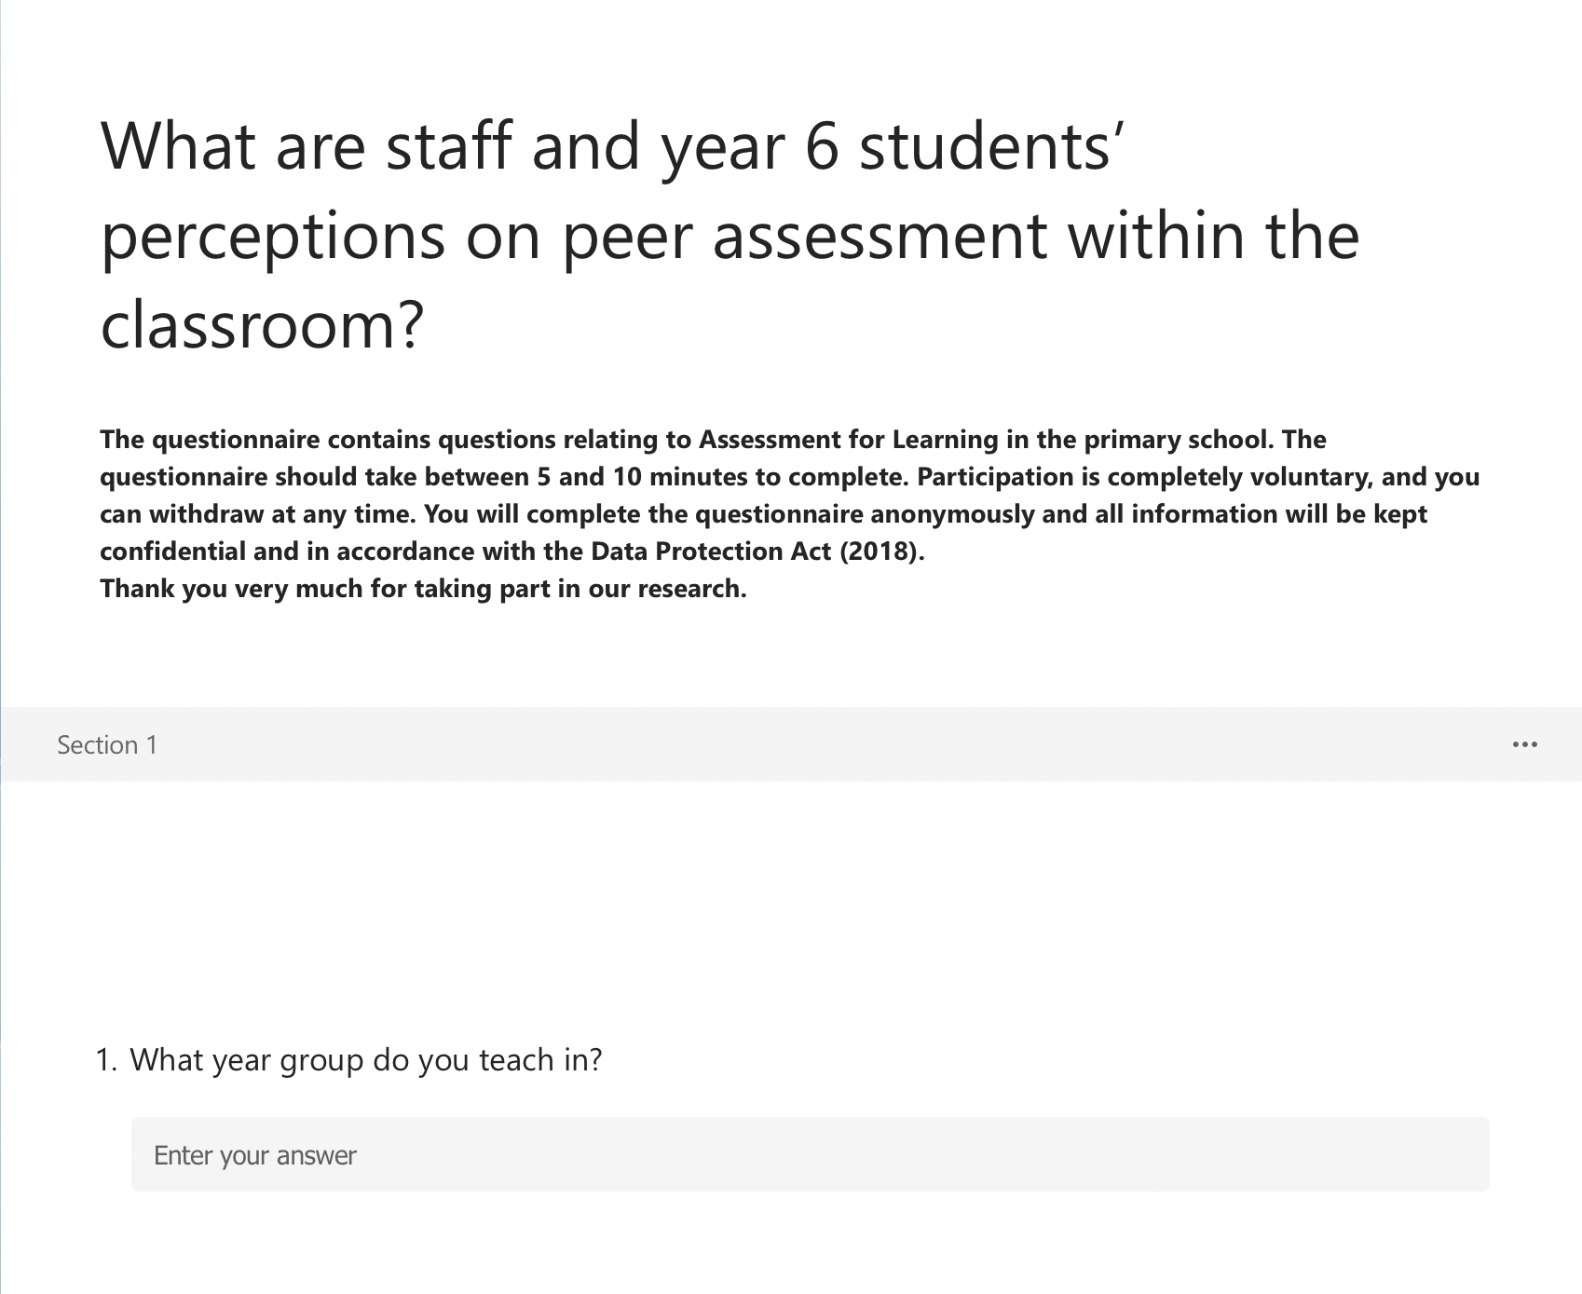
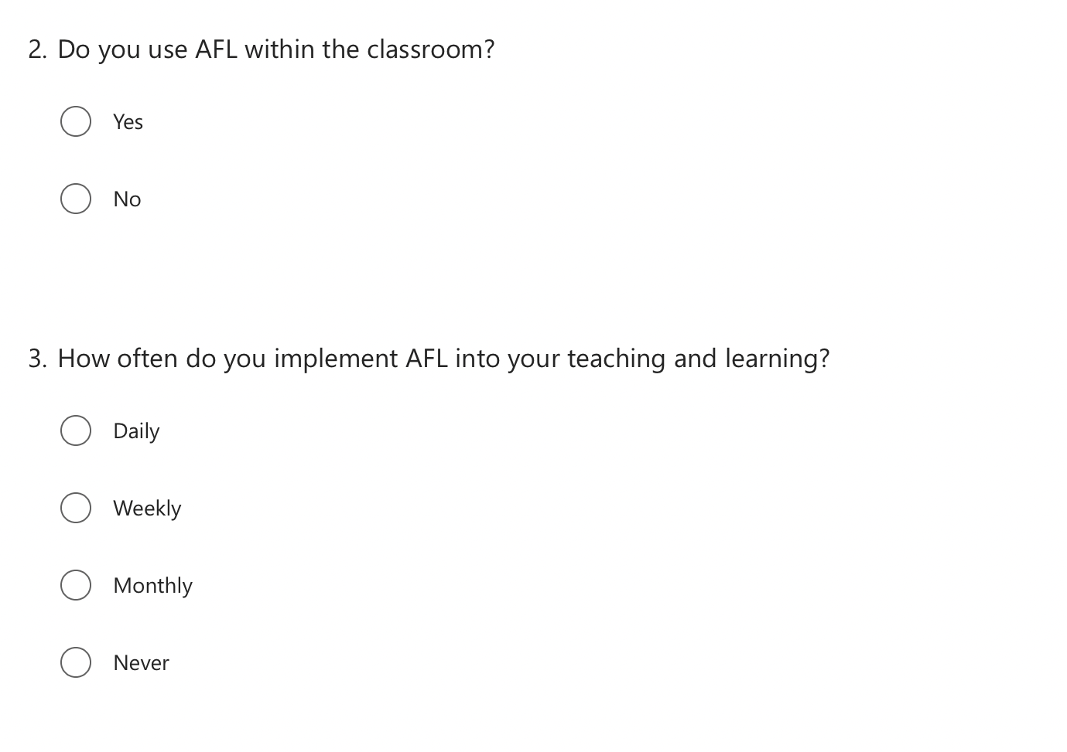

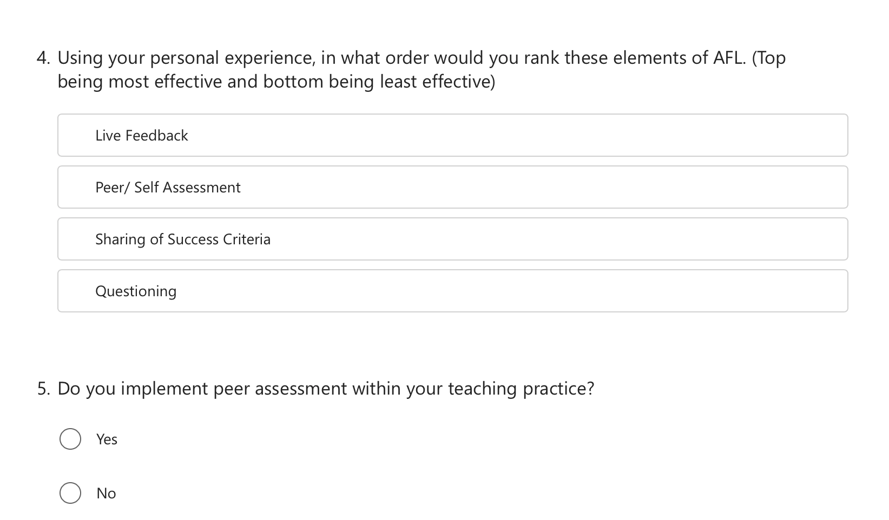
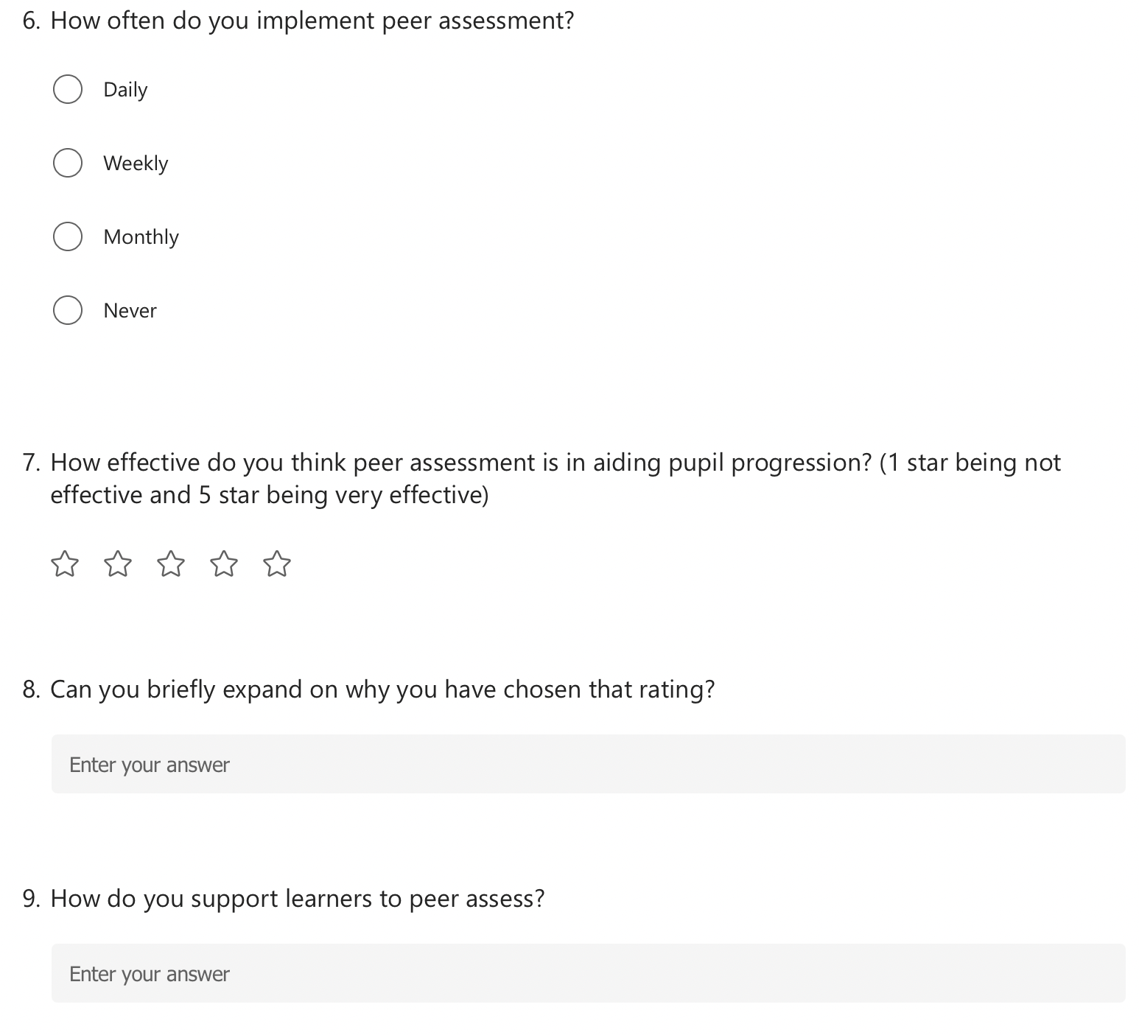

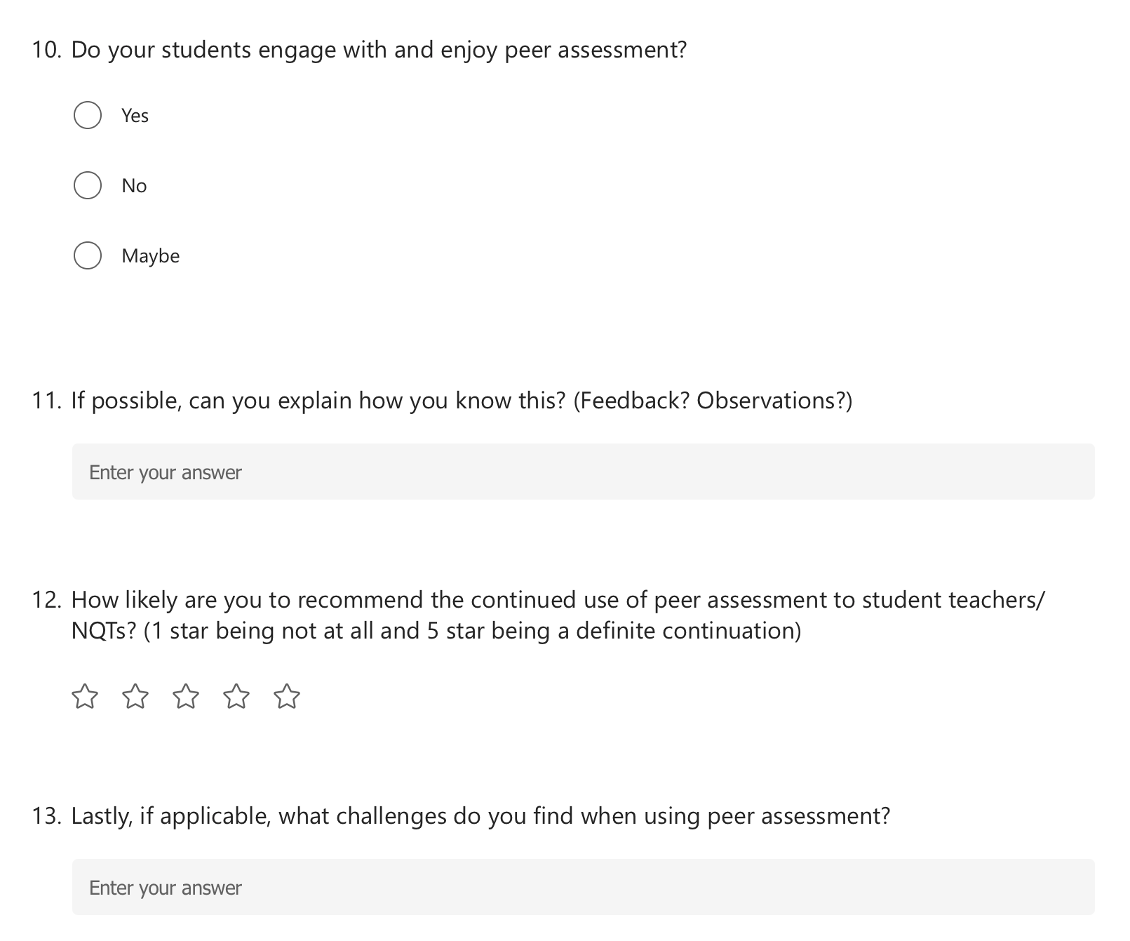

Staff Questionnaire Responses:

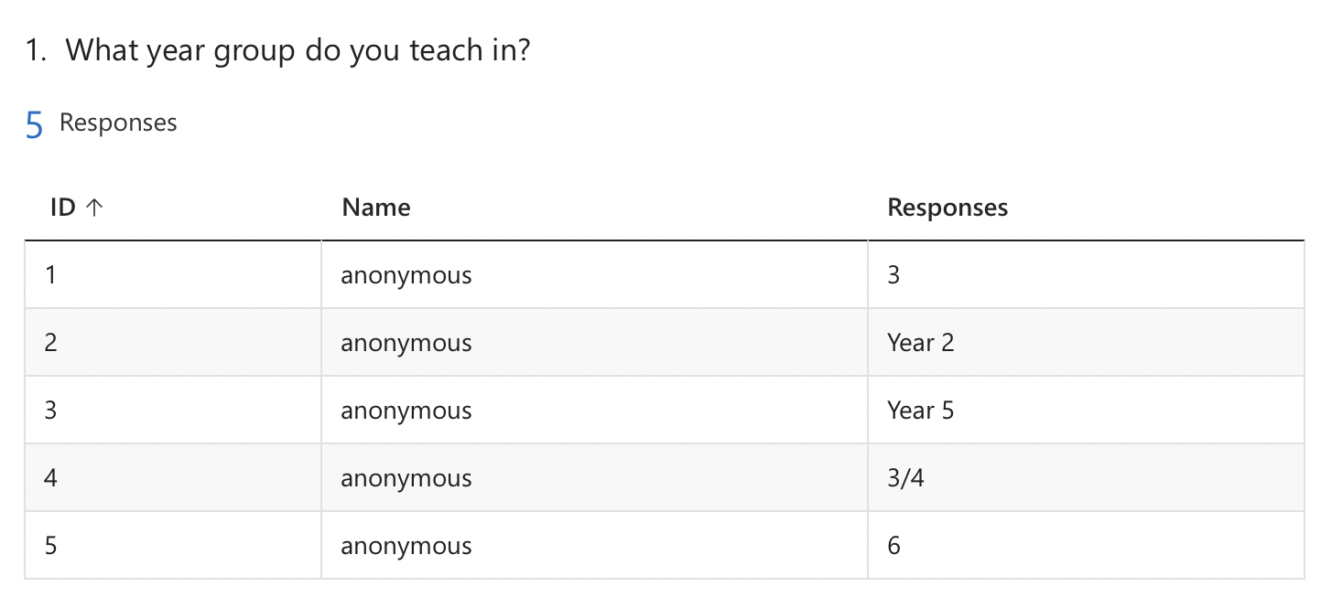
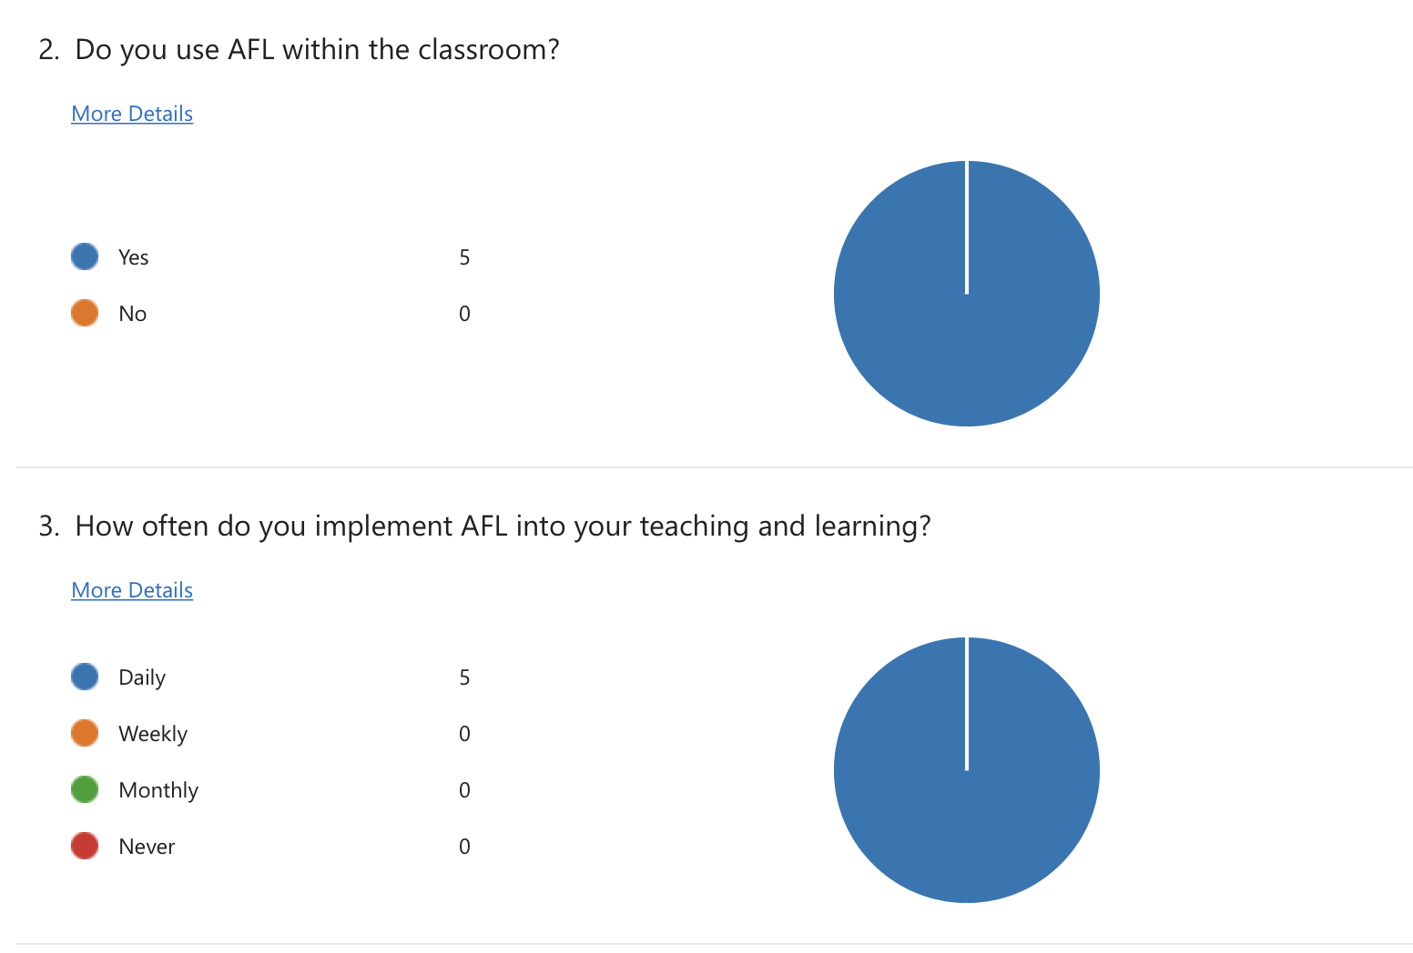

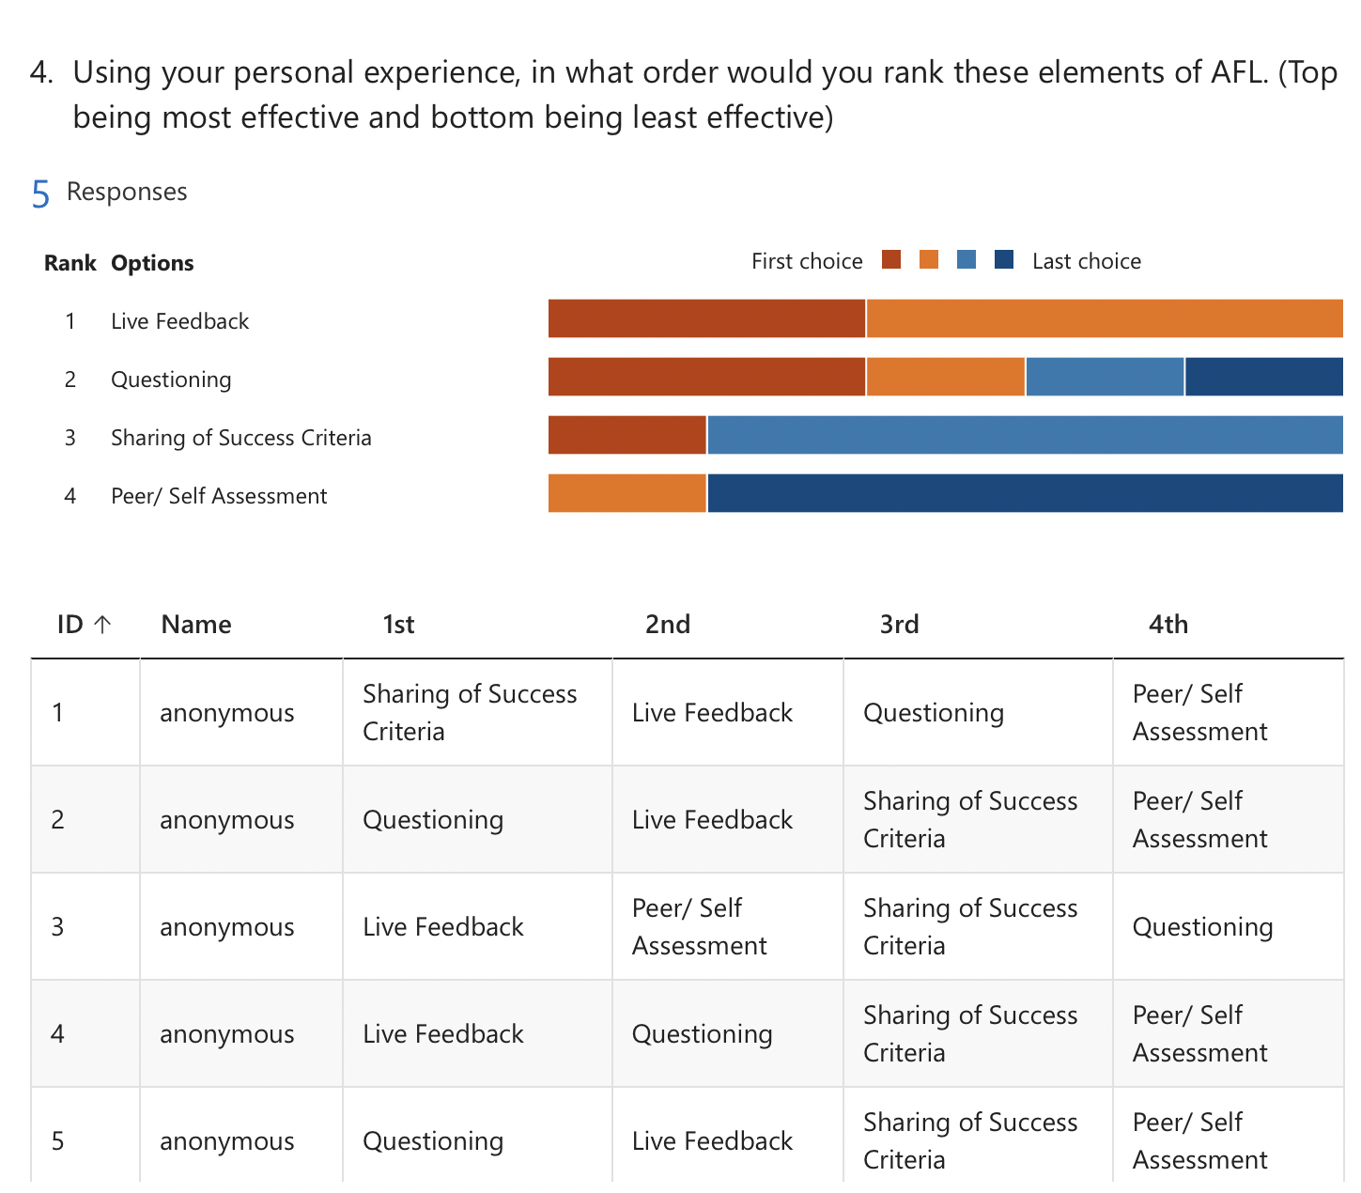

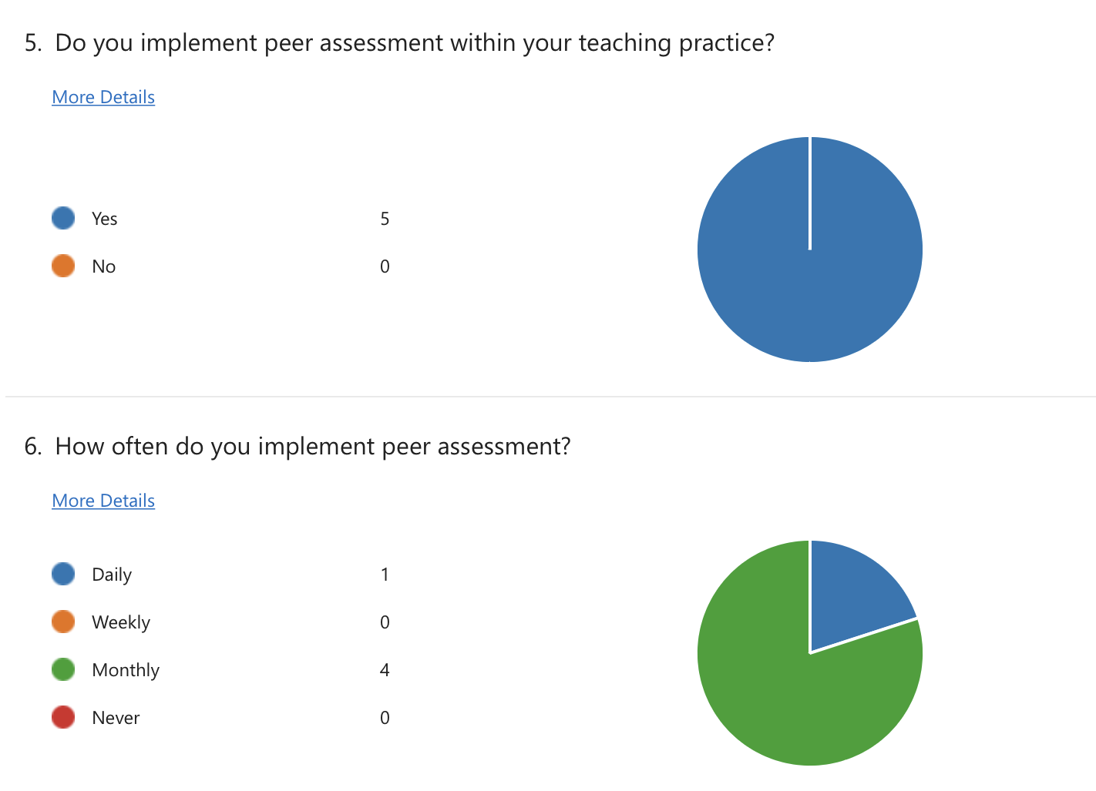

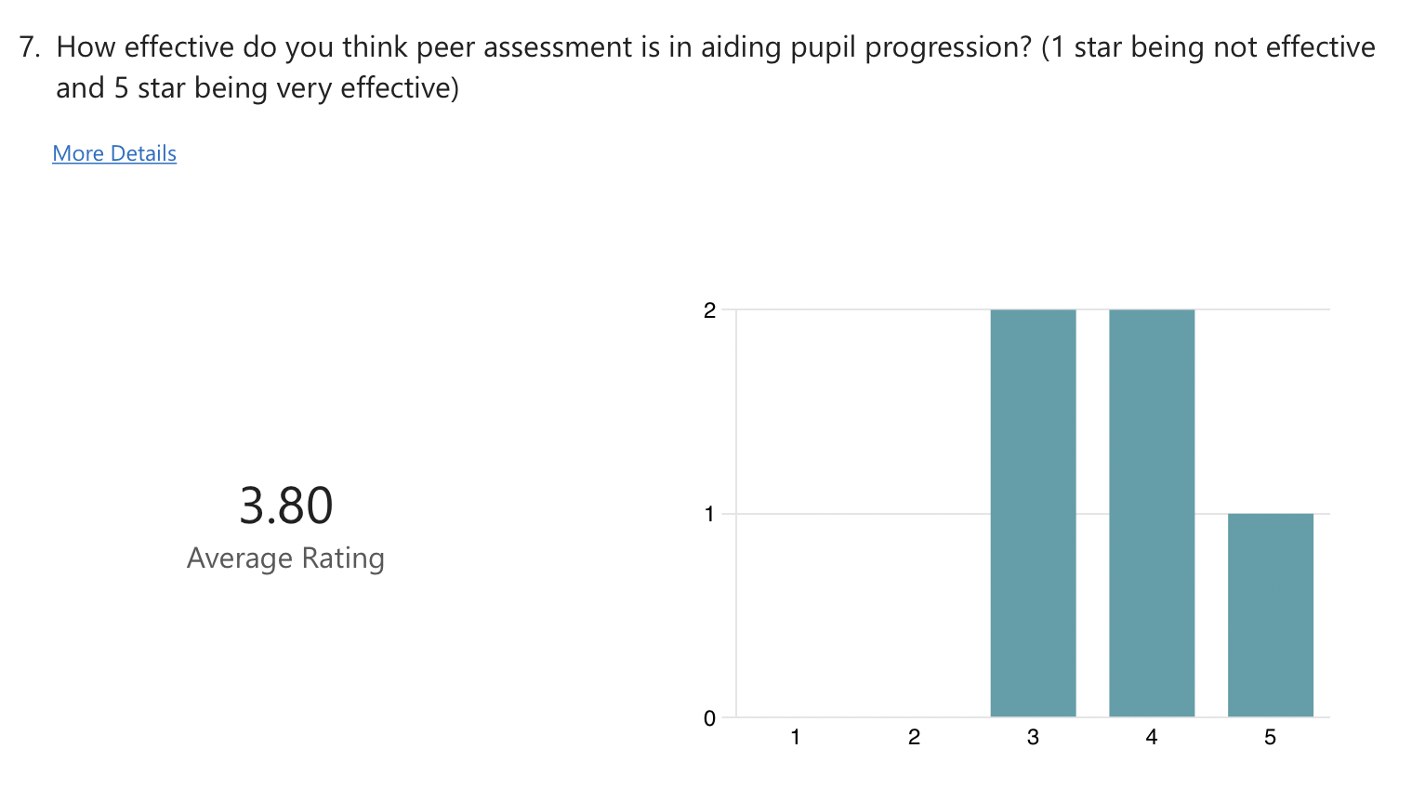

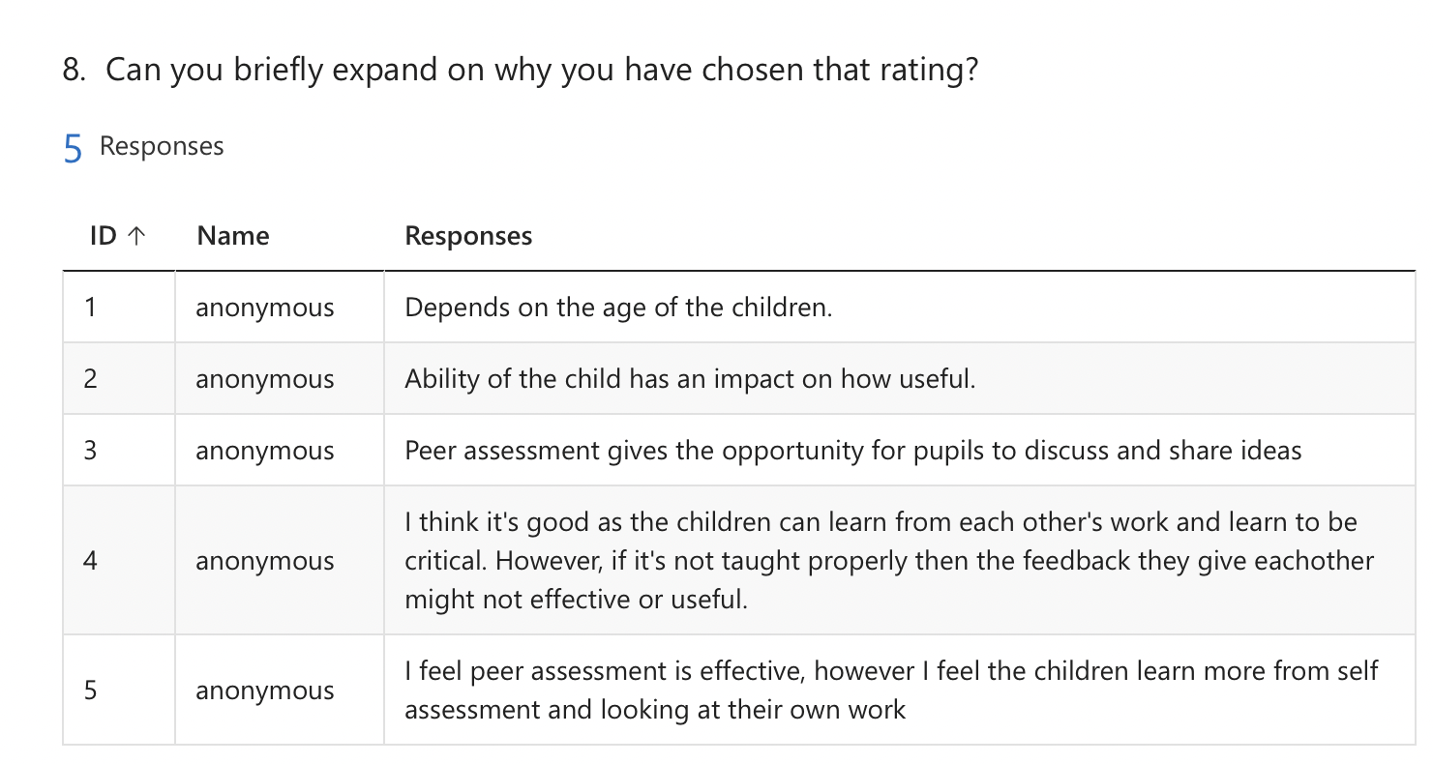

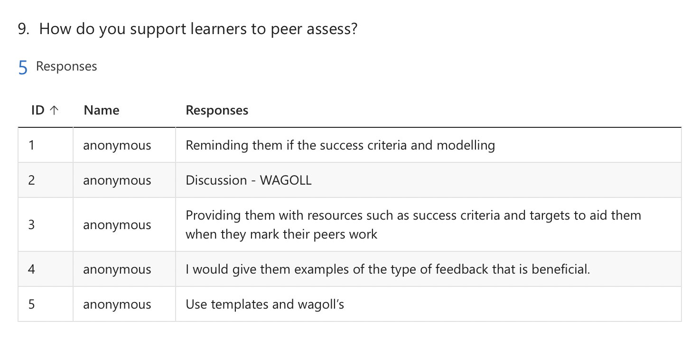
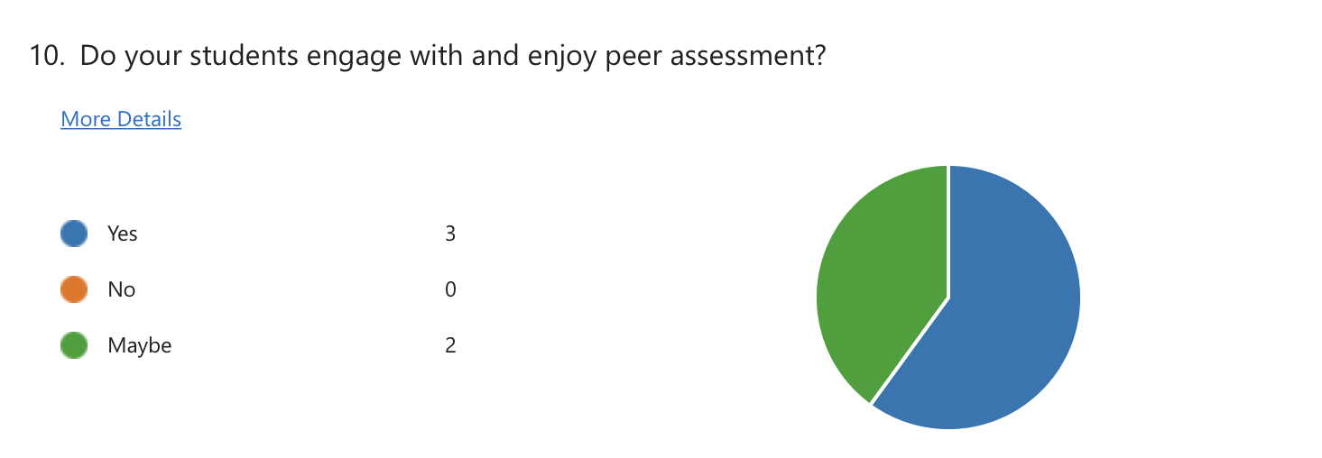

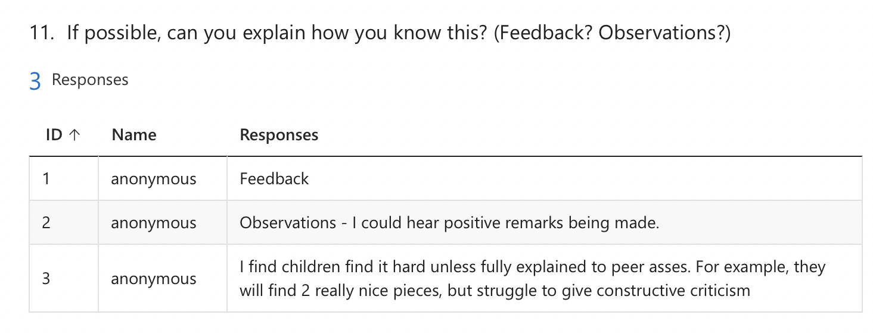

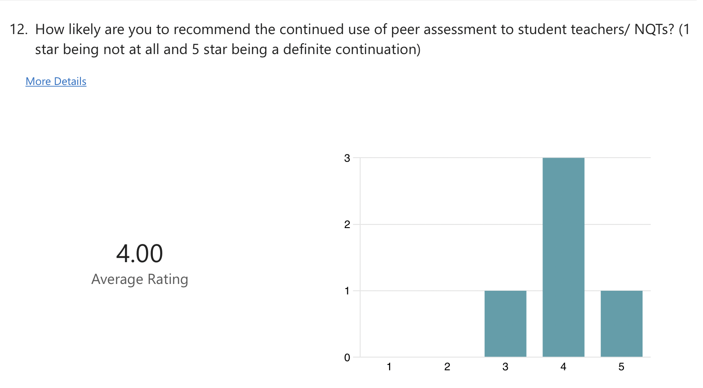

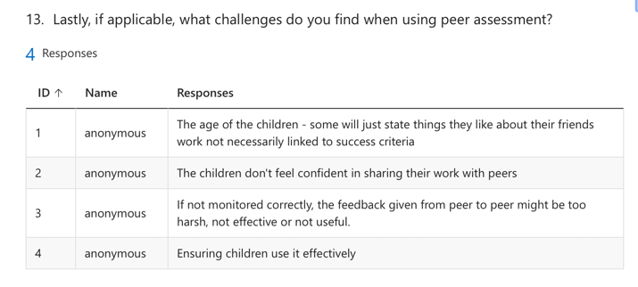

Parental Consent Form:


CONSENT FORM (PARENTS/GUARDIANS)
PROJECT TITLE: What are staff and year 6 students’ perceptions on peer assessment within the classroom?

Name of Researcher: Miss. N Colclough

Please initial box

1.I confirm that I have read and understand the information sheet dated 19/01/24 for the above study.

2. I understand that my child’s participation is voluntary and that I am free to withdraw my child from the study at any time, without giving any reason.

3. I understand that my child can choose to withdraw at any time, without giving a reason.

4. I understand that the information given by my child will be used in a university assignment.

5. I understand that my child’s name will not appear at any time.

6. I agree for my child to take part in the above study.

_____________________ _____________________________ __________
Child’s name Parent signature Date

When completed, please return to the school by the 24th of January 2024.

Thank you.
School Consent Form:

ECAD5010 Consent Form

Student teachers must gain the following written consent of the head teacher before trialling their research tools.

To be completed by the school:

I agree to ____________________________________ as a representative of Yr Athrofa to:

-Take photographs (Tick accordingly)

-Interview

-Take video

-Observe

-Quote school policy documents

-Questionnaires

Name of Head teacher ________________________ Signed _____________________

Name of school _______________________________

To be completed by the student teacher:

If I am granted such permission, I agree to abide by the ethics embodied within the EWC Code of Conduct and BERA Ethical Guidelines (2018) and will not distribute any such material to audiences beyond the University authorities without their permission.

Name of student teacher: Nia Colclough Signed: 18/01/24

Student teacher UWTSD e-mail address: 2100479@student.uwtsd.ac.uk

Programme (BA Education QTS/ Primary): BA Primary Education with QTS

Date: 18/01/24

