TITLE -ASSIGNMENT 2 WRITTEN DOCUMENT
MODULE CODE -BMHP5015
STUDENT NAME – ELAINE ARTWELL
STUDENT NUMBER – 2008821
LECTURER NAME- DR TAYO KOREDE

INTRODUCTION

In this reflection, I will be identifying key points that I have gained doing the E-portfolio and what I have achieved by learning from different aspects of the module. I will be exploring what employability skills I have gained that stood out and can be used in the real environment or workplace. I will draw upon each unit, unit 1, brand you. Unit 2, it’s a small world. Unit 3, Opportunity knocks and Unit 4, the pursuit of happiness. I will evaluate my understanding of personal skills and their congruence with the skills required for professional practice. In the findings, I will reflect upon what goals I aim or intend to achieve in the future with recommendations.

Overview
This lesson presents the idea of the Brand Called Me and explains what it implies in the context of the future workplace.

Unit 1 Brand you. Topic 1- Ambition Is critical.

This topic taught me how to define ambition and how many different things may be considered ambition. Ambition, in my opinion, is when you are driven to reach personal goals and are satisfied when your work ethic is met. According to Merriam- Webster (2022), Ambition is defined as a strong drive to succeed. Ambition refers to a desire for personal advancement or preference and it can apply to a commendable or excessive ambition. However, Bartleby (2021) argued that Imagine someone who lacks motivation, squandering their days away in bed, oblivious to what is going on around them. This is the polar opposite of ambition indifference. I also found that this topic opened my imagination about what I want to become and what I want to achieve in life. I have always wanted to become a nurse in mental health but had to overcome obstacles to get there, but if you believe in yourself there are no limits to what skills and ambition you can achieve. In life, you cannot always choose what you do but, you can always choose who you are.
I recall watching a video on the philosophy of Jean-Paul Sartre about choice and how the choices we make can make a difference. I aspire to advance professionally and to uphold excellent standards in healthcare, possibly to the top. This topic also taught me how to be real and how to be myself without assuming a different identity. Being yourself and avoiding outside influences are the keys. I took a survey to determine my level of ambition and the result was nineteen, which suggests that I have strong ambitions for my professional progress. The topic taught me how to believe in myself and how to push myself to the limit. Determination is a skill that I have gained for my professional development plan.

Overview
I will assess the strength of my network in this unit and consider how to strengthen it to support my success moving forward.

Unit 2 it’s a small world. Topic 1- No one is an island

This subject helped me rethink what I previously believed networking to be. We can not hide from the many forms of networks since they are all around us all the time. Networking will be used in some capacity in each career we choose. Weaver and Morrison (2008) claim that the idea of social networking has existed for a lot longer than the internet or even mass communications. People have always been social creatures, and one of our greatest strengths is our capacity to collaborate in groups to produce value that is greater than the sum of our contributions. I found this topic interesting because, in my future career, networking will be important, especially evaluating a network to help improve business. I learned that goal-based, process-based and outcomes-based are the main types of evaluation methods and to succeed in any form of business, this method will help to develop awareness for my personal and professional development. What interested me in this topic was the video presented by physicist Albert-Laszlo Barabasi. He talked about the secret of success and how performance is about you and success is about us. My understanding is that to be successful does not necessarily mean that you have to perform extremely well in school to determine your success. I think that in my future line of work as a nurse, performance may be evaluated using tools like performance appraisals, which rate a nurse’s productivity, but success is something that can be achieved anytime. Buchanan (2018) mentioned that Albert Laszlo Barabasi quoted, according to the first,” performance drives success, but where performance can not be evaluated, networks drive success.” Better athletes consistently prevail in competitive tennis, demonstrating their dominance.
The story of the peppered moths was interesting because, in an environment where things can change dramatically, you must learn how to adapt. I would apply this metaphor to improve my employability by becoming adaptable to changing environmental circumstances. This would expand my network and have a significant impact. By expanding my connections, the rewards would be successful.

Overview
You will examine how you present yourself to create future work prospects in this unit, including your web presence.

Unit 3 opportunity knocks. Topic 1- Creating Your Own Luck

In this topic, I learned about how luck can be accidental and how inventions were made by accident that have become useful items to this day. The topic also focused on “blind “luck and active
luck. This scenario could be useful in a work setting, where you would need to act on an impulse to solve situations, look at it as quick thinking. According to Random House (2022), chance meetings, altered plans, delayed travel, human mistake, and other catastrophes are common occurrences in modern life. Serendipity is the occult power that governs our universe. But what if we could take advantage of this lack of predictability? Dr Christian Busch has spent the last ten years researching how chance encounters if taken advantage of, can broaden our social networks, improve our worldviews, and open new career prospects. I think serendipity works well in business because you are looking for opportunities to boost your career or create innovations. I believe that in my professional career development, it’s good to take risks and think outside the box.
I watched a video on curiosity and how we can see things differently. Albert Einstein said, “I have no special talents. I am passionately curious” (Einstein, 2012, P.4). I believe it is crucial to be curious and ask questions in order to be successful in the work Market. Since I will be networking more and meeting folks outside of my circle, curiosity will have its adventures.
I found the Cynefin framework to be useful in a work environment as it is inevitable that we will have accidents and will need to make decisions in certain situations. O’Connor (2015) claims, that a decision framework called cynefin, pronounced “Ku- ne-vin,” recognises the casual differences that exist between various types of systems and suggests new methods for making decisions in a complex social context. It also suggests new ways to comprehend increasing levels of complexity as decisions are made. I was motivated to start my own business after reading after reading about stretch goals. With the right attitude and a strong work ethic, I will have the chance to open sites in additional cities. I think you must leave options open when considering your goals and careers.

Overview
Success entails overcoming hardship and remaining persistent. You will study methods in this unit to assist you in overcoming various problems.

Unit 4 The pursuit of happiness. Topic 1- Future Me

This topic helped me to reflect upon the reason why I decided to go to university and what I expected to achieve from learning different modules. At the beginning of my studies, I did not know what to expect, but with perseverance and determination, I set myself a goal of what I wanted to achieve in 3 years of study. I came to the university to gain knowledge in healthcare to further branch out into nursing. My downfall is procrastinating, but I am trying very hard to overcome this habit. I have felt more confident as the years have gone by and hopefully with dedication, I plan to pursue my master’s degree. After watching the video about why university, my expectations remain the same. The top three reasons for studying at university are, to pursue a particular career, to learn essential skills and to change direction in life. The time spent at university has given me the knowledge and direction of what goals I want to achieve. I attended graduation in June of this year and my confidence increased significantly which also gave me that extra boost to continue studying hard to gain a qualification. Everyone will experience limiting beliefs at a certain extent. My experience usually happens when negative people are around me who do not want to prosper in life, even when you encourage them. Reflecting on limiting beliefs, the video did resonate with myself. I often tell myself that I cannot do this, but when I think about where I want to be soon in terms of careers, the motivation keeps me going. Although I experience limiting beliefs, my results for the quiz revealed that I have a growth mindset rather than a fixed mindset. Vandewalle (2012) said that Chiu et al (1997) found that people with a fixed mindset made judgments and predictions about other people more quickly than people with a development mindset and they were willing to do so based on the sparse information of only one behaviour. I am a happy person who usually knows what she wants in life and wants to achieve. 66Another quality that the institution has assisted me in developing is self-belief. I particularly loved the concept about writing a zander letter to myself to justify why I have received a first-class classification in my degree. This letter gave me the confidence and motivation to self-praise on my accomplishments. My confidence increased as a result of the video's ability to make me believe in myself. This letter provided me the self-assurance and inspiration to celebrate my successes,

Conclusion
In findings, the overall units combined revealed that to achieve goals and high standards, you must find your direction and which path you want to take. Set yourself challenges to determine how far you can go. The goal is to abandon giving up and learn new skills in either education, employment.
Motivation, communication skills and perseverance are the key points needed for employability. We can draw the conclusions that interpersonal skills are more of a natural trait than something that can be taught. When working you must have a flexible approach to deal with potential situations.

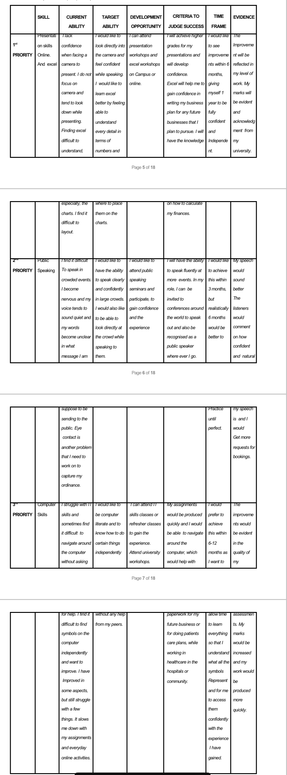
Personal Development Plan

References

Bartleby Research, 2021. Disadvantages of Ambition.
https://www.refseek.com/search?q=Disadvantages+of+ambition
https://www.bartleby.com/essay/Disadvantages-Of-Ambition-FKZJQPQ4HAR

Buchanan, M. The secret of status, 2018
https://media.nature.com/original/magazine-assets/d41586-018-07524-5/d41586-018-07524-5.pdf

https://www.refseek.com/search?q=Performance+and+success+Albert+laszlo+Barbara’s

Busch, C., 2022. Connect the Dots: The Art and Science of Creating Good Luck. Random House.
https://scholar.google.com/scholar?hl=en&as_sdt=0%2C5&q=what+is+blind+luck+and+active+luck&btnG=

Einstein, A., 2012. Albert Einstein Quotes. Retrieved from Brainy Quote. Com, P.5
https://scholar.google.com/scholar?hl=en&as_sdt=0%2C5&q=albert+einstein&oq=Albert

Merriam-Webster.com.
https://www.merriam-webster.com/dictionary/ambition

O’Connor, R. V, 2015. Exploring the Use of the Cynefin Framework to Inform Software Development Approach Decisions, (P.2.)
https://www.researchgate.net/publication/281345229_Exploring_the_Use_of_the_Cynefin_Framework_to_Inform_Software_Development_Approach_Decisions

Oradini, F. and Saunders, G., 2008, February. The use of social networking by students and staff in higher education. In iLearning forum
(PP. 4-5)

Vandewalle, D., 2012. A growth and fixed mindset exposition of the value of conceptual clarity. Industrial and Organizational Psychology, 5(3), pp.301-305.
http://www.alearningboxblog.com/uploads/5/8/0/2/58020745/a_growth_and_fixed_mindset_exposition_of_the_value_of_conceptual_clarity.pdf
https://scholar.google.com/scholar?hl=en&as_sdt=0%2C5&q=growth+mindset+v+fixed+mindset&btnG=#d=gs_cit&t=1660554418000&u=%2Fscholar%3Fq%3Dinfo%3Asf0moLessVcJ%3Ascholar.google.com%2F%26output%3Dcite%26scirp%3D3%26hl%3Den

Weaver, A.C. and Morrison, B.B., 2008. Social networking. Computer, 41(2), pp.97-100.

