Application of Computer Aided Engineering Processes
An examination of the 14.5mm armour piercing round impacting on high hardness steel (HHA)
Joshua Ede (2023302)
Approximate wordcount 4,452
2024
Contents
1. Introduction 5
2. Impact Dynamics: Overview 5
2.1 Simplified collision and impact in physics 5
2.2 Collision and impact in the real world 6
2.3 Parameters to consider in impact models 7
3. Model Setup 9
3.1 Geometries 9
3.2 Material properties 11
3.3 Velocity 11
3.4 Meshing and variables examined 12
4. Results 12
4.1 Preliminary Run 13
4.2 Results 14
4.3 Further simulations 24
5. Discussion 24
5.1 Expected results based on the real world study 24
5.2 Expected results based on the EPIC Code model 27
5.3 Simplified geometry in 3D 30
5.4 Meshing 30
5.5 Boundary conditions 30
5.5 Results conclusion 31
6. Conclusion 31
Bibliography 32
Annex A: Geometries 35
Annex B: Increased velocities 40
Annex C: Simplified Geometry 47

Figure 1: Assembly created in SolidWorks. 9
Figure 2: Digital image of the 14.5mm round created in SolidWorks dimensions taken from [1]. 9
Figure 3: Different meshed zones, four rings on the plate and two parts to the core. Initial runs used meshing 1mm on the core, inner, first, second, third plate rings then 5mm for the fourth ring and rest of target. 11
Figure 4: Sectioned view of the plate showing the depth of penetration (DoP) by the core at 750ms-1 – DoP = 0.9mm as worked out from 25.4 – 24.5mm, Core velocity 750ms-1, meshing 0.01mm on core, inner, first, second, third plate rings then 0.05mm for the fourth ring and rest of target. 13
Figure 5: Mie Gruniesen parameters used for target, but not for core at 750ms-1. 14
Figure 6: Model rerun with finer meshing, 0.75mm centre ring and core, ring 1 at 1mm, ring 2 at 5mm, ring 3 at 10mm, ring 4 and rest 50mm. 15
Figure 7: Depth of penetration with new mesh, JC parameters and a velocity 750ms⁻¹is 7.6mm or 25.4 - 17.8mm. 16
Figure 8: Max principal stress of core, 0.3879GPa at 0.375ms. 17
Figure 9: Total deformation of core at 0.62919m at 375ms. 18
Figure 10: Max strain of core 0.59899mm/mm at 375ms. 19
Figure 11: Max strain of target 0.3552mm/mm at 375ms. 20
Figure 12: Max stress of target at 1.7927GPa at 375ms 21
Figure 13: Total deformation of target 9.3102m at 375ms. 22
Figure 14: Surrogate 1, note the V50 velocity of 738 and the comments on the penetrator or core from [2]. 24
Figure 15: Surrogate 2 again note the V50 velocity and the comments from [1]. 25
Figure 16: Penetration of the target by a modelled projectile taken from [2]. 26
Figure 17: Long solving time due to complexity of model. 28
Figure 18: Original geometry for projectile. 34
Figure 19: original geometry showing different parts of the projectile. 35
Figure 20: Original assembly imported into ANSYS. 36
Figure 21:Geometry of tungsten carbide core. 37
Figure 22: Core and plate imported into ANSYS and used to derive results. 38
Figure 23: Max Deformation of target at velocity of 937.5ms⁻¹, deformation measured 0.696mm at 4.87ms. 39
Figure 24: Maximum strain in target for a velocity of 937.5ms⁻¹ 0.094188mm/mm at 750ms. 40
Figure 25: Maximum stress 0.74219GPa for a velocity of 937.5ms⁻¹ at 487ms. 41
Figure 26: total deformation of core at 937.5ms⁻¹ recorded at 750ms, a similar level of deformation was recorded for the simulation at 1125ms⁻¹. 42
Figure 27: Maximum deformation of 0. 89957mm at velocity 1125ms⁻¹ and a time of 487ms. 43
Figure 28: Maximum stress 0.93705GPa at a velocity of 1125ms⁻¹ shown on reverse note the waves refracting at the edges of the plate, at 450ms. 44
Figure 29: Maximum strain 1.5443mm/mm at a velocity of 1125ms⁻¹ at 750ms. 45
Figure 30: total deformation of simplified geometry, mesh size 0.075mm across all parts. 46
Figure 31: Total deformation of core in simplified geometry 0.22062m. 47
Figure 32: Total deformation of target in simplified geometry 0.1181m. 48

Table 1: Summary of the criteria applied to the impact problem examined in this report. 6
Table 2: Material properties used in the model 8
Table 3: Percentage decrease of penetration observed in model vs. real-world results. 23

Introduction
This report critically examines the use of computer modelling in ordnance munitions and explosives engineering. This report aims to demonstrate that while computer modelling is an effective tool, careful consideration must be given to the model’s design, construction and execution. Any results obtained should be carefully analysed. The report uses ANSYS-AUTODYN to analyse the expected interaction between a 14.5mm tungsten carbide core and a high-hardness steel (HHA) armour plate. The original geometry of the experiment is created in SolidWorks and then imported into the ANSYS-AUTODYN workbench tool; this will be expanded on in the model setup section of the report.
The model is validated against an experiment conducted when selecting a new surrogate for use in armour testing by the United States Army Research Laboratory [1]. The modelled results are also compared to a study conducted using the EPIC code and material library [2].
It is noted that the results obtained during this study do not match either the experiment nor the computed model, and the reasons for this are examined as part of the discussion in this report. It is nevertheless argued that despite the differences between results computer modelling is a valid and useful tool in examining impact problems, indeed the differences illustrate the complexities of the issue, which makes modelling solvers necessary for their ability to account for the many different variables present in such problems.
The structure of this report guides the reader to first consider the nature of the problem with a simple discussion on physics. This will be expanded upon with the introduction to the different variables that need to be accounted for in order to make the problem more applicable to the real world and how these are accounted for within a model.
Following this, the model setup section will contain a description of the creation of the geometries within SolidWorks and the setup in ANSYS. The results will be presented in the form of pictures taken from the software with some discussion of values obtained. A longer discussion will then encompass analysis and validation of the model before the report reaches its conclusion.

Impact Dynamics: Overview

2.1 Simplified collision and impact in physics

When considering the impact of a projectile on a target, it is useful to consider the first principles of the problem being discussed. In essence, impact dynamics is looking at the interaction between two or more bodies colliding at force. The equation governing the physics of this relationship is given below [3].

$$m_{a}v_{a}+m_{b}v_{b}=m_{a}v_{a}^{'}+m_{b}v_{b}^{'}$$
(1)
Where m is mass and v is velocity. It can be said that the combined masses of two bodies, a and b, multiplied by their respective velocities immediately prior to impact, must be equal to their combined mass and velocity immediately post-impact. Assuming mass does not change, then the new velocities of the bodies will be illustrated in the value of v’. This is governed by the conservation of energy [3]. This is the first step of a rigid body problem, i.e. where there is no loss or change in mass. The problem almost immediately becomes more complicated, however, as energy can be lost in the impact between the bodies, and thus, the right-hand side of the equation will not equal the left, or more simply, the total v’ is not the same as the total v.
Physics uses a value e to account for this, referred to as the coefficient of restitution, which gives the Newtonian law of impact shown in equation 2.

$$e=\frac{v_{b}^{'}-v_{a}^{'}}{v_{a}-v_{b}}$$
(2)
In the equation where e is 1, there is no loss of energy and therefore no reduction in total velocity between the moment before impact and the moment after, then the impact is said to be perfectly elastic [3]. While the underlying physics here is important to understand, it is not fully representative of a bullet impacting an armour plate, and the following section will outline some of the further parameters that are part of the real-world problem [4].

2.2 Collision and impact in the real world

The previous section gave an overview of a very simplified impact problem within physics in order to outline some of the underlying principles that needed explaining. However, for the purposes of examining a bullet impacting plate, it is too much of a simplification in order to provide useful incite [3] [4]. A real-world impact study needs to account for and is not limited to the following factors: stress, strain, pressure and failure mechanisms, and each of these factors need to be considered in complex materials with their own variation in terms of structure [5].
Furthermore, in many of these cases, the change between rest and peak values occurs in a very short time span and many of the variables are interrelated, making the overall problem very complex [6] [7]. As a method of solving these problems hydrocodes have been developed that use the principles of conservation of mass, momentum and energy while accounting for large changes in strain, pressure, or other variables within the model [6].
Furthermore, as these codes have matured, they have been able to incorporate more complex equations for understanding different parts of the impact problem, such as damage [7]. ANSYS is an example of one of a hydrocode software package and incorporates an explicit dynamics feature, which essentially looks at problems where sharp changes in values happen in very short timespans, such as those of interest in a bullet impacting a target experiment [7] [8].
In order to construct any model choices have to be made in terms of the parameters that will best represent the problem. As mentioned in section 2.1, although the rigid body problem provides the underlying physics for subsequent analysis, it is not appropriate for studying the kinds of variables present in the bullet-impacting plate example. Therefore, there is a question as to what mathematical equations and assumptions should be incorporated to examine the variables of interest. The following section will explore some of these choices.

2.3 Parameters to consider in impact models

2.3.1 Software

The different aspects to consider when examining hydrocodes can essentially be broken down into the software, the processor, the equation of state (EoS), strength models and damage criteria [7]. The software aspect has previously been mentioned, as the author used ANSYS for this particular study, and other software packages also exist. Indeed, the study used as validation for the model in this report uses the EPIC 2010 software code [2].
ANSYS has been used in studies similar to the one in this report to examine projectile impact into high-strength low alloy steel (HSLA), which has material properties similar to those of steel looked at [9]. The tungsten carbide core was specifically focused on in [10] [11] and indeed very different material properties but similar impact problems were examined in [12]. This is not to say that ANSYS is the only solver capable of this kind of analysis some reports prefer using LS-DYNA as a solver [13] [14] [8] and this is a module available within the ANSYS suite, however overall the differences in software are not so large and instead it is in the different material libraries they contain, along with the different formulations, EoS, strength models, etc that cause differences in results between studies [15].
Thus, modelling the problem in ANSYS and comparing these results to the study in EPIC and the experimental results is regarded as a suitable level of validation for this particular aspect of the study.

2.3.2 Processor

The choices in terms of a processor can have a very large impact on the model and the likelihood that the model will be able to solve to completion. Processors can essentially be divided into four different types of interest for impact studies, Lagrangian, Eulerian, Smooth Particle Hydrodynamics (SPH) and Arbitrary Lagrangian Eulerian (ALE) [7]. The processing type essentially effects which parameters are being kept constant and which are able to change at different locations within the model [7].
In a Lagrangian model, a numerical grid maps and moves with the material, not allowing for changes in mass but giving a representation of deformation by changes in a mesh shown to a user [16]. Large changes in the mesh can cause errors and, in the worst case, incomplete solving when a Lagrangian method is employed. Nevertheless, it also offers highly accurate results at the point of interaction in impact and penetration problems [16] [11].
In contrast, an Eulerian processor has fixed grid points, and instead, material flows across it, which requires more computing power in order to solve and does not give as much detail on the interaction at the point of contact between the projectile and target [15] [16].
The ALE method combines elements of these two previous processing regimes and adds another layer of complexity by adding another reference domain to better analyse the changes from [7]. These models are more commonly used in shaped charge analysis due to the extreme deformations present in such simulations [17] [15] [18]. SPH is another popular processor within ballistic studies and has the advantage of treating each particle as discrete and removing the need for a mesh. This, in turn, means it can handle distortion much more easily [12]. It is, however, argued that it is more applicable to the study of ceramics rather than metals due to the ductility of metals, making the discretisation less representative of their real-world material properties [12] [9].
From a review of the relevant processors and given the interests of the study, namely deformation within the steel target and tungsten carbide core, the processor chosen used was Lagrangian [16]. This also makes the report directly comparable to the study using EPIC code, which also used a Lagrangian processor as part of its analysis [2].

2.3.3 Equation of State (EoS)

Equations of state essentially relate different properties of the materials within the model in equilibrium. An example of an EoS is the ideal gas law, which states that all other things being equal pressure, volume and temperature of a system may be related to the material properties, specifically density, of the ideal gas [19].

For the purposes of the initial setup of the model, the EoS used was the default linear analysis.
This is because this is considered sufficient for ballistic impact problems and involves the least computational strain [6]. However, as shall be shown in the discussion, some simulations were redone using a Mie-Gruniesen EoS, which is based on shock wave analysis for the analysis of pressure within materials [9]. It is noted that some authors view the Mie-Gruniesen as not appropriate for problems with projectiles with less than 2km/s velocity [5] [6] [20]; thus, although it has been explored as a variable within this report, it is the initial parameters using a linear analysis that are the basis for the results.

2.3.4 Strength Model and damage criteria

These two components can be considered together and essentially relate the material properties to how they respond to external force [7]. The strength and damage models used in this study are the Johnson Cook (JC) parameters which are widely used in such studies [7].
Due to their widespread adoption and use, deficiencies have been identified, notably by Meyer [5], however they continue to be popularly applied and are understood to give accurate results. The computed modelling study used as validation for this report uses the Johnson Cook parameters [2], as do [10] [8] [11] [21].
Although popularity should not be mistaken for accuracy, it may be said that part of the widespread use of the Johnson Cook strength and damage criteria is based on the performance and evaluation of physical material testing done using standardised tests such as the Split Hopkinson pressure bar (SHPB) and quasi-static tensile tests and the numerical values found within the model [22], hence part of their appeal is the accurately referenced and understood material properties it is based on.

2.3.5 Parameters applied to the model

The previous sections 2.3.1-2.3.4 have outlined some of the different parameters used in models used to examine bullet impact problems. Furthermore, it has been suggested why certain parameters were used in this report, the choices made are summarised in the table below for reference.
Table 1: Summary of the criteria applied to the impact problem examined in this report.
Software | Processor | Equation of State | Strength Criteria | Damage Criteria
ANSYS | Lagrangian | Linear | Johnson-Cook | Johnson Cook

The following section will provide greater detail on the exact model setup, including the geometries of the constituent pieces, the material properties used, the velocities examined, and the variables being solved.

Model Setup

3.1 Geometries
The geometries for the model were initially created using SolidWorks, and then the entire assembly was imported into ANSYS. Larger images are available in Annex A.
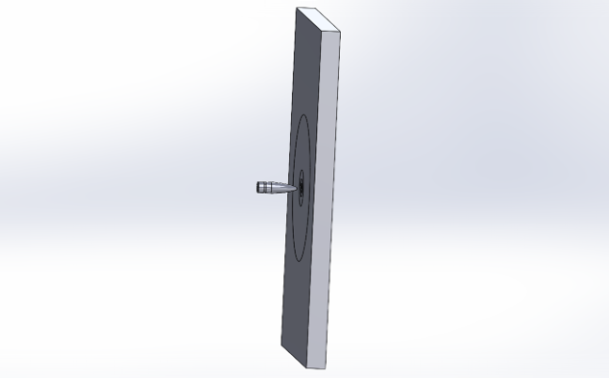
Figure 1: Assembly created in SolidWorks.
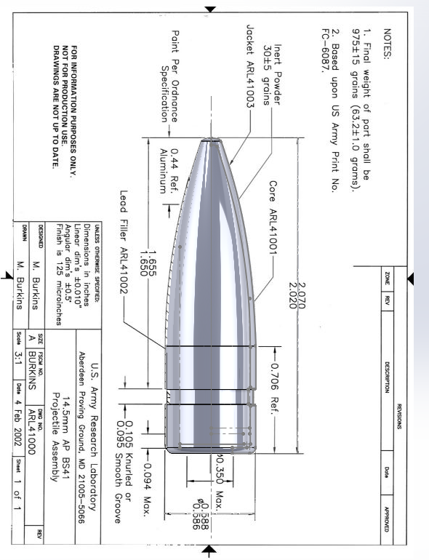
Figure 2: Digital image of the 14.5mm round created in SolidWorks dimensions taken from [1].

The target and the projectile were both modelled based on the experiments done by the US Army Research Laboratory. In their report, the target plate dimensions listed are 300mm x 450mm x 25.4mm [1]. As the US Army study is interested in comparing two surrogate bullets, the dimensions supplied for the projectile are contained in some detail in the annexes of their report [1]. Fig 2. shows one of the annex images used as a basis for some of the geometry for the projectile examined as part of the ANSYS simulation.
The US Army report also goes into detail on the materials used in both the target and the projectile, with the target consisting of a high hardness steel/armour (HHA) that conforms to MIL-DTL-46100E, the materials for the bullet are listed as an annealed steel jacket, containing an inert powder, a lead antimony liner and a tungsten carbide core [1]. An image of the sectioned projectile, with its different constituent parts, can be seen in Fig. 19 of Annex A.

Material properties

The material properties examined for the core come from the modelling paper used for validation [2]. The rest of the bullet material properties were taken from [10] as these were not listed in the original study. Similarly, the target details were taken from another source.
In order to ensure that the model run was using representative materials, the material properties for the plate were taken from [16], which utilised Secure 500 M HHA armour plates, which are rated to the same standard of MIL-DTL-46100E [23] as used in the experimental study [1].
The table below summarises the relevant material properties of the bullet core and target. The reason for it only being the target and the core shall be apparent in the results and discussion sections.
Table 2: Material properties used in the model.
Parameter and unit | Target | Core
Density (kgm-³) | 7850 | 14770
Youngs Modulus (GPa) | 206 | 620
Poisson’s Ratio | 0.3 | 0.215
Bulk Modulus (GPa) | 171 | 362
Shear Modulus (GPa) | 80 | 255
Specific Constant Volume (JKg⁻¹K⁻¹) | 450 | 250
Specific Constant Pressure (JKg⁻¹K⁻¹) | 450 | 250
Strain rate correction | First order | First Order
Initial yield stress (MPa) | 1200 | 3
Hardening Constant | 1580 | 89
Hardening Exponent | 0.175 | 0.65
Strain rate Constant | 0.004 | 0
Thermal Softening Exponent | 1 | 1
Melting Temperature (K) | 1800 | 1768
Reference Strain Rate (/sec) | 0.0001 | 1
Damage Constant D1 | 0.1 | 0
Damage Constant D2 | 0.4 | 0.0019
Damage Constant D3 | -1.3 | -3
Damage Constant D4 | 0.05 | 0
Damage Constant D5 | 0 | 0

Velocity

The velocity of the projectile was taken from the initial experimental study and set to 750 ms⁻¹ [1]. This velocity is the V50 ballistic limit of the target and bullet setup. This is where the target will fail at least 50% of the time and be fully penetrated by the projectile [5] [24].
The model run using the EPIC code looked at 700ms⁻¹ and 800ms⁻¹ and also came to 750ms⁻¹ as the ballistic limit. Therefore, it was thought that this would be an appropriate starting value in order to examine the penetration of the bullet core into the target.

Meshing and variables examined

The main run of the model utilised 11377 nodes across 57568 elements, with the run time being approximately 7.8 hours, given the computing processing power available. The parts of the model were divided into different zones of interest, with tip of the bullet having a different size mesh to the core and the target having a series of rings Fig. 3 indicates where the mesh areas were and Fig 6. shows the variation in mesh across the different parts.
The mesh size was varied between different runs to try to assess the impact this was having on the results obtained. The variables looked at in the solver were primarily the total deformation within the model and its constituent parts namely the target and the bullet core.
Upon later runs of the model, further variables were added to try to understand the results. These included the stress and strain for both the target and core. By looking at these additional variables, it was hoped that the results obtained within the model could be better explained.

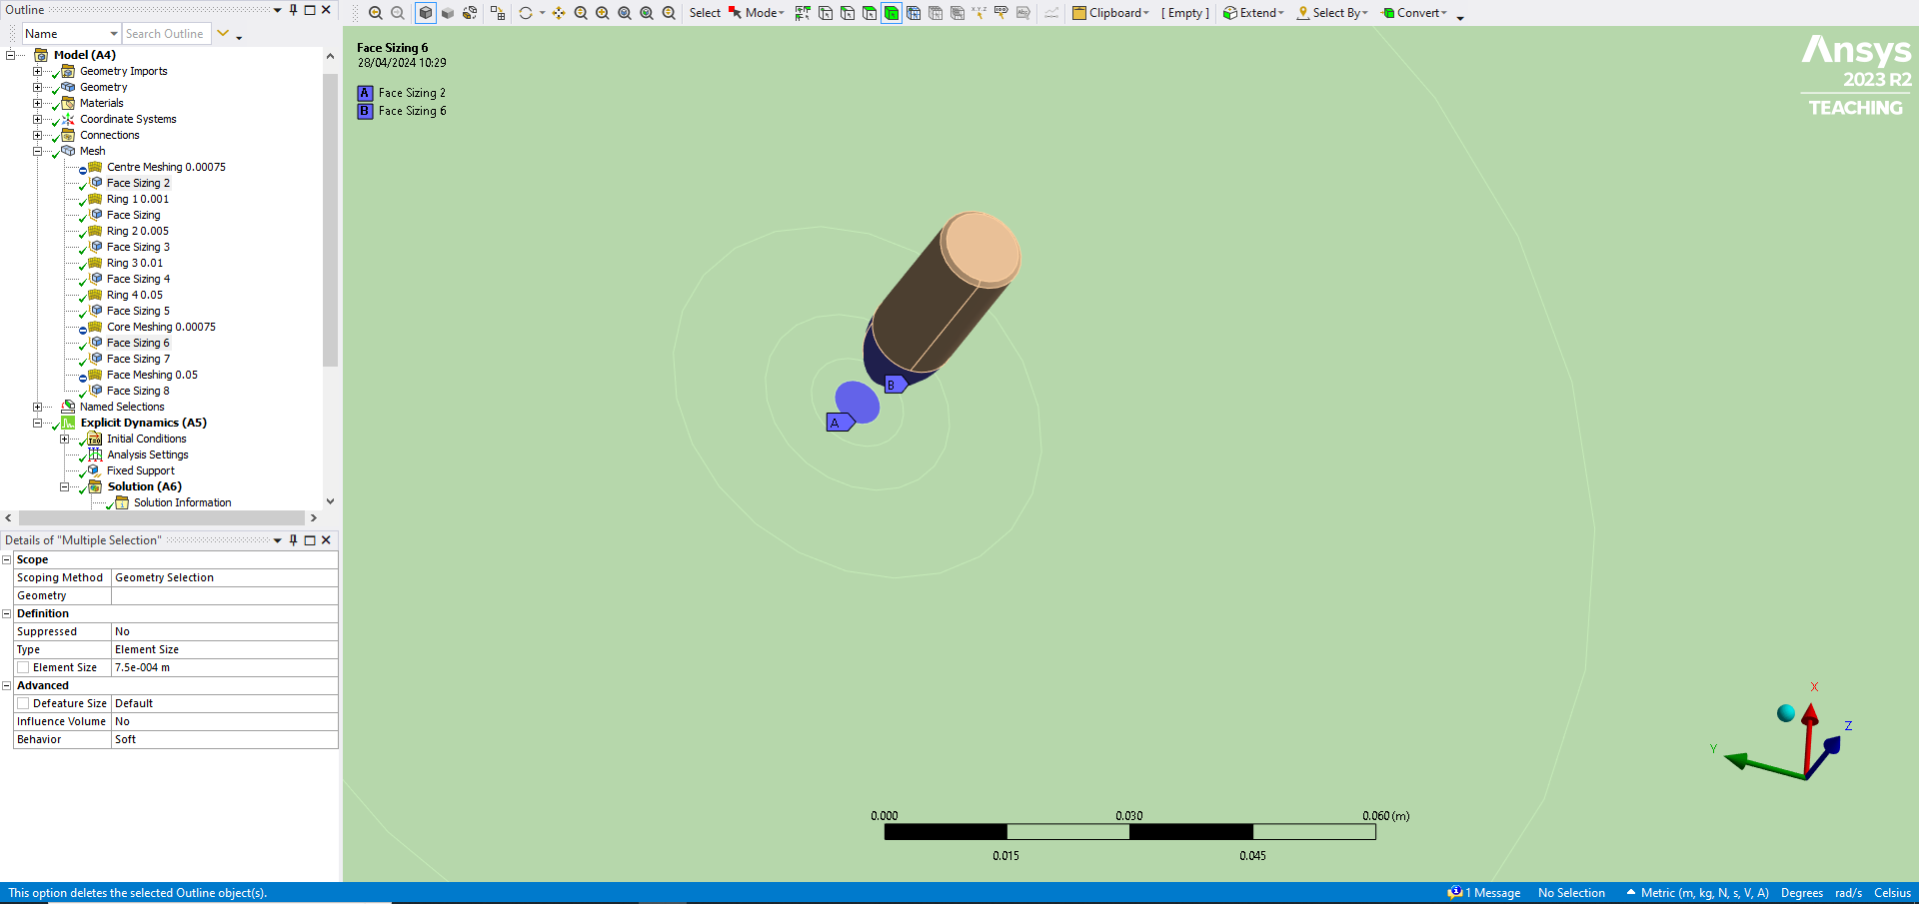
Figure 3: Different meshed zones, four rings on the plate and two parts to the core. Initial runs used meshing 1mm on the core, inner, first, second, third plate rings then 5mm for the fourth ring and rest of target.

Results

4.1 Preliminary Run

Before documenting any detailed results, a note is included here that a preliminary run of the model was computed using simplified representative materials as opposed to the real values using the geometries and velocities already stated in previous sections.
Unfortunately, that gave a computational time for the solver at 1421.6 hours. Given the computational power available at this point, it was decided that the geometry would be altered to only include the target and the bullet core reducing the overall complexity of the model. An image of this proposed solving time is shown in Fig 17. Therefore, the following results are only for the bullet core impacting the target and do not account for the jacket, liner or inert powder found in the round. This is also why the full detailed material properties for the model in section 3.2 only included the values relating to the target and core.

Results
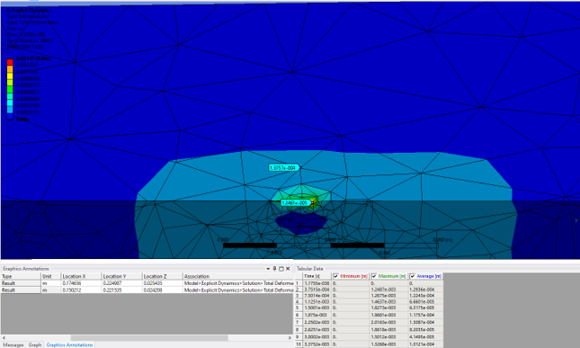
Figure 4: Sectioned view of the plate showing the depth of penetration (DoP) by the core at 750ms-1 – DoP = 0.9mm as worked out from 25.4 – 24.5mm, Core velocity 750ms-1, meshing 0.01mm on core, inner, first, second, third plate rings then 0.05mm for the fourth ring and rest of target.

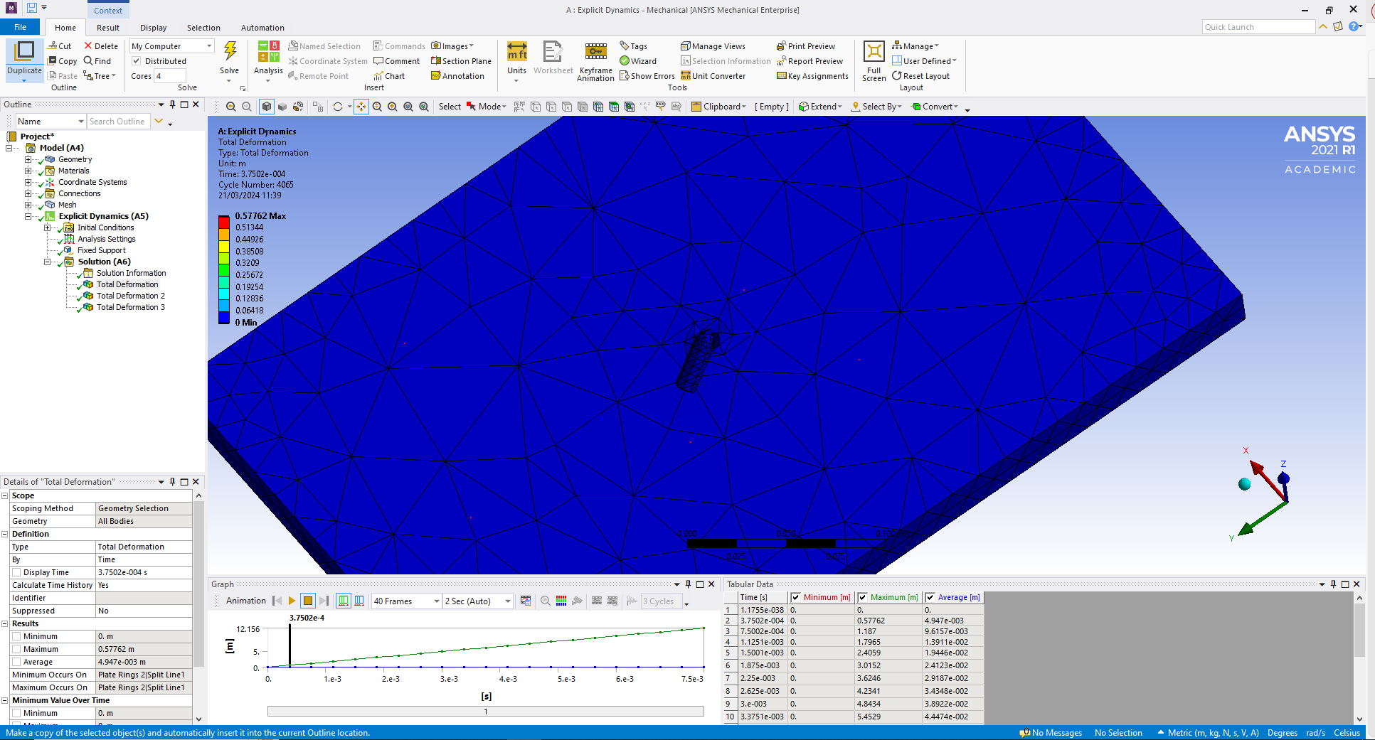
Figure 5: Mie Gruniesen parameters used for target, but not for core at 750ms-1.

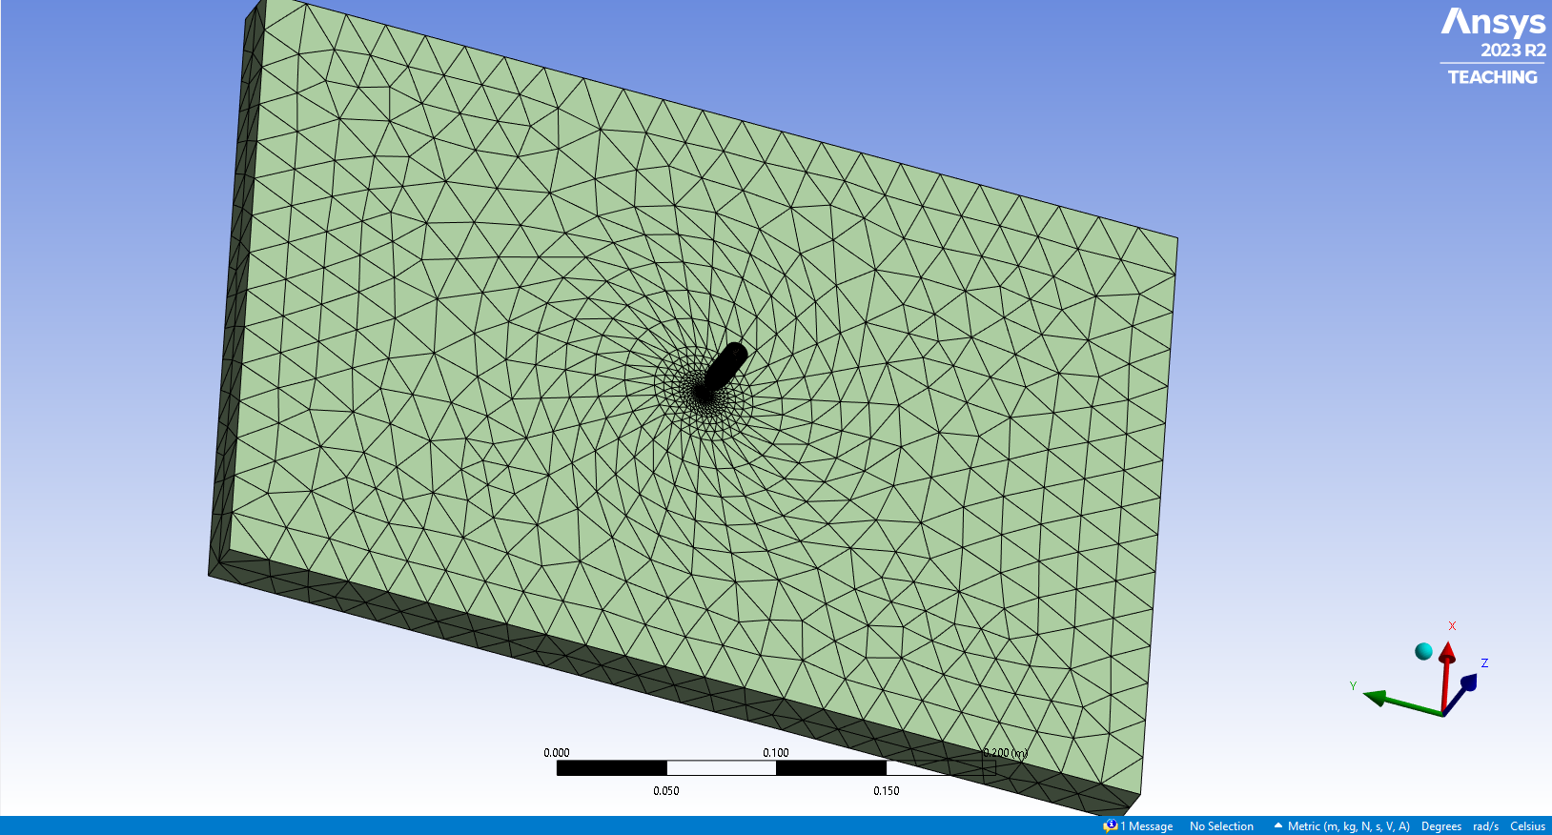
Figure 6: Model rerun with finer meshing, 0.75mm centre ring and core, ring 1 at 1mm, ring 2 at 5mm, ring 3 at 10mm, ring 4 and rest 50mm.

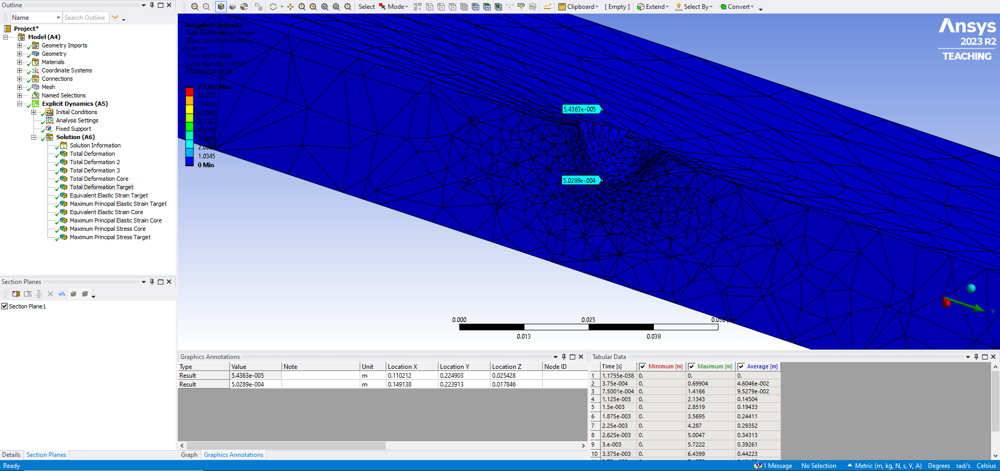
Figure 7: Depth of penetration with new mesh, JC parameters and a velocity 750ms⁻¹is 7.6mm or 25.4 - 17.8mm.

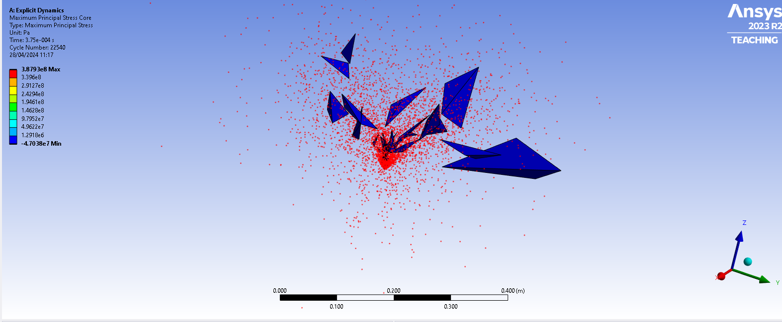
Figure 8: Max principal stress of core, 0.3879GPa at 0.375ms.

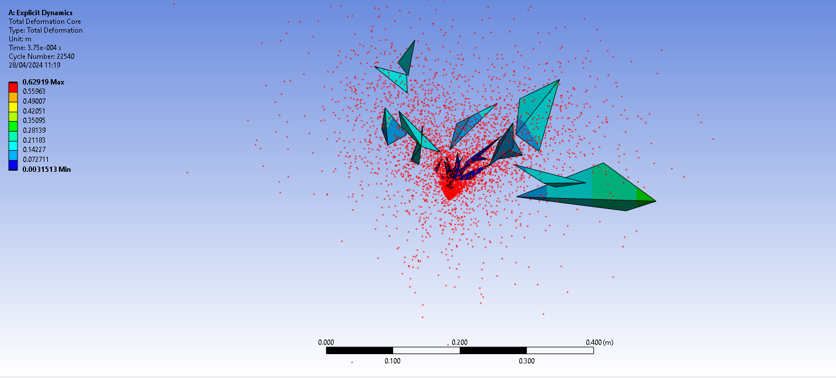
Figure 9: Total deformation of core at 0.62919m at 375ms.

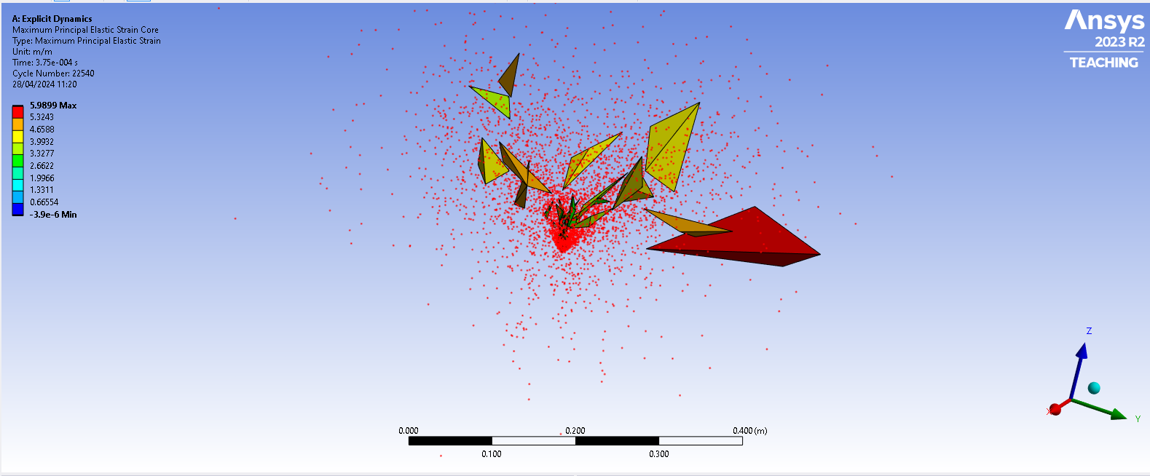
Figure 10: Max strain of core 0.59899mm/mm at 375ms.

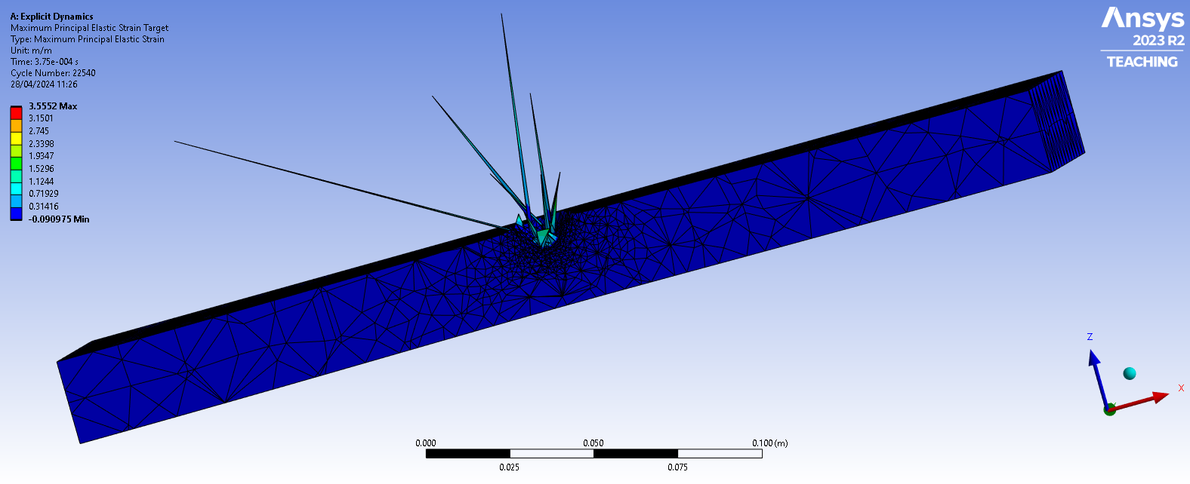
Figure 11: Max strain of target 0.3552mm/mm at 375ms.

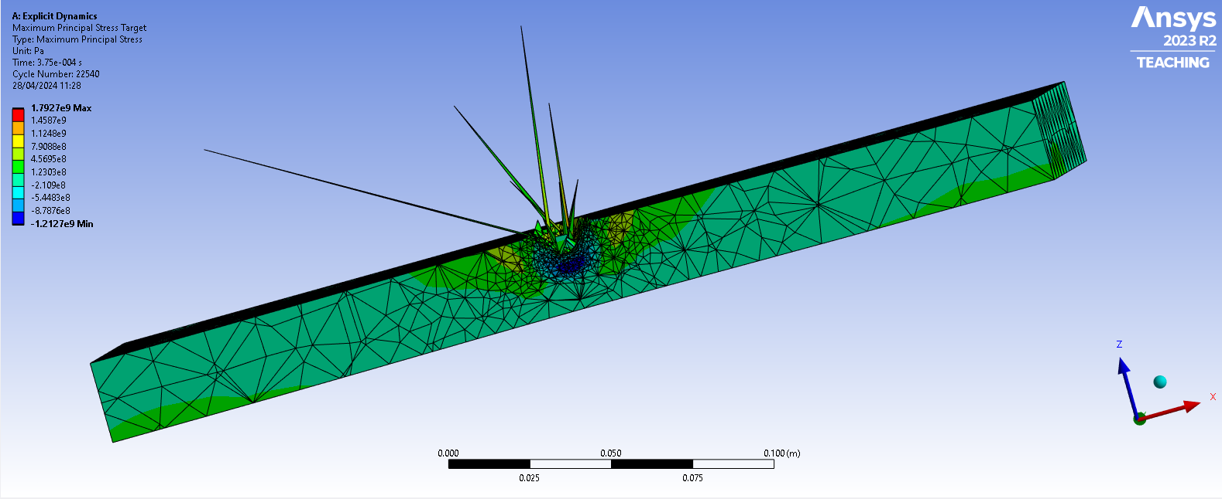
Figure 12: Max stress of target at 1.7927GPa at 375ms

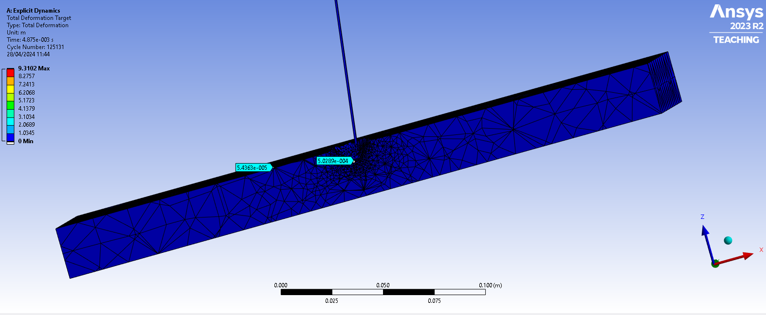
Figure 13: Total deformation of target 9.3102m at 375ms.

4.3 Further simulations

To check and verify results further simulations were run increasing the velocity to 937.5ms⁻¹ and 1125 ms⁻¹, or an increase of 25% then 50% to see what effect this would have on the target penetration. Furthermore, a simulation was done using simplified geometries not representative of the core or target but utilising their material properties and the V50 velocity.
The results of these simulations are included in Annexes B and C for interest and to inform parts of the discussion.

Discussion

5.1 Expected results based on the real world study

During the experiment conducted by the US Army Research Laboratory two variations of 14.5mm bullet were tested, this is because the designs of the bullet were originally soviet in origin and new surrogates that could be manufactured in the US needed to be explored [1].
The results of both surrogates are illustrated below.
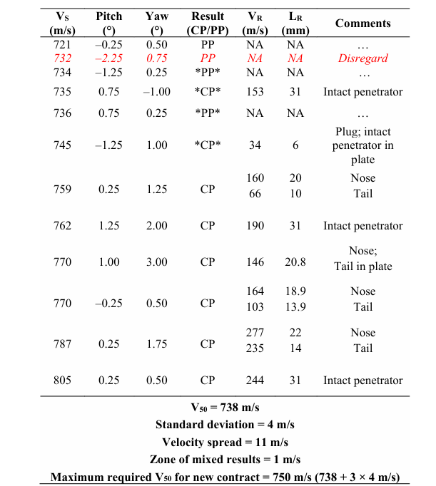
Figure 14: Surrogate 1, note the V50 velocity of 738 and the comments on the penetrator or core from [2].

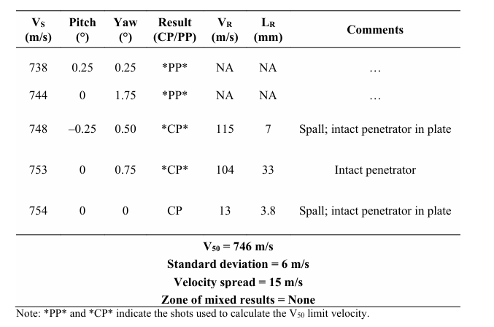
Figure 15: Surrogate 2 again note the V50 velocity and the comments from [1].

In the tables the result CP is complete penetration, whereas PP notes partial penetration [1]. Based on the parameters inputted into the simulation it would be expected that the core would fully penetrate the target and not deform to the extent seen in Fig. 8.
Unfortunately, as is highlighted in the table below the model created has a 70% reduction in penetration by the core into the target when compared to the real-world results.

Table 3: Percentage decrease of penetration observed in model vs. real world results.
Velocity 750 | Experimental | Experimental | Modelled | Percentage decrease
Penetration in mm | 25.4 | 25.4 | 7.6 | 70%

The ricochet of the core was an interesting observation where changing the parameters to include the Mie Gruniesen values for the core meant that it did not break apart but also did not penetrate the target properly, so it ricocheted off the plate instead. Updating the target to also include the Mie Gruniesen parameters, unfortunately, caused the solver to crash at the point of impact.
No real-world experimental data demonstrated this ricocheted behaviour and as noted previously the literature would suggest that these parameters are not necessary for velocities below 2000ms⁻¹ [6], so the Mie Gruniesen parameters were not explored further as it was thought that this result was unrealistic and could not be validated. While the scale of the depth of penetration is not to the extent that would be expected by the real-world results, the JC parameters and the model created do at least seem to represent a reasonable approximation of the experimental results witnessed.
The expectation would be that at 750ms⁻¹ the core would fully penetrate the target at least 50% of the time, it is possible that the model is only capturing the 50% where full penetration was not observed. In order to test this, the velocity was increased by 25% and then 50% to try to determine whether this was occurring. The results in Annex B, unfortunately, show that this is not the case and even at these increased velocities the core does not fully penetrate the target and instead shatters.
One interesting aspect to note is that the reverse of the target shown in Fig 28. indicates that a large amount of pressure is being reflected from the edge of the plate back towards the point of impact, which may be causing the model to fail.

5.2 Expected results based on the EPIC Code model

A second method of validation for this report’s model is to compare it against the model using a different hydrocode solver, EPIC [2]. In this study the following results were found. 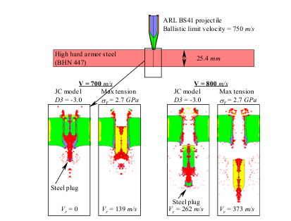
Figure 16: Penetration of the target by a modelled projectile taken from [2].
As can be seen from Fig 16. the authors of this study found that within the EPIC hydrocode the total penetration of the target was observed even at 700ms⁻¹, suggesting that the JC parameters slightly overestimate the real-world results [2]. During the study, the authors ran preliminary models in order to best characterise the JC damage parameters for tungsten carbide, as it is an unusual material that has not been widely studied previously [2]. The values inputted however are used in other studies [9] and in both cases they do seem to correlate to experimental observations witnessed.
The model run in ANSYS for this report does not quite emulate the results found within the EPIC code. The approach and general trends are however, similar. The values for the core and plate do seem to suggest that there will be penetration at 750ms⁻¹, but that unlike the EPIC model, it appears to only be partial. This seems to be because the projectile fails and breaks apart before the target is fully penetrated. There is the possibility that the full projectile, including the jacket, inert powder and liner, helps in protecting the core during the penetration process. In the EPIC study it is noticeable that all these elements break apart, leaving only the core. It is also noted that the EPIC model was only done using a 2D study, and therefore, this may have greatly reduced their processing times as, unfortunately, when trying to replicate their findings even with a very coarse mesh, the overall processing time was around 1421.6 hours in 3D.
From examining findings in shaped charge problems it is noted that often 2D simulations are used as the full 3D solvers can make the operation too complex. 2D solutions are therefore accepted for numerical bullet impact studies [2] [11] [4].

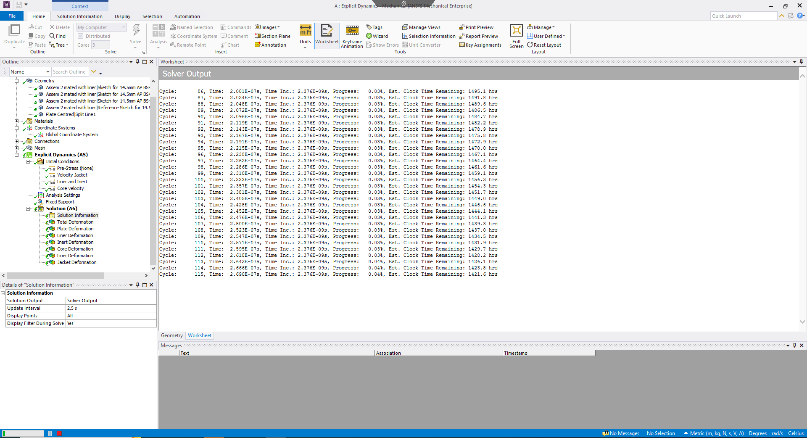
Figure 17: Long solving time due to complexity of model.

5.3 Simplified geometry in 3D

As a further means of validation, the author decided to redo the simulation using simplified geometries that did not represent the 14.5mm or the 25.4mm plate used during the experiment. Instead, this simplified model was done to check whether the material properties for both parts of the model would interact more similarly to the real-world example within ANSYS.
The material properties for this study were the same as using the actual geometries, but the plate size was much reduced to being only 3mm thick and the core was greatly simplified to give it a more rounded nose. The results of this simulation are included in Annex C.
It is notable that using this much-simplified geometry and reduced thickness of the target, there was complete penetration. Therefore, it is certainly possible for ANSYS to compute deformation comparably to the EPIC code. A similar study using spheres rather than a projectile in order to better understand the material properties of tungsten carbide was also done by [9].

5.4 Meshing

The mesh size is an important part of any numerical simulation [6] [15]. The mesh in a Lagrangian processor contains the locations for the solving of the various equations occurring within the model [7] [15]. Therefore, if there are large changes in areas in between where the model is solving, discontinuities and issues can occur [5].
These are reflected as step errors within the model, which can also cause the solver to terminate and not be able to account for changes seen across a meshed area. This occurred during a number of the runs of this particular model, leading to a finer mesh selection for the final results but meaning a longer processing time. The mesh for the altered velocities was, therefore, deliberately left coarse in order to simply provide an estimation of interaction between the projectile and plate at those velocities. Instead, a measure of the witnessed stress and strain within the plate was used to give an approximation of what would occur during a simulation with a finer mesh.
In both cases it was noted that DoP result was likely to be unaffected by the change in velocity, thus there was no reason to use a finer mesh and repeat the calculation with a longer solving time.

5.5 Boundary conditions

The model used fixed constraints in order to hold the target in place. This is comparable to the modelled study shown in [2], though slight changes in the position of the target might occur in real life. It is, however, unlikely that these would be significant otherwise the real-world results would be affected, and this movement would be detected by the flash X-ray instrumentation used [1].
Flash X-rays are used to capture highly dynamic events and, therefore, have a very narrow time span over which they capture fast-moving objects, as such, any distortions caused by movement are often visible within the X-ray, and these are not found within the results in [1].
Similar assumptions and bounding conditions are used within [10] [8] and therefore fixed conditions, though not specifically studied here, are thought to be the most appropriate for the problem examined.

5.5 Results conclusion

Overall, although the depth of penetration from the model does not fully replicate the results of the real-world study, nor does the model using the different EPIC code, it is fair to say that it does show similar trends. It is therefore possible to say that the approach used can be validated but that careful consideration needs to be taken to other aspects of the model. It is, in the author’s opinion, likely that the loss of the other components of the bullet, along with the added complexities of looking at the problem in 3D, are the reasons why the model did not perform completely as expected.
Further work could be done to reduce the model to a 2D study and see whether this yields different results or increase the available processing power in order to include the more complicated geometry of the full projectile. Nevertheless, neither of these steps change the ultimate findings of this report and the applicability of the ANSYS explicit linear solver for the type of problem presented.

Conclusion
This report has demonstrated the applicability and effectiveness of computer modelling to solving complex impact problems. It notes that while the exact parameters of the experimental results on 14.5mm armour-piercing ammunition could not be replicated, the general trends do seem to be correct. There was a reduction of 70% in the overall depth of penetration modelled in the study and that observed in the real-world experiment, showing it as unrepresentative but trending in the correct direction.
It is possible that by including other parts of the projectile’s geometry that this trend may move closer to the real-world experiment or indeed fully replicate those results. In exploring the very basic assumptions on rigid body problems and taking this as the underlying, but too simplistic, physics, this report has argued that computer modelling has to be undertaken in order to solve the more complex problems seen within bullet impact studies. The report has also tried to demonstrate some of the options available to a computer modeller interested in these problems and then has outlined why the author made their choices for the study of the 14.5mm armour piercing round.
The overall conclusion of this report is that computer modelling is a powerful tool capable of exploring highly complex dynamic impact problems, but that careful and conscious choices are made throughout the modelling process, such as the damage parameters and equation of state and that these can have a profound effect on expected outcomes.

Bibliography

[1] | D. Little, M. Burkins and J. Paras, “Evaluation of Surrogate 14.5-mm BS41 Armor-Piercing Projectiles,” DEVCOM Army Research Laboratory, Aberdeen, MD, 2020.
[2] | T. J. Holmquist, G. R. Johnson and W. A. Gooch, “ Modeling the 14.5 mm BS41 projectile for ballistic impact computations,” Computational Ballistics II, vol. 40, pp. 61-75, 2005.
[3] | S. Abrate, “Impact Dynamics,” in Impact Engineering on Composite Structures, Udine, Italy, SpringerWienNewYork, 2011, pp. 71-97.
[4] | S. Abrate, Impact on Composite Structures, Cambridge: Cambridge University Press, 1998.
[5] | M. A. Meyers, Dynamic Behavior of Materials, New York: John Wiley, 1994.
[6] | J. A. Zukas, “Impact Dynamics: Theory and Experiment,” U.S. Army Ballistic Research Laboratory, Aberdeen, MD, 1980.
[7] | M. Saleh, L. Edwards and I. Crouch, “Numerical modelling and computer simulations,” in The Science of Armour Materials, Oxford, Elsevier, 2017, pp. 483-580.
[8] | T. Borvik, M. Langseth, O. Hopperstad and K. Malo, “Ballistic penetration of steel plates,” International Journal of Impact Engineering, vol. 22, pp. 855-886, 1999.
[9] | C. G. Fountzoulas, G. A. Gazonas and B. A. Cheeseman, “Computational Modling of Tungsten Carbide Sphere Impact and Penetration into High-Strength-Low-Alloy (HSLA)-100 Steel Targets,” Journal of mechanics of materials and structures, vol. 2, no. 10, pp. 1965-1980, 2007.
[10] | A. Basyir, R. O. Bura, D. Lesmana and L. D. Antika, “Evaluation of Steel and Tungsten Carbide – Cobalt (WC-8Co) 5.56 x 45mm Calibre Projectile Penetration into Silicon Carbide (SiC) Experiment and Numerical Simulation,” Defence Science Journal, vol. 72, no. 2, pp. 205-216, 2022.
[11] | N. J. Woolmore, The Failure of a Tungsten Carbide - Cobalt Cored Projectile against a Hard Target, Cranfield: Cranfield University (PhD. Thesis), 2005.
[12] | G. Sabadin, M. Gaiotti, C. M. Rizzo and A. Bassano, “ Development and validation of a numerical model for the simulation of high-velocity impacts on advanced composite armor systems,” Nonlinear Dynamics, vol. 91, pp. 1791-1816, 2018.
[13] | V. Narayanamurthy, C. L. Rao and B. Rao, “ Numerical Simulation of Ballistic Impact on Armour Plate with a Simple Plasticity Model,” Defence Science Journal, vol. 64, no. 1, pp. 55-61, 2014.
[14] | N. Kılıça and B. Ekici, “Ballistic resistance of high hardness armor steels against 7.62 mm armor piercing ammunition,” Materials and Design, vol. 44, pp. 35-48, 2013.
[15] | J. Molinari, “Finite element simulation of shaped charges,” Finite Elements in Analysis and Design, vol. 38, pp. 921-936, 2002.
[16] | N. Kılıça, S. Bedira, A. Erdika, B. Ekicib, A. Tasdemircic and M. Güden, “Ballistic behavior of high hardness perforated armor plates against 7.62 mm armor piercing projectile,” Materials and Design, vol. 63, pp. 427-438, 2014.
[17] | Z. Zheng and W. Jin, “Finite element modeling of the shaped charge jet and design of the reusable perforating gun,” Petroleum Science, vol. 17, pp. 1389-1399, 2020.
[18] | D. Pyka, A. Kurzawa, M. Bocian, M. Bajkowski, M. Magier, J. Sliwinksi and K. Jamroziak, “Numerical and Experimental Studies of the ŁK Type Shaped Charge,” Applied Sciences, vol. 10, no. 19, pp. 6742-6762, 2020.
[19] | P. Atkins and J. d. Paula, Physical Chemistry, 8th ed., Oxford: Oxford University Press, 2006.
[20] | D. Tria and R. Trebinski, “Methodology for experimental verification of steel armour impact modelling,” International Journal of Impact Engineering, vol. 100, pp. 102-116, 2017.
[21] | P. Siriphala, T. Veeraklaew and G. T. W. Kulsirikasem, “Validation of finite element models of bullet impact on high strength steel armors,” State of the Art in Science and Engineering, vol. 75, pp. 63-71, 2014.
[22] | A. Banerjeea, S. Dhara, S. Acharyyaa, D. Dattab and N. Nayakc, “Determination of Johnson cook material and failure model constants and numerical modelling of Charpy impact test of armour steel,” Materials Science and Engineering A, vol. 640, pp. 200-209, 2015.
[23] | D. H.-J. Kaiser, P. D. A. Kern, D.-I. S. Scharf and M. W. A. G. Jr, “Ballistic Testing of ThyssenKrupp Steel Europe Armor Steel in Accordance with U.S. Military Armor Specifications,” in 26th International Symposium on Ballistics, Miami, 2011.
[24] | I. G. Crouch, “Introduction to Armour Materials,” in The Science of Armour Materials, Oxford, Elsevier, 2017, pp. 1-52.
[25] | M. Çakırcah, C. Kılıçaslan, M. Güden, E. Kıranh, V. Y. Shchukin and V. V. Petronko, “Cross wedge rolling of a Ti6Al4V (ELI) alloy: the experimental studies and the finite element simulation of the deformation and failure,” International Journal of Advanced Manufacturing Technology , vol. 65, pp. 1273-1287, 2013.

Annex A: Geometries
Figure 18: Original geometry for projectile.
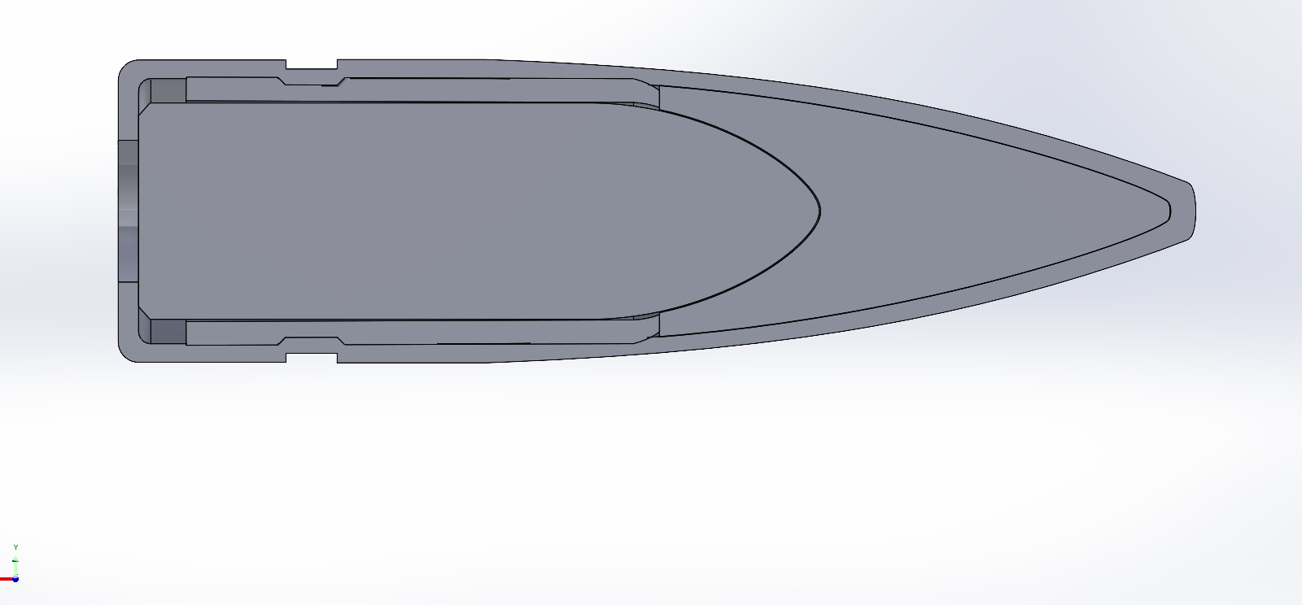
Figure 19: original geometry showing different parts of the projectile.

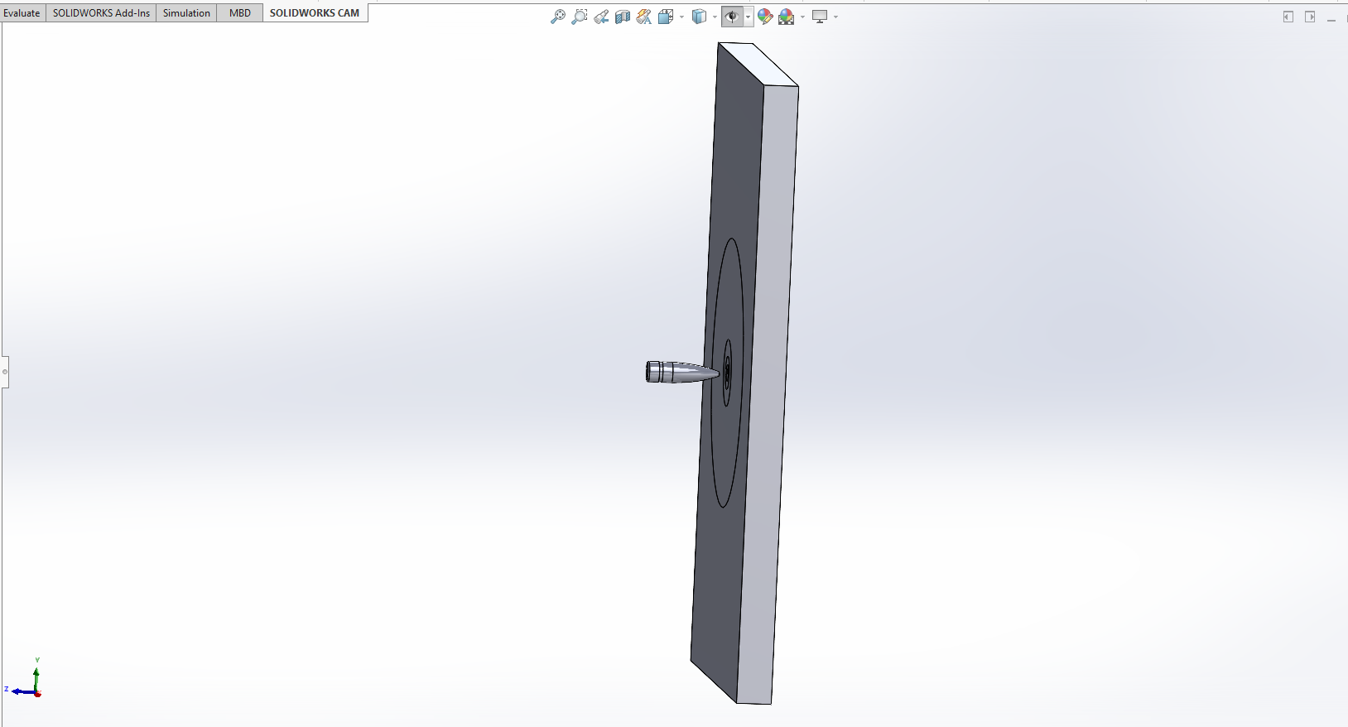
Figure 20: Original assembly imported into ANSYS.

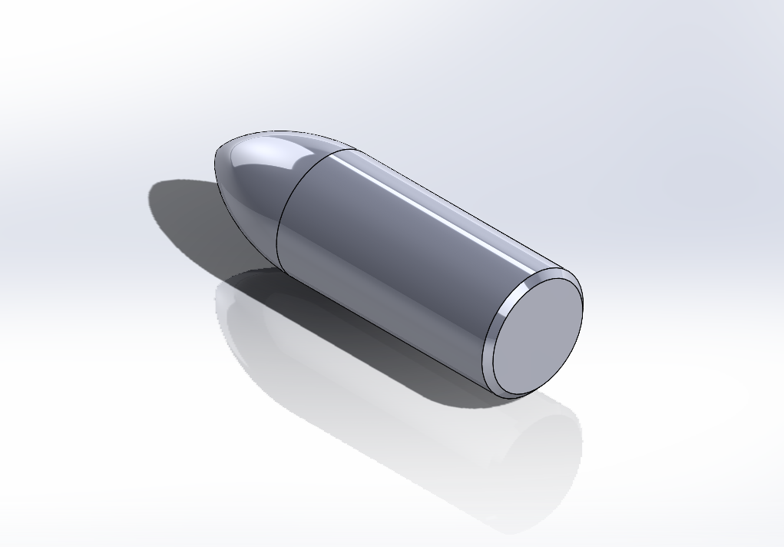
Figure 21:Geometry of tungsten carbide core.

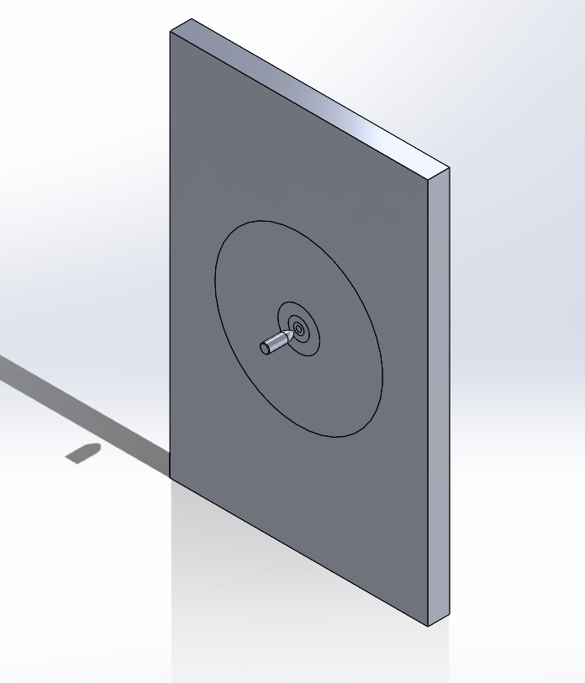
Figure 22: Core and plate imported into ANSYS and used to derive results.

Annex B: Increased velocities
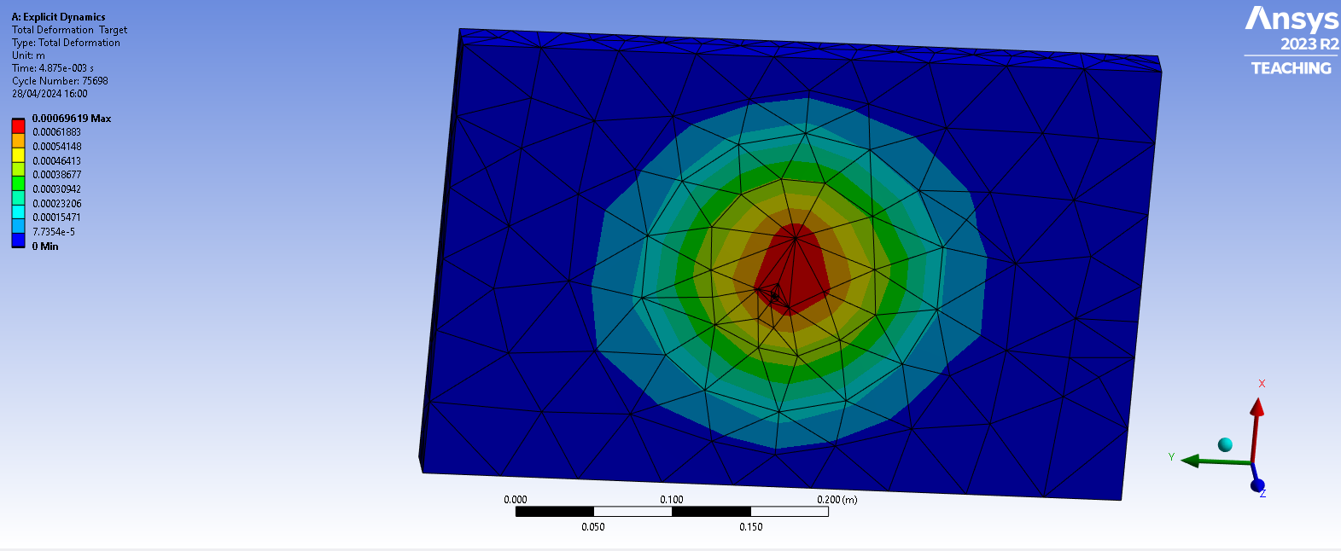
Figure 23: Max Deformation of target at velocity of 937.5ms⁻¹, deformation measured 0.696mm at 4.87ms.

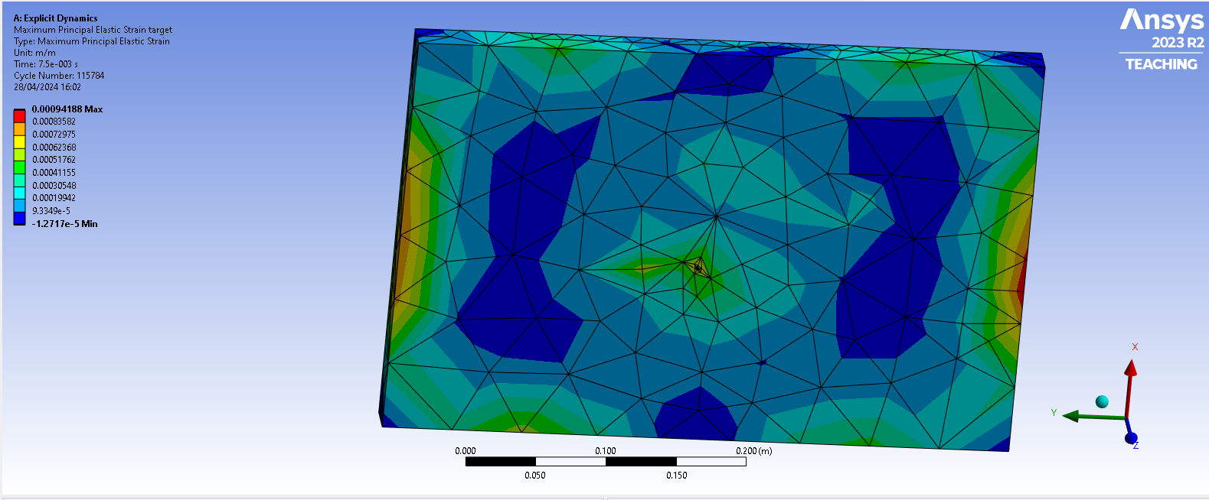
Figure 24: Maximum strain in target for a velocity of 937.5ms⁻¹ 0.094188mm/mm at 750ms.

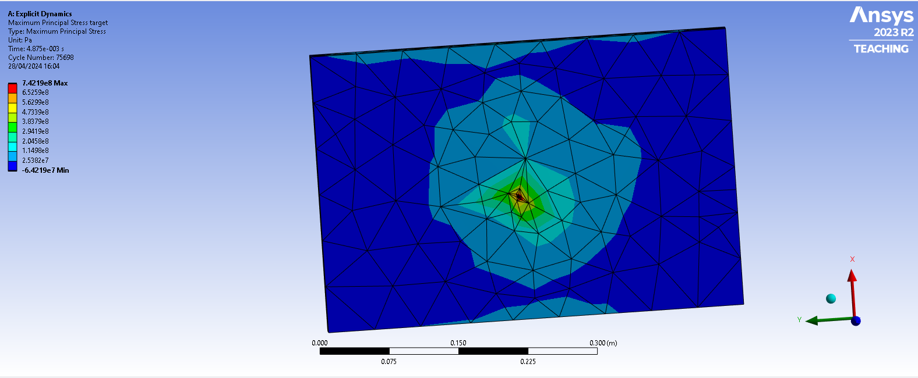
Figure 25: Maximum stress 0.74219GPa for a velocity of 937.5ms⁻¹ at 487ms.

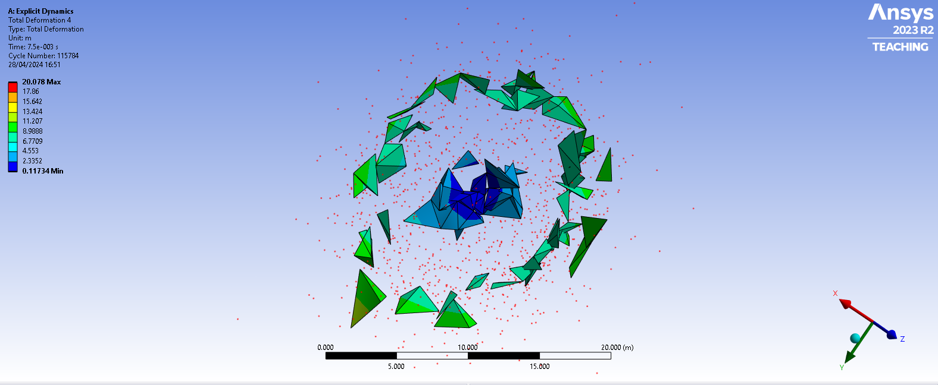
Figure 26: total deformation of core at 937.5ms⁻¹ recorded at 750ms, a similar level of deformation was recorded for the simulation at 1125ms⁻¹.

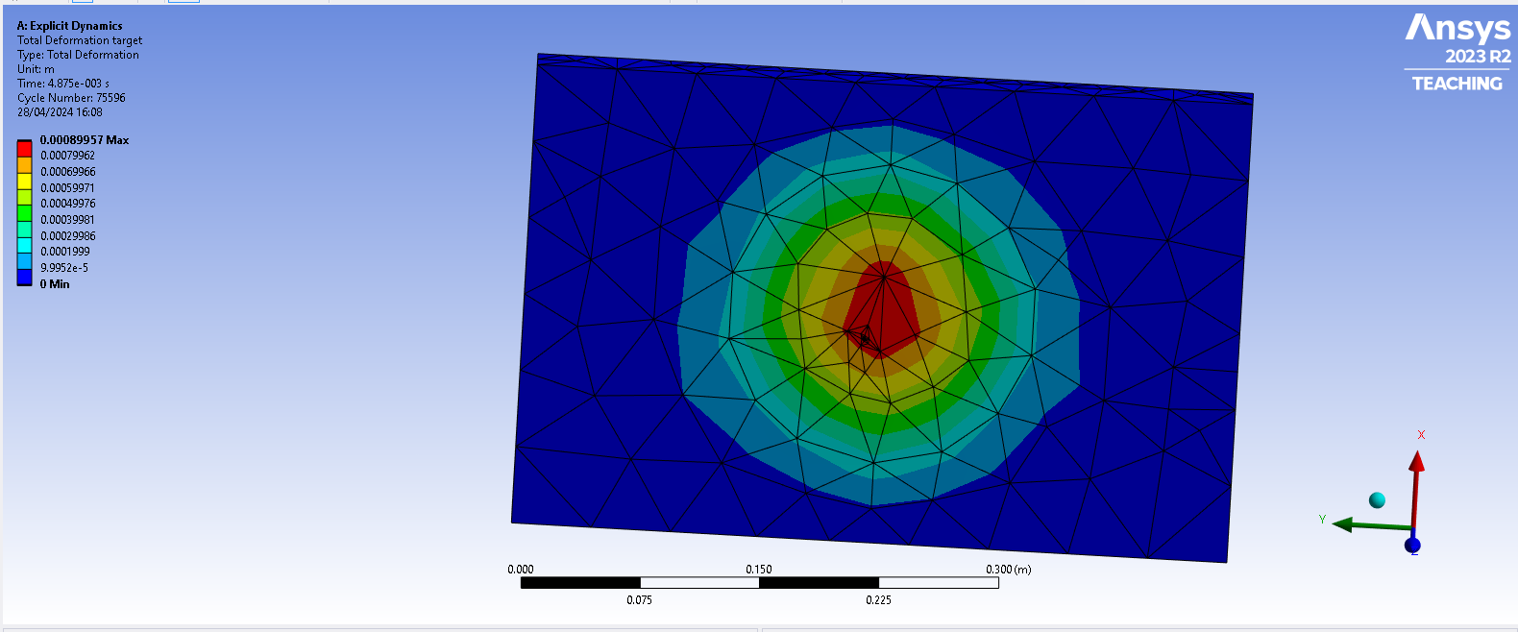
Figure 27: Maximum deformation of 0. 89957mm at velocity 1125ms⁻¹ and a time of 487ms.

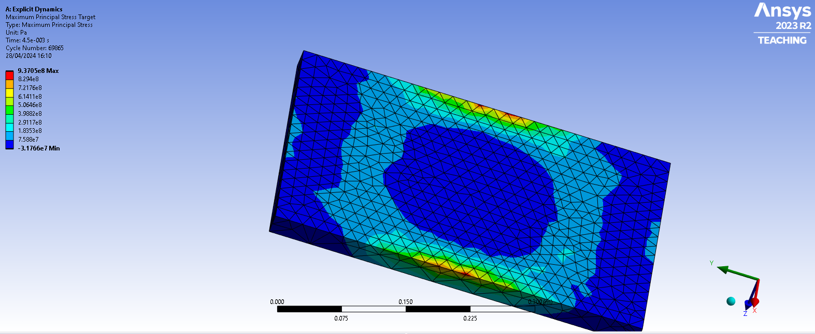
Figure 28: Maximum stress 0.93705GPa at a velocity of 1125ms⁻¹ shown on reverse note the waves refracting at the edges of the plate, at 450ms.

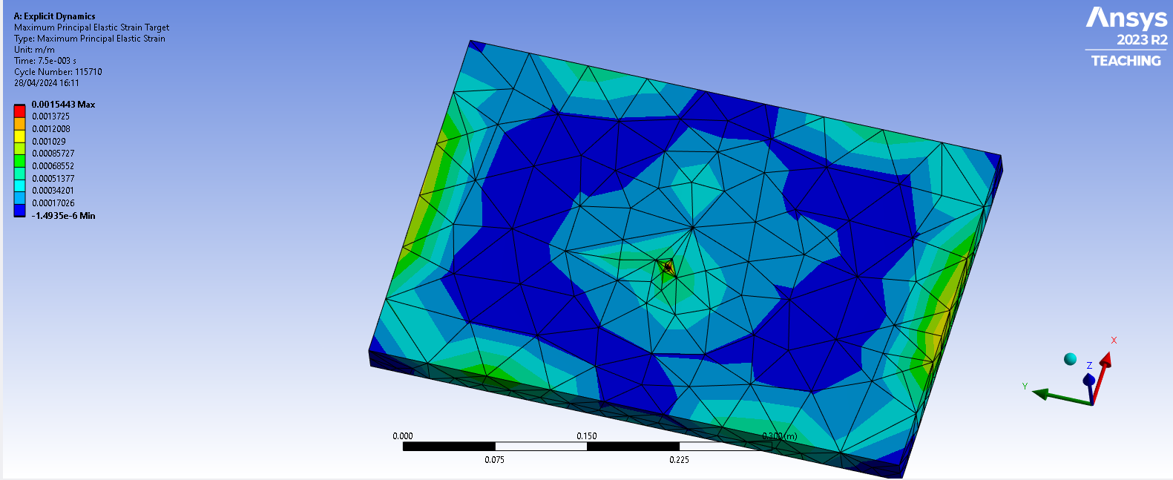
Figure 29: Maximum strain 1.5443mm/mm at a velocity of 1125ms⁻¹ at 750ms.

Annex C: Simplified Geometry
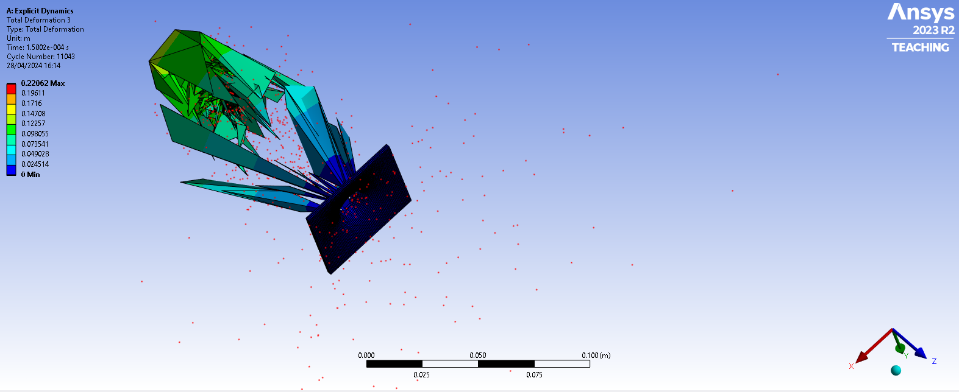
Figure 30: total deformation of simplified geometry, mesh size 0.075mm across all parts.

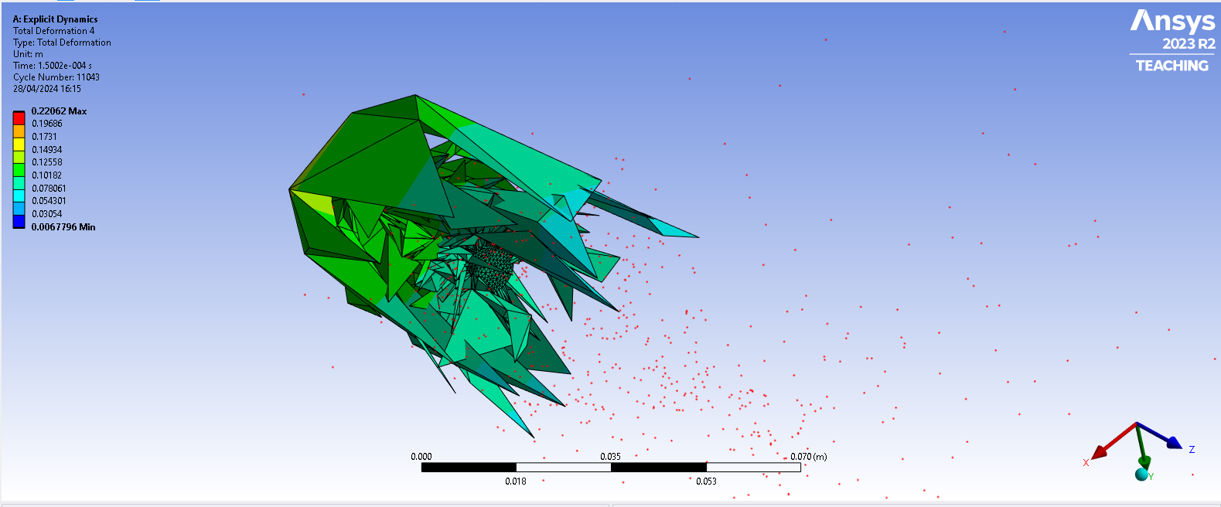
Figure 31: Total deformation of core in simplified geometry 0.22062m.

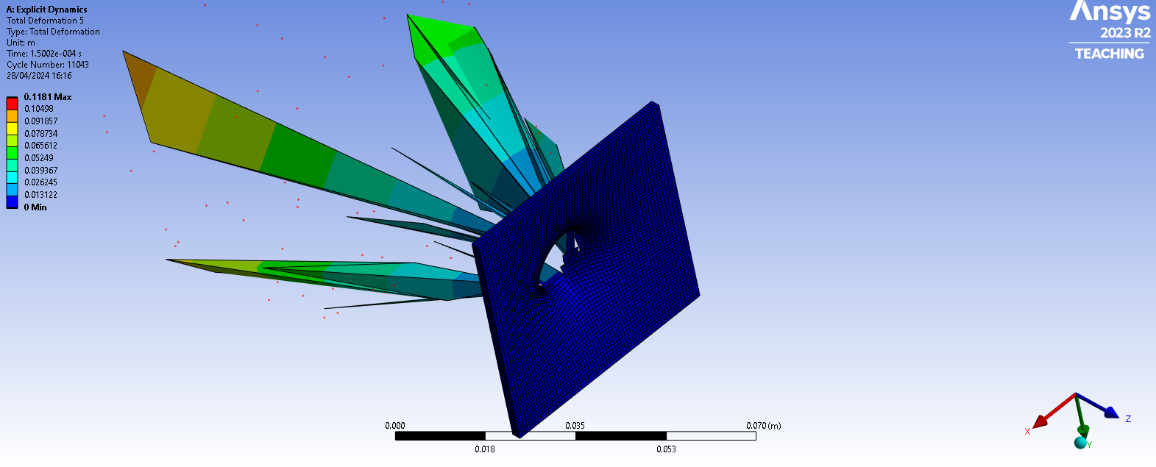
Figure 32: Total deformation of target in simplified geometry 0.1181m.

