Module title: Data Handling & Business Intelligence
Module code: LCBB5014

Component 1: Coursework: Individual Report

EXECUTIVE SUMMARY
The opportunity that is discussed in the report is the opportunity to use business intelligence (BI), data warehousing (DW) and data mining (DM) to facilitate strategic decision-making at Monsoon Accessories Ltd., which is a medium-sized fashion retail organisation that is based in the UK retail industry. The essence of the report is to demonstrate that it is possible to enhance the performance of organisations, their competitive position, and long-term strategic planning in a very competitive retailing environment through the use of structured data management and advanced analytics. The report is analysed in terms of significant BI technologies, including the enterprise data warehouses, data mining techniques including the clustering and association rule mining techniques, predictive analytics tools and visual reporting tools. The structured analysis that is based on the theory is reflected in the reference frameworks of academics like the dimensional data warehouse architecture developed by Kimball, and the CRISP-MS data mining lifecycle is employed to ensure that the technical solutions meet the business objectives.
The most significant inference is that Monsoon Accessories Ltd. is now undertaking underutilisation of the useful operation and customer-related data due to the disintegration of systems. This would improve the data integration process, data accuracy in reporting and decision-making efficiency since a centralised data warehouse would be used. The predictive analytics and the data mining would enable predictions in terms of demand and customer segmentation and optimise the inventory. Further, interactive presentations would help the management to view important performance indicators in real time. The report proposes a succession plan for BI solutions implementation with effective ethical governance, GDPR compliance, excellent data security practice and perpetual training of employees to achieve the entire strategic potential of data-driven decision-making.

Table of Contents
EXECUTIVE SUMMARY 2
1. Introduction 4
2. Trends In BI, DW, And DM 4
3. Data Warehousing In The Organisation: Applications 5
4. Data Mining Techniques 6
5. Predictive Analysis 7
6. Ethical And Data Security Considerations 8
7. Reporting And Dashboard Solutions 8
8. Conclusion 9
References 10

1. Introduction
Monsoon Accessories Ltd. is a fashion retail organisation which is based in the UK and operates within the industry of clothes and accessories. The company has a system of sub-physical stores but also an online commerce system, which generates large volumes of transactional, stock, and customer information. As a middle-sized business, Monsoon Accessories is entering a very competitive environment where multinational retailers, fast fashion and online-only competitors are operating, which threatens to reduce margins and overall performance. This report is also directed towards discussing how business intelligence, data warehousing and data mining can be utilised in assisting the strategic decision-making at Monsoon Accessories Ltd. The report evaluates the current trends in the BI technologies, examines organisational applications of data warehousing and data mining, and proposes the applicable predictive analytics and reporting tools. The subject of ethical and data security is also taken seriously. The report is structured in line with the BI trends, data warehousing applications, data mining techniques, predictive analytics, and ethical concerns, in addition to reporting solutions and a final strategic analysis.

2. Trends In BI, DW, And DM
Business intelligence may be described as referring to the technologies and systems and processes in the collection, integration, analysis, and presentation of data utilised in managerial decision-making (Provost and Fawcett, 2023). Data warehousing involves the integration of data from different sources of operation in a centralised warehouse to be examined by queries. Data mining is an attempt to find the concealed relationships, patterns and trends in huge datasets through the use of statistical and machine learning algorithms (Power, Sharda and Burstein, 2020). The trend of real-time and self-service analytics is one of the most notable trends in BI. The utilisation of the contemporary BI platforms allows the decision-makers to access dashboards and reports without any technical assistance and to make the decision-making more responsive and decentralised.
Another high demand has also been cloud-based data warehousing since it is also scalable, the cost of infrastructure is also low as well, and it is also highly integrable with BI tools, making it quite attractive to medium-sized organisations (Watson, 2021). BI and DM systems are now being combined with artificial intelligence and machine learning. The technologies support automated prediction, trend detection and generation of recommendations. The AI analytics application can be implemented in the retail sector to assist organisations to detect the emergent fashion trends, improve the pricing processes, and optimise the precision of the demand forecasting.
A data warehouse supports these trends by providing one credible location of organisational data. Kimball's dimensional modelling structure systematises the data into fact and dimension tables and improves the performance and analytical clarity (Sharda, Delen and Turban, 2020). This, in the case of Monsoon Accessories Ltd, enables it to compare its products in the same manner, its outlets and across periods of time. The CRISP-DM model offers the data mining processes a stipulated lifecycle as they align the outcome of the analytics and the business goals. The organisations that embrace such models have an improved strategic realisation and competitive advantage.

3. Data Warehousing In The Organisation: Applications
Data warehousing is the process through which the process of gathering, combining and storing information of different operational systems into a central repository is aimed at facilitating the analysis and strategic decision-making (Ponniah, 2021). Unlike the transactional databases, which are faster and more accurate to execute daily tasks, data warehouses are more concerned with the complicated query, past analysis and management reports. In Monsoon Accessories Ltd, data are developed by different channels and systems, like point-of-sale systems, online sales systems, inventory systems, supplier database systems, and customer relationship management systems (McAfee and Brynjolfsson, 2019). These systems will now be operated independently, and this is a data silo that limits the analytical capability and complicates reporting.
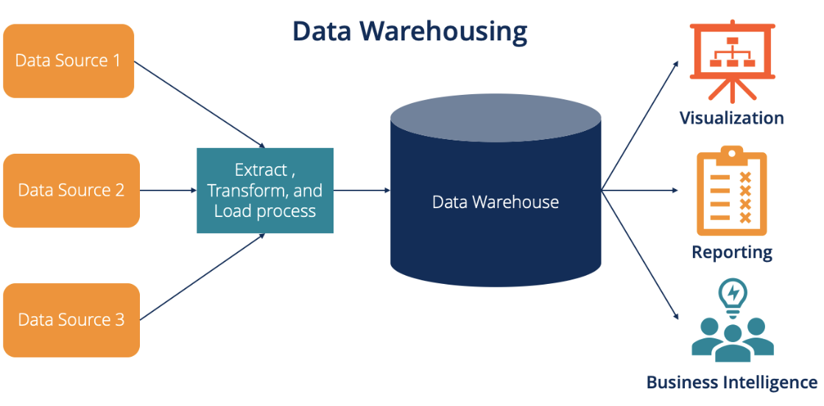
Figure 1: Data Warehousing (McAfee and Brynjolfsson, 2019)
A centralised data warehouse would consolidate these datasets into one data warehouse, which would improve the quality of data and its accessibility. The increased access to data means increased operational efficiency because it saves on time that would have been lost in extracting and reconciling data manually (Kimball and Ross, 2020). The finance departments will be able to produce consolidated reports on finance as compared to the merchandising departments, which will be able to analyse the performance of products in various geographical locations and channels. It will augment the precision in decision-making and will help the staff focus on strategic analysis rather than administration (Laudon and Laudon, 2022). In the strategic front, data warehousing enables long-term strategic planning insofar as it assists in the analysis of past trends.
The management will be in a position to establish the trend of seasonal demand, supplier performance and effectiveness of promotions over the years. The sales fact table is linked to product, store, customer and time dimensions, and with the aid of Kimball star schema design, one is able to flexibly and in detail analyse the facts (Eckerson, 2020). An organisation-specific application is omnichannel sales reporting that provides an organisation with a clear view of its customer engagement practices in bricks-and-mortar and online environments.
Data consolidation in the supply chain will facilitate the inventory optimisation through monitoring the stock turnover, the lead time and the replenishment time. Customer data integration gives the opportunity to analyse target marketing and loyalty (Chen, Chiang and Storey, 2021). The data warehousing will generally transform the data in the operations into an evidence-based strategic resource that will be able to assist Monsoon Accessories Ltd to improve efficiency, competitiveness and decision-making. The retail industry can also apply the AI analytics software in order to help organisations identify the emergent fashion patterns, enhance the pricing mechanisms and the accuracy of the demand forecasting.

4. Data Mining Techniques
Two data mining tools that can be very useful in Monsoon Accessories Ltd. are clustering and association rule mining, which are employed in clustering customers or products. The retailing clustering might be applied to segment the customers based on their purchasing frequency, spending behaviour or preferences for products (Golfarelli and Rizzi, 2021). Customer clustering, which Monsoon Accessories Ltd. has in this case, assists in promoting specific marketing campaigns, customised promotion and customer retention. It also helps in the strategic decision-making of the product assortment and store merchandising. The association rule mining establishes the correlations among the products that are commonly purchased simultaneously. This kind of technique is normally used in the market basket analysis.
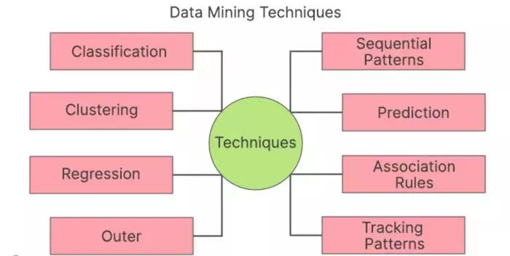
Figure 2: Data Mining Techniques (Few, 2020)
As an example, association rules can reveal that the customers purchasing some clothing products can be expected to purchase some accessories to match the purchase. The cross-selling strategies, promotions, and improved product placement in both stores and the Internet may be supported with these findings (Few, 2020). Both the approaches are aligned with the strategic aims of the organisation to increase the revenues and enhance customer experience. They do not have problems housing huge volumes of transactional information generated by the retailing business. The tools that support these techniques are RapidMiner, SPSS Modeller, and Microsoft Azure Machine Learning, which are provided with the assistance of integrated workflow and connection with the data warehouse (Marr, 2021). The application of these techniques to CRISP-DM structures would ensure the validity of the analytical results and their consistency with the business and their application in the operational systems.

5. Predictive Analysis
Predictive analytics is a procedure where the historical data and statistical models are utilised to identify what is to be anticipated in the future. Predictive analysis would be of relevance in the Monsoon Accessories Ltd case, particularly in demand forecasting, inventory planning and customer behaviour forecasting (Han, Kamber and Pei, 2022). Power BI is the right predictive analytics system, as it is highly compatible with Microsoft applications, has an interactive dashboard, and has built-in capabilities to make predictions. It supports automated updates of data and predicting of time series and can thus be utilised by managers who are not technical. The SPSS can be used to give advanced statistical modelling, i.e., regression and classification, though it needs expert knowledge.
Excel can still be used in simple forecasting, as it is familiar, but it cannot be used for enterprise-level analytics. RapidMiner is a more expensive and more trained end-to-end predictive analytics platform that is utilised to prepare, model, and deploy data (Davenport and Bean, 2020). The most appropriate solution in the case of a medium-sized organisation would be the use of Power BI in terms of usability, cost and integration. It is also prediction and automation that enables Monsoon Accessories Ltd to anticipate variations in demand, cases of overstocking and increase precision of strategy formulations.

6. Ethical And Data Security Considerations
The ethics and security of data are major issues with the application of BI and analytics. The requirements of GDPR have to be followed by Monsoon Accessories Ltd, which include legal processing of the data, transparency, and informed consent of the customer. Customers should be aware of the methods to collect their personal data, store it and process it (Han, Kamber and Pei, 2022). The ability to possess and access data should also be instituted in a way that will not allow its misuse. Internally, least privilege access should be implemented to minimise the risk amongst the employees. Outsourcing and cybersecurity threats such as hacking and data breaches are to be verified with the assistance of encryption, secure authentication, regular audits, and monitoring (Davenport and Bean, 2020). Confidential data should be secured with the help of technical security and employee training. Ethical governance can assist in ensuring the project of analytics makes more ethical decisions without losing customer trust and violating regulations.

7. Reporting And Dashboard Solutions
The BI dashboards include graphic representations of the key organisational actions, and consequently, the informed decision-making is realised in a timely fashion. The recommended options to be used at Monsoon Accessories Ltd. include Power BI and Tableau, as they offer the connection to the real-time information and enable interaction (Davenport and Bean, 2020). Some of the examples of KPIs that can be displayed in the form of a dashboard include sales revenue per channel, inventory turnover, gross margin, stock-out rates and customer retention. Real-time monitoring will also help the managers to be aware of the underperforming stores or products in a short period and act proactively. Ethical governance may help to make the project of analytics make more ethical decisions without losing the trust of customers and breaking laws. Visual reporting increases the level of strategic alignment because it makes sure that the information available at the management levels is consistent. Drill-down allows the user to see data from high-level summaries to low-level transactions so as to help in making strategic and operational decisions.

8. Conclusion
The report has shown that business intelligence, data warehousing and data mining can have an immensely significant role in facilitating strategic decision-making in Monsoon Accessories Ltd. Data warehousing lays a substantial foundation of data integration in the organisation; at the same time, data mining techniques yield beneficial information on customer and product behaviour. The predictive analytics can be used to plan and predict the future and reduce uncertainty in inventory and demand management. Others that it renders through utilisation of visual dashboards include real-time tracking and overall management strategy. By incorporating a formal BI solution with a set of ethical governance and effective data protection, Monsoon Accessories Ltd. will have a chance to transform data into a strategic resource, which will allow the company to become more efficient and competitive and will ensure its performance in the long term.

References
Chen, H., Chiang, R.H.L. and Storey, V.C. (2021) Business Intelligence and Analytics: From Big Data to Big Impact. New York: Routledge.
Davenport, T.H. and Bean, R. (2020) Big Data and AI Executive Guide: Driving Business Value with Analytics. Boston, MA: Harvard Business Review Press.
Eckerson, W.W. (2020) Performance Dashboards: Measuring, Monitoring, and Managing Your Business. 3rd edn. Hoboken, NJ: John Wiley & Sons.
Few, S. (2020) Now You See It: Simple Visualization Techniques for Quantitative Analysis. 2nd edn. Oakland, CA: Analytics Press.
Golfarelli, M. and Rizzi, S. (2021) Data Warehouse Design: Modern Principles and Methodologies. 2nd edn. New York: McGraw-Hill Education.
Han, J., Kamber, M. and Pei, J. (2022) Data Mining: Concepts and Techniques. 4th edn. Cambridge, MA: Morgan Kaufmann.
Kimball, R. and Ross, M. (2020) The Data Warehouse Toolkit: Definitive Guide to Dimensional Modeling. 4th edn. Hoboken, NJ: John Wiley & Sons.
Laudon, K.C. and Laudon, J.P. (2022) Management Information Systems: Managing the Digital Firm. 17th edn. Harlow: Pearson Education.
Marr, B. (2021) Data Strategy: How to Profit from a World of Big Data, Analytics and AI. London: Kogan Page.
McAfee, A. and Brynjolfsson, E. (2019) Machine, Platform, Crowd: Harnessing Our Digital Future. New York: W.W. Norton & Company.
Ponniah, P. (2021) Data Warehousing Fundamentals for IT Professionals. 3rd edn. Hoboken, NJ: John Wiley & Sons.
Power, D.J., Sharda, R. and Burstein, F. (2020) Decision Support Systems. 2nd edn. Hoboken, NJ: John Wiley & Sons.
Provost, F. and Fawcett, T. (2023) Data Science for Business: What You Need to Know About Data Mining and Data-Analytic Thinking. 2nd edn. Sebastopol, CA: O’Reilly Media.
Sharda, R., Delen, D. and Turban, E. (2020) Analytics, Data Science, and Artificial Intelligence: Systems for Decision Support. 12th edn. Hoboken, NJ: John Wiley & Sons.
Watson, H.J. (2021) Business Intelligence: Concepts, Components, Techniques and Benefits. 2nd edn. New York: Springer.

