
UNIVERSITY OF WALES
TRINITY SAINT DAVID
LONDON CAMPUS

NETWORKS AND CYBER SECURITY ESSENTIALS

Module Name: Networks and Cyber Security Essentials
Module Code: ACCA 4024
Student Name: Azubuike Orizu
Student ID: 2440637
Group:1
Lecturer’s Name: Amit Naik
Contents
1. Introduction 2
2. Identification of Threats 2
2.1 External Threats 2
2.2 Internal Threats 3
3. Security Policies. 4
3.1 Access Control Policy 4
3.2 Data Protection Policy 4
3.3 Acceptable Use Policy 4
3.4 BYOD Policy 4
3.5 Incident Response Policy 5
3.6 Backup and Recovery Policy 5
4. Mitigation Measures 5
4.1 Technical Measures 5
4.2 Organisational Measures 5
4.3 Physical Security Measures 6
5. Monitoring and Incident Response 6
5.1 Monitoring Systems 6
5.2 Incident Response Process 6
6. Training and Awareness Program 7
6.1 Training Objectives 7
6.2 Training Activities 7
6.3 Awareness Campaigns 7
6.4 Monitoring and Compliance 7
7. Presentation Summary (Appendix) 7
Conclusion 12
References 12

Introduction
In recent years, cybersecurity has moved from being a purely technical concern to becoming a core organisational priority. This is particularly true in the healthcare sector, where organisations handle highly sensitive personal and medical data. HealthPlus Analytics (HPA), as a data-driven healthcare technology company, plays a critical role in processing and storing patient information for hospitals and clinics across the UK. As a result, it faces a heightened level of responsibility when it comes to protecting data and maintaining secure systems.
The nature of healthcare data makes HPA an attractive target for cybercriminals. Patient records contain valuable personal information that can be exploited for financial gain, identity theft, or even blackmail. In addition, the increasing reliance on digital platforms, cloud storage, and remote working environments has significantly expanded the organisation’s attack surface.
Recent incidents at HPA, including unauthorised access to cloud-based patient data and a ransomware attack on its analytics infrastructure, have exposed weaknesses in the current cybersecurity framework. These events are not only operationally disruptive but also raise serious concerns regarding compliance with legal frameworks such as the UK Data Protection Act 2018 and NHS Digital Security Standards. Beyond regulatory penalties, such breaches can damage the organisation’s reputation, erode client trust, and potentially compromise patient safety.[1]
This report aims to present a comprehensive and practical cybersecurity and data governance framework for HPA. It explores the threats facing the organisation, outlines essential security policies, recommends realistic mitigation strategies, and proposes a structured approach to monitoring, incident response, and staff training. The overall goal is to strengthen HPA’s security posture while fostering a culture where cybersecurity is understood and valued across the entire organisation[2]

Identification of Threats
To build an effective defence strategy, it is important to first understand the range of threats that HPA faces. These threats can be broadly categorised into external threats, originating from outside the organisation, and internal threats, which arise from within.[3]

External Threats
One of the most pressing external threats is ransomware. This type of cyberattack involves malicious software that encrypts an organisation’s data, effectively locking it until a ransom is paid. Healthcare organisations are particularly vulnerable because their operations often depend on real-time access to data. This urgency increases the likelihood that organisations may feel pressured to pay attackers to restore services quickly.
Phishing and social engineering attacks are also highly prevalent. Rather than targeting technical vulnerabilities, these attacks exploit human behaviour. Employees may receive emails that appear legitimate but are designed to trick them into revealing sensitive information or clicking on malicious links. Given that HPA staff regularly handle confidential data, even a single successful phishing attempt could have serious consequences.
Cloud-related vulnerabilities present another significant risk. As HPA relies on cloud platforms to store and process data, any misconfiguration such as incorrect access permissions or unsecured storage can lead to data exposure. Attackers often actively scan for such weaknesses, making cloud environments a common target.
Distributed Denial of Service (DDoS) attacks also pose a threat. By overwhelming systems with excessive traffic, attackers can disrupt services and make systems inaccessible. In a healthcare context, this could delay critical operations and affect patient care.
Finally, Advanced Persistent Threats (APTs) represent a more complex and long-term risk. These attacks involve highly skilled attackers gaining access to systems and remaining undetected for extended periods. Their goal is often to quietly extract sensitive data over time rather than cause immediate disruption.

2.2 Internal Threats
While external threats are often highlighted, internal risks can be equally damaging.
Insider threats may arise from employees who intentionally misuse their access or, more commonly, from those who make mistakes. For example, an employee might accidentally send sensitive information to the wrong recipient or store data in an insecure location.
Weak password practices remain a widespread issue. Employees may reuse passwords across multiple platforms or choose passwords that are easy to guess. This significantly increases the risk of unauthorised access, especially if credentials are compromised in a separate breach.
The use of personal devices for work purposes, often referred to as Bring Your Own Device (BYOD), introduces additional vulnerabilities. Personal devices may lack proper security controls, making them more susceptible to malware or data breaches.
Another important factor is the general lack of cybersecurity awareness among staff. Without proper training, employees may not recognise potential threats or understand the importance of following security protocols. This makes human error one of the leading causes of security incidents.

3. Security Policies.
To address these risks effectively, HPA must establish clear and practical security policies. These policies should align with recognised standards such as ISO 27001 and the NIST Cybersecurity Framework while also being tailored to the organisation’s specific needs.[4]

3.1 Access Control Policy
Access to systems and data should be carefully managed. Employees should only have access to the information necessary for their roles, following the principle of least privilege. This reduces the risk of data being accessed or misused unnecessarily.
Multi-factor authentication (MFA) should be implemented across all systems, particularly those accessed remotely. By requiring an additional verification step, MFA significantly reduces the likelihood of unauthorised access.

3.2 Data Protection Policy
Sensitive data must be protected at all times. This includes encrypting data both when it is stored and when it is being transmitted.
Data should also be classified based on its sensitivity, ensuring that the most critical information receives the highest level of protection. Regular audits should be carried out to monitor who is accessing data and why.

3.3 Acceptable Use Policy
Employees should have a clear understanding of how to use company systems responsibly. This policy should outline acceptable behaviour and highlight prohibited actions, such as installing unauthorised software or accessing inappropriate content.
Clear guidelines for remote working should also be included, ensuring that employees follow secure practices outside the office environment.[5]

3.4 BYOD Policy
Given the risks associated with personal devices, HPA must implement a strong BYOD policy. Employees should only be allowed to use approved devices that meet security requirements.
Mobile device management (MDM) systems can be used to enforce security settings, such as encryption and antivirus protection.
Must have remote wipe capability.

Incident Response Policy
A clear incident response policy ensures that security incidents are handled quickly and effectively. This policy should define roles and responsibilities and outline the steps to take when an incident occurs.
It should also ensure compliance with legal requirements, such as reporting data breaches under UK data Protection act 2018.

Backup and Recovery Policy
Regular backups are essential for recovering from cyberattacks such as ransomware. Backups should be stored securely and tested regularly to ensure they can be restored when needed

Mitigation Measures
To support these policies, HPA must implement a combination of technical, organisational, and physical measures.

4.1 Technical Measures
Technical controls form the backbone of cybersecurity. Multi-factor authentication should be deployed across all systems to strengthen access control.
Endpoint security solutions, such as antivirus software and endpoint detection and response (EDR) tools, should be installed on all devices to detect and prevent threats.
Network segmentation can limit the spread of attacks by dividing the network into smaller, controlled sections. This ensures that even if one area is compromised, the rest of the network remains secure.
Encryption technologies should be used to protect sensitive data, ensuring confidentiality and compliance with regulations. Encryption technologies should be used to protect sensitive data, ensuring that even if data is intercepted, it cannot be read.

4.2 Organisational Measures
Regular risk assessments should be carried out to identify vulnerabilities and address them before they can be exploited.
Compliance audits should ensure that HPA meets regulatory requirements and industry standards.
Third-party vendors should also be assessed to ensure they follow appropriate security practices.

4.3 Physical Security Measures
Although much of cybersecurity focuses on digital threats, physical security is still important.
Access to data centres should be restricted, and surveillance systems such as CCTV should be used to monitor activity. In some cases, biometric authentication may be appropriate.[6]

5. Monitoring and Incident Response
Effective monitoring allows HPA to detect threats early and respond quickly.

5.1 Monitoring Systems
Security Information and Event Management (SIEM) systems can collect and analyse data from across the network to identify unusual activity.
Intrusion Detection Systems (IDS) can alert the security team to potential attacks, while real-time monitoring tools provide continuous visibility.

5.2 Incident Response Process
The incident response process can be summarised as follows:

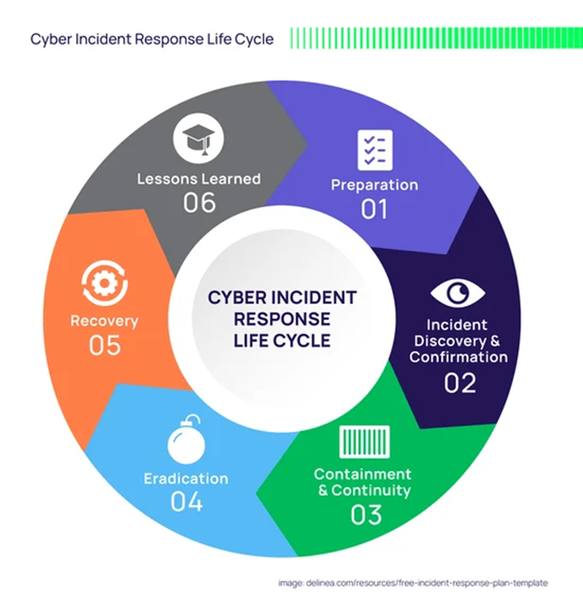
Fig 1
This structured approach ensures that incidents are handled efficiently and lessons are learned.

6. Training and Awareness Program
Technology alone is not enough to ensure security. Employees play a critical role, and their behaviour can either strengthen or weaken security.[7]

6.1 Training Objectives
The main goal of training is to help employees understand cyber risks and adopt secure practices.

6.2 Training Activities
New employees should receive cybersecurity training as part of their induction.
Regular workshops should be held to cover topics such as phishing, password security, and data protection.
Phishing simulations can be used to test employee awareness and identify areas for improvement.
Online learning modules provide flexible training options for staff.

6.3 Awareness Campaigns
Ongoing awareness campaigns can reinforce key messages. These might include posters, newsletters, and internal communications.

6.4 Monitoring and Compliance
Training effectiveness should be monitored through assessments and completion rates. Employees who fail to comply with policies may require additional training or disciplinary action.[8]

7. Presentation Summary (Appendix)
A short presentation for the board would highlight:
Current cybersecurity risks
Key threats facing HPA
Proposed security framework
Policies and mitigation measures
Monitoring and response strategy
Importance of staff training
Benefits of improved security

The aim is to clearly communicate the importance of investing in cybersecurity.

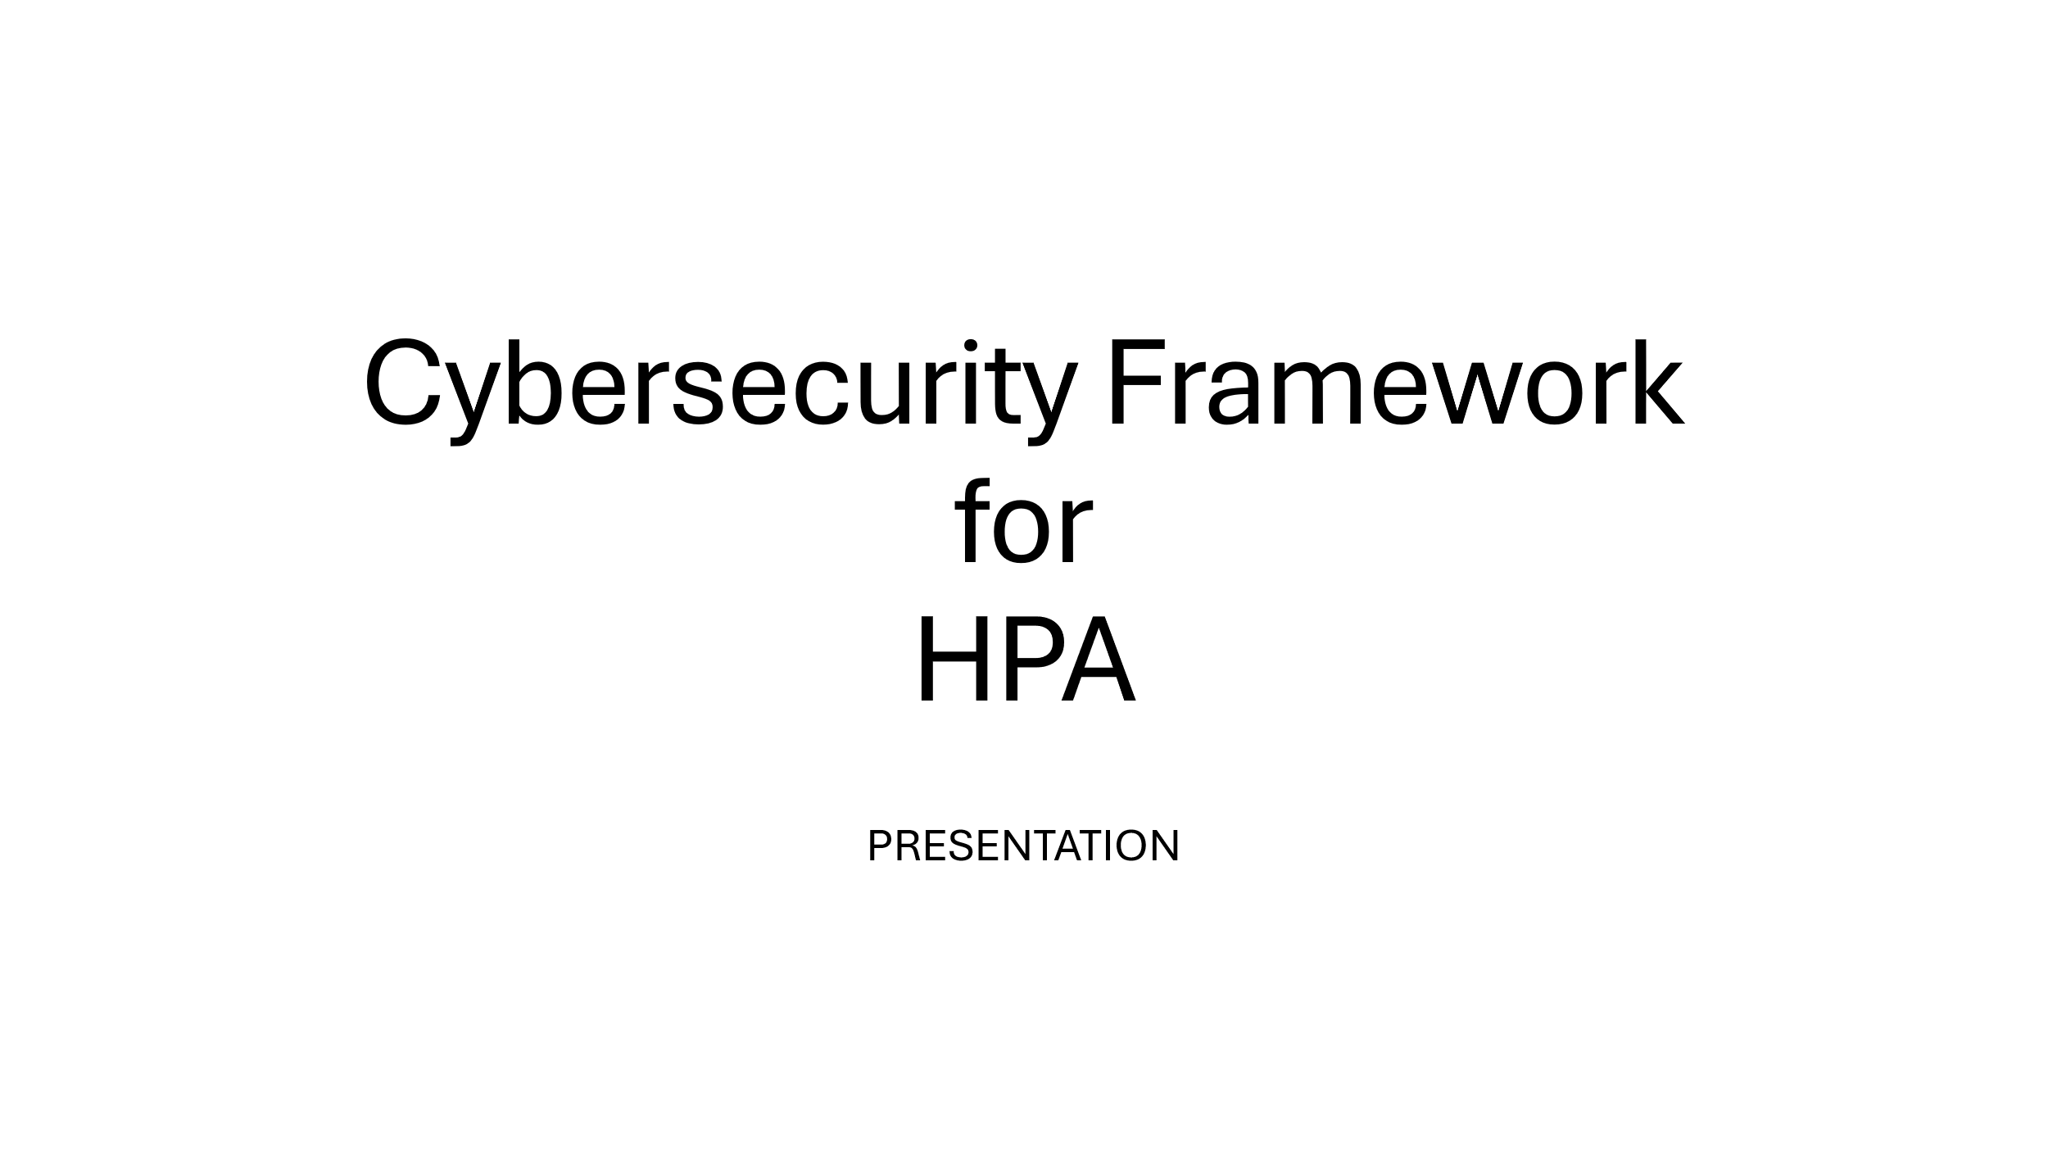
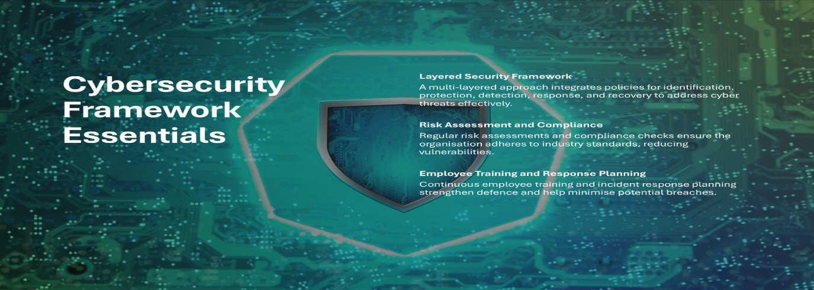

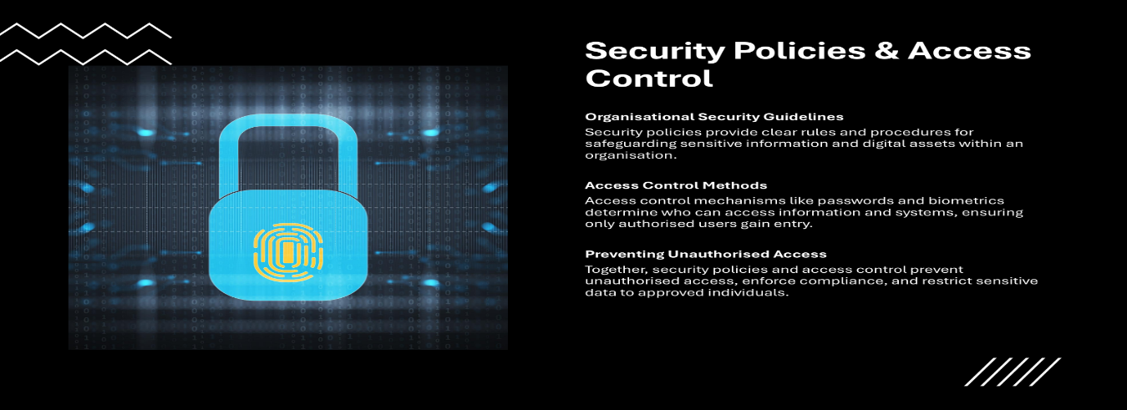

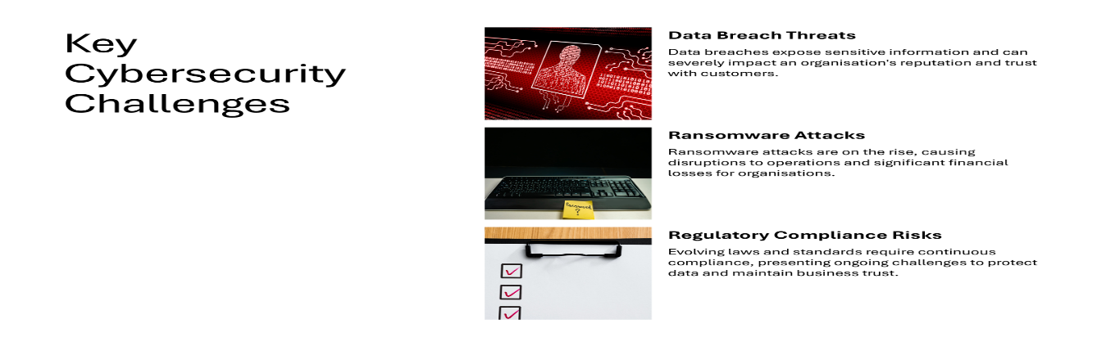

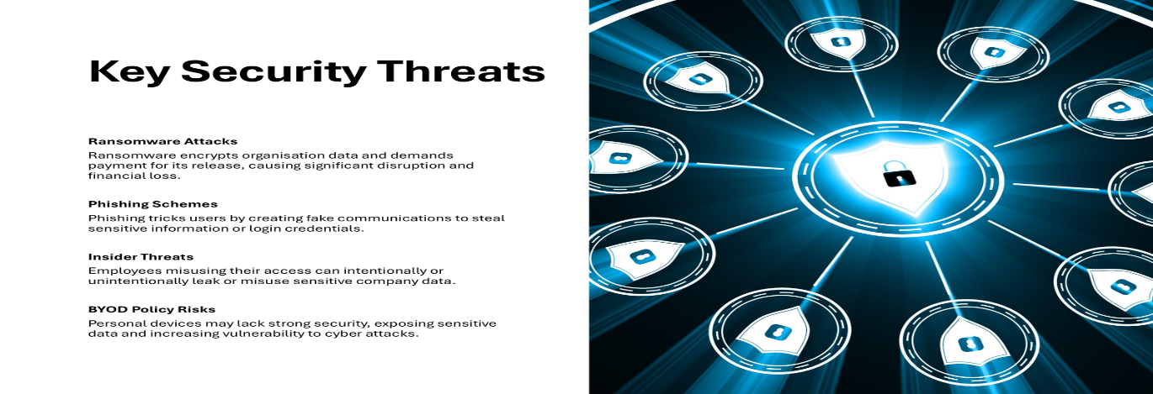
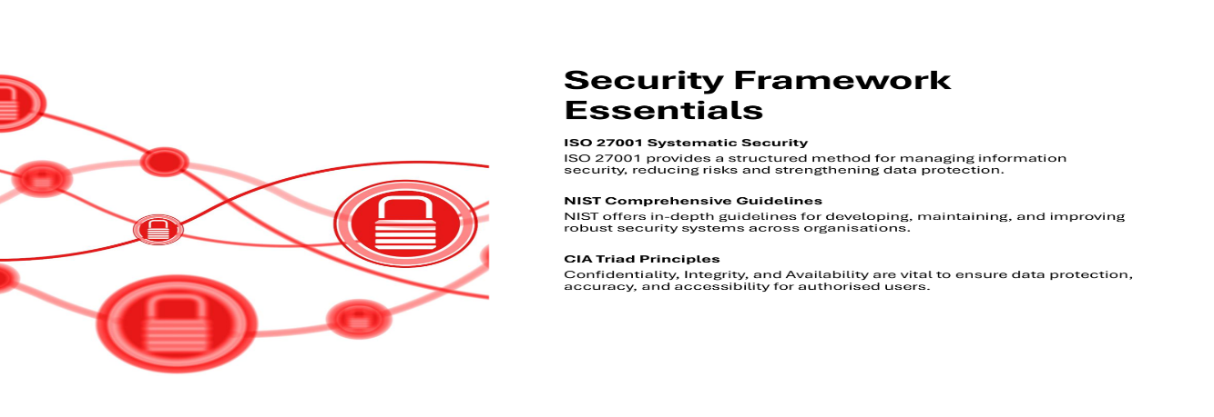

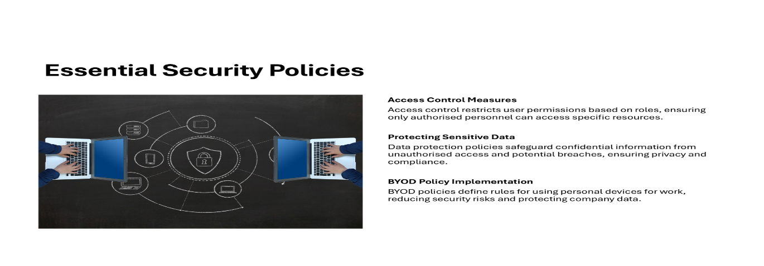
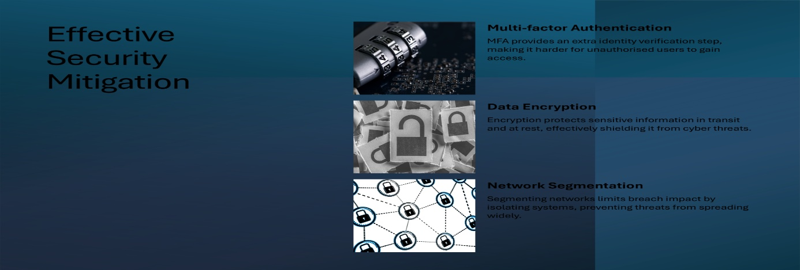
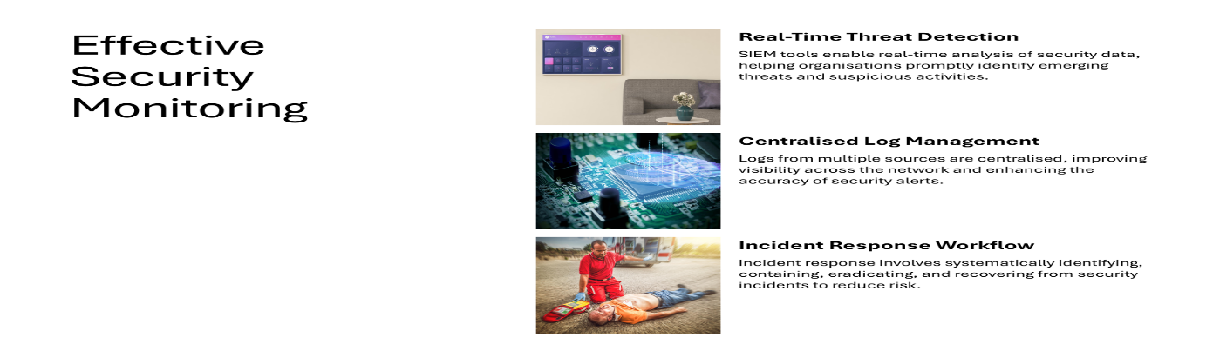

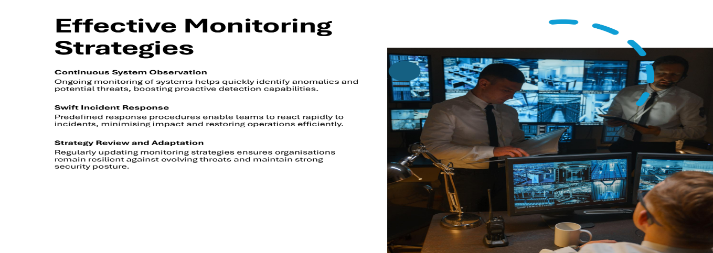

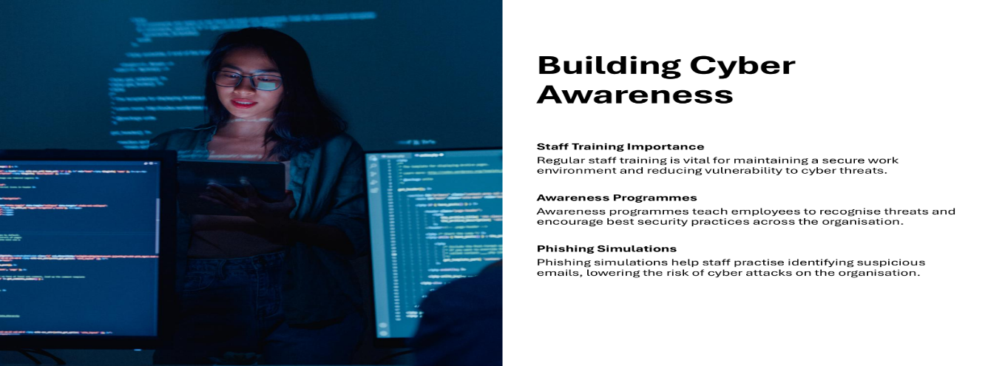
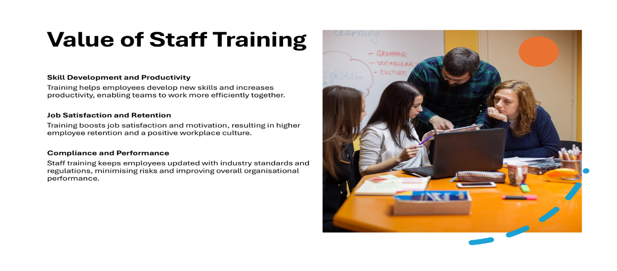
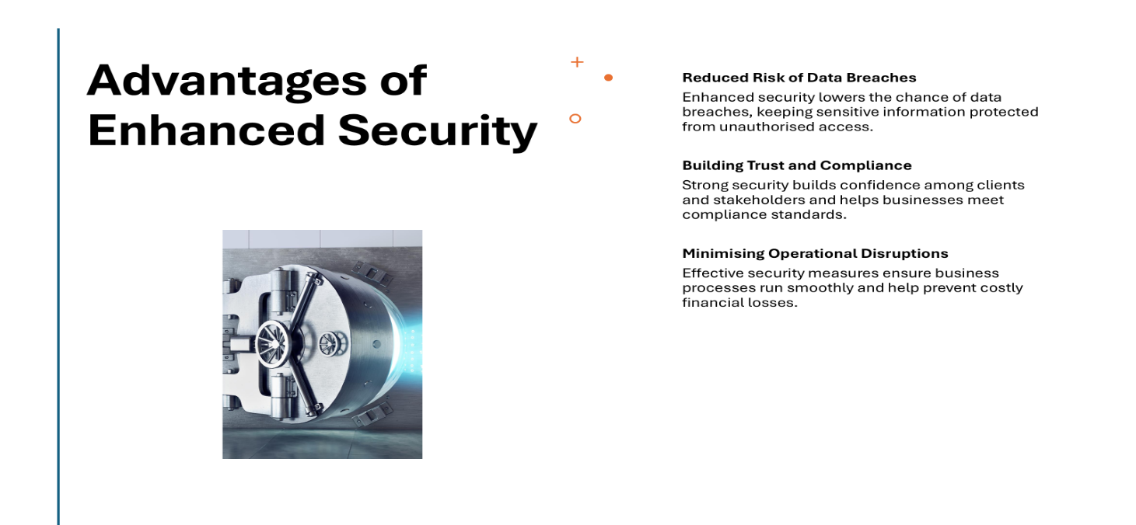

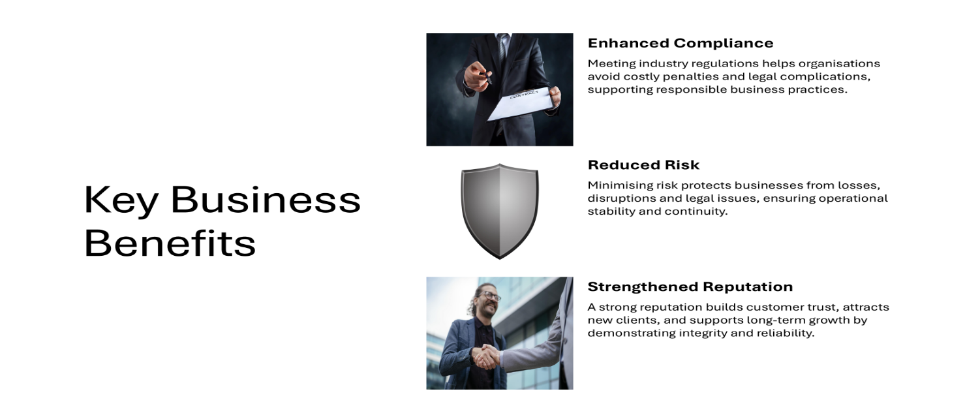
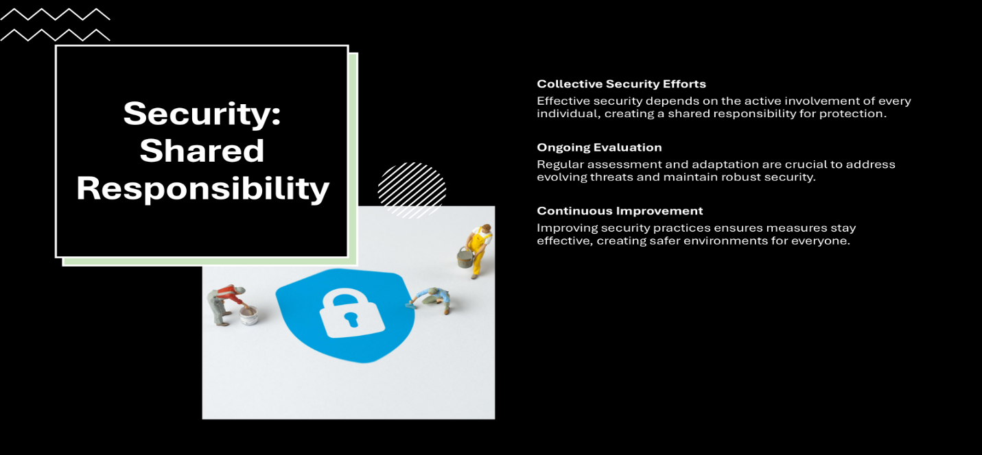

Conclusion
Cybersecurity is an ongoing challenge that requires a proactive and structured approach. For HealthPlus Analytics, the risks are particularly high due to the sensitive nature of healthcare data.
This report has outlined a comprehensive framework that addresses key threats, strengthens security policies, and introduces practical mitigation measures. It also highlights the importance of monitoring systems and incident response, as well as the role of staff training in reducing risks.
By implementing these recommendations, HPA can significantly improve its security posture, ensure compliance with regulations, and build trust with its clients. Ultimately, cybersecurity is not just about technology, it is about people, processes, and continuous improvement.

References

[1] J. Parsola, "Cybersecurity risk assessment and management for organizational security," vol. 20, no. 5, pp.5330, 2022,
[2] F. Mızrak, "Integrating cybersecurity risk management into strategic management: a comprehensive literature review," vol. 10, no. 3, pp.98–108, 2023,
[3] V. Falkevych and A. Lisnyak, "Internal and external threats in cyber security and methods for their prevention", 2023 13th International Conference on Advanced Computer Information Technologies (ACIT), pp. 414–419.
[4] N. S. Safa, R. Von Solms and S. Furnell, "Information security policy compliance model in organizations," Comput.Secur. vol. 56, pp.70–82, 2016,
[5] A. Al-Omari, O. El-Gayar and A. Deokar, "Security policy compliance: User acceptance perspective", 2012 45th Hawaii International Conference on System Sciences, pp. 3317–3326.
[6] W. K. Fulton, "Physical security measures," vol. 7, no. 5, pp.327–336, 1964,
[7] S. Hu, C. Hsu and Z. Zhou, "Security education, training, and awareness programs: Literature review," vol. 62, no. 4, pp.752–764, 2022,
[8] L. T. Ly, F. M. Maggi, M. Montali, S. Rinderle-Ma and W. M. Van Der Aalst, "Compliance monitoring in business processes: Functionalities, application, and tool-support," Inf Syst. vol. 54, pp.209–234, 2015,

