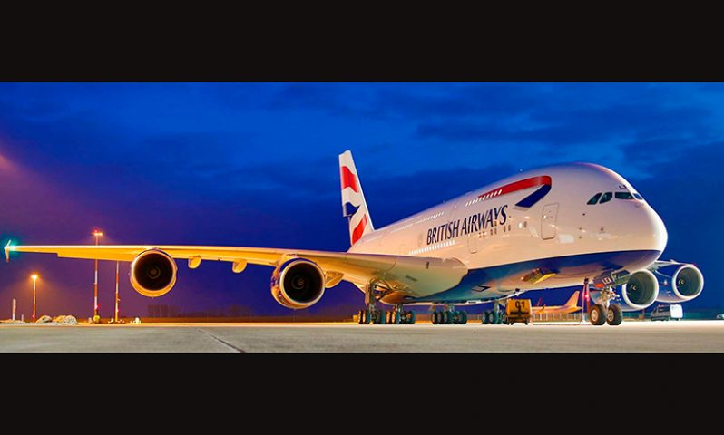

An analysis and critical evaluation of a major change within an organisation.
by
Danielle Tooze
1812486

Executive summary

The focus of the report will be critically analysing, the major change of British Airways – Strategy change which took place in 2022. The critical evaluation will examine the stages of the process along with a conclusion on the successful areas. Furthermore, the assignment will include an analysis of any failures and offer an improvement plan to resolve errors created because of the change.
The purpose of the change strategy within the company, will establish a more efficient airline by lowering its carbon footprint, which will use aviation fuel by joining partnership with Lanza Jet.
The organisation must create a strategic plan to follow a step-by-step process to ensure they can reach the end goal, becoming zero emissions in 2050 with all flights.

The models included in the report are:
- Kotter's 8 step model
- Lewin's change model
- The force field analysis
- McKinsey 7 - s model

The results show that Bristish Airways have 2 different management styles within the company but the main style within the innovation is
The conclusion is drawn from all evidence based on facts, the writer identified British Airways used the Covid19 pandemic to its advantage, to become more efficient and excel profits, through new strategies – Structural change.
For the formal report there are no recommendations required.
There will be a personal development plan in the appendices of the report.
To complete the report the author will be referencing and researching, various sources from websites.

Content page

Page 2 Executive summary
Page 3 Contents page
Page 4 Introduction
Page 5 Main findings - task 1
Page 6 &7 Task 2
Page 8 SWOT
Page 9 & 10 & 11 PESTLE
Page 11 & 12 & 13 Task 3 – Leaders and Leadership
Page 14 Task 4 – Culture of organisation
Page 15 & 16 &17 Task 5 – Change agents
Page 18 & 19 &20 Task 6 – Impact of change models and theories
Page 21 Task 7 – Conclusion
Page 22 & 23 & 24 Appendices
Page 25 &26 Reference list

Introduction

The aim of the report is to critically analyse a major change within an organisation, in strategic management, by providing a critical analysis on transformational Change Management within the organisation British Airways. The scope of the research is based on clearly outlining the external and internal factors, which the Chief Executive, Sean Doyle, must consider to successfully drive the company forward. In the report different change models are explained as well as the reasons for the change. There will be research conducted to gain clarity on the issues raised and information extracted.
The change that will be critically analysed is the change strategy. Progressing the development and commercial deployment of SAF is crucial to decarbonising the aviation industry and a key part of the organisations plans to reach zero carbon emissions by 2050.
“SAF is a biofuel used to power aircraft that has similar properties to conventional jet fuel but with a smaller carbon footprint. Depending on the feedstock and technologies used to produce it, SAF can reduce life cycle GHG emissions dramatically compared to conventional jet fuel.” (Energy.gov,2023)
That means they will be the first airline in the world to use SAF produced on a commercial scale in the UK.

“We’ve always led the industry in addressing climate change. Launching Flightpath net zero, our commitment
to net zero CO₂ emissions by 2050, puts environmental sustainability firmly
at the heart of our business and reaffirms our leadership in this critical area.” (_{IAirGroup,2023)}

Main findings

Task 1 - Background information

British Airways is a global airline and the first UK flag carrier, the organisation has been flying customers to different destinations for over 100 years. The airline connects Britain with the rest of the world and vice versa, sustainability and customers at its hard, along with providing exceptional customer service. The CEO of the organisation is Sean Doyle, he plans on innovating the company to carbon net zero by 2050.

British Airways - Key dates
In 1919 The merger of Imperial, BOAC and BEA was created.
In 1974 British airways was born. Merging from the previous name Imperial Airways.
In 1950 The first transaltanic jet flights from Lonon to New York.
In 2005 Willie Walsh became the CEO of British Airways until his retirement 2020.
In 2022 British Airways start using SAF sustainable aviation fuel.

The organisation has drastically innovated from 1919 to 2022, implementing new strategies, change management and pledge to an extraordinary change on its carbon footprint, to use more sustainable fuel on its planes.

Task 2 - Nature of the change (SWOT & PESTLE)

The nature of the change being examined, is a transformational change. BA believe that they will be the leading airline to become zero emissions. The core strategy of the organisation states:
“Our BA Better World programme launch positioned sustainability at the heart of BA’s core strategy.” (BritishAirways.com,2023)

TIt accompany take sustainability very seriously, having already made huge changes to lower its carbon footprint. Furthermore, the organisation has also stated that it has big plans for the upcoming future and becoming zero emissions in just a few years.

The problem is that another website believes the company are emitting millions of CO2 into the air,
According to transport and environment -
“British Airways is the second biggest airline polluter in Europe. Its flights emit some 18.4 million tonnes of CO2: similar to the emissions from all the vans on the UK's roads.” (transport and enviroment,2023)
Which isnt what the organisation, British Airways portray to the world.

All companies are trying to reduce their carbon footprint in one way or another to help the environment. The writer believes that BA are trying to reduce carbon emissions, yet the truth seems slightly stretched for the company to go zero emissions.

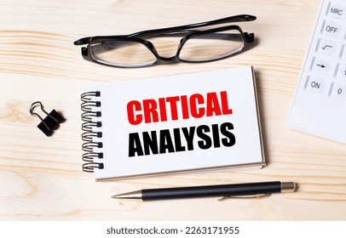 (Shutterstock,2023)

SWOT Analysis
The SWOT analysis model is situated in the Appendices section (appendix 1)

Strengths
- Well established brand name British Airways gained loyalty and trust from customers.
- With strong international alliances BA has a global geographic exposure with excellent communication.
- BA took full advantage of technological developments though innovative culture, for example, online sales and mobile check ins.
- Purchase of the new fleet and aircraft to make travelling more comfortable for passengers give BA advantage over competitors.
Weaknesses
- Soaring depts are still a main concern for BA.
- Rising fuel costs
- Rising labour costs
- Staff shortages

Opportunities

- BA’s online customer base expanded further by the growth of internet worldwide
- As customers' expectations are raising value added and innovative flight services will attract more customers.
- Prevent wastefulness
- Working closely with the government to reduce carbon waste.

Threats
- BA market share is under threat from the low-cost airlines which continuously enjoy strong growth and power in the market.
- Fluctuations and continuing to grow of fuel prices pose another threat to BA.
- Covid19 pandemic.
- Brexit.

“SWOT Analysis can help you to challenge risky assumptions and to uncover dangerous blind spots about your organization's performance” (mindtools,2023)

Pestle analysis
The pestle analysis model is situated in appendices (appendix 3)

A Pestle analysis has been undertaken, to investigate the micro and macro factors that influenced the organisation.

Political factors

- Government policies changing.

Economic factors

- Covid19 pandemic.

Social factors
- Competing with low cost carriers.

Technological factors
- British Airways use automation technology.
Legal factors
- Aviation related laws
Enviromental factors
- Mitigate carbon emissions.

The PESTLE Analysis provides a contextual information about the business direction, its brand positioning, growth targets, risks and productivity. It can help determine if the change is valid or not.
BA has made a pledge to reduce their carbon emissions and by 2050 to become a zero emissions organisation. The six factors need to be taken into consideration, political factors affected the company when the government changed polies on using Russian airspace after Russia invaded Ukraine. Russia even banned all UK flights from using their air space.
Economy factors affected the organisation when the Covid19 pandemic occurred, to prevent the spread of virus, government impose lockdowns, stopped flights which had a knock on effect declining BA’s profits.
Social factors include competing with low-cost carriers, for example, cheap plane tickets attract travellers immensely since people do not have extra money on flight tickets, knowing the mindset of people, British Airways decided to reduce the legroom of its planes, and add extra seats to compete with competitors of their low-cost tickets.
The main technological factor is growing technology phase, the business needs to adapt and implement technology to keep up with competitors. BA has already invested in automation technology to save the cost of data collection and provide a pathway for customers living in different parts of the world to connect with British Airways.
Legal factors need to be addressed to avoid lawsuits and abide by laws as not complying can destroy many years of hard work. The organisation is subject to all aviation related and country specific regulations. Furthermore, in 2018 cost BA was fined £20m on data breach charges.

Enviromental factors shouldn’t be ignored to achieve sustainable growth.
With a number of flights and aircraft carriers increasing each year, the environmental impact of the airline industry, has now become more of a central concern for authorities around the world. BA is the first airline that uses sustainable fuel in its jets, reducing carbon emmissions by 80%.
“Not only do aircraft emit carbon dioxide from burning fuel, but other pollutants are also given off mid-flight such as greenhouse gases. The emissions released remain in the atmosphere and contribute towards the warming of the planet.”(Etihard,2023)

Task 3 - Leader’s and leadership

The McKinsey 7-s Framework model

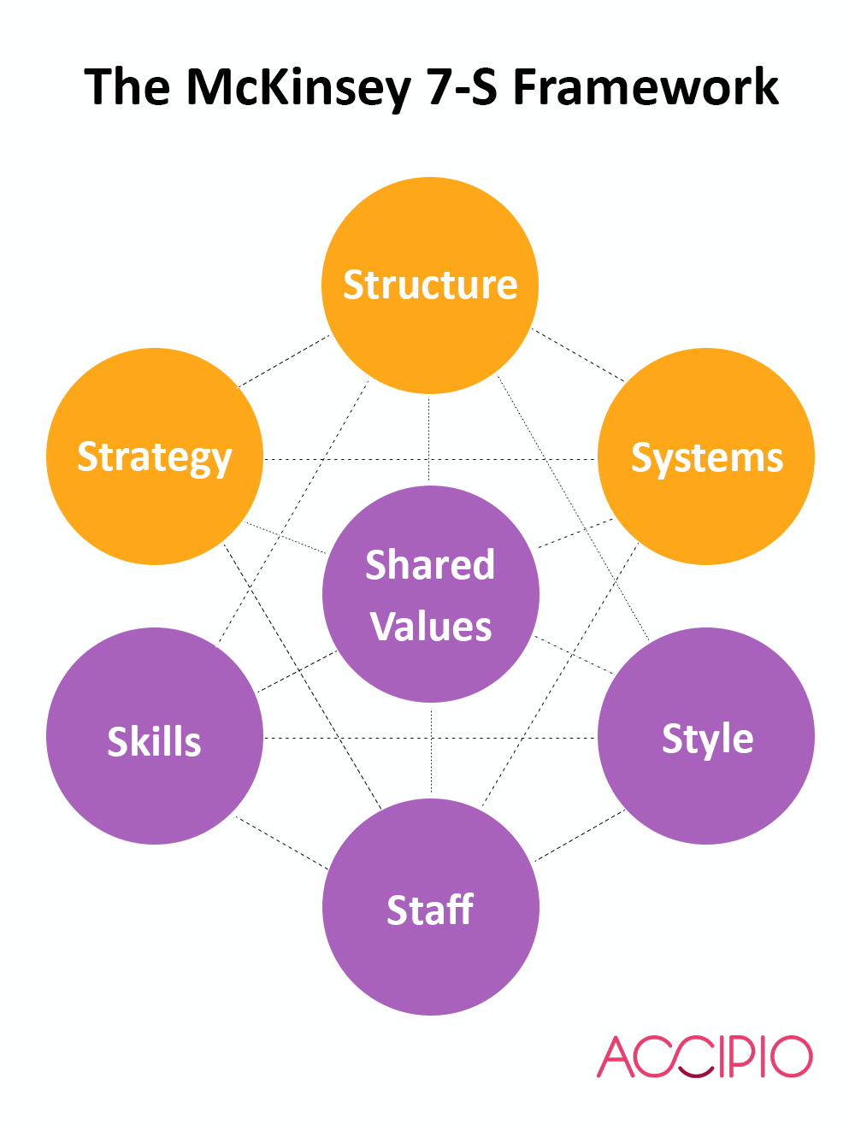 (Accipio LTD,2023)

The leaders of the 21st century is finding it hard to manage the progressively more multi-faceted and constantly fast paced nature of the businesses. Engrossed in the unpredictable markets, leadership failures continue to rise even among highly eminent CEOs.
As the model shows above, leaders must have structure followed by management strategies, with systems, all employees must share values for change to work, employees must always develop their skills through, training courses, seminars and coaching-and attaining 21st century leadership skills are no different.
In business management, leadership plays a successful role in identifying strengths and weaknesses of an organization and utilise them efficiently to accomplish the goals and objectives set by the organisation. Other than decision making, leader has to encourage and lead his team on the road to success.
21st century leaders have many roles to perform due to changing trends in markets, cajole organisations, numerous stakeholders and shared the job where they persistently face trade offs in focus, energy and time.
“British Airways focuses on the customers that are seeking quality of air travel experience; therefore it can be stated that the business level strategy pursued by the organisation reflects differentiation.” (MBU tutorials, 2023)

Change Leadership must set clear goals and objectives, with a positive, enthusiast and growth mindset before the change can happen, before introducing new technologies, collection of data and marketing, there should be talk of unexpected scenarios and learn about the new aviation fuel, to understand exactly why the change needs to happen.
The complex areas identified problems that were surfacing in the organisation, some areas lack of policy direction, need of cross functional communication, long distance communication between chain, such as the decision-making unit and the primary source of information and top management is always hard to reach.

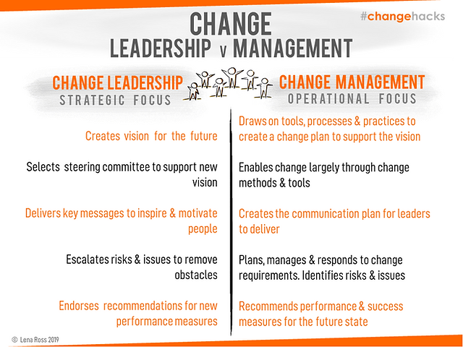 (Change hacks,2023)

Leaders must create vision for the future, support the new vision, deliver key messages to motivate people to change, evaluate risks and remove barriers and endorse new performance recommendations.
Whereas managers draw on tools and practices to create the vision, use methods to enable the largely thought through change, create communication plans for leaders to deliver to employees, plan, manage and identify risks which could occur and lastly recommend performance and success measures for the future.
Therefore, managers create the tools for leaders and leaders deliver the message to employees.
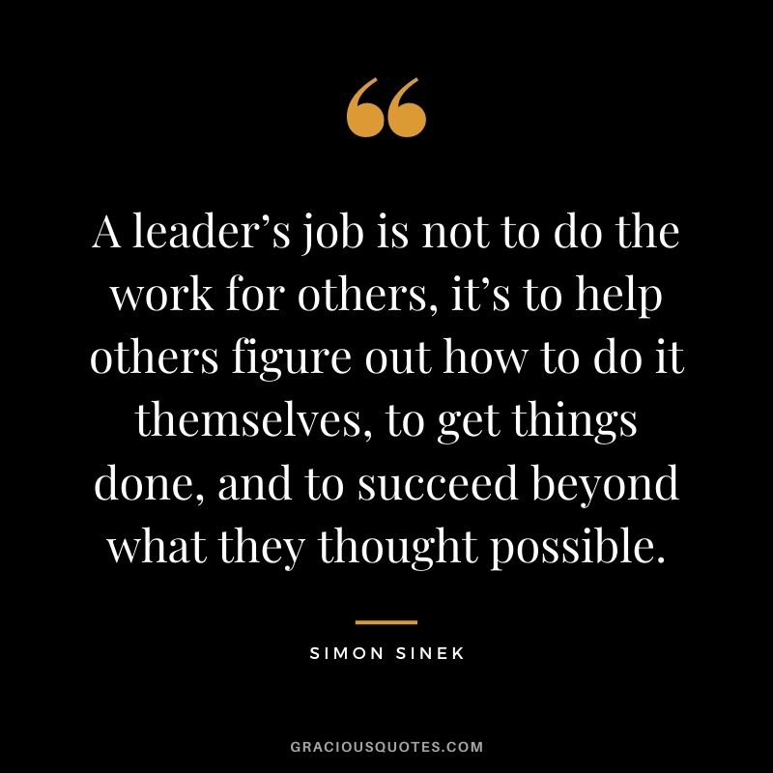(Gracious quotes, 2023)

Task 4 - Culture of organisation.

British Airways Culture and influence on change process.
According to British Airways,
“It's a dynamic, fast-paced environment that will bring out the best in you – if you're ready to embrace responsibility and step up to any challenge. Whatever your role, your warmth, positivity, commitment and adaptability can truly come to the fore, making you a trusted ambassador of the British Airways brand.” (Birtish airways,2023)
British Airways has launched it’s a new BA better world sustainability programme, stating they strive at becoming more sustainable and it's their most important journey yet. The airline partnered with Airbus to paint its most modern, fuel efficient a320neos in its new sustainability programme colours.
The company has also announced a new collaboration with BP to source sustainable aviation fuel for all its Uk based flights.
The main influence of the sustainable change is climate, as an industry leader BA are proud to be part of the first airline group in the world (IAG) to commit to becoming carbon net zero by 2050. They have invested in new aircrafts that are 40% more efficient than the ones they replaced and changes to the way they fly to further reduce their emissions.

Task 5 - Change agents – Did they help or hinder the change process?

Tech Target states,
“In business, a change agent is an individual who promotes and supports a new way of doing something within the company. This can be the use of a new process, the adoption of a new management structure or the transformation of an old business model to a new one.”(TechTarget,2023)
Internally, change agents helped the change by serving a distinct role within a change initiative as a proponent of the change, as well as a conduit between leadership and the rest of the organisation. The change agent smoothed out resistance to change, secondly, the change agent solved problems and address any issues before they derail an initiative, ultimately ensuring the success is implemented and adopted the new change project.
Externally, the advantage of having the external change agent is they give their objectivity and the ability to give honest feedback to management without fear of reprisal. They also bring perspectives from other organisations, so they can share a broad range of experience.

Lewin’s model of 1951

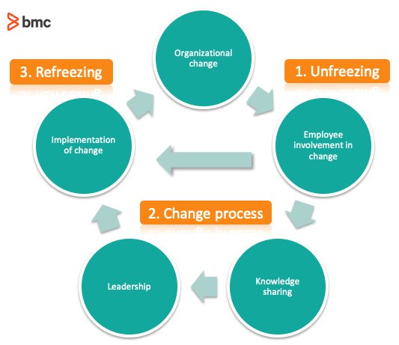(BMC,2023)

The Lewin 1951 model is used to manage the change in British Airways, by unfreezing, existing attitudes are supported by knowledge sharing within the team, the change in the present equilibrium, new responses can be developed according to new information from leadership. Lastly, Refreezing, by introducing new responses in the personality concerns, can stabilise the change.

Lewin's Force Field Analysis

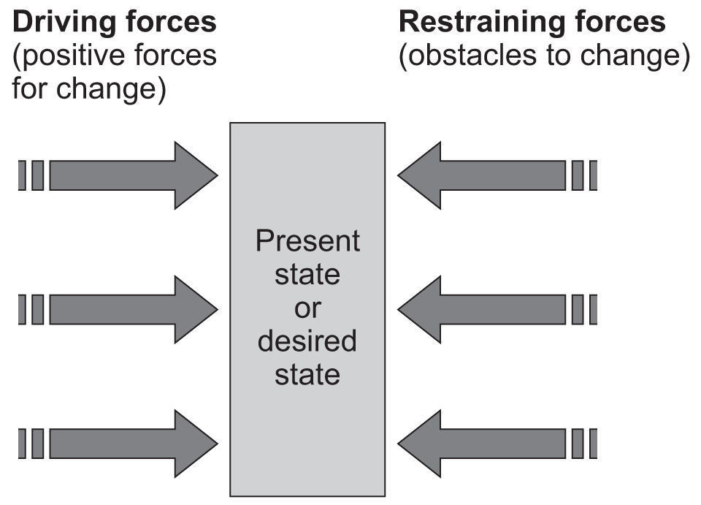(AQA,2023)

THE FIELD FORCE ANALYSIS is the only methodology observes change suggested by Lewin that involves:
The transition to the future state is affected analysing the driving forces.
The differentiation between driving and restraining forces is necessary.
Measures should be taken to give rise to critical driving forces and diminish critical restraining force.

To conclude the need and capability of organisational change management should begin with the identification of the current circumstances, deep understanding about leadership skills, group dynamics, and creative marketing.
RESISTANCE TO CHANGE: can be external or internal.

EXTERNAL

External resistance defiantly affects the process of change. The cultural, social and political environment all resist to change.
Effective Communications with various stakeholders explaining them the reasons for the change, the benefits of successful implementation (what is in it for the company, and you) as well as the details of the change (when? where? who is involved? how much will it cost? etc).

INTERNAL

At the time of implementation of change, organisation can face some resistances to change internally from the workers like:
- Lack of knowledge
- Deficiencies in training
- Fears to lose something.
- Absence of trust.
- Communication problems.
Normally, people perceive change processes in seven typical stages.

Task 6 – Impact of change models and theories.

British Airways use - MASLOW THEORY OF MOTIVATION
Self esteem needs: BA is satisfying its employees this need by giving them job titles, position in the company and receiving feedbacks of job. Social needs: BA fulfils this need of its employees by making them work in groups and motivate them to work as a team.
British Airways use the theory of needs which dictate a human's behaviour. Those needs are physiological needs, safety needs, love and belonging needs, esteem needs and self-actualisation needs. It's very important to make sure employees feel belonging within the organisation, to make them feel part of something, can also have an impact on their productivity.
The organisation has been impacted positively by using change models and theories. Creating positive leadership relationships, easy communication when creating a change and even higher productivity when change theories and models are explained thoroughly.

Change models and theories have a positive impact on the change process, for example, it can identify potential areas of resistance and implement strategies designed to reduce or eliminate resistance before the change process starts. It can align benefit to help create an effective communication strategy.
The disadvantage of using change models and theories, can create insercurity among employees. Employees tend to worry about their performance, when they hear about a new change, it creates doubt in their mind whether they would be able to effectively perform their job or not,

The writer believes that the change process, must use change models and theories to take into consideration all areas which will be affected by the new change. There are many benefits to change management, for example, improve communication, increased productivity, reduced stress and improved decision-making. Change management can also help improve employee morale and create a more positive work environment.

Kotter's 8 stage change model (1996)

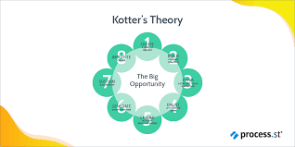(Process.st,2023)

Kotter’s 8 Stage Change Model (1996)
1.Sense of urgency
2.Powerful coalition
3.Vision for change
4.Communicate vision
5.Remove obstacles
6.Creating short-term wins
7.Building on the change
8.Anchoring the change

BA use Kotter’s model to create a sense of urgency, recruit powerful change leaders, build a vision and effectively communicate it, remove obstacles, create quick wins, and build on your momentum. If you do these things, you can help make the change part of your organizational culture.
Although there are some disadvantages of Kotter's 8-step change model,
“some steps remain unclear: While some steps provide you with examples of how to make your way through the change process, other steps don't provide you with enough guidance to help you sustain the implemented change” (Indeed,2023)

Task 7 – Conclusion
All research is completed, the analysis and critical evaluation of the major change within the British Airways organisation. All evidence is based on facts, the writer found that BA used the covid19 pandemic to its advantage. The CEO Sean Doyle has clearly outlined the external and internal factors for the change to be effective, he used models such as Kotter's 8 step model, Lewin’s change model, the force field analysis, and the McKinsey 7 s model, to enable the change to drive the plan forward. The reason for the change is clear to see, the company wants to do right by the planet and be more sustainable.
To concentrate on making a strategic plan to excel sustainably through new strategic plans to work towards becoming zero carbon emissions by 2050, the company had taken huge steps already to partner up with BP and Lanza Jet to be the first airline to use Aviation fuel for all UK flights.
A SWOT Analysis helped BA uncover the dangerous and blind spots it could have missed within the organisation's performance.
PESTLE Analysis shows that the change is valid and supplied contextual information about the brand about the business direction, its brand positioning, growth targets, risks, and productivity.
Leaders set clear goals and objectives to encourage team members to engage the change, by being giving all the information around the planning of the change and what needs to be done to reach the end goal.
Some areas of BA lacked direction, especially in the data protection sector, the company was fined £20million in 2018 for leak of data, due to negligence.
The organisation works hard with consumers in mind as well as the planet. Furthermore, BA have competitors who are offering lower prices as they use cheaper fuel and less staff, less outgoings means more profit, which is not a good thing for BA.
The writer believes that British Airways does want to help the environment by using aviation fuel, however the steps they are taking is a very slow process, the end goal for the company is 2050, that is a long way away and within that time competitors will overtake them with better innovative ideas and BA will sadly still be trying to catch up.
The organisation is already making leaps in becoming more sustainable and therefore there are no recommendations needed.

appendices
Appendix model 1

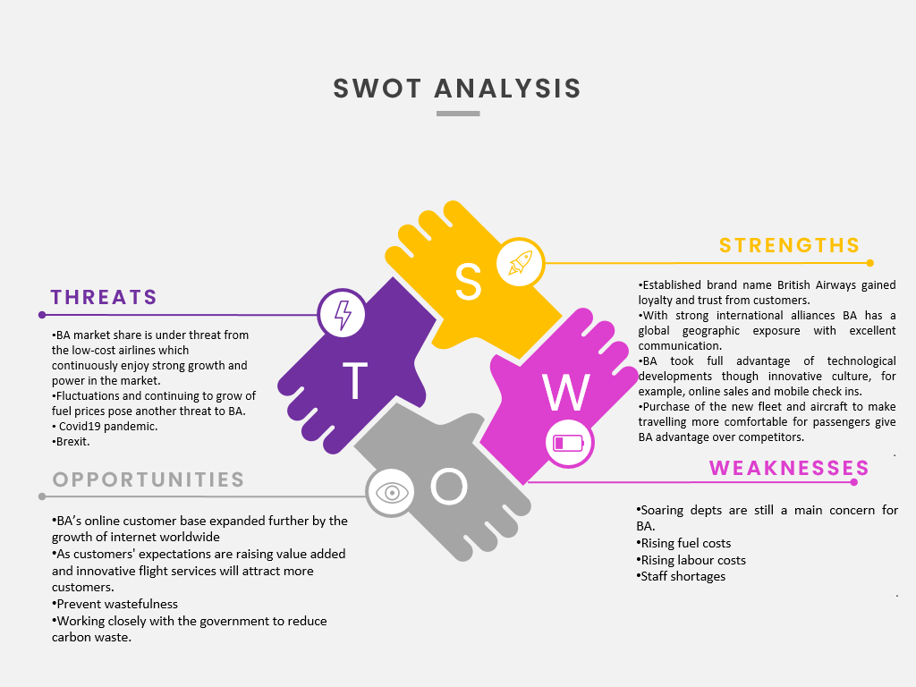
(Designed by Danielle tooze)

Appendix model 2
Personal development plan (PDP)

NAME: | Danielle Tooze | MEMBERSHIP NUMBER: | 1812486
COVERING THE PERIOD FROM: | 2021 | TO: | 2022

What do I want/need to learn? | What will I do to achieve this? | What resources or support will I need? | What will my success criteria be? | Target dates for review and completion
Change announcement | Create a meeting with change department | Support from other managers &  HR | Start using more sustainable Aviation fuel in all aircraft carriers | 6th March 2022 review  6th June 2022 completion
Stakeholders' invitation | Create a team’s meeting for all stakeholders | Microsoft teams & other management to assist meeting | Start using more sustainable Aviation fuel in all aircraft carriers | 6th March 2022 review  6th June 2022 completion
(Created by Danielle Tooze)

Appendix model 3
PESTLE Analysis

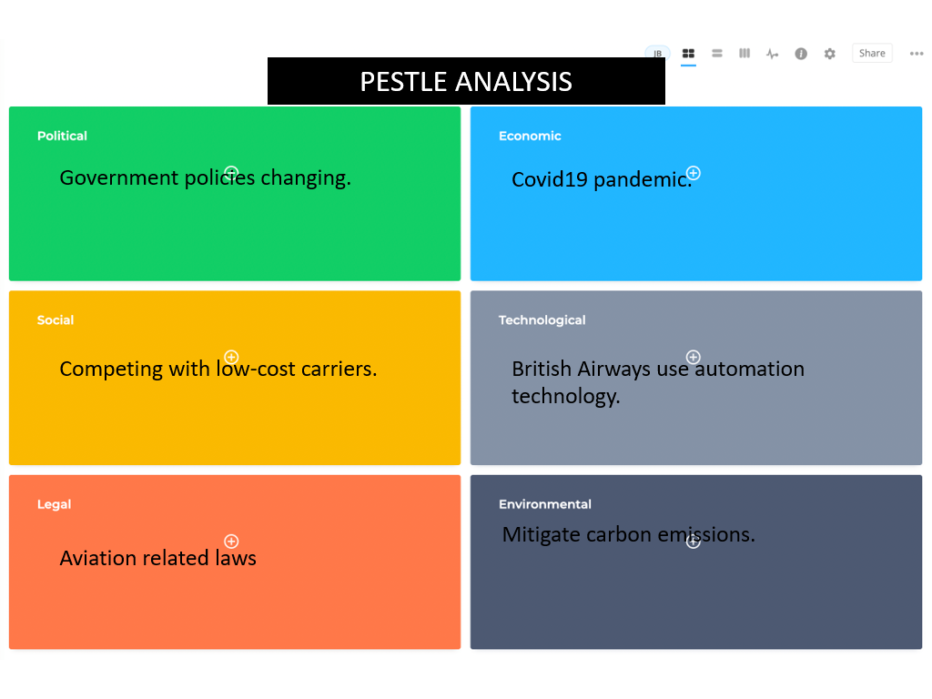
(Created by Danielle Tooze)

Reference list

Accipio LTD, (2023) The McKinsey 7-S Framework.
https://www.accipio.com/eleadership/mod/wiki/view.php?id=1864 (accessed on 08/03/23)

Alignment, (2023) PESTLE Analysis.
https://www.alignment.io/blog/pestel-analysis (accessed 18/03/23)

AQA, (2023) Teaching guide: Lewin's force field analysis.
https://www.aqa.org.uk/resources/business/as-and-a-level/business-7131-7132/teach/teaching-guide-lewins-force-field-analysis (accessed on 19/03/23)

BMC, (2023) Lewin’s 3 Stage Model of Change Explained.
https://www.bmc.com/blogs/lewin-three-stage-model-change/ (accessed on 22/03/23)

British Airways, (2023) Working with us.
https://careers.ba.com/working-with-us (Accessed on 20/03/23)

Change hacks, (2023) Change Leadership: Spot the Difference.
https://www.lenaross.com.au/single-post/2019/11/22/change-leadership-spot-the-difference (accessed on 20/03/23)

Energy.gov, (2023) Sustainable Aviation Fuel: Safe, Reliable, Low Carbon.
https://www.energy.gov/eere/bioenergy/sustainable-aviation-fuels (accessed on 14/03/23)

Etihad,(2023) Environmental Impacts of Aviation.
https://www.etihad.com/en/sustainability/environmental-impacts-of-aviation (accessed on 24/03/23)

Gracious quotes, (2023) 59 Simon Sinek Quotes on Leadership (CHANGE).
https://graciousquotes.com/simon-sinek/ (accessed on 23/03/23)

Guyana chronicles, (2023) British Airways coming in 2023; tickets already on sale
https://guyanachronicle.com/2022/08/11/british-airways-coming-in-2023-tickets-already-on-sale/ (accessed on 20/02/23)

Indeed, (2023) Guide to kotter’s 8 step change model.
https://www.indeed.com/career-advice/career-development/kotter%27s-8-step-change-model (accessed on 20/03/23)

IAirGroup, (2023) LEADING SUSTAINABLE AVIATION.
https://www.iairgroup.com/~/media/Files/I/IAG/documents/IAG%20Annual%20report%20and%20accounts%202019.pdf (Accessed on 23/03/23)

MBU tutorials, (2023) Strategic Analysis of British Airways.
https://mba-tutorials.com/strategic-analysis-of-british-airways/ (Accessed on 10/03/23)

Mindtools, (2023) SWOT Analysis.
https://www.mindtools.com/amtbj63/swot-analysis (Accessed on 17/03/23)

Process.st, (2023) Change Management Models: 8 Proven Examples to Evolve & Thrive
https://www.process.st/change-management-models/ (Accessed on 21/03/23)

Shutter stock, (2023) Critically analyse royalty free images.
https://www.shutterstock.com/search/critical-analysis (Accessed on 15/03/23)

Transport and environment,(2023) British Airways emitted as much CO2 as all the vans on the UK’s roads, new data shows.
https://www.transportenvironment.org/discover/british-airways-emitted-much-co2-all-vans-uks-roads-new-data-shows/ (Accessed on 18/03/23)

PESTLE – created by Danielle Tooze
SWOT - created by Danielle Tooze
PDP - created by Danielle Tooze

