

Name : Ashfaq Mohammad
Student no : 2504711
Module : Digital Skills and Research Methods
Lecturer: Hajra Mustasim (Module lead)
Internal Verifier: Dr Besty Jose
Module code : LCHS4007
Assignment Title : Component 2 – Research Report

Table of Contents

Introduction 3
Task 1 of 3 – Research Topic Identification 3
Three Relevant Information Sources: 3
1. UK Parliament Health and Social Care Committee. (2026). 3
2. Locock, L., Maclaren, A.S., Skea, Z., et al. (2025). 4
3. Social Care Institute for Excellence (SCIE). (2026). 4
Task 2 of 3 – Research Methodologies 4
Task 3 of 3 – Data Collection 6
Conclusion 7
Reference List 8

Introduction
This research proposal aims to investigate a major problem affecting health and social care in the UK — there are not enough workers for community-based services. The research design will focus on the workforce themselves to investigate why there is insufficient availability of workers within this sector/discipline. It will identify the research problem and collect data from a variety of sources to analyse the proposed research question and define the methodology and methods for obtaining qualitative data regarding the challenges of employment in community services.

Task 1 of 3 – Research Topic Identification
The topic of this research project relates to the crisis of recruitment and retention in the workforce working in health and social care. The implications of this issue are fundamental to the success of the Government's 10-Year Health Plan to shift services from hospitals to community settings (Health and Social Care Committee, 2026).
There are a number of groups that this crisis affects. Patients are likely to wait longer for services; continuity of care may be compromised due to a lack of staff. The workforce (e.g., district nurses, social care workers) is struggling with low morale, unmanageable workloads, and pay that is less than acute hospital staff (Health and Social Care Committee, 2026). Organisations, for example the NHS, are not meeting their legal obligations and face increased costs of agency workers (Social Care Institute for Excellence, 2026).
There is an urgent need for research. There are figures that can quantify the issue; however, in order to understand why there is persistent shortage of staff, qualitative research is required. Without a stronger community workforce, the NHS's neighbourhood shift will "flounder" (Health and Social Care Committee, 2026). Research that explores how staff experience their job will help to identify drivers of attrition and support the development of targeted interventions.

Three Relevant Information Sources:

UK Parliament Health and Social Care Committee. (2026).
Evidence of insufficient pay, in addition to lack of training and few opportunities for growth in community positions, was discussed in an official communication summarizing these issues. The relationship between the quality of the workforce and the major government policies was also addressed.

Given this high level, authoritative reference to the research issue at the policy level, this source is critical in establishing the research challenge's national significance (Health and Social Care Committee, 2026).

Locock, L., Maclaren, A.S., Skea, Z., et al. (2025).
Evidence of the Recruitment and Retention Challenges in Rural Settings with Community-Based Solutions for Recruitment and Retention through a Qualitative NIHR Report Reviewing Workforce Experiences (Locock et al. 2025).

Rationale: Given that this source is of an academically rigorous level, this report illustrates that qualitative methodology is a suitable way to address these issues and can therefore be seen to provide a model to reference against for the research project to be conducted (Locock et al., 2025).

Social Care Institute for Excellence (SCIE). (2026).
Focus and Substance: To demonstrate the effects of workforce instability on quality of care, as well as to call for sector leaders to work with front-line staff to generate solutions, since they "know how things work in reality"

Rationale: To support their standing as authorities, they will connect the worker crisis with care providers and recipients, creating a research approach that is based on the views of workers.

Task 2 of 3 – Research Methodologies
Research has been grouped into categories such as quantitative methodologies, qualitative methodologies, and research methodologies that incorporate both. For example, quantitative methodology places emphasis on utilizing numerical data and examining numerical data to identify trends, test assumptions (hypotheses) & determine if there is a correlation between 2 variables. It utilises mechanisms such as closed-ended surveys and will incorporate statistical evaluation to report outcome data that can be generalised to a greater population (Illinois Institute of Technology, 2025). In comparison, qualitative research (methodologies) attempt to understand complex behaviours, experiences, and the meaning individuals apply to those behaviours and/or experiences. It utilises non-numerical data sources through mechanisms such as in-depth interviews (individual interviews) and focus groups (group discussions) and will yield more in-depth contextual insights than can be obtained through quantitative methodologies, but the results cannot be statistically generalised (Scilit, n.d.). Combining both methodologies into a mixed methodologies research approach allows the researcher to obtain numerical trends and an in-depth understanding to gain a more complete view of a specific topic.
I would use a qualitative approach to investigate the causes of workforce shortages, as it allows us to explore the why and how behind poor recruitment and retention. In particular, I will focus on understanding the experiences, perceptions and motivations of care workers, as these things cannot be expressed through numbers. Sources also suggest that in order to understand these problems, you must listen to frontline staff who know the practical realities and obstacles to providing good care in long term services (Social Care Institute for Excellence, 2026). Through the use of semi-structured interviews with healthcare and social service staff, I will gather an understanding of the non-numeric reason(s) for their career choices; including workplace culture, emotional impact of their job, and perceived lack of support. This level of understanding is critical in order to develop solutions that will effectively address the workforce needs based on the real-life, lived experiences of those in the industry.

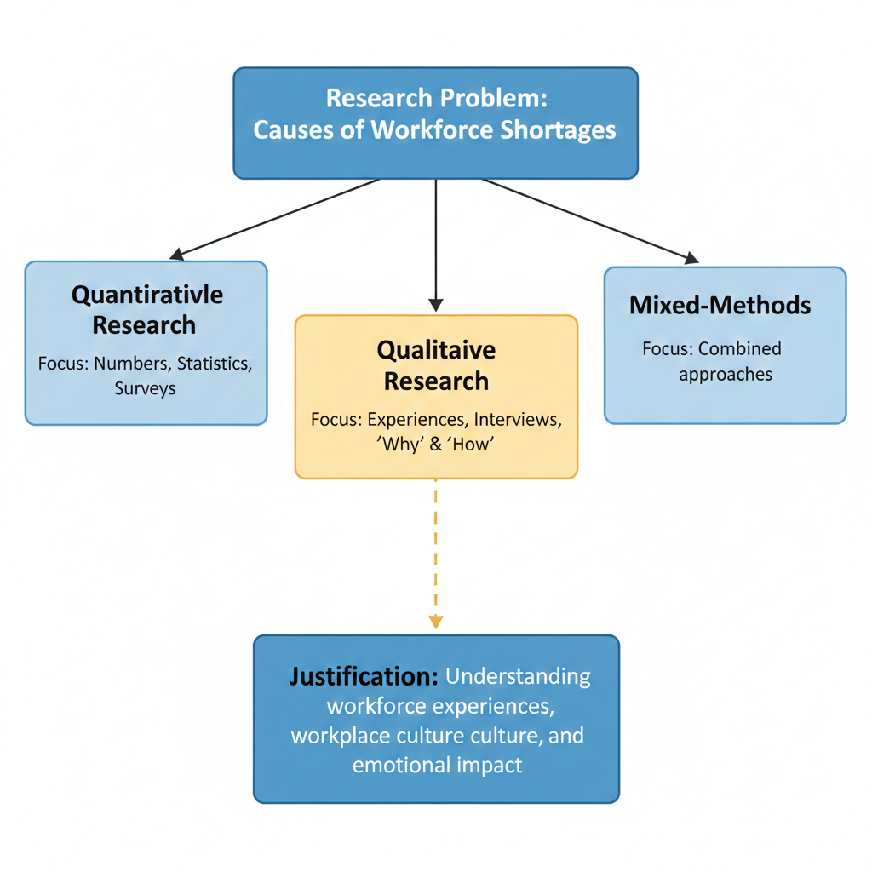
Figure 1: Flowchart illustrating the selection of a qualitative research methodology to investigate workforce shortages. The diagram highlights the focus on understanding experiences, workplace culture, and emotional impact.

Task 3 of 3 – Data Collection
In research, data is normally finds into two types of data if it is collected. The first type is Primary data, which is; all data collected directly by the researcher and is original – it is first-hand information for a distinct purpose. Interviewing, focus groups, surveys, and observational research methods (City University of Hong Kong, 2025) are commonly used methods for collecting primary data. The other type of data is Secondary data; this is information that has already been collected and published by another party. Secondary data sources may consist of government reports, peer-reviewed journal articles, official statistics, and databases for organisations (Mandlik, Kalkar and Singh, 2025). The primary data collection method will be used for this research study based on the qualitative methods that have been selected, which are complementary to the research objectives. Parachuric and NIHR studies are significant pieces of secondary data to provide context to the problem and to conduct a literature review; however, they will not provide the level of specificity and details that is needed to give an understanding to individuals that experience their jobs locally now, with regard to the actual motivation and other factors that impact their work in this locality.
In order to better understand the workforce crisis from the standpoint of its most affected parties, I will be implementing a series of semi-structured interviews with practitioners. By utilizing a qualitative method, I aim to gather thoroughly rich, detailed, complex and nuanced data related to people's personal experiences in terms of the various factors influencing someone’s desire to enter, remain or exit from the community health/social care workforce, and in so doing, I will be ensuring that my research is built upon the authentic voices of practitioners to help meet the expressed desire of sector leaders to involve frontline workers in determining how care is delivered in the future (Social Care Institute for Excellence, 2026).

Conclusion
This paper has provided a summary of a research proposal regarding the challenge of the workforce shortage within community health and social care in the UK. This research is aimed at addressing a significant issue that threatens the stability and functionality of the services relied on by a growing number of elderly people.
As demonstrated throughout this document, the workforce recruitment and retention crisis is not an administrative issue, it is a fundamental barrier to providing safe, compassionate and integrated care in communities throughout the UK.
This report has justified the need for urgency in this research by demonstrating how ongoing staff shortages create a barrier to achieving the government’s aim of shifting services from hospitals to neighbourhood settings. If a sustainable and supported workforce is unable to support this goal, these policy objectives will be at risk of failing, therefore leaving patients without timely access to health care and providing unsustainable pressure on already over-burdened acute services. In addition, there is an overwhelming degree of stress placed on care workers themselves as a result of poor morale, burnout and low remuneration, driving experienced professionals away from community-based services.
The parliamentary, National Institute for Health and Care Research, and Social Care Institute for Excellence analysis have established both the gravity of the issue and the need to understand the perspective of the staff who make up the care workforce. All three sources consistently indicate that frontline staff are an unendingly rich source of information about real-world experiences and obstacles that lead to staffing crisis, but their contributions are rarely included in the development of policies.
To meet the depth of understanding needed to deal with this issue, this project has made a clear case for using qualitative methods including primary data collection using semi-structured interviews. Qualitative research is uniquely suited to obtain a first-hand account of the actual lived experiences, motivations and concerns of current and former care workers in order to prioritise the narratives of the workforce, as well as to produce richness and substance in the development of evidence-based solutions to ensure the right number of staff are available to provide quality services to those in need. Ultimately, this study will offer evidence that will help shape the community health and social care workforce of the future; a workforce that is valued, has the right numbers of qualified staff, and is able to meet the services required by the communities they are serving.

Reference List
- City University of Hong Kong (2025) Research Guides: RDM - Collect & Organize: Data Collection. Available at: https://libguides.library.cityu.edu.hk/rdm/collect_organize/collect (Accessed: 26 February 2026).
- Health and Social Care Committee (2026) NHS's shift to neighbourhoods could flounder without strengthening the workforce, Health Committee tells Govt. Available at: https://committees.parliament.uk/committee/81/health-and-social-care-committee/news/211224/nhss-shift-to-neighbourhoods-could-flounder-without-strengthening-the-workforce-health-committee-tells-govt/ (Accessed: 26 February 2026).
- Illinois Institute of Technology (2025) LibGuides: Research Methods: Quantitative vs. Qualitative Research. Available at: https://guides.library.iit.edu/c.php?g=1481358&p=11040919 (Accessed: 26 February 2026).
- Locock, L., Maclaren, A.S., Skea, Z., et al. (2025) 'Come and work here!' Qualitative research exploring community-led initiatives to improve healthcare recruitment and retention in remote and rural areas. Health and Social Care Delivery Research, No. 13.34. Available at: https://www.ncbi.nlm.nih.gov/books/NBK618069/ (Accessed: 26 February 2026).

