

Report: Strategies and Progress Towards Sustainable Development Goals in the UK: Focus on No Poverty and Good Health and Well-being

Student name: MARYAM ANWAR
Student ID: 2015318
Module name: Health, Wellbeing and Sustainable
Development (BMHP6021_BIRM)
Lecturer: CHLOE HARRIES

Submitted on: 22/07/2024
CONTENTS
Introduction……………………………………………3
Key Concepts…………………………………………3
Well-being……………………………………………..3
Sustainable Development……………………….4
Health……………………………………………………5
Sustainable Development Goals……………….6
SDG 1 No Poverty……………………………………6
UK Policies………………………………………….7
Critical review…………………………………….8
Recommendations………………………………10
SDG 3 Good Health and Well-Being………….10
UK Policies…………………………………………10
Critical Review…………………………………….11
Recommendations………………………………...12
Conclusion……………………………………………….13

Introduction
This report evaluates the progress made in the United Kingdom towards achieving two of the United Nations Sustainable Development Goals (SDGs) which are SDG 1- No Poverty and SDG 3– Good Health and Wellbeing. (UN,2015). The objective is to analyze the difficulties encountered in achieving these goals. Furthermore, it looks at how government actions and policies affect the UK's overall progress towards reaching the SDGs.
SDG 1 aims to eradicate extreme poverty in all of its forms (Joseph Rowntree Establishment, 2022). This ensures that every individual and family has access to a basic quality of life, which includes basic necessities like food, shelter, and hygiene. In order to create a society in which every individual has the chance to realize their full potential, SDG 1 must be achieved. Similarly, SDG 3 aims to create a society in which all people have access to high-quality healthcare and the resources necessary for a healthy way of life. It encompasses social, mental, and physical wellness. Financial success, a productive workforce, and overall societal well-being all depend on having a healthy population (Marmot et al., 2020).

Key Concepts
Wellbeing
According to the World Health Organization (2014), avoiding illnesses alone would not guarantee prosperity, it also includes a condition of physical, mental, and social well-being. Without a sense of purpose and the ability to manage stress effectively, one may struggle to achieve true prosperity. Finding meaning in one's actions and learning how to handle challenges are crucial aspects of overall well-being. (The King's Support, 2012). Achieving a balance in all of these areas is essential for experiencing true prosperity in life.
Importance of Wellbeing
When individuals are thriving in all aspects of life, they can effectively contribute to the welfare of society as a whole.
Benefits for People: Well-being is associated with improved safety standards, improved physical health, and a lower risk of chronic diseases (Flinter & Keyes, 2012). Overall, achieving prosperity can lead to a more fulfilling and balanced life. Public health and population health leaders are responsible for promoting well-being in the communities. (The King's Fund, 2012).
Social Benefits: Healthy individuals have a more prominent positive impact on their communities. A happy and contented person can contribute to the advancement of a society. (Helliwell & Saxton, 2014).
Economic Picks up: According to the World Health Organization (2020), a workforce that's in great wellbeing is more beneficial, and stimulates financial development. Moreover, a high level of prosperity brings down costs related to sicknesses and treatments. (New Economics Foundation, 2010).

Sustainable Development
The United Nations (1987) defines “economic progress as meeting current needs without compromising future generations' ability to meet their own needs”.
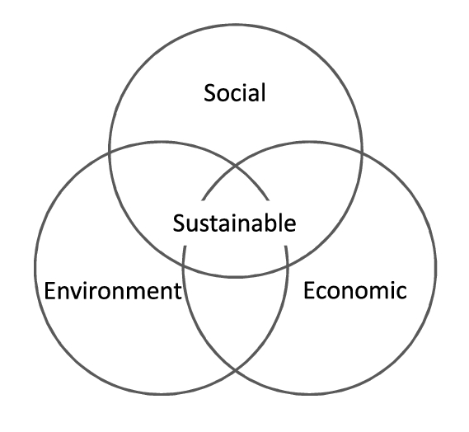
(Purvis, Mao, and Robinson, 2019)
Sustainable development comprises of three pillars as shown in the above figure: Economic development is the method of guaranteeing financial advances while decreasing the effect on the environment and making effective utilization of resources. (Purvis, Mao, and Robinson, 2019).Social value is the method of building a fair society in which all individuals, have the chance to attain their full potential.
Environmental security: In order to protect the environment for future generations, it is important to reduce pollution, climate change, and biodiversity loss.(Omer, 2008)
Importance of Sustainable Development
In arrange to ensure a solid world and an evenhanded society for all, economical improvement is fundamental. Usually the reason why:
Sustaining Vocations: Concurring to Sachs (2015), a sound environment offers the assets fundamental for human life and financial activity.
Reducing Imbalance: By ensuring that everybody has get to to assets and openings, feasible advancement may progress social reasonableness (Joined together Countries, 2015).
Ensuring Long-Term Well-Being: Maintainable advancement secures future generations' well-being by handling natural issues (World Commission on Environment and Improvement, 1987).

Health
According to the World Health Organization (1948), well-being is more than the absence of ailment or disease, it may be a condition of entire physical, mental, and social well-being. This concept highlighting a comprehensive understanding of wellbeing, which incorporates not only fair physical wellbeing but moreover mental and social well-being.
Importance of Health
A high rate of population well-being is necessary for communities and society to function well, and this can only be attained by efficient healthcare systems and laws that address the underlying social and economic determinants of health. This necessitates a comprehensive strategy that emphasises boosting general well-being and avoiding diseases before they arise in addition to simply treating symptoms. Because of the reasons below:
Individual Benefits: Agreeing to the World Health Organization (WHO,2009), being healthy, empowers individuals to have satisfying lives, seek after their targets, and feel great almost themselves.
Social Benefits: A healthy and fit population underpins a more energetic society, facilitates the burden on healthcare frameworks, and produces a strong and profitable workforce (WHO, 2020).

Sustainable Development Goals (SDGs)
Received by United Nations in 2015, the Feasible Improvement Objectives (SDGs) are a collection of 17 interconnected worldwide objectives (UNO, 2015). By 2030, they stand for a shared commitment to handle the planet's and humanity's most crucial problems.
Importance of SDGs
The SDGs are important due to:
“Sustainable mobility is critical to achieving the SDGs, and with the 2030 deadline approaching”, (Fund, 2015) it is essential for governments and organizations to prioritize investments in eco-friendly transportation solutions. By promoting the use of public transportation, cycling, and electric vehicles, we can reduce greenhouse gas emissions and improve air quality in urban areas.
All Interconnected: They handle a wide extend of issues, understanding that worldwide troubles call for an all-encompassing technique (Griggs et al., 2014).
Global and optimistic: They envelop all countries and endeavor to guarantee that no one is left behind, setting up a more attractive and more economical worldwide community (UNO, 2015).
Action-Oriented: Agreeing with Briggs et al. (2014), the SDGs offer a system for activity that energizes participation between enterprises, governments, and gracious society within the interest of a common future.

Goal A: SDG 1 - No Poverty
Definition
Poverty is the state where individuals are unable to meet even the most basic needs, makes it difficult for them to study, get employment, take care of their family, and maintain a healthy diet. Breaking this vicious cycle is the main goal of the world's countries and organizations. (Zavyalova and Krotova, 2021). “Poverty is not quite the same thing as having low income”(The Economy,2019). It is influenced by a variety of factors including education, employment opportunities, and social support systems.
SDG 1
This goal includes providing for basic needs, enabling individuals and families to reach their maximum potential, and the UN's mission to eradicate poverty and hunger in all of its forms. (United Nations,2015) It also involves fostering sustainable economic growth and guaranteeing that everyone has equal access to resources.
UK Arrangements, Plans, and Activities
The UK has undertaken numerous initiatives and policies aimed at decreasing the poverty rate in the country. Their target is to eradicate extreme poverty for all people everywhere, by 2030.(sdgdata.gov.uk). There are two major initiatives which were taken by UK government to achieve their goal:
1. Implementing the Living Wage: This encourages businesses to provide a wage above the government minimum wage, providing low-paid workers with a more stable income. (Living Wage Foundation, 2023). Even with jobs, people's struggles have increased since the COVID-19 pandemic. Implementing laws that give equal pay and job security can assist in rescuing people from poverty and fostering a more stable financially. (Yuesti, Rustiarini, and Suryandari,2020). Governments and corporations must collaborate to address the underlying causes of poverty and guarantee that everyone has access to opportunities for economic progress. The living wage is crucial for protecting low earners and promoting social justice in a UK context. (Johnson, 2017). Around 20 out of 350 local authorities in England, Wales, and Scotland have pledged to the key standards, including a full living wage and guaranteed hours contracts for workers.( Johnson, Koukiadaki, and Grimshaw,2019). Local government agencies can significantly improve community well-being and reduce poverty by putting these strategies into practice
2. Social Housing Investment: According to the National Housing Federation (2023) the government invests in the construction and maintenance of affordable housing to guarantee a safe and stable living environment for low-income families. “This can be seen as a major cause of declining levels of public expenditure on housing production”.( Priemus and Smith, 1996). To improve its social housing programme, the UK government has committed a substantial amount of funding over a five-year period. The programme will emphasise sustainable features and a sustainable development policy that takes the environment, economy, and society into account. (Carter and Fortune, 2007)

Critical Review

Living Wage Implementation:
Adequacy: Many researchers demonstrate that the Living Wage might reduce dependency on benefits and improve workers well-being (Living Wage Foundation, 2020). Its impact on combating poverty, in any case, is still up for address since a few claim it might result in work hardships (McConnel, 2016).
Benefits: Having more cash can offer assistance with getting nutritious food, accommodation, and a common quality of life.
Challenges: The Living Wage's cautious nature limits its suitability, and not all companies can manage to execute it, especially in businesses with contract benefit margins.
Investment in Social Housing:
Effectiveness: Agreeing to the National Housing Federation (2023), social housing decreases homelessness and by promoting secure and safe homes. However, social housing is scarce because of its high demand and restricted supply. This has raised questions about how well the government is handling the housing issue and giving individuals in need of inexpensive home options. (Shelter, 2023).
Benefits: Individuals who live in council house have sense of security that they will push out of the house as people living in rented properties. They can have better physical and mental wellbeing, which enable them to concentrate on their work and education.
Difficulties: There are less reasonable housing units accessible due to a reduce in financing for social housing building.

Progress made by UK
Poverty is a multidimensional issue, driven by systemic failures, inequalities, and power asymmetries. A holistic approach must address gender equality, food security, economic growth, education, and inequality, addressing all levels of poverty(Bond,2022). The extent of the population that creates less than 60% of the minimum pay, is still an issue, (Joseph Rowntree Establishment, 2022),UK government still needs to provide funding for skill and development programs to enhance people's potential and expertise. Low-income families have been excessively influenced by the COVID-19 widespread, which has encouraged expanded wage imbalance (Marmot et al., 2020).

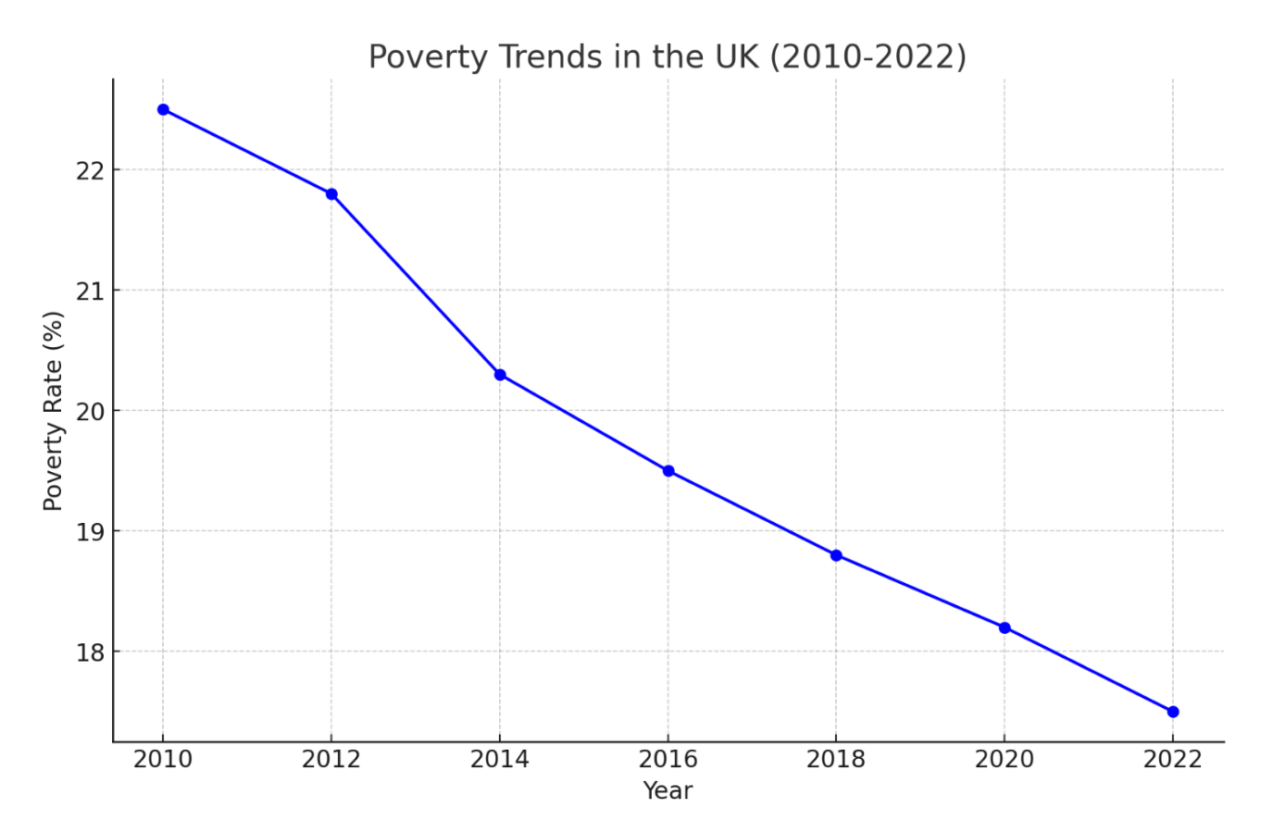
(google.UK)
Here is the graph depicting the poverty trends in the UK from 2010 to 2022.
Although the graph indicates a drop in the poverty rate for adult workers without children, inflation is essentially driving up the incidence of poverty for workers with families. This suggests that whereas certain groups of people are seeing gains in their financial security, others are dealing with difficulties that are pushing them deeper into poverty. To build a more just society, legislators must address these inequalities and put policies in place to assist disadvantaged families.(Sustainable Development Goals,2019)

Challenges
SDG 1 is still exceptionally troublesome for the UK to realize. Among them are:
Wage stagnation: When living costs rise speedier than pay development, it becomes more troublesome for those with basic salaries to meet basic needs. (Machin, 2024)
Insecure work: It has been noticed that contributing to pay uncertainty is the development of dubious business, which incorporates low pay and zero-hour contracts.
Welfare changes: A few individuals presently discover it more troublesome to get essential benefits as a result of alterations to the welfare system.
Recommendations
In arrange to combat poverty, the UK government has to take into account:
Mandating a better minimum wage to ensure decent pay for all workers is known as the "widespread living wage."
Increasing social housing ventures by developing more reasonable homes and raising the standard of living conditions. (Gertner, 2006).

Goal B: SDG 3 - Good Health and Well-being
Definition
Ensuring sound lives and advancing well-being for all ages is the objective of Good health and Well-being 3 (SDG 3) (United Nations, 2015). This incorporates empowering solid ways of life, anticipating and treating irresistible and non-communicable infections, and ensuring access to high-quality healthcare services.
UK Arrangements, Plans, and Activities
The United Kingdom government has organized numerous strategies aimed at upgrading wellbeing. There are two major projects:
Enhancing access to healthcare, cutting down on waiting times, and raising the standard of care advertised by the National Health Service (NHS) (NHS Britain, 2023).
Public wellbeing campaigns: To avoid infection spread and illnesses, the government provides awareness on how to protect ourselves like eating an adjusted count of calories, getting standard work out, and stopping smoking (Open Wellbeing Britain, 2023).

Critical Review
NHS Improvements:
Adequacy: By providing services to all, the NHS brings down barriers to treatment. In any case, accessing a healthcare may be limited by long hold-up times and asset deficiencies (The King's Support, 2023).
Benefits: Guaranteeing everybody has access to basic therapeutic care brings down well-being disparities.
Obstacles: The weight of a growing population and evolving healthcare needs is bearing down on the NHS. Furthermore, labour shortages in certain areas may impact access to particular services.
Campaigns for Public Health:
Effectiveness: According to the Department of Health (2010), public wellbeing campaigns can empower positive way of life changes and induce information of solid improvements. In any case, behavior adjustment is now and then complicated, and the long-term impacts may well be difficult to quantify.
Benefits: By avoiding persistent infections like cancer, diabetes, and heart disease, healthy lifestyle can reduce healthcare costs over time(WHO,2005).
Challenges: It can be troublesome to communicate with a group of people from different backgrounds. Broader arrangement mediations are crucial due to the significant influence of social and financial factors on well-being behaviors.

Progress made by UK
The UK has progressed in some SDG 3-related ranges. There has been a diminish in newborn child mortality and an increment in life hope (Office for National Measurements, 2023). In any case, there are still incongruities in well-being, with lower financial bunches having more regrettable well-being results (Marmot et al., 2020). Besides, the COVID-19 epidemic has brought consideration to the deficiencies within the healthcare framework and underlined the need for extra financing.
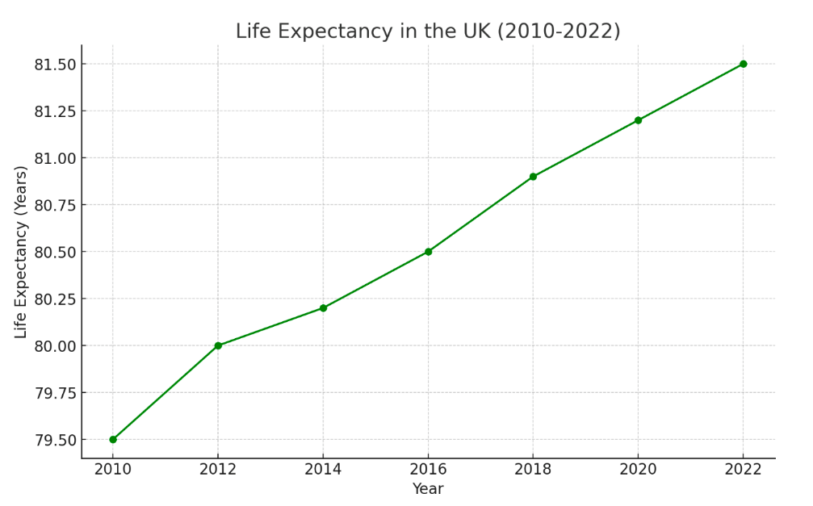
(Voluntary National Review of progress towards the Sustainable Development Goals,2019)
The graph shown above depicting life expectancy in the UK from 2010 to 2022.The graph is raising which showing decrease in the rate of mortality.

Obstacles
SDG 3 is still exceptionally troublesome for the UK to attain. Among them are:
Health inconsistencies: There's a diligent extending distinction in wellbeing results between different social classes. (Dolan,and Kind, 1996)
Mental wellbeing: Treatment waiting periods can be long, and mental well-being administrations are underfunded.
Lifestyle components: Illnesses that can be avoided are a result of unhealthy choices for instance smoking, eating ineffectively, and not exercising.
Reccomendations
In arranging for public health to be made strides, the UK government got to take into account:
Economic growth varies in contexts, with some being environmentally and socially damaging and others not. Understanding the interdependency between growth and long-term health is crucial for minimizing trade-offs. Further research is needed on income gains, employment, and health at higher development levels.(Chapman, et.al,2017)
By placing a strong emphasis on early diagnosis and public health initiatives, investing in preventative treatment can help reduce the burden of chronic illnesses. By encouraging healthy behaviours and routine examinations, people may take charge of their health and possibly prevent more significant health problems down the road. Over time, this proactive strategy can lower healthcare expenses and result in a generally healthier population.
Resolving financial determinants of wellbeing: Sanctioning laws that address homelessness, poverty, and the need to afford wholesome food, might improve common wellbeing results.
Enhancing access to productive treatment and expanding financing for mental wellbeing administrations are two ways to reinforce mental well-being care.Provide a bearable wage for all laborers by means of the Widespread Living Wage.
Enhanced Social Security Net: Offer more help to those that are most in need.
Invest in open wellbeing programs and early intercession in preventative healthcare.
Reducing health inequities and enhancing overall health outcomes require addressing social variables such as housing. We can establish a basis for improved physical and mental health by making sure people have secure and stable homes.
Improved Mental Wellbeing Administrations: Grow treatment choices and budgetary support. Enhance accessibility to mental health resources and promote community awareness and education on mental health issues.

Conclusion
Reducing poverty and improving health outcomes are two areas where the UK has achieved noteworthy progress towards reaching SDG 1 and SDG 3. Constant problems, however, need for continuous work and innovative solutions. To ensure a better and more sustainable future for all citizens, the UK can move closer to accomplishing these important SDGs by tackling health inequities, improving mental health services, strengthening social security networks, and encouraging sustainable employment. Investments in education and programmes for skill development can also contribute to ending the cycle of poverty and enhancing general wellbeing.
While they have certain downsides, current activities just like the Living Wage and open well-being campaigns have certain crucial points. To fulfill these SDGs, the UK ought to think about enacting laws that support income equality and fair pay, funding public health and education, and encouraging environmentally responsible business practices in order to achieve these SDGs. Partnerships with other nations and organizations can also facilitate the sharing of resources and expertise needed to accomplish these objectives globally.

Reference List
Bond,2022.The UK’s global contribution to the Sustainable Development Goals.Progress, gaps and recommendations
Carter, K. and Fortune, C., 2007. Sustainable development policy perceptions and practice in the UK social housing sector. Construction Management and Economics, 25(4), pp.399-408.
Department of Health. (2010). Change4Life: A national healthy weight campaign. https://www.nhs.uk/healthier-families/about-and-contact/
Dolan, P. and Kind, P., 1996. Inconsistency and health state valuations. Social Science & Medicine, 42(4), pp.609-615.
Flinter, D., & Keyes, C. L. M. (2012). Well-being and its measurement. Social Indicators Research, 106(1), 53-77. https://link.springer.com/book/10.1007/978-94-007-2421-1
Foundation for Democracy and Sustainable Development. Available at: (https://www.fdsd.org/the-challenge/what-is-sustainable-development/).Accessed on: 02/06/2024
Fund, S., 2015. Sustainable development goals. Available at this link: https://www. un. org/sustainabledevelopment/inequality.
Gertner, J., 2006. What is a living wage?. New York Times Magazine, 15.
Griggs, D., Nilsson, M., Stevance, A., & McCollum, D. (2014). Policy coherence for the SDGs: Sustainable development goals good health and well-being. Sustainability, 6(8), 4681-4702. https://www.mdpi.com/sdg/goal17
Helliwell, J. F., & Saxton, J. (2014). World happiness report 2014. Sustainable Development Solutions Network. https://worldhappiness.report/
Joseph Rowntree Foundation. (2022). UK Poverty 2022: The essential guide to understanding poverty in the UK. https://www.jrf.org.uk/uk-poverty-2022-the-essential-guide-to-understanding-poverty-in-the-uk
Howden-Chapman, P., Siri, J., Chisholm, E., Chapman, R., Doll, C.N. and Capon, A., 2017. SDG 3: Ensure healthy lives and promote wellbeing for all at all ages. A guide to SDG interactions: from science to implementation. Paris, France: International Council for Science, pp.81-126.
Johnson, M., 2017. Implementing the living wage in UK local government. Employee Relations, 39(6), pp.840-849.
Living Wage Foundation. (2020). Living Wage benefits report 2020. https://livingwage.org.uk/
Living Wage Foundation. (2023). Living Wage rates. https://livingwage.org.uk/
M Johnson, A Koukiadaki, D Grimshaw,2019. Transfer: European Review of Labour and Research -journals.sagepub.com
Machin, S., 2024. Wage controversies: real wage stagnation, inequality and labour market institutions. LSE Public Policy Review, 3(2).
Marmot, M., Allen, J., Goldblatt, P., Herd, E., Morrison, J., & National Institute for Health and Care Excellence Centre for Reviews and Dissemination. (2020). Build Back Fairer: The COVID-19 Marmot Review. The Pandemic, Socioeconomic and Health Inequalities in England. Institute of Health Equity. https://www.instituteofhealthequity.org/resources-reports/build-back-fairer-the-covid-19-marmot-review
McConnel, A. (2016). The impact of the national living wage on employment: A review of the literature. Resolution Foundation. https://assets.publishing.service.gov.uk/media/5c52d516e5274a492912eb62/The_impact_of_the_introduction_of_the_NLW_on_employment__hours_and_wages__NIESR.pdf
National Housing Federation. (2023). Why we need social housing. https://www.housing.org.uk/resources/why-we-need-a-long-term-plan-for-housing/
New Economics Foundation. (2010). The well-being economy. https://neweconomics.org/campaigns/wellbeing
NHS England. (2023). The NHS Long Term Plan. https://www.longtermplan.nhs.uk/
Office for National Statistics. (2023). Health and life expectancy. https://www.ons.gov.uk/peoplepopulationandcommunity/birthsdeathsandmarriages/lifeexpectancies
Omer, A.M., 2008. Energy, environment and sustainable development. Renewable and sustainable energy reviews, 12(9), pp.2265-2300.
Priemus, H. and Smith, J., 1996. Social housing investment: Housing policy and finance in the UK and the Netherlands, 1970–1992. Netherlands journal of housing and the built environment, 11(4), pp.401-419.
Public Health England. (2023). Better Health campaigns. https://www.gov.uk/government/news/new-campaign-launch-reveals-six-major-health-benefits-to-losing-weight
Purvis, B., Mao, Y. and Robinson, D., 2019. Three pillars of sustainability: in search of conceptual origins. Sustainability science, 14, pp.681-695.
Sachs, J. D. (2015). The age of sustainable development. Columbia University Press.
SDG UK Government Statistical Data. Available at: https://sdgdata.gov.uk/1/. Accessed on 07/07/2024.
Shelter. (2023). Homelessness in England. https://england.shelter.org.uk/media/press_release/at_least_271000_people_are_homeless_in_england_today
The Economy/Inequality in UK,2019.Poverty in the UK: a guide to the facts and figures. Available at: https://fullfact.org/economy/poverty-uk-guide-facts-and-figures/. Accessed on:14/07/2024.
The King's Fund. (2012). Well-being and the future of health and social care.
The King's Fund. (2023). The NHS waiting times crisis in England. https://www.kingsfund.org.uk/insight-and-analysis/blogs/nhs-waiting-times-symptom-of-health-service
United Nations. (1987). Our Common Future. Report of the World Commission on Environment and Development. https://sustainabledevelopment.un.org/content/documents/5987our-common-future.pdf
United Nations. (2015). Transforming our world: the 2030 Agenda for Sustainable Development. https://sdgs.un.org/2030agenda
Voluntary National Review of progress towards the Sustainable Development Goals. June 2019 United Kingdom of Great Britain and Northern Ireland. Available at: https://assets.publishing.service.gov.uk/media/5d2f3d6aed915d2feeac49f4/UKVNR-web-accessible1.pdf. Accessed on 24/06/2024.
World Health Organization and Public Health Agency of Canada, 2005. Preventing chronic diseases: a vital investment. World Health Organization.
Yuesti, A., Rustiarini, N.W. and Suryandari, N.N.A., 2020. Financial literacy in the COVID-19 pandemic: pressure conditions in Indonesia. Entrepreneurship and Sustainability Issues, 8(1), pp.884-898.
Zavyalova, E.B. and Krotova, T.G., 2021. Methods for achieving SDG 1, poverty eradication. In Modern Global Economic System: Evolutional Development vs. Revolutionary Leap 11 (pp. 1987-2001). Springer International Publishing.

