BA International Hotel Management
Module: Food and Beverage Operations
Module code: BMIH4002
Assignment Title: Menu Engineering
Lecturer: Rohan Dudrey

Student name: Mohammad Assadujjaman
Student ID: 2207975

Contents
Starter 2
Main 3
Dessert 4
Drinks 4
References 5

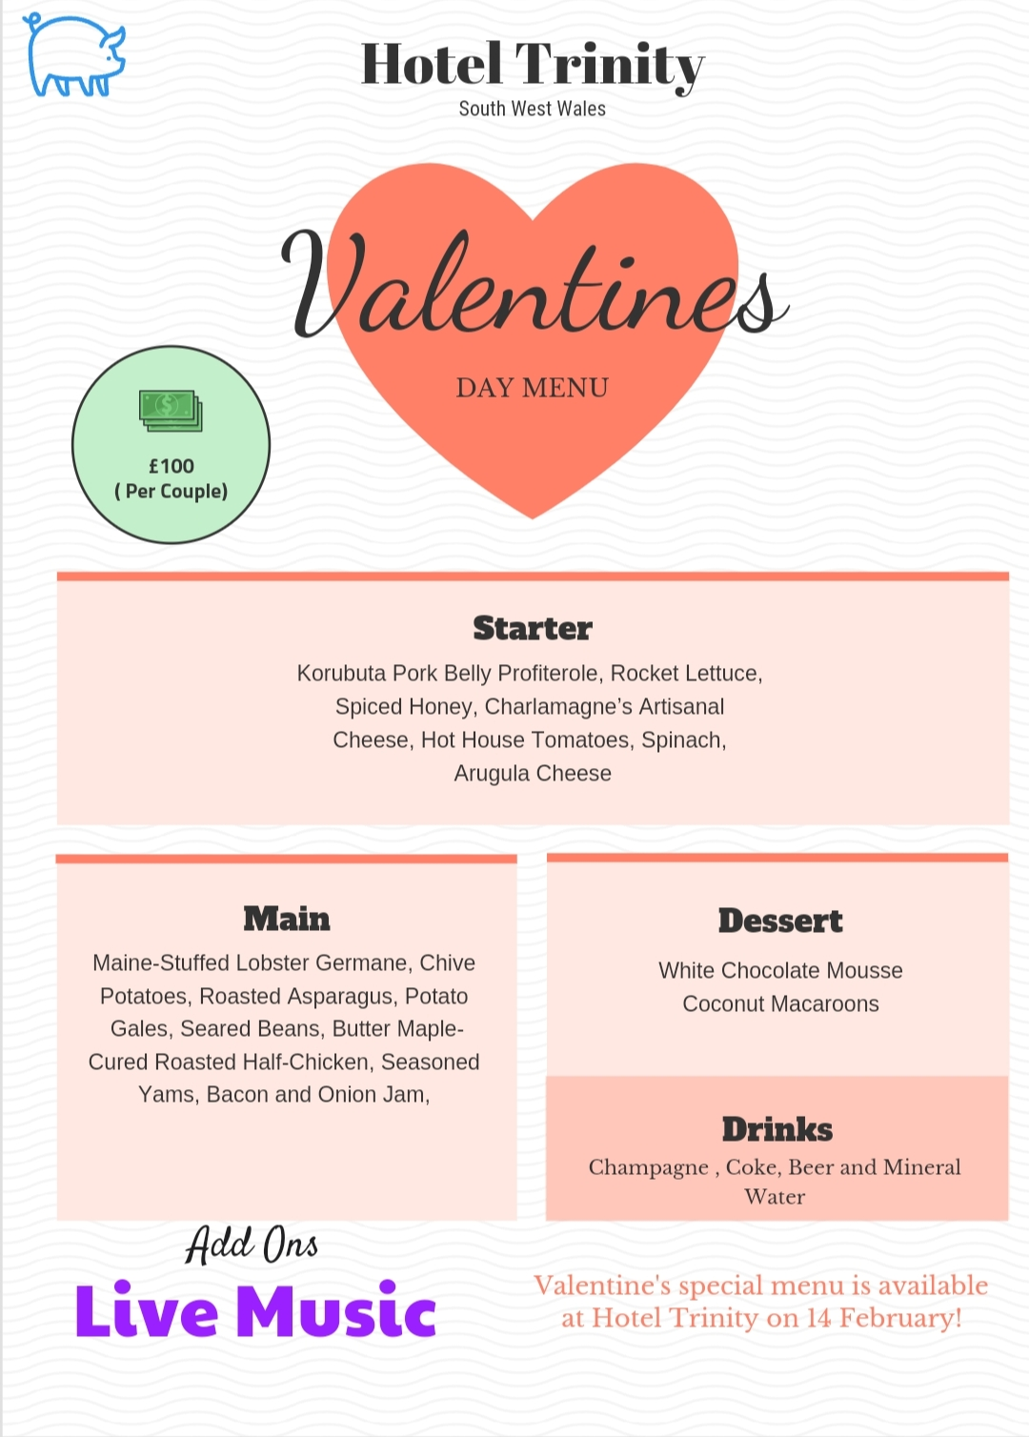Source: Canva-pro

Starter
Dish Name | Food Description | Ingredients | Allergic Reaction
Kurobuta pork belly Profiterole | Kurobuta pork belly Profiterole is extremely flavourful, soft, and juicy. The finest pork belly roast is made with our Kurobuta pork belly (FISH, 2019). | 100% United Kingdom Kurobuta Pork | Meat allergies are rare.
Rocket Lettuce | Rocket Lettuce has small, black leaves that are leafy in colour. It tastes smoky, peppery, and mustard-like. It mainly seen in salads (Spadafora et. al., 2016). | Lettuce, oil, balsamic vinegar and lemon. | Leaf allergies are uncommon.
Spiced Honey | Spiced in taste and Chili peppers with honey add heat. It has an unique flavour. | Natural | Quite uncommon.
Charlamagne’s Artisanal Cheese | Artisan cheese is handmade in small amounts using various traditional cheesemaking techniques. | Pasteurized cow milk, salt, herbs etc. | Milk allergies are frequent in new-borns and children.
Hothouse Tomatoes | Hothouse tomatoes are grown indoors. It is a heathy item. | Tomatoes and black pepper. | Uncommon
Spinach | Spinach is a common vegetable which surely make you feel good (Donovan, 2017). | Spinach and salt | Uncommon
Arugula Cheese | Arugula Cheese is commonly used in making food salad | Pasteurized cow milk, salt, starter culture, herb blend 2.4% (fresh arugula, garlic, tomatoes), microbial rennet. | Common

Dish Name | Food Description | Ingredients | Allergic Reaction
Maine-Stuffed Lobster Germane | For an appealing seafood dish, stuff lobster tails with a mixture of lobster meat, Parmesan cheese, and buttery cracker crumbs (Benedict, 2014). | Lobster, Parmesan cheese and Buttery cracker crumbs. | May cause Allergy
Chive Potatoes | Very good, despite its simplicity. If you prefer white potatoes to red ones, feel free to swap them in. | Unsalted butter, small red potatoes, black pepper and fresh chives | Uncommon
Roosted Asparagus | Spring's best side dish is roasted asparagus. Additionally, it's easy to make while your main meal cooks. | Lemon zest, fresh mint, red pepper flakes, butter, thick balsamic vinegar and toasted sliced almonds | Butter and almonds may cause allergic reaction.
Potato Gales | Simple but very testy. It will melt your mouth with butter and soft potatoes. | Butter, parmesan cheese and potatoes. | Recipe may contain lactose and milk.
Seared Beans | Garlic-Sauteed Seared Beans are tasty and easy to make. | Seared beans, garlic and black pepper. | Uncommon
Butter Maple Cured Roosted Half-Chicken | Roasting a chicken in the oven with melted butter and basting it with the characteristic autumn tastes of maple and rosemary ensures a juicy and tender end result (Berry, 2013). | Half-Chicken, Butter, maple and rosemary. | Butter may cause allergic reaction.
Seasoned Yams | This blend of spices is perfect for sprinkling on baked, roasted, or mashed sweet potatoes, or for seasoning yam fries. | Paprika, yams, brown sugar and white peeper. | Non-allergic
Bacon and Onion Jam | Even if you're not a fan of the more unusual flavours of preserves, you should give Onion Bacon Jam a shot. The unique and delicious preserve will satisfy your craving for something special. | Onion, Shallots, Sauce and Bacon | Non-allergic

Main

Dessert

Dish Name | Food Description | Ingredients | Allergic Reaction
White Chocolate Mosses | Do you think it's tough to whip up a delicious mousse? Ignore the notion! Made with cream cheese instead of eggs, this white chocolate mousse is indeed a simple dessert that's good for any occasion. Mousses, whether sweet or savoury, get their airy structure from a whipped component (often cream or eggs) (Larmour et. al., 2010). | Whipping cream, eggs, white chocolate, cream cheese, sugar and salt | Milk allergies are frequent.
Coconut Macaroons | These are the best coconut macaroons I've ever had: chewy and tender on the inside, but crisp and golden on the outside. | Condense milk, whip cream, coconut, sugar and egg white. | Milk allergies are frequent.

Drinks
Dish Name | Food Description | Ingredients | Allergic Reaction
Veuve Clicquot Yellow Label  (Champagne) | Two-thirds of the grapes in this dry Champagne are black (Pinot Noir and Pinot Meunier), providing weight, with one-third Chardonnay providing balance and elegance. It has the colour of a golden Champagne and has a beautiful, sustained sparkle. | Champagne is only prepared from chardonnay, pinot noir, and pinot Meunier, all white grapes. | May cause allergic reaction.
Coke | Cola is a type of carbonated soft drink that has many flavours added to it. | Carbonated water, high fructose corn syrup, phosphoric acid, natural flavours, and caffeine. | Contains Caffeine
Blossom hill  (Wine) | Delicate flavours of strawberry, cherry, and watermelon are wonderfully complemented by exquisite floral notes in this fresh and refreshing rose, making for a tasty and satisfying final product (Maguire, 2018). | Bloom | Contains Sulphones

References
Spadafora, N.D., Amaro, A.L., Pereira, M.J., Müller, C.T., Pintado, M. and Rogers, H.J., 2016. Multi-trait analysis of post-harvest storage in rocket salad (Diplotaxis tenuifolia) links sensorial, volatile and nutritional data. Food Chemistry, 211, pp.114-123.
Donovan, S., 2017. Does an Apple a Day Keep the Doctor Away? And Other Questions about Your Health and Body. Lerner Publications™.
FISH, F., 2019. TALES.
Benedict, J.C., 2014. The Blue-Ribbon Cook Book. University Press of Kentucky.
Berry, W., 2013. The Kentucky Barbecue Book. University Press of Kentucky.
Larmour, I.A., Faulds, K. and Graham, D., 2010. Rapid Raman mapping for chocolate analysis. Analytical Methods, 2(9), pp.1230-1232.
Maguire, J.S., 2018. Wine, the authenticity taste regime, and rendering craft. In The organization of craft work (pp. 60-78). Routledge.

