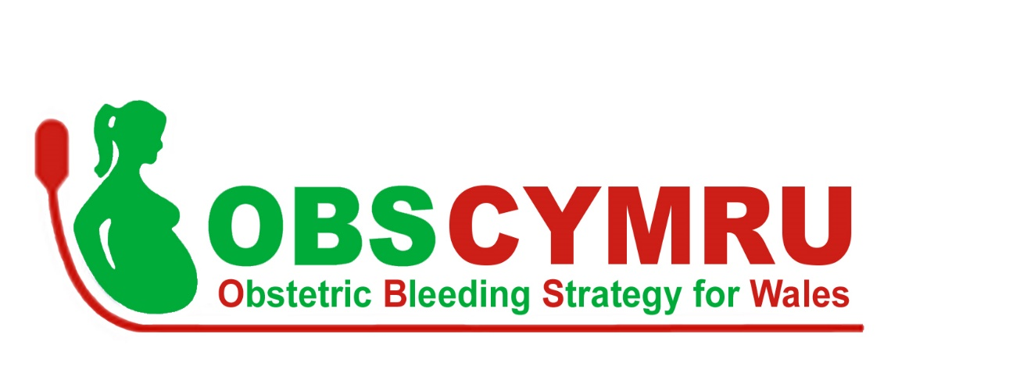

Student Name: Dr Cerys Scarr

Student Number: 1812509

Assignment Title: Sustainability of the Obstetric Bleeding Strategy for Wales (OBS Cymru)
Leading Service Improvement Project

Module Number: BMPF7058

Institution: University of Wales, Trinity St David

Word Count: 6427

 | Page
Project Proposal | 3
Project Report | 7
Background | 7
Leadership Roles | 7
What is OBS Cymru? | 8
Patient and Service Impact | 10
Methodology: Leading Sustainability in PPH Management | 12
Establishing Key Factors | 12
Monitoring Change | 13
Leading Infrastructure Change | 14
Challenge | 14
Kotter’s Change Model | 14
Personal Learning | 18
Leading Involvement & Training | 19
Challenge | 19
Engaging for change | 20
Organisational Culture | 21
Influencing for Change | 21
Personal Learning | 22
Conclusion | 23
References | 24
CONTENTS PAGE

PROJECT PROPOSAL
Sustainability of the Obstetric Bleeding Strategy for Wales (OBS Cymru)

Introduction
OBS Cymru is an All Wales quality improvement project aiming to reduce the impact of postpartum haemorrhage (bleeding after childbirth) on maternal morbidity and mortality. Commencing in April 2016 this project is reaching the end of its implementation phase. As the current Welsh Clinical Leadership Fellow, it is my role to ensure that the project is embedded into routine clinical practice ensuring future sustainability.

This project proposal will briefly review important factors enabling a service improvement project to become sustainable and the practical activities I plan to undertake with the wider team to improve the chances that OBS Cymru achieves this.

OBS Cymru
OBS Cymru is a complex clinical intervention, devised by a multiprofessional team, incorporating evidence-based best practice in management of a woman experiencing postpartum haemorrhage. The intervention consists of four components:
- Risk assessment for haemorrhage
- Cumulative, objective measurement of the blood loss at every birth to identify early the women who require targeted therapy
- Multidisciplinary team presence at the mother’s bedside with management guided by measured blood loss and clinical assessment
- Point of care testing of blood clotting and haemoglobin to inform blood product replacement through an evidence-based algorithm

Through an extensive implementation phase, the OBS Cymru intervention has now been adopted by all 12 obstetric units in Wales. The project was registered locally with each health board’s clinical governance department and a national data sharing agreement was signed by representatives including their Caldicott Guardian covering implementation and sustainability. The ethics committee was consulted with no formal ethical approval being required.

Project funding was via an Efficiency Through Technology grant (Welsh Government), 1000 Lives Improvement and Werfen (industry partner). This funding and formal support from all Welsh health boards ended on 31st March 2019.

Initial patient-reported and clinical outcomes of the project are encouraging suggesting reduced variation in practice between units and improving incidences of maternal morbidities including postpartum haemorrhage of more than 2.5 litres, blood product transfusion and intensive care admission. A full description of these outcomes is awaited but significantly they align with the prudent healthcare principles as outlined in ‘A Healthier Wales’ (Welsh Government 2019)

Sustainability model
With clear clinical benefits, it is essential that this good practice is embedded and continued. There is a risk to the project that with time there is ‘improvement-evaporation’ (NHS Institute 2007) whereby benefits wane after formal project end. This is particularly concerning when financial support, used to implement and maintain the technological innovation, is withdrawn from units.

To ensure that the project has the best chance of becoming securely embedded in clinical practice and adaptive to local needs, I have researched sustainability models. Using the NHS Improvement sustainability model and guide (2010) as a diagnostic tool has been invaluable. The tool outlines evidence-based factors key to sustaining change and highlights areas that require attention. I have completed self-assessment of these factors which broadly fit into 3 themes: staff (purple), process (green) and organisation (blue) factors (figure 1).
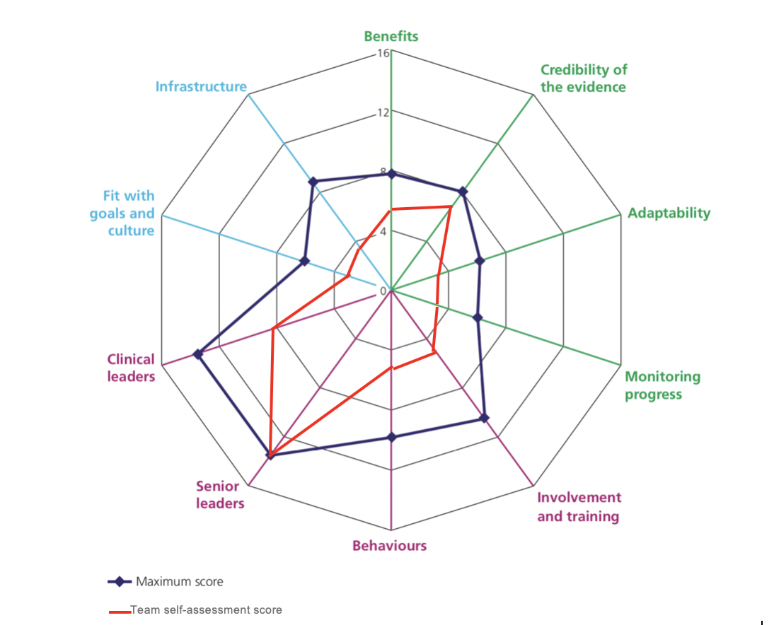
Figure 1: Portal diagram of sustainability factor self-assessment

I have used this model to target activities but also in emphasising the importance of a more robust sustainability assessment through the completion of this tool by a variety of team members. As such one of my first actions will be to repeat this exercise with the wider stakeholder network of clinical teams, senior leaders and OBS Cymru national team to ascertain whether there is discrepancy in scoring of factors. My self-assessment portal diagram highlights factors which have greatest potential for improvement gains and has identified two areas to focus my future activities: infrastructure and involvement & training.

Infrastructure
The greatest challenge facing the project is funding to retain the technology essential to continue point of care testing. I will develop a cost-effectiveness analysis to inform the business case for this technology. This will then be discussed with Welsh Government and Heads of Midwifery Group to request that technology be funded centrally. If this does not progress that we will have developed the business case to submit within each health board’s finance structures.

Involvement and Training
Training on the OBS Cymru approach currently occurs through the health board’s regular skills and drills sessions, facilitated by OBS Cymru champion midwives. From October 2018, obstetric emergencies training will be standardised through the commissioning of PROMPT (Practical Obstetric Multi-Professional Training) Wales. This training package is to be delivered by local multi-professional faculty to all maternity staff in Wales by March 2020. Postpartum haemorrhage management is included in this training but in a different format to that encouraged by OBS Cymru. It is essential for project sustainability that these training materials are adapted to ensure that they align with OBS Cymru. As such, I will work with the PROMPT Wales national team to adapt their obstetric haemorrhage and critical care scenarios, textbook material and develop training videos to reflect OBS Cymru management for faculty who may not have previously taught this approach.

Success Criteria
Through this project proposal I have outlined how the team plan to approach sustainability of OBS Cymru beyond April 2019. Monitoring success will be through both process and outcome measures. Process measures will include presence of a point of care testing device on each obstetric unit, a cost-effectiveness plan outlining funding of the device and ongoing staffing and consumable costs, ongoing measurement of blood loss in all deliveries in Wales, and presence of OBS Cymru in the PROMPT Wales programme. Outcome measures will be those of the OBS Cymru project including incidence of haemorrhage over 2.5 litres, intensive care admissions, blood product transfusions and hysterectomy rate. If these outcome measures display sustained or continued improvement then these initial sustainability interventions will be considered effective in ensuring the approach is embedded. The focus will then be directed to spread of this improvement outside Wales.

PROJECT REPORT

Sustainability of the Obstetric Bleeding Strategy for Wales (OBS Cymru)

Background

OBS Cymru, the Obstetric Bleeding Strategy for Wales, is an All Wales quality improvement project which aims to reduce the impact of postpartum haemorrhage (bleeding after childbirth) on maternal morbidity and mortality. Commencing in April 2016 and led by a multi-professional national OBS Cymru board, this project reached the end of its implementation phase on March 31st 2019. As the current Welsh Clinical Leadership Fellow, I joined the OBS Cymru board in May 2018 and have taken a number of formal leadership roles in the project, most prominently in planning future sustainability of the OBS Cymru project beyond the formal end date. Ensuring this approach to postpartum haemorrhage management (PPH) is embedded into routine clinical practice is essential given the improvements in care seen across Wales, which I will outline through this report.

Leadership Roles

My leadership responsibilities with OBS Cymru have taken various formats and were formalised into 3 key areas:

1. Leading the project sustainability plan

Leading the sustainability strategy and co-ordinating the activities required by the OBS Cymru national team to support individual obstetric units in Wales. This was to ensure that this new way of managing obstetric haemorrhage becomes the norm and that the positive impact seen on patient outcomes maintained.

2. Leading scale and spread of the project outside Wales

Using the high-profile recognition of OBS Cymru in securing an NHS Wales Award, being shortlisted for a Patient Safety Award and a highly commended place in the BMJ Awards to collaborate with influential national and international multi-professional groups. Broadening the reach of the project will increase the impact that this approach has on reducing harm and unnecessary intervention for mothers on a larger scale.

3. Leading local change, data collection and presentation

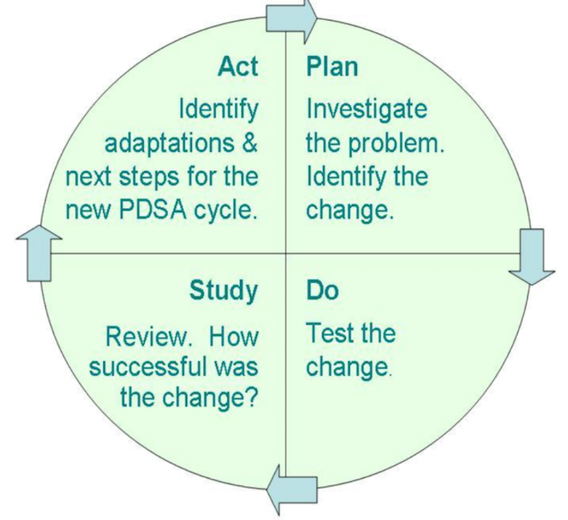
Continuing local obstetric unit team leadership in three health boards, following on from the activities of the previous Welsh Clinical Leadership Training Fellows. They had used a distributed leadership model (NHS Improving Quality, 2013) to enable local teams to adapt the OBS Cymru approach to suit their individual unit, empowering them with the tools to perform iterative plan-do-study-act cycles (Deming 1986) to test local changes
Figure 1: Plan-Do-Study-Act cycle (Deming 1986)

This report will focus on the first of these leadership responsibilities: strategic leadership of the project sustainability plan. The project proposal reviewed important factors enabling a service improvement project to become sustainable and the practical activities that I planned to undertake with the wider team to improve the chances that OBS Cymru achieves this. Here I will outline these activities, initial outcomes and my personal learning and reflection on the leadership models and theories that have been instrumental in achieving sustainability.

Improving clinical outcomes for women experiencing postpartum haemorrhage has required adaptability of my personal leadership style and an enhanced understanding of the organisational cultures that exist not only in maternity services in Wales but also in the teams and stakeholders with whom I collaboratively worked with through my post. Ultimately this work has been driven by my focus on how management of obstetric haemorrhage impacts on mothers and has been at the forefront of my mind when engaging others and developing and communicating this shared vision for how management of PPH should look. This patient centred approach is consolidated into the original project development and reiterated through the project outcome measures that were chosen based on what mattered to women about their care, and shared through public and patient engagement events

The project - What is OBS Cymru?

OBS Cymru is a complex clinical intervention, devised by a multiprofessional team, incorporating evidence-based best practice in management of a woman experiencing postpartum haemorrhage. The intervention consists of four components (figure 2):
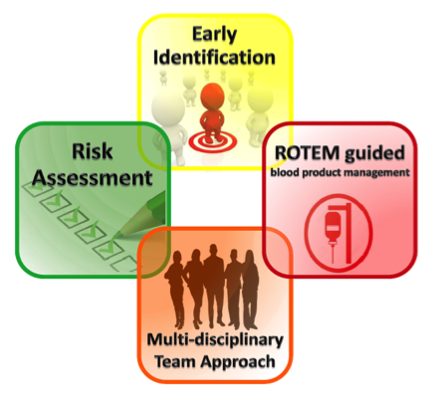
1. Risk assessment for haemorrhage
2. Cumulative, objective measurement of the blood loss at every birth to identify early the women who require targeted therapy
3. Multidisciplinary team presence at the mother’s bedside with management guided by measured blood loss and clinical assessment
4. Bedside testing of blood clotting and haemoglobin with a point of care testing machine (ROTEM) on each obstetric unit to inform blood product replacement
Figure 2: Four key pillars of OBS Cymru

Through an extensive implementation phase, the OBS Cymru intervention has now been adopted by all obstetric units in Wales supported by a national PPH guideline and paperwork guiding teams through sequential clinical actions during a PPH. There are approximately 31,000 maternities per annum across Wales in 12 obstetric units with significant variation in staffing levels, case mix, and size of unit ranging from 450 to 6000 births per year. In each of these units a local champion team of obstetrician, anaesthetist, haematologist and midwife supported the project and cascade trained maternity staff in the approach and the use of the ROTEM. The champion midwife was funded for 3.7 hours a week in support the project and collect data on process and outcome measures

The project was registered locally with each health board’s clinical governance department and a national data sharing agreement was signed by representatives including their Caldicott Guardian covering implementation and sustainability. A national database collecting information on all women experiencing a PPH greater than 1 litre was populated by champion midwives during their allocated time. The ethics committee at Cardiff & Vale University Health Board was consulted for advice with no formal ethical approval being required.

Project funding was initially through an Efficiency Through Technology grant (Welsh Government) supplemented by support from 1000 Lives Improvement and Werfen (industry partner who manufacture the point of care testing device). This funding and formal support from all Welsh health boards ended on 31st March 2019. Beyond this date the management of women experiencing postpartum haemorrhage is decided by local units including the decision of whether to support ongoing use of point of care testing devices and the associated algorithms and paperwork.

What is the patient and service impact of the project?

Postpartum haemorrhage is the leading cause of maternal mortality worldwide (WHO 2012) and was the cause of 18% of all direct maternal deaths in the UK between 2014-2016 (Knight 2018). Additionally, the Scottish Maternal Morbidity Enquiry recorded an increase in incidence of major postpartum haemorrhage with PPH contributing to 80% of all severe maternal morbidity (Lennox 2012). Baseline data in Wales suggested that there was significant variation in care and outcomes for women experiencing PPH with rates of intensive care admission, hysterectomy and blood transfusion varying widely between the 12 maternity units.

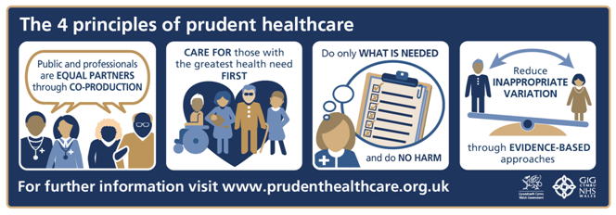
The overarching project aims were to reduce the number of women requiring blood product transfusion, intensive care admissions and hysterectomy due to PPH. Additionally there was a specific outcome measure to reduce the number of women experiencing a massive PPH of over 2.5 litres of blood loss, as at this stage maternal morbidity increases substantially (Lennox 2012).
Figure 3: Prudent Healthcare Principles (Bradley 2014)

These aims have a wider impact in aligning with Welsh Government (2014) prudent healthcare principles (figure 3) in having an evidence-based package of care reducing inappropriate variation, doing only want is needed and reducing harm by minimizing unnecessary blood product transfusions, conserving therapies (blood products and surgical intervention) for those who need it most, and considering outcomes important to women like intensive care admissions which involve separation from their baby.

A full description of project outcome measures will be published following completion of this phase of the project as they continue to be monitored following implementation, these will further support whether sustainability has been achieved. Initial patient-reported and clinical outcomes of the project are encouraging with reduced variation in practice between units and significantly reduced incidence of blood product transfusion, intensive care admissions and 2.5 litre postpartum haemorrhage at which maternal morbidity increases (Figure 4)

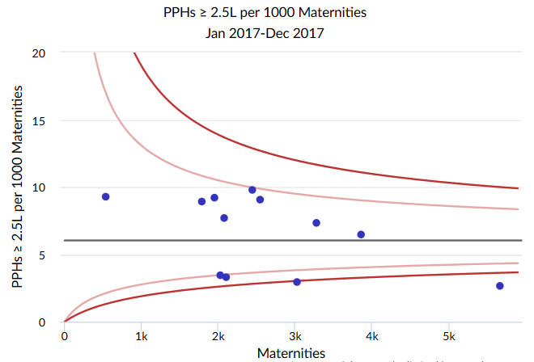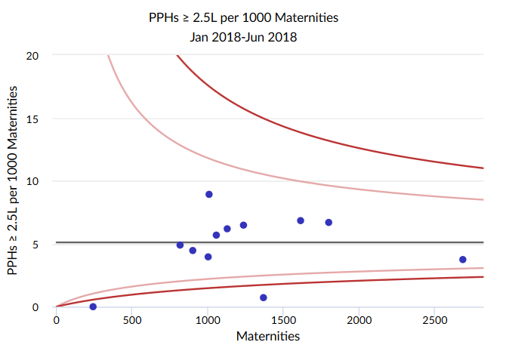
Figure 4 Incidence of 2.5 litre postpartum haemorrhage in Wales
a) January - December 2017 b) January - June 2018

Each blue dot is one of the 12 Welsh obstetric units. Arrow highlights reduced mean incidence of PPH.
Circle highlights reduced variation in PPH incidence between units with similar number of maternities now clustered around the mean.

Importantly in addition to this clinical impact there has been a marked difference in the multi-disciplinary team working in each of the units with qualitative staff surveys indicating 100% of staff felt that their management of PPH had improved and that there had been a change in culture from estimating to measuring blood loss and that this had positively impacted on effective escalation and team working. I also undertook a patient survey which revealed that women universally felt supported by the multiprofessional team and that they were listened to during their experience of postpartum haemorrhage. The majority also highlighted the importance of seeing how calm and professional the team were.

Methodology: Leading sustainability in PPH management

Establishing key sustainability factors
With such key patient, staff and health service benefits being seen it was apparent that these new ways of working and the improved outcomes needed to become the norm. There is a risk to any project that with time there is improvement-evaporation whereby benefits wane after the formal project end date and in a number of studies it has been shown that around 33% of improvement projects revert to previous ways of working after the project formally ends (NHS Institute 2007). This was particularly concerning with sustainability of OBS Cymru when financial support, used to implement and maintain the technological innovation, was being withdrawn from units from April 2019. Sustainability of OBS Cymru needed effective preparation and a strategic plan.

This led to a literature review and discovery of the NHS Improvement sustainability model and guide (NHS England 2010). This a self-assessment diagnostic tool which asks a number of detailed questions and outlines evidence-based factors key to sustaining change and highlights areas that require specific attention. These sustainability factors broadly fit into 3 themes: staff (purple), process (green) and organisation (blue) factors (figure 5).
Figure 5: OBS Cymru national team portal diagram of sustainability factor self-assessment

To ensure a robust sustainability assessment, the questions were completed by a number of OBS Cymru national team members and the aggregated self-assessment is seen in the portal diagram (red line). This diagrammatic representation is supported by a supplementary report highlighting the specific factors which have greatest potential for improvement gains for OBS Cymru and identified two key areas to focus future activities and some questions to trigger the necessary actions: Infrastructure and Involvement & Training (Table 1). Through the rest of this report I will describe the sustainability activities undertaken in these workstreams and the leadership models and theories I have identified and applied to effect change in these areas.
Infrastructure | Are there facilities and equipment to support the new process?  Are there policies and procedures supporting the new way of working?
Involvement & Training | Is there a training and development infrastructure to identify gaps in skills and knowledge?  Are staff educated and trained to take the change forward?
Table 1: Key sustainability factors and questions to direct activities (NHS Institute 2007)

Monitoring change
There is a significant lag time in seeing sustained improvement in clinical outcome measures such as hysterectomy and intensive care admissions as they are thankfully rare and therefore not as useful to track and monitor project implementation or continued patient impact. Incidence of 2.5 litre PPH, intensive care admissions, blood product transfusions and hysterectomy will be the sustainability outcome measures that indicate whether improved care has become the norm but this will not be apparent until early 2020 when annual data from 2019 is collated and reviewed. Success of the sustainability strategy will therefore be monitored through process measures in each of the three key domains with an understanding that if the process is understood and is reliable then the outcomes are more likely to be consistent (Table 2)
 | Process Measures
Infrastructure | 1. Cost effectiveness plan for project  2. Business case incorporating cost-effectiveness plan  3. Summary event linking local teams to wider stakeholders  4. Presence of point of care device on each unit after April 2019
Involvement & Training | 1. Ongoing teaching of approach through a national strategy and local implementation with associated resources

Table 2: Process measures as success criteria for sustainability of OBS Cymru

Leading infrastructure change
Are there facilities and equipment to support the new process?
Are there policies and procedures supporting the new way of working?

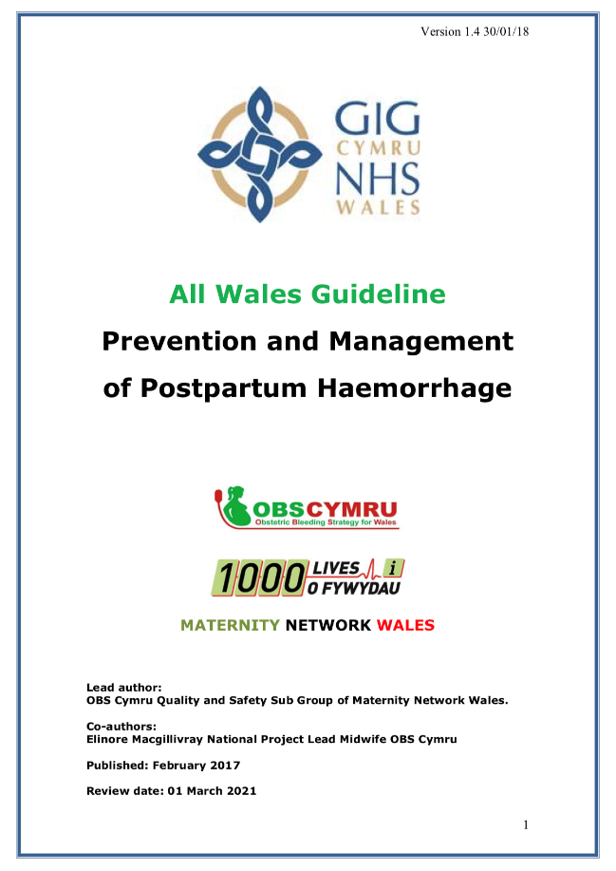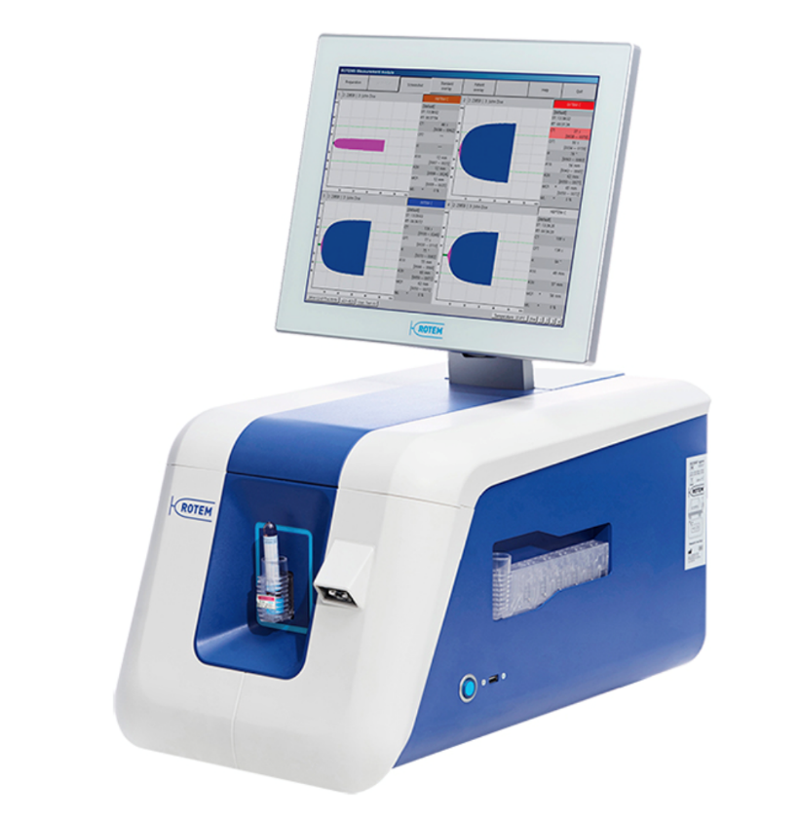

Challenge
The greatest challenge facing the project was funding to retain the technology essential to continue point of care testing. As outlined the project funding stream including subsidised ROTEM costs were being discontinued at the end of March 2019. After this point the decision to provide this technology, consumables and standardised quality control would be with each of the seven health boards in Wales. The policies and procedures in which the management principles and ROTEM algorithms were embedded were already ratified by the senior clinical multiprofessional leadership group, Wales Maternity Network and would be available for health board use after the project end date. Focus was required to ensure that there was a robust plan for funding and that the individual obstetric units were aware of this change from national project board to local leadership of their devices.

Kotter’s 8 Step Process

Using Kotter’s eight step process for leading change was an effective tool for structuring the changes required to ensure units took over the leadership of their ROTEM devices and that there were financial plans in place to support ongoing use. This model ensured that I had thoroughly developed the sense of urgency and a coalition of interested team members before tackling the barriers for change and overcoming these with influencing techniques and practical application of cost-effectiveness planning. Throughout this process there was the potential for two different funding streams; a national procurement plan securing a commitment from Welsh Government to purchase the devices for each obstetric unit or through the development of separate business cases in each health board.
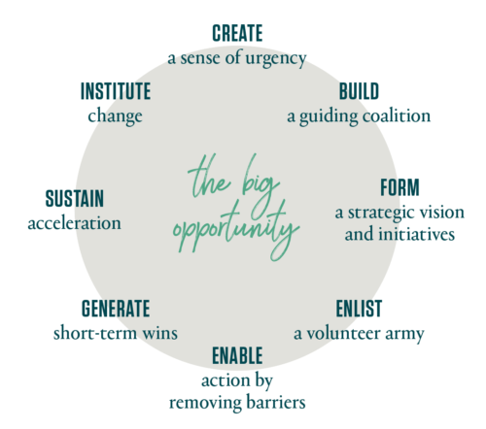
Figure 6: 8 step process for leading change (Kotter 1986, 2014)

Create a sense of urgency
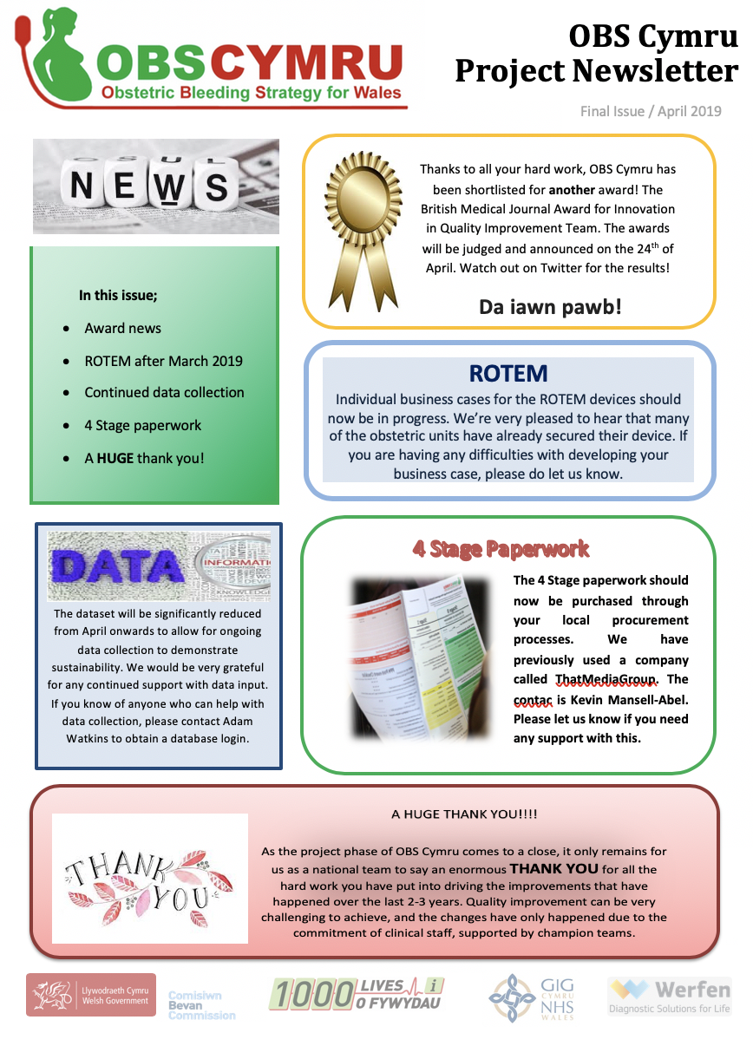
Building a sense of urgency was essential in the early phase of my involvement in the project and was aided by having the time pressure of funding withdrawal for the ROTEM devices in March 2019. This window of opportunity to focus attention was essential in engaging local teams in retaining their bedside test. As a national project team, we decided to focus on the ROTEM device as the key component to creating a sense of urgency as paperwork and training required limited financial input and were not as big a challenge to retain. I communicated widely about the threat of losing the ROTEM device through one-to-one conversations with champion teams in each obstetric unit, OBS Cymru newsletters with updates and posters in each unit. Alongside mentioning the ROTEM funding I also celebrated successes of the project through awards won and promoted the key role local teams were playing in successes and the patient impact.

I communicated the need for developing a local business case rather than relying on the possibility of central funding as I felt that there needed to be local ownership and leadership to continue to manage the devices. The distributed leadership model (Ham 2014) utilised by previous Welsh Clinical Leadership Fellows had been effective when used for change cycles in each obstetric unit and this model had resulted in local teams being effective at making decisions and in developing local changes.

Build a guiding coalition
Although there was a multi-professional champion team identified in each unit, I first met or contacted the key person in each champion team who had taken leadership of the ROTEM machine training, ordering of consumables and who was seen as a ‘super-user’ by the obstetric unit. I felt that these individuals were the most likely to feel strongly about retaining the technology and had the best understanding of local barriers and enablers to retaining the device. Most of these individuals were the champion anaesthetists, in some units operating department practitioners (ODP), and many had already contacted the industry partner to elucidate future plans without requiring national team input.

Form a strategic vision and initiatives
These individuals were asked to identify how procurement of devices happened in their health board, acquire the business case paperwork, identify key individuals to engage in the task and communicate their plan with the rest of the champion team. I also suggested that they work with the other champion teams to avoid duplication of common tasks. These champions were encouraged to explain in their business case the specific difference in blood product usage that they had seen in their unit and the patient impact of minimising blood product transfusion. This was particularly pertinent given the timing of the Infected Blood Inquiry (Langstaff 2019) and the heightened awareness of transmission of blood borne infections which could be avoided if unnecessary transfusions were reduced.

Alongside these local plans, I developed the national strategy with the OBS Cymru board to support units. This included liaising with Cardiff & Vale University Health Board finance directors to negotiate ongoing costings with Werfen, Welsh Government to assess whether ongoing support for the device would be supported through the national evidence-based procurement board, and CEDAR (Healthcare Technology Research Centre, Cardiff) to develop economic modelling for the project.

Enlist a volunteer army
With a guiding coalition of champion teams and identified leads in each unit I then organised a national event bringing together key people from each health board. Multi-professional health board teams were introduced to their point of care testing managers, quality improvement leads, Werfen representatives, finance teams and senior clinical leaders such as Heads of Midwifery and Clinical Directors who would be able to progress the OBS Cymru approach at formal project cessation. Additionally, the Chief Nursing Officer was invited to open the event, giving us the opportunity to promote the project and how she could support us in maintaining the positive patient impact seen.

Enable action by removing barriers
The largest barrier to change was the champion team’s ability to develop a cost-effectiveness analysis for their health board. To deal with this barrier I worked with CEDAR, a healthcare technology assessment unit based at Cardiff & Vale University Health Board to develop an economic model. I developed this model with a researcher at CEDAR who had experience of evaluating complex interventions. The new programme costs were inputted focussing on the point of care device procurement, maintenance, calibration and testing, consumables and also incorporating staff time for training, performing the test and analysing results. Using the known reduction in costs associated with intensive care admissions, blood products and reduction in hospital stay we were then able to generate a cost per patient experiencing a PPH and model the savings for each unit. This model was adaptive and acknowledged the difference between obstetric units in their total number of maternities and therefore cost per use. We demonstrated that for all obstetric units in Wales, it was cost-effective to retain the technology with a cost-benefit in the units with a larger number of maternities.

This analysis was based on the subsidised costs offered by Werfen during the project period, so I then negotiated this rate further with Werfen to ensure this cost benefit was retained and could be used in the local business cases to support retention of ROTEM devices. This information was also included in a bid to the Welsh Government Evidence-Based Procurement Board but they rejected the application on the basis that health boards should be able to procure the devices locally given the cost-effectiveness seen and that they if necessary and requested by all health boards that they could offer support for co-ordinating contracts.

Generate short term wins
The short-term win was that we negotiated an ongoing discounted rate from Werfen for the rental and maintenance of ROTEM devices which enabled local teams to input much lower costs into their business case. Additionally, the work I had done to engage with Welsh Government senior clinical leaders resulted in the release of a Welsh Health Circular from the Chief Nursing Officer. This asked that health boards ensure that the OBS Cymru approach to PPH management continued to be embedded into routine practice following project cessation. There was a stated expectation that health boards would continue to support full implementation of the project including bedside test technology, paperwork and data collection.

Sustain acceleration
The impetus generated from the Welsh Health Circular gave champion teams a greater ability to negotiate with finance teams and their directorates to ensure that it was successful.
Having such high-level support changed the dynamic and was very powerful in ensuring that each obstetric unit in Wales now has a ROTEM device and a plan for funding of consumables and training from the industry supplier Werfen.

Institute changes
Each obstetric unit in Wales now has a ROTEM machine located on their delivery suite and a plan for ongoing funding. Developing the local champions through the method of disseminated leadership has been essential in enabling them to progress their own business cases. Local ownership with national team support to remove barriers has ensured that units have now taken over the running of their own with gradual withdrawal our national board level of support so enabling sustained change through empowered teams.

Personal Learning
Working through Kotter’s 8 steps to leading change was an effective method for leading change and led to the development of the individual health board business cases which were successful in ensuring that each unit now has a ROTEM device in situ and an ongoing plan for funding. Even though this fulfilled the sustainability success criteria, I felt frustrated that I was unable to secure an all Wales technology procurement plan despite best efforts to engage with appropriate stakeholders. Through the professional coaching I had alongside the medical leadership programme I was able to work through these frustrations by using the Circle of Concern and Influence (Covey 1989).

This model (figure 7) describes that you may have various issues within your circle of concern but there may be very little that you can do about them as they are outside of your influence. Within this circle of concern is your circle of influence which you can do something about. By focussing energies in this area, you are more likely to be able to effect change.
Understanding this enabled me to act more effectively in leading this change. I was able to
extend my circle of influence further by engaging with the industry partner, Werfen, and Welsh Government such that even though there isn’t an All Wales procurement strategy, there is now a national statement of intent that implores health boards to implement the project in its entirety including the bedside test technology which has a negotiated subsidised pricing structure.
Figure 7: Circle of Concern & Influence (Covey 1989)

Leading Involvement & Training

Is there a training and development infrastructure to identify gaps in skills and knowledge?
Are staff educated and trained to take the change forward?

The Challenge
During the OBS Cymru project the training of the multi-professional maternity team has been through regular skills and drills teaching which occurs within each health board and also at undergraduate level for student midwives. The arrangement of such training is determined locally with each member of maternity staff having annual scenario-based simulation of a variety of obstetric emergencies including postpartum haemorrhage. PPH drills are facilitated by the local champion supported by materials developed by the national project team to ensure consistency. These resources include training videos, mock blood loss stations, practice paperwork and standardised scenarios. Alongside this ad hoc training sessions on obstetric units are provided by the champion midwife, in their allocated OBS Cymru time, to troubleshoot and analyse PPH critical incidents. Originally the plan for training after the loss of allocated champion midwifery time was that all staff would continue to engage in the regular skills programme supported by the existing materials and facilitated by local faculty with experience in teaching the approach alongside champion midwives but also in its real-life use.

From October 2018 obstetric emergencies training in Wales was standardised through the commissioning by Welsh Risk Pool of PROMPT (Practical Obstetric Multi-Professional Training) Wales. This programme of training was developed in Bristol and the package was to be rolled out across Wales delivered by local multi-professional faculty trained centrally to provide cascade training on their own obstetric unit PROMPT days. PPH training was incorporated in this programme but in a very different format to that promoted by OBS Cymru. In particular they encourage estimation of blood loss, empirical blood product use based on laboratory tests not point of care testing and no structured plan for escalation at set blood loss volumes.

Engaging for change
I initiated contact with the Welsh Risk Pool lead and PROMPT Wales team to meet and outline modifications that would incorporate the OBS Cymru approach and paperwork. It was vital sustainability of OBS Cymru that this be prior to initial ‘train the trainer’ days at which faculty from each health board would be trained and provided with materials to use on their own days. Any variation from our established approach to PPH management may be confusing for staff and undermine the principles and initial outcome improvements we had seen.

This meeting held just three weeks before project launch was challenging. The PROMPT team were present, but not the lead clinician, and they had not expected to modify their materials as they had not previously adapted their resources when the programme had been used in Scotland or Australia. They had not been aware of our project until very late in their preparations for rollout when we had initiated contact after being told of their commissioning. Despite this the PROMPT team members appeared interested and enthusiastic about OBS Cymru, acknowledging the improvements we had seen in Wales and echoed our stance that this approach should be continued through their programme. I started to evaluate what needed to be adapted with them and worked through some of the practical challenges of how to amend printed manuals.

The PROMPT clinical lead attended late in our meeting and on becoming involved there was a distinct negative change in the response to our involvement. He stated that there would be no material changes and I had the distinct impression that the saw the OBS Cymru team as an annoyance rather than a team to work collaboratively with. Despite best efforts to discuss progressing further he seemed to have marginalised us and the harmonious relationship we had generated with the PROMPT team disintegrated.

Organisational Culture
Understanding different organisational cultures was key in this scenario and coincided with a workshop about Handy’s Gods of Management, (Handy 2011). This was invaluable in outlining the differences between both teams, why they were so abrasive towards each other and strategies to improve these relations and ensure that we were able to collaborate to ensure that the patient outcomes we had seen were maintained through ongoing staff training. This organisational model suggests that there are four main cultures that exist in teams; Athena, Dionysus, Zeus and Apollo. These two teams fitted succinctly into Apollo (OBS Cymru) and Zeus (PROMPT) and highlighted the differences in how the teams worked.
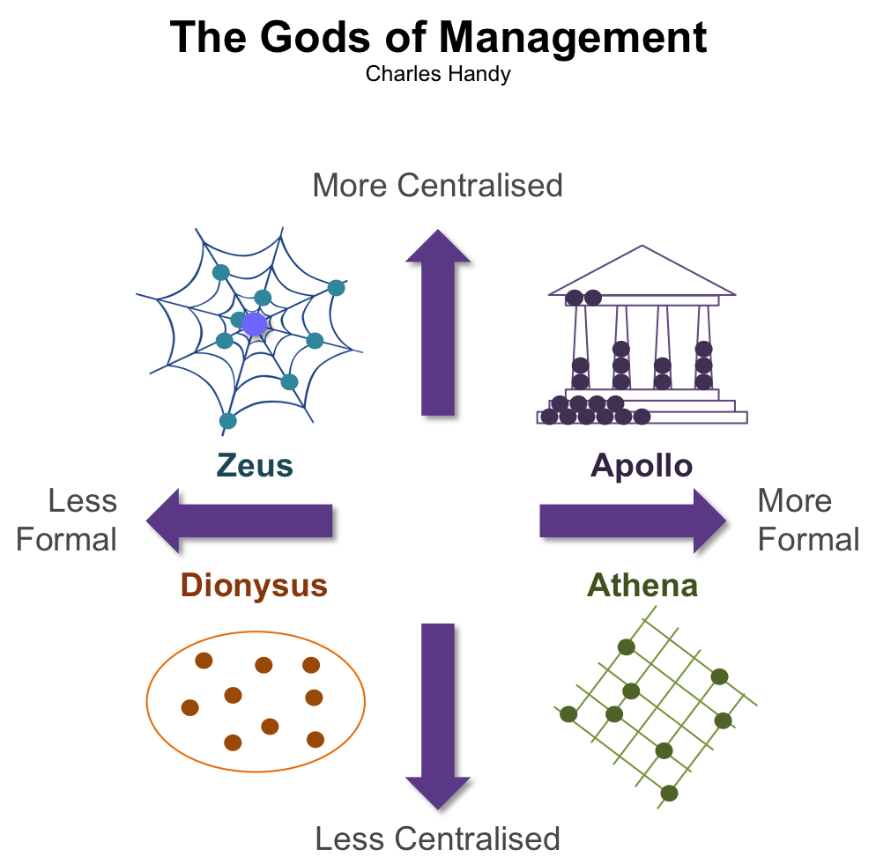

The OBS Cymru team valued consistency, specificity of roles and authority levels, and robust evidence in making decisions and initiating change. This was very different to the Zeus culture of PROMPT whereby power was retained by the central clinical project lead and shared sparingly at his discretion, conventional organisational processes were not followed strictly and challenge was met with further confrontation.

Influencing for Change
Using the knowledge of these cultures enabled me to develop a plan to approach embedding OBS Cymru management more effectively. The Zeus culture of PROMPT was based on the clinical lead’s agenda and I thought, based on my reflection of Handy’s work, was best served by bringing solutions rather than problems to his attention and working with trusted advisors to influence. It appeared that his agenda was to ensure reproducibility of the PROMPT programme in each of the areas that implemented it as this model had been successful in previous adopter sites.

Modification of the programme was perceived to be a threat rather than an opportunity to the clinical lead and he wasn’t able to responsively adapt to change. By identifying and engaging with favoured inner circle team members working around the project lead I was able to discuss the benefits of implementing OBS Cymru into the training programme and used the already highlighted patient and staff impact to validate the credibility of our approach. Engaging with team members whose views were respected by the Zeus leader, influenced his decision to work collaboratively with us. Alongside trusted members of the PROMPT team I suggested a practical solution to how the training materials could be adapted and that we would support them in training faculty in our approach.

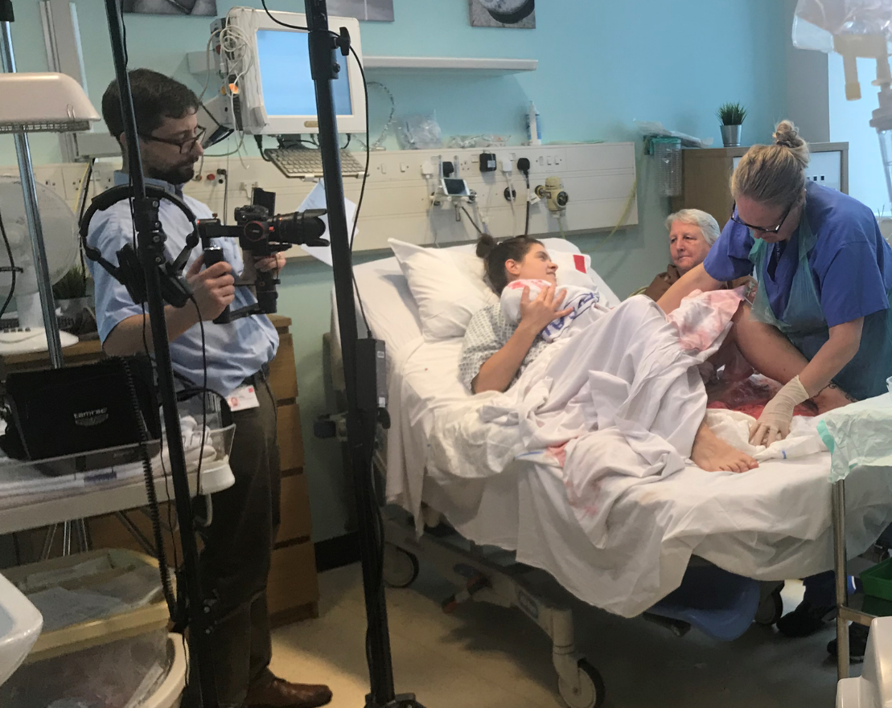
I worked with a key individual respected by the clinical lead to sensitively adapt their materials and develop new training materials including a PPH simulation video. I co-ordinated the writing, filming and editing of this video with the PROMPT team to ensure important themes from their programme were incorporated, paying due heed to ensuring the project lead felt that their project ethos was not compromised.

Inspiring a shared purpose through emphasising the patient impact meant that he saw our collaboration as a real opportunity to improve care. Once we had established both credibility and trust from the project lead, with proven sensitivity to their philosophy of managing obstetric emergencies, the task of writing scenarios and amending their training manual was straightforward. Additionally, I also identified other OBS Cymru project team members who had the practical skills to support PROMPT Wales on their project launch day and at their faculty training through participating and leading mock PPH scenarios. The OBS Cymru approach to PPH management is now taught on each of the local obstetric unit PROMPT Wales courses.

Personal Reflection
This challenging relationship made me acknowledge my own limitations in my dislike of conflict and the high value I place on harmonious relationships. Performing the Myers-Briggs Type Indicator was insightful as to why this is so important to me and offered some practical advice when faced with such scenarios. I identified as being ISFP, Introverted Sensing Feeling Perceiving (Myer’s Briggs 2015), genuinely caring about people and having a strong set of values which I strive to consistently meet. When disagreement is encountered I see this as a deep conflict with my values and find it hard to communicate this as I’m generally reserved due to the introverted part of my personality. Retracting from these situations enables me to think about my responses and formulate my ideas and opinions. I have learnt that I can perform better when I establish common ground in the first instance (desire for improved patient outcomes in this case) and arrange a repeat meeting when I’ve had this time for contemplation.

Conclusion
This report highlights the key strategies used in developing and leading the sustainability strategy for OBS Cymru and the personal reflections I have had on my leadership style and the theories behind change management and influencing. This phase of the project has been completed successfully with all five process measures being in place:

- Cost effectiveness analysis of OBS Cymru
- Local business cases incorporating the cost-effectiveness plan
- Summary event linking local teams to wider stakeholders
- Presence of ROTEM device on each unit after April 2019
- Ongoing teaching of OBS Cymru approach through a national strategy and local implementation with associated resources

However, these measures do not describe the overall project outcomes as these are awaited with continuing data collection in obstetric units defining the incidence of 2.5 litre PPH, hysterectomy, intensive care admissions and blood product use following formal project cessation. The patient impact has already been partially outlined and the challenge for future analysis is in how we monitor progress. Through the project we have been fortunate to have champion midwives with dedicated time for data collection, local analysis and testing and monitoring the impact of change. What we do not have in Wales is a system to continue to identify and measure improvement in maternity services. There is currently no central database with quality and performance indicators or a validated dataset for health boards to report. Moving forward I will be working on the national data strategy and sitting on the steering group for this within the Wales Maternity Network, not only to embed PPH indicators but also the other areas within our service that are important to identify and measure, including patient and staff reported measures. National oversight of this to share good practice and work sensitively with outlier units to improve care will ensure the sustainability and continuous improvement of the whole maternity service, not just obstetric haemorrhage management.

References
- Bradley, P. & Willson, A. (2014) Achieving prudent healthcare in NHS Wales (revised). Cardiff: Public Health Wales

- Briggs, K. and Briggs Myers, I. (2015). The Myers-Briggs Type Indicator.

- Covey S 1989 The 7 habits of highly effective people: powerful lessons in personal change. New York USA Simon & Schuster

- Deming WE. Out of the crisis, 1986. Cambridge, MA: Massachusetts Institute of Technology Center for Advanced Engineering Study xiii, 1991;507)

- Ham, C. (2014). Reforming the NHS from within. The King's Fund, pp.25-30.

- Handy, C. (2011). Gods of Management. London: Souvenir Press.

- Knight M, et al on behalf of MBRRACE-UK. Saving Lives, Improving Mothers’ Care - Lessons learned to inform maternity care from the UK and Ireland Confidential Enquiries into Maternal Deaths and Morbidity 2013–15. Oxford: National Perinatal Epidemiology Unit, University of Oxford 2017

- Kotter JP (1996) Leading Change. Boston, Mass.: Harvard Business School Press

- Kotter, JP. (2014). Accelerate. Boston, Mass.: Harvard Business Review Press.

- Langstaff (2019) Infected Blood Inquiry. [online] Available at https://www.infectedbloodinquiry.org.uk/about [Accessed 22nd July 2019]

- Lennox C et al. Scottish Confidential Audit of Severe Maternal Morbidity: Reducing Avoidable Harm (2014) 10th Annual Report (2012 Data & 10-year summary) Healthcare Improvement Scotland.

- NHS Institute for Innovation and Improvement (2010) NHS Sustainability Model [online] Available at: https://www.aquanw.nhs.uk/resources/academy/NHS%20Sustainability%20Model.pdf

[Accessed 22nd July 2019]
- NHS Institute for Innovation and Improvement (2007) Improvement Leaders' Guide – sustainability and its relationship with spread and adoption [online]. Available at: http://www.institute.nhs.uk/index.php?option=com_joomcart&main_page=document_p roduct_info&products_id=300&cPath=65 (login required) [Accessed 1st July 2019]

- Welsh Government (2018) A Healthier Wales: Our plan for Health and Social Care. Digital ISBN 978-1-78937-332-5

- World Health Organization. (2012). Maternal mortality. [online] Available at: http://www.who.int/news-room/fact-sheets/detail/maternal-mortality [Accessed 22nd July 2019].

