
Programme: BA (Hons) Leadership and Management Skills for the Workplace

Module: Developing Emotional Intelligence Skills
Assignment Title: Component 2 - Individual
Written Report
Student Name Willan Marcelo Espin Tapia
Student ID 2411166
Module: LCLM5006
LECTURER`S NAME: Nishi Ramsurrun

TIMETABLE
Introduction
Emotional Intelligence in the Workplace
Relevant emotional intelligence models
Goleman’s Emotional Intelligence framework
Mayer and Salovey’s Ability Model
Bar-On’s Emotional-Social Intelligence Model
Managing a Multigenerational Workforce
Generation X
Generation Y (Millennials)
Generation Z
Conclusion
Reference list

Introduction
For organisational performance, leadership, and employee wellbeing. In environments characterised by rapid change, hybrid working, and diverse multigenerational teams, the ability to recognise, understand, and regulate emotions, while sustaining present-moment awareness, directly shapes communication quality, conflict dynamics, and psychological safety. This report critically analyses EI and mindfulness in workplace contexts, drawing on leading EI models and contemporary research, and applies them to the realities of performance, collaboration, and managing a multigenerational workforce.
EI and mindfulness have moved from soft skills to strategic capabilities that shape performance, culture, and retention. EI broadly, the ability to perceive, understand, manage, and use emotions effectively has been consistently linked to higher individual performance, better leadership, and stronger organisational outcomes. Mindfulness, understood as non‑judgemental present‑moment awareness, complements EI by enhancing attention, self‑regulation, and psychological safety
Emotional intelligence has become central to contemporary discussions about organisational effectiveness, leadership capability, and employee well‑being. In complex, fast‑changing workplaces, technical skills alone are insufficient; organisations increasingly rely on employees and leaders who can manage emotions, communicate constructively, and create psychologically safe environments. This report critically analyses the role of EI and mindfulness in improving performance, collaboration, and well‑being
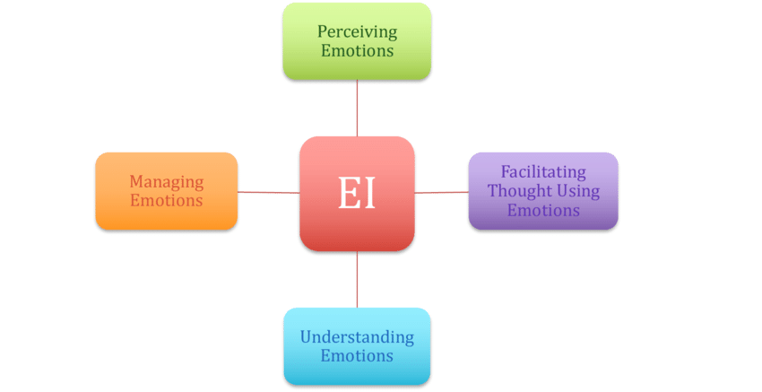

Goleman’s Emotional Intelligence framework
Goleman conceptualises EI as a set of competencies: self‑awareness, self‑regulation, motivation, empathy, and social skills. These are framed as learnable capabilities that underpin effective leadership and workplace performance. Self‑awareness and self‑regulation enable employees to recognise and respond constructively, while empathy and social skills support relationship management and collaboration. A strength of Goleman’s model is its practical focus, but critics argue it blends personality traits, competencies, and outcomes, making it conceptually broad and sometimes difficult to measure.
Also, self-awareness, self-regulation, motivation, empathy, and social skills. These are grouped into personal and social competencies and are explicitly linked to workplace outcomes such as leadership effectiveness, team cohesion, and resilience. High-EI employees are more capable of recognising their emotional triggers, managing impulses, and responding constructively under pressure, which in turn supports sustained performance and healthier relationships
Mayer and Salovey’s Ability Model
Mayer and Salovey define EI as a cognitive ability: the capacity to perceive, use, understand, and manage emotions. Their four-branch model emphasises:
Perceiving emotions: in self and others
Using emotions: to facilitate thinking
Understanding emotions: and their trajectories
Managing emotions: for goal-directed behaviour
This model treats EI as a form of intelligence that can be assessed through performance‑based tests Its strength lies in conceptual clarity and emphasis on information processing, employees use emotional information to guide thinking an behaviour. However, some scholars question whether EI can be fully captured by ability tests and whether such measures reflect real‑world behaviour under pressure.

Bar‑On’s Emotional‑Social Intelligence Model
Bar‑On’s model views EI as a constellation of emotional and social competencies, including intrapersonal skills (self‑regard, emotional self‑awareness), interpersonal skills (empathy, social responsibility), stress management, adaptability, and general mood. It emphasises well‑being and resilience, linking EI to mental health and coping. While widely used in organisational settings, critics note that the model overlaps with broader personality constructs and may risk conceptual inflation.
Conceptualises EI as a constellation of emotional and social competencies, skills, and facilitators that influence how effectively individuals cope with environmental demands. His model includes intrapersonal skills (example, self-regard, emotional self-awareness), interpersonal skills (example, empathy, interpersonal relationships), adaptability, stress management, and general mood. This broader lens connects EI to wellbeing and psychological adjustment, not only task performance.
Taken together, these models highlight EI as both an ability and a set of competencies that influence how employees perceive, interpret, and respond to emotional information in the workplace.

(EI) and employee performance
Application to individual performance
Employees with high EI are better able to regulate stress, maintain focus, and adapt to changing demands. Self‑awareness helps individuals recognise when emotions are impairing judgement: for example, frustration leading to rushed decisions. Self‑regulation allows them to pause, reframe the situation, and choose more effective responses. Motivation, in Goleman’s sense, supports persistence and goal orientation, particularly in challenging projects.

From an Ability Model perspective, employees who can accurately perceive and understand emotions are more likely to interpret feedback correctly, anticipate interpersonal reactions, and adjust their behaviour to achieve desired outcomes. This can enhance decision‑making quality, as emotional information is integrated rather than ignored or allowed to dominate irrationally.
EI as a predictor of performance can obscure structural factors such as workload, resources, and organisational culture. Moreover, if EI is framed solely as an individual responsibility, organisations may expect employees to “self‑manage” stress without addressing systemic causes. Effective use of EI therefore requires alignment with supportive policies, realistic expectations, and fair performance management systems.

Collaboration, and communication
Improving collaboration
Empathy and social skills are central to collaborative work. Employees who can understand colleagues’ perspectives are better able to negotiate roles, share information, and resolve misunderstandings. In cross‑functional teams, EI supports the ability to bridge different professional languages and priorities.

Ability‑based EI contributes to recognising subtle emotional, tone of voice, facial expressions, silence, that signal disengagement or conflict. Employees can then initiate conversations to clarify expectations or offer support, preventing issues from escalating.

Effective communication and Psychological Safety
EI supports psychologically safe environments where employees feel able to speak up, admit mistakes, and challenge ideas without fear of humiliation. Leaders who demonstrate empathy, active listening, and non‑defensive responses model inclusive communication norms. This, in turn, encourages innovation and learning.

Critically, psychological safety depends not only on individual EI but also on power dynamics and organisational structures. High‑EI employees may still struggle to voice concerns if leadership is punitive or dismissive. Thus, EI must be embedded within broader cultural and leadership practices.

Conflict management
EI enables employees to distinguish between task conflict (differences in ideas) and relationship conflict (personal tension). Self‑regulation helps individuals avoid reactive, emotionally charged responses, while empathy supports understanding the underlying needs or fears driving conflict. Leaders with strong EI can facilitate dialogue, reframe disagreements as opportunities for improvement, and ensure that all voices are heard.
Leadership and decision‑making
Emotionally intelligent leaders integrate rational analysis with emotional awareness. They recognise how decisions will be experienced by different stakeholders and anticipate emotional reactions. This can improve change management, as leaders communicate with sensitivity and provide support during transitions.

However, there is a risk that EI may be used manipulatively, for example, leaders who read emotions accurately but use this insight to exploit or coerce. Ethical leadership is therefore essential; EI should be combined with integrity, transparency, and respect for autonomy.

EI and employee well‑being
Bar‑On’s emphasis on stress management and adaptability highlights the link between EI and well‑being. Employees who can identify early signs of burnout, seek support, and adjust coping strategies are more likely to sustain performance over time. Mindfulness practices such as focused breathing, non‑judgemental awareness, and reflection, complement EI by enhancing self‑awareness and emotional regulation.

Organisations must avoid framing well‑being solely as an individual responsibility. EI and mindfulness are most effective when supported by realistic workloads, supportive supervision, and access to resources such as employee assistance programmes.

Generational groups: characteristics and expectations
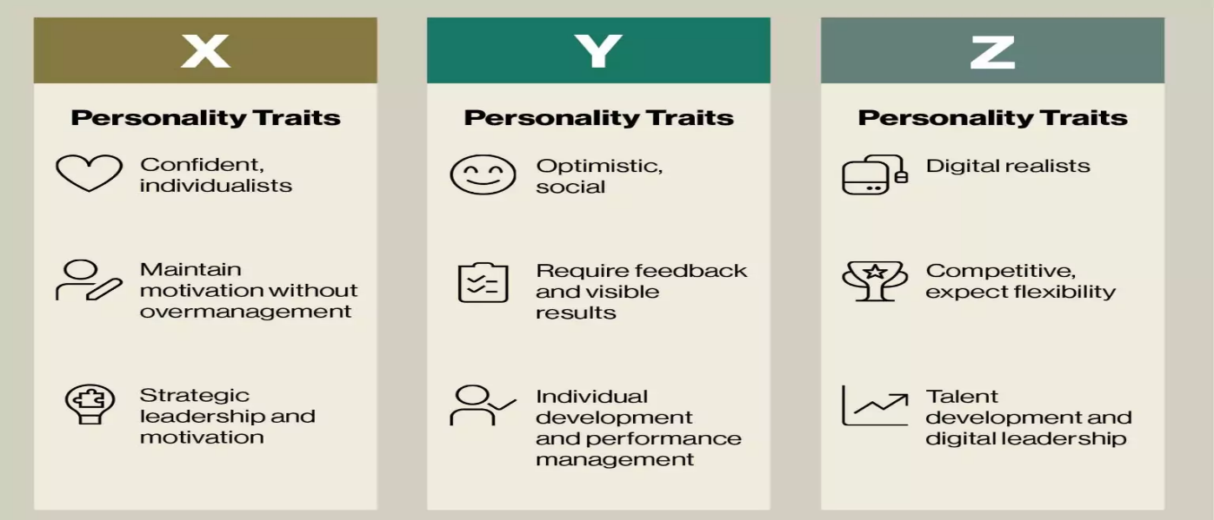
Generation X (1965/1980)
Values: Independence, pragmatism, work, life and balance.
Communication style: Direct, often preferring email or face‑to‑face over constant instant messaging.
Motivation: Autonomy, recognition of expertise, stability.
Technological adaptability: Comfortable with technology but may prefer tools that clearly support efficiency rather than constant novelty.
Generation Y / Millennials (1981/1996)
Values: Purpose, collaboration, flexibility, continuous learning.
Communication style: Frequent digital communication, preference for feedback and dialogue.
Motivation: Meaningful work, development opportunities, inclusive culture.
Technological adaptability: Highly comfortable with digital tools and social media; expect technology to be integrated into work processes.
Generation Z (1997 onwards)
Values: Diversity, authenticity, social responsibility, mental health awareness.
Communication style: Fast, multimedia communication (messaging apps, video); expect transparency.
Motivation: Opportunities for creativity, rapid progression, psychological safety.
Technological adaptability: (Digital natives) who expect intuitive, mobile‑friendly systems and rapid adoption of new technologies.
These generalisations must be treated critically: individuals within each generation vary widely, and socio‑economic, cultural, and organisational contexts shape behaviour. Nonetheless, generational patterns can help managers anticipate differing expectations and design more inclusive practices.
Impact on organisational effectiveness
Differences in values and communication styles can both enrich and challenge organisations.
Positive impact
Multigenerational teams bring diverse perspectives, problem‑solving approaches, and technological skills. Generation Z may drive innovation in digital tools, Millennials may champion collaboration and purpose, while Generation X may provide stability and experience.
Misunderstandings can arise when, for example, Generation X interprets frequent feedback requests as neediness, or Generation Z perceives traditional hierarchies as rigid and exclusionary. Differences in preferred communication channels (formal vs. informal, email vs. instant messaging) can also create friction.
Technological adaptability can widen gaps: younger employees may embrace new platforms quickly, while older employees may require more structured training. If not managed thoughtfully, this can lead to stereotypes and marginalisation.
Using emotional intelligence to manage a multigenerational workforce
Emotionally intelligent leadership across generations
Managers with high EI recognise that generational differences often reflect distinct experiences rather than fixed.
Empathy
Enables leaders to understand why certain practices feel comfortable or uncomfortable to different groups, for example, why Generation X may value clear boundaries between work and personal life, while Millennials may seek flexible arrangements.
Self‑awareness helps managers identify their own generational and challenge them.
Social skills support the creation of communication norms that respect diverse preferences, for instance, combining structured meetings with informal digital channels.
Conflict management and inclusion
EI supports constructive dialogue when generational tensions arise. Managers can facilitate conversations that focus on shared goals rather than stereotypes, encouraging each group to articulate needs and constraints. Ability‑based EI helps leaders read emotional cues and intervene early when frustration or disengagement emerges.
Inclusive leadership requires that EI be applied consistently: listening to all generations, avoiding favouritism, and ensuring that policies (example, flexible working, development opportunities) are accessible across age groups.
Mindfulness practices: such as reflective pauses, non‑judgemental awareness, and attentive listening enhance leaders’ capacity to respond rather than react to generational differences.
Reducing reactivity: When confronted with behaviours they find unfamiliar (Generation Z, preference for rapid feedback), mindful managers can notice their own irritation or confusion, pause, and explore the underlying needs rather than dismiss them.
Enhancing presence: Mindfulness supports deep listening during one‑to‑one conversations, allowing employees from all generations to feel heard and respected.
Supporting psychological safety: Leaders who model calm, non‑judgemental responses to mistakes and questions create environments where employees feel safe to express concerns, propose ideas, and admit limitations—crucial for retaining diverse talent.
Mindfulness also benefits employees directly: training in attention regulation and stress reduction can help all generations cope with information overload, constant connectivity, and performance pressure.
Recruitment, management, and retention strategies
Using EI and mindfulness, managers can design practices that attract and retain talent across generations:
Recruitment: Emotionally intelligent recruiters communicate organisational values clearly, recognise different motivations (example, stability vs. purpose), and avoid age‑based assumptions. Mindful interviewing allows fair, present‑focused assessment rather than reliance on stereotypes.
Management: Leaders tailor communication and feedback styles, balancing structure with flexibility. EI helps them recognise when employees need autonomy, support, or challenge. Mindfulness supports consistent, calm leadership during change.
Mentoring and reverse mentoring to share expertise and perspectives.
Retention: Creating psychologically safe, inclusive cultures, where diverse generational voices are valued, reduces turnover.
EI and mindfulness underpin trust, fairness, and respect, which are central to long‑term engagement.
Offer flexible working arrangements and personalised development plans. Recognise contributions in ways that resonate across generations (example, public recognition, autonomy, growth opportunities). Regularly assess psychological safety and act on findings (example, addressing patterns of silence or exclusion).
Conclusion:
Emotional intelligence and mindfulness are powerful, complementary resources for contemporary organisations. EI, as conceptualised by Goleman, Mayer and Salovey, and Bar‑On, enhances performance, collaboration, communication, conflict management, and leadership by enabling employees and managers to understand and manage emotions effectively. Mindfulness deepens self‑awareness and emotional regulation, supporting psychologically safe environments where learning and innovation can flourish.
In multigenerational workplaces, EI and mindfulness help leaders navigate differences in values, communication styles, and technological adaptability without resorting to stereotypes. By applying these principles to recruitment, management, and retention, organisations can foster inclusive leadership across generations and strengthen overall organisational effectiveness.

References:
1-) Goleman, D. (1995) Emotional Intelligence: Why It Can Matter More Than IQ. New York: Bantam Books.
https://www.scirp.org/reference/referencespapers
2-) Goleman, D. (1998) Working with Emotional Intelligence. New York: Bantam Books. https://d1wqtxts1xzle7.cloudfront.net
3-) Goleman, D., Boyatzis, R. and McKee, A. (2002) Primal Leadership: Realizing the Power of Emotional Intelligence. Boston: Harvard Business School Press. https://onlinelibrary.wiley.com/doi/abs
4-) Mayer, J.D. and Salovey, P. (1997) ‘What is emotional intelligence?’, In: Salovey, P. and Sluyter, D. (eds.) Emotional Development and Emotional Intelligence: Educational Implications. New York: Basic Books,
https://www.scirp.org/reference/references
5-) Mayer, J.D., Salovey, P. and Caruso, D.R. (2004) ‘Emotional intelligence: Theory, findings, and implications’, Psychological Inquiry,
https://www.tandfonline.com/doi/abs
6-) Bar‑On, R. (1997) Bar-On Emotional Quotient Inventory (EQ-i): Technical Manual. Toronto: Multi-Health Systems.
https://prod-com-bibliolabs
7-) Bar‑On, R. (2006) ‘The Bar-On model of emotional-social intelligence (ESI)’, Pliothermal,
https://www.psicothema.com/pdf/3271.pdf
8-) Cherniss, C. (2010) ‘Emotional intelligence: Toward clarification of a concept’, Industrial and Organizational Psychology, https://emotrab.ufba.br/wp-content
9-) Ashkenazy, N.M. and Daus, C.S. (2005) ‘Rumours of the death of emotional intelligence in organisational behaviour are vastly exaggerated’, Journal of Organizational Behaviour, https://espace.library.uq.edu.au
10-) Jordan, P.J. and Troth, A.C. (2011) ‘Emotional intelligence and conflict resolution’, Journal of Management & Organization,
https://research-repository.griffith.edu.au/items
11-) Wong, C.S. and Law, K.S. (2002) ‘The effects of leader and follower emotional intelligence on performance and attitude’, The Leadership Quarterly, https://research.cuhk.edu.hk/en/publications/the-effects-of-leader
12-) Carmeli, A. (2003) ‘The relationship between emotional intelligence and work attitudes, behaviour and outcomes’, Journal of Managerial Psychology, https://www.emerald.com/jmp/article

