
Network Security
LEVEL 7 ASSESSMENT SOLUTION

SUBMITTED BY
STUDENT NAME
STUDENT ID
Table of Contents
PART 1 1
1. Security Threats Facing Towards Network Infrastructures 1
1.1 Network Security 1
1.2 Types of Security risk and Attacks 1
1.3 Techniques, Tools and Procedures for Mitigation Towards Network Attacks 2
1.4 Basic of Securing a Network 2
1.4.1 Defense in Depth Approach 2
1.4.2 Least Privilege Methodolody 3
1.4.3 Segmentation of Network 3
1.4.4 Patch Management Process 3
1.4.5 Solid Authorization & Authentication 3
1.4.6 Logging & Monitoring 3
1.4.7 Encryption & Decryption 3
1.4.8 Security Awareness and Training 3
1.4.9 Incident Response Programs & Planning 3
1.4.10 Regular Security Assessments 3
1.5 Mitigation of Known & Most Common Network Attack Methods Effects in Small & medium enterprisess 4
1.5.1 Network Layer Security 4
1.5.2 Endpoint Security 4
1.5.3 Access Control List 4
1.5.4 Data Encryption Techniques 4
1.5.5 Backup and Recovery Process 4
1.5.6 Monitoring and Incident Response 4
1.6 Cisco Network Foundation Protection (NFP) Framework 4
1.6.1 Management Plane Protection (MPP) 4
1.6.2 Control Plane Protection (CPP) 5
1.6.3 Data Plane Protection (DPP) 5
1.7 Mitigating the effects of Malwares, Worms, and Trojan Horses in Small & Medium enterprisess 6
1.7.1 Endpoint Protection 6
1.7.2 Firewalls 6
1.7.3 Patch Management 6
1.7.4 Email Security Appliances 6
1.7.5 Web Security 6
1.7.6 Application Control 6
1.8 Endpoint Vulnerabilities and Protection Methods 7
2. Configuration of Secure Network 7
2.1 Securing Routers and Implementing AAA 7
2.2 Mitigate common Layer 2 Attacks 8
2.3 Configuration of ZPF on Routers 10
2.4 Configuration of Firewall 11
2.5 Implementation of Intrusion prevention Security 12
2.6 Configuration of VPN (Virtual Private Network) 14
2.6.1 Purpose of VPN 14
2.6.2 Functionailty of IPSec VPN 14
PART 2 16
1. Secure Network Architecture Proposal 16
1.1 Proposed Design and Security Measures 16
1.1.1 Network Segmentation 16
1.1.2 Virtual Private Network (VPN) 16
1.1.3 Network Access Control (NAC) 17
1.1.4 Firewall and Intrusion Prevention System (IPS) 17
1.1.5 Endpoint Security 17
1.1.6 Cloud Security 17
1.2 Cost Analysis 18
1.2.1 Network Segmentation 18
1.2.2 VPN Solution 19
1.2.3 NAC Implementation 19
1.2.4 Firewall and IPS 19
1.2.5 Endpoint Security 19
1.2.6 Cloud Security 19
1.3 Attacks that Plagues A2Z Technologies Network Infrastructure 20
1.3.1 Distributed Denial of Service (DDoS) Attacks 20
1.3.2 Advanced Persistent Threats (APTs): 20
1.3.3 Ransomware Attack 20
1.4 Recommendation of Security Tests 21
1.4.1 Vulnerability Scanning 21
1.4.2 Penetration Testing & Vulnerability Assesment 21
1.4.3 Social Engineering Testing (SET) 22
1.5 Cost Analysis & Prices for the Professional Services 22
References 23

List of Tables
Table 1: Types of Threats and Attacks Towards Network Security 1
Table 2: Tools & Procedures to Mitigate the Various Types of Potential Threats and Attacks 2
Table 3: Endpoint Vulnerabilities and Approach Towards Mitigation Techniques 7

List of Figures
Figure 1: A Secure Network Design for A2Z Technologies 18

PART 1

Security Threats Facing Towards Network Infrastructures

Network Security
Network security is a set of measures and strategies employed to protect the CIA (Confidentiality, Integrity & Availability of computer networks and data collected from unauthorized access, misuse, or damage (Srinivas, 2019). It involves a wide range of security practices, including the deployment of strong authentication, authorization & accounting mechanisms, encryption, intrusion detection and prevention systems, firewalls, and secure network architecture design (Srinivas, 2019). The primary goal of network security is to ensure that sensitive information remains protected from the unauthorized access and the network services must be available to only authorized users, while defending against threats such as cyberattacks, ransomware, malware, Dos and data breaches.

Types of Security risk and Attacks
Table 1 summarizes the various types of threats and attacks to network security.
Attack Type | Description
Malware | Malicious software, including viruses, worms, and Trojans, is a piece of code which is purposely designed to infiltrate, damage, or compromise systems.
DDoS | Distributed Denial of Service attacks send thousands or millions of request to a devices oa network or system with traffic, causing a service outage which results in system down.
Man-in-the-Middle | In this type of attack attacker can intercept & modify the communication between the two parties by modifying the default gateway & ip routing information.
SQL Injection | SQL injection is a technique in which attacker send malicious code to the server in form of SQL queries to fetch the hidden or unauthorized information.
Cross-Site Scripting | Three are various type of XSS attack in XSS attacker sends a malicious crafted URL to trick the victim to execute the malicious code
Zero-Day | This type of attack or it is a type of vulnerability which is discovered by the attacker & make it public without informing the vendor for this type of exploit there is not patch available on immediately.
Brute Force | In this type of attack the attacker uses a well-developed User name & password file with the help of automation tool checks until the correct user name & password is found.
Table 1: Types of Threats and Attacks towards Network Security

Techniques, Tools and Procedures for Mitigation Towards Network Attacks
Table 2 summarizes the various tools,procedures for mitigating the different types of threats and attacks towards network security.
Tools and Procedures | Description
Antivirus Security Solution | This product helps in Detecting, quarantines, and removes the malicious from systems.
Next Gen Firewalls | Next gen firewalls come with modern features from Filters the traffic, to prevention of attacks blocking unauthorized connections & access
IPS & IDS | IDS & IPS works on a signature based technique which regularly monitors the network traffic for abnormal activity alerts administrators, and blocks potential threats.
Patch Management | Regularly updating the outdated software and hardware to fix common & known vulnerabilities.
Secure Network Design | Segments networks, using VLAN’S, Guest network implements access controls, and uses VPNs for secure communication.
2FA Authentication | Enhancing the user account security by asking an additional verification step by the end user.
Backups Cycle | Regularly copies of critical data, which enables data recovery after an attack.
Robust Security Policies | Clear guidelines and procedures for handling and protecting sensitive information.
Incidence Response &Planning | Outlines steps to follow in case of a security breach, minimizing the impact and ensuring a swift recovery.
Security Awareness Employee Training | Security Awareness training for organization employee on security best practices, such as recognizing phishing attempts and using strong passwords malicious links.
Table 2: Tools & Procedures to Mitigate the Various Types of Potential Threats and Attacks

Fundamental Principles of Securing a Network
Securing a network involves plenty of fundamental principles which serve as the foundation towards a robust security posture. These principles include:

Defense in Depth (DiD)
Implement multiple layers of security controls to create a comprehensive defense system, ensuring that if one layer is compromised, others can still protect the network (Fink et al., 2017).

Least Privilege
Limit user access rights to the minimum necessary for their job function, reducing the potential damage caused by unauthorized access or insider threats (Catescu, 2018).

Segmentation
Divide the network into smaller segments to contain potential breaches, limit lateral movement, and reduce the attack surface (Fink et al., 2017).

Patch Management
Regularly updating of software and hardware from the vendor with security patches to fix known & common will adversely help to fix vulnerabilities and prevent exploitation.

Strong Authentication and Authorization
Implementation of strong authentication mechanisms, such as two-factor authentication (2FA), behavioral based detection enforcing granular access control policies to ensure only authorized users can access to network services.

Monitoring and Logging
Continuously monitoring the network traffic, system activities, and user behavior to detect and respond to anomalies and potential threats in real-time. Maintaining of logs for audit and forensic purposes can help.

Encryption
Using of encryption to protect the sensitive data in transit and at rest, making it unreadable to unauthorized users can help.

Security Awareness and Training
Educating the employees towards security best practices, such as recognizing phishing links, using strong passwords & regular changing & updating of password, and reporting suspicious activities.

Incident Response Planning
Develop a comprehensive incident response plan outlining MTTD (mean time to detect), MTTR (Mean time to respond), and recover from security breaches, minimizing their impact.

Regular Security Assessments
Quarterly periodic assessments, such as VAPT (Vulnerability assessment & penetration testing), to identify and remediate security weaknesses and ensure the effectiveness of security controls.

Mitigation of Known & Most Common Network Attack Methods Effects in Small & medium enterprisess
To mitigate the effects of known network attack & methodologies in a small to medium-sized business, consider implementing the following strategies:

Endpoint Security
Installing antivirus software solutions and firewalls on all user end devices to prevent malware infections and unauthorized access. Enable automatic updates to keep software up-to-date.

Network Security
Set up a network firewall to filter incoming & outgoing traffic and segment the network to limit lateral movement in case of a breach. Use Virtual Private Networks (VPNs) for secure remote access.

Access Control
Implement the principle of least privilege, where blocking user access to only minimum & necessary for their job function. Keeping a Regular check & reviewing and update access rights.

Data Encryption
Encryption of sensitive information both the during in transit and the data at rest, through using strong encryption algorithms and secure key management practices.

Backup and Recovery
Regularly backing up the critical & sensitive data including system configurations files and systems, storing backup’s offsite or in the cloud. Also testing backup and recovery procedures in a simulated environment to ensure it should work effectively in case of an attack or system failure.

Monitoring and Incident Response
Deployment of a monitoring system to detect and alert on suspicious activities. Development of an incident response plan towards how to detect (MTTD), respond to (MTTR), and recover from security incidents.

Cisco Network Foundation Protection (NFP) Framework
The Cisco Network Foundation Protection (NFP) Framework is a comprehensive approach to securing a network infrastructure (Paquet, 2012). It consists of three functional areas that focus on different aspects of network security, aiming to provide a robust and resilient foundation for the overall network (Paquet, 2012). The author (Paquet, 2012) described these three layers as:

Management Plane Protection (MPP)
MPP focus on securing the management interfaces and protocols used to access, configure, and monitor network devices. MPP involves implementing the following measures:
- Minimum access to devices using management interfaces through implementing & using access control lists (ACLs) and authentication mechanisms.
- Using secure management protocols, such as SSH for remote access and SNMPv3 for network management rather than going with Telnet or Outdates versions of SNMP.
- Implementation of role-based access control (RBAC) to prevent & limit user privileges based on their roles to perform the functions.
- Logging and monitoring user activities for internal auditing and detecting suspicious behavior of user in case of an attack.

Control Plane Protection (CPP)
CPP aims to provide secure the control plane, which is responsible for maintaining communication between network devices and determining the best path for data traffic. Key components of CPP include:
- Using of Rate limiting control plane traffic to prevent malicious traffic from overwhelming the control plane.
- Implementation of routing protocol authentication helps to secure communication between routers and prevent unauthorized devices from participating in routing updates.
- Protecting the routing infrastructure by filtering incoming and outgoing route advertisements to validate the trusted routes are used in the routing table.
- Deploying security mechanisms like Control Plane Policing (CoPP) to limit the impact of Denial of Service (DoS) attacks on control plane resources.

Data Plane Protection (DPP)
Purpose of DPP is on securing the data plane, which carries the user data traffic between network devices. A few measures to protect the data plane are as follows:
- Implementing ingress and egress filtering using ACLs to filter or block the unwanted traffic and prevent network spoofing attacks.
- Enabling security features in Network devices like Switch, Firewalls & Routers like Dynamic ARP Inspection (DAI) and DHCP Snooping to prevent ARP and DHCP-based attacks.
- Using Virtual LANs (VLANs) and Private VLANs (PVLANs) to segment the network and isolate sensitive traffic from the common traffic.
- Deploying traffic monitoring and intrusion detection/prevention systems (IDS/IPS) to identify and block malicious traffic.
By implementing the NFP framework, organizations can secure their network infrastructure across the management, control, and data planes, thereby providing a solid foundation for the overall network security posture.

Mitigating the effects of Malwares, Worms, and Trojan Horses in Small & Medium enterprises
Mitigating the effects of Malwares, worms, and Trojan horses in a small to medium-sized businesses involves a multi-layered approach towards security. The following measures can help to protect the organization from these various types of malwares:

Endpoint Protection
Usage of a well know vendor antivirus solutions on all devices which supports, including end users devices, servers, and smart devices. Ensure the solution is updated regularly with the latest malware definitions.

Firewall
Usage of network & application level firewalls at the network perimeter also on individual devices to block malicious traffic and prevent unauthorized access.

Patch Management
Regular updates on operating systems, including applications, and firmware from the vendor with the latest security patches to address known vulnerabilities that malware may exploit.

Email Security
Implementing strict email filtering & usage of secure policies to detect and block phishing attempts and malicious attachments. Security training of employees towards recognizing and report suspicious emails.

Web Security
Utilize web filtering and reputation-based systems to block access to malicious websites and prevent drive-by downloads.

Application Control
Restricting the execution of unauthorized applications on devices also blocking admininstrator privileges, minimizing the risk of malicious program execution.
By implementing above-mentioned security measures, can help SMEs to significantly reduce the attack surface & risk of falling victim to viruses, worms, and Trojan horses, and minimize the potential impact of such malware on their operations.

Endpoint Vulnerabilities and Protection Methods
Table 3 summarizes the endpoint vulnerabilities and their mitigation methods.
Endpoint Vulnerabilities | Protection Methods
Outdated software | Keeping a regular check for software update and applying patches
Malware infections | Install antivirus solution with regular definition update
Unauthorized access | enable 2FA & enforcing users to use strong passwords
Phishing attacks | Email filtering & security awareness programs
Drive-by downloads | Utilize web filtering and reputation systems
Unauthorized applications | Implement application control policies
Insider threats | Apply the principle of least privilege
Data leakage | Encryption of sensitive information and control access
Physical theft | Implement device tracking and remote wipe feautres
Network-based attacks | Use personal firewalls and VPN’S
Table 3: Endpoint Vulnerabilities and Approach Towards Mitigation Techniques

Configuration of Secure Network

Securing Routers and Implementing AAA
Authentication, Authorization, and Accounting (AAA) is a framework used to secure a network by providing a comprehensive set of measures for controlling access to network resources. Together, All the three components of AAA helps in a comprehensive framework for securing a network by controlling access to resources and tracking network & user activity. With implementation usage of AAA in an organizations can enforce access policies, monitor activity, and respond fasters to security incidents, reducing the attack surface which reduces the risk of unauthorized access, data breaches, and potential security incidents.
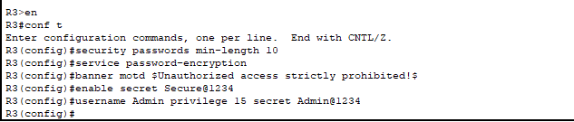
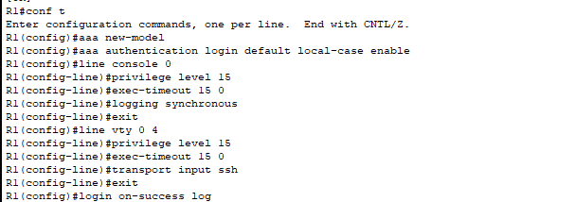
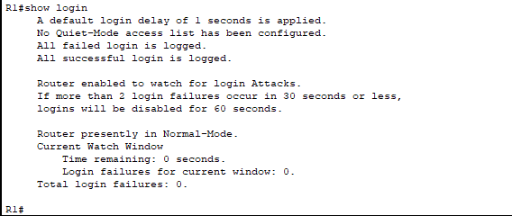

Mitigate common Layer 2 Attacks
The Layer 2 infrastructure of a network can be vulnerable to various security threats, such as MAC flooding, ARP spoofing, STP manipulation, VLAN hopping, and DHCP snooping (Alabady, 2008). Above mentioned vulnerabilities can lead to network downtime, data theft, or unauthorized access to sensitive resources which will adversely affects the production. To secure the Layer 2 infrastructure, organizations must use various mitigation techniques which can help to improve the attack surface. Which include usage of port security, Mac filtering limiting the number of MAC addresses allowed on each port, configuring trusted DHCP servers, and enabling DHCP snooping (Alabady, 2008). Other techniques which may involve using static ARP entries, enabling ARP inspection, and configuring root guard and BPDU guard to prevent STP manipulation (Mustafa, 2015). Additionally, organizations can also use layer 2 encryption technologies such as MAC sec to secure traffic between devices at the data link layer. Implementing a combination of network design, configuration, and monitoring best practices can reduce the attack & helps to mitigate Layer 2 vulnerabilities and reduce the risk of security threats.
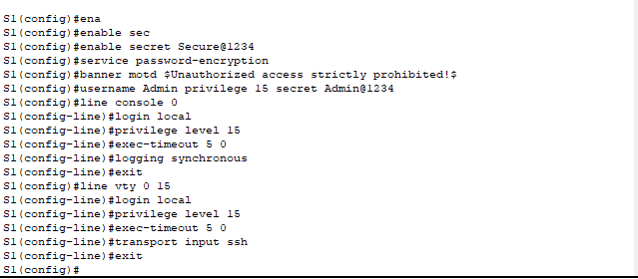
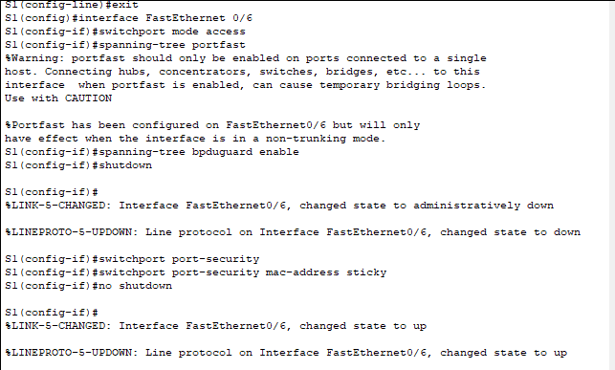
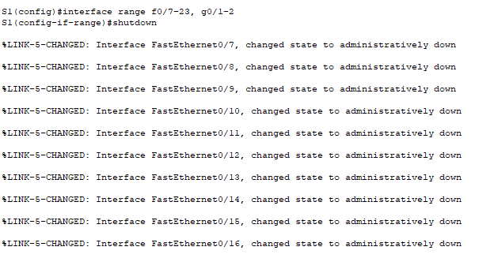

Configuration of ZPF on Routers
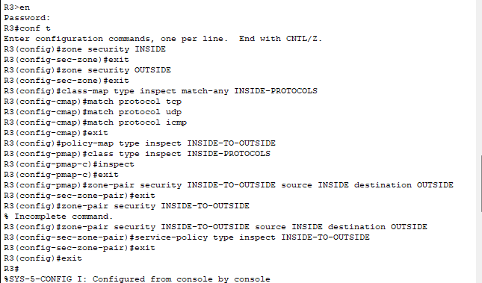
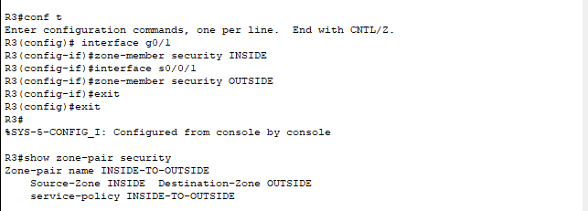

Configuration of Firewall
The ASA Adaptive Security Appliance works as an advanced stateful firewall by inspecting and creating the mirror image of network traffic in real-time, which enforcess access control policies based on the context of the connections helps in providing advanced threat prevention features to protect against various types of cyber threats.
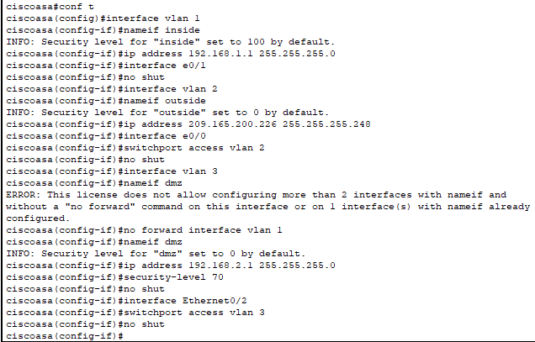
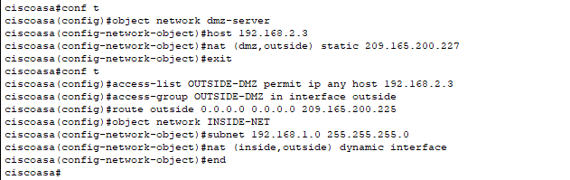
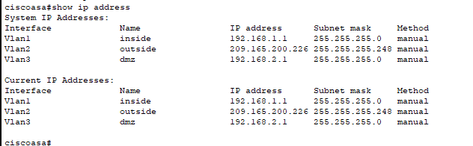

Implementation of IPS
Network-based Intrusion Prevention Systems (IPS) are security devices which are in used in industries from a long run & still maintaining the image of security solution as the function & operations of IPS is to monitor & protect networks from malicious activity. Network-based IPS are an essential tool for securing networks from cyber threats. As with the operations of monitoring network traffic in real-time, detecting known and unknown threats, alerting and blocking suspicious traffic, and integrating with other security technologies & signature based methodologies, network-based IPS can help organizations stay one step ahead of cyber attackers and keep their networks secure.
Signatures are the core component which is used to detect malicious network traffic by comparing network traffic against a database of known signatures that are associated with specific types of attacks, viruses, malwares, or other malicious activity. Signatures can be used in different types of security technologies, such as intrusion detection systems (IDS), intrusion prevention systems (IPS), and antivirus software. Signatures are regularly updated to keep pace with emerging threats, and are an important component of an effective security strategy.
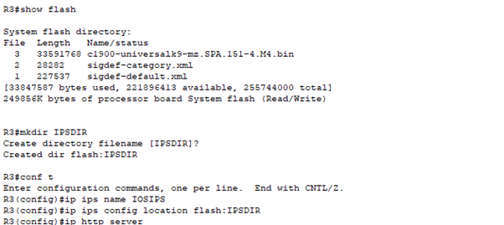
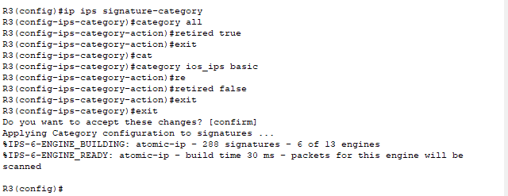
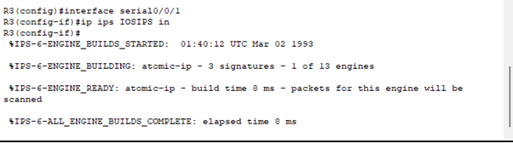
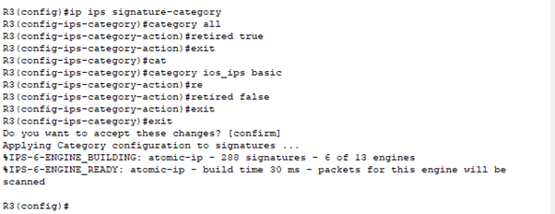

Configuration of VPN

Purpose of VPN
A VPN (Virtual Private Network) is a technology that allows users to securely access a private network over the internet (Jyothi, 2018). The main goal of a VPN is to provide secure remote access to a private network, which allowing the users to work from anywhere across the globe without compromising security this is the reason corporate enforces their employees to use VPN to access the corporate network. VPNs are more commonly used to connect remote employees, branch offices, and business partners to a central network, such as a company's intranet or a cloud-based infrastructure (Jyothi, 2018).

Operation of IPSec VPN
IPsec (Internet Protocol Security) is a widely used protocol for creating secure VPN connections over the internet. IPSEC vpn is most commonly used in the corporate due to is various features of security. IPsec VPNs operate by using a combination of encryption, authentication, and key exchange mechanisms to ensure the confidentiality, integrity, and authenticity of data transmitted between two networks.
According to Gunleifsen (2019), the following are the steps involved in the operation of IPSec VPN:

Authentication and Key Exchange
The IPsec client and gateway establish a secure channel by exchanging authentication credentials and negotiating encryption keys as IPSEC connection goes into two phases phase-1 & phase-2. This process typically uses one of two protocols: IKEv1 (Internet Key Exchange version 1) or IKEv2 (Internet Key Exchange version 2).

Encryption and Tunneling
As soon as the authentication and key exchange process is finished, IPsec client and gateway use encryption algorithms to encrypt all traffic transmitted between the two networks. The encrypted traffic is then encapsulated within IP packets headers and sent over the internet in a secure "tunnel".

Traffic Filtering and Access Control
The IPsec gateway can filter and control the flow of traffic between the two networks, based on policies and rules configured by the network administrator. This allows the IPsec gateway to enforce access control and security policies, such as restricting access to specific applications, services, or devices.

Decryption and Processing
Upon receiving the encrypted traffic, the IPsec gateway decrypts it using the shared encryption key during phase-1 and passes it to the destination network. The traffic is then processed and handled as if it originated from within the destination network.
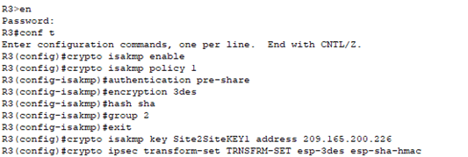
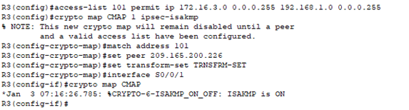
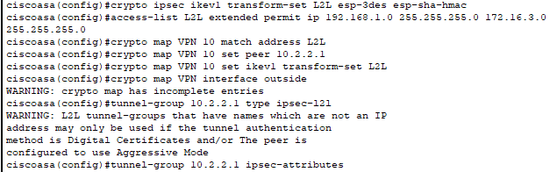usage of encryption, hashing, and digital signatures together, an information shared across the network can be protected against unauthorized access, tampering, and impersonation. For instance, an secured information sent on the network with encryption can only be decrypted with the correct key, ensuring confidentiality. Hashing can be used to detect any changes to the original message, ensuring integrity. Finally, digital signatures can be used to confirm the authenticity of the sender and the integrity of the message, ensuring authentication. By combining these techniques, cryptographic systems can provide secure and trustworthy communications.

PART 2

Secure Network Infrastructure Proposal
As a cybersecurity experts, we need to understand the significance of securing the organization’s network infrastructure, as during the given increase in remote work, cloud services adoption, and the use of personal devices includes IOT & Smart devices. With this in mind, we have to design a comprehensive blueprint for a secure network infrastructure tailored towards securing the organization’s unique requirements.
Our proposal will be including with detailed explanations of the proposed choices and security measures, a cost analysis for implementing the solutions, and a three-month project plan timeline for implementation.

Proposed Choices and Security Measures

Network Segmentation
Vlan’s helps in creating separate small network for each department and the manufacturing unit plant, isolating them to prevent unauthorized access and also to limit the spread of potential attacks. By implementing network segmentation, we will create separate Virtual Local Area Networks (VLANs) for each department and the manufacturing plant. This approach will minimize the attack surface and prevent unauthorized access to sensitive information from the attackers. In case of a security breach, it will limit the spread of the attack by containing it within the affected VLAN. Additionally, we can deploy Access Control Lists (ACLs) to manage inter-VLAN traffic and ensure that only authorized personnel can access specific resources.

Virtual Private Network (VPN)
To ensure next level protection remote access services like VPN’s, we recommend implementing a robust VPN solution that uses strong encryption algorithms & hashing in addition to multi-factor authentication (MFA). Implementing a robust VPN solution will provide secure remote access to A2Z Technologies Ltd organization’s network resources. By using strong encryption protocols, such as OpenVPN or IKEv2/IPSec, we will ensure that all data transmitted between remote workers & services being used over the network or on cloud. A2Z Technologies Ltd network is encrypted and secure from eavesdropping. Furthermore, multi-factor authentication (MFA or 2FA) will be integrated to provide an extra layer of security, requiring users to present two or more pieces of evidence (e.g., password, security token) to verify their identity.

Network Access Control (NAC)
Implemention of NAC can provide & helps to regulate access to network resources based on user roles, device types, and security policies. Network access control will help regulate access to A2Z Technologies Ltd network resources based on predefined user roles, device types, and security policies. This will enable A2Z IT or Security team to monitor and control as authorized users can access A2Z Technologies network and which resources they are allowed to access. NAC implementation will involve profiling devices, enforcing access policies, and providing remediation actions for non-compliant devices. This will ensure that only authorized devices can connect to A2Z network and help prevent unauthorized access.

Firewall and Intrusion Prevention System (IPS)
A next-generation firewall with an integrated IPS will help protect organization’s network from external threats and unauthorized access. We will deploy a next-generation firewall with an integrated IPS to protect A2Z Technologies Ltd network from external threats and unauthorized access. The Next gen firewall will be configured to allow only necessary traffic while blocking potentially harmful traffic. The Intrusion Prevention System will monitor network traffic, detect and prevent intrusion attempts, and alert security personnel about potential threats in real-time. Regularly updating to Next gen firewall and intrusion prevention system signatures will ensure up-to-date protection against emerging threats.

Endpoint Security
We strongly recommend to deploy endpoint security solution on all devices which supports, including personal ones, to prevent malware infections and data breaches. To safeguard organization from malware infections and data breaches, we will deploy comprehensive endpoint security solution on all end devices, including those owned by employees. The endpoint security solution will offer anti-malware, anti-phishing, and exploit prevention capabilities. It will also be including a host-based intrusion prevention system (HIPS), which will be monitoring the system behavior and block suspicious activities. We will enforce a security policy that mandates regular updates and scans on all devices connected to A2Z Technologies Ltd network.

Cloud Security
For A2Z Technologies Ltd cloud services, we suggest the implementation of robust access controls, encryption, and monitoring solutions to safeguard sensitive data and applications. As A2Z Technologies Ltd adopts cloud services, it is crucial to ensure the security of sensitive information and applications. We will implement robust access controls using Identity and Access Management (IAM) to define and manage user roles and permissions within A2Z Technologies Ltd cloud environment. Security policies towards Data-at-rest and data-in-transit encryption will be used to protect sensitive information from unauthorized access. We will also be deploying cloud-native security tools to monitor activity and detect potential threats in real-time. Regular audits of system and reviews of cloud security configurations will be conducted to maintain a strong security posture.
By adopting & enforcing the security policy these in-depth security measures, A2Z Technologies Ltd will greatly enhance its cybersecurity resilience and minimize the risk of cyber-attacks in near future.
Figure 1 illustrates the secure network design for A2Z Technologies
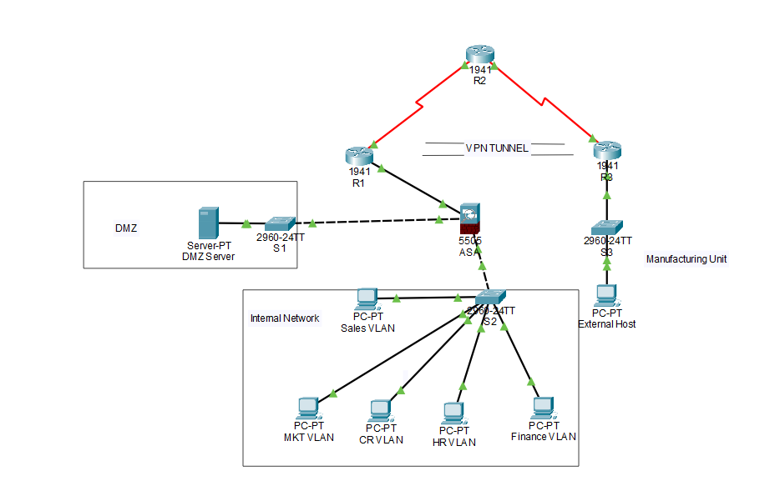
Figure 1: A Secure Network Design for A2Z Technologies

Cost Analysis
Cost analysis will be done in this section, we provide a detailed technical cost analysis for the proposed security measures, including hardware, software, and subscription services. The costs are broken down into initial setup, ongoing maintenance, and support costs.

Network Segmentation
Switches with VLAN-Support: $3,900 (4 x $975 per switch)
Installation and Configurations: $3,100
Annual Maintenance and Support: $3,100
Initial Cost = Switches + Installation
Total Initial Cost: $10,100

VPN Solution
VPN Server Hardware: $6,000
VPN Software Licenses: $10,000 (100 x $100 per user)
Installation and Configuration: $6,000
Annual Maintenance and Support: $6,000
Initial Cost = Server + Licenses + Installation
Total Initial Cost: $28,000

NAC Implementation
NAC Server Hardware: $6,000
NAC Software Licenses: $10,000 (100 x $100 per user)
Installation and Configuration: $4,000
Annual Maintenance and Support: $3,000
Initial Cost = Server + Licenses + Installation
Total Initial Cost: $23,000

Firewall and IPS
Next-Generation Firewall Hardware: $19,500
Firewall and IPS Subscription Services: $7,500 (annual)
Installation and Configuration: $4,000
Initial Cost = Firewall Hardware + Installation
Total Initial Cost: $31,000

Endpoint Security
Endpoint Security Software Licenses: $10,000 (100 x $100 per user, annual subscription)
Installation and Configuration: $6,000
Initial Cost = Licenses + Installation
Total Initial Cost: $16,000

Cloud Security
Cloud Security Services Subscription: $12,000 (annual)
Implementation and Configuration: $4,000
Initial Cost = Subscription + Implementation
Total Initial Cost: $16,000
Total Initial Cost = $10,100 + $28,000 + $23,000 + $31,000 + $16,000 + $16,000 = $101,100
Total Annual Maintenance and Support = $3,100 + $6,000 + $3,000 + $7,500 + $10,000 + $12,000 = $41,600
The total initial cost of implementing the proposed security measures is $101,000, along with the ongoing annual maintenance and support cost is estimated to be $41600.

Attacks that Plagues A2Z Technologies Network Infrastructure
In order to provide a comprehensive understanding of the potential threats to A2Z Technologies Ltd network infrastructure, we have outlined three common attacks which is commonly used by attackers to make the organizations victim. As making aware of these threats, A2Z Technologies Ltd can better protect A2Z Technologies organization and maintain a secure network infrastructure.

Distributed Denial of Service (DDoS) Attacks
DDoS attacks occur when multiple systems are used to flood a target, such as a server, website, or network, with an overwhelming amount of traffic (Durcekoca, 2012). This type of attack can lead to a total denial of service, make the target inaccessible to legitimate users which adversely affects in reputation of the organization. DDoS attacks may be motivated by financial gain, activism, or simply the desire to disrupt an organization’s operations. Implementing robust security measures such as Intrusion Prevention Systems (IPS), Web Application Firewalls (WAF) & third party solutions, and traffic monitoring solutions can help detect and mitigate DDoS attacks.

Advanced Persistent Threats (APTs):
APTs are stealthy, long-term attacks carried out by skilled adversaries, often targeting organizations with high-value information or resources (Siddiqi, 2016). The attackers typically gain access to the network through targeted phishing campaigns, exploiting the vulnerabilities, or leveraging compromised credentials or password spraying. As they gain access to network they move laterally, maintain a low profile, and gradually exfiltration of sensitive data. To defend against APTs, it is essential to adopt a multi-layered security approach, including network segmentation, continuous monitoring, endpoint protection, and employee security training.

Ransomware Attacks
Ransomware is a type of malicious software that encrypts an organization’s data, rendering it inaccessible until a ransom is paid to the attacker (Mos, 2020). Ransomware attacks can have severe financial and operational consequences also the reputation of organization will be affected, often causing downtime. These attacks are carried out & executed through phishing emails, drive-by downloads, or exploiting known vulnerabilities in applications. To build a protectection against ransomware, it is critical to maintain regular backups of important data, keep software and systems up-to-date, deploy endpoint security, and educate employees about the risks of phishing and other social engineering tactics.
By underlying these known & attacks and implementing the industry validated security measures, A2Z Technologies Ltd can significantly reduce the risk of falling victim to cyber threats and maintain a secure network infrastructure.

Recommendation of Security Tests
After implementing the secure network infrastructure, it is crucial to verify its effectiveness and identify any potential vulnerabilities. We recommend conducting the following three types of security tests periodically to ensure that A2Z Technologies Ltd network infrastructure remains secure over time. These tests will help A2Z Technologies Ltd to stay proactive in addressing potential security issues and maintaining a strong security posture.

Vulnerability Scanning
Vulnerability scanning is an automated process that identifies potential security weaknesses in A2Z Technologies Ltd network infrastructure, end systems, servers and applications. Which involves using specialized automated tools to scan A2Z Technologies Ltd network for known & common vulnerabilities, security misconfigurations, and other security issues. Regular vulnerability scanning helps A2Z Technologies Ltd.

Penetration Testing
Penetration testing, or "pen testing," is a simulated cyberattack on A2Z Technologies network infrastructure designed to identify exploitable vulnerabilities and assess A2Z Technologies organization’s security posture. Approach of Pen testing involves different types of penetration testing, including black-box (no prior information will be shared to Security Engineer), grey-box (limited information will be shared), and white-box (brief information about the network), depending on the level of information provided to the tester (Blackwell, 2014). Penetration testing should be conducted periodically, at least quarterly or twice year, or after significant changes to network infrastructure, to ensure that A2Z Technologies security measures are effectively protecting A2Z Technologies organization.

Social Engineering Testing
Social engineering attacks, such as phishing, are the most common method which is used by cybercriminals to gain unauthorized access to A2Z Technologies network. To assess A2Z Technologies organization’s security against social engineering attacks, it is essential to conduct regular social engineering tests. These tests include simulate real-life scenarios, which can include phishing emails or phone calls, to evaluate employee awareness and adherence towards security policies. Based on the test results, A2Z Technologies Ltd can provide targeted training to employees, reinforcing best practices and improving overall security awareness. We recommend conducting social engineering tests at least twice a year.
By performing these security tests on a regular basis, A2Z Technologies Ltd will be able to identify and address potential vulnerabilities proactively, ensuring that A2Z Technologies network infrastructure remains secure and resilient against cyber threats.

Cost Analysis & Prices for the Professional Services
Date: 18th July 2023
Invoice No: 1111
Bill To:
A2Z Technologies Ltd
Item Description | Rate | Amount
Network Security Consultation
Security Assessment & Gap Analysis | $3,500.00 | $3,500.00
Secure Network Infrastructure Design | $4,500.00 | $4,500.00
Vendor & Solution Selection | $3,000.00 | $3,000.00
Technical Cost Analysis | $3,000.00 | $3,000.00
Security Measures & Attack Overview | $3,000.00 | $3,000.00
Post-Implementation Security Testing Recommendations | $4,000.00 | $4,000.00
Sub Total | $21,000
Network Security Implementation
Project Management & Implementation Support | $6,000.00 | $6,000.00
Assistance with Vendor Coordination | $3,000.00 | $3,000.00
On-site Support & Remote Assistance (as required) | $6,000.00 | $6,000.00
- Post-Implementation Security Testing & Validation | $9,000.00 | $9,000.00
Sub Total | $24,000
Grand Total | $45,000.00

References
Alabady, S.A.J., 2008, April. Design and implementation of a network security model using static VLAN and AAA server. In 2008 3rd International Conference on Information and Communication Technologies: From Theory to Applications (pp. 1-6). IEEE.
Blackwell, C., 2014. Towards a penetration testing framework using attack patterns. Cyberpatterns: Unifying Design Patterns with Security and Attack Patterns, pp.135-148.
Catescu, G., 2018. Detecting insider threats using Security Information and Event Management (SIEM). University of Applied Sciences Technikum Wien. Available at: shorturl. at/dtzOT.
Durcekova, V., Schwartz, L. and Shahmehri, N., 2012, May. Sophisticated denial of service attacks aimed at application layer. In 2012 ELEKTRO (pp. 55-60). IEEE.
Fink, G.A., Edgar, T.W., Rice, T.R., MacDonald, D.G. and Crawford, C.E., 2017. Overview of Security and Privacy in Cyber‐Physical Systems. Security and Privacy in Cyber‐Physical Systems: Foundations, Principles and Applications, pp.1-23.
Gunleifsen, H., Kemmerich, T. and Gkioulos, V., 2019. Dynamic setup of IPsec VPNs in service function chaining. Computer Networks, 160, pp.77-91.
Jyothi, K.K. and Reddy, B.I., 2018. Study on virtual private network (VPN), VPN’s protocols and security. International Journal of Scientific Research in Computer Science, Engineering and Information Technology, 3(5), pp.919-932.
Mos, M.A. and Chowdhury, M.M., 2020, July. The growing influence of ransomware. In 2020 IEEE International Conference on Electro Information Technology (EIT) (pp. 643-647). IEEE.
Mustafa, A., Siddique, N. and Zubair, M., 2015. Data link layer security problems and solutions.
Paquet, C., 2012. Implementing Cisco IOS Network Security (IINS 640-554) Foundation Learning Guide: Imp Cisco IOS Netw Sec F _c2. Cisco Press.
Siddiqi, M.A. and Ghani, N., 2016. Critical analysis on advanced persistent threats. Int. J. Comput. Appl, 141(13), pp.46-50.
Srinivas, J., Das, A.K. and Kumar, N., 2019. Government regulations in cyber security: Framework, standards and recommendations. Future generation computer systems, 92, pp.178-188.

