Assessment – All means all
Practitioners guide related to one additional learning need (4000 words)
Policy, legislation
Theory
2 case studies

ADHD in children: Effective Practice Guidelines
Introduction – Purpose of this guide
Currently, 2% to 5% of school age children in the UK are thought to have Attention deficit hyperactivity disorder (ADHD).
This guide is intended for teachers, other staff members and volunteers who work with students who have attention deficit hyperactivity disorder (ADHD) in primary school settings. This resource will describe the various forms of ADHD that children may experience. Additionally, this guide will include evidence from Case studies, policies and legislations, and theories. This recourse will discuss the difficulties and challenges that children and primary educators could encounter when confronting this additional learning need (ALN). The aim of this guide is to provide effective practice guidelines, which includes a variety of ideas with effective support and inclusion.
Background
“Attention deficit hyperactivity disorder (ADHD) is a condition that affects people’s behaviour. People with ADHD can seem restless, may have trouble concentrating and may act on impulse.” (NHS N.D.)
Children with ADHD may exhibit symptoms at a young age, and they may become more apparent as their surroundings change, such as when they start school. Although the majority of instances are identified in children under the age of twelve, it can occasionally be identified later in life. Sometimes an adult diagnosis of ADHD is made when the disorder was not identified in childhood. Despite the fact that the symptoms of ADHD may lessen with age, many individuals who receive an early diagnosis still struggle.
Symptoms of ADHD in children (NHS N.D.)

Attention deficit hyperactivity disorder (ADHD) symptoms fall into two categories of behavioural issues:
- Inattentiveness (difficulty focusing and concentrating)
- Hyperactivity and impulsiveness
Inattentiveness (difficulty concentrating and focusing )
- Being easily distracted and having short attention span
- Making thoughtless errors, for example in school work
- Often forgetful, disorganisation and losing things
- Being incapable of completing time-consuming or challenging tasks
- Seeming incapable of paying attention to or following directions.

Hyperactivity and impulsiveness
- An excessive amount of talking
- Impatient
- Persistent fidgeting
- Unable to concentrate for long periods of time
- Acting without thinking
While this isn’t always the case, many people with ADHD have issues that fit into both of these categories. For instance, about two to three out of ten individuals with the disorder struggle with focus and concentration, but not with impulsivity or hyperactivity.
Attention deficit disorder (ADD) is another name for this kind of ADHD. Because the symptoms of ADD might be less evident, it can occasionally go undiagnosed.
Boys are diagnosed with ADHD more frequently than girls. Girls are less likely to exhibit disruptive behaviour that highlights signs of ADHD and are more likely to exhibit inattentiveness alone. This implies that girls with ADHD might not always receive a diagnosis.
- Being unable to concentrate on tasks
- Excessive physical movement
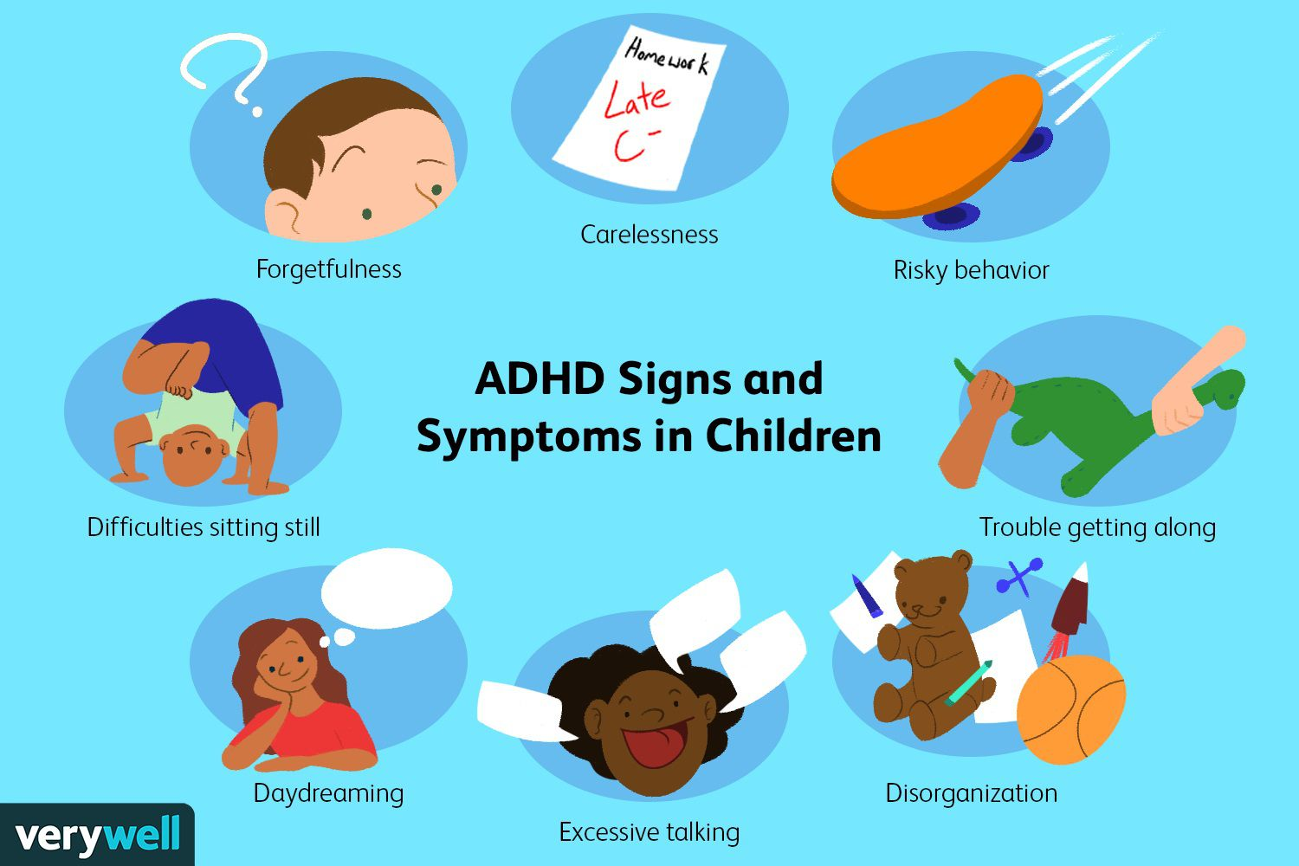
- Excessive talking
- Constantly fidgeting
- Being unable to wait their turn
- Acting without thinking
- Interrupting conversations
- Easily distracted
- Impatient
- Carelessness
- Disorganisation
Although the true cause of ADHD is uncertain, it has been demonstrated that the disorder runs in families. When comparing the brains of those with ADHD to those without the disorder, research has also shown many potential changes. Although it is more prevalent among those with learning disabilities, ADHD may affect persons of any intellectual capacity.
It is generally believed that the genes you acquire from your parents have a major role in developing ADHD, which tends to run in families. According to research, there is a higher likelihood of ADHD in parents and siblings of someone with the disorder. ADHD is not believed to be caused by a single genetic flaw, but rather is likely to be inherited in a complicated manner.

How ADHD is treated
Although there is no know treatment for ADHD in children, it may be controlled with the right kind of educational support, guidance, and assistance for parents and impacted children, as well as medication if needed.
Although therapy or medication can be used to treat ADHD, a combination of the two is frequently most effective. A professional, such as a psychiatrist or paediatrician, often arranges treatment, while a general practitioner (GP) may keep an eye on the disorder.
Medicine
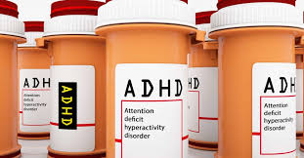
There are five types of medicine for ADHD
- Methylphenidate
- Lisdexamfetamine
- Dexamfetamine
- Atomoxetine
- Guanfacine
These medications may help someone with ADHD focus better, be less impulsive, feel calmer, and acquire and practice new abilities, but they are not a permanent solution. While some medications must be taken daily, others can only be taken during school hours. Sometimes it is advised to take a pause from treatment to determine whether the medication is still necessary.
Children, teens, and adults with ADHD may benefit from many different therapies, in addition to medication. Additional issues that may arise with ADHD, such as anxiety disorders, can also be effectively treated with therapy.
Here are some different types of therapies that can be useful
- Psycho education
- Behaviour therapy
- Parent training and education programs
- Cognitive behavioural therapy (CBT)
Brain function
It’s unclear exactly what these changes mean, but research has shown some potential distinctions between the brains of those with ADHD and those without the disorder. Brain scan studies, for instance have revealed that individuals with ADHD may have bigger brain regions and smaller brain regions alternately. Other research has indicated that neurotransmitters may not function correctly in the brains of people with ADHD or that there may be an imbalance in their levels.
Diagnosis
If its believed that a child in your primary school setting has attention deficit hyperactivity disorder (ADHD) the school special education needs coordinator (SENCO) will be consulted as well as the headteacher or deputy and the students parents. The parents can then consult a general practitioner (GP) and they can communicate with the school. However the GP cannot officially diagnose ADHD, they may talk about concerns and if needed send the child for a specialised evaluation. Additionally the child’s school may be able to set up a referral to the specialist.
Related conditions in Children and young adults with ADHD
- Anxiety disorder
- Depression
- Autistic spectrum disorder (ASD)
- Dyspraxia
- Tourette’s syndrome
- Learning difficulties such as dyslexia
Ways to cope with children with ADHD
Living with attention deficit hyperactivity disorder (ADHD) can be challenging for children since the symptoms can make daily tasks more difficult. It can be challenging to care for and teach children with ADHD. Daily tasks might be difficult and draining due to the impulsive, reckless and disorganised behaviours associated with ADHD. It is helpful to remember that a child with ADHD cannot control their behaviour, even if it might be challenging at times. Impulse suppression may be a challenge for children with ADHD, so they might not pause to think through a situation or its implications before acting.
Effective practice guidelines
Plan the day – Since children with ADHD are frequently quite disorganised, it is very beneficial to plan the day so the student is aware of what to anticipate. The way a child handles daily life in school environments might be influenced by established routines. The school already will have a routine, so this adjustment shouldn’t be too challenging. For instance, explain the day’s schedule to the student in the morning and break it down into phases so they know precisely what they need to prepare for, for example physical education or an assessment.
Setting clear boundaries – Make sure everyone understands the expectations for behaviour, and enforce positive behaviour management strategies, ensure to give praise and rewards for good, positive behaviour. However it is important to be positive, Express specific gratitude. Rather than saying something generic like “thanks for doing that” you can say something like “well done you did a great job of tidying the scissors and glue away thank you” This will ensure that your student clearly knows that you are happy with them and why. For example, allow the children to create their own class rules at the start of the educational year they then know that if they break these rules there will be consequences, allowing them to create their own rules holds them accountable, they know what is expected of them and gives them a sense of independence. As an educator set clear guidelines, enforce them consistently, an use consequences, so that if children do not follow the class rules they know what will happen for example, loosing some of their break time, or missing out on part of golden Friday.
Reward and incentive schemes – Create your own reward system using a star chart or points system so that excellent behaviour can lead to rewards. For instance the child will get ipad time on the last Friday of the term if they behave well and gain enough points or stars. Engage the child in the process and allow them to choose their rewards.
Giving instructions – As a teacher give your student brief, concise instructions if your asking them to perform something. Instead of requesting ”can you tidy up” try being more specific “please can you put the Lego away now, and put the books back on the shelf” This clarifies what the child must do, and provides opportunity for them to receive praise when they succeed.
Support at school – ADHD can have detrimental impact on a child’s academic development and frequently causes behavioural issues in the classroom. To ensure the teacher and child receives support a discussion between the child’s parents and educator should be had to see what kind of support they can can offer, for example the schools special educational needs coordinator (SENCO) or Additional learning needs coordinator (ALNCO) will get involved and see what support they can offer, the school may also provide a one to one in the classroom for the child depending on the severity of their behaviour.
Exercise- Throughout the day, make sure the student receives enough exercise and fresh air. Playing sports, walking, skipping, even just getting outside can help the student exhaust themselves and get better sleep.
Theory
A prevalent and highly heritable neurodevelopment psychiatric condition is attention deficit hyperactivity disorder (ADHD). The ability of the four main psychological theories of ADHD, executive dysfunction, state regulation, delay aversion and dynamic developmental, to explain all of the symptoms of ADHD, as well as their testability and susceptibility to falsification, are severely examined here. We come to the conclusion that theorists ought to concentrate more on creating debatable theories of ADHD than is currently the case. (Johnson, Wiersema, Kuntsi, 2009)
The four main behavioural and cognitive theories of dysfunction linked to ADHD are the following: state regulation, executive dysfunction, delay aversion, and dynamic developmental theories. The past ten years have seen changes to each of these theories. Theorists have added auxiliary hypotheses to explain new evidence as they have emerged, as Lakatos anticipated; some of these auxiliary hypotheses are parts of the other dominant theories. H

https://www.nhs.uk/conditions/attention-deficit-hyperactivity-disorder-adhd/
https://behavioralandbrainfunctions.biomedcentral.com/articles/10.1186/1744-9081-5-15

