Introducere
IHG HOTELS, History, Present and Organization
IHG in formed in 2003 when Six Continents plc divides into Mitchells & Butlers plc, a retail firm, and InterContinental Hotels Group plc (IHG), a distinct hotel and soft drink corporation. In April 2003, the separation is finalised, and IHG becomes an independent business(IHG Hotel and Resorts,2024). One of the top hotel chains in the world, IHG® Hotels & Resorts employs almost 345,000 people to provide True Hospitality for Good in more than 100 countries at present(IHG hotel and Resorts,2024).
Their decision to operate hotels for independent hotel owners or to franchise to them is mostly based on the specific brand, owner desire, and market maturity. While managed models are more common in growing economies like China, franchise models are more common in mature regions like the Americas and Europe. Their franchisees may use one of their many well-known and recognisable trademarks to brand their hotels, and they will also get access to a robust reservation system and loyalty scheme. To generate business and new demand, they also provide an extensive suite of tools, including marketing campaigns and revenue management. Some independent property owners desire their hotel handled for them, and they count on IHG to deliver the best service possible wherever in the globe. Although IHG are the hotel's manager, a third company still owns the actual structure. Senior management positions with authority to form a successful team are often held by IHG personnel, such as the General Manager of the hotel and the Fiscal Controller.
IHG put a lot of effort into creating businesses—from brainstorming meetings for new projects to organising every aspect of hotel operations to the actual launch. After the hotel opens, tHEY provide owners with top-notch, brand-specific services that boost staff productivity, raise visitor satisfaction levels, and boost income. Their emphasis on a capital-light business model is underpinned by a methodical, long-term approach to capital allocation and a reduction in the company's asset intensity. Also, their goal is to keep an investment-grade credit rating and an effective balance sheet. IHG company generates a lot of cash, which they primarily employ for three purposes: investing in the company to spur development, maintaining steady increase in the regular dividend, and paying out excess cash to shareholders( IHG Hotel and Resorts, 2022).
ORGANIZATIONAL STRUCTURE
Whether they acknowledge it or not, all businesses require an organisational structure. The corporation assigns roles, duties, job functions, accountability, and decision-making power through its organisational structure. The "chain of command" and the flow of information inside the corporation are frequently shown in the organisational structure. It's critical to have an organisational structure that supports the aims and objectives of business. Workers want to know what their job duties are, who they respond to, what choices they may and should make, and how they work with other team members and individuals inside the organisation. This framework is established by an organisational structure. Organisational structures can be flat or vertical, hierarchical or circular, centralised or decentralised( Bottorff, 2023).
By dispersing decision-making responsibilities among teams and departments as opposed to originating from the top, the matrix organization fosters dedication and buy-in from all areas of the company. It respects the diversity of leadership experiences and enables skill cross-training across team members. There is still value in the manner that a 2012 article published in the Harvard Business Review summed up the principles of matrix management. Four key qualities for effective matrix management were listed in the paper, hinting at the structural shift in leadership that will occur over the next 10 years. These abilities include self-awareness, influence, empathy, and conflict resolution. Although they may not be aware of how these essential abilities relate to matrix management, today's managers are aware of their importance( Logemann, 2023).
CENTRALISED VS DECENTRALIZED STRUCTURE
The decision-making process under a centralised organisational structure is mostly hierarchical. All pertinent choices must be approved by someone or an executive team, who then communicates with different levels of management. Companies that prioritise their production strategy and work to save operational expenses are most suited for centralised management. Additionally, centralization promotes departmental cooperation, streamlines best practices, and facilitates communication with outside parties and vendors.
Decentralised organisations distribute decision-making power across a number of staff members or departmental groups. Decisions are approved by subordinates and subsequently reported to higher-level management staff. Decentralised organisational structures are common in emerging sectors because they make it simpler to assign staff members to new positions and alter their duties. This organisational structure works well for businesses that wish to react fast to changing market demands or geographically distinct client needs. Because a decentralised organisational structure uses an additional relaxed structure of command methodology, it's also fantastic for enhancing career progression chances and giving staff the freedom to offer new ideas (Indeed, 2023).
HIERARCAL STRUCTURE AND FLAT STRUCTURE
Because a defined authority structure and a line of command from top to bottom are in place, an organisational framework that is hierarchical resembles a pyramid. The board of directors, which sits at the top, is responsible for making important decisions that will last for the business. Large organisations benefit from hierarchical organisational structures because they create a clear line of authority as well as interaction throughout the whole business.
A organisational layout that is flat occurs when a small number of workers share the company's power and duties. This management approach is popular among startups as they frequently lack the funding to hire enough people for a hierarchical organisation. Instead of using hierarchical structures, modern businesses are starting to use flat ones, which provide employees greater freedom and foster an environment of openness and collaboration. This approach fosters a culture of commitment and value among all employees by allowing for less oversight and increased employee participation(Indeed,2023).
IHG CONTINENTAL CULTURE
CIPD says that executive teams, business boards, senior HR experts, and governance specialists all need to know about organisational culture. The famous management scholar Peter Drucker is quoted as saying that "culture eats strategy for breakfast," which emphasises the importance of a strong and positive corporate culture in enabling organisations to achieve their goals and execute their plans(CIPD, 2023).
IHG CONTINENTAL CULTURE
Corporate responsibility is ingrained in the DNA of IHG Hotels and Resorts. It serves as the cornerstone of their whole approach and their dedication to offering True Hospitality for Good.
IHG put forth just as much effort to maintain their stellar reputation, which they have worked so hard to establish. This implies that they have to constantly act with the utmost ethical standards, honesty, and integrity, no matter where the staff are in society or who they are dealing with. The values outlined in their Code of Conduct assist them in doing this( IHG, 2021).
The goals of IHG's incentive programme are to draw in, keep, inspire, and involve elite personnel. It is bolstered by a strong governance framework that guarantees our policies regarding rewards and recognition are equitable and uniform for all of our employees and colleagues, irrespective of gender and other factors of diversity, and that executive compensation and the larger direct workforce are in line. IHG is very aware of the culture they created as it supports their mission to offer True Hospitality for Good and is essential to whom they are, how they collaborate, and how they expand as a company. Because of this, one of their main Journey to Tomorrow pledges is to support a varied culture in which everyone may prosper( IHG Hotels and Resorts, 2022).
The global Diversity, Equity, Inclusion & Equal Opportunities Policy supports their commitment, which is emphasised in all of their global hiring policies and initiatives. IHG work in this area is centred around a DE&I framework that covers three main areas: addressing underrepresentation in their leadership, fostering an inclusive and inspiring culture for all of their employees, and promoting gender balance globally(IHG, 2023).
IHG GOVERNANCE STRUCTURE
Establishing the group's strategic goals, keeping an eye on the group's performance, and enforcing risk management controls are all ways in which the Board directs the group's strategic direction, long-term goals, and success. Many important choices and issues are not given to management; instead, they are held for the Board's approval. These cover issues pertaining to the Group's commercial strategy and business operations; noteworthy investment proposals; keeping tabs on the Group's financial and operational performance; and overseeing the Group's overall structure of internal controls, risk management, governance, and compliance( IHG, 2024).
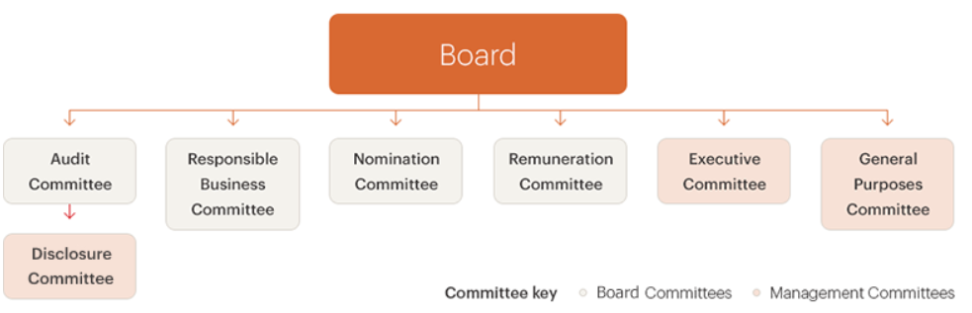
BCG MATRIX
A business planning tool used to assess the strategic position of a firm's brand portfolio is the Boston Consulting Group Matrix (BCG Matrix), sometimes called the product portfolio matrix. Among the most often used portfolio analysis techniques is the BCG Matrix (CFI, 2023).
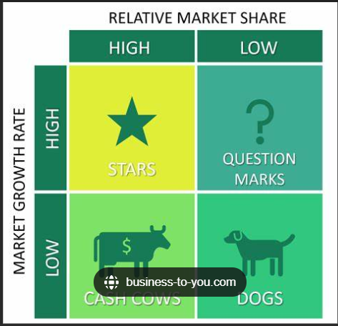
Well known brands likeInterContinental, Holiday Inn, Kimpton Hotels or Crowne Plaza are among those in the company’s portfolio. IHG offers a variety of lodging options, from luxorious resorts to reasonably priced, cosy stays to suit business and leasure travellers. In BCG Matrix, Kimpton Hotels and InterCONTINENTAL Hotels are classified as star, with 12% respective 9% growth increase, on question mark are Even Hotels and Voco, that are focused on fitness and wellness segments, cash caw for IHG are Holiday Inn and Holiday Inn Express with 7.8 bilion revenue in 2022 respectively 5.3 billion revenue in 2023 ( Discounted Cash Flow, 2023).
Comparing IHG with Hyatt Hotels Corporation it is noticed that Hyatt brands are in growth, their cash cows products for example are Hyatt Regency and Hyatt Place( Discounted Cas Flow, 2023).
PORTER’S FIVE FORCES
Organisations utilise the well-known Porter's Five Forces model to analyse their competitive setting and arrive at wise judgements. The methodology, created by eminent Harvard Business School ,Michael E. Porter, enables businesses to assess the external factors influencing the direction of their sector. This 5 forces are competitive rivalry, buyer power, supplier power, threat of new entrants and threat of substitution( Watts, 2024)
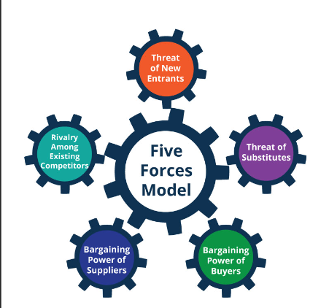

InterContinental Hotels Group may evaluate the attractiveness of the sector, make wise decisions about entering or leaving, and evaluate how these forces affect their rivals' and their own businesses by utilising Five Force analysis. Furthermore, this model's dynamic analysis can provide crucial details. For instance, InterContinental Hotels can assess the prospective future attractiveness of the sector by combining the PESTEL framework with the Porter 5 force model. Companies may lack the necessary data to assess the five factors ( Henry, 2018).

BUSINESS PERFORMANCE
IHG and the UK Environmental Building Council worked together on the Second Nature LIVE project in 2021, which allows professionals in the built environment to apply transformative sustainability ideas to a real-world case study. Participants in the training involved themselves in the tourism sector in order to learn how to operate a net-zero-emissions hotel and to discover what a genuinely resilient, sustainable hotel industry may entail( IHG Hotels and Resorts, 2024).
The $550 billion hotel sector is supported by strong structural growth drivers, such as population expansion, the innate need and desire to travel for both business and pleasure, and the burgeoning middle class in emerging nations with rising disposable income. Travel expenditures are still among the most resilient consumer discretionary categories, and corporate travel demand is still strong, with hotels adjusting to accommodate the flexible working norms of the post-Covid19 era(IHG Hotels and Resorts, 2022).
The IHG Hotels & Resorts, acknowledge that their duty is to uphold the fundamental human right to an environment that is healthy, sustainable, and clean as well as to safeguard the environment. One of IHG's top strategic goals and a cornerstone of the company culture is taking care of people, communities, and environment. Their ethical business strategy, Journey to Tomorrow, outlines their pledges to improve both the company and the community in which they operate. IHG fulfil the mission of True Hospitality for Good by upholding their environmental responsibilities and supporting local communities (IHG, 2023).
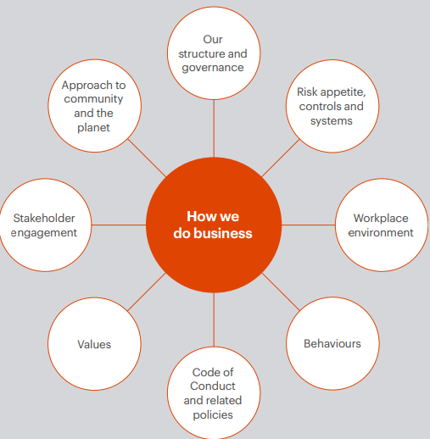

CONCLUSION

IHG dedication to a culture of functioning in an ethical and accountable way serves as the foundation for their mission of offering True Hospitality for Good. The business practices are shaped by their culture( IHG Hotels and Resorts, 2021).

References
Cassie Bottorff (Jul 2023) 7 Organizational Structure Types (with examples). Available at 7 Organizational Structure Types (With Examples) – Forbes Advisor (Accessed on 19 Feb 2024).

CFI Team (2023) Boston Consulting Group (BCG) Matrix. Available at BCG Matrix - Overview, Four Quadrants and Diagram (corporatefinanceinstitute.com) (Accessed on 24 Feb 20204).

CIPD (2023) Organizational Structure. Available at Organisational culture | CIPD (Accessed on 20 Feb 2024).

Discounted Cash Flow (2023) InterContinental Hotel Groups PLC IHG BCG Matrix Analysis. Available at dcf.fm/blogs/blog/ihg-bcg-matrix (Accessed on 25 Feb 2024).
Discounted Cash Flow (2023) Hyatt Hotels Corporation BCG Matrix. Available at dcf.fm/blogs/blog/h-bcg-matrix (Accessed on 25 Feb 2024).

IHG Hotels and Resorts (2024) Our History. Available at Our history - InterContinental Hotels Group PLC (ihgplc.com) (Accessed on 21 Feb 2024).

IHG Hotels and Resorts (2024) About Us. Available at About us - InterContinental Hotels Group PLC (ihgplc.com)( Accessed on 20 Feb 2024).

IHG Hotels and Resorts (Mar 2022) How our business works. Available at How our business works - InterContinental Hotels Group PLC (ihgplc.com)( Accessed on 19 Feb 2024).

IHG Hotels and Resorts (2022) Annual report and Form. Available at annual-report-2022.pdf (ihgplc.com) (Accessed on 25 Feb 2024).

IHG Hotels and Resorts (2021) Annual report and form. Available at 240101725-IHG-AR_2020 (ihgplc.com)( Accessed on 25 Feb 2024).

IHG Hotels and Resorts (2024) Building a brighter future. Available at Collaborating with the UK Green Building Council to help build a brighter future - InterContinental Hotels Group PLC (ihgplc.com)( Accessed on 25 Feb 2024).

Indeed, Editorial Team (Mar 2023) Hierarchical vs Flat Organization Structure (basic guide). Available at Hierarchical vs flat organisational structure (basic guide) | Indeed.com UK (Accessed on 19 Feb 2024).

Indeed, Editorial Team (Oct 2023) Centralize vs Decentralized structures:7 keys differences. Available at Centralized vs. Decentralized Structures: 7 Key Differences | Indeed.com (Accessed on 19 Feb 2024).

IHG Hotels and Resorts (2022) Annual report and Form. Available at annual-report-2022.pdf (ihgplc.com) (Accessed on 25 Feb 2024).

IHG Hotels and Resorts (2021) Annual report and form. Available at 240101725-IHG-AR_2020 (ihgplc.com)( Accessed on 25 Feb 2024).

IHG Hotels and Resorts (2021) Our Code of Conduct. Available at ihg-coc-2021-en-new.pdf (ihgplc.com) (Accessed on 21 Feb 2024).

IHG Hotels and Resorts (2022) True Hospitality for Good. Available at ihg-responsible-business-report-2022.pdf (ihgplc.com)(Accessed on 22 Feb 2024).

IHG Hotels and Resorts (2024) Corporate Governance. Available at Corporate governance - InterContinental Hotels Group PLC (ihgplc.com)(Accessed on 21 Feb 2024).

Robert Logemann (Sep 2023) Managing for success in a Matrix Organization. Available at Managing For Success In A Matrix Organization (forbes.com) (Accessed on 20 Feb 2024).
Rob Watts (Feb 2024) Porter’s Five Forces: Definition and how to use the model. Available at Porter’s Five Forces: Definition & How To Use The Model – Forbes Advisor (Accessed on Feb 2024).
Zander Henry (Aug 2018) InterContinental Hotels Group Porter Five Forces Analysis. Available at InterContinental Hotels Group PLC Porter Five Forces Analysis (case48.com) (Accessed on 25 Feb 2024).

