BMSW4007
Cotemporary Challenges: Making a Difference
Assignment Title: Evidence of Learning E-Portfolio

Karim Md Shahadat
Student ID: 22088458

Table of Contents
Blog Post 1 3
The Causes of Climate Change 3
Impacts of Climate Change 4
Mitigation and Adaptation 4
Conclusion 5
References 5
Blog Post 2 6
Economic Inequality 6
Discrimination 7
Political Polarization 7
Environmental Degradation 8
Conclusion 8
References 9
Blog Post 3 10
The Challenge of Knowledge 10
The Challenge of Bias 10
The Importance of Interdisciplinary Perspectives 11
Conclusion 11
References 12

Blog Post 1
One of the most urgent challenges of current time is climate change, and its effects are becoming more and more obvious on a global scale. That is a challenging issue that necessitates a multi-faceted solution, involving not only individual actions, but also collective efforts from governments, businesses, and organizations (Change, 2017). In this blog, I will explore the science behind climate change, its impacts, and the steps we can take to mitigate and adapt to it.

The Causes of Climate Change
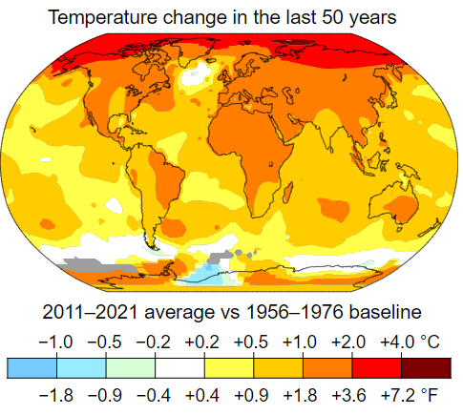
The primary factor that contributes to climate change is the global generation of greenhouse gases, most significantly carbon dioxide. As a result of greenhouse gas trapping heat and raising the temperature of the earth, a variety of unfavorable impacts are caused. Some of these effects include a rise in sea level, more extreme weather, and a decrease in biodiversity (Urry, 2015). Human activities, such as the burning of fossil fuels for energy, the clearing of land for agricultural and industrial use, and the destruction of forests, are the primary contributors to these emissions. In addition to this, natural phenomena like as volcanic eruptions and shifts in the Earth's orbit may also be contributing factors in the progression of climate change. Yet, the majority of experts are in agreement that human activity is mostly to blame for the rapid speed of climate change that we are now seeing. The temperature of the planet has increased by 4 degrees Celsius over the course of the last 10 years (Yang, et al., 2023). During the years 2000 and 2021, the concentration of carbon dioxide in the atmosphere of the Earth increased by around 45 parts per million (ppm), going from approximately 370 ppm to over 415 ppm (Robbins Schug, et al., 2023). This increase is mostly attributable to the burning of fossil fuels for energy, which is one of the contributors to climate change as well as global warming.

Impacts of Climate Change
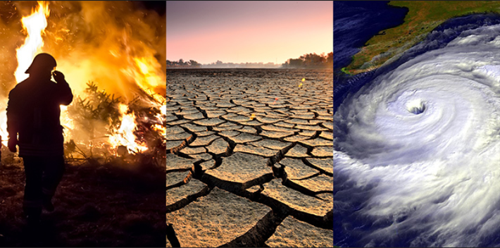
Climate change has far-reaching impacts on our environment, economy, and society. Rising sea levels threaten to inundate coastal cities and cause displacement of millions of people (Change, 2017). Crop failures, food shortages, and water scarcity are all on the rise as a direct result of the increasing frequency and severity of extreme weather events such as hurricanes and droughts. Climate change also poses a threat to biodiversity, as species struggle to adapt to changing temperatures and habitats (Yang, et al., 2023).

Mitigation and Adaptation
Mitigation and adaptation are the two main approaches to addressing climate change. Reducing emissions of greenhouse gases is one of the goals of mitigation, which may largely be accomplished by shifting to renewable energy sources, boosting energy efficiency, and cutting down on deforestation (Robbins Schug, et al., 2023). The process of preparing for and adjusting to the effects of climate change is referred to as adaptation. Some examples of adaptation include the construction of sea walls, the development of drought-resistant crops, and improvements in water management.
In order to effectively combat climate change, all levels of society, including governments, corporations, and people, must work together. Pricing carbon and mandating the use of renewable energy are two examples of the policies that governments may take to cut emissions (Urry, 2015). Companies may lessen their impact on the environment by embracing environmentally responsible practices and making investments in renewable energy. One way for individuals to make a difference is by lowering their own personal carbon footprint. This may be accomplished in a number of ways, including decreasing the number of miles driven, adopting a plant-based diet, and purchasing energy-efficient home appliances (Yang, et al., 2023).

Conclusion
The issue of climate change is a worldwide concern that calls for a worldwide response. It is critical that everyone of us take steps to lessen the impact that we have on the environment by producing carbon emissions and that we work to enact legislation that combat climate change on both the national and international levels. In addition to this, we need to put money into adaptation measures so that we can be ready for the effects of climate change that are already here (Urry, 2015). We can lessen the impact of climate change's most severe consequences and build a more sustainable future for ourselves and for future generations if we collaborate on finding solutions.

References
Change, M.S.S.I.C., 2017. Climate change.
Robbins Schug, G., Buikstra, J.E., DeWitte, S.N., Baker, B.J., Berger, E., Buzon, M.R., Davies-Barrett, A.M., Goldstein, L., Grauer, A.L., Gregoricka, L.A. and Halcrow, S.E., 2023. Climate change, human health, and resilience in the Holocene. Proceedings of the National Academy of Sciences, 120(4), p.e2209472120.
Urry, J., 2015. Climate change and society (pp. 45-59). Palgrave Macmillan UK.
Yang, M., Chen, L., Wang, J., Msigwa, G., Osman, A.I., Fawzy, S., Rooney, D.W. and Yap, P.S., 2023. Circular economy strategies for combating climate change and other environmental issues. Environmental Chemistry Letters, 21(1), pp.55-80.

Blog Post 2
Society faces many social challenges, ranging from economic inequality and discrimination to political polarization and environmental degradation. These challenges are complex and multifaceted, and they require a collaborative and interdisciplinary approach to solve (Di Nauta, et al., 2018). In this professional blog, we will explore some of the social challenges faced by society, their root causes, and potential solutions.

Economic Inequality
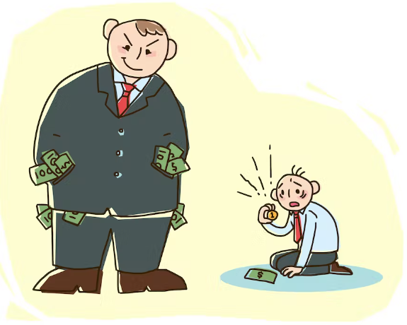
Economic inequality is one of the most pressing social challenges facing society. The gap between the rich and poor has been growing for decades, and it is exacerbated by globalization, technological change, and policies that favor the wealthy (Salvador Casara, et al., 2023). Economic inequality has negative effects on individuals and society as a whole, leading to increased social tensions, reduced economic growth, and diminished democracy. One solution to economic inequality is to implement progressive tax policies that ensure the wealthy pay their fair share. Additionally, investments in education, training, and infrastructure can help level the playing field and create more opportunities for everyone olve (Di Nauta, et al., 2018). Finally, policies that promote collective bargaining and unionization can help increase wages and reduce income inequality.

Discrimination
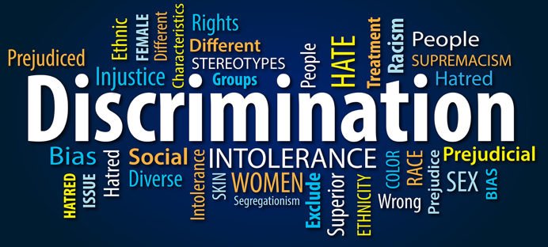
Discrimination on the basis of race, gender, sexuality, and other characteristics remains a pervasive social challenge. Discrimination leads to unequal opportunities, reduced social mobility, and harms individuals and communities (Bayrakdar and King, 2023). It also perpetuates social divisions and undermines social cohesion.

To address discrimination, we must promote greater diversity, equity, and inclusion in all spheres of life. This means creating policies and programs that promote diversity and inclusion, investing in education and awareness-raising efforts, and holding individuals and institutions accountable for discriminatory behavior (Di Nauta, et al., 2018). It also means addressing the underlying social and economic conditions that contribute to discrimination, such as poverty and social exclusion.

Political Polarization

Political polarization is a social challenge that threatens to undermine democracy and social cohesion. It is characterized by increasing ideological distance between political parties and decreasing levels of compromise and cooperation (Prior, 2013). Political polarization has negative effects on governance, leading to policy gridlock, reduced public trust, and diminished legitimacy of institutions. One solution to political polarization is to promote greater civic engagement and participation. This can be done through policies that encourage voter participation, such as automatic voter registration and expanded early voting. Additionally, efforts to promote dialogue and compromise, such as the use of citizen assemblies and deliberative democracy, can help build bridges between political factions and promote a more collaborative political culture (Li and Reuveny, 2006).

Environmental Degradation
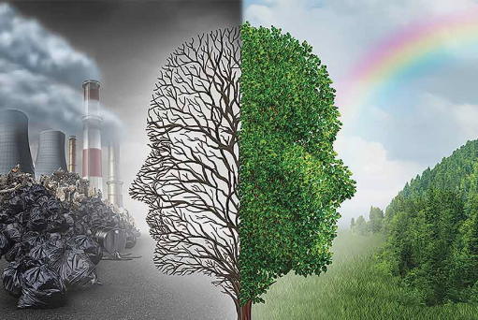
Environmental degradation is a social challenge that threatens the health and well-being of individuals and communities. It is caused by a range of human activities, including pollution, deforestation, and climate change. Environmental degradation leads to negative health outcomes, reduced economic growth, and harms biodiversity and ecosystem services (Li and Reuveny, 2006). To address environmental degradation, we must promote sustainable development and reduce our environmental footprint. This means investing in renewable energy, reducing waste, and promoting conservation efforts. Additionally, policies that promote sustainable transportation, agriculture, and industry can help reduce our environmental impact and promote a more sustainable future (Di Nauta, et al., 2018).

Conclusion
Social challenges are complex and multifaceted, and they require a collaborative and interdisciplinary approach to solve. By addressing economic inequality, discrimination, political polarization, and environmental degradation, we can create a more just and sustainable society. It is important to recognize that these challenges are interconnected and that solutions must address root causes rather than symptoms. By working together, we can create a more inclusive, equitable, and sustainable world for everyone.

References
Bayrakdar, S. and King, A., 2023. LGBT discrimination, harassment and violence in Germany, Portugal and the UK: A quantitative comparative approach. Current sociology, 71(1), pp.152-172.
Di Nauta, P., Merola, B., Caputo, F. and Evangelista, F., 2018. Reflections on the role of university to face the challenges of knowledge society for the local economic development. Journal of the Knowledge Economy, 9, pp.180-198.
Li, Q. and Reuveny, R., 2006. Democracy and environmental degradation. International studies quarterly, 50(4), pp.935-956.
Prior, M., 2013. Media and political polarization. Annual Review of Political Science, 16, pp.101-127.
Salvador Casara, B.G., Filippi, S., Suitner, C., Dollani, E. and Maass, A., 2023. Tax the élites! The role of economic inequality and conspiracy beliefs on attitudes towards taxes and redistribution intentions. British Journal of Social Psychology, 62(1), pp.104-118.

Blog Post 3
Exploring contemporary challenges, such as climate change, economic inequality, and social polarization, requires a deep understanding of the available knowledge and potential biases that may exist (Nyumba, et al., 2018). In this professional blog, I will examine the challenges of navigating knowledge and bias when exploring contemporary challenges.

The Challenge of Knowledge

One of the primary challenges I faced when exploring contemporary challenges is the vast amount of available knowledge. With so much information at my fingertips, it was difficult for me to know which sources are reliable and which are not (Heath, 2006). Additionally, new information is constantly emerging, making it challenging to keep up with the latest developments. To navigate this challenge, it is important to rely on reputable sources of information and to critically evaluate the information we encounter. I have to check the credibility of sources, look for multiple perspectives, and evaluate the evidence presented. I also recognized that knowledge is often provisional, and that new information lead to revised understanding and policy recommendations (Sowa, 2006).

The Challenge of Bias
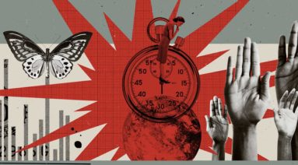
Another challenge I faced when exploring contemporary challenges is the potential for bias. Bias can take many forms, including confirmation bias, selection bias, and cultural bias (Christie, et al., 2021). These biases lead me to a distorted understanding of the issue, and result in policy recommendations that are ineffective or even harmful. To navigate bias, it is important to approach the issue with an open mind and to seek out diverse perspectives (Southwick, et al., 2014). I actively seek out voices that challenged my preconceptions and being willing to revise my understanding in light of new evidence. Additionally, it is important to recognize that biases are often subconscious, and to engage in self-reflection to identify and address my own biases.

The Importance of Interdisciplinary Perspectives

Finally, it is important to recognize that contemporary challenges are complex and multifaceted, and require an interdisciplinary approach to understand and address. I brought together experts from different fields, including science, economics, sociology, and politics, to explore the issue from multiple perspectives (Southwick, et al., 2014). I recognized the limits of my own expertise and being open to learning from others. Interdisciplinary perspectives helped me to identify potential biases and blind spots, and lead me to more effective policy recommendations. For example, an interdisciplinary approach to climate change might involve scientists studying the physical impacts of climate change, economists studying the costs and benefits of different policy options, and sociologists studying the social and cultural factors that influence behavior change (Heath, 2006).

Conclusion
Exploring contemporary challenges requires a deep understanding of the available knowledge and potential biases that may exist. By relying on reputable sources of information, critically evaluating the evidence, and seeking out diverse perspectives, I navigated the challenges of knowledge and bias. Additionally, an interdisciplinary approach can help us to identify potential biases and blind spots, and can lead to more effective policy recommendations. As we confront the complex challenges of the 21st century, it is essential that we remain vigilant in our pursuit of knowledge and committed to exploring issues from multiple perspectives.

References
Christie, A.P., Amano, T., Martin, P.A., Petrovan, S.O., Shackelford, G.E., Simmons, B.I., Smith, R.K., Williams, D.R., Wordley, C.F. and Sutherland, W.J., 2021. The challenge of biased evidence in conservation. Conservation Biology, 35(1), pp.249-262.
Heath, H., 2006. Exploring the influences and use of the literature during a grounded theory study. Journal of Research in Nursing, 11(6), pp.519-528.
Nyumba, T., Wilson, K., Derrick, C.J. and Mukherjee, N., 2018. The use of focus group discussion methodology: Insights from two decades of application in conservation. Methods in Ecology and evolution, 9(1), pp.20-32.
Southwick, S.M., Bonanno, G.A., Masten, A.S., Panter-Brick, C. and Yehuda, R., 2014. Resilience definitions, theory, and challenges: interdisciplinary perspectives. European journal of psychotraumatology, 5(1), p.25338.
Sowa, J.F., 2006. The challenge of knowledge soup. Research trends in science, technology and mathematics education, pp.55-90.

