

Student name: Fariha Batool
Student ID number: 2328297

BSc Health and Social Care

Module: Changemaker: Creativity and Value Creation
Module Code: BMHP5014

Lecturer: Dr Precious Igbinigie

Assignment Title: Component 2
Written Assignment (Report)

Submission Date: 24th November 2025
Content
Poster………………………………………………………………………………3
Pitch………………………………………………………………………………...4
References…………………………………………………………………………9

Poster
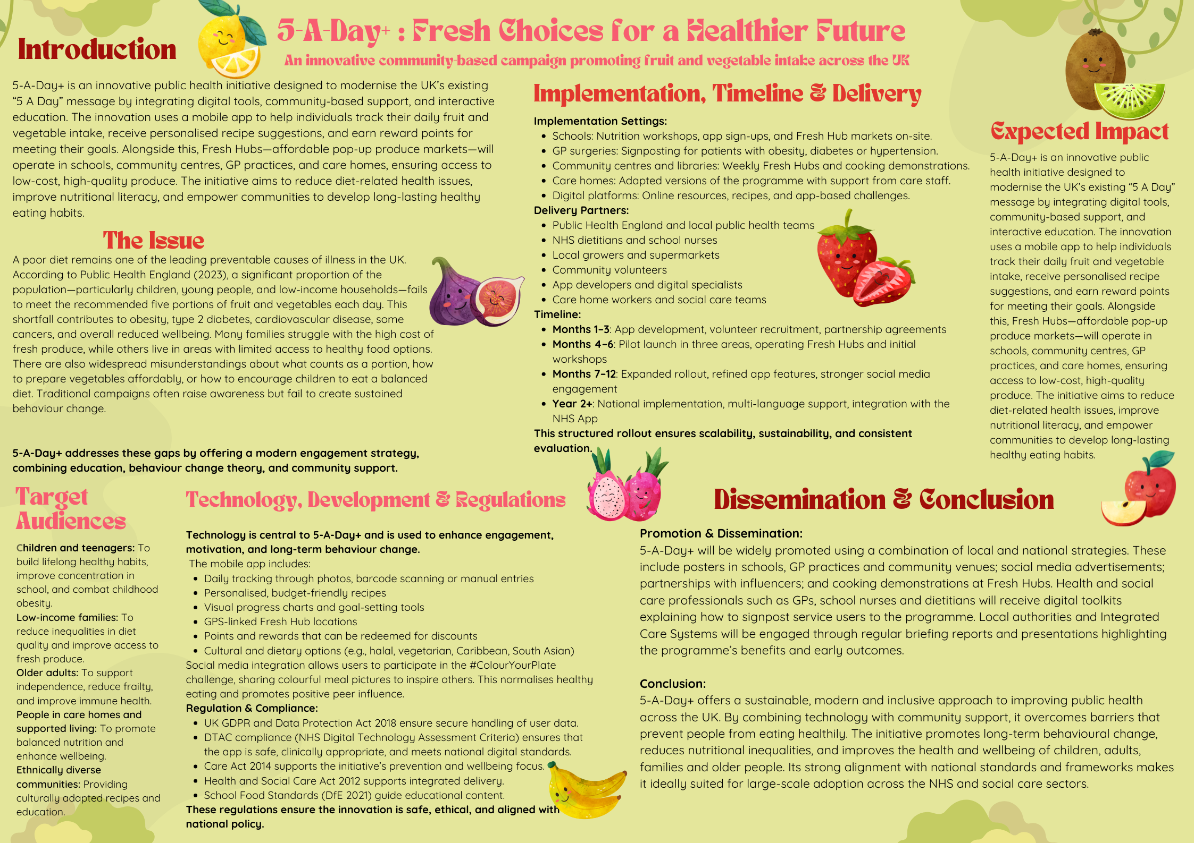

Pitch
Introduction
This pitch outlines and justifies 5-A-Day+, an innovative public health initiative designed to increase fruit and vegetable intake across UK communities. Building on the long-established “5 A Day” message, the initiative integrates technology, community-based support, and educational activities to improve dietary behaviour and reduce nutrition-related health inequalities. Poor diet is a major contributor to chronic illness, placing significant pressure on the NHS, and the current challenge requires a more modern, engaging approach that supports sustained lifestyle change (Public Health England, 2023). 5-A-Day+ responds to this need through a comprehensive strategy that blends digital motivation with real-world access to nutritious food.
Rationale and Evidence Base for the Innovation
The need for this innovation is clear. Public Health England data shows that only 31% of adults and 8–10% of children meet the recommended five daily portions of fruit and vegetables (PHE, 2023). Low consumption of these foods contributes significantly to obesity, type 2 diabetes, cardiovascular disease and some cancers (NHS, 2022). The NHS Long Term Plan emphasises prevention and early intervention to reduce lifestyle-related illness (NHS England, 2019), yet traditional healthy-eating campaigns often fail to reach the communities most at risk.
There are clear gaps in accessibility, affordability and nutritional knowledge, particularly in deprived areas. Low-income families often face higher prices for fresh produce, limited local availability, and a lack of confidence in preparing healthy meals (Marmot et al., 2020). Younger people, while highly engaged with technology, often receive health messaging that feels outdated or unrelatable. Older adults and care-home residents can experience reduced mobility and limited opportunities to access fresh foods.
The 5-A-Day+ initiative addresses these gaps by offering a multi-layered solution: digital tracking and motivation, affordable community produce stalls, practical education, and social media engagement. This approach aligns with NICE guidance on obesity and lifestyle change, which recommends accessible, community-based interventions supported by behaviour-change techniques (NICE, 2014).
Description of the Innovation
5-A-Day+ is built around four core components:
1. Mobile Nutrition App
The app allows users to track daily fruit and vegetable intake using photos or barcode scanning. It includes meal suggestions, portion guidance, and weekly goals tailored to cultural preferences, dietary needs, and budgets. The inclusion of a rewards system—where points earned for meeting goals can be redeemed at Fresh Hubs—supports motivation based on the Theory of Planned Behaviour, which identifies intention, attitude, and perceived control as key drivers of behavioural action (Ajzen, 1991). Progress charts and push notifications reinforce positive habits and provide ongoing encouragement.
2. Fresh Hubs
Fresh Hubs are low-cost pop-up produce markets situated in schools, GP practices, community centres, libraries, and care homes. They provide affordable fruit and vegetables sourced from local growers or supermarkets. Fresh Hubs reduce financial barriers, improve local availability, and foster community engagement—key to tackling health inequalities (Marmot et al., 2020).
3. Educational Workshops
Workshops are delivered by dietitians, school nurses, and trained volunteers, focusing on quick, affordable meals, shopping on a budget, and family-friendly recipes. This increases food confidence, improves cooking skills, and supports sustained behaviour change. For older adults and care-home residents, workshops also focus on preventing malnutrition and promoting independence, aligning with the Care Act 2014 wellbeing principle.
4. Social Media Campaign: #ColourYourPlate
The campaign uses platforms such as TikTok, Instagram, and Facebook to encourage users to share colourful, balanced meals. This promotes social norms around healthy eating, increasing engagement particularly among young people.
Implementation, Timeline & Delivery
5-A-Day+ will be implemented across multiple community and health settings to ensure maximum reach and accessibility.
Delivery Partners:
- Public Health England and local public health teams
- NHS dietitians and school nurses
- Local growers and supermarkets
- Community volunteers
- App developers and digital specialists
- Care home workers and social care teams
Timeline:
- Months 1–3: App development, volunteer recruitment, partnership agreements
- Months 4–6: Pilot launch in three areas, operating Fresh Hubs and initial workshops
- Months 7–12: Expanded rollout, refined app features, stronger social media engagement
- Year 2+: National implementation, multi-language support, integration with the NHS App
This structured rollout will ensure sustainability, and consistent evaluation.
Technology, Regulation and Safety
Technology is central to 5-A-Day+ and is used to enhance engagement, motivation, and long-term behaviour change.
The mobile app includes;
- Daily tracking through photos, barcode scanning or manual entries
- Personalised, budget-friendly recipes
- Visual progress charts and goal-setting tools
- GPS-linked Fresh Hub locations
- Points and rewards that can be redeemed for discounts
- Cultural and dietary options (e.g., halal, vegetarian, Caribbean, South Asian)
Social media integration allows users to participate in the #ColourYourPlate challenge, sharing colourful meal pictures to inspire others. This normalises healthy eating and promotes positive peer influence.
Regulation & Compliance:
- UK GDPR and Data Protection Act 2018 ensure secure handling of user data.
- DTAC compliance (NHS Digital Technology Assessment Criteria) ensures that the app is safe, clinically appropriate, and meets national digital standards.
- Care Act 2014 supports the initiative’s prevention and wellbeing focus.
- Health and Social Care Act 2012 supports integrated delivery.
- School Food Standards (DfE 2021) guide educational content.
These regulations ensure the innovation is safe, ethical, and aligned with national policy.
Dissemination and Stakeholder Engagement
Promotion of the initiative will occur through multiple channels to reach the widest possible audience. This includes posters and leaflets in GP practices, schools, community centres, libraries and care homes; targeted social media advertising; cooking demonstrations during Fresh Hub events; and partnerships with youth groups and sports organisations.
Health and social care professionals, including GPs, dietitians, school nurses and community social workers, will receive digital toolkits and training resources to encourage them to signpost individuals to the programme. Local authorities and Integrated Care Systems will be kept engaged through regular progress briefings and data insights.
Conclusion
5-A-Day+ is a comprehensive, innovative and sustainable approach to improving dietary behaviours in UK communities. By combining technology, community support and education, the initiative addresses key barriers to healthy eating and supports long-term lifestyle change. Its alignment with national policy frameworks, its focus on prevention and inequality reduction, and its evidence-based design make it highly suitable for integration across health and social care settings.
This innovation has the potential to significantly improve public health outcomes and support a healthier, more empowered population.
References
Ajzen, I. (1991) ‘The theory of planned behaviour’, Organizational Behaviour and Human Decision Processes, 50(2), pp.179–211.
Department for Education (2021) School Food Standards: Guidance. London: DfE. Available at: https://www.gov.uk/government/publications/school-food-standards-resources-for-schools (Accessed:10 November 2025).
Department of Health & Social Care (2014) Care Act 2014. London: DHSC. Available at: https://www.legislation.gov.uk/ukpga/2014/23/contents(Accessed:11 November 2025).
Department for Education (2021) School Food Standards: Practical Guide. London: DfE. Available at: https://www.gov.uk/government/publications(Accessed:29 October 2025). Information Commissioner’s Office (2018) Guide to the General Data Protection Regulation (GDPR). Wilmslow: ICO. Available at: https://ico.org.uk(Accessed:2 November 2025).
Marmot, M. et al. (2020) Health Equity in England: The Marmot Review 10 Years On. London: Institute of Health Equity. Available at: https://www.health.org.uk/publications/reports/the-marmot-review-10-years-on(Accessed:12 November 2025).
NHS (2022) The Eatwell Guide. London: NHS. Available at: https://www.nhs.uk/live-well/eat-well/food-guidelines-and-food-labels/the-eatwell-guide/(Accessed:25 October 2025).
NHS England (2019) The NHS Long Term Plan. London: NHS England. Available at: https://www.longtermplan.nhs.uk/publication/nhs-long-term-plan/(Accessed: 29 October 2025).
NICE (2014) Obesity: Identification, Assessment and Management (CG189). London: NICE. Available at: https://www.nice.org.uk/guidance/cg189(Accessed:12 November 2025).
NHS (2022) The Eatwell Guide: Helping You Eat a Healthy, Balanced Diet. London: NHS. Available at: https://www.nhs.uk/live-well/eat-well/the-eatwell-guide/(Accessed:29 October 2025).
NHS England (2019) The NHS Long Term Plan. London: NHS England. Available at: https://www.longtermplan.nhs.uk/(Accessed: 29 October 2025).
NICE (2015) Community Engagement: Improving Health and Wellbeing (NG7). London: NICE. Available at: https://www.nice.org.uk/guidance/ng7(Accessed: 29 October 2025).
Public Health England (2023) Healthy Eating and Obesity Data Profile. Available at: https://fingertips.phe.org.uk/profile/obesity-physical-activity-nutrition (Accessed:18 November 2025).
Public Health England (2017) Health Matters: Obesity and the food environment. London: PHE. https://www.gov.uk/government/publications/health-matters-obesity-and-the-food-environment/health-matters-obesity-and-the-food-environment--2( Accessed: 12 November 2025).

