

UNIVERSITY OF WALES: TRINITY SAINT DAVID PRIFYSGOL CYMRU:
Y DRINDOD DEWI SANT

London Campus/ Weekend Study

BA Leadership and Management skills for the Workplace

Strategic Management for SME’s/BMSW 6104

Lecturer name: Dr. Gamage Toyin Arisa

Student ID: 2121081

Introduction

In order to better comprehend small to medium sized organisations (SMEs), I will start this research by looking at the definition of a SME. "Styles Ahead" Barkingside, a small hair and beauty company, will be the focus of my analysis.
According to (Smith,2023). Small and medium-sized companies are those that fall below a specific threshold in terms of both income and staff count. Every country defines a small to medium-sized business differently. A few size standards are adhered to, and occasionally the industry the business works in is taken into consideration. (Smith,2023).

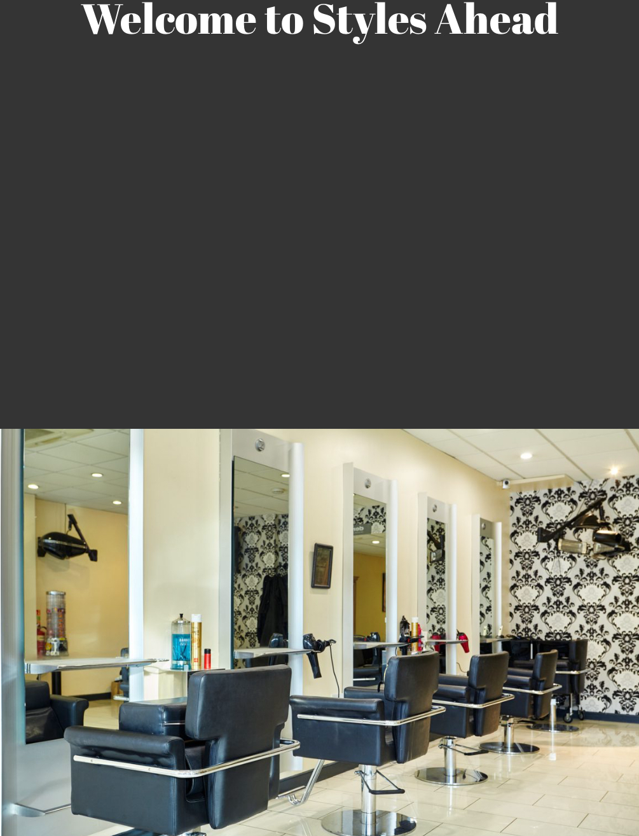
Figure 1 Styles Ahead beauty salon. Copied from (Styles Ahead,2020).

The EU has a different definition of a SME than the UK does. Typically, a small or medium-sized business in the UK employs 500 people or less, whereas in the EU, the same business employs 250 people or less. (Smith,2023).
In the UK, the majority of beauty salons are classified as small to medium-sized enterprises (SMEs). They provide services such as massages, facials, manicures, hair styling and makeup. Beauty salons are also well-liked as places for specific therapy to be applied to the body, face and hair to enhance the client's appearance. (Cambridge dictionary, n.d.)
With less than 100 employees, Styles Ahead is a hair and beauty specialist firm that is classified as a small business in the UK. Two further salons owned by Styles Ahead are situated in Loughton and Chingford. The business was established in 1992, and its sole location is in London. This beauty shop provides the following services to its clients:
- Cosmetic procedures- which include anti-wrinkle injections, dermal filler for hydration and all these procedures and more are performed by expert technicians and doctors.
- Hair - includes dyeing, cutting, and curling. Styles Ahead, 2023).
- Beauty - cosmetic procedures, relaxing procedures, massages, and waxing.
Styles Ahead offers its customers modern and specialized hair, beauty, and plus training services in the same field. Styles Ahead salons provide a welcoming environment and a high level of expert service with their professional staff. (Styles Ahead, 2020).

Current Strategic direction of “Styles Ahead”
The company wants to grow even more by extending its operations into other areas of London. All people are welcome at Styles Ahead salons, regardless of their age, race, or whether they live in the city or the country. This target market can ensure the company's progress, so why not establish itself as a London leader in its industry? It's a positioning strategy that can guarantee that the business has an edge over rivals.
Because of this, Styles Ahead beauty salons have varied their service prices to cater to a range of income levels and socioeconomic backgrounds. With the goal of serving everyone, this is the company's secondary positioning approach. As a result, Styles Ahead salons provide premium goods and services at reasonable costs. Their services are dependable, easily accessible, and available to everyone in the necessary quantity. (Styles Ahead, 2020).

The situational analysis in the specific business refers to the internal and external environment, the direct and indirect competitors of the company such as local salons with low prices, the target market, and the position that the company would take.


Figure 2 Styles Ahead beauty salon. Copied from (Styles Ahead,2020).

Analysing the Internal Environment. SWOT Analysis

The microenvironment is actually the internal environment that corresponds to what happens in the company, which can be controlled from the inside.
And this internal environment can best be explained through a SWOT analysis. SWOT looks at the strengths and weaknesses, opportunities and threats that affect the business from the inside. First, I want to look at the strengths of the Styles Ahead beauty salon and they are:
- with each new haircut, the staff gives the client tricks on how they can maintain their new look for a longer period of time. This is also a type of training that the staff gives to their clients and in this way the clients are satisfied with the services offered. This is a strength because customers will know how to handle their new style and how to maintain it for a long time.
- The salon also works with highly licensed products that it stocks at very affordable prices, and which it then sells to its customers at more affordable prices than its competitors in the same industry. Thus, the customers of the salon who have lower incomes can afford to buy quality products at convenient prices. This is also another strength because Styles Ahead clients will not feel discriminated against based on their low income, therefore the salon will attract more clients.
The services provided by Styles Ahead are thought to be of better quality than those of other salons in the vicinity. This gives the salon an advantage over rivals. The salon retains more clients and generates more revenue when its staff members are qualified and well-trained. Friends and family of clients who receive courteous treatment from them also seek their services. Customer complaints are addressed seriously and made required improvements in order to guarantee the satisfaction of the customer. Customers are the company's top priority, and they are valued individually because their determines whether the salon succeeds or fails. (Styles Ahead, 2020).

Styles Ahead salons have a lot going for them, but they also have certain weaknesses, like their location. Since there are numerous other beauty salons on the same street, some of the new clients might not recognise it and end up in the hands of the competing establishment. The salon may suffer as a result of this since it will lose clients.

One of the other weaknesses of the company is the workload they have, so they are constantly hiring new employees, so they don't lose customers, but this turns out to be another major problem for Styles Ahead salons because it's hard for their customers to get used to or trust the new employees and this takes time.
Most customers in beauty salons prefer to be served by the same employee rather than the one they are happy with and are used to.
For this reason, the salon is likely to lose customers, as other salons in the same industry have regular employees that customers can rely on. This is a weakness for the company because the competition will surely take advantage of this weakness and can attract even the loyal customers of the salon. (Styles Ahead, 2020).

The main threat to Styles Ahead beauty salons comes from their competitors who are located on the same street and are four in number. The other threat is the prices that the competition offers for their services and products, if any of them have lowered the prices and thus attract customers, it may lead to the closure of the Styles Ahead salons.

The opportunities of Styles Ahead salons are many and the company is using them to their full potential so far. The supplier companies that the salon works with to stock the necessary products are highly qualified and of high quality, and this gives Styles Ahead an edge over the competition. The company is aware that their products are of higher quality than their competitors and therefore this is an opportunity to maximize the company's returns. (Styles Ahead, 2020).

Analysing the External Environment. PESTEL Analysis

External environment is also known as macro environment analysis. These are those factors that happen and affect the company in one way or another that are beyond the company's control. In this report I use PESTEL analysis to analyse those external factors that affect the company, and they are political, economic social cultural, technological, legal, and environmental.

Political analysis is related to governance and exactly when changes occur in it and the political stability of the country. If the politics of a country is stable, then regardless of the type of business, it will grow and prosper because there will be no interruptions from say war or any conflicts.
However, when the government decides to introduce new policies in the industry, it sometimes affects the business negatively. Policies can be expensive and time-consuming due to the procedures and implementation processes they go through, and which are monitored during implementation. The government supports the various policies where government bodies and departments responsible for the industry engage all stakeholders for talks and consultations in case there are new guidelines and policies that need to be introduced. (UKessay,2015).

Economic factors can be the biggest challenge for a company if it is not financially stable, this means that the company's profits are decreasing or when the company is making losses. If a company's returns are unstable, then it makes big losses due to its costs. When unions pressure a company to increase wages for its employees, the company's wages and costs increase and it may be forced to close. This happens because the profitability of the company is unstable, and it is the profits that can increase the salaries of the employees and so the enterprise can expand its activities.

Social factors refer to fashion changes in tastes and preferences to cultural beliefs and norms. When a new fashion or style appears on the market, the salon must adapt to it, even if this sometimes means additional costs. The emergence of the new fashion or style requires additional training of employees and therefore costs additional costs for the salons to keep their customers satisfied, otherwise if the salons do not comply with these newly emerging styles, they risk losing their authority and being closed. (UKessay,2015).
For clients of beauty salons, it is very important to have trendy hairstyles and they want the salon to have all the novelties on the market, including new products. Therefore, hairdressing salons must always keep up with fashion and know all the new trends that have appeared on the market. When all the novelties are offered, they retain their customers, but also attract new ones thanks to the quality services offered. Different cultures and races, genders, and religions value and like different hairstyles. Therefore, this requires beauty salon managers and their employees to get to know their customers' needs very well.

Technological factors play a decisive role in hairdressing salons because they change very quickly and become more and more modern. Different hairstyles require the use of different machines in the 21st century, modern machines designed specifically for salons are very innovative and rapidly evolving and sought after by customers. Every new modern machine protects the strength and naturalness of the hair and that is why customers are attracted to these new innovative machines. This type of technology is expensive for salons, but they are obliged to equip themselves with it in order to remain in the market as the best, because the competition in this industry is very high. These new technologies also require training of employees to be able to use the machines well.
Due to the strong competition, the company must allocate its budget so that it equips its salons with new modern equipment. With new technologies, Styles Ahead is able to provide quality services and gain more customers and therefore an edge over the competition.
Customers are sensitive about their money and want to get value service when they pay which service, they get from the salons with modern and advanced technology. (UKessay,2015).

One of the important external factors is legal factors. Laws play a leading role in any business. All the laws created in the country must be obeyed, otherwise the business may turn out to be illegal. Sometimes the government may impose strict rules, and this may prove difficult for the company to achieve due to financial reasons. In the hairdressing industry, the government may mandate that certain salon products are not used or prohibit certain hairstyles, and this may negatively affect salons and force them to close due to loss of customers. Laws can also affect the growth of businesses in certain areas of the city. (UKessay,2015).

The impact of beauty salons on the environment is significant. Visiting a hair salon can have a significant impact on the environment. Beauty salons use a huge amount of water every day, they also have large amounts of waste and use chemicals when colouring or sterilizing hair. All this has a great impact on the environment. (Elle,2022).
Every year, the cosmetics business creates at least 120 billion packaging pieces. The extent of the environmental difficulties is very high this causes, considering that 95% of cosmetic packaging is thrown away.
Fortunately, things are not entirely dire. Numerous cosmetic brands are beginning to revaluate their effects on the environment. (Davison,2022).

Growth choices of “Styles Ahead”
To discuss the available growth strategy for Styles Ahead beauty salon I will use Porter's Generic Strategies which include Cost Leadership, Differentiation, Cost Focus and Differentiation Focus.
According to (Banuba,2024) marketing strategy is important to the company because it helps the salon stand out from the crowd, take its name to the next level, attract new customers, and increase its sales.

In terms of marketing strategy, Styles Ahead salons create a plan that will help them rise to the top of the industry in the London regions where their beauty salons are located.
In addition to these two locations, the company hopes to grow in well-known malls with significant visitor numbers. Due to their popularity and the volume of people who visit them every day, salon rents in these areas are greatly inflated; however, Styles Ahead salon managers say they will be able to handle this because their clients receive high-quality services that are valued by their clientele. The salon's marketing strategy consists of more frequent advertising through various media and distribution of leaflets. Since not all target markets can be reached with the media, the other alternative for advertising is through the Internet and social networks, which are very popular nowadays and are a cheap way to advertise and reach a wider audience of women. (Styles Ahead, 2020).

The financial goals of the company are related to all the advertising that is undertaken for the strategy, because ultimately every advertisement must turn into a sale. With the implementation of this marketing strategy, the company's profit is expected to grow by 2% per year. (GOV.UK, n.d.).

This growth is anticipated, as the company's strategy is to increase customer flow by 7% for the quarter, and operating salons should maintain stability and growth each month. (GOV.UK, n.d.).
Mission
The purpose of the marketing strategy is to show the customers, the Styles Ahead salons that they are not only affordable, but also offer convenient prices to attract and retain customers.
Styles Ahead salon services will meet the expectations of their customers and thus reach safe and secure markets in the future.

As it was understood above, as part of the strategy of Styles Ahead beauty salons is the target market which includes:
Men - statistics from the 21st century show that men nowadays use the services of hair salons quite often, with a percentage between 70% and 75%. For this purpose, the company must make the necessary advertisements to be able to reach these groups as well. (PolicyBee,2022).

Women - about 90% of women regularly visit hairdressing salons, therefore large revenues are expected from them. Women identify themselves with expensive and classy services and products. Although there is no lack of discrimination in terms of class and prices, Styles Ahead beauty salons strive to significantly reduce this feeling from their customers. Hence, there is also an opportunity for a large number of female clienteles. (PolicyBee,2022).

Children - Children are an emerging market in the hairdressing industry.
Young mothers with children visit the appropriate salons, where there is appropriate equipment for children and an approach to small customers, this gives a big plus to the salons and more new customers.

Each of these groups will have a separate seat in the salon, and for men it will be on a first-come, first-served basis. On some days, the salon will be open until 7pm to have more satisfied and well-served customers. (Styles Ahead, 2020).

Excellent customer service is very important to the company because the beauty salon market is crowded and everyone is fighting for a customer, which is exactly why Styles Ahead must be distinguished by quality accuracy and affordable prices.
The company has the opportunity to provide all these services and products to its customers and rise to the market as a leader because it invests in its staff, knowing that their staff is one of the important figures in the salons and they will be as flexible as possible with customers.

The Ansoff matrix model is an additional approach for explaining the company's strategy.
According to (Hendron,2021) there are four strategies in the Ansoff Matrix that businesses may use to grow and expand. The matrix is designed to assist business owners in better understanding their existing strategy and in analysing the risks involved in implementing a new one.
The following are the four Ansoff Matrix growth strategies:
- Market Penetration
- Product Development
- Market Development
- Diversification
Management teams and the analyst community use the Ansoff Matrix, also known as the Product/Market Expansion Grid, as a two-by-two structure to help plan and assess expansion projects. Specifically, the tool assists stakeholders in understanding the degree of risk connected to various growth strategies. (Peterdy,2024).
The managers of Style's Ahead will find great value on this matrix in implementing their growth strategy.

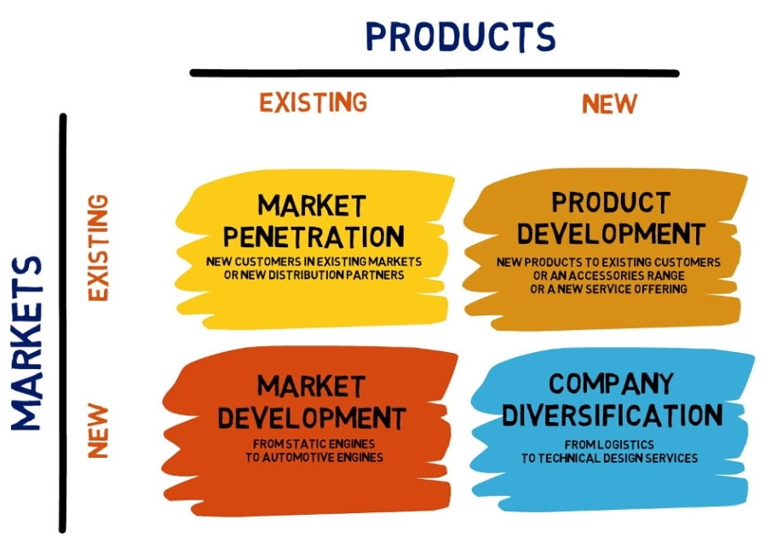
Figure 3 Ansoff Matrix, Copied from Forbes Baxter,2021.
The company's strategy is to grow and gain popularity in more places in London. Therefore, the Ansoff matrix will be used in the market development column. In this way, the managers of the Styles Ahead company will have a clear marketing development because Market development repurposes the product to fit the needs of completely new clients or broadens the current market to reach additional people.
There are two steps involved in reaching an undiscovered market. To begin with, a thorough market study should be carried out in order to establish market segments, which are smaller subsets of the population that may be labelled.
Factors such as industry, location, age, and income of the population.
Once the ideal location for the new Styles Ahead salons has been identified, the next step is to create a targeted promotional strategy. This consists of general marketing and branding strategies for awareness and growth in this segment. This tries to use the existing product or service to attract new customers.
Once the ideal location for the new Styles Ahead salons has been identified, the next step is to create a targeted promotional strategy. This consists of general marketing and branding strategies for awareness and growth in this segment. This tries to use the existing product or service to attract new customers.
A business strategy creates a vision and direction for the whole organisation. It is important that all people within a company have clear goals and are following the direction, or mission of the organisation. A strategy can provide this vision and prevent individuals from losing sight of their company's aims. (Evolve,2024).

Stakeholder Analysis

Beauty salon industry growth is occurring quickly. Beauty salons are public places that carry the risk of spreading diseases and polluting the environment through chemicals or waste. To achieve balance and the highest quality of a healthy environment, the role of stakeholders is necessary to improve the occupational safety of staff and customers in beauty salons. In this part of the report, I identify the potential stakeholders in a Styles Ahead salon. (Denny,2024).

Styles Ahead's salon stakeholders are the main contributors to the salon's success. The stakeholders in this salon are entirely based on the results of the company, whether they are satisfactory or not. Convincing and impressing the stakeholders of a project is a difficult task and a challenge for a company. It was necessary for the managers of Styles Ahead to manage the stakeholders in an effective way and understand their attitude towards the salon and what they think about it.
The figure 3 shows the stakeholders who have a high interest in the salon and high power.
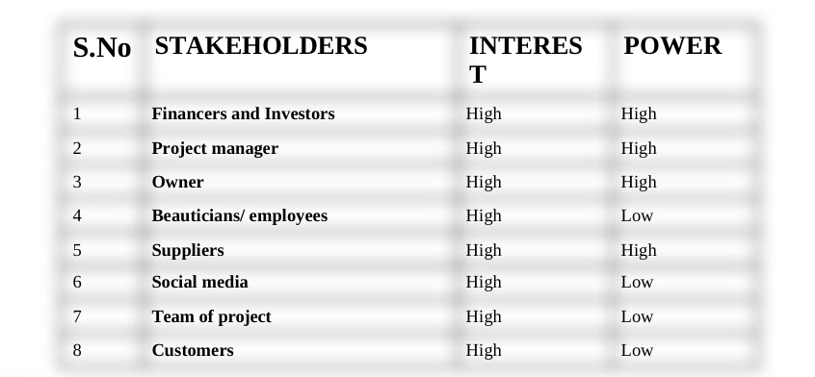
Figure 4 Stakeholder Analysis for “Styles Ahead” beauty salon.

The power held by the stakeholders can be easily understood with the power interest graph. This chart helps salon managers work according to the interests and power held by stakeholders. Also, the graph shows the impact of stakeholder power on the salon and with its help, communication methods are developed to connect with each stakeholder and thus give importance to them individually.
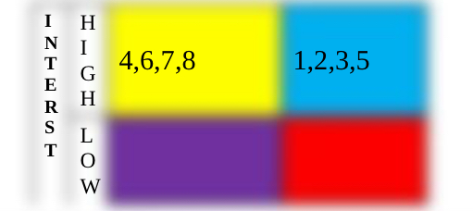
Figure 5 Stakeholder Analysis for “Styles Ahead” beauty salon.

As stakeholders have the greatest input into salon management, a stakeholder reporting framework is being developed. This framework helps Styles Ahead salon managers communicate with stakeholders so that individual stakeholder communication is also easily remembered.

The stakeholders of Styles Ahead salons receive particular attention and recognition for their achievements, which encourages them to become more involved in the business.
The Beauty Salon Styles Ahead reporting framework is depicted in the figure below, along with the format and subject matter of the correspondence with each stakeholder. The impact and interest of the stakeholder in the salon will be considered when determining the duration and mode of pertinent stakeholder communication.
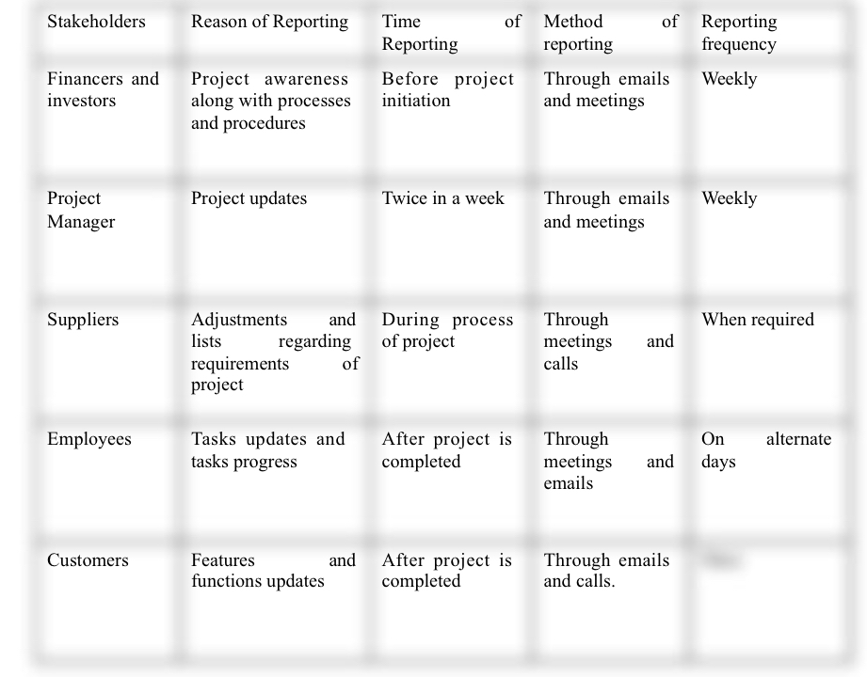
Figure 6 Stakeholder Analysis for “Styles Ahead” beauty salon.

Recommendation

In order to help the company, implement its current strategy, I would like to give them recommendation as a suggestion for business development, and I will use the analysis from this report—which employed a variety of techniques including Porter's Generic Strategies and the Ansoff Matrix—to guide their actions. They will be helpful in helping them gain knowledge about who they are, what they do, and the choice they will make in the future for the business grow.

I additionally want to suggest to the organisation that they promote their upcoming salon openings as well as the ones they currently have well. Advertisements created by customers with a larger following on social media, as social media is now where most of the popularity is gathered. Thus, effective advertising is crucial.

My next recommendation for the company is in the area of customer support. I think it would be a good idea to provide each customer with a drink, such as tea or coffee. The customer will find this to be exceptionally grateful and friendly.

As I've previously stated, advertising is crucial to the salon's expansion. My next piece of advice to the business is to offer discounts to every client who refers a salon to a friend or family member. This will satisfy current clients and attract new ones for the salon.

While attracting new customers is a strategy my next recommendation to the company is to focus on its current customers by trying to sell them more services or products. The discounts made in this way will not be felt and the company will make more profit. Sell more to existing customers.

It is my recommendation that company increase personnel investment. Employees must be well-trained and knowledgeable about current practices. They must be able to provide their clients contemporary views while also listening to their needs and embracing their fresh ideas. The salon will see an increase in revenue and customer because of the staff investment.

Finally, I advise the Style Ahead organisation to do thorough research on the areas in which they hope to launch a new salon. Here, it's critical to consider both the salon's rent and the opportunities available to the local populace. If the majority of people in the region don't make good money, the location isn't a good place to make investments.
In the chosen neighbourhood, there should not be many beauty salons that are well known to the locals. This will promote the Style Ahead salon faster.

Conclusion

I conclude this report by describing the main thesis, which is the strategic management of small and medium enterprises (SMEs). This report examines Styles Ahead, a modest salon that provides quality hair and beauty services to its customers. Using PESTEL and SWOT analysis, I examined and evaluated both internal and external factors that impact or have the potential to impact the company. To ensure that the business is clear about what it needs to do, where it is today and how to continue to grow, I researched and analysed the company's future plan using Porter's general strategies and Ansoff's matrix.
In my study of the company's Stakeholders, I described the main stakeholders. I have also included some recommendations at the end of the report that I believe the company should be focusing on right now.

