

PROGRAMME NAME: MASTER OF BUSINESS ADMINISTRATION
MODULE NAME: MARKETING MANAGEMENT
MODULE CODE: LCMB7024
TITLE: MARKETING ENVIRONMENT ANALYSIS AND SUSTAINABLE GROWTH STRATEGY OF TATA STEEL: TRANSITIONING TOWARDS A LOW-CARBON STEEL BUSINESS
KAONGA SOBERE-SNITHERS (BIRMINGHAM)
STUDENT NAME: Keval Joshi
STUDENT ID: 2616038
WORD COUNT: 2658
SUBMISSION DATE: 22/10/2026

TABLE OF CONTENTS
1.0 Introduction 3
2.0 Task 1: Marketing Environment Analysis 3
2.1 Introduction to Tata Steel 3
2.2 Environmental forces 3
2.3 Political and legal forces 5
2.4 Customer and stakeholder forces 5
3.0 Task 2: Strategic Growth and Competitive Positioning 7
3.1 Application of the Ansoff Matrix 7
3.2 Recommended growth strategy 8
3.3 Competitive advantage and marketing strategy 9
3.4 Implementation, risks and performance measures 10
4.0 Task 3: Managerial and Professional Reflection 10
4.1 Selection rationale 10
4.2 Decision reflection 11
4.3 Limitations 11
4.4 Professional learning 11
5.0 Conclusion 12
Reference Lists 13

1.0 Introduction
This report critically analyses the marketing environment of Tata Steel in the context of the change in the country to lower-carbon steel production. This reports focuses on three external factors which affect Tata Steel's marketing decision viz., customers/expectations, political /legal changes and environmental issues. These vary from macro-environmental driving forces and regulatory influences up to the micro-environment of customers and other stakeholders which can have a direct impact on the company's business activity and positioning. Possible growth opportunities and product development to create competitive advantage are subsequently discussed using the Ansoff Matrix and Porters. Finally, it reflects on the impact of the assessment on managerial decision-making, professional learning and analysis elements.

2.0 Task 1: Marketing Environment Analysis

2.1 Introduction to Tata Steel
Tata Steel is one of the Steel Giant Companies, which has its headquarters in India and has operations in Southeast Asia, Europe and India. The company has the capacity to produce steel for use in industry, which is compatible with the auto industry, construction and infrastructure applications (Tata Steel, 2026). However, the emissions profile of the steel industry is high, and the industry must be innovative and move towards the adoption of cleaner production processes. Currently, Tata Steel's goals include net-zero carbon by 2045 and energy efficiency. Tata uses electric arc furnace (EAF) technology to manufacture steel using scrap as the raw material (Tata Steel, 2026). The developments pose big sustainability marketing challenges and opportunities.

2.2 Environmental forces
Environmental forces have a tremendous impact on manufacturing costs, product development, corporate image and positioning of Tata Steel. Both the steel industry and the energy needed for steel production are energy-intensive and emit large amounts of greenhouse gases, resulting in pressure for this to be changed to steel production with a lower carbon footprint (Mokrzycki and Gawlik, 2025). While addressing climate change and environmental concerns, demanding higher expectations for sustainable materials stimulate Tata Steel in improving energy efficiency, reducing emissions and researching on alternative technologies for steel production (Tata Steel, 2026).
A key one is that there is a greater focus on the use of lower carbon steels and circular resource utilisation. The use of recycled steel scrap and the use of electric arc furnaces (EAF) will be considered in the context of source reduction; the benefit to the environment will depend on the sources of electricity generation, raw materials, and manufacturing processes (La Rosa et al. 2025).
Tata Steel's investments in other production routes will enable it to sustain production of materials with a lower environmental footprint, which will be in demand with its customers. The transition from the traditional production methods would entail a high investment, as well as the availability of a metal scrap supply with good quality in both type and quantity, and a low-carbon power supply at attractive prices (Tata Steel, 2026). Any such requirement could lead to a higher cost and delay in the commercialisation of lower-carbon products.
What's good for marketing is what's produced after the pressure is applied to the environment. At the customer level, a significant pressure to reduce the emissions of supply chains, particularly in the construction, automotive and infrastructure sector. Being able to deliver credible information about the environmental performance of Tata Steel's products could help it stand out. However, the statements on sustainability need to be backed up with clear and transparent emission data and accepted measurement methods. Otherwise, a company may be alleging greenwashing, thereby hurting its customer base and corporate image (Pedersen, 2023).
Source scarcity, impact on water resources, waste management and effects on biodiversity are further factors that can limit companies' social acceptance and resilience (Sharma et al. 2024). Environmental management should not simply be a compliance role, but also be part of the product development process, and a part of the customer communication, long-term marketing strategy. Considering the long-term impact, the environment affords opportunities for differentiation and sustainable growth, but its commercial opportunity relies on the technical viability, cost competitiveness and proven reductions in emissions.

2.3 Political and legal forces
The political and legal environment has consequences for Tata Steel's investments, costs of production and marketing strategies. The targeting of policies relating to climate and environment towards the steel industry is attracting one such prospect: the introduction of a system of Carbon pricing and emission regulation. In the UK, the Climate Change Act 2008 has been passed to provide a statutory framework for the reduction of greenhouse gas emissions, and the UK Emissions Trading Scheme (UK ETS) provides the UK with a carbon cost for greenhouse gas emissions for the covered industrial sector, which includes the aviation sector (Oreggioni et al. 2022; Workman et al. 2022). While the policies put a cost on the existing steel producers, they may offer an incentive to invest in the lower CO₂ alternative.
Tata Steel's European business is also covered by the European Union climate policy. European Union's Carbon Border Adjustment Mechanism (CBAM) imposes carbon environmental requirements for imported products, like the iron and steel industry, and affects the trade environment and competitiveness (Shee Weng, 2025). These policies may provide an incentive for the purchase of products with traceable information on emissions, giving an opportunity for sustainable marketing campaigns. However, the regulatory requirements and upfront investments or savings against/or uncertainties regarding regulations can bring an additional financial and administrative burden.
Programs and jurisdictions differ in their availability, conditions and eligibility of government incentives for decarbonisation of industrial processes. Therefore, it is imperative that Tata Steel closely monitors regulatory changes, appreciates the cost of compliance and ensures transparency on environmental performance. It will be balancing sustainability positioning and affordability elements, as well as products that must prove emissions reduction experience in the real world.

2.4 Customer and stakeholder forces
Both customer needs and stakeholder pressures have an interesting impact on Tata Steel's marketing strategies and its aim to become a low-carbon steel company. In contrast with other environmental and political influences, the impact of customers and stakeholder is direct and occurs within Tata Steel's micro- environment that affects its purchasing decision, supplier relationships, positioning capabilities in the competitive market and expectations on low carbon steel. Environmental concerns have become a part of the supply chain decision-making process for customers in the construction industry, as well as in automotive manufacturing and infrastructure. This generates a further demand for steel products with lower embodied carbon, especially when there are sustainability commitments and the demand for green procurement (Climatecatalyst, 2026). At Tata Steel, the goal is to develop products with lower carbon, and to get the customers' attention so that they are 'open loop' about the way that they think about their carbon footprint, making it easier to gain the attention of customers.
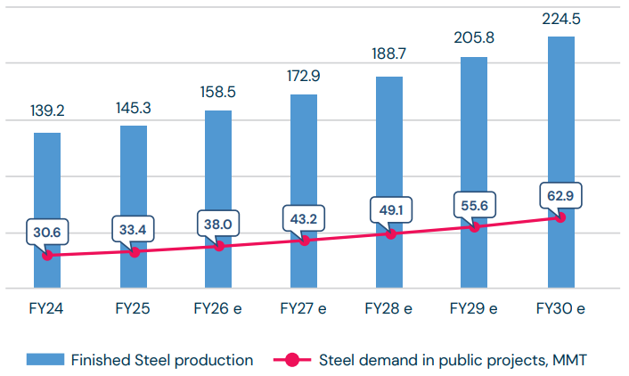
Figure 1: Finished steel production Vs estimated steel demand in public projects (All values in MMT)
(Source: Climatecatalyst, 2026)
But this is not the only factor in purchasing to ensure environmental sustainability. Price is another consideration industrial buyer’s make when picking between industrial closest manufacturers. Industrial manufacturing company producers correctly gain reaction when it comes to the quality, reliability and consistency of supply also durability of an industrial closest maker to an industrial customer (Zhao and Luethje, 2025). In both of these cases, however, if there is a big difference in cost between two different lower carbon steels or if customers don't know the positive effects of using steel, they may not be willing to pay the premium. This is where Tata Steel will be challenged to demonstrate its ability to make real progress with the environment without compromising Commercial competitiveness.
Likewise, other stakeholders, investors, employees, vendors, regulators, and communities, affect the company's reputation and course of action. Investors could seek out real objectives that are related to environmental degradation for the world, whilst staff/communities may have more value in the employment stability of the employer, along with good trade growth and maintaining the natural environment.
Suppliers are very important, and the production performance of recycled scrap will be impacted, especially with regard to the quality of the primary materials used to produce manufactured goods (electric power, new and old raw materials with lower carbon emissions). Marketing messages, such as those needed for Tata Steel, should be based on evidence-based sustainability outcomes, and not unverifiable environmental messages. To sum up, it looks like there are possibilities to be sustainable and differentiated with consumers' demand and stakeholders' expectations, but the challenge is: Affordability, product and product quality, product trust and environmental performance.

3.0 Task 2: Strategic Growth and Competitive Positioning

3.1 Application of the Ansoff Matrix
The Ansoff Matrix represents four potential strategies for growth based on existing products and markets as well as new ones (Ferreira and de Sá, 2024). Market penetration comprises more sales of Tata Steel's successful steel materials at competitive prices, better customer relationships, and a better distribution chain. Product development is aimed at offering new or improved products to existing customers, such as low-carbon steel. This uniquely addresses the growing needs of the building, vehicle, and infrastructure industries for sustainability.
Market Development involves the process of offering existing products to new areas and new customer groups, and Tata Steel can extend the market of existing products to the accessible market for customers who look for Sustainable products. The diversification aspect is symbolised in the entry to new product markets/business areas, such as advanced recycling and circular-material solutions, which are an extension beyond steel production. But diversification is usually a riskier procedure that could involve the growth of fresh capabilities, investments, and understanding of market dynamics. An opportunity or risk will depend on customer options, competition considerations, the availability of financial resources, and environmental legislative considerations.
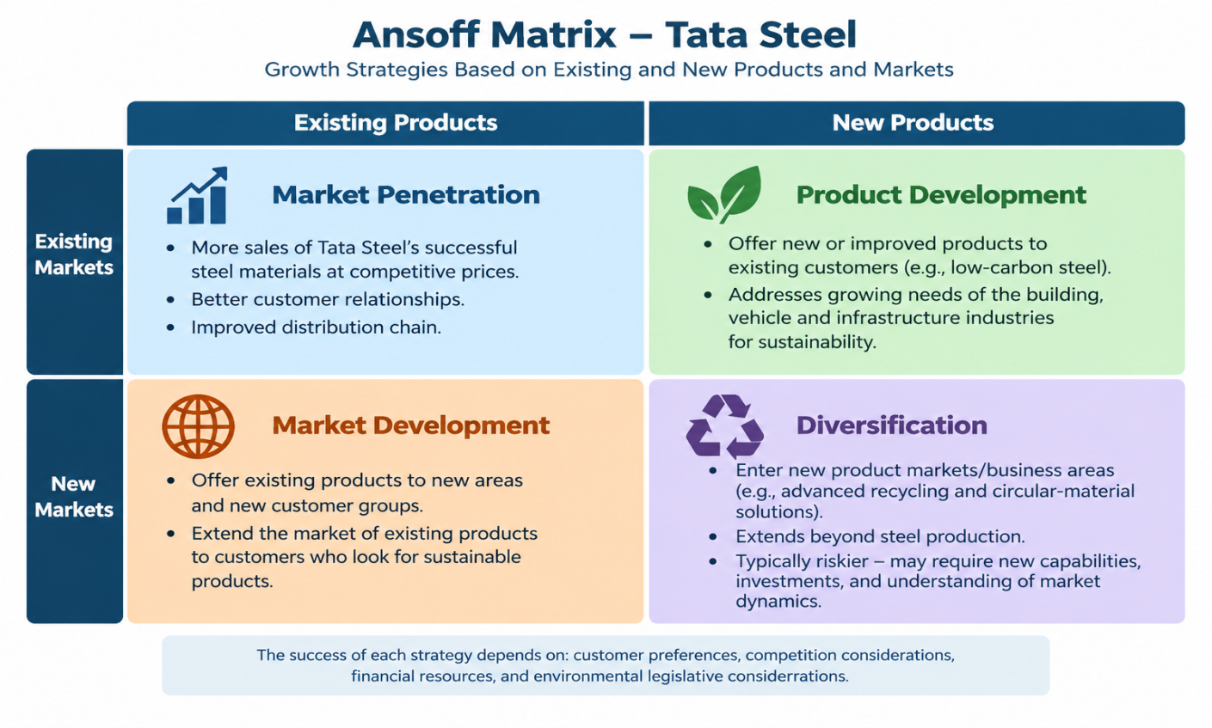
Figure 2: Ansoff Matrix
(Source: Self Created)

3.2 Recommended growth strategy
Tata Steel needs to focus more on the product development line with lower-priced and lower-carbon steel products for current users of the construction, automotive and infrastructure lines. In doing so, the company will be able to satisfy growing orders for higher environmental standards and help differentiate itself from traditional steel products. This transition can be facilitated by investing in technologies for energy efficiency and cleaner production, as well as investment in steelmaking using scrap (Zhang et al. 2025). Additionally, industrial customers can be engaged to better define the requirements for products and create longer-lasting relationships. Having access to low-carbon energy and proving statistically significant emissions reductions are necessary to achieve success on the ground, which means reducing production costs.
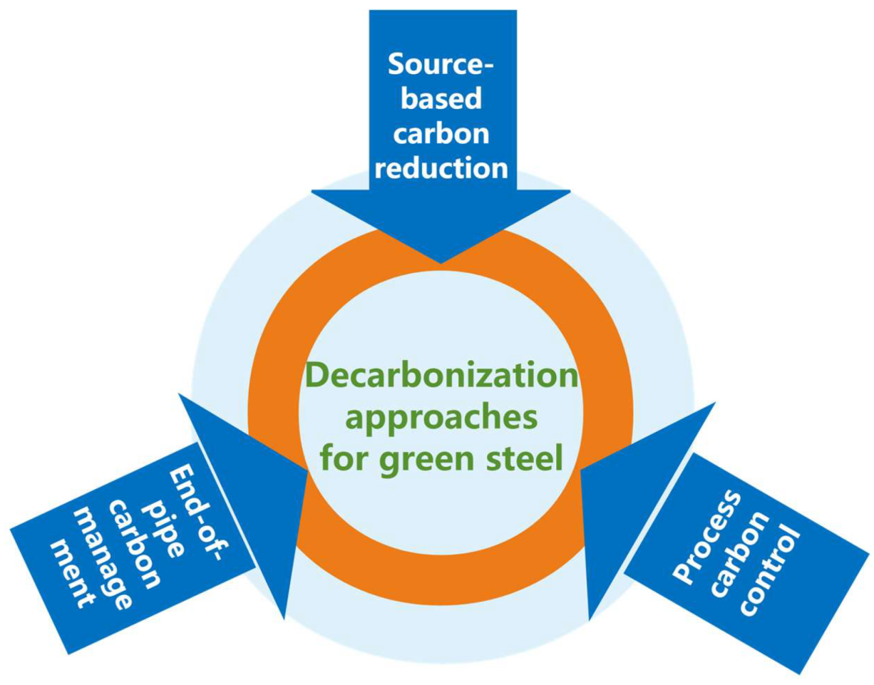
Figure 3: Technological pathways for sustainable steel production
(Source: Zhang et al. 2025)

3.3 Competitive advantage and marketing strategy
Tata Steel can add a competitive edge further by differentiating its product offering by making the lower-grade carbon steel a 'Green' choice. Its product should be targeted at customers within the construction and automotive/infrastructure businesses who are interested in reducing their emissions along the supply chain. The company may be able to carve out the market segments based on the various sustainability needs of the industrial buyers and develop a value proposition. Proven emissions reductions and reliability in terms of quality and supply are the focus of effective product positioning – alongside sustainability.
Competitive pricing is going to be key, and so will be the economic aspect because they may be unwilling to pay a high price for eco-friendly materials (Khachatryan et al. 2023). Additionally, Tata Steel needs to further develop its B2B ties, fostering technical cooperation and providing environmental information about products in a transparent format and establishing long-term sourcing agreements. Digital communication and sustainability reporting are possible means of demonstrating the steps forward and of ensuring that the stakeholders remain convinced (Di Tullio and La Torre, 2022). But something as seemingly simple as differentiation will only become a lasting competitive edge if the benefits that come from the environment are independently verifiable and coupled to commercially viable production systems. Taking a holistic approach to sustainability and quality, affordability and customer value can help Tata Steel's market position.

3.4 Implementation, risks and performance measures
Tata Steel needs to undertake its lower-carbon products development policy through staged investment in cleaner production technology, training staff and engaging with industrial customers. Capability challenges include high capital expenditure, increasing energy costs, lack of scrap and potential customer unwillingness to pay. The problems can be solved by Investment Appraisal, Business Partnerships with Suppliers and Frequent Market Research (Qian et al. 2023). Progress towards a continuous reduction in the sale of lower-carbon steel, greenhouse gas emission intensity, customer retention and production costs and profitability should be measured by the achievement of performance indicators. Though it is important to continue monitoring, it should be done so that if marketing issues arise with the implementation of the system, adjustments can be made. Environmental performance will also be disclosed transparently, which will increase stakeholders' confidence and promote sustainable competition.

4.0 Task 3: Managerial and Professional Reflection

4.1 Selection rationale
The selection of Tata Steel was made because of its significance in the steel industry worldwide and due to environmental issues in the steel industry. It's one of the appropriate examples that can be used when talking about how environment, political and customers pressure the marketing decisions of going to lower carbon steels. This company is also looking into ways of putting into practice marketing principles in business problems that arise. The sustainability report is an important insights document for policy development and strategic growth opportunities, as well as to measure a player's position in the market.

4.2 Decision reflection
The environmental and external forces, which include customer and stakeholder forces, were selected in order to obtain a balanced view of the external environment for Tata Steel's marketing. Lower-carbon steel was cited as a growth prospect as it can meet changing needs and help to differentiate. It is a trade-off between sustainable investing and production costs, and customers' affordability, though. The Ansoff Matrix was used to make the comparison of the various described growth processes easier, while differentiation facilitated the connection between the environment and customer value and future competitiveness.

4.3 Limitations
The analysis has been restricted as the external secondary data used may not have accurately captured the customer preferences/priorities for investment and may not have captured the cost of Tata Steel. Corporate sustainability reports tend to cover a story of results, but few report on the issues that would be faced in getting the results. Furthermore, it's difficult to conclude from the market point of view what customers would be prepared to pay for lower carbon steel. Geographical market differences in their regulation and energy availability may also affect the applicability of the recommendations. Before they can make a decision, management needs to collect comprehensive production-cost data, along with analysis of competitor production, and identify and review customer demand for low-carbon steel periodically, and then complete independent emissions estimates to better the decision-making process.

4.4 Professional learning
This analysis confirmed my knowledge that external environmental pressures, regulations and Stakeholder expectations are influencing and impacting the decision-making requirements for marketing. The process engaged in our Ansoff Matrix was beneficial in demonstrating that other strategies of growth need to be assessed and identified before making a strategic choice. I also discovered that the sustainability strength of competitive advantage depends on it adding value for the environment and, if it is recognised and valued by customers, on whether it is believable. As seen from a managerial point of view, achieving a compromise between the environment and low cost, and between the environment and operability and profitability is crucial. It was also reinforced that evidence-based recommendations were a necessity, and there was a call for critical examination of information and transparent communication in the analysis. These learnings can be applied more responsibly and with a sound strategy in future work practice.

5.0 Conclusion
In conclusion, Tata Steel has significant opportunities as well as challenges to address in this new era where environmental sustainability is a key factor in the steel industry. Affected by the market, industry rules, changing consumer tastes in the marketing strategies they follow and the influence of their competitors. Differentiation is an area where differentiation can be increased—product development provides opportunity for growth in the lower carbon steels, as well as in other areas of differentiation. However, technological requirements and costs need to be met; resources need to be reliable and credible environmental claims need to be justified to succeed. Implementing and monitoring performance regularly, therefore, needs to be based on evidence to enable sustainable growth and ensure the trust of stakeholders.

Reference Lists
Journals
Di Tullio, P. and La Torre, M., 2022. Sustainability reporting at a crossroads in Italian universities: is web-based media adoption deinstitutionalising sustainability reporting?. Administrative Sciences, 12(1), p.34.
Ferreira, A.P.P.F.S. and de Sá, M.M.B.P., 2024. The importance of the Ansoff matrix for the study of the information services market. The Canadian Journal of Information and Library Science, 47(2), pp.78-84.
Khachatryan, A., Sakhbieva, A., Kirpicheva, M., Dolgova, M. and Chernov, S., 2023. Consumer demand for environmental friendliness as a new round of modern marketing development. Polish Journal of Environmental Studies, 32(5), pp.4095-4111.
La Rosa, A.D., Åsen, I., Ingarao, G. and Fratini, L., 2025. Life Cycle Assessment of a steel component produced from electric arc furnace. CIRP Journal of Manufacturing Science and Technology, 59, pp.127-134.
Mokrzycki, E. and Gawlik, L., 2025. Possibilities of reducing greenhouse gas emissions in the steel industry. Advances in Science and Technology. Research Journal, 19(11).
Oreggioni, G.D., Mahiques, O., Monforti-Ferrario, F., Schaaf, E., Muntean, M., Guizzardi, D., Vignati, E. and Crippa, M., 2022. The impacts of technological changes and regulatory frameworks on global air pollutant emissions from the energy industry and road transport. Energy Policy, 168, p.113021.
Pedersen, L.N., 2023. Brand image & greenwashing (Doctoral dissertation, Master’s Thesis, Aalborg University).
Qian, C., Dion, P.A., Wagner, R. and Seuring, S., 2023. Efficacy of supply chain relationships–differences in performance appraisals between buyers and suppliers. Operations Management Research, 16(3), pp.1302-1320.
Sharma, S., Singh, R.K., Mishra, R. and Subramanian, N., 2024. Developing climate neutrality among supply chain members in metal and mining industry: natural resource-based view perspective. The International Journal of Logistics Management, 35(3), pp.804-832.
Shee Weng, L., 2025. The EU's carbon border adjustment mechanism (CBAM): balancing climate action and global trade. The EU's Carbon Border Adjustment Mechanism (CBAM): Balancing Climate Action and Global Trade (March 01, 2025).
Workman, M., Platt, D., Reddivari, U., Valmarana, B., Hall, S. and Ganpatsingh, R., 2022. Establishing a large-scale greenhouse gas removal sector in the United Kingdom by 2030: first mover dilemmas. Energy Research & Social Science, 88, p.102512.
Zhang, J., Guo, H., Yang, G., Wang, Y. and Chen, W., 2025. Sustainable transition pathways for steel manufacturing: Low-carbon steelmaking technologies in enterprises. Sustainability, 17(12), p.5329.
Zhao, W. and Luethje, B., 2025. Manufacturing competency from local clusters: Roots of the competitive advantage of the Chinese electric vehicle battery industry. World Electric Vehicle Journal, 16(6), p.319.
Websites
Climatecatalyst, (2026), Catalysing Demand for Green Steel through Public Procurement in India, [Online], Available at: https://climatecatalyst.org/wp-content/uploads/2026/02/Catalysing-Demand-for-Green-Steel-through-Public-Procurement-in-India-Report.pdf, [Accessed on: 12.10.2026]
Tata Steel, (2026), CLIMATE CHANGE REPORT, [Online], Available at: https://www.tatasteel.com/investors/integrated-report-2025-26/pdf/Climate%20Change%20Report.pdf, [Accessed on: 12.10.2026]
Tata Steel, (2026), Company Profile, [Online], Available at: https://www.tatasteel.com/corporate/our-organisation/company-profile/, [Accessed on: 12.10.2026]
Tata Steel, (2026), Scrap To Steel, [Online], Available at: https://www.tata.com/newsroom/business/tata-steel-scrap-recycling, [Accessed on: 12.10.2026]
Tata Steel, (2026), Tata Steel Inaugurates its first Scrap-based Electric Arc Furnace in India, [Online], Available at: https://www.tatasteel.com/newsroom/press-releases/india/2026/tata-steel-inaugurates-its-first-scrap-based-electric-arc-furnace-in-india/, [Accessed on: 12.10.2026]

