

Student name: Florence Chijioke Oguledo
Student ID: 2411483
Module name: Creativity and Value Creation
Module code: BMHP5014
Lecturer's name: Liala Surani

Table of Contents
Section | Title
 | Introduction
Task 1 | Defining Key Concepts in Practice
 | Innovation
 | Creativity
 | Value Creation
 | Change
Task 2 | Mind Map: Staff Burnout in NHS Community Teams
Task 3 | Self-Reflection of Group Activity
Task 4 | Case Study Analysis: NHS Virtual Ward Model
Task 5 | Research Task: Staff Burnout in Health and Social Care
Task 6 | Exploring Digital Innovation in Health and Social Care
 | 6a: Wearable Health Technologies
 | 6b: Electronic Health Records
 | 6c: Digital Technology for Preventative Care
Task 7 | Understanding the NHS Leadership Framework
 | 7a: Summary of the NHS Leadership Framework
 | 7b: Leadership Behaviour - Leading with Curiosity
 | 7c: Self-Reflection on Learning
Task 8 | Self-Reflection Journal Entry
Reference List

Conclusion

Introduction
This portfolio demonstrates my engagement with key concepts explored throughout the Changemakers: Creativity and Value Creation module. The following tasks examine creativity, innovation, value creation, and change within health and social care contexts, applying theoretical frameworks to real-world challenges and reflecting on personal learning and professional development. Each section critically evaluates the practical application of these concepts, acknowledging both their strengths and limitations in contemporary healthcare settings.

Innovation
Innovation refers to the process of introducing new ideas, methods, or technologies that bring about meaningful improvement. Rogers' Diffusion of Innovation Theory explains how new ideas spread through organisations and are gradually adopted by individuals over time, depending on perceived benefits and compatibility with existing practices (Rogers, 2003). While this theory offers valuable insights into adoption patterns, critics argue it assumes rational decision-making and overlooks contextual barriers such as resource constraints and organisational resistance (Greenhalgh et al., 2004). In health and social care, innovation is essential for improving patient outcomes and responding to evolving needs. However, successful implementation depends heavily on staff engagement and adequate training, challenging the assumption that beneficial innovations will naturally diffuse. For example, virtual wards represent a significant innovation, yet their effectiveness varies across settings due to differences in infrastructure and workforce capacity (NHS Confederation, 2023).

Creativity
Creativity involves generating novel and potentially useful ideas or solutions. Amabile's Componential Theory of Creativity states that creativity occurs when individuals combine domain-relevant skills, creativity-relevant processes, and intrinsic task motivation, supported by a conducive social environment (Amabile, 1996). A limitation of this theory is its focus on individual-level factors, potentially underestimating systemic barriers such as hierarchical cultures and time pressures that characterise healthcare environments (West and Sacramento, 2012). Creativity matters in healthcare because complex problems require fresh thinking beyond routine approaches. However, healthcare systems often prioritise standardisation and risk-aversion, creating tension between creative problem-solving and safety requirements (Baxter et al., 2019). A creative example is care teams designing personalised activity programmes for dementia patients, but implementing such approaches requires organisational support and protected time that may not always be available.

Value Creation
Value creation in healthcare means improving outcomes that matter to patients relative to the cost of achieving them. Porter defines value as outcomes divided by cost, emphasising that true value comes from better health results, not simply cost reduction (Porter, 2010). While influential, this framework has been criticised for oversimplifying complex care processes and struggling to measure outcomes that patients truly value, such as dignity and quality of life (Gray, 2017). Value creation is vital in resource-constrained systems to ensure quality care is sustainable. However, tensions arise between financial efficiency and person-centred care, requiring careful navigation. A falls prevention programme demonstrates value creation by reducing hospital admissions through home assessments, yet measuring long-term outcomes and patient satisfaction remains methodologically challenging (Sousa, 2022).

Change
Change involves moving from current practice to an improved state. Lewin's Change Management Model describes change through unfreezing existing behaviours, implementing new approaches, and refreezing improvements as the new norm (Burnes, 2017). Critics argue this model oversimplifies change as a linear process, whereas healthcare change is often complex, iterative, and faces unpredictable challenges (Buchanan and Boddy, 2020). Change is necessary to implement evidence-based practice and respond to shifting population needs. However, change fatigue and staff resistance frequently undermine implementation, particularly when front-line staff feel excluded from decision-making. Implementing electronic record systems requires unfreezing old habits, training staff, and embedding new workflows, yet many implementations fail due to insufficient attention to cultural and human factors (Cresswell and Sheikh, 2013).

Task 2: Mind Map
Problem: Staff burnout in NHS community teams

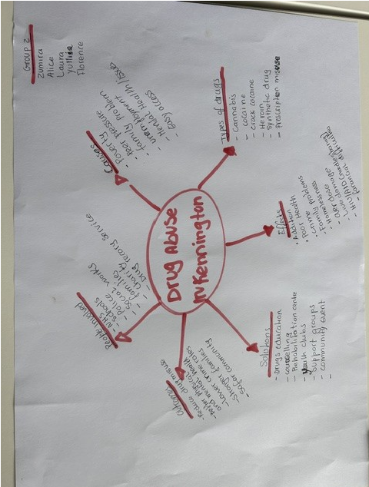
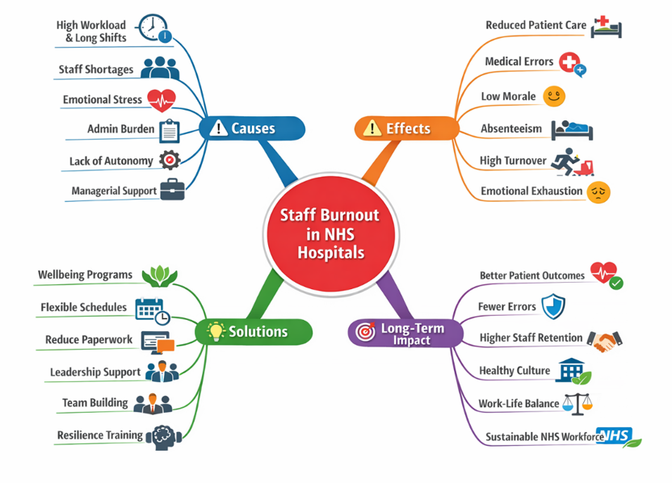

Figure 1: Mind Map: Staff burnout in NHS hospitals
Sources: (Author)

Staff burnout is a significant issue affecting NHS community teams, driven by excessive workloads, staff shortages, and emotional demands of patient-facing roles. The impact is wide-reaching: burnout reduces care quality, increases sickness absence, and contributes to staff leaving the profession, worsening workforce shortages (Kinman and Teoh, 2025).
Using a systems thinking approach, these factors interconnect rather than operating in isolation. High workloads lead to stress, which impairs team communication and reduces capacity for supportive supervision, creating a downward cycle (Meadows, 2008). This framework is valuable because it prevents simplistic, blame-focused responses and encourages holistic interventions. However, systems thinking can feel abstract and difficult to translate into practical action without dedicated resources and leadership commitment.
Potential solutions include introducing protected wellbeing time, improving flexible working, and ensuring regular supervision. Staff feedback mechanisms and peer support networks can
help identify early warning signs. The NHS Leadership Framework's emphasis on
compassionate leadership provides a structure for addressing burnout through supportive management. Without intervention, burnout will continue compromising patient safety and workforce sustainability, creating long-term systemic damage that is costly to reverse.

Task 3: Self-Reflection of Group Activity
Using Gibbs' Reflective Cycle (1988) to examine the convergent and divergent thinking class activity.
Description: We worked in small groups to generate solutions for improving patient discharge processes. We began by freely sharing any ideas (divergent thinking), then evaluated options to select the most practical (convergent thinking).
Feelings: Initially I felt hesitant to share unusual ideas, fearing they might appear impractical or naive. This anxiety affected my participation, as I held back potentially valuable contributions. However, the facilitator encouraged creative thinking without judgment, which gradually reduced my self-consciousness. When we moved to convergent thinking, I felt more confident applying analytical skills to assess feasibility, although I noticed tension within the group as members defended their preferred solutions.
Evaluation: Divergent thinking generated creative ideas like digital checklists and patient follow-up calls, but some suggestions were impractical due to staffing constraints. The convergent phase helped us prioritise effectively. I struggled with the shift from open creativity to critical evaluation, feeling that some creative ideas were dismissed too quickly. Group dynamics were generally positive, though quieter members contributed less during the convergent phase.
Analysis: I recognised that both thinking styles are essential. Divergent thinking fosters innovation by expanding possibilities, while convergent thinking ensures practical implementation (Cropley, 2006). Research suggests that effective problem-solving requires deliberate switching between these modes, yet individuals often prefer one style (Runco and Acar, 2012). Our group balanced these well because members had complementary strengths, though we could have managed the transition more explicitly.
Action Plan: I will consciously practise divergent thinking by writing down all ideas before evaluating them, using techniques like brainstorming alone to build confidence. I will also encourage quieter group members to share their perspectives, recognising that diverse input strengthens innovation.
Conclusion: I learned I naturally prefer convergent thinking, which means I risk dismissing creative ideas prematurely. I also recognised that my initial hesitation reflected a fear of judgment, which may limit my creative contributions in future. I could have contributed more during the divergent phase by building on others' ideas rather than waiting to evaluate.

Task 4: Case Study Analysis of a UK Innovation
The NHS virtual ward model at Wrightington, Wigan and Leigh NHS Foundation Trust represent a significant innovation addressing hospital capacity pressures. The problem was rising hospital admissions and bed occupancy, particularly for patients with chronic conditions who could be safely monitored at home (Pugmire et al., 2025).
Creativity was applied by developing a service with both step-up and step-down pathways, meaning patients could be admitted directly from primary care to avoid hospital admission, or discharged early from hospital with remote monitoring. This dual approach demonstrates creative flexibility, adapting the model to different patient journeys rather than imposing a single pathway. The service used wearable technology for continuous vital signs monitoring, tablets for communication, and integrated with community teams.
Value was created for patients through the comfort of receiving hospital-level care at home, with high satisfaction rates reported. Staff benefited from efficient remote monitoring tools, reducing time spent on routine observations. The system reduced hospital bed occupancy, creating system-level value. Outcomes reported across 1,835 admissions included a median stay of eight days, 92% adherence to wearable devices, and 94% of patients rating the experience as 'excellent' or 'good' (Pugmire et al., 2025).
Rogers' Diffusion of Innovation Theory explains the adoption of virtual wards as they are seen as useful and beneficial by both staff and patients (Rogers, 2003). However, this theory does not fully account for implementation challenges, including digital literacy gaps among some patient populations and interoperability issues between different technology platforms (NHS Confederation, 2023). Evidence suggests that virtual wards are most effective when accompanied by robust training and support, reinforcing that innovation adoption requires active facilitation rather than passive diffusion.

Task 5: Research Task
Issue: Staff burnout in health and social care
Article 1: Kinman and Teoh (2025) examined burnout in healthcare professionals using a comprehensive literature review, identifying workload, emotional demands, and lack of organisational support as primary causes. Their analysis emphasised that burnout results from chronic workplace stress rather than individual weakness, challenging resilience-focused interventions that place responsibility on individuals. The authors highlighted that effective interventions must combine organisational-level changes with individual support strategies, including improved staffing levels, accessible supervision, and wellbeing initiatives. This article is methodologically robust, drawing on multiple studies and providing clear evidence-based recommendations. However, the review does not include primary data and may not capture context-specific factors affecting different professional groups. This article helps me understand burnout as a systemic issue requiring cultural and structural responses, not merely individual resilience.
Article 2: Van der Lippe et al. (2024) studied integrated care implementation, finding that staff concerns and lack of organisational communication limited effective change. Using qualitative methods including interviews and focus groups, the research revealed that leadership and organisational culture are critical factors in supporting staff through transformation. When staff feel ignored or unsupported during change processes, burnout increases regardless of workload levels. This article provides rich contextual data, though the small sample size limits generalisability. It reinforces that burnout is exacerbated by poor change management and unclear communication, adding a valuable dimension not fully explored by Kinman and Teoh.
Comparison: Both articles agree that burnout is driven by organisational factors, not personal failings. Kinman and Teoh (2025) focus on workload and emotional strain with a broad evidence base, while van der Lippe et al. (2024) emphasise leadership and communication gaps using qualitative depth. Together, they demonstrate that addressing burnout requires improving work conditions, supporting staff through change, and fostering compassionate leadership. The quality of evidence is stronger in the Kinman and Teoh review due to its comprehensive scope, though the qualitative insights from van der Lippe et al. offer practical understanding of implementation challenges. These complementary perspectives strengthen the case for multi-level intervention strategies.

Task 6: Exploring Digital Innovation in Health and Social Care

6a: Wearable Health Technologies
Wearable technologies such as smartwatches offer significant benefits for managing chronic heart failure. Continuous monitoring of vital signs including heart rate, activity levels, and thoracic impedance enables early detection of deterioration before symptoms become severe (Bayoumy et al., 2021). This early warning capability supports timely clinical intervention, potentially reducing hospital admissions. Bayoumy et al. (2021) found that integrated telemonitoring with structured clinical response during the post-discharge period reduces cardiovascular events and heart failure hospitalisations. However, evidence quality varies, with some studies showing limited benefits when monitoring is not paired with responsive clinical pathways (Bayoumy et al., 2021). For patients, wearables provide reassurance and promote self-management, supporting daily activity tracking and medication adherence. The Technology Acceptance Model (Davis, 1989) explains that patients are more likely to use these devices when they perceive them as useful and easy to operate. A limitation is that older adults and those with limited digital literacy may struggle with these technologies, potentially widening health inequalities (Honeyman et al., 2020).

6b: Electronic Health Records
Electronic Health Records (EHRs) enhance communication and collaboration by providing a single, accessible patient record across care settings. The Connecting Care Records programme ensures authorised professionals access the information they need when delivering care (NHS England Digital, 2025). This integration reduces time spent gathering information and prevents duplication, allowing more focus on direct patient care. For example, ambulance services accessing shared records can make informed decisions about whether to admit patients to hospital, avoiding unnecessary admissions (NHS England Digital, 2025). However, implementation challenges include staff training requirements, interoperability issues between different systems, and concerns about data security and confidentiality (Manca, 2015). Research indicates that while EHRs improve information access, they can also increase administrative burden and reduce face-to-face interaction time if not carefully designed (Cresswell and Sheikh, 2013). EHRs support integrated working as multiple professionals contribute to and access the same record, but achieving this requires standardised data entry and a culture of information sharing.

6c: Digital Technology for Preventative Care
Digital technology supports preventative care through risk identification and personalised interventions. The NHS Digital Neighbourhoods programme uses AI tools to identify people at risk of becoming seriously unwell, enabling proactive outreach (NHS England, 2025). For example, an algorithm analyses patient data to flag those with deteriorating health, prompting integrated teams to arrange preventative conversations and personalised care plans. This shifts care from reactive hospital treatment to proactive community support. Patients benefit from timely interventions addressing root causes like social isolation or poor nutrition, preventing escalation to acute care. However, ethical concerns include algorithmic bias and the risk of creating digital dependency (NHS England, 2025). The Technology Acceptance Model is relevant as successful adoption depends on healthcare professionals finding AI tools useful and intuitive (Davis, 1989). Evidence suggests that combining AI predictions with human judgement, rather than replacing it, yields the best outcomes, reflecting the importance of maintaining professional discretion alongside digital innovation.

Task 7: Understanding the NHS Leadership Framework

7a: Summary of the NHS Leadership Framework
The NHS Leadership Framework, known as 'Our Leadership Way', sets out six principles organised under three themes: Heart (Compassion), Head (Curiosity), and Hands (Collaboration) (NHS Leadership Academy, 2025). The framework emphasises inclusive, kind leadership that promotes equality and challenges discrimination. Under Curiosity, leaders are encouraged to aim for high standards, seek continuous improvement, and embrace creative thinking. The Collaboration principle focuses on forming effective partnerships and celebrating success. This framework is important because leadership behaviour significantly influences workplace culture, staff wellbeing, and patient outcomes (West et al., 2015). However, critics argue that frameworks risk becoming tick-box exercises if not embedded in organisational culture and supported by appropriate resources (Buchanan and Boddy, 2020). It provides a shared language for leadership development and supports the NHS People Promise by formalising compassionate leadership expectations for all levels, though translating principles into practice requires ongoing commitment and systemic support.

7b: Leadership Behaviour - Leading with Curiosity
The leadership behaviour of curiosity involves aiming for high standards, seeking continuous improvement, and encouraging creative thinking ( NHS Leadership Academy, 2025). A leader can encourage creativity by creating psychologically safe environments where staff feel able to suggest new ideas without fear of criticism. For example, a ward manager could hold regular 'innovation huddles' where staff share improvement ideas and receive support to test them. This approach aligns with Amabile's (1996) theory that creativity flourishes when individuals feel intrinsically motivated and supported. Transformational leadership suggests leaders inspire staff through vision, encouragement and support, helping teams adopt new ideas and improve practice (Bass and Avolio, 1994). By visibly valuing creative contributions and acting on suggestions, the leader empowers staff to improve care processes, enhancing patient safety and experience. However, curiosity must be balanced with accountability, as not all ideas are feasible or evidence based. Effective leaders actively create conditions for safe experimentation while maintaining critical evaluation and learning from failures.

7c: Self-Reflection on Learning
Reflecting on this module, my understanding of creativity and value creation has developed significantly. Previously, I viewed innovation as something external imposed on practice, often associated with technology or large-scale policy initiatives. I now understand that creativity is a skill that can be cultivated and applied daily by healthcare professionals through small, iterative improvements. The emphasis on value creation has shifted my perspective from focusing on activity to outcomes that genuinely matter to patients, challenging me to question whether routine practices benefit those we serve. The NHS Leadership Framework has shown me that leadership is not a role but a set of behaviours accessible to all, which is empowering for someone at the beginning of their career. I will carry forward the concept that creativity, supported by compassionate leadership, is essential for sustainable healthcare improvement. I also recognise that systemic barriers and organisational culture can either enable or constrain creative practice, so I will seek to understand and navigate these factors.

Task 8: Self-Reflection Journal Entry
Using Gibbs' Reflective Cycle (1988), this module has transformed my understanding of creativity and value creation in healthcare. Initially, I associated innovation with high-tech solutions developed externally. Through the tasks and discussions, particularly the case study analysis and group activity, I now appreciate that creativity is an everyday process involving adapting existing resources to patient needs. The concept of value creation has reframed my thinking about care quality: value means improving outcomes that matter to patients, not simply delivering more services (Porter, 2010).
The NHS Leadership Framework has inspired me to develop leadership behaviours regardless of my formal role, recognising that curiosity and collaboration are accessible to all staff. In future placements, I will apply creativity by questioning routine practices and suggesting small improvements, while remaining sensitive to the practical constraints that healthcare professionals navigate daily. I will seek feedback and use reflective models to learn from experiences, recognising that innovation often involves trial and error. The research task deepened my appreciation for evidence-based practice, showing that understanding problems fully is essential before designing solutions.
Ultimately, this module has equipped me to contribute meaningfully to innovation in health and social care by thinking critically, collaborating effectively, and always focusing on patient-centred value. I will carry forward the understanding that sustainable improvement requires persistence, teamwork, and commitment to compassionate care, values that I now see as central to professional identity.

Conclusion

This portfolio demonstrates that creativity, innovation, and value creation are not abstract concepts but practical tools for improving health and social care. Through systematic analysis of real-world challenges from staff burnout to digital transformation, I have learned that sustainable improvement requires compassionate leadership, systems thinking, and a commitment to outcomes that genuinely matter to patients. The module has equipped me to approach practice critically and creatively, recognising that meaningful change emerges from collaboration, curiosity, and persistence, while acknowledging the systemic barriers that must be navigated to translate ideas into tangible patient-centred value.

Reference List
Amabile, T.M. (1996) Creativity in Context. Boulder, CO: Westview Press.
Bass, B.M. and Avolio, B.J. (1994) Improving Organizational Effectiveness through Transformational Leadership. Thousand Oaks, CA: Sage Publications.
Baxter, R., Taylor, N. and O'Neill, M. (2019) 'Creativity in healthcare: a qualitative study', Journal of Health Organization and Management, 33(5), pp. 601-616.
Bayoumy, K., Gaber, M., Elshafeey, A., Mhaimeed, O., Dineen, E.H., Marvel, F.A., Martin, S.S., Blumenthal, R.S. and Cikes, M. (2021) 'Smart wearable devices in cardiovascular care: where we are and how to move forward', Nature Reviews Cardiology, 18(4), pp. 245-260.
Buchanan, D.A. and Boddy, D. (2020) The Expertise of the Change Agent. London: Routledge.
Burnes, B. (2017) Managing Change. 7th edn. Harlow: Pearson Education.
Cresswell, K. and Sheikh, A. (2013) 'Organizational issues in the implementation and adoption of health information technology innovations', Journal of Medical Internet Research, 15(4), pp. 35-49.
Cropley, A.J. (2006) 'In praise of convergent thinking', Creativity Research Journal, 18(3), pp. 391-404.
Davis, F.D. (1989) 'Perceived usefulness, perceived ease of use, and user acceptance of information technology', MIS Quarterly, 13(3), pp. 319-340.
Gibbs, G. (1988) Learning by Doing: A Guide to Teaching and Learning Methods. Oxford: Further Education Unit, Oxford Polytechnic.
Gray, M. (2017) 'Value-based healthcare: a critical analysis', Journal of Health Services Research and Policy, 22(4), pp. 254-260.
Greenhalgh, T., Robert, G., Macfarlane, F., Bate, P. and Kyriakidou, O. (2004) 'Diffusion of innovations in service organizations: systematic review and recommendations', Milbank Quarterly, 82(4), pp. 581-629.
Honeyman, M., Maguire, D., Evans, H. and Davies, A. (2020) 'Digital technology and health inequalities: a scoping review', Journal of Public Health, 42(3), pp. e271-e279.
Kinman, G. and Teoh, K. (2025) 'Burnout in health care: risk factors and solutions', Occupational Medicine, 75(6), pp. 295-301.
Manca, D.P. (2015) 'Do electronic medical records improve quality of care?', Canadian Family Physician, 61(10), pp. 846-847.
Meadows, D.H. (2008) Thinking in Systems: A Primer. White River Junction, VT: Chelsea Green Publishing.
NHS Confederation (2023) Virtual Wards: A Guide for NHS Leaders. London: NHS Confederation.
NHS England (2025) Digital Neighbourhoods Programme. Available at: https://www.england.nhs.uk/south/our-work/digital-neighbourhoods/ (Accessed: 16 July 2026).
NHS England Digital (2025) Connecting Care Records Programme. Available at: https://production-like.nhsd.io/services/connecting-care-records (Accessed: 16 July 2026).
NHS Leadership Academy (2025) Our Leadership Way. Available at: https://www.leadershipacademy.nhs.uk/organisational-resources/our-leadership-way/ (Accessed: 16 July 2026).
Porter, M.E. (2010) 'What is value in health care?', New England Journal of Medicine, 363(26), pp. 2477-2481.
Pugmire, J., Ashish, A., Chadwick, A., Wilkes, M., Meekin, D., Zaniello, B. and Zahradka, N. (2025) 'A 2-year retrospective clinical evaluation of a novel virtual ward model', Journal of Primary Care and Community Health, 16, pp. 1-9.
Rogers, E.M. (2003) Diffusion of Innovations. 5th edn. New York: Free Press.
Runco, M.A. and Acar, S. (2012) 'Divergent thinking', in Runco, M.A. and Pritzker, S.R. (eds.) Encyclopedia of Creativity. 2nd edn. San Diego, CA: Academic Press, pp. 392-397.
Sousa, P. (2022) 'Rediscovering quality improvement and value creation in healthcare using a value-based healthcare approach', Revista Portuguesa de Cardiologia, 41(8), pp. 707-712.
van der Lippe, T., van Klaveren, C. and Schippers, J. (2024) 'Implementing integrated care: staff concerns and organisational communication', Journal of Integrated Care, 32(1), pp. 45-58.
West, M. and Sacramento, C. (2012) 'Creativity and innovation in healthcare', in Routledge, C. (ed.) The Oxford Handbook of Organizational Psychology. Oxford: Oxford University Press, pp. 135-162.
West, M., Armit, K., Loewenthal, L., Eckert, R., West, T. and Lee, A. (2015) Leadership and Leadership Development in Health Care: The Evidence Base. London: The King's Fund.

