OPERATING SYSTEMS, CLI COMMANDS
AND SCRIPTING

Student name: Akeem Raja Rafiq
Student number: 2519519
Course name: Operating Systems Assignment
Module name: Computer Architecture and Operating Systems

Contents
Introduction 3
1. Key Functions of General Operating Systems 3
1.1 Process and processor management 3
1.2 Memory management 4
1.3 File, device and storage management 4
1.4 User, security and network management 4
2. Use of Windows OS CLI Commands 5
3. Use of Linux OS CLI Commands 6
4. Use of Windows OS Scripts 8
4.1 Batch script 1: text-file backup 8
4.2 Batch script 2: repeated connectivity test 9
5. Use of Linux OS Scripts 9
5.1 Bash script 1: validated file backup 9
5.2 Bash script 2: disk-use monitor 10
Conclusion 12
References 13
Appendices 14
Appendix A – Tutorial Activity: OS Types 14
Appendix B – Lecture Activities / Activity Log 14
Appendix C – Certified Online Course Engagement 15
Reflective Summary 16

Introduction
Because they facilitate the execution of applications, manage hardware resources, and act as an interface between users and computer hardware, operating systems are crucial parts of contemporary computer systems. The primary features of general-purpose operating systems, including process management, memory management, file management, user administration, security, and network management, are examined in this paper. Using Batch, PowerShell, and Bash commands, it also examines how to use Windows and Linux command-line interfaces practically. The article also shows how basic Linux Bash and Windows Batch scripts can leverage variables, user input, arithmetic operations, loops, and conditional statements to automate repetitive administrative duties. To show how operating system features, commands, and scripts can be watched, controlled, and used in actual computer situations, screenshots and useful examples are provided. These exercises highlight how crucial operating systems are to the effective, safe, and dependable operation of computer resources [15].

1. Key Functions of General Operating Systems
Many applications and users can safely and effectively share hardware in a controlled environment offered by general-purpose operating systems. Although Windows, macOS, and Linux distributions have different interfaces and designs, they all carry out the same essential tasks.
Allocating processing time, controlling physical and virtual memory, organising files and storage, managing linked devices, and safeguarding user accounts and data are some of these fundamental duties. Additionally, the operating system offers services that let programs interact with hardware without having to comprehend every component's technical specifications. It keeps rights and processes apart in multi-user settings to prevent one user from simply interfering with the work of another. Additionally, it manages faults, keeps an eye on system performance, and manages background services including networking, printing, updates, and scheduled activities. Thus, general-purpose operating systems strike a compromise between security, dependability, performance, and usability. While command-line tools provide administrators with more exact control, their graphical interfaces make routine operations accessible. In order to offer a stable environment for software and users during both ordinary work and intensive workloads, Windows, macOS, and Linux all rely on process scheduling, memory protection, file systems, device drivers, user authentication, and network management, despite platform differences.

1.1 Process and processor management
In order to give the impression that several programs are running simultaneously, the OS starts, schedules, pauses, and ends processes. Additionally, it controls threads, inter-process communication, and priorities. Microsoft refers to Windows Task Manager as the integrated tool for tracking resource consumption and process performance [2]. It shows running programs, background processes, CPU usage, and process identifiers. Linux uses tools like ps, top, and the /proc virtual filesystem to reveal similar information. While preventing one operation from monopolising the processor, efficient scheduling increases responsiveness.
Which processes should use the CPU, for how long, and in what order are all determined by the scheduler. To balance speed, fairness, and system efficiency, it may employ time slices, priority, and various scheduling methods. Depending on user behaviour and resource availability, processes can be in one of four states: running, waiting, ready, or terminated. Context switching, in which the CPU saves one process state and loads another, is also managed by the operating system. This makes it possible for many apps to advance without direct confrontation. Additionally, processor management facilitates multitasking, helps distribute work among several processing cores, and identifies unresponsive programs. For system stability, quick application response, and dependable performance under demanding workloads, effective process control is crucial.

1.2 Memory management

When running programs need more memory than is immediately accessible, operating systems use virtual memory, assign protected address spaces, and keep track of physical RAM. Protection prevents the memory of one regular process from being read or overwritten by another. Linux tools like free and vmstat report RAM and swap utilisation, while Windows displays memory pressure and per-process use in Task Manager. Stability, multitasking, and security all depend on memory management.

1.3 File, device and storage management

The operating system uses device drivers to interact with storage, maintain metadata, enforce permissions, and arrange data into files and directories. While Get-ChildItem, Copy-Item, and associated PowerShell cmdlets offer scriptable access, File Explorer and Windows Storage Settings offer graphical administration [2]. Linux has a single hierarchical directory tree and common utilities like ls, cp, mv, chmod, and chown that are described in Linux documentation pages and GNU Coreutils [10], [11]. Printers, monitors, USB devices, and network adapters are all included in device management.

1.4 User, security and network management
Systems with multiple users keep audit data, grant privileges, and authenticate accounts. Windows utilises User Account Control, Windows Security, access-control lists, and local or domain accounts. Linux employs ownership and permission bits, user and group identities, and sudo for restricted administrative access. Interface configuration, addressing, routing, name resolution, firewalling, and connection monitoring are examples of networking functions. While Linux offers ping, ip, and ss, PowerShell Test-Connection sends ICMP echo requests to test reachability [3]. Additionally, the OS executes scheduled tasks and background services; Linux cron/systemd timers and Windows Task Scheduler enable work to perform automatically at certain periods [4], [12].
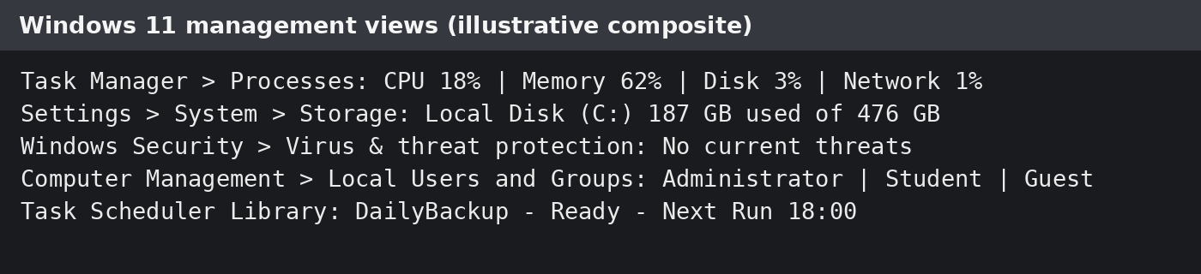
Figure 1. Windows management views.
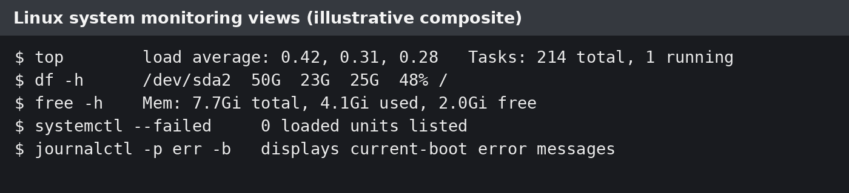
Figure 2. Linux monitoring views.

2. Use of Windows OS CLI Commands
Both object-based PowerShell cmdlets and conventional CMD functions are available to Windows administrators. The necessary management areas are covered by the examples that follow. While Stop-Process ends a chosen process and -WhatIf anticipates a possibly disruptive action, Get-Process lists processes; sorting by CPU identifies heavy users. Running and halted services are reported by Get-Service [5]. Get-ChildItem -Recurse, New-Item -ItemType Directory, Copy-Item -Force, and Remove-Item -Recurse are used to operate with files and directories. The ability of Get-ChildItem to recursively enumerate child objects is confirmed by Microsoft documentation [2].
Get-NetTCPConnection -State Established shows active TCP sessions, ipconfig /all reports adapter configuration, and Test-Connection -Count checks IP reachability [3]. Get-LocalUser and New-LocalUser can be used to show user administration; account creation typically necessitates enhanced rights. Scheduling is presented with Get-ScheduledTask and schtasks /Create, where options determine frequency, task name, command and start time. Because output can be filtered, piped, and saved, these commands are useful because they allow for repeatable troubleshooting instead of depending solely on graphical tools.
Every command in a practical lab should be executed from a non-administrative PowerShell window initially, and elevation should only be utilised when absolutely required. Export-Csv can be used to export process output for comparison at a later time, and -WhatIf and -Confirm can be used with file commands to minimise unintentional destruction. A successful ping does not prove that an application service is available, but packet loss may signal reachability issues. Therefore, network findings should be analysed rather than just recorded. Thus, to check a particular service, Get-NetTCPConnection can be used in conjunction with Test-NetConnection -Port. Strong passwords and membership in least-privilege groups are more crucial for user management than just setting up an account. A clear trigger, action, security context, and failure-monitoring technique should all be specified in scheduled activities. These procedures show that planning, verification, and auditability are all part of CLI management, not just learning syntax by heart.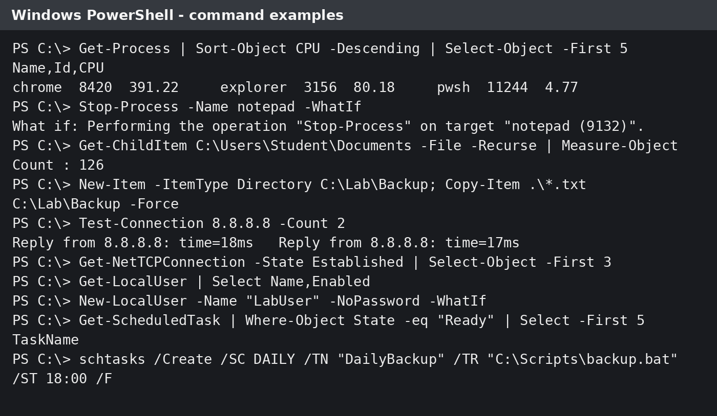
Figure 3. PowerShell/CMD commands and sample output.

3. Use of Linux OS CLI Commands
Small tools that can be coupled via pipelines and redirection are the foundation of Linux command-line administration. Process management tools include kill -TERM for controlled termination, top for real-time monitoring, and ps aux --sort=-%cpu to list processes by CPU usage. According to GNU Coreutils and Linux handbook pages [10], [11], file management utilises mkdir -p, cp -av, find, and chmod.
Ping -c for restricted connectivity checks, ip -brief address for succinct interface information, and ss -tuln for TCP and UDP socket listening are examples of networking utilities. Use id, getent passwd, and sudo useradd -m -s /bin/bash to manage users. Systemctl list-timers --all and crontab -l are used to evaluate scheduled jobs. Simple schedules work well with Cron, but systemd timers offer better logging, dependency management, and run recovery.
Grep, sort, head, awk, and cut can be used to filter outputs, and journalctl can limit logs by boot, service, or priority. Administrators must log command output, employ absolute paths in cron jobs, apply permissions properly, and adhere to least-privilege guidelines. Password, group, expiration, sudo, and rollback planning should all be used when creating users or changing rights. Although the command line is a powerful tool, its proper use requires clear documentation, validation, and exact arguments.
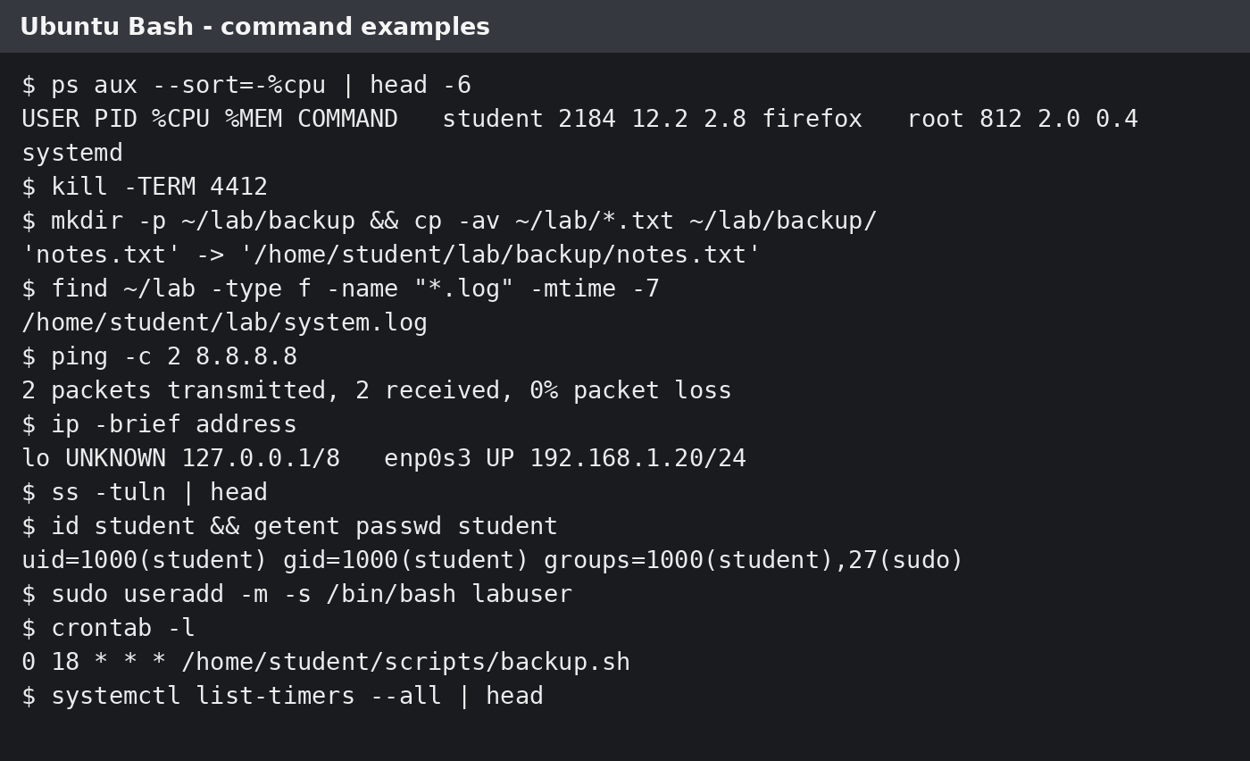
Figure 4. Bash commands and sample output.

4. Use of Windows OS Scripts

4.1 Batch script 1: text-file backup
The source and destination folders are requested by the user in the first script. It counts copied files using SET /A, cycles through.txt files, generates the destination if necessary, and verifies the source using IF NOT EXIST. This gives a visible success total and automates a regular selective backup. Paths with spaces are protected by quotation marks.
Due to its default availability and tight compatibility with CMD programs, batch scripting is suitable for simple Windows jobs. However, because values may be extended before the loop executes, variable expansion inside parenthesised blocks might be misleading. Therefore, delayed expansion with SETLOCAL would be possible with a production version of the backup script. Use !count and activateDelayedExpansion! within the loop. Additionally, it should test the disc space that is available, write the date, source, destination, and copy errors to a log file, and produce a sensible exit code. By testing a hostname and its resolved address, the connection script may track response times and differentiate between packet loss and DNS failure. These enhancements demonstrate how a simple classroom script can evolve into a regulated administration tool.
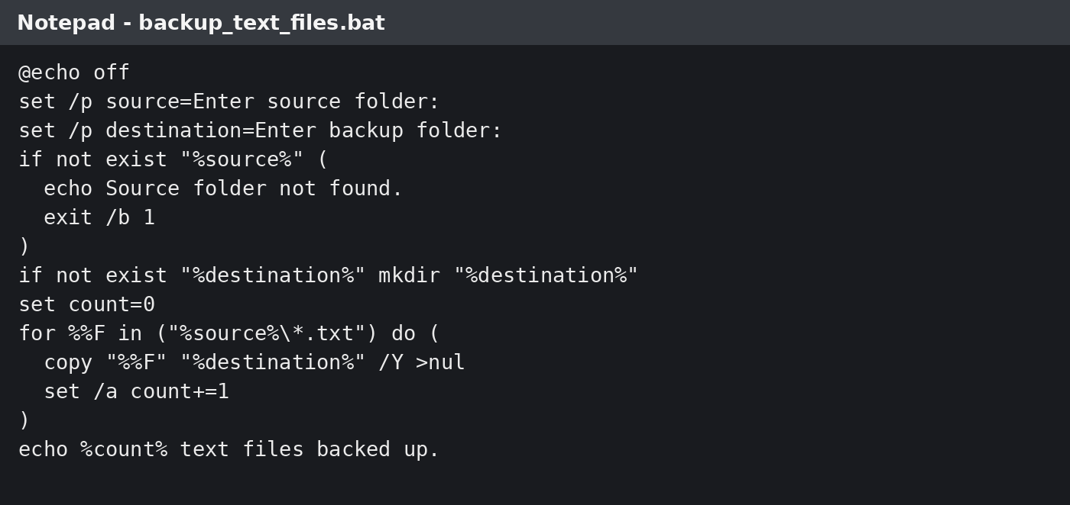
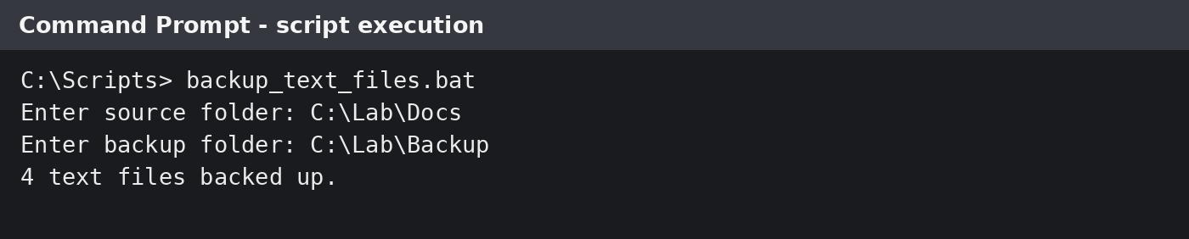

4.2 Batch script 2: repeated connectivity test
The second script utilises FOR /L to repeat ping after gathering a host and the number of attempts. Arithmetic increases the successful-test counter, ERRORLEVEL manages the success/failure branch, and FIND looks for the TTL response. It creates a consistent test with a final report from a recurrent network check. Before automating administrative activities, Microsoft command documentation advises inspecting switches and using safe previews when available [6].
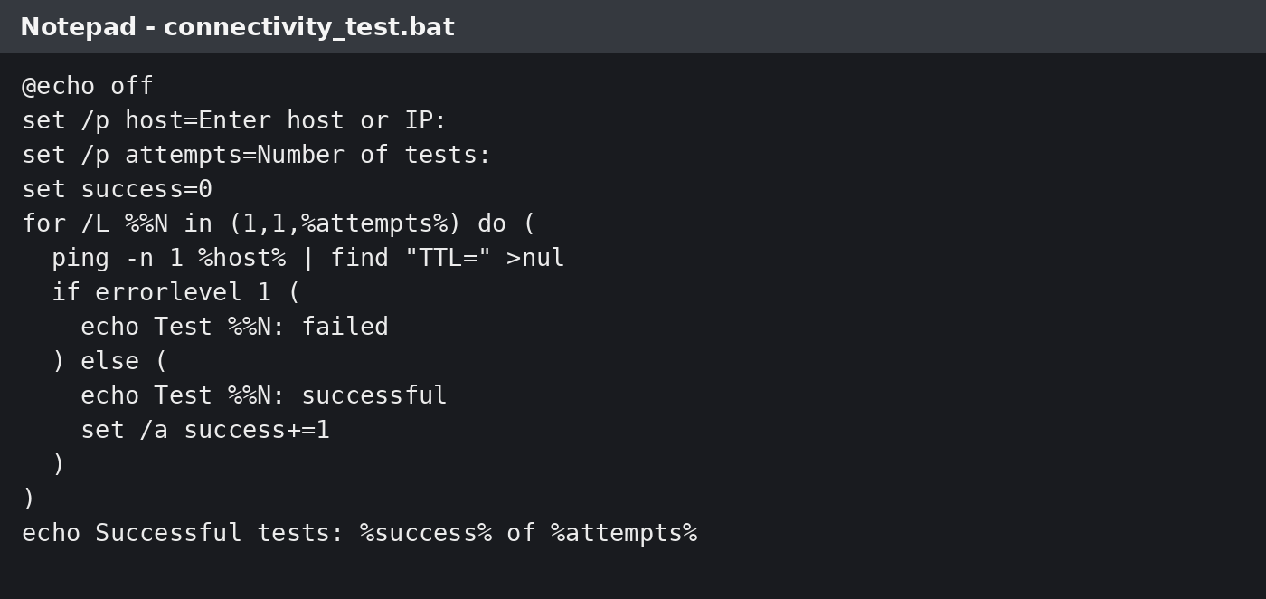
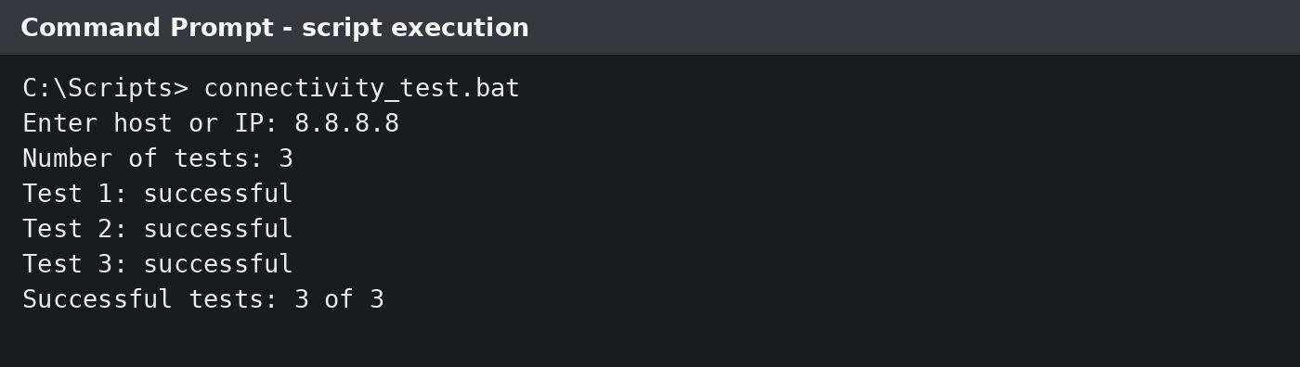

5. Use of Linux OS Scripts

5.1 Bash script 1: validated file backup
After receiving two paths, this Bash script uses [[ -d ]] to verify the source, mkdir -p to build the destination, loops through matching files, and then increases a counter. The continue guard stops someone from copying a literal unmatched wildcard. When compared to manual repetition, the script provides reliable validation and may be scheduled using Cron.
Compared to standard Batch, Bash has better quoting, functions, exit-status handling, and text processing integration. Reliable scripts may use set -euo pipefail to identify failed commands, unset variables, and pipeline issues. They should start with an appropriate interpreter line. To avoid spaces or wildcard expansion altering the command, user-supplied paths must stay quoted. Date-stamped folders, checksum checking, and a retention loop that eliminates backups beyond a predetermined time frame might all be included to the backup script. To enable cron or a monitoring service to identify failure, the disc monitor might take command-line parameters, write to syslog with logger, and return a non-zero exit code when the threshold is exceeded. Automation is safer, simpler to diagnose, and appropriate for repeated execution thanks to these controls.
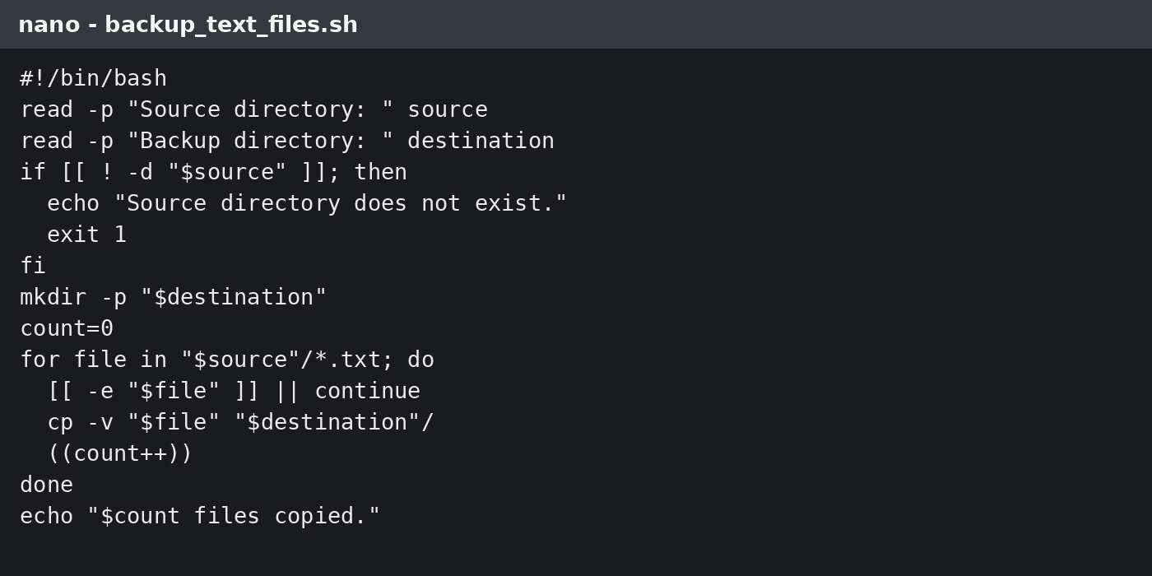
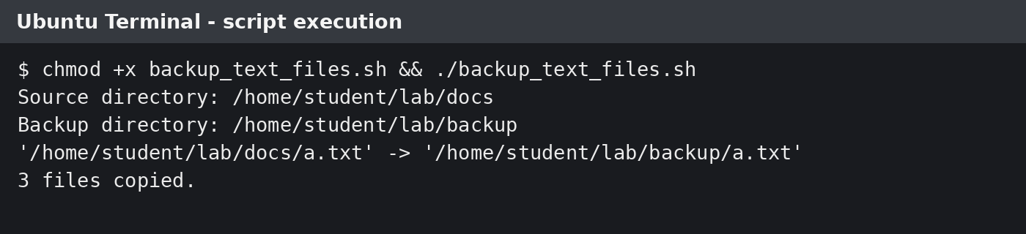

5.2 Bash script 2: disk-use monitor
The disc monitor uses an arithmetic conditional to compare integers, requests a warning threshold, and uses awk to retrieve the root-filesystem percentage from df. Next, a loop uses du to report the size of significant directories. Variables, user input, arithmetic comparison, conditionals, loops, pipelines, and error redirection are all demonstrated here. The GNU Bash manual defines arithmetic evaluation and Bash control structures [13]. In actuality, a scheduled operation might email the result or reroute it to a log.
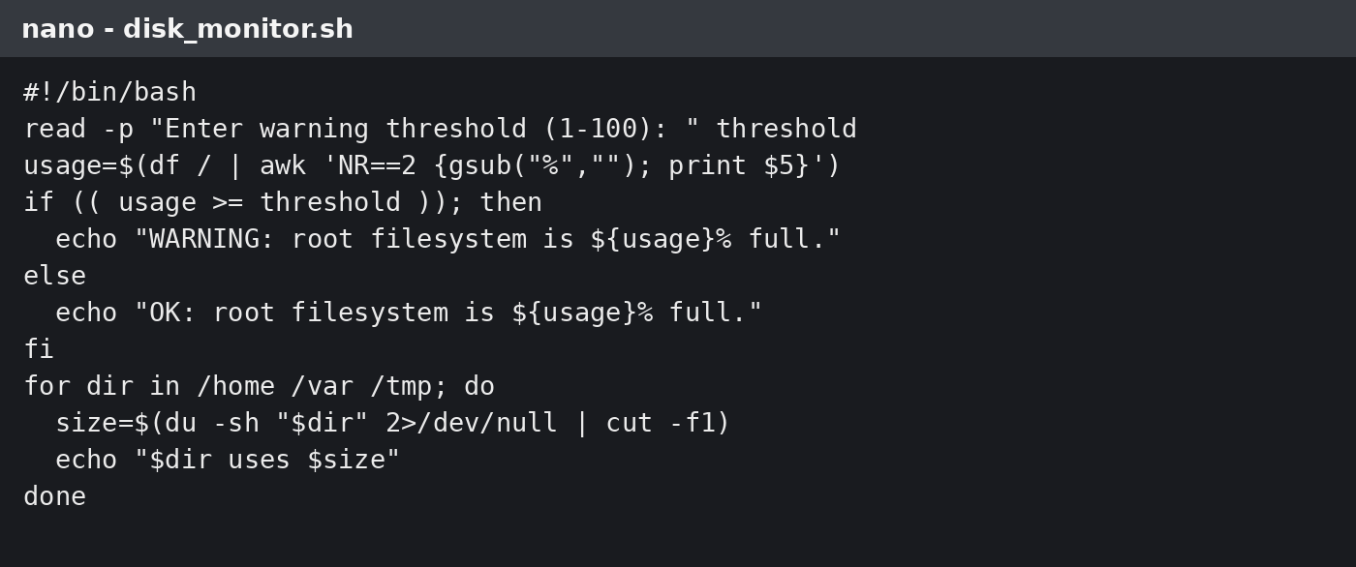
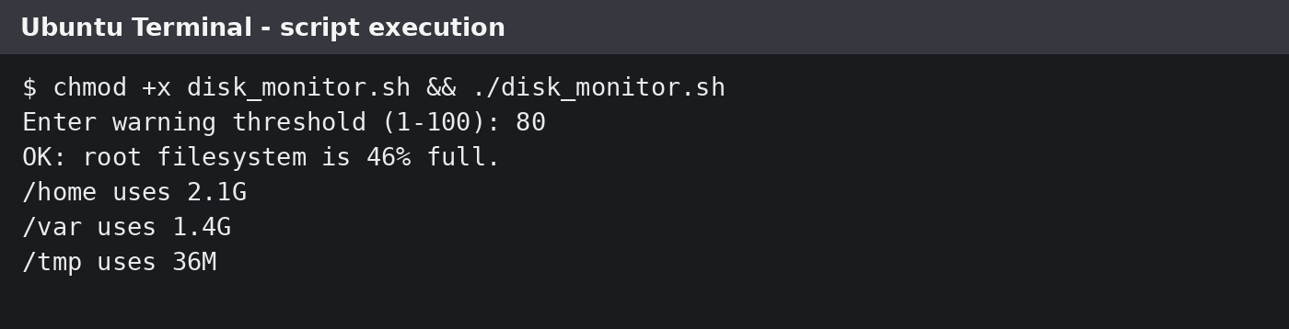

Conclusion
The general OS functions, Windows command-line commands, Linux command-line commands, Windows batch scripting, and Linux Bash scripting were the five primary areas of operating-system administration that were covered in this paper. The results demonstrate that by controlling processor time, memory, files, storage devices, user accounts, security, and network resources, operating systems offer the crucial link between people, applications, and hardware. Both Windows and Linux give administrators useful tools for managing resources, keeping an eye on performance, and automating repetitive operations, despite the fact that their interfaces and command structures differ.
The Windows exercises illustrated how process, file, network, user, and task management may be supported by PowerShell and CMD commands including Get-Process, Get-ChildItem, Test-Connection, Get-LocalUser, and Get-ScheduledTask. Because PowerShell works with structured objects and enables the filtering, sorting, and exporting of results, it is especially helpful. Similar administrative tasks are provided by Linux commands as ps, top, search, chmod, ip, ss, useradd, crontab, and systemctl. Linux is particularly good at integrating minor utilities via pipes and redirection, which makes it appropriate for text-based automation and in-depth monitoring.
The practical results demonstrated that both platforms are capable of carrying out the necessary duties; nevertheless, the environment determines which strategy is best. Because PowerShell closely interacts with Windows services, user accounts, and scheduled tasks, it is the preferred tool for controlling contemporary Windows systems. Because it offers powerful text-processing facilities, adaptable pipelines, and simple system utility integration, Bash is frequently more appropriate for Linux servers. Command output, however, needs to be interpreted with caution. A successful ping, for instance, verifies basic network reachability but does not demonstrate the functionality of a specific application or port.
The Batch and Bash scripts showed how to automate file backups, connectivity testing, and disk monitoring using variables, user input, arithmetic operations, loops, and conditional statements. Batch has limitations, such as variable-expansion behaviour within loops, although it can be used for basic Windows operations. Bash is better suited for complicated or frequent Linux administration because it has superior quoting, error handling, and pipeline control. Reliable scripts should verify input, log failures, employ suitable exit codes, and be tested in both successful and unsuccessful scenarios.
Overall, by eliminating tedious manual labour, scripting and command-line administration can increase productivity, accuracy, and consistency. Least-privilege access, cautious permission control, output verification, transparent documentation, and appropriate rollback processes are all necessary for their safe use. Thus, the paper comes to the conclusion that responsible professional judgement and technical command expertise are both necessary for efficient operating-system administration.

References
[1] Microsoft, “Troubleshoot processes by using Task Manager,” Microsoft Learn, Feb. 12, 2026. [Online]. Available: Microsoft Learn. [Accessed: Jul. 16, 2026].
[2] Microsoft, “Get-ChildItem,” PowerShell 7.6 documentation, Microsoft Learn, 2026. [Online]. Available: Microsoft Learn. [Accessed: Jul. 16, 2026].
[3] Microsoft, “Test-Connection,” PowerShell 7.6 documentation, Microsoft Learn, 2026. [Online]. Available: Microsoft Learn. [Accessed: Jul. 16, 2026].
[4] Microsoft, “Task Scheduler,” Windows documentation, Microsoft Learn, 2023. [Online]. Available: Microsoft Learn. [Accessed: Jul. 16, 2026].
[5] Microsoft, “Get-Service,” PowerShell 7.6 documentation, Microsoft Learn, 2026. [Online]. Available: Microsoft Learn. [Accessed: Jul. 16, 2026].
[6] Microsoft, “PowerShell documentation,” Microsoft Learn, 2026. [Online]. Available: Microsoft Learn. [Accessed: Jul. 16, 2026].
[7] Microsoft, “ForEach-Object,” PowerShell 7.6 documentation, Microsoft Learn, 2026. [Online]. Available: Microsoft Learn. [Accessed: Jul. 16, 2026].
[8] Microsoft, “Get-Command,” PowerShell 7.6 documentation, Microsoft Learn, 2026. [Online]. Available: Microsoft Learn. [Accessed: Jul. 16, 2026].
[9] Microsoft, “Security guidelines for system services in Windows Server,” Microsoft Learn, Aug. 22, 2024. [Online]. Available: Microsoft Learn. [Accessed: Jul. 16, 2026].
[10] Free Software Foundation, “GNU Coreutils Manual,” GNU Project. [Online]. Available: GNU documentation. [Accessed: Jul. 16, 2026].
[11] M. Kerrisk, “Linux manual pages,” man7.org, 2026. [Online]. Available: Linux man-pages project. [Accessed: Jul. 16, 2026].
[12] Canonical, “Ubuntu Server documentation: systemd and scheduled tasks,” Ubuntu Documentation, 2026. [Online]. Available: Ubuntu documentation. [Accessed: Jul. 16, 2026].
[13] Free Software Foundation, “Bash Reference Manual,” GNU Project, 2025. [Online]. Available: GNU documentation. [Accessed: Jul. 16, 2026].
[14] The Linux Foundation, “Introduction to Linux,” Linux Foundation Training. [Online]. Available: Linux Foundation. [Accessed: Jul. 16, 2026].
[15] A. Silberschatz, P. B. Galvin and G. Gagne, Operating System Concepts, 10th ed. Hoboken, NJ, USA: Wiley, 2018.

Appendices

Appendix A – Tutorial Activity: OS Types

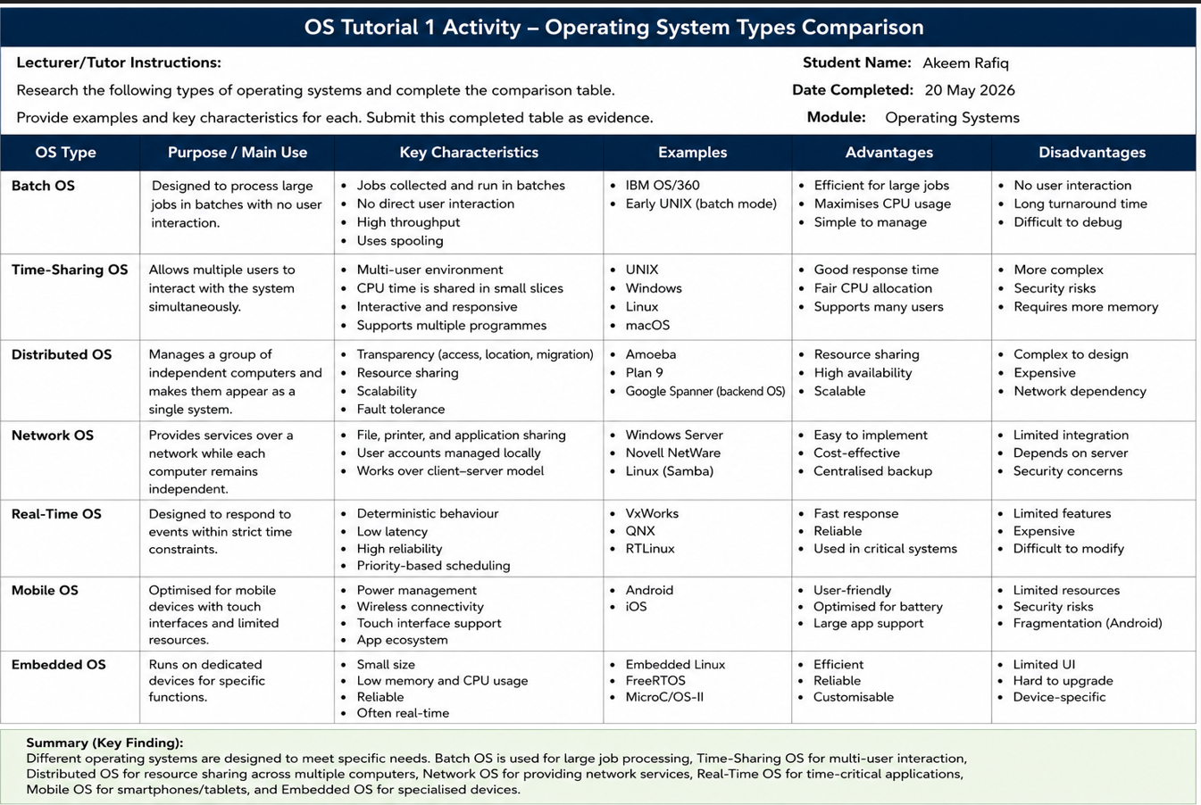

Appendix B – Lecture Activities / Activity Log
Date | Activity | What I completed | Evidence reference
20 May 2026 | OS Tutorial 1 – Types of Operating Systems | Researched and compared batch, time-sharing, distributed, network, real-time, mobile and embedded operating systems. I identified their main purposes, characteristics, examples, advantages and disadvantages and completed the comparison table. | Appendix A – Completed OS Tutorial 1 comparison table
27 May 2026 | Operating-System Functions Activity | Investigated the main functions of an operating system, including process management, memory management, file management, device management, user interaction and security. I recorded examples showing how these functions support computer users and applications. | Section 1 of the report and lecture activity notes
3 June 2026 | Command-Line Administration Activity | Practised Linux commands for creating folders, copying files, searching for files, changing permissions and monitoring processes. Commands included mkdir, cp, find, chmod, ps, top and kill. Screenshots were taken as evidence of the completed commands and their outputs. | Command-line screenshots included in the practical evidence section
10 June 2026 | Networking, Users and Scheduling Activity | Used Linux commands to examine network connections, user information and scheduled tasks. I practised ping, ip, ss, id, getent, useradd, crontab and systemctl list-timers. I also considered security, least privilege and the importance of recording administrative changes. | Networking, user-management and scheduling screenshots in the report

Appendix C – Certified Online Course Engagement
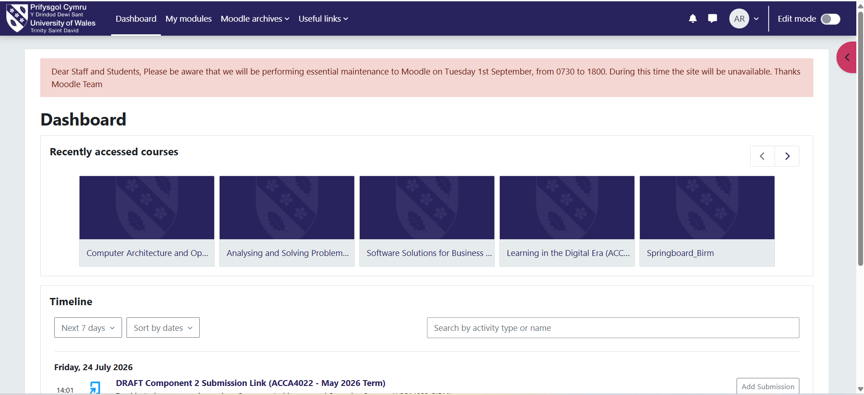
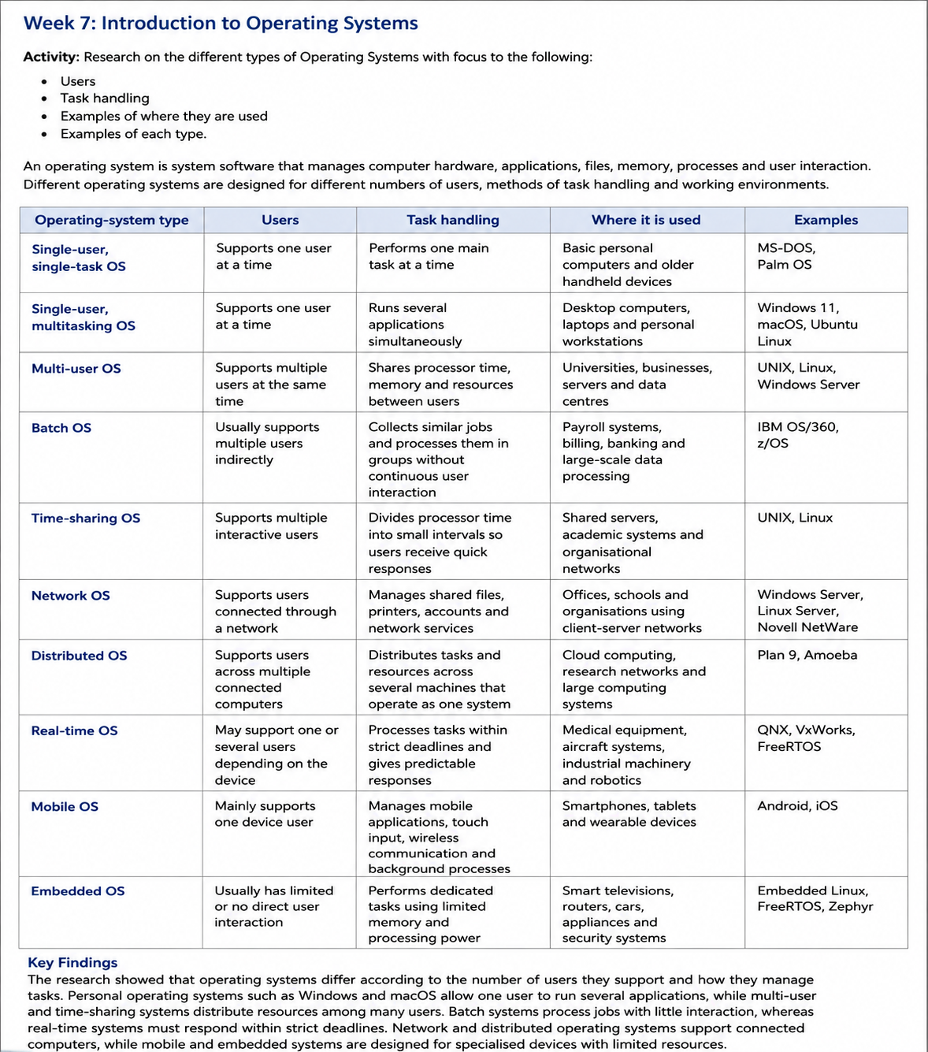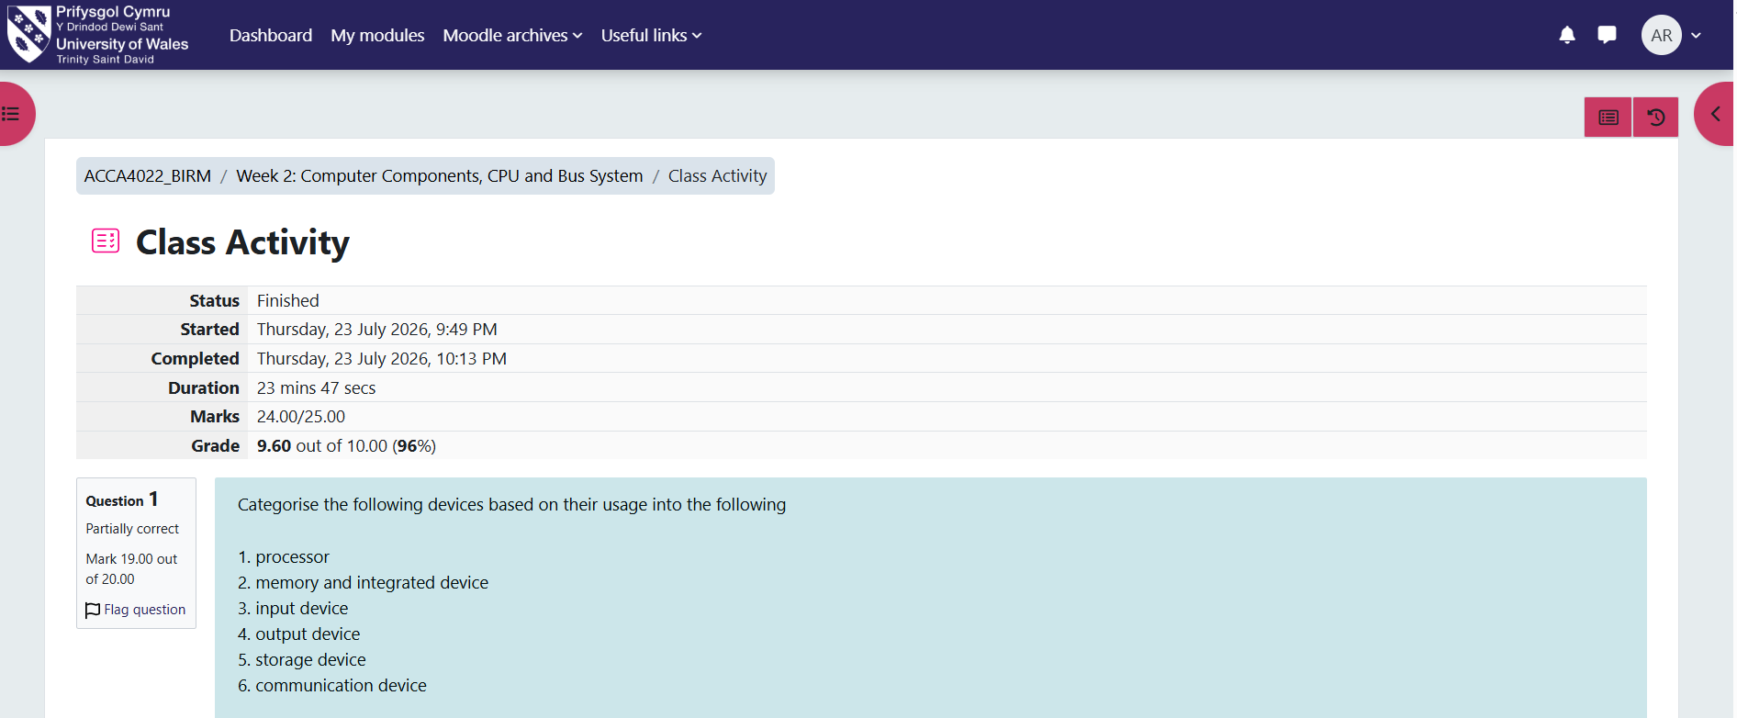

Reflective Summary
I was able to acquire three crucial technical abilities by doing the online operating systems exercises. I started by learning how to utilise the Linux command line to manage files, directories, and processes. Second, I became more knowledgeable about file permissions and how system security is supported by access rights. Third, I gained knowledge about how to examine network configurations and identify common connectivity issues. My confidence was bolstered by the practical exercises since I was able to put the instructions into practice and evaluate the outcomes instead of depending just on theoretical justifications.

