BMBM6016 Strategic Marketing
Assessment 2: Strategic Marketing Plan for McDonald’s UK
Student ID: 2500752
Student Name: Yuhao Li
Module Code: BMBM6016
Word Count: 2770
Submission Date: 13 May 2026

Executive Summary
This report aims to analyse the strategic marketing position of McDonald's UK and to formulate a strategic marketing plan looking at how to improve its position within the UK fast food market from May 2026 to April 2027. The report uses the SOSTAC framework of Situation analysis, Objectives, Strategy, Tactics, Actions and Control, as well as SMART goals to aid in the development of strategic planning and effective measurement of performance. Key external challenges identified in the report range from rising awareness of health concerns and sustainability to digital transformation and shifting consumer habits, and an intense market competition. Internally, the key strengths for McDonalds UK are brand recognition, developments around digital systems and the size of their franchise network, however, there are also harmful brand perceptions and sustainability concerns that present significant weaknesses. The report applies a more strategic lens to the changing nature of repositioning menus to be healthier and more sustainable, whilst focusing on Gen Z and younger shoppers. The plan aims to increase the sale of healthier products by tailoring the promotion to the customer, improving the innovation of healthier products and promoting sustainability with customers. The proposed direction is supported by Ansoff’s Product Development strategy and Porter's Differentiation Strategy. The report suggests that healthier repositioning and a rise in digital engagement will help boost customer loyalty, market relevance and long-term competitiveness of McDonald's UK.

Table of Contents
Executive Summary 2
1.0 Introduction 4
2.0 SOSTAC Marketing Plan 5
2.1 Situation Analysis – Where Are We Now? 5
2.2 Objectives – Where Do We Want to Be? 8
2.3 Strategy – How Do We Get There? 9
2.4 Tactics – How Exactly Do We Get There? 10
2.5 Actions – Who Does What, When and How? 12
2.6 Control – How Do We Know We Will Get There? 14
3.0 Recommendations 15
4.0 Conclusion 16
References 18

1.0 Introduction
In today's competitive, consumer-driven, technologically advanced, and environmentally conscious market, strategic marketing planning has become a more vital component of the UK fast-food sector. As shown in figure 1, UK digital ordering and delivery and convenience is gaining momentum set to generate over £64.5 billion in revenue in the fast-food market by 2025 (Mintel, 2025). At the same time, consumers are increasingly concerned with maintaining healthy lifestyles and about the environment, which will drive fast-food companies to offer healthier food items, sustainable packaging and enhance their digital customer experience (IBISWorld, 2025). McDonald's continues to be one of the top quick-service restaurant brands in Britain, with more than 1,400 outlets, and has built a strong brand image based on price, convenience and digital innovation, (Restroworks, 2025). But competitive pressure from other brands that have been advertising healthier and more eco-friendly options has driven McDonald's UK to focus more on future position. This marketing plan seeks to identify a strategic direction which will increase the market performance of McDonald's UK to improve their menu value proposition to healthier and sustainability-focused customers by leveraging digital customer engagement. The report uses a SOSTAC planning framework, which ensures the marketing plan is broken down into the following stages, situation analysis, objectives, strategy, tactics, action, and control (Smith, no date). Moreover, SMART objectives are employed to ensure that the proposed marketing objectives are specific, measurable, achievable, relevant, and time-bound to facilitate more effective implementation and evaluation of the proposed objectives (Bjerke and Renger, 2017).
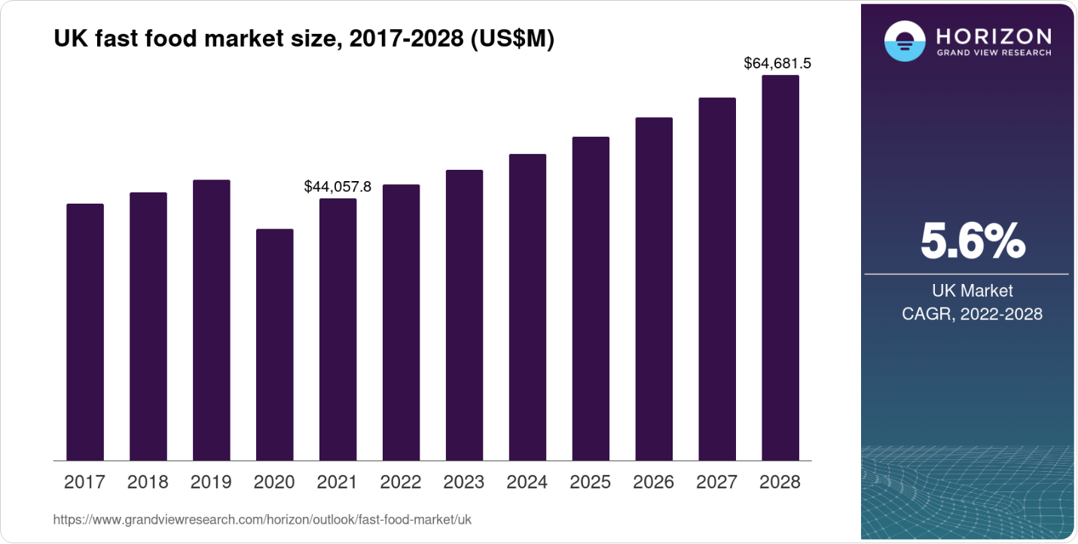
Figure 1: UK Fast-Food Market Revenue Growth
Source: https://www.grandviewresearch.com/horizon/outlook/fast-food-market/uk

2.0 SOSTAC Marketing Plan

2.1 Situation Analysis – Where Are We Now?
The UK fast-food industry continues to experience rapid transformation due to changing consumer preferences, sustainability concerns, and technological development. The UK market is very competitive with organisations needing to constantly evolve to retain market share and customer loyalty. An important macro-environmental trend is the growing attention towards health issues, which is driven by younger consumers wanting healthier, plant-based food options. As such, the UK plant-based market is anticipated to expand by more than 11% per year (see Figure 3) (Euromonitor, 2024), and about 52% of UK consumers say they actively try to eat more healthily (Mintel, 2025).
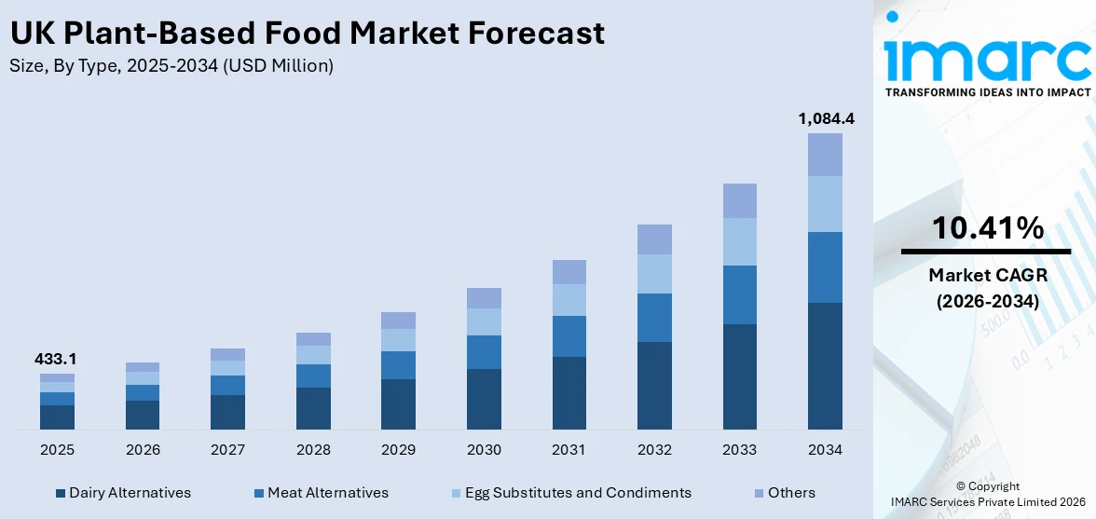
Figure 2: UK Plant Based Meat Market Size & Outlook, 2023-2030
Source: https://www.grandviewresearch.com/horizon/outlook/plant-based-meat-market/uk
Additionally, sustainability issues such as packaging waste, sourced raw materials, and carbon emissions are expected to further impact buying habits (IBISWorld, 2025; Statista, 2025). As shown in Figure 3, the UK online food delivery market is forecast to grow substantially and reach approximately US$18.8 billion by 2030, demonstrating the increasing strategic importance of digital ordering and delivery platforms within the sector (Grand View Research, 2025). Yet, persistent food cost pressures persist, making customers feel the pinch and presenting a strategy challenge to fast-food companies aiming to be both affordable and innovative and high quality.
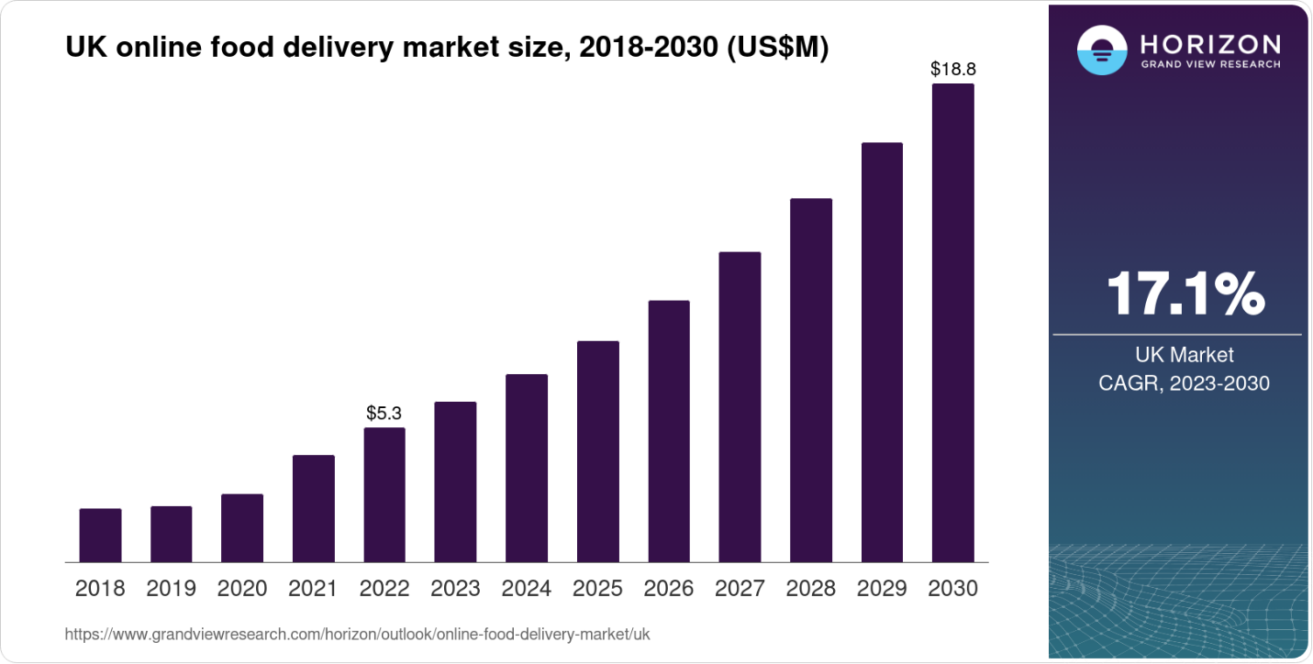
Figure 3: UK Online Food Delivery Market Revenue Forecast
Source: https://www.grandviewresearch.com/horizon/outlook/online-food-delivery-market/uk
In addition, there are significant competitive pressures in the microenvironment. There is high competition in the market, with KFC and Subway and Greggs well-known brands who compete heavily on price, service and quality (Sievert et al., 2025). Consumers can still easily switch brands by accessing the prices and nutrition and ease of use of the products online, giving them a sense of buyer power(Kotler and Armstrong, 2021). Also, alternative products are also driving up competition, particularly supermarket ready meals and meal-kit products(Dhuria, Muir, Shaw, et al., 2025).
From an internal perspective, the UK branch of McDonald's is well-recognized, has sophisticated digital ordering procedures, boasts of a widespread outlet structure, and operates an efficient supply chain (Barney and Hesterly, 2019). However, there are still negative brand perceptions and sustainability concerns to address. Based on SWOT and TOWS analysis, it is recommended that McDonald's maximise its strengths and operational efficiency to tap into opportunities associated with healthier eating and sustainable consumption (Weihrich, 1982). Ansoff's Growth Matrix suggests that Product Development is the best possible strategy: Focusing on healthier menus, plant-based expansion, and low-cal meal bundles(Ansoff, 1957).

2.2 Objectives – Where Do We Want to Be?
After the situation analysis, the primary marketing area proposed for development is larger menu repositioning toward health and sustainability in the UK fast food sector. This strategic emphasis has become crucial as the market's health and alternative product demands, as well as environmental awareness, have continued to rise significantly especially among Gen Z shoppers (Mintel, 2025; Euromonitor, 2024). So, McDonald's UK needs to improve brand equity in customer minds when thinking about health, sustainability and digital marketing, while still being budget-friendly and convenient.
Each marketing objective should be Specific, Measurable, Achievable, Relevant, and Time-bound (SMART) as outlined by (Gano-Overway and Sackett, 2022). Specific objectives are measurable objectives which enable organisations to monitor their performance effectively and clearly states the intended outcome. The objectives must be attainable given the market and organisation factors. Whereas strategic objectives are related, time bound can be done to set up a very clear implementation period (Chaffey and Ellis-Chadwick, 2019).
The primary strategic marketing objective for McDonald’s UK is:
To increase sales of healthier and plant-based menu items among UK Gen Z and young adult consumers by 20% between May 2026 and April 2027 through digital loyalty campaigns, personalised promotions, and sustainability-focused menu innovation.
These objective is critical to the strategic importance as they outline tangible goals such as increasing unit sales, customer retention, app usage and market share for health-conscious consumers (Oliveira, Belitski and Perez-Vega, 2025). Furthermore, the goals are attainable since McDonald's already has a strong Digital Infrastructure, brand recognition, and operational capability for long-term implementation.

2.3 Strategy – How Do We Get There?
The suggested strategic direction for McDonald's UK is that the brand will concentrate on repositioning its business as a healthier fast-food firm with an emphasis on sustainability and using digital personalisation strategies to appeal to younger and health-conscious consumers. The direction is essential due to a quick change in consumer expectations in the UK fast food sector. Around half (52%) of UK consumers are actively trying to make healthier food choices when buying foods, with more than one-third (34%) of Gen Z consumers regularly buying healthier fast-food or plant-based options (Mintel, 2025; Statista, 2025). In addition, Theocharis and Tsekouropoulos (2025) notes that more than 70% of Gen Z consumers said they favor brands that express a clear commitment to sustainability and offer them customized digital experiences (McKinsey, 2024). So, differentiation for McDonald's UK needs to go beyond either affordability or convenience.
Ansoff's Growth Matrix suggests that product development is the right growth direction (Ansoff, 1957). The approach is driven towards bringing new menu innovation, plant-based food and sustainable packaging into the UK market alongside new low-calorie meal packs. The strategy is suitable as McDonald's has over 1400 restaurants in the UK with ample operational infrastructure and brand recognition (McDonald's Corporation, 2025). Nevertheless, Kotler, Keller and Chernev (2021) argues that long-term differentiation is difficult to achieve because competitors can copy healthy products relatively quickly.
In addition, Porter's generic strategies further indicate that McDonald's should not only focus on cost leadership but rather should pursue a differentiation strategy (Porter, 1985). Through diversifying with healthier products, sustainability and customized digital interaction, it is possible to enhance competitive positioning and customer loyalty. The STP strategy therefore focuses on Gen Z and health-conscious urban consumers and aims to establish McDonald's as “healthy and sustainable and easier to eat with digital innovation” at affordable and convenient prices.

2.4 Tactics – How Exactly Do We Get There?
To implement McDonald's UK's approach, the 7Ps of the marketing mix will be extended to ensure that tactical decisions will squarely focus on repositioning the company toward a healthier and sustainability-focused goal. Healthy menu innovations should be key considerations for product decisions, including increasing plant-based meals, low calorie meal bundles, beverage reduction to sodium and healthier children's meal options. This is significant as around 52% of UK consumers ( See Figure 4) say they are actively trying to eat a healthier diet, and in recent years, there has been a significant increase in plant-based food intake among Gen Z consumers (Mintel, 2025; Statista, 2025). But, just introducing healthier food products doesn't automatically equate with competitive success as Alsubhi et al. (2023) argues that it may fail because of weak consumer perception and inadequate marketing communication. Healthier products, therefore, will need to be affordable, convenient, and be some part of McDonald's brand instead of breaking from the core customer's expectations.
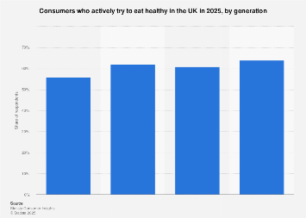
Figure 4: Consumers who actively try to eat healthy in the UK in 2025
Source: https://www.statista.com/forecasts/1388045/consumers-who-actively-try-to-eat-healthy-uk-by-generation/?srsltid=AfmBOopZ_kv8EB6XJI4pEA6L1QE2PapAMNYoAUQY77ugX_oOzJAXLXxI#google_vignette
To achieve a healthy product uptake, price tactics should be synced with value-based pricing, penetration pricing and promotions for mobile apps for the target mass market segments, so it doesn't discourage the latter. With the cost-of-living crisis having taken a significant toll, more than 60% of consumers across the UK have said the affordability of fast-food has had a direct impact on their eating habits (Dhuria, Muir, Bird, et al., 2025). This means that premium pricing for healthier products will deter the biggest customer base of McDonald's. In contrast, Kotler and Armstrong (2021) argues that leveraging introductory pricing, loyalty rewards, and bundled overall healthy meal offers can lead to purchase increase and the promotion of behaviour change without compromising competitiveness.
Place decisions should focus heavily on digital accessibility and convenience through McDonald’s mobile applications, drive-thru services, self-service kiosks, and partnerships with delivery platforms such as Uber Eats and Deliveroo. Caterer Licensee (2024) shows online food ordering in the UK is still booming and revenue for ordering food online is expected to hit over £15bn by 2026. Thus, the inclusion of healthy products in digital channels is expected to have a positive impact on the visibility created and leading to re-purchasing of these products. However, Chaffey and Ellis-Chadwick (2019) argues that relying too heavily on third party delivery relationships could lead to decreases to profit margins because of third-party commission costs and increase competition between brands to compare their offers.
Promotion strategies can leverage integrated marketing communications via TikTok campaigns, partnership programs with influencers, sustainability narratives and direct app notifications to Gen Z consumers. McKinsey (2024) discovered that around 71% of Gen Zers opt for brands that provide a personalised digital experience, alongside a clear signal of sustainability efforts. Because promotional communication becomes increasingly suspect, and consumers are increasingly critical about spending money on an organisation that they consider is engaged in 'greenwashing' or superficial health positioning(Dyck and Manchanda, 2021). Therefore, the three-step strategies of people, process and physical evidence should strengthen authenticity through training for the employees, AI-driven ordering systems, use of recyclable packaging, digital menu boards and transparent calorie information.

2.5 Actions – Who Does What, When and How?
Implementation of the UK McDonald's healthier and sustainable plan will require a multi-pronged effort involving the marketer, operations, suppliers, digital teams and the franchise manager. The action stage is designed to outline the steps needed to translate strategy into action and to ensure that staffing can execute the strategy consistently at every touch point with customers (Smith, no date)). With over 1,400 outlets and more than 170,000 employees, employee engagement and operational alignment are vital to delivery service excellence and effective strategic change at McDonald's UK (McDonald's Corporation, 2025).
Implementation should take place over the course of 12 months from May 2026 through April 2027 as defined by a phased rollout approach shown in Gantt Chart (see Figure 5). First, product and supply chain departments should be responsible for rolling out prettier new foods as well as sustainable packaging and lower calorie menu bundles. The second phase will involve employee training programmes to build staff awareness about healthier products, communicating sustainability and digital ordering systems. During implementation, the importance of staff involvement is further evidenced by organisations with robust programmes of employee engagement reporting a 23% greater level of customer satisfaction (Deloitte, 2024). Poor communication and training, however as Kotler and Keller (2015) notes may result in less effective implementation because the changes at the operational level and higher workload pressure may cause resistance. The marketing and digital teams should then begin personalised app promotions, influencer marketing, and communication about sustainability on TikTok and Instagram. Sales analytics, app engagement and customer feedback should be used monthly to track progress.
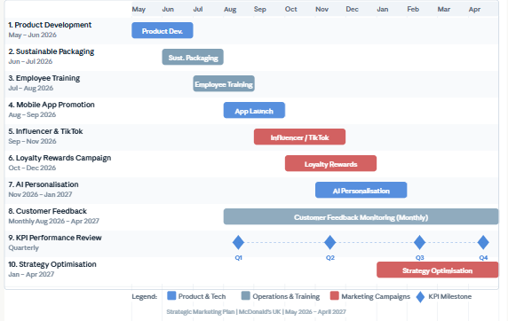
Figure 5: Gantt Chart for the Implementation Timeline of McDonald’s UK Strategic Marketing Plan (May 2026 – April 2027)

2.6 Control – How Do We Know We Will Get There?
The control stage is fundamental to assessing whether there will be adequate effectiveness to meet the strategic goals of McDonald's UK and if tactical changes on implementation of the goal should be made throughout the timeframe of implementation. According to Smith (2022), marketing planning needs to be monitored continuously, as performance measurement would help organisations identify market gaps, optimize campaigns, and make better decisions. As a result, the UK needs to have clear Key Performance Indicators (KPIs) directly related to its goals for a healthier menu and digital engagement.
The key measures should comprise increased menu sales growth, higher app engagement, repeat purchase rates, customer satisfaction, market share and return on investment (ROI). A goal of 20% more healthier and plant-based menu sales will be tracked monthly using sales analytics and unit sales performance. In addition, app metrics like active users, click-through and personalised offer redemption should be reviewed on a weekly basis as digital engagement is fundamental to the success of this strategy (Chaffey and Ellis-Chadwick, 2019). Monitoring customer satisfaction scores and the sentiment of online reviews should also be conducted on a quarterly basis to determine if a healthier repositioning affects brand perception by key customers. Açikgöz et al. (2024) notes that organisations that adopt data-driven approaches to marketing are around 23 times more likely to successfully acquire a customer.
But overemphasis on short-term sales targets could result in strategic constraints as short-term results do not necessarily indicate long-term customer loyalty and brand equity (Kotler and Keller, 2015). For this reason, McDonald's needs to track customer lifetime value (CLV), repeat purchases and the participation in loyalty programs to measure the sustainability of the behavioural change. The data gathered should then be employed to enhance the promotion activity, refine menu strategies, modify pricing plans, and customize digital communication. Therefore, continuous monitoring and assessing will allow McDonald's UK to act ahead of consumer change and help it maximize the impact of its strategic repositioning towards healthier eating and a more sustainable future.

3.0 Recommendations
McDonald's UK must keep investing in healthier menu innovation and sustainability-minded operations, to further solidify its competitiveness in the market for fast food in the UK on a longer playing field. While plant-based and lower-calorie products have been launched, these products are still not as extensive as there is a demand for healthier alternatives among consumers (Mintel, 2025). So, McDonald's should increase their variety of food items to create more healthful food and drink types, be more transparent about what they serve, have fit options for the seasons based on the health concerns of Gen Z and health-conscious people. Strategically it is significant as the UK plant-based food market is expected to see over double-digit growth each year.
The organisation should also enhance its sustainability profile with the adoption of more sustainable packaging, sourcing and carbon reduction programmes for the benefit of the future. About 63% of consumers in the UK are more inclined to buy from companies they think are environmentally responsible (Deloitte, 2024). However, sustainability communication must remain authentic because “greenwashing” presents significant reputational risks for global brands (Kotler, Keller and Chernev, 2021). Therefore, McDonald's should report it in a transparent manner and set targets for the environment to measure.
Moreover, McDonald's UK needs to move forward with further personalisation and loyalty features using AI to enhance its digital platform. According to Zeithaml, Bitner and Gremler (2017), customer retention rates may rise by as much as 25% with the appropriately personalised digital marketing strategy. However, digital changes need to be balanced by easy shopping in the store and robust practices around customer data protection.

4.0 Conclusion
The fast-food sector remains highly competitive in the UK, with evolving consumer attitudes and heightened scrutiny on health and sustainability issues. As a result, McDonald's UK needs to respond strategically to stay competitive in the longer term and remain relevant to customers. The marketing plan identified healthier and "sustainability" orientated menu repositioning as the most appropriate strategy to address consumer wants and market conditions. The report created SMART objectives using the SOSTAC framework, all of which concentrated on boosting healthier menu sales and improving digital interactions with customers. The strategy leveraged Ansoff's Product Development and Porter's Differentiation Strategy to help develop healthier menu innovation, sustainability position, and personalised digital experiences. Moreover, the 7Ps marketing mix offers a coherent tactical plan for enhancing customer interaction and competitive edge.

References
Açikgöz, F.Y. et al. (2024) “Brand Reputation and Trust: The Impact on Customer Satisfaction and Loyalty for the Hewlett-Packard Brand,” Sustainability, 16(22). Available at: https://doi.org/10.3390/su16229681.
Alsubhi, M. et al. (2023) “Consumer willingness to pay for healthier food products: A systematic review,” Obesity Reviews, 24(1), p. e13525. Available at: https://doi.org/10.1111/obr.13525.
Ansoff, H.I. (1957) Strategies for Diversification.
Barney, J.B. and Hesterly, W.S. (2019) Strategic Management and Competitive Advantage: Concepts, Global Edition. Pearson Education.
Bjerke, M.B. and Renger, R. (2017) “Being smart about writing SMART objectives,” Evaluation and Program Planning, 61, pp. 125–127. Available at: https://doi.org/10.1016/j.evalprogplan.2016.12.009.
Caterer Licensee (2024) ‘UK foodservice delivery market to reach £14.8bn in 2026 as affluent young consumers reshape demand’, Caterer Licensee, 18 September. Available at: https://catererlicensee.com/uk-foodservice-delivery-market-to-reach-14-8bn-in-2026-as-affluent-young-consumers-reshape-demand (Accessed: 10 May 2026).
Chaffey, D. and Ellis-Chadwick, F. (2019) Digital Marketing. Pearson.
Deloitte (2024) Consumer Products Industry Outlook. Available at: https://www.deloitte.com/global/en/industries/consumer/analysis/consumer-products-industry-outlook.html (Accessed: 10 May 2026).
Dhuria, P., Muir, S., Shaw, S., et al. (2025) “‘It will sort of drive us to rethink our approach to high fat salt sugar products’- a qualitative analysis of businesses’ reactions to the landmark Food (Promotion and Placement) Regulations in England,” BMC Medicine, 23, p. 576. Available at: https://doi.org/10.1186/s12916-025-04384-5.
Dhuria, P., Muir, S., Bird, A., et al. (2025) “The Food (Promotion and Placement) regulations are beginning to shift the onus for healthier choices from individuals to businesses: in-depth perspectives from health experts,” BMC Medicine, 23, p. 686. Available at: https://doi.org/10.1186/s12916-025-04484-2.
Dyck, B. and Manchanda, R.V. (2021) “Sustainable marketing based on virtue ethics: addressing socio-ecological challenges facing humankind,” AMS Review, 11(1–2), pp. 115–132. Available at: https://doi.org/10.1007/s13162-020-00184-7.
Euromonitor (2024) Consumer Foodservice in the United Kingdom. Available at: https://www.euromonitor.com/consumer-foodservice-in-the-united-kingdom/report (Accessed: 10 May 2026).
Gano-Overway, L. and Sackett, S.C. (2022) “Let’s Get Smart and Set Goals to ASPIRE,” Journal of Sport Psychology in Action, 13(4), pp. 230–244. Available at: https://doi.org/10.1080/21520704.2021.2007192.
IBISWorld (2025) Fast Food Franchises in the UK. Available at: https://www.ibisworld.com/united-kingdom/industry/fast-food-franchises/14535 (Accessed: 10 May 2026).
Kotler, P. and Armstrong, G. (2021) Principles of Marketing Global Edtion. Harlow, England London New York Munich: Pearson.
Kotler, P. and Keller, K.L. (2015) Framework for Marketing Management, A, Global Edition: European Edition. Pearson Education.
McDonald’s Corporation (2025) Financial Information and Annual Reports. Available at: https://corporate.mcdonalds.com/corpmcd/investors/financial-information.html (Accessed: 10 May 2026).
McKinsey & Company (2024) State of the Consumer. Available at: https://www.mckinsey.com/industries/consumer-packaged-goods/our-insights/state-of-consumer (Accessed: 10 May 2026).
Mintel (2025) UK Fast Food Restaurants Market Report. Available at: https://store.mintel.com/report/uk-fast-food-restaurants-market-report (Accessed: 10 May 2026).
Kotler, P., Keller, K.L. and Chernev, A. (2021) Marketing Management. Pearson Education.
Office for National Statistics (ONS) (2025) Consumer Price Inflation, UK: May 2025. Available at: https://www.ons.gov.uk/releases/consumerpriceinflationukmay2025 (Accessed: 10 May 2026).
Oliveira, F., Belitski, M. and Perez-Vega, R. (2025) “Sales digitization and sales process optimisation for firm performance: Evidence from European firms,” Technological Forecasting and Social Change, 217, p. 124172. Available at: https://doi.org/10.1016/j.techfore.2025.124172.
Porter, M.E. (1985) Competitive Advantage: Creating and Sustaining Superior Performance. Free Press.
Restroworks (2025) Fast Food Restaurant Statistics UK. Available at: https://www.restroworks.com/blog/fast-food-restaurant-statistics-uk (Accessed: 10 May 2026).
Sievert, K. et al. (2025) “Global market trends and financial performance of the corporate fast-food industry and their potential contributions to diets high in meat and ultra-processed foods,” Globalization and Health, 21, p. 60. Available at: https://doi.org/10.1186/s12992-025-01158-9.
Smith, M.P. (no date) SOSTAC® Guide to your Perfect Digital Marketing Plan. PR Smith.
Smith, P.R. (2022) Digital Marketing Excellence: Planning, Optimizing and Integrating Online Marketing. 6th ed. London: Routledge. Available at: https://doi.org/10.4324/9781003009498.
Statista (2025) Online Food Delivery Market in the United Kingdom. Available at: https://www.statista.com/outlook/emo/online-food-delivery/united-kingdom (Accessed: 10 May 2026).
Theocharis, D. and Tsekouropoulos, G. (2025) “Sustainable Consumption and Branding for Gen Z: How Brand Dimensions Influence Consumer Behavior and Adoption of Newly Launched Technological Products,” Sustainability, 17(9). Available at: https://doi.org/10.3390/su17094124.
Weihrich, H. (1982) “The TOWS matrix—A tool for situational analysis,” Long Range Planning, 15(2), pp. 54–66. Available at: https://doi.org/10.1016/0024-6301(82)90120-0.
Zeithaml, V.A., Bitner, M.J. and Gremler, D.D. (2017) Services Marketing: Integrating Customer Focus Across the Firm. McGraw-Hill Education.

