Module title: Foreign Languages and Cultural Awareness

Module code: BMIH5003

Lecturer name: Antoinette Milne
Student name: Claudia Butnariu
Student ID: 2239415
Word count: 983

Contents
Introduction 3
Main Body 4
England and China 4
GLOBE Project’s Culture and Leadership Study 5
Intercultural Leadership 8
Conclusion 9
REFERENCES 10

Introduction

Socio-cultural diversity usually denotes to the various aspect of society and culture which have direct influence upon the behaviour, engagement and interaction of individuals among each other and the individuals of differentiate backgrounds. The phenomena of socio-cultural difference can further influence to the demands of the management and administration, individual demand and perspective and the interaction between individual and groups. The following report will provide an outline of the major differences between England and the chosen country i.e. China. The report analyse and compare of the chosen countries using the GLOBE Project's culture and leadership Study along with the challenges of intercultural leadership within the hospitality industry.

Main Body

England and China
There are major differences between the socio cultural aspects of the England and China. One of the key difference between the two countries within the GLOBE Project List is the infrastructural planning and execution. The culture and the infrastructure within England are systematically planned and organised, similar to that of United States of America, Germany and France. On the contrary to England, China have similar infrastructure like India, South Africa and Brazil. China's Infrastructure is dynamic and robust with complementary incorporation of technology and innovative solutions.
Another aspect is the difference between the communication style of both the England and China. The Chinese tradition and culture is majorly inclined towards indirect communication leveraging non-verbal cues and actions whilst committing respect for the hierarchical system. In comparison to Chinese culture, British populace embrace direct communication, open discussions and clarity.
The Hierarchy and respect plays a significant role in the Chinese culture where the tradition place individual respect for authority figures and peers (Yu, and Zhou, 2023). In contrast to Chinese tradition, the British populace are usually informal in addressing the dominating hierarchy along with following the concept of egalitarianism.
The major difference between the Chinese and British culture is the difference of individualism and collectivism. The Chinese are more inclined towards being a collectivist majorly emphasising on the importance of family and socio cultural values. In the Chinese culture, the critical thinking and decision making are considered keeping the values and well being of the family (Yan, 2020). Whereas, the British culture demonstrates characteristics of individualistic that majorly focus on the individual assessment, achievements and freedom.
In the Chinese culture, the political, religious and income considerations are often considered to be sensitive and taboo. While considering, the British culture, political and religious conversation are generally open and are subjected to the discussions and does not consider the discussions as taboo.

GLOBE Project’s Culture and Leadership Study
CHINA
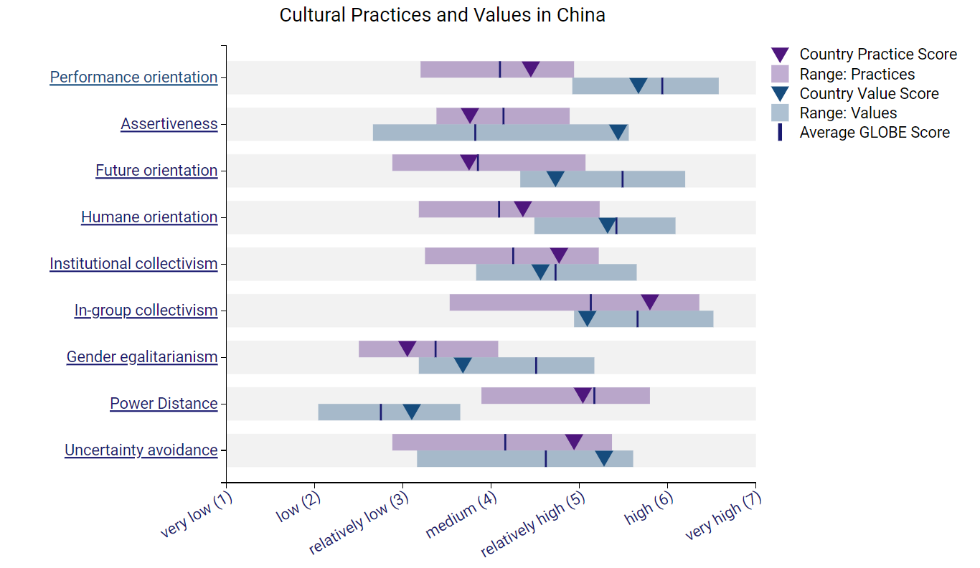
Source: https://globeproject.com/results/countries/CHN%3Fmenu=list.html
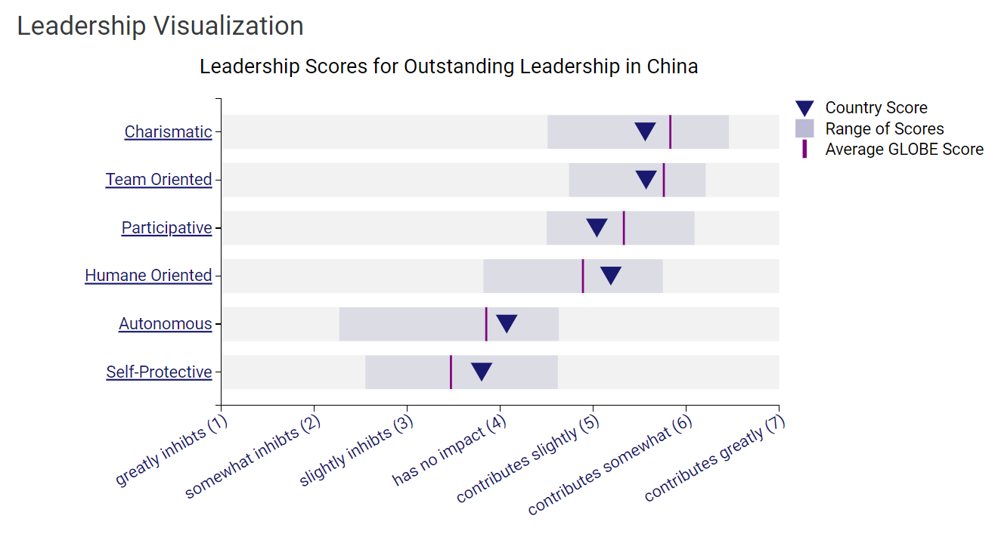
Source: https://globeproject.com/results/countries/CHN%3Fmenu=list.html

ENGLAND
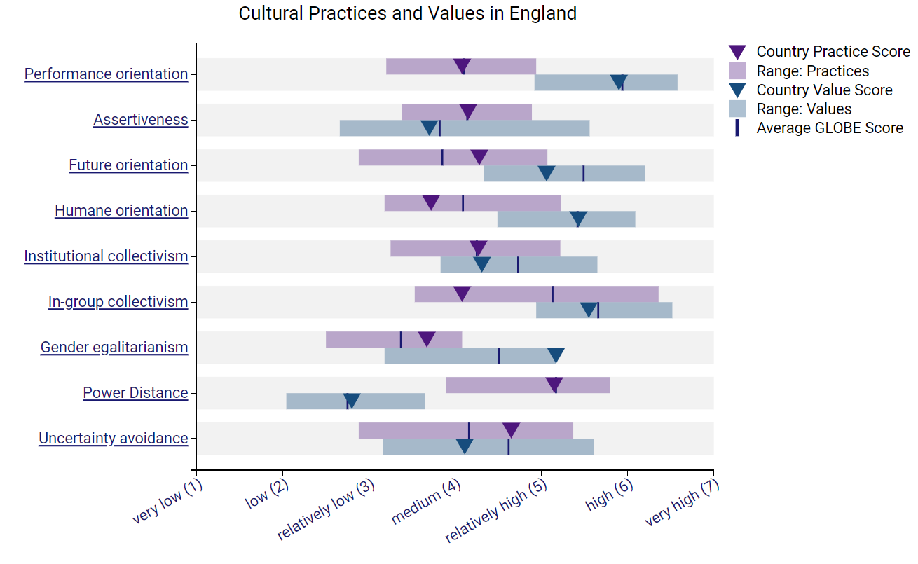
Source: https://globeproject.com/results/countries/GBR%3Fmenu=list.html#list

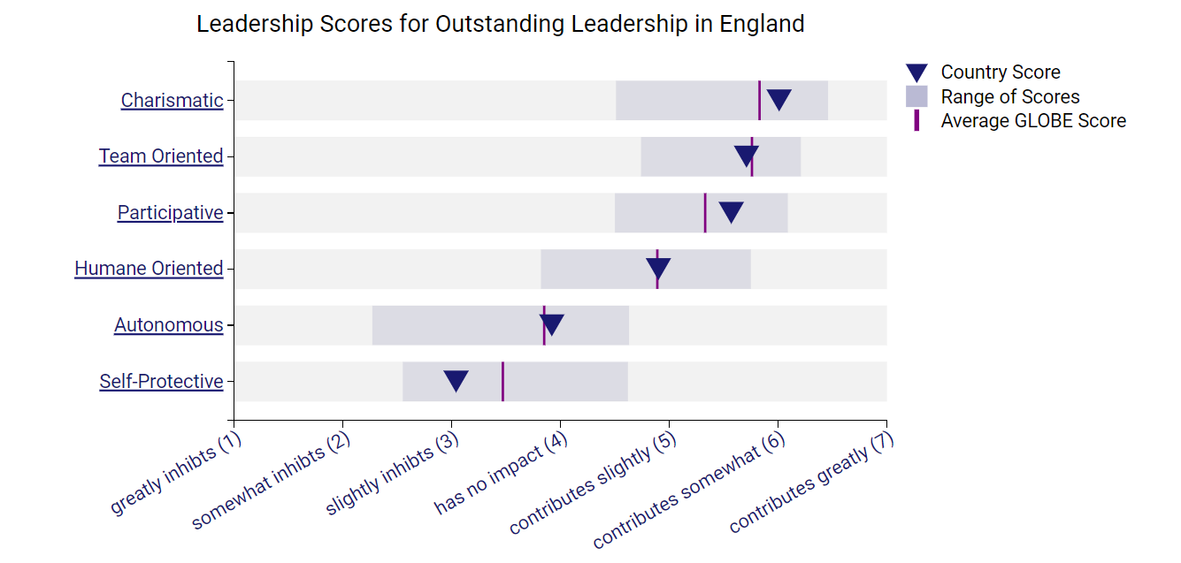
Source: https://globeproject.com/results/countries/GBR%3Fmenu=list.html#list

The GLOBE project's culture and leadership study is a comprehensive framework for analysing the different cultural dimensions and leadership practices across countries of the world. In considering the English Culture, the characteristics exhibits performance based culture that majorly emphasise on the achievements, competitiveness and accomplishments. On the other hand, the Chinese culture is often associated with collectivist culture that prioritises harmony, cooperation and loyalty amongst the populace. The fundamental difference in cultural orientation can be influenced by various introspect of social interactions, decision-making processes and organisational infrastructures (Tursunovich, 2022).

In regards to the leadership styles, British culture generally embraces the participative and democratic leadership approach. This approach allows the leadership to encourage contributions from the subordinates while emphasising on collaboration and empowerment. In contrast to the British Culture, China is more inclined towards paternalistic leadership style in which the leadership are perceived as authority figures that provides guidance and support.

The GLOBE study identifies different dimensions of cultural differentiation such as assertiveness, avoidance and power dynamics that enhance differentiate between the cultural and leadership practices between the British and Chinese culture. Regarding the English culture, it tends to have lesser power dynamics and avoidance while comparing to the Chinese culture.

The English and Chinese mainland inherits diverse societies along with cultural and leadership differences. The GLOBE project's framework ensures systematic comparison and demonstration of dimensions that influence the decision making and behaviour towards individuals.

Intercultural Leadership

The Intercultural leadership within the dimensions of hospitality industry can possess several challenges due to the diverse nature of the market and the consumers. One of the most notable examples can be leveraged from the Hampton hotel industry. The organisation has encountered the challenge of effective communication within the intercultural leadership domain. These challenges can consist of language barriers and cultural differences within the communication style, along with the nonverbal cues that can lead to misinterpretation, misinterpretation and misunderstanding of the assigned roles and responsibilities. The intercultural differences in the services delivery can possess significant challenge for the Intercultural leadership (Armstrong, 2020). The different cultures consist of varying preferences that can accommodate desired service as standards, etiquettes and requirements. Lastly, the managing and monitoring of a diverse workforce requires robust intercultural leadership styles. The hospitality industry is one of the most diverse industrial segments consisting of employees from different culture, backgrounds and heritage. This can lead to the overburdening of different perspective and experience; can bring forth conflicts and misinterpretation of knowledge and information. Mitigating these conflicts, promoting inclusivity and ensuring fair treatment for the employees can be demanding for the leaders to accomplish (Gómez-Hurtado, 2021). Furthermore, the organisation can adapt innovative products and services offering to meet the diverse needs of consumers can acquire strategic intercultural leadership style.

Conclusion

The following report provide a critical discussion of the socio-cultural difference between the British and the chosen GLOBE project list i.e. China. The report analyse and compare British and China leveraging the GLOBE Project's Culture and leadership study. The report also critical discuss various challenges of the intercultural leadership within the hospitality industry and the potential areas of conflicts within the dimension of the business.

REFERENCES

Armstrong, J.P., 2020. Assessing intercultural competence in international leadership courses: Developing the global leader. Journal of Leadership Education, 19(4), pp.1-19.
Gómez-Hurtado, I., Valdés, R., González-Falcón, I. and Jiménez Vargas, F., 2021. Inclusive leadership: Good managerial practices to address cultural diversity in schools. Social Inclusion, 9(4), pp.69-80.
Hendrycks, D., Burns, C., Basart, S., Zou, A., Mazeika, M., Song, D. and Steinhardt, J., 2020. Measuring massive multitask language understanding. arXiv preprint arXiv:2009.03300.
Koc, E., 2021. Intercultural competence in tourism and hospitality: Self-efficacy beliefs and the Dunning Kruger effect. International Journal of Intercultural Relations, 82, pp.175-184.
Ríos-Martín, M.Á., Folgado-Fernández, J.A., Palos-Sánchez, P.R. and Castejón-Jiménez, P., 2019. The impact of the environmental quality of online feedback and satisfaction when exploring the critical factors for luxury hotels. Sustainability, 12(1), p.299.
Tursunovich, R.I., 2022. Linguistic and cultural aspects of literary translation and translation skills. British Journal of Global Ecology and Sustainable Development, 10, pp.168-173.
Yu, B. and Zhou, X., 2023. Urban administrative hierarchy and urban land use efficiency: evidence from Chinese cities. International Review of Economics & Finance, 88, pp.178-195.
Yan, Y., 2020. The individualization of Chinese society. Routledge.
Adeani, I.S., Febriani, R.B. and Syafryadin, S., 2020. Using GIBBS’reflective cycle in making reflections of literary analysis. Indonesian EFL Journal, 6(2), pp.139-148.
Drouvelis, M. and Paiardini, P., 2022. Feedback quality and performance in organisations. The Leadership Quarterly, 33(6), p.101534.
Hampden-Turner, C., Trompenaars, F. and Hampden-Turner, C., 2020. Riding the waves of culture: Understanding diversity in global business. Hachette UK.
GLOBE 2020 (2023) The GLOBE Studies. Available at: https://globeproject.com/about?page_id=intro#globe2020_intro (Accessed: 9th February 2024).
Jenkinson, P. (2022) GLOBE Project Cultural Dimensions [video]. Available at: https://www.youtube.com/watch?v=3du_rZ0U90Q (Accessed: 10th February 2023).
Kharouf, H., Sekhon, H., Fazal-e-Hasan, S.M., Hickman, E. and Mortimer, G., 2019. The role of effective communication and trustworthiness in determining guests’ loyalty. Journal of Hospitality Marketing & Management, 28(2), pp.240-262.
Mohamed, A.R., 2019. Multi-Cultural Communication is Essential for Tourism Industry: Global to Local Perspective. In Contemporary Human Resources Management in the Tourism Industry (pp. 211-236). IGI Global.
Sarhan, N., Harb, A., Shrafat, F. and Alhusban, M., 2020. The effect of organizational culture on the organizational commitment: Evidence from hotel industry. Management Science Letters, 10(1), pp.183-196.

