Programme: BA International Hotel Management
Module: Foreign Languages ; Cultural Awareness

Module code: BMIH5003
Assignment Title: Portfolio 4 components

Aiga Bordasa
Student nr 2238996
Lecture: Giulia Chifari

Hilton Garden Inn

Table of Contents
1 Component 1 - Professional reflection 2
2 Component 2 - Training plan 4
3 Component 3 - Student self-reflection 6
4 Component 4 – Training presentation 8
5 References 13

Component 1 - Professional reflection
In my Level 4 work at the Hilton Garden Inn, I faced a situation that showed the cultural misunderstandings in the F&B sector. It took place one dinner service at the hotel restaurant when I saw Alex, a colleague, talking with a guest from Japan. Alex, who is a committed and hard-working server, was at the table with his usual friendly attitude, and he was ready to give the best service to the customer. Nevertheless, when he started to talk with the guests, it turned out that there was a cultural barrier between them. The guest was a little bit confused and reluctant to respond to Alex's friendly remarks and relaxed attitude.
Thus, now I can see that these kinds of cultures misunderstandings are very easy, especially in a diverse place such as a luxury hotel. Examples of these causes are language barriers, different communication styles, and many social norms that are the reasons of misunderstandings and discomfort to both the guests and the employees.In this case, the cultural misunderstanding most likely was caused by the differences in the communication styles and expectations (Korkut et al. 2018). In Japanese culture, there is usually high regard for formality and respect, especially in service interactions (Fukushima and Sifianou, 2017). Alex's friendly and casual attitude, which was his good deed, was interpreted by the guest as being too informal or even disrespectful.
I recognise that in need to stop such misunderstandings in in the future, I must improve in a number of skills:
- Cultural Awareness: To begin with, one has to acquire a better understanding of diverse cultural norms and practices. This implies not only the knowledge of the basic etiquette but also the awareness of the details in communication and the behaviour.
- Adaptability: Being a hotelier, adaptability is the key to handling different situations well (Wortsman et al. 2019). Now, I have to find out the likes and dislikes of my guests and adjust my communication style according to the cultural context, whether it is formal or warm and friendly, for example.
- Effective Communication: Clear and effective communication is the main tool for the solving of the problems of cultural barriers (Venter, 2017). I have to ensure that I speak to the people in a clear and sensitive manner, without any assumption or stereotype. Active listening and empathy are the factors that the guests feel understood and respected.

By the development of these skills, I will be able to create a more hospitality and friendly atmosphere for guests from all the cultures. Every contact is an opportunity for you to learn and grow, and I am determined to always improve my way of doing things to give a universal service.

Component 2 - Training plan
Cultural misunderstanding that happens during the dinner service at the Hilton Garden Inn, especially in the Food and Beverage (F&B) department, is a reason for the need to have a staff training plan which will enable the employees to be able to handle the different interactions with the guests (Bharwani and Jauhari, 2017).
Objectives for Training
- Cultural Awareness: Boost the understanding of the cultural norms and practices, which are mostly about the guest interactions in the F&B sector.
- Customer Service Excellence: Create a culture of inclusiveness and sensitivity, so that all guests feel valued and respected no matter their cultural background.
- Communication Skills: Enhance the employees' ability to communicate effectively and respectfully in diverse cultures, and thus, to understand and adjust to the different communication styles and preferences..
Training Components:
- Cultural Sensitivity Workshops: Plan the workshops that are run by the cultural experts to talk about the key cultural dimensions like communication styles, social norms and etiquette. The sessions will enable employees to learn about the different cultural views and thus they will be able to realize the possible points of misunderstanding (Danso, 2018).
- Role-Playing Scenarios: Organize role-playing games that replicate various guest interactions, especially those, where the cultural differences are the main issue. In this way, the employees will learn how to adjust their communication style and approach to the needs of the guests from different cultural backgrounds (Othlinghaus-Wulhorst and Hoppe, 2020).
- Cross-Cultural Communication Training: Draft different trainings for the improvement of cross-cultural communication skills. Hence, this could be taught by lessons on active listening, empathy, and non-verbal communication, giving the importance of the cultural cues and the subtleties on them.
- Case Studies and Reflection Sessions: Hence, it is convenient to discuss the practical situations of success in cross-cultural communication and also the problems and misunderstandings that often take place in it. The employees are put into a situation where they have to think about what they have done and what they can do to increase the cultural competency in their everyday encounters (Foster, 2018).
Implementation Strategy:
- Mandatory Training Sessions: Ensure that all workers who are in the F&B department, including servers, hosts, and managers, are involved in the training program. Set up sessions during the non-busy hours to avoid the interference with the regular projects.
- Ongoing Support and Feedback: Make a connection among the people who can provide people with advice and feedback on cultural issues for the employees. Encourage the free communication of ideas and hence, pave the way for an uninterrupted learning and development.
- Integration into Onboarding Process: Cultural competency training should be included in the onboarding process of new hires, as it is a crucial part of providing exemplary customer service at the Hilton Garden Inn.

Evaluation and Feedback:
- Pre- and Post-Training Assessments: Conduct pre-training assessments to ascertain the level of employees' initial understanding of cultural competency. It is important to do tests after the training to see whether the improvements are there and to find out what areas still need to be developed.
- Feedback Mechanisms: Get input from employees after every training session to find out its effectiveness and relevance. Apply this feedback to make future training programs better.
- Guest Feedback Analysis: Check the guest feedback and reviews to evaluate the effect of the training program on guest satisfaction and the perception of service quality. Implement guest feedback into the continuous training and service improvement programs.

Through this training plan, the Hilton Garden Inn can guarantee that all employees in the F&B department are always ready to deal with cultural differences and to provide guests from various backgrounds with the best service possible.

Component 3 - Student self-reflection
Kolb's reflexive cycle will be applied to the reflection of my own opinion on the significance of cultural awareness in the hospitality sector. It has 4 stages mentioned below: It has 4 stages mentioned below:
Concrete Experience:
Through the hospitality industry, especially during my Level 4 placement at the Hilton Garden Inn, I have seen many cases proving the necessity of cultural awareness. One unforgettable situation was that of the cultural misunderstanding between a guest and an employee of the F&B department.
Reflective Observation:
I used to think of cultural awareness as a typical component in the list of things to find out while training to be a host. Nonetheless, as I met various guests and saw different interactions, I began to realize that cultural awareness is not just about knowing the customs but it is about the real understanding and respect of the backgrounds and viewpoints of the people (Nazarian et al. 2017). I observed that cultural misunderstandings can cause the disagreement, discomfort, and even the conflict of the whole guest experience through observation and reflection..

Abstract Conceptualization:
I comprehended that the meaning of cultural awareness was the depth of the theoretical knowledge, that was learned through the study of the academic literature on intercultural communication and hospitality management. Hofstede cultural dimension (Gerlach and Eriksson, 2021) and Schein's Three-Level Model (Cole and Martin, 2018) theories are the examples of the models that stress the cultural differences that play a great role in guest satisfaction and the organizational success in the hospitality industry.

Active Experimentation:
I have merged the knowledge from theory and the insights from my practical experiences and have taken every opportunity to increase my cultural awareness and competence. I participated in the cultural sensitivity workshops, cross-cultural communication training, and home-study programs to gain a wider understanding of the various cultural norms and practices. I have used the knowledge I learned from conversations with guests and colleagues, therefore, I have changed my way of communication and the way I deal with people coming from different cultures.
Why it Matters:
This immersion into the culture of the people of the host country and this one-way trip of reflection and learning is a voyage that has drawn the attention to the importance of cultural awareness in the hospitality industry. Hospitality workers can turn guests into guests that feel unique if they are willing to accept cultural diversity and provide a place that is friendly for everyone. Besides, in the present world we live in, cultural competence is not a luxury but a requirement for being competitive and relevant in the global market.
Therefore, my perception of the importance of cultural awareness in the hospitality industry has changed over time, guided by Kolb's Reflective Cycle. Through concrete experiences, reflective observation, abstract conceptualization, and active experimentation, I've realized that cultural awareness is the essential factor of excellence in hospitality. Through the constant improvement of my cultural competency skills, I am aiming to be part of a team that develops rewarding and changing cultural experiences that cross cultural borders.

Component 4 – Training presentation

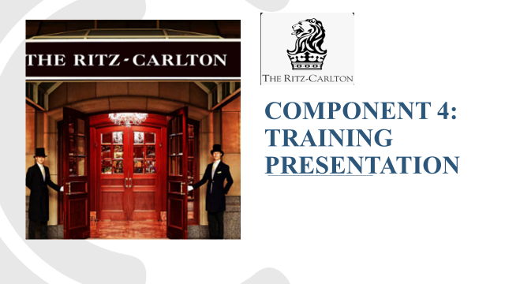
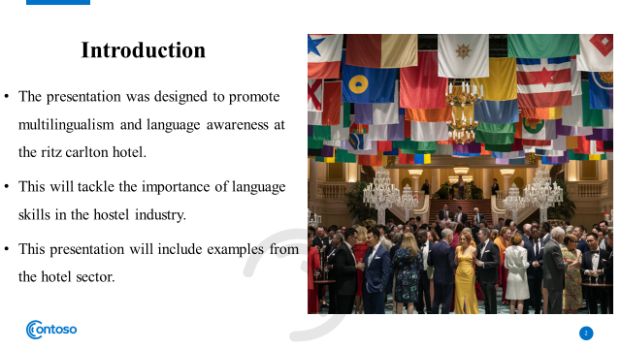
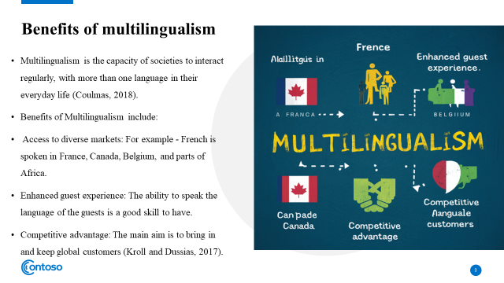
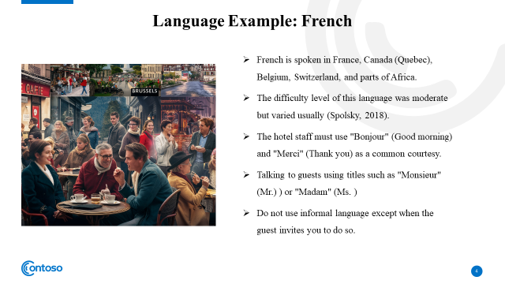
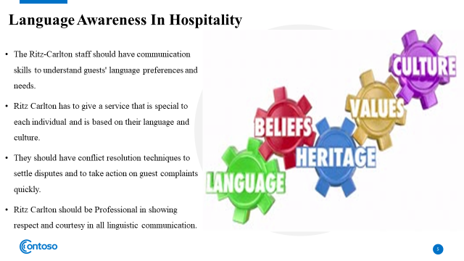
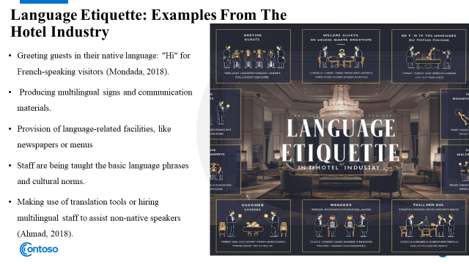
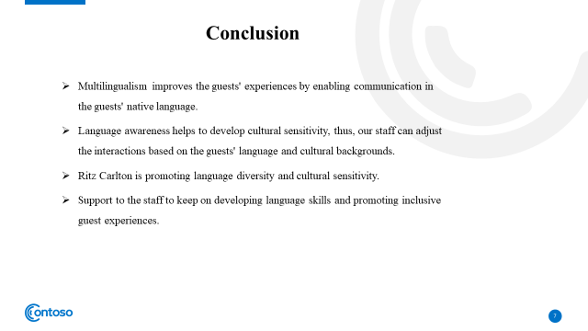
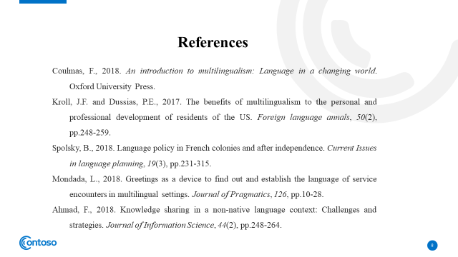


References
Bharwani, S. and Jauhari, V., 2017. An exploratory study of competencies required to cocreate memorable customer experiences in the hospitality industry. In Hospitality marketing and consumer behaviour (pp. 159-185). Apple Academic Press.
Cole, J. and Martin, A.J., 2018. Developing a winning sports team culture: organizational culture in theory and practice. Sport in Society, 21(8), pp.1204-1222.
Coulmas, F., 2018. An introduction to multilingualism: Language in a changing world. Oxford University Press.
Danso, R., 2018. Cultural competence and cultural humility: A critical reflection on key cultural diversity concepts. Journal of Social Work, 18(4), pp.410-430.
Foster, E., 2018. Cultural competence in library instruction: A reflective practice approach. portal: Libraries and the Academy, 18(3), pp.575-593.
Fukushima, S. and Sifianou, M., 2017. Conceptualizing politeness in Japanese and Greek. Intercultural Pragmatics, 14(4), pp.525-555.
Gerlach, P. and Eriksson, K., 2021. Measuring cultural dimensions: external validity and internal consistency of Hofstede's VSM 2013 Scales. Frontiers in Psychology, 12, p.662604.
Korkut, P., Dolmacı, M. and Karaca, B., 2018. A study on communication breakdowns: Sources of misunderstanding in a cross-cultural setting. Eurasian Journal of Educational Research, 18(78), pp.139-158.
Kroll, J.F. and Dussias, P.E., 2017. The benefits of multilingualism to the personal and professional development of residents of the US. Foreign language annals, 50(2), pp.248-259.
Kwan, M. and Tong, L., 2023. Exemplifying Exceptional Hospitality: Creating Unforgettable Home Away From Home Experiences For A Diverse Range Of Discerning Guests Case Study Of Intercontinental Zhuhai Hotel, IHG. Gulf Journal of Advance Business Research, 1(1), pp.44-59.
Nazarian, A., Atkinson, P. and Foroudi, P., 2017. Influence of national culture and balanced organizational culture on the hotel industry’s performance. International Journal of Hospitality Management, 63, pp.22-32.
Othlinghaus-Wulhorst, J. and Hoppe, H.U., 2020. A technical and conceptual framework for serious role-playing games in the area of social skill training. Frontiers in Computer Science, 2, p.28.
Spolsky, B., 2018. Language policy in French colonies and after independence. Current Issues in language planning, 19(3), pp.231-315.
Venter, E., 2017. Bridging the communication gap between Generation Y and the Baby Boomer generation. International Journal of Adolescence and Youth, 22(4), pp.497-507.
Wortsman, M., Ehsani, K., Rastegari, M., Farhadi, A. and Mottaghi, R., 2019. Learning to learn how to learn: Self-adaptive visual navigation using meta-learning. In Proceedings of the IEEE/CVF conference on computer vision and pattern recognition (pp. 6750-6759).
Mondada, L., 2018. Greetings as a device to find out and establish the language of service encounters in multilingual settings. Journal of Pragmatics, 126, pp.10-28.
Ahmad, F., 2018. Knowledge sharing in a non-native language context: Challenges and strategies. Journal of Information Science, 44(2), pp.248-264.

