

BA (Hons) Leadership and Management
BUPA
Student Name: Cornelia Sterea
Student Number:2416524
Course Name: Understanding and Engaging Stakeholders LCLM5001
Lecturer Name: Kazeem Oseni
Session: October 2025 Term 1

Table of Content
Contents
Introduction to Bupa 3
Appraisal of Bupa Using SWOT Analysis 4
SMART Objectives for the Project 7
Key Internal and External Stakeholders for the Wearable Health Device Project at Bupa 7
Internal Stakeholders 7
External Stakeholders 8
RACI Matrix for the Wearable Health Device Project at Bupa 9
Stakeholder Map, Engagement Plan, and Communication Plan 10
Stakeholder Engagement and Conflict Management Using the 4C’s Model 11
Managing Conflicts Using the 4C's 14
Evaluation of Stakeholder Engagement Impact on Business Performance 15
Recommendations for Future Stakeholder Engagement 17
Conclusion 18
Reference 19

Introduction to Bupa
 Bupa is one of the leading healthcare providers in the world that is devoted to transforming digital healthcare and make it more accessible. Bupa was founded in the year 1947 and has a presence in more than 190 countries with millions of customers worldwide. The general purpose of the company is to improve the health and wellbeing of its customers through high quality yet affordable healthcare solutions. Bupa is especially recognised in the provision of health insurance to individuals, families and businesses in markets like the UK, Australia, Spain, Chile, Poland, Hong Kong, Turkey, Brazil, Mexico and India, as well as international private medical insurance under its Bupa Global brand (Bupa Global, 2025).
Bupa offers a wide spectrum of healthcare services on top of its health insurance services, such as health clinics, dental services, and hospital services, aged care, and physiotherapy. Bupa has been leading in digital health initiatives, which are called Blua, a digital health platform created to provide healthcare services in a smart, seamless, and frictionless manner with a strong focus on being accessible (Rankin, 2023). Innovation is also applied at the sustainable practice level as the company is collaborating with partners to make the company less harmful to the environment and encourage climate-sustainable activities. The global nature of Bupa and its extensive healthcare service provision makes it a reliable and critical stakeholder in the healthcare sector in terms of serving varied needs of customers, as it has remained focused on the quality and accessibility of care.

Appraisal of Bupa Using SWOT Analysis
Bupa is an international healthcare organization that has a mission of changing the healthcare delivery environment by innovation and accessibility emphasis. Bupa has a wide scope in terms of products and services, such as health insurance, healthcare services, and aged care, which makes it a leader in the healthcare market (Bupa Global, 2025). The current organizational activities in digital healthcare such as creation of Blua, which is a digital healthcare platform, further confirm the interests of the company in enhancing customer care. The company undertakes a project that outlines development, design, and market launch of a wearable health device to monitor the key health parameters like the heart rate, oxygen level, and pattern of sleep. The device will be part of the digital health platform by the company to which users will have real-time and actionable information about their health and make well-informed choices concerning their health.
A SWOT analysis would offer an in-depth overview of both the internal and external environment of a company to allow assessing the feasibility of the proposed project of launching a wearable health device, which tracks heart rate, oxygen levels, and sleep patterns (Phadermrod, Crowder and Wills, 2019).
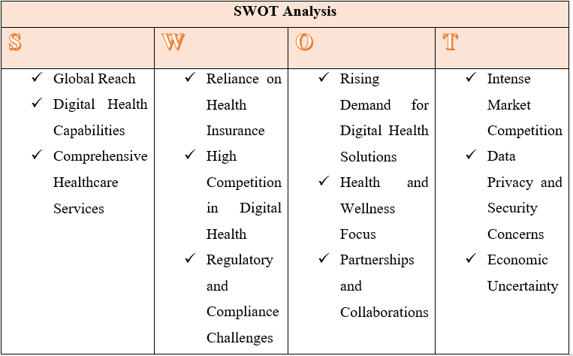
Strengths
Established Brand Reputation: Bupa enjoys a huge reputation in terms of providing good quality health insurance and healthcare services. This credibility is important when the new products are being launched such as a wearable health device as customers tend to accept innovations by a provider they are trusting.

- Global Reach: Bupa is a multinational company that does not only serve a different healthcare provider but also operates in other markets such as the UK, Australia and many others. This global presence allows Bupa to launch a new product in each market with a locally oriented device to the healthcare-related needs (Lee and Lee, 2020).
- Digital Health capabilities: Bupa has already put a lot of money in digital health, with its Blua platform, which enables it to integrate seamlessly with wearable health devices. Such a current infrastructure prepares Bupa to create and implement digital health solutions to monitor and process health data (Morton, 2021).
- Full-fledged Healthcare Services: Bupa has a wide market of healthcare services which encompass clinics, hospitals, and aged care, and through which it can provide a comprehensive approach to health. This breadth can enable the integration of a wearable health device to complement its existing services seamlessly.

Weaknesses
- Dependence on Health Insurance: Health insurance remains the main source of revenue at Bupa although it offers a wide range of services. This high dependency on insurance may reduce the flexibility of new projects such as wearable health devices in case of a slower adoption of the products by the customers than expected.
- Great Competition in Digital Health: The wearable health device market is a very competitive one with the leading players such as Apple, Fitbit, and Samsung taking the center stage. Bupa has the difficulty of product differentiation and positioning it in a market that has already become saturated.
- Regulatory and Compliance Issues: The healthcare sector is very regulated, and the launch of a wearable health device will have to comply with a range of medical devices regulation and data protection (e.g., GDPR). Operating within this regulatory environment might slow down the launch of the product or cause further complications.

Opportunities
- Increasing Need in Digital Health Solutions: The world is witnessing an increase in the demand of digital health solutions that will enable people to become in-charge of their health. As people become more conscious of their health and, in particular, after the COVID-19 pandemic, Bupa can seize this new opportunity and launch a wearable health device that will become part and parcel of its Blua platform (Emmanuel, 2025).
- Health and Wellness Focus: The consumers are becoming more concerned with preventive care and thus seek tools that can monitor and enhance their health. The wearable health gadget can follow this trend as it enables individuals who wear it to track such vital health indicators as heart rate and sleep habits, which encourages a proactive nature towards health.
- Alliances and Strategic Cooperation: Bupa can also use the collaboration with technology manufacturers to create a high-tech wearable health device. Partnerships with other well-known health technology firms might speed up the development of the product, assist in obtaining the more sophisticated technologies, and allow entering the market more easily.

Threats
- Strong Competition in the market: Being already full of well-established business participants, Bupa has to overcome the obstacle of uniqueness. The rivalry with firms that have more brand awareness, technology savvy and market share might jeopardize the popularity of the new wearable device.
- Data Privacy and Data Security Issues: Due to the sensitive health information offered by the wearable devices, data security and privacy will be of great concern to users and regulators. The data breach would have a devastating impact on the reputation of Bupa and destroy the trust that customers have towards it, as the market is highly regulated.
- Economic Uncertainty: The situation in the global economy (i.e., recessions or healthcare spending cuts) might have an effect on non-essential health products consumer spending (Leibovici and Santacreu, 2020). In case of deterioration in the economic conditions, a wearable health device might not be as attractive to customers.

SMART Objectives for the Project
a) Specific: To create and release a wearable health device that measures heart rate, oxygen levels, sleep patterns and connects it with the digital health platform of the company to promote the management of health in the user.
b) Measurable: Within the initial 12 months of launch, attain a customer adoption rate of 10-15 percent amongst the current healthcare customers.
c) Practicable: Take advantage of the current digital health infrastructure and technology relationships of the company to develop and introduce the device.
d) Relevant: Make the wearable align with the mission of the company offering easy, customer-based healthcare services (Winter et al., 2018).
e) Time-constrained: The product should be successfully launched within 6 months, and the initial stage of customer adoption should be achieved within 12 months.

Key Internal and External Stakeholders for the Wearable Health Device Project at Bupa

Internal Stakeholders
Product Development Team
The Product Development Team is critical in coming up with design and functionality of the wearable health product. They are also expected to choose the right sensors to monitor the heart rate, oxygen levels, and sleep patterns and make the technical specifications of the product to correspond to the healthcare standards. Another thing they will do is making the device integrated with the previous digital health system used by Bupa, Blua. The team also applies technical skill and innovation in order to make the device successful (Munoru, 2024). Nevertheless, the team might experience difficulties, including the need to strike a service-meets-usefulness and the technical failure in the design or testing stage.
Clinical Teams
The Clinical Teams offer the necessary information on the clinical usefulness of the wearable health device. These are the teams of doctors, nurses, and other medical workers whose responsibility is to prove that the device is applicable to real-life medical environment. They, also, provide feedback to perfect the device depending on the user experience and clinical requirement. The clinical groups play an important role in ensuring that the device is of medical standards and can be used in situations dealing with patients. The adoption of new technologies into the clinical setting, however, may not be highly welcomed by some people, which might be a challenge to introduce the device, as well as the disturbance of the regular workflow.

Marketing Team
Marketing Team will be involved in marketing the wearable health device, developing awareness of the device benefits, and influencing the customer to buy (Christopher, Payne and Ballantyne,2013). They are to formulate specific marketing plans, create online marketing campaigns, and train the potential buyers about the functionality of the device. Marketing plays a crucial role in making sure that the product is sent to the correct audience (Dinh-Le et al., 2019). Nevertheless, a problem that they encounter is the issue of breaking the scepticism especially in an already competitive market that is being already dominated by older brands such as Apple and Fitbit and making the product stand out.
Sales Team
The Sales Team will be a key part in the distribution of the wearable health device. They will be entrusted with the role of setting up the partnerships with the healthcare providers, negotiating prices and putting the product into the hands of the targeted consumers. The product heavily relies on the success of the Sales Team in creating strong distribution systems and form relationships with the healthcare professionals. Some of the challenges they might encounter are logistical problems, competition and working around the intricacies of the distribution channels.
Regulatory Bodies
The regulatory authorities like MHRA (Medicines and Healthcare products Regulatory Agency) and other local regulators will be instrumental in making sure that the wearable health device will comply with all medical safety and data protection regulations (Smuck et al., 2021.). They have to approve that the device can be sold and utilized in healthcare facilities. Patient safety and privacy are heavily dependent on regulatory compliance, which is time-consuming and complicated to achieve the approval that might slow the launch.

External Stakeholders

Patients and End-Users
The ultimate consumers to the wearable health device are the patients and End-Users. They will give first hand feedback concerning usability, functionality and comfort that will be utilized in further successive versions of the product. They are involved in product trials and usage, which makes them central to the achievement of the needs of healthcare with the help of the device. The key issues in this case are making the device available to as many users as possible, including those not technologically inclined, and managing the issues of data security and privacy (Rosery and Schönfelder, 2018).

External Suppliers
External Suppliers will supply the parts required in the production of the wearable health device including sensors, batteries and hardware. Their capacity to deliver high quality products with time depends on the success of the product. Suppliers play a very important role in providing the device to be reliable; however, they may also present challenges in the form of supply chain problems and delays in order of parts delivery, or quality control problems.

RACI Matrix for the Wearable Health Device Project at Bupa
The RACI Matrix will assist in explaining the roles and responsibilities of stakeholders engaged in the wearable health device project (Besnik, 2020).
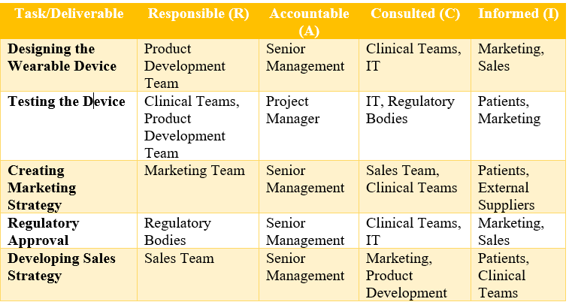

Stakeholder Map, Engagement Plan, and Communication Plan
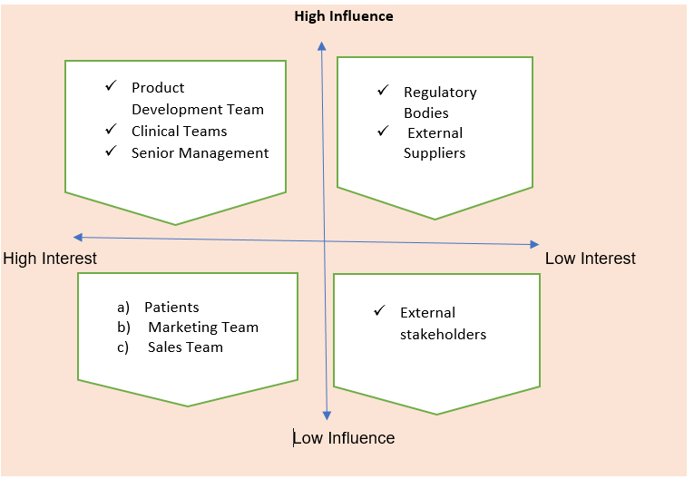
The Engagement Plan will imply the continuous cooperation among all the critical stakeholders. In the case of the Product Development Team, regular meetings and updates would be planned in order to solve design and functionality problems in time. The Clinical Teams will also be involved in regular consulting to test and do iterations of the product to ensure that the device responds to the healthcare requirements in the real world. Regulatory Bodies It will also involve regulatory bodies at the initial stages of the process to guarantee that they meet the required standards (Sanghera, 2018). The Sales and Marketing Teams will work together on the strategy of launch, price, and education of consumers. They will involve patients in constant surveys and feedback channels to enhance the user experience.

The Communication Plan will also involve internal stakeholders being informed on the weekly progress of the project in meetings and on the same platform such as the project management tools. This makes sure that all are on track with the progress and any problems (Sanghera, 2018). To the external stakeholders, communication will be sustained through email newsletters, social media updates, and specific web portals so that the information flow remains continuous, especially to the patients and suppliers, and transparency and engagement will be promoted in the project.

Stakeholder Engagement and Conflict Management Using the 4C’s Model
My role as the Project Manager in the wearable health device project at Bupa is to ensure that all major stakeholders are engaged successfully during the project through its development, launch, and post-launch process. The proper involvement of the stakeholders is critical to the successful completion of the project and the entry of the device to the market. I will use the 4C’s of Model (Communication, Coordination, Cooperation, and Collaboration) as my reference point in planning the stakeholder interaction and solving possible conflicts (Koilakonda and Gudala, 2023).
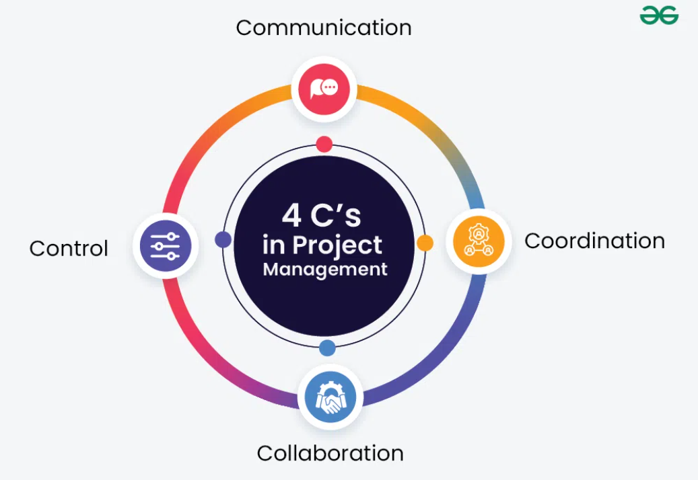
Communication
The main elements of effective stakeholder engagement are clear, timely and transparent communication. My role as the project manager is to ensure that there are open communication channels among all internal and external stakeholders, where everyone is aware and focused on the project objectives, project schedules, and project concerns.

In the case of the Product Development Team, I will have regular meetings with them to discuss the design process, functionality, and any difficulties encountered in the course of the testing. Such meetings will create a space to talk about the progress, problems that may arise will be spotted early and most of them will be solved before escalating. Team members can be able to exchange updates, documents, and other milestones with ease by creating a centralized communication platform (e.g. project management tool) or shared digital workspace (Tey et al., 2018).

In the case of Clinical Teams, regular consultation will be done to make sure that the device is in line with the healthcare requirements. Will these consultations enable one to obtain feedback, but also create a feeling of a collective responsibility so that the clinical staff will feel not only heard and engaged. This frequent communication is crucial, and the lack of it could lead to any discrepancy in clinical efficacy or fitting of the product into the healthcare practice.

In the case of Regulatory Bodies, communication at the beginning and throughout is important. I will also begin negotiations as soon as the project will be launched, where the device must meet the corresponding health and safety standards. Clear communication with the regulatory bodies can also be established to predict the delays in any particular approval. Since the regulatory approval process is usually a long process, clear communications about progress in the project and schedule, will assist in keeping the stakeholders informed and assured of the project progress (Firdaus, 2018).

In the case of external stakeholders such as suppliers and patients, contact will take place at regular intervals through emails, newsletters, and special platforms. Frequent contact with the patients will entail surveys and feedback forms to get an idea of how the product is doing, and the way it will keep on improving in its usability will be ensured. Through ensuring effective and timely communication, I will be able to avoid misunderstandings and conflicts, as well as make sure that all stakeholders are moving in the same direction and are interested in achieving the objectives of the project.

Coordination
Different departments and stakeholders need to be coordinated to have smooth execution of the project. I will strive to make sure that there exists a common approach in handling tasks, allocating deadlines and locating bottlenecks. The coordination will entail the development of a comprehensive project plan that will describe all important deliverables and timelines and will be distributed among all stakeholders. This plan will act as a road map and each team will know how it is related to the bigger project.

To give an example, the Product Development Team will design it technically, the Sales Team should be ready to launch it, and the Marketing Team should have the resources to create awareness. It is a sensitive task to organize such functions by meeting with each other, making joint documents and delegating clear tasks. To track the progress and ensure that everyone is on course, I will employ a project management tool, like the Gantt chart or workflow systems (Do et al., 2023).

An important element of coordination is to make sure that the Clinical Teams and Sales Teams are pulling in the same direction as regards the functionality of the device and the situation in which a patient can use it. Consistent coordination will make sure the sales pitch is pegged on the real benefits the device will have on the patients, and that the clinical teams are sure that it can be applied to the real-life situation.

Moreover, when dealing with outside sources, it is required to coordinate the process of delivery of the materials on time and on the appropriate level of quality. I will also make frequent visits to suppliers to ensure that parts such as sensors and batteries are on time and that any possible delays are reported in good time.

Cooperation
Cooperation means the establishment of a cooperative and supportive atmosphere in which all stakeholders aim at a common destination. As the project manager, I will focus on establishing a culture of mutual understanding and respect. Every member of the team or department contributes to the project with some useful knowledge and information. The project will be easily implemented by making sure that all the stakeholders collaborate and exchange their skills.

In the Clinical Teams, collaboration is very vital as it is the key to learning the clinical use of the wearable device. It is my duty to make sure that their ideas and issues are taken into account by the product design and testing period. This cooperation will lead to a more clinically relevant product and one that is more integrated into healthcare practices.

Equally, the Sales Team and Marketing Team should work hand in hand to make sure that the product is marketed in an efficient manner and the target audience is receiving it. The marketing team will have to develop a strong message with the clinical teams and product developers, and the sales team must make sure they know all the features and advantages of the product to sell it correctly to the target customers (Sanghera, 2018).

Lastly, collaboration with other suppliers is essential. They are supposed to supply the required elements within the required time and as per quality. In the event of delays or problems, the creation of a collaborative partnership with them will promote openness and a joint method of resolving all the problems.

Collaboration
Collaboration entails working actively with stakeholders to innovate, get solutions and better processes. Within the framework of the wearable health device project, internal teams (including IT, clinical experts, marketing staff) need to work together in order to reach the goals of the project (Ashcroft, 2017).
The departments will also need to collaborate to make it easier to integrate the device with the current health systems and the Blua platform. Indicatively, the Product Development Team and the IT Department will be required to work together in order to facilitate a smooth connection between the wearable device and the digital health platform. The same way, the Clinical Teams will work with the PD Team to enhance the functionality of the device and make it meet the standards of healthcare.
Besides that, working with the external technology partners may also help bring new features to the wearable device, including adding AI to track health more accurately or enhance the compatibility of the device with other digital health devices.

Managing Conflicts Using the 4C's
Conflict management is a very critical factor to the success of the project. Through effective communication, facilitating coordination, enhancing cooperation, and encouraging collaboration, I will be in a position to resolve any form of disagreement or challenge in good time (Sanghera, 2018).
As an example, in the event that there is a friction between the clinical teams and the product development team on a functionality of the device, free trade will see the concerns addressed. Subsequently, interdepartmental coordination can be used to arrive at a middle ground. The cooperation will allow two teams to find an agreement that will be beneficial to the project, whereas cooperation will help to ensure that the device corresponds to both clinical and technical requirements.

Evaluation of Stakeholder Engagement Impact on Business Performance
Timely stakeholder involvement is critical towards the success of the wearable health device project at Bupa. The connection with internal and external stakeholders could directly impact the efficiency of the operation of the project, its success on the market, customer satisfaction and its sustainability in the long term (Koilakonda and Gudala, 2023). I will assess how stakeholder engagement affects Bupa business performance and give future recommendations to the stakeholders on how this issue can be improved below.
1. Operational Efficiency and Product Development
Among the major effects of stakeholder engagement on the business, performance is operational efficiency. The involvement of the Product Development Team in the initial stages and regular communication between them will help the project to make sure that the wearable health device is created to address the needs of the clinical and technical requirements. As an illustration, during testing stages, constant feedback on the utility and functionality of the device provided by the clinical teams allows making timely modifications to the design, which will save time spent in costly delays and enhance time-to-market (Cooper, 2019).

In addition, it is essential to involve regulatory authorities at the very beginning so that the device would conform to all the necessary regulations of a medical device (e.g., MHRA, FDA, GDPR). This consideration is done at an early stage to prevent delays in acquiring the required certifications and regulatory approvals that can greatly affect the project schedule as a whole. Thus, an effective engagement plan with these stakeholders would make the product development process much easier and the regulatory compliance process much quicker, which would help facilitate operations efficiency and minimize risks of the project.

2. Enhanced Customer Satisfaction and Market Adoption
Customer satisfaction is also a key promoting factor that involves the stakeholder in making sure that the device is successful in the market. Through involvement of clinical teams, Bupa will ascertain that the product satisfies the real-life healthcare requirements of patients and healthcare practitioners. This process of collaboration results in a device that will be more accepted by clinicians and prescribed to patients resulting in customer satisfaction and confidence (Hubbart, 2024).

The necessary communication with individuals during the testing makes sure that their feedback is taken into consideration into the design of the device and it will be more convenient and efficient. As an example, patients can offer useful information on the comfortability and the convenience of using the device, as well as its effectiveness in monitoring health indicators such as heart rate, oxygen levels, and sleep patterns. Bupa can gather feedback and improve on the device, enhancing its chances of uptake by users by both individuals and companies in healthcare plans, through the collection of feedback and refinement of the device.

Furthermore, through the early engagement of Sales and Marketing Teams, Bupa will be able to develop powerful marketing messages and sales policies, which will appeal to the target audience. The fit between the marketing strategy and the design of the product makes the benefits of the device well-articulated, which can make the device gain more demand and adoption in the market.
3. Risk Management and Continuous Improvement
Risk management and sustenance of a steady improvement also requires stakeholder involvement. With a healthy relationship between Bupa and its external suppliers, the latter will be able to mitigate the risks in the supply chain and make sure that the materials required to create the wearable health device will be provided on schedule and of high quality. Frequent interaction with the suppliers would provide that any problem that might occur, like a delay or shortage of components, may be detected early and addressed before they cause delay in the project (Iandolo et al., 2025).

Besides, the feedback loop created with the help of stakeholder engagement creates the culture of constant improvement. By working with the clinical teams, patients, and IT specialists, Bupa will make sure that the device will be developed and enhanced even after its launch. As an illustration, constant customer feedback may be used to update the product or improve the software, which will result in increased customer satisfaction and retention.

4. Long-Term Relationships and Competitive Advantage
The advantages of stakeholder involvement go beyond the short-term project. Good relationships that have been developed with regulatory bodies, suppliers, clinical teams and customers, provide a platform on which future projects are developed. Such relations generate trust and bring possibilities of cooperation in the further product innovations (Watson et al., 2018). As an example, an effective introduction of the wearable health device may result in more collaborations with healthcare providers, technology providers, or even new regulatory approvals of new products.
Long-term relationships with suppliers reduce the risks related to supply chain disruptions because Bupa guarantees the reliability of future sourcing of the projects. Likewise, through consulting regulatory bodies at the initial stages of developing the product, Bupa can speed up the process of approving new healthcare technologies in the future, providing the company with a competitive advantage in the highly dynamic market.

Recommendations for Future Stakeholder Engagement
To keep advancing the success of the wearable health device project and manage to make subsequent projects equally successful, I would suggest the following:
- Increase Stakeholder Feedback Mechanisms: Have organized and regular feedback of patients and clinical groups in the post-launch period. Data analytics and real-time user reviews will provide an opportunity to discover problems and steer the process of continuous improvement.
- Improve Cross-Department Cooperation: Improve greater cooperation between Product Development, Marketing, Sales, and Regulatory Teams by holding frequently scheduled cross-functional meetings to make sure that their goals are aligned and they work together in a coordinated manner.
- Enhance Collaboration with Healthcare Providers: Strive to establish excellent relationships with healthcare providers, by providing training and educational materials to enhance their confidence and motivation towards device use.
- Develop Long-term Relationships with Suppliers: Form long-term relationships with suppliers to guarantee stable supply chain with high quality and acquire competitive prices in future projects.
- Data Privacy and Security a priority: It is important to emphasize the presence of data security, GDPR compliance and clarity on how the wearable device is used to establish trust and allow the attainment of safe and secure use of a wearable device.

Conclusion
In conclusion, ensuring the success of the launch of a wearable health device by Bupa will depend on the successful stakeholder engagement in its development, testing, and post implementation processes. Through involving the stakeholders and including the Product Development Team, Clinical Teams, Sales and Marketing, Regulatory Bodies and Patients, Bupa can be sure that the product will satisfy the technical, clinical and user requirements hence enhance the adoption rates and success in the longrun. The 4C's Model (Communication, Coordination, Cooperation, and Collaboration) has played a critical role in the engagement process and creating a kind of alignment among the various teams, as well as eliminating any possible conflicts.

Operational efficiency and integration of the product into the clinical environment would be challenging without the proper management of stakeholder expectations and mitigating issues with regular feedback and open communication and collaboration. Bupa can improve customer satisfaction by encouraging long-term relationships with suppliers, new improvements in the product with the help of customer feedback, and securing future development in the digital health sector by focusing on data privacy.
Following the suggestions of enhancing cross-departmental collaboration, diversifying feedback systems, and enhancing relations with healthcare providers, Bupa can use stakeholder engagement as the main source of innovation and long-term prosperity in the wearable health devices market.

Reference
Ashcroft, J. (2017) The relational lens: understanding, measuring, and managing stakeholder
Besnik, Q., 2020. The Framework of a Real-time Patient Monitoring System (Doctoral dissertation, Budapesti Corvinus Egyetem).
Bupa Global, 2025. Premium international private healthcare. [online] Available at: https://www.bupaglobal.com/en/ [Accessed 21 October 2025].
Christopher, M., Payne, A., and Ballantyne, D. (2013). Relationship Marketing: Creating Stakeholder Value. Saint Louis: Taylor and Francis
Cooper, R.G., 2019. The drivers of success in new-product development. Industrial marketing management, 76, pp.36-47.
Dinh-Le, C., Chuang, R., Chokshi, S. and Mann, D., 2019. Wearable health technology and electronic health record integration: scoping review and future directions. JMIR mHealth and uHealth, 7(9), p.e12861.
Do, V., Maniate, J.M., Sultan, N. and Sonnenberg, L., 2023. The 4C’s of influence framework: fostering leadership development through character, competence, connection and culture. Leadership in Health Services, 36(4), pp.461-478.
Emmanuel, M., 2025. Insurance Coverage and Reimbursement for Wearables.
Firdaus, A., 2018. Dynamic stakeholder management approach: Using 3C-Model™ as framework (case studies from Indonesia) (Master's thesis, University of Twente).
Hubbart, J.A., 2024. The importance of stakeholder engagement across market domains. Journal of Global Entrepreneurial Management, 2(1), pp.1-7.
Iandolo, F., La Sala, A., Turriziani, L. and Caputo, F., 2025. Stakeholder engagement in managing systemic risk management. Business Ethics, the Environment & Responsibility, 34(4), pp.1069-1085.
Koilakonda, R.R. and Gudala, L., 2023. Effective communication strategies for stakeholder engagement. International Journal of Core Engineering & Management, 7(8), pp.2348-9510.
Lee, E.K. and Lee, J., 2020, December. Competition strategy for healthcare insurance plans. In 2020 IEEE International Conference on Bioinformatics and Biomedicine (BIBM) (pp. 1972-1978). IEEE.
Leibovici, F. and Santacreu, A.M., 2020. International trade of essential goods during a pandemic. Covid Economics, 21(1), pp.59-99.
Morton, A.J., 2021. European health care systems and the emerging influence of European Union competition policy. Journal of Health Politics, Policy and Law, 46(3), pp.467-486.
Munoru, E., 2024. Stakeholder involvement in the implementation of digital health technologies.
Phadermrod, B., Crowder, R.M. and Wills, G.B., 2019. Importance-performance analysis based SWOT analysis. International journal of information management, 44, pp.194-203.
Rankin, D., 2023. Private Health and Insurance. In Textbook of Medical Administration and Leadership (pp. 293-317). Singapore: Springer Nature Singapore.
relationships. Cambridge: Cambridge University Press. Available at: https://www-cambridgeorg.ezproxy.uwtsd.ac.uk/core/books/relational-lens/value-and-importance-ofrelationships/718C31032061BDFA3F480BA2A53F45D4#CN-bp-1
Rosery, H. and Schönfelder, T., 2018. Healthcare system stakeholders. White Paper on Joint Replacement, p.91.
Sanghera, P., 2018. Monitoring stakeholder engagement and communication. In PMP® in Depth: Project Management Professional Certification Study Guide for the PMP® Exam (pp. 519-533). Berkeley, CA: Apress.
Smuck, M., Odonkor, C.A., Wilt, J.K., Schmidt, N. and Swiernik, M.A., 2021. The emerging clinical role of wearables: factors for successful implementation in healthcare. NPJ digital medicine, 4(1), p.45.
Tey, K.H., Chai, C.S., Olanrewaju, A.L. and Aminah, M.Y., 2018. Conceptualising 4Cs in Construction Project Team Integration. Malysian Construction Research Journal (MCRJ), ISSN, (1985-3807), pp.83-96.
Varadarajan, R., 2024. Inclusive innovations in services: leveraging digital technologies for inclusive innovations in healthcare services. European Journal of Marketing, 58(13), pp.107-129.
Watson, R., Wilson, H.N., Smart, P. and Macdonald, E.K., 2018. Harnessing difference: a capability‐based framework for stakeholder engagement in environmental innovation. Journal of Product Innovation Management, 35(2), pp.254-279.
Winter, A., Stäubert, S., Ammon, D., Aiche, S., Beyan, O., Bischoff, V., Daumke, P., Decker, S., Funkat, G., Gewehr, J.E. and de Greiff, A., 2018. Smart medical information technology for healthcare (SMITH). Methods of information in medicine, 57(S 01), pp.e92-e105.

