STUDENT NAME: DANIELA KRASTEVA
REPORT

2022
STUDENT NUMBER: 2124368
UNIVERSITY OF WALES TRINITY SAINT DAVID
LECTURER: ALFRED MEN’S
TESLA MOTORS, INC.

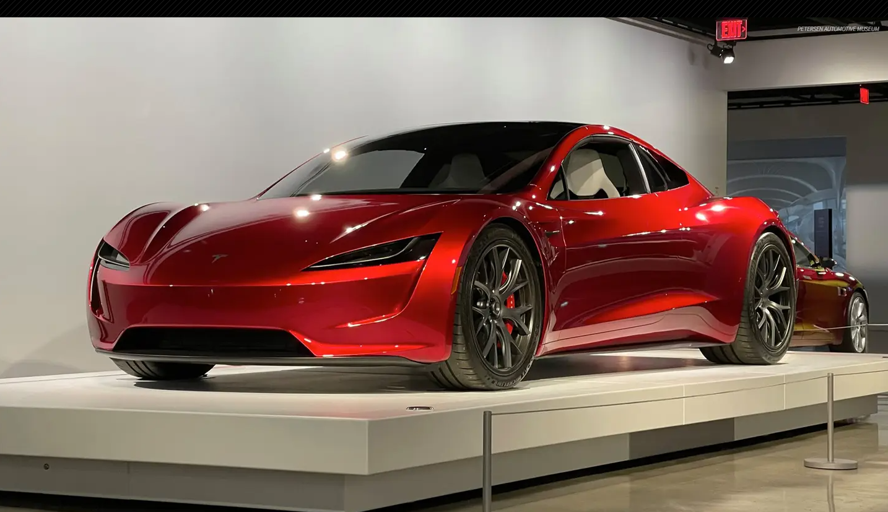

TESLA MOTORS, INC.

Executive summary

As a result of globalisation and technological advancements, the electric automobile industry is changing and evolving significantly compared to fuel-powered automobile vehicles. Tesla Motors, Inc. has been chosen to examine significant driving forces in the internal and external environment. The phrase "global business environment" has been established in this study. A critical assessment has been made utilising the major driving force – PESTLE. The report reflects on obstacles experienced while Tesla Motors, Inc. is trading globally.

Contents
Executive summary 4
Introduction to Global Business Environment 5
The importance of the business environment 5
Assignment purpose 5
Specification of brand 5
Report Plan 5
Introduction of Tesla 5
Critical evaluation 5
Internal business environment 5
External business environment 5
PESTLE analysis of Tesla 5
Challenges in trading across the globe 5
Conclusion 5
Reference list 5

Introduction to Global Business Environment

Report Plan Structure
- Cover page
- Executive summary
- Table of content
- Introduction to Global Business Environment
- Introduction to Tesla Motors, Inc.
- Critical evaluation
- Challenges in trading across the globe
- Conclusion
- Reference list

The importance of the business environment

It is critical to be informed of your rivals' actions and strategies in any business. In a commercial situation, businesses can analyse their competitors' methods and behaviours. They could also come up with their own methods in this regard. Identification of growth areas, building a strong brand image, remaining in sync with rivals, and determining dangers are some of the most essential benefits of a business environment.

The assignment report focuses on critically evaluating the external and internal business environment of a specific brand considered in the automobile industry and reflection on the encounter in global international trading.

Tesla is a company for electric automobiles with specific innovative battery technology and electric powertrain, which was started in 2003 by a formed a team of engineers. One of the company's key goals is to supply users with endlessly scalable clean energy generation and powerful goods that reduce the risk of global warming and pollution.

Introduction of Tesla Motors, Inc.

Tesla, Inc. is a public green energy and electric vehicle company headquartered in Austin, Texas. Tesla, among other things, manufactures electric automobiles, home-to-grid batteries, solar panels, and solar roof tiles. Tesla is one of the world's most valuable firms, as well as the most valuable automobile, with a market value of around $1 trillion.

The industry

Automotive Renewable Energy is a division of the corporation.

Chairman and CEO

Elon Musk, the previous co-founder is now the chairman and CEO, and the largest shareholder of the company since 2008.

According to the most current data analysis, the company has completed 930,422 autos (2021), 3.99 GWh battery energy storage systems (2021), and 345 MW solar energy systems (2021). North America, Europe, Oceania, and East and West Asia are among the regions covered globally.

"At a cheaper cost than most high-performance sports vehicles, it is now feasible to construct a very rapid lithium-ion powered electric sports car that looks beautiful, handles well, and is a delight to drive." Despite this car will be the most fuel-efficient and ecologically friendly vehicle available. You can have it all. “Has been written in the document ‘’The 21st Century Electric Car Tesla Motors’’ (2006) by Martin Eberhard and Marc Trepanning.

Critical evaluation

External business environment

In order to conduct its company, Tesla Motors must contend with challenges such as the existing economy, market, industry dynamics, regulatory constraints, and socio-cultural influences.

‘’The worldwide 2007-2009 fiscal crisis triggered a significant battle for three major vehicle manufacturers in the United States, with several of them approaching bankruptcy. Tesla Motors, on the other hand, benefitted from the car industry's downturn. The firm successfully shifted all Model S makers back to the United Writes after acquiring an idle plant in Fremont, California, jointly owned by General Motors (GM) and Toyota," states the analytical business essay "Tesla Motors Company's Environment Analysis."

Source: http://fernfortuniversity.com/term-papers/pestel/nyse4/862-tesla--inc-.php

Tesla Motors' operations are impacted by rising demand for a low-carbon lifestyle and renewable energy. Tesla Motors, for example, tailors its low-emission marketing to customers' preferences for low-carbon living.

Increasing trash disposal limitations and increased concern about climate change have an impact on Tesla Motors' external environment. The zero-emission capabilities of electric cars help to increase their commercial appeal. Indeed, California law requires car dealers to sell a particular percentage of zero-emission vehicles.

Dealer regulations in the United States, the United Kingdom, and other countries are threatening Tesla's business .The dealership business was successful in persuading state legislators to pass legislation requiring automobile manufacturers to sell exclusively via independent recognised dealers rather than company-owned showrooms.

Source: https://www.jstor.org/stable/26488657

- Internal business environment

Identifying critical abilities and resources in a variety of areas of a company, including operations, finance, and marketing , is facilitated by an internal study of the organisation.

Advantages of the corporation

- Strength

A well-known, strong brand founded on features such as excellent performance, and dependability.

Operational skills that are well-established.

Has an excellent design, sales, and marketing staff.

Has unshakable devotion to the company's future creative and innovative development.
- Weaknesses

As a consequence of the technology, there are concerns regarding electric vehicles' performance in comparison to gasoline or diesel engines, as well as unfavourable perceptions about their performance.

Negative operational margins are reported.

The worldwide the market for brand is underdeveloped (Only Europe, Asia, and the United States sell it.)

- Opportunities

This is a well-known brand with outstanding qualities.

The ability to eliminate negative perceptions and misunderstandings about electric cars.

Performance has been sacrificed in hybrid cars, as well as a range of other ecologically friendly autos presently on the market.

- Threats

Has the combined challenge of putting a new company and a new product on the market? (Stringham, Miller & Clark 2015)

IC automotive manufacturers' trademarks are well-known and well-protected.

IC carmakers market brands with comparable levels of luxury, comfort, and speed.

Source: https://ieeexplore.ieee.org/abstract/document/7273032

A graphic example of Tesla’s Financial Ratios for Analysis 2009-2022 TSLA

Table 1 GRAPHICAL EXAMPLE OF TESLA’S FINANCIAL RATIOS, ANALYSIS 2009-2022 TSLA

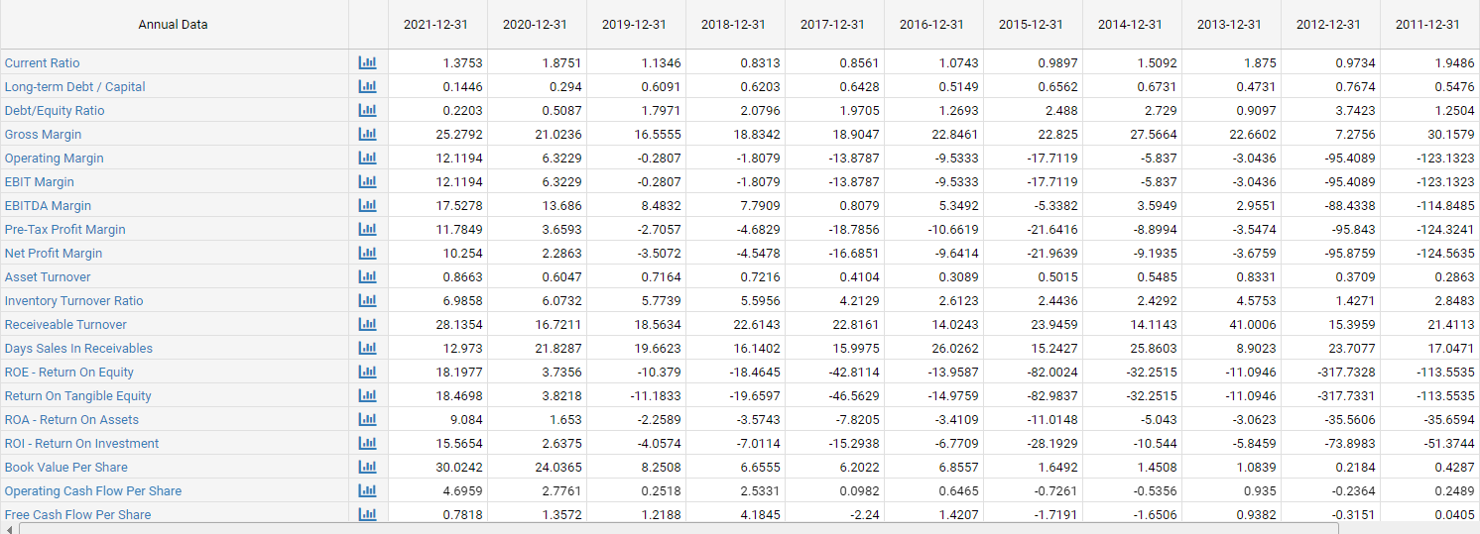

Tesla's net profitability was negative in 2016 and 2017. This, however, does not imply a lack of financial resources, as Tesla is a brand-new company. To increase sales, it spends a lot of money on marketing and its negative operational margins and net profits are also a result of the research and design strategy, which erodes the company's comparative and competitive advantage.

Source: https://www.sec.gov/cgi-bin/browse-edgar?action=getcompany&CIK=TSLA&type=10-K&dateb=&owner=exclude&count=100

PESTEL analysis of Tesla Motors, Inc.
Table 2 PESTEL analysis
Tesla Inc. went public in 2010, and it received a lot of interest throughout the world. Tesla vehicles run on electricity rather than gasoline, which reduces carbon emissions significantly. Automobiles are often considered a luxury item since they are typically out of reach for those with a middle or lower income.

Key drivers | External factors to consider
Political | You may be eligible for tax incentives if you purchase a Tesla vehicle.  Furthermore, because to its dedication to environmental sensitivity, the government incentive has enhanced its financial performance.  Tesla is growing into new areas, including China, where it has a delivery hub, and the Netherlands, where it has an administrative centre. It may also experience difficulties as a result of political unrest in the nations where it operates, which might interrupt the supply chain and cause financial losses. It also has a significant number of international sourcing partners, whose supply is contingent on each country's political stability and foreign ties with the United States.
Economics | Interest rates, currency exchange rates used to determine consumer income, inflation, economic growth rates, and other factors all have an impact on a company's performance. It also considers the rate of unemployment.  The car is mostly regarded as a high-end vehicle. The sale of electric automobiles has benefitted the global economy. The global vehicle sector grew at a breakneck pace between 2016 and 2017. The promise of creating cost-effective autos in the future has grown as the quantity of sales has increased.  A country's growth is determined by its local economy. Putting inexpensive cars within reach of typical people will help the corporation in two ways in the long run. To begin with, to compete with the other businesses in the industry. Second, to accommodate the market's expanding demand for electric vehicles. While the falling cost of renewable energy is favourable for Tesla's expansion, one of its major challenges is economic volatility.
Technology | In terms of technology, Tesla automobiles are cutting-edge. These high-end cars with cutting-edge technology entice buyers because they represent the future. The fuel-efficiency feature totally modifies what "sustainable" means.  Cutting-edge technology is also a feather in the cap. Technology, on the other hand, is ever-changing.
Legal | Electric vehicles are marketed as being more ecologically friendly than gasoline-powered vehicles. Tesla vehicles are compliant with a variety of environmental requirements, and carbon emissions are maintained to a bare minimum (compared to traditional cars). Tesla has earned a reputation for prioritising the environment in a way that few other businesses can match
Environment | Tesla is in a great position to fight the disease. Tesla Motors continues to deliver automobiles directly to customers, despite the fact that parking lots are filling up with unsold vehicles and dealers are chewing at the bit to be able to sell cars. On the results conference, the business addressed its progress toward a touchless car purchasing strategy, claiming that a vehicle could be purchased in five minutes using a mobile phone app.  Source: https://ir.tesla.com/#tab-quarterly-disclosure  Between 2016 and 2017, the global vehicle sector grew at a breakneck pace. As the quantity of sales grows, so does the prospect of developing cost-effective vehicles in the future.

.

Challenges in trading across the globe

The electric carmaker's major achievements in 2018 — impressive Model 3 sales and first consecutive profitable quarters — were overshadowed by a slew of challenges and controversies, including a Securities and Exchange Commission (SEC) lawsuit against CEO Elon Musk, overburdened service centres, and workplace safety concerns.

In 2019, though, not much has changed. Even excellent news, like the arrival of a $35,000 Model 3 sedan and the Model Y SUV, has been met with scepticism.

Tesla has a lot on its plate as it approaches the second quarter, with waves of layoffs, fresh SEC issues, and a loss of Consumer Reports' rating. (2019)

Tesla said in February that many of its stores would close, with the remaining ones being converted into galleries and showrooms.

Tesla's senior vice president, Sanjay Shah, wrote an email to staff in March asking for volunteers to assist with car deliveries, according to Business Insider.

During the global supply crisis, Tesla outperformed traditional manufacturers, although CEO Elon Musk has warned of difficulty sourcing semiconductors and other resources.

Due to Tesla's exposure to the cryptocurrency's volatility, all eyes are now on the company's second-quarter earnings to see if recent price drops in bitcoin would impact its bottom line.

Conclusion

Tesla Motors was founded by carving out an uncontested niche market for rich sports car enthusiasts who shared the company's goal for sustainability and the use of fossil fuels. The Model S, which competes well in the battery and hybrid electric vehicle industries as well as the luxury sedan market, has now been added to the company's product line.

The company has demonstrated great technical innovation and operational resiliency, demonstrating its capacity to remain profitable beyond 2014.

Reference list

About Tesla | Tesla (no date). Available at: https://www.tesla.com/about (Accessed: 2 April 2022).

Eberhard, M. and Tarpenning, M. (2006) ‘The 21st Century Electric Car Tesla Motors’, p. 10.

Electric Cars, Solar & Clean Energy (no date) Tesla. Available at: https://www.tesla.com/ (Accessed: 2 April 2022).

PESTLE Analysis | Factsheets (no date) CIPD. Available at: https://www.cipd.co.uk/knowledge/strategy/organisational-development/pestle-analysis-factsheet (Accessed: 2 April 2022).

Tesla Financial Ratios for Analysis 2009-2022 | TSLA (no date). Available at: https://www.macrotrends.net/stocks/charts/TSLA/tesla/financial-ratios (Accessed: 2 April 2022).

Tesla Motors Company’s Environment Analysis | Business Paper Example (no date) Business-Essay.com. Available at: https://business-essay.com/tesla-motors-companys-environment-analysis/ (Accessed: 2 April 2022).

