Design and Analysis of Electromagnetic Systems

Electromagnetic Radiation

ACDC5009

Sarah Butler
2315177
Table of Contents
1. Task 1 3
1.1 Abstract 3
1.2 Introduction 3
1.3 Methodology 3
1.4 Results 6
1.4.1 Task 1a 6
1.4.2 Task 1b 7
1.5 Discussion 8
1.6 Conclusion 8
2. Task 2 9
2.1 Abstract 9
2.2 Introduction 9
2.3 Methodology 9
2.4 Results 10
2.5 Discussion 11
2.6 Conclusion 11
3. Task 3 12
3.1 Introduction 12
3.2 Literature Review 12
3.3 Discussion 13
3.4 Conclusion 13
4. References 14

1. Task 1
1.1 Abstract
Applications of electromagnetic and mathematical principles were applied to design two rectangular waveguide models of different materials When these models were simulated in different modes, gave results calculated from theoretical equations. These results from both designs enabled a comparison of suitable materials to medium for specific ideals.

1.2 Introduction
Waveguides are structures to guide waves by restricting energy transmission in one direction with minimal energy loss. Waveguides direct electromagnetic waves efficiently and they guide using specialised, hollow metallic structures [1]. Constructed from Perfectly Electric Conductor (PEC) walls, waveguides are also filled with a perfect insulator. This is what allows it to guide the waves as they are reflected through the confined structure.
This experiment tests the material within the PEC walls and compares the outcomes of using Teflon with a vacuum. The role the material within the walls plays is affecting the permittivity and permeability of the medium inside, which affects the speed and propagation characteristics of the waves. This research is conducted to prove this difference it is calculated to make.
The cut-off frequency for a waveguide is a certain frequency value at which, the signal begins to attenuate rather than pass through [2]. This is the measurement taken in the simulation to prove the theories and calculations.
Rectangular waveguides are a subset of waveguides that have a cross section in the shape of a rectangle. This type of waveguide has TE and TM modes. Modes in waveguides refer to the configuration of electric and magnetic field pattern in the waveguide [3]. Within this research, the TE mode is considered, which concerns only the electric field. Further, the mode is specified with the number of half cycles in the x and y axis, in the format TE_{mn,} with ‘m’ being the number of half cycles in the x-axis and ‘n’ the number of half cycles in the y-axis. The modes used in the simulations are TE₁₀, TE₂₀, TE₀₁. The dominant mode, in this case TE₁₀, is the lowest order mode for the waveguide for a given frequency.

  - Methodology
The simulations used in this research are performed using Ansys software. Using this High Frequency Structure Simulator (HFSS) to design and simulate allows visualization of the fields of propagating modes in the waveguide. It also allows the material of the waveguide to be selected meaning the opportunity for comparison between them.
When using the simulation, the behaviour of the rectangular waveguide is able to be analysed, and a plotted graph is given as a result showing the cut-off frequency of the different modes. The result of this is then compared to the equation from theory of wave guides:
$f_{c}=\frac{c}{2}\sqrt{{(\frac{m}{a})}^{2}+{(\frac{n}{b})}^{2}}$ | $c=\frac{1}{\sqrt{εμ}}$
Where,
- ‘fc’ is the cut-off frequency in Hertz (Hz)
- ‘c’ is the velocity of light
- ‘a’ is the width of the rectangular waveguide
- ‘b’ is the height of the rectangular waveguide
- ‘m’ is the number of half cycles in the x-axis
- ‘n’ is the number of half cycles in the y-axis
- ‘$ε$’ is the permittivity of the medium
- ‘$μ$’ is the permeability of the medium

The models in this experiment have a cross-section of 23mm wide with 9mm height. The length of both waveguides is 50mm long. The simulation allows them to be visualised and below are the models.
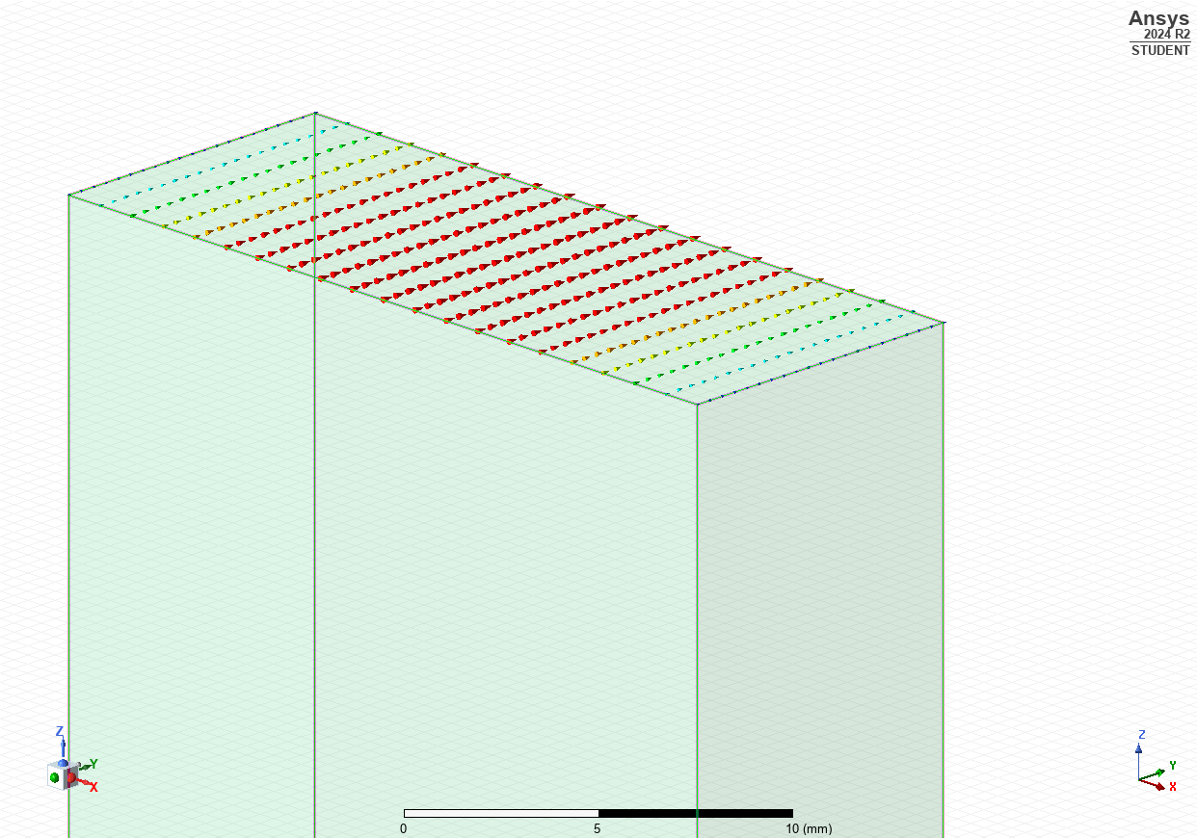
Figure 1: Port Field Display Mode 1

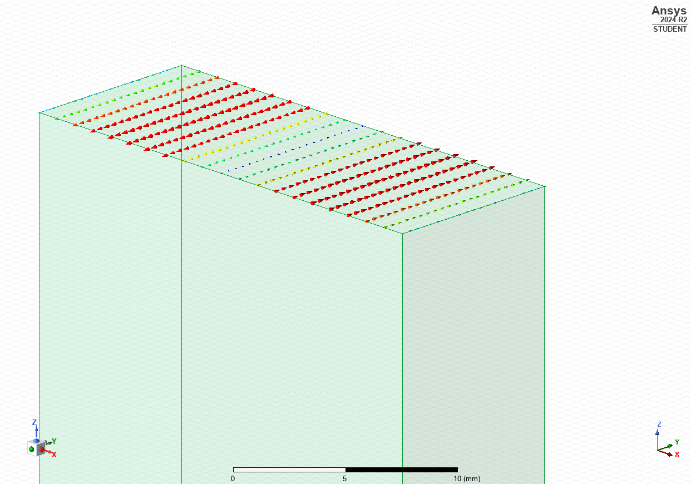
Figure 2: Port Field Display Mode 2

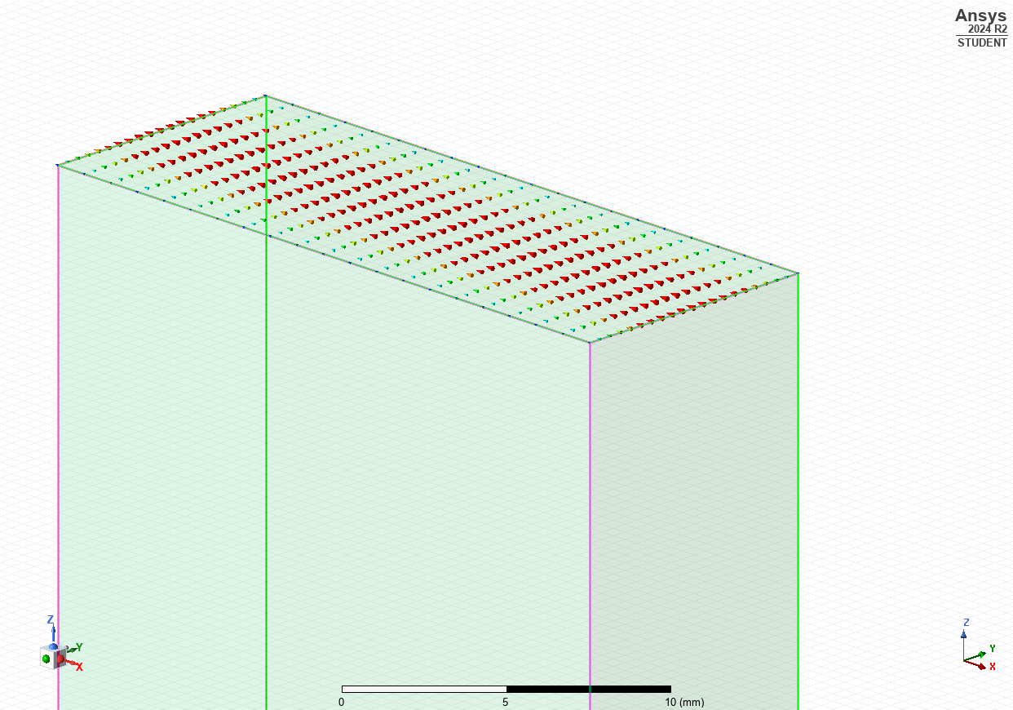
Figure 3: Port Field Display Mode 3
Figures 1-3 show the different modes in which this rectangular waveguide is compared in this report. These images are a visual representation of the number of half-wavelength variations along the two principal directions of the structure.
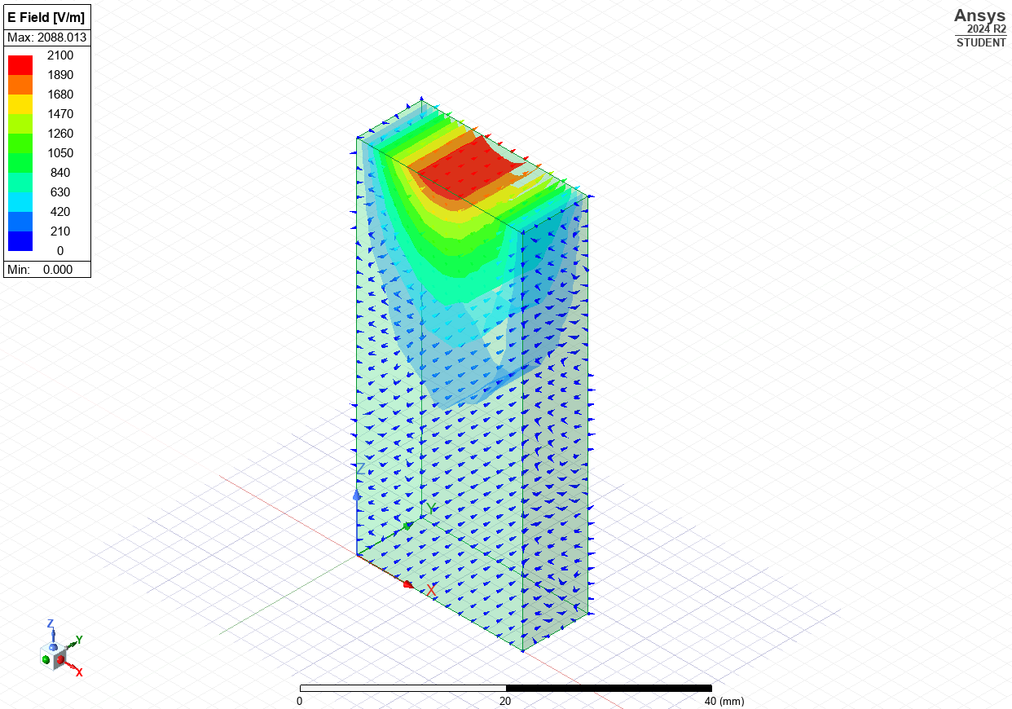
Figure 4: Magnitude and Vector of the Electric Field
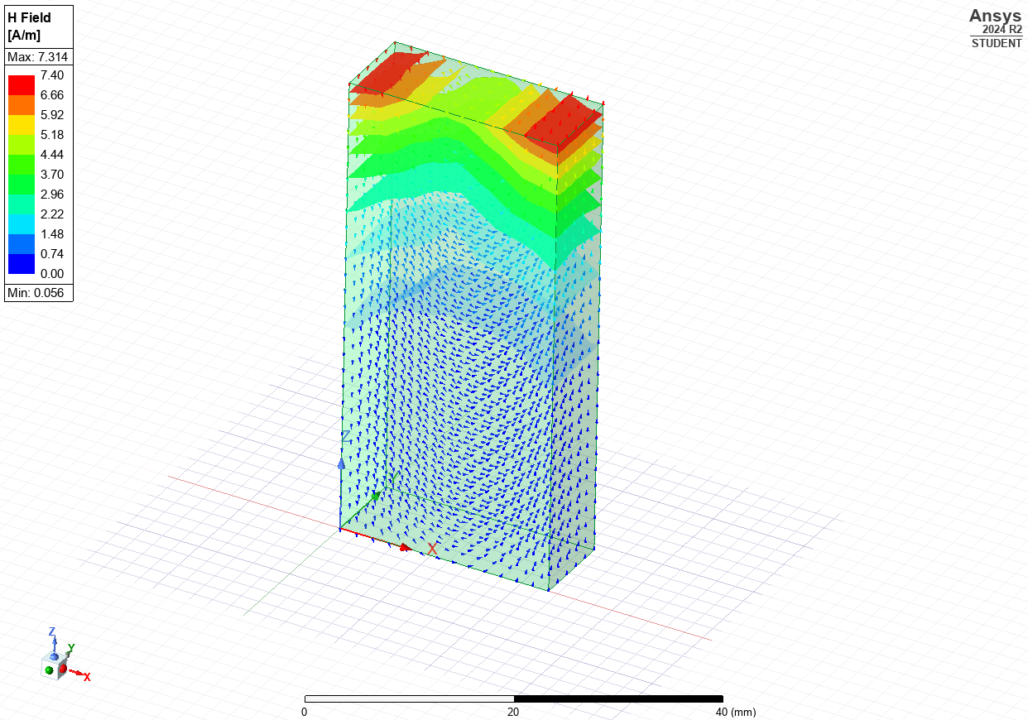
Figure 5: Magnitude and Vector of the Magnetic Field
Figures 4 and 5 show the electric and magnetic field properties. This is important information as they define the Poynting Vector. The Poynting vector is the direction of power flow of an electromagnetic field [4]. This allows assessment on the efficiency of power transfer in the waveguide.
  - Results

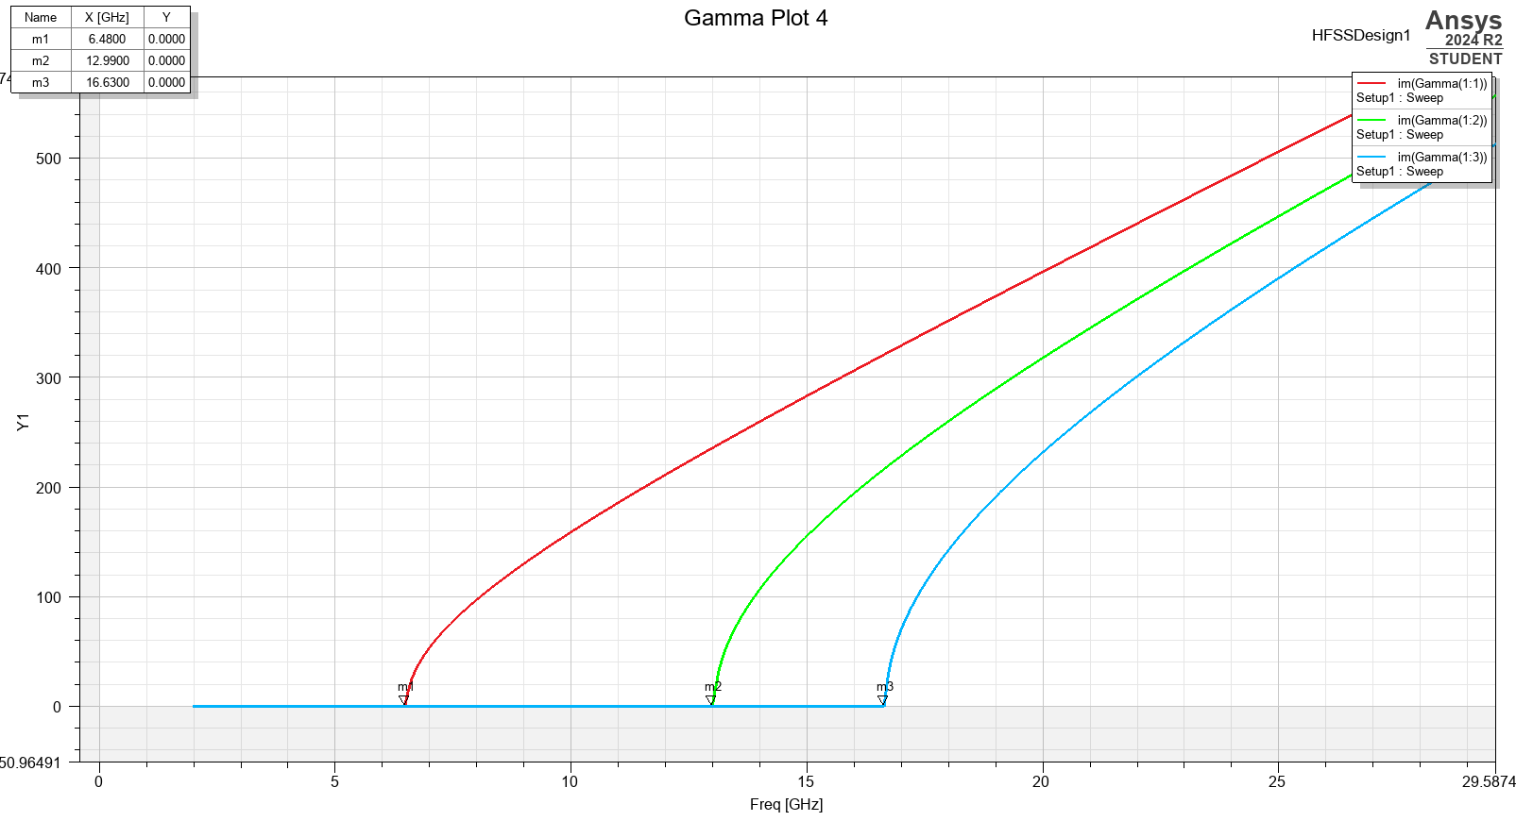
Task 1a
Figure 6: This graph shows the cut-off frequencies of the different modes of the vacuum filled rectangular waveguide.
In figure 6, there are three plots labelled ‘m1-3’. These are the cut-off frequencies for the different modes on the waveguide. In the top-right of the image is a table of the labelled marker and its coordinates. The frequency value is the goal of the theoretical calculation.

The calculation of the theoretical result using two equations. The first is to calculate the speed of the wave as it travels through the waveguide. This is done by using the permeability of the medium and the permittivity of the medium. This calculation is for the waveguide filled with vacuum:
$c=\frac{1}{\sqrt{εμ}}$ $c=\frac{1}{\sqrt{\left(8.854×{10}^{-12}×1\right)×(1.256637×{10}^{-6}×1)}}=299.796×{10}^{6}$

This calculation of speed is then used in each calculation of cut-off frequency for the different modes. The first cut-off frequency result is for mode TE₀₁:
$$f_{c}=\frac{299.796×{10}^{6}}{2}\sqrt{{(\frac{0}{0.023})}^{2}+{(\frac{1}{0.009})}^{2 }}=16.655×{10}^{9 }Hz$$
Cut-off frequency for TE₁₀:

$$f_{c}=\frac{299.796×{10}^{6}}{2}\sqrt{{(\frac{1}{0.023})}^{2}+{(\frac{0}{0.009})}^{2 }}=6.517×{10}^{9 }Hz$$

Cut-off frequency for TE₂₀:
$$f_{c}=\frac{299.796×{10}^{6}}{2}\sqrt{{(\frac{2}{0.023})}^{2}+{(\frac{0}{0.009})}^{2 }}=13.035×{10}^{9 }Hz$$

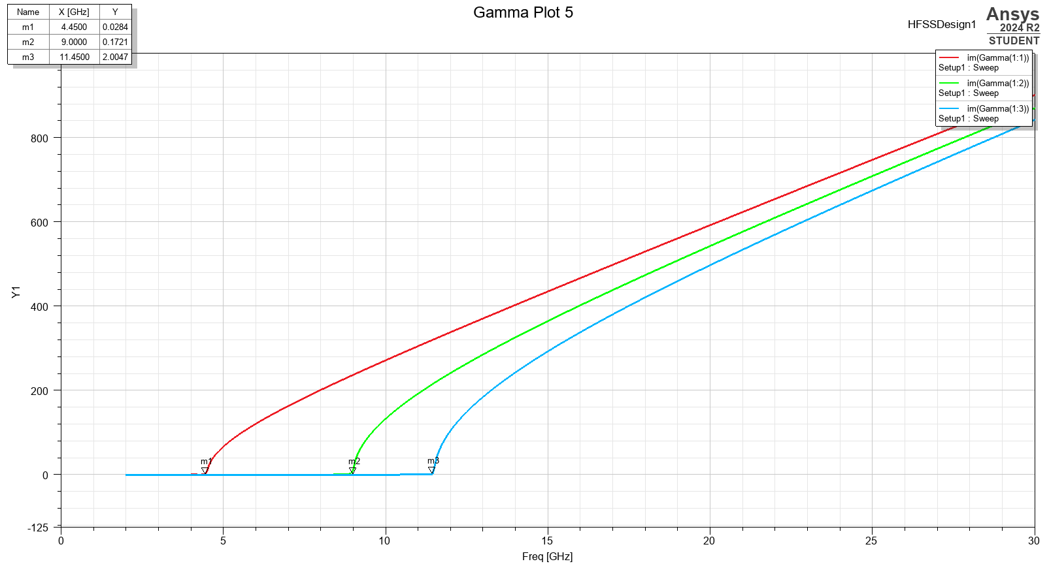
1.4.2 Task 1b
Figure 7: This graph shows the cut-off frequencies for the different modes of the Teflon filled rectangular waveguide.
Above (Figure 7) is the graph for the Teflon filled waveguide and labelled is the cut-off frequencies of the different modes. These are calculated into the table in the top-right of the image and are a reference for the theoretical equation calculation.

The calculation of the theoretical result using the same two equations as the vacuum-filled waveguide. The first is to calculate the speed of the wave as it travels through. This is done by using the permeability of the medium and the permittivity of the medium. This calculation is for the waveguide filled with Teflon:
$c=\frac{1}{\sqrt{εμ}}$ $c=\frac{1}{\sqrt{\left(8.854×{10}^{-12}×2.1\right)×(1.256637×{10}^{-6}×1)}}=206.9×{10}^{6}$

This calculation of speed is then used in each calculation of cut-off frequency for the different modes. The first cut-off frequency result is for mode TE₀₁:
$$f_{c}=\frac{206.9×{10}^{6}}{2}\sqrt{{(\frac{0}{0.023})}^{2}+{(\frac{1}{0.009})}^{2 }}=11.49×{10}^{9 }Hz$$
Cut-off frequency for TE₁₀:

$$f_{c}=\frac{299.796×{10}^{6}}{2}\sqrt{{(\frac{1}{0.023})}^{2}+{(\frac{0}{0.009})}^{2 }}=4.497×{10}^{9 }Hz$$

Cut-off frequency for TE₂₀:
$$f_{c}=\frac{299.796×{10}^{6}}{2}\sqrt{{(\frac{2}{0.023})}^{2}+{(\frac{0}{0.009})}^{2 }}=8.995×{10}^{9 }Hz$$

  - Discussion
It is clear from the calculations that TE₁₀ is the dominant mode, as it has the lowest cut-off frequency.
By the results, the theory of cut-off frequency calculation was extremely close to the calculation. This slight error margin may be from the marker placement on the plotted graph. The marker is manually placed leaving room for human error in the placement.
Having Teflon as the medium filling the rectangular waveguide made the cut-off frequency decrease. Lower cut-off frequency means the ability to operate over a wider frequency range. The rectangular waveguide filled with vacuum had a higher cut-ff frequency which is more beneficial for improved signal integrity over long distances by exhibiting lower attenuation.

  - Conclusion
In summary, the findings underscore the different mediums which fill rectangular waveguides have a critical role in optimising the purpose of the waveguide. The report highlights the effect of this variable and the impacts of this change.

2. Task 2

2.1 Abstract
This study presents the design, simulation and analysis of a halfwave dipole antenna. Theoretical calculations were used to confirm simulation findings and high-frequency simulation software enable the construction and generation of the S-parameter plot and radiation pattern.

2.2 Introduction
An antenna is an electrical device electromagnetic waves into electric power and vice versa [5]. A signal from a transmission line is received by an antenna which converts the signal into electromagnetic energy, which is then transmitted through space. Antennas can both transmit and receive electromagnetic radiation, which makes them an asset for data transfer signals where other methods are unavailable.
The type of antenna focussed on in this report is the Halfwave Dipole Antenna which is a subtype of the wire antennas. The name includes the term ‘half-wave’ in reference to its design; the length of the dipole antenna is equal to a half-wavelength at the frequency of operation [6].
Halfwave dipole antenna are often used because of their simplicity, versatility and efficiency. They are found in a range of applications, like radio and television but often they are used in conjunction to another type of antenna.
The operating frequency is the specific frequency at which the antenna functions optimally. This frequency is by design and is inversely proportional to the wavelength.
Scattering parameters (S-parameters) are a way of describing the relationship between input-output ports in an electrical system [7]. They can be used for antenna performance analysis, showing the signal reflection, transmission and impedance matching.

2.3 Methodology

The antenna used in this experiment has been designed with a radius of 1mm. As the intention of this antenna is to radiate electromagnetic waves of wavelength 231mm; the length of the halfwave dipole antenna is 115.5mm. The antenna is constructed with PEC and 50Ω and is designed within a rectangular radiating surface.
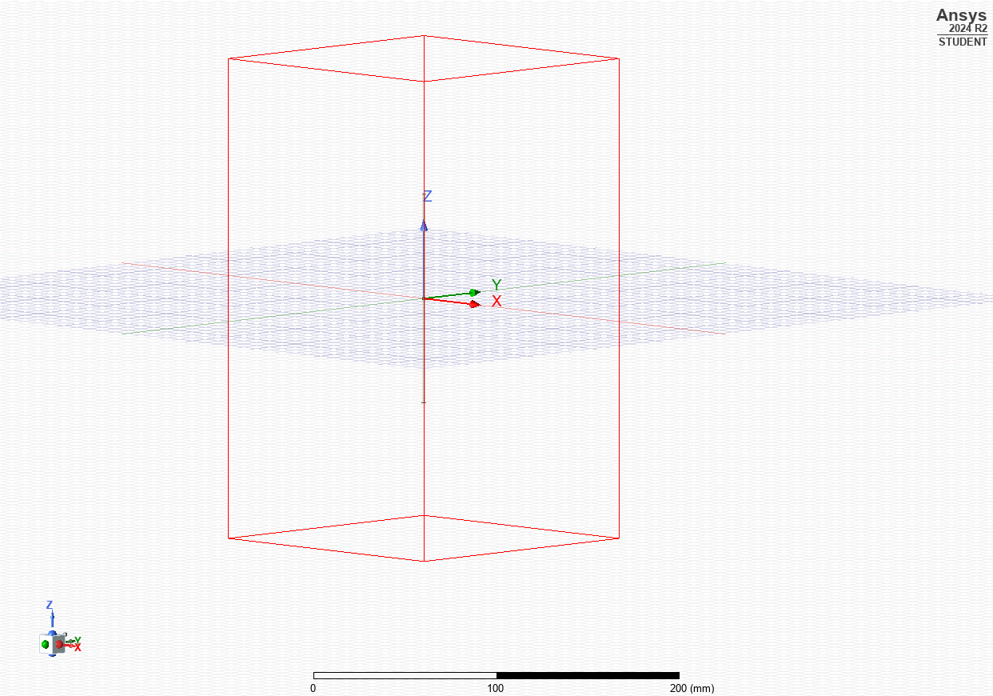
Figure 8: Simulated halfwave dipole antenna within a rectangular radiating surface.

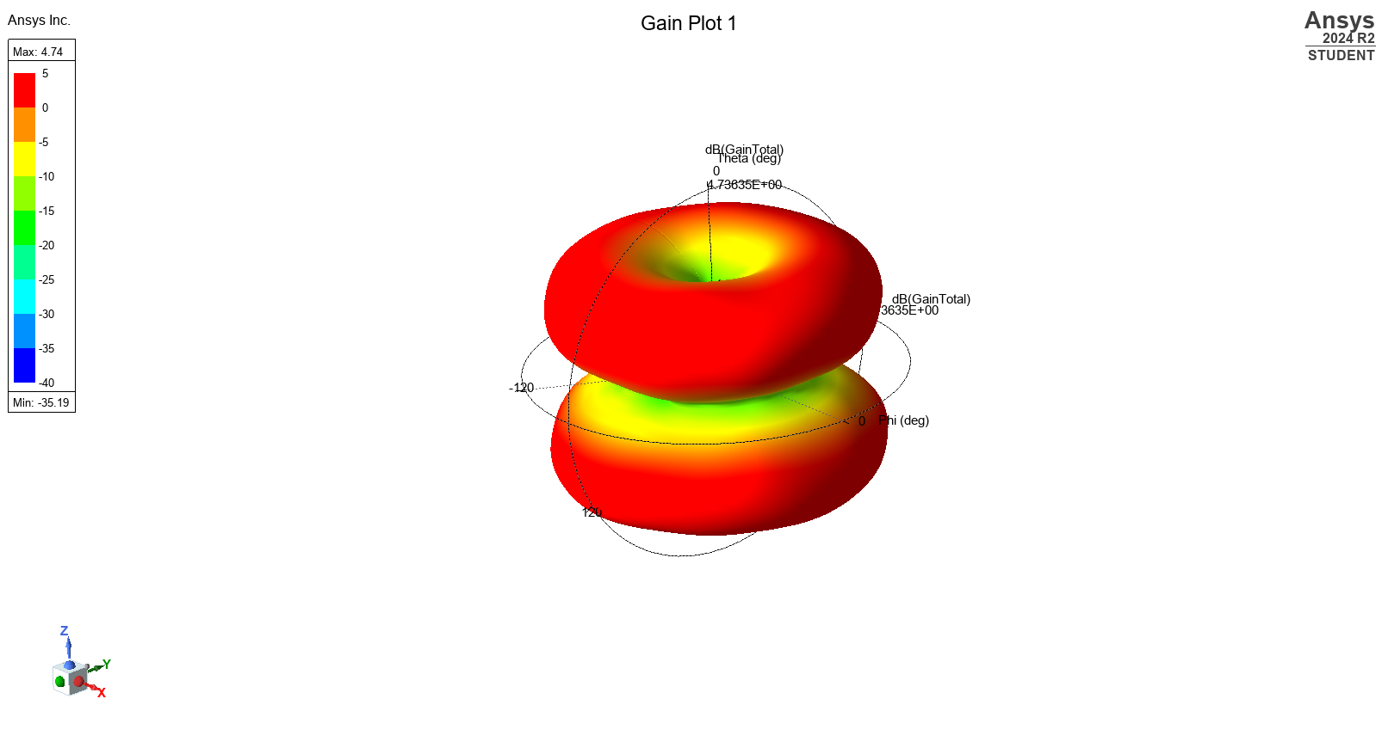
Figure 10: Radiation pattern for the simulated antenna
Figure 10 shows the radiation pattern for this experiment. The radiation pattern is a diagram which represents the radiated energy into a space. In this diagram, the pattern shows most radiation efficiency in red.

2.4 Results

To calculate the length a halfwave dipole antenna must be for a desired wavelength; there is a theoretical formula.
$$L=\frac{λ}{2} | \frac{231mm}{2}=115.5mm$$
The operating frequency, or resonant frequency of an antenna is calculated using the constant speed of light; which is 3x10⁸ m/s. The resonant frequency for this simulation is calculated using this equation:
$$f=\frac{c}{λ} | \frac{3×{10}^{8}}{231×{10}^{-3}}=1.299×{10}^{9}$$

The theoretically calculated resonant frequency can be proven by the result of an S-parameter plot of the simulated antenna.
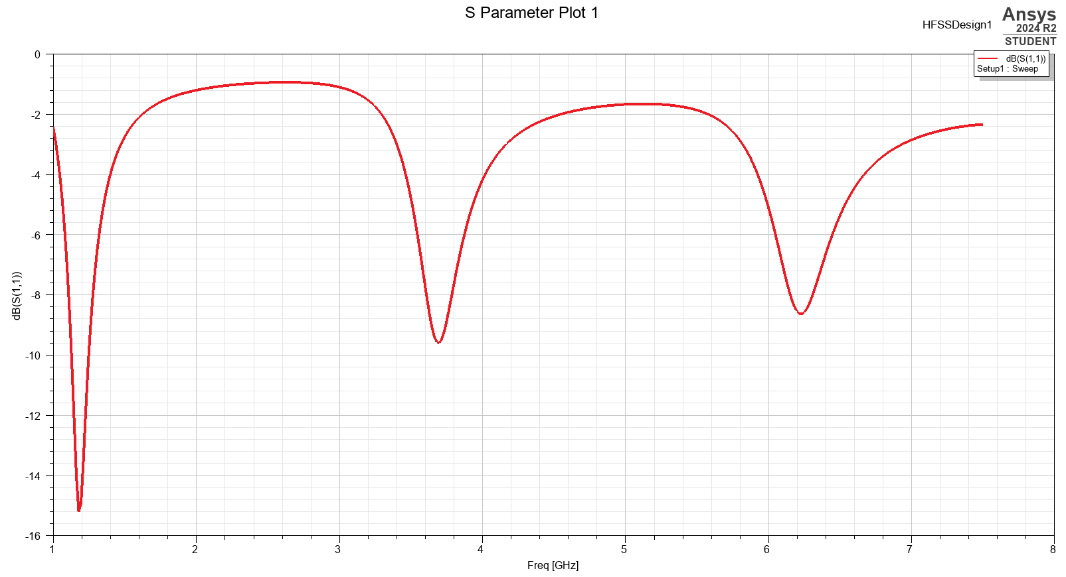
Figure 9: S-parameter plot of the simulated antenna
As shown in Figure 9, the lowest point on the plot sits at around 1.2GHz. This is the resonant frequency of the simulated halfwave dipole antenna.

2.5 Discussion
The generated S-parameter shows; the calculation from the theoretical formula of the resonant frequency was similar. The rounding in the equation could be a contributing factor to the misalignment, as well as the human error of judging the lowest point of the graph.

2.6 Conclusion
This experiment proves the relationship of simulation to theoretical findings, by similar result of the resonant frequency. Simulating the halfwave dipole antenna also allowed a visual representation of the radiating pattern of the antenna which allowed analysis of the radiation efficiency.

3. Task 3

3.1 Introduction
RADAR (Radio Detection and Ranging) is a system used to detect an objects velocity, angle and range. By radiating Electromagnetic waves into space and monitoring the return which is reflected from the object – it allows the position, distance, and speed to be mapped.
RADAR was developed for use in World War 2, to detect enemy aircraft by transmitting bursts of radio waves and measuring the time taken to receive and echo back. The technology is now used in many different fields – from tracking commercial air routes to keep them safe, to imaging of polar ice caps and deforestation, and detecting vehicles speed on highways.

3.2 Literature Review

As time continues, threats evolve. This puts pressure on RADAR technology to become adaptable and resilient to the new measures. Adversaries continue to develop sophisticated methods that disrupt RADAR, and techniques of evading by sending false echoes or interference are becoming increasingly complex. As the number of Unmanned Aircraft Systems (UAS) increase along with the complexity of the threat they pose, the current RADAR technologies become inadequate and call for improvement.

By using higher data rate samples in the radar system, a more detailed analysis is available for the received signals. In research from Microwave Project Digest (2021) [8], the exploration of ultra-high data rate sampling oscilloscopes was used for RADAR and Electronic Warfare signal analysis. The article highlights advancements in digital signal processing and how this improvement would progress RADAR ability to detect drones and UAS better. The growth in this area of the RADAR system allows more detailed information to be received faster allowing improved resolution, and faster updates which is especially needed when tracking fast and agile devices such as drones.

Another way of improving radar system is to implement use of Software Defined Radar. According to RF Wireless World, [9] this technology allows internal modules to be configure via software which reduces time and distance for maintenance. For the radar system to adapt to the ever-changing situation, instead of recalling and interfering with hardware; the software can be update to a new structure. The modules in the system which are software-configurable enable engineers to prototype, test and validate advance radar technology quickly and by using common hardware. This solution permits flexibility to unclear circumstances, and an adaptable platform of detection.

To expound on the importance of software in the improvement of radar systems, artificial intelligence and machine learning are introduced. Turner and Scholten [10] explore this idea in their 2019 article. Artificial intelligence is technology which solves tasks by incorporating human intelligence to problem solving algorithms. As it imitates the human brain, it has thought processes as well as rational agents which make it ideal to adapt to unexpected situation changes. Machine Learning is technology which generates techniques to solve problems using computer systems, through learning. Though similar, the terms are not interchangeable. Artificial intelligence relies on machine learning to operate. Machine learning will read problems that appear in the situation and techniques to overcome this, while artificial intelligence evaluates the most practicable approach. By using combination of the two technologies together, a constantly adapting and improving software filtration system will be created to optimise the radar system.

3.3 Discussion

Through this research, the underlying idea appears to be the reliance on software to take the next step toward to future of radar systems. However, this depends on the advancement of drone and UAS capability. The idea of innovation for radar in the research discussed relies on the evolution of the target’s operation; to learn from this and adapt to match the technology – rather than further it.

3.4 Conclusion

There is potential for the future of radar systems, though focus should be allocated to overtaking drone and UAS evolution. To be able to predict the next steps of the target’s progress would be the ultimate improvement to radar effectiveness.

4. References

- “Waveguide Basics: Types, Propagation Modes, Advantages & Disadvantages,” Rfwireless-world.com, 2025. https://www.rfwireless-world.com/tutorials/waveguide-basics/waveguide-basics#google_vignette (accessed Apr. 24, 2025).
- V. Muthukrishnan, “Cutoff Frequency: What is it? Equation & How To Find it | Electrical4U,” https://www.electrical4u.com/, Nov. 19, 2022. https://www.electrical4u.com/cutoff-frequency/
- “Waveguides | How it works, Application & Advantages,” Electricity - Magnetism, Oct. 26, 2023. https://www.electricity-magnetism.org/waveguides/
- Wikipedia Contributors, “Poynting vector,” Wikipedia, Oct. 08, 2024.
- R. Teja, “What is an Antenna? Different Different Types of Antennas & Characteristics of Antenna | Characteristics,” Electronics Hub, Mar. 04, 2019. https://www.electronicshub.org/types-of-antennas/
- ‌“(Half-Wavelength) Half-Wave Dipole Antenna,” www.antenna-theory.com. https://www.antenna-theory.com/antennas/halfwave.php
- “S-Parameters for Antennas (S11, S12, ...),” www.antenna-theory.com. https://www.antenna-theory.com/definitions/sparameters.php
- ‌B. Frieden et al., “Radar/EW Signal Analysis Using Ultra High Sample Rate Oscilloscopes,” Microwave Product Digest, May 24, 2021. https://www.mpdigest.com/2021/05/24/radar-ew-signal-analysis-using-ultra-high-sample-rate-oscilloscopes/ (accessed Apr. 24, 2025).
- “Software Defined Radar (SDR) Basics,” Rfwireless-world.com, 2025. https://www.rfwireless-world.com/terminology/radar-terms/software-defined-radar-basics (accessed Apr. 24, 2025).
- ‌D. M. T. and U. Scholten, “Machine Learning and Artificial Intelligence in Radar Technology,” www.skyradar.com, May 17, 2019. https://www.skyradar.com/blog/machine-learning-and-artifical-intelligence-in-radar-technology

