Geodemographic analysis using GIS software
Author: Dylan Thomas 2014801
Geographical Information System (ACCA5027)
School of Applied Computing
Wales Institute of Science and Art
25/05/23 Date of Submission

Abstract
This Assignment involves the gathering of data from multiple data sources, geographic and sociodemographic, to create a workspace to visually answer hypothesis I have for a specific topic. The chosen topic is Covid, the hypotheses will look at figures at a county, Swansea, MSOA and LSOA level for different granularity.

Table of Contents
Contents
1. Task 1 4
1.1 Introduction 4
1.2 Data Acquisition for Workspace 4
Tableau 4
InFuse 5
UK Data Service 6
Digi Map 7
1.3 Creation of Layers and Maps 8
Output Area Layers 8
Bing Aerial Map/OS Survey Map 10
Roads Map 10
1.4 Creation of Point Data 11
Finding of Point Data 11
Adding Point Data to Dataset 11
2. Task 2 13
2.1. Introduction 13
2.2 Discussion Topic 1 14
Deprived and Wealthy Areas 16
Anomalies/Discussion Points 16
2.4 Discussion Topic 2 17
2.5 Discussion Topic 3 20
2.5 Conclusion 23
3. References 24
3.1 Table of Figures 25

Task 1

Introduction
The requirement of Task 1 is to agree on a topic area of investigation for the second aspect of this Assignment, identify data sources and cleanse the subsequent data that will be utilised to prove/disprove individual hypothesis relating to the topic area. Having discussed multiple topics, we agreed to focus on Covid as the main topic of our investigations. The rationale behind this decision, covid had played a big factor in our lives over the previous 3 years, it effected the world as well as local regions, so this could provide some interesting visuals for Task 2 outputs.
The outputs will be a combination of sociodemographic and geographical data to provide location specific visuals, utilising the data that’s been collated within my Workspace.

Data Acquisition for Workspace
Having agreed on COVID as the topic of investigation, the next step was to seek data to create a workspace cleansed data to build a visual picture to aid discussion topics. When compiling the data, there are various sources that data can be acquired from.

Tableau
Tableau is a platform that’s used to create and share data visualisations. Tableau Public is utilised by the NHS, and it helped provide the Rapid Covid Surveillance data to the government for the daily Covid briefings during the peak of the pandemic. The data collected and made available covered multiple topics including vaccination rate, mortality, and Hospitalisations. As my case study is Swansea, I’ve extracted the data from the NHS Wales specific site. The datasets best suited to my requirements were the rapid surveillance data and Vaccination data. [1]

Figure – NHS Wales Vaccination Page
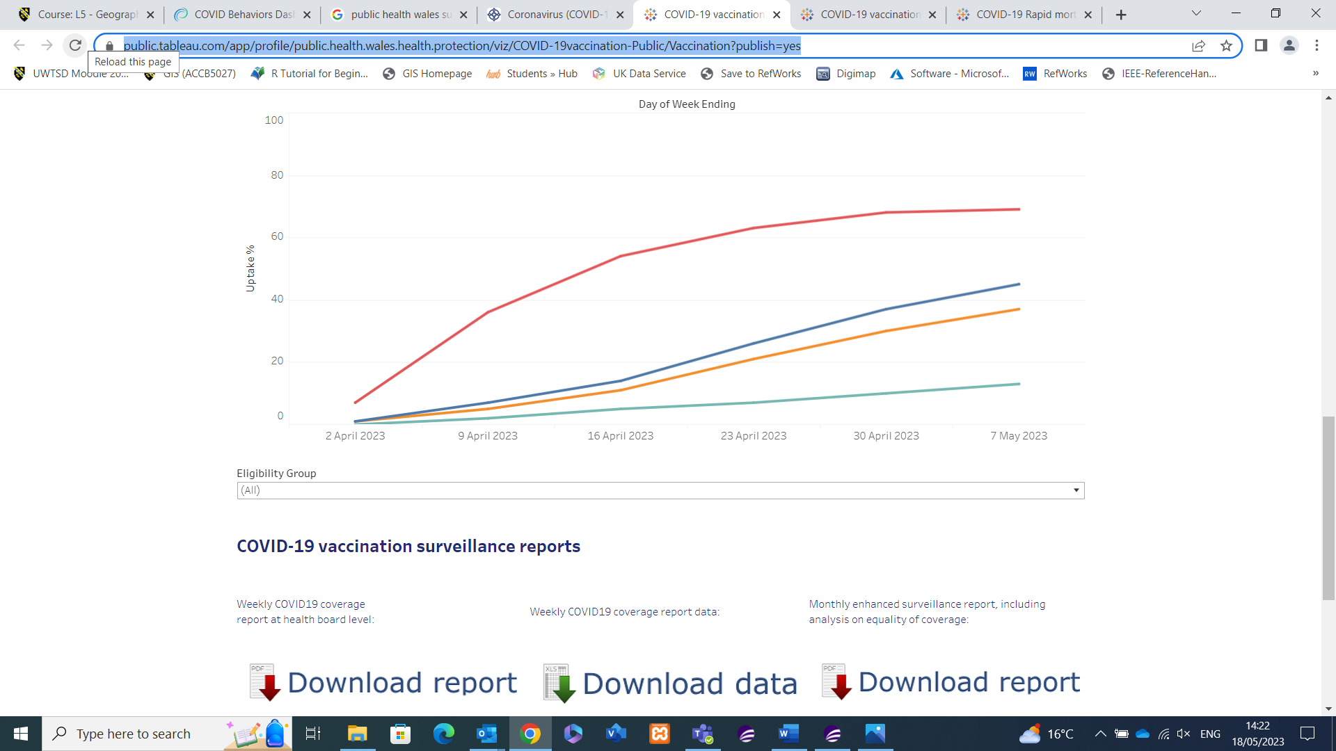
Having selected the applicable data option, I was able to access the NHS Dashboard which shows a variety of visuals, but it also allows the viewer to download the raw data for their own data visualisation purposes.

Figure – Rapid Covid Data File and Raw Data
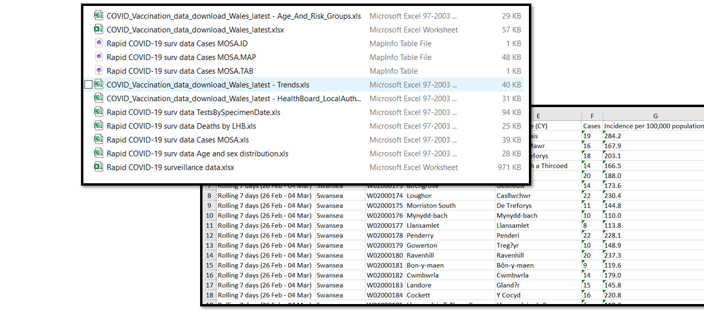
Having Downloaded the data, it can then be filed accordingly to be used within the MapInfo Workspace. The data will form the basis of multiple thematic views for my discussion points.

InFuse
InFuse provides end users with free access to aggregated UK census data which is accessible to everyone. Currently it provides access to the 2001 and 2011 Census data, it provides the option to select Geographical or topics data first. Whichever route is selected, the geographical data and topic data will need to be specified.
Using the geography route, this allows me to split the dataset geographically prior to selecting what data topics I want to investigate. As visible by below screenshot, it allows me to drill down even as far as Middle and Lower Output areas for the Swansea area. [2]

Figure – Infuse Geography Data selection.
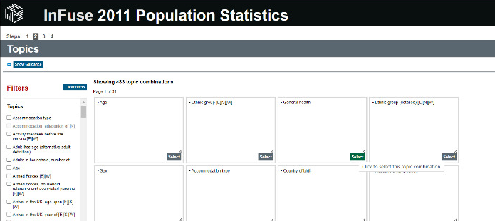
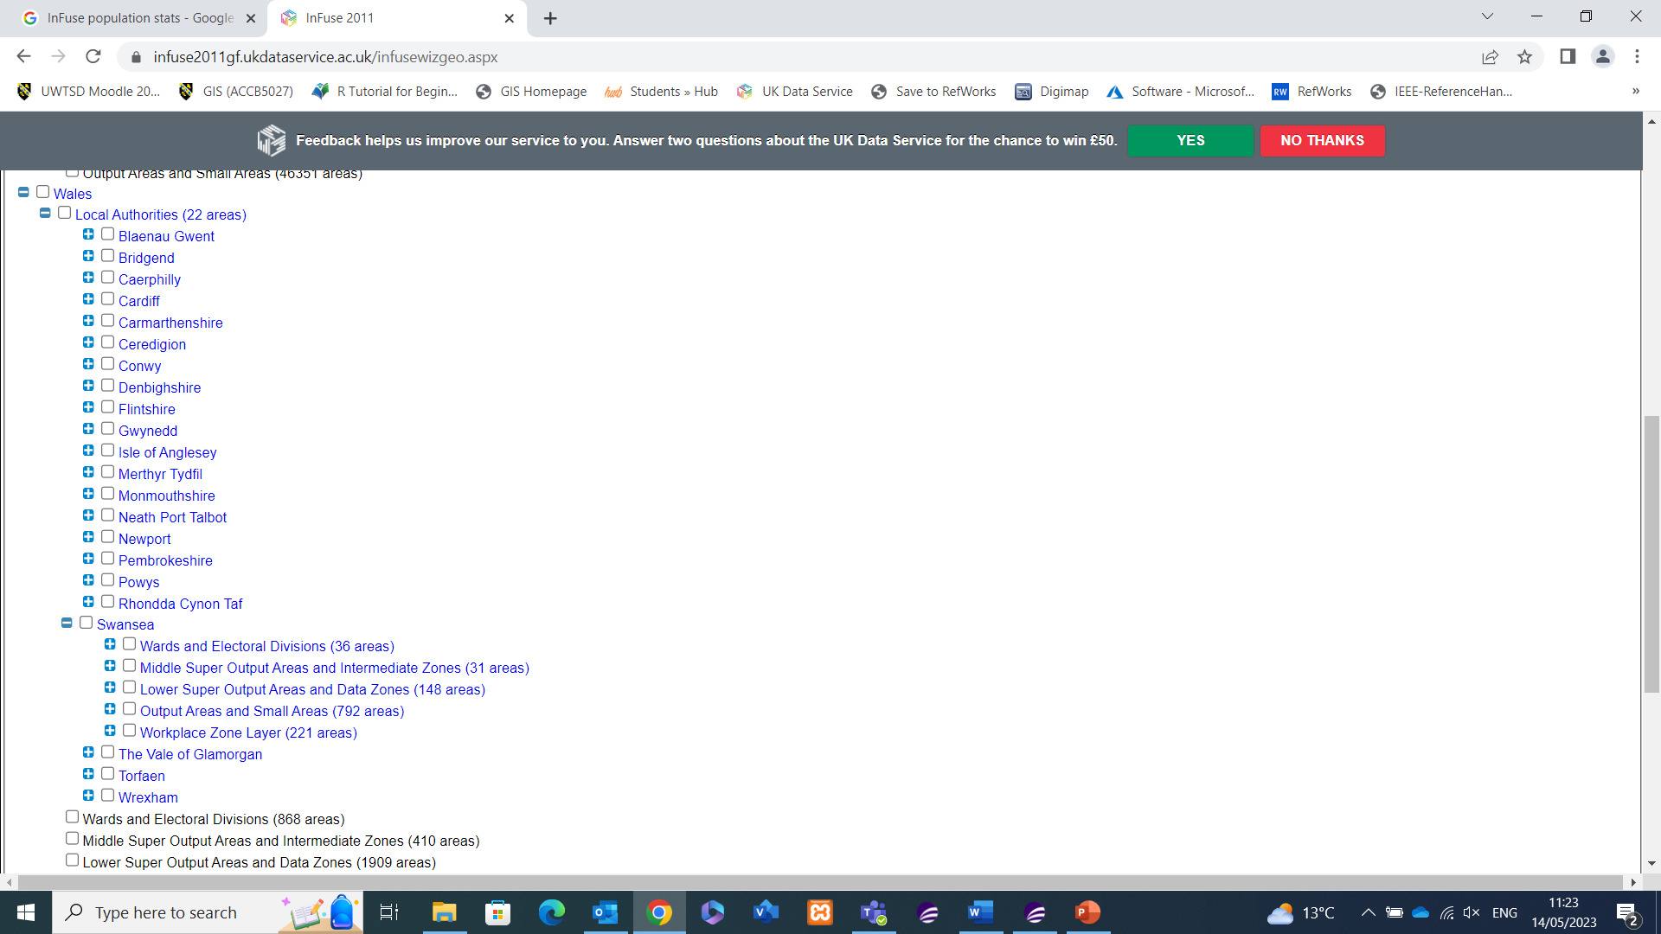
This has allowed me to select the location data prior to the topic data. I can now select topic data for my case study locations. For example, having selected the General Health option, then filtering which options I want I can then download the dataset.

Figure – Infuse Data within MapInfo
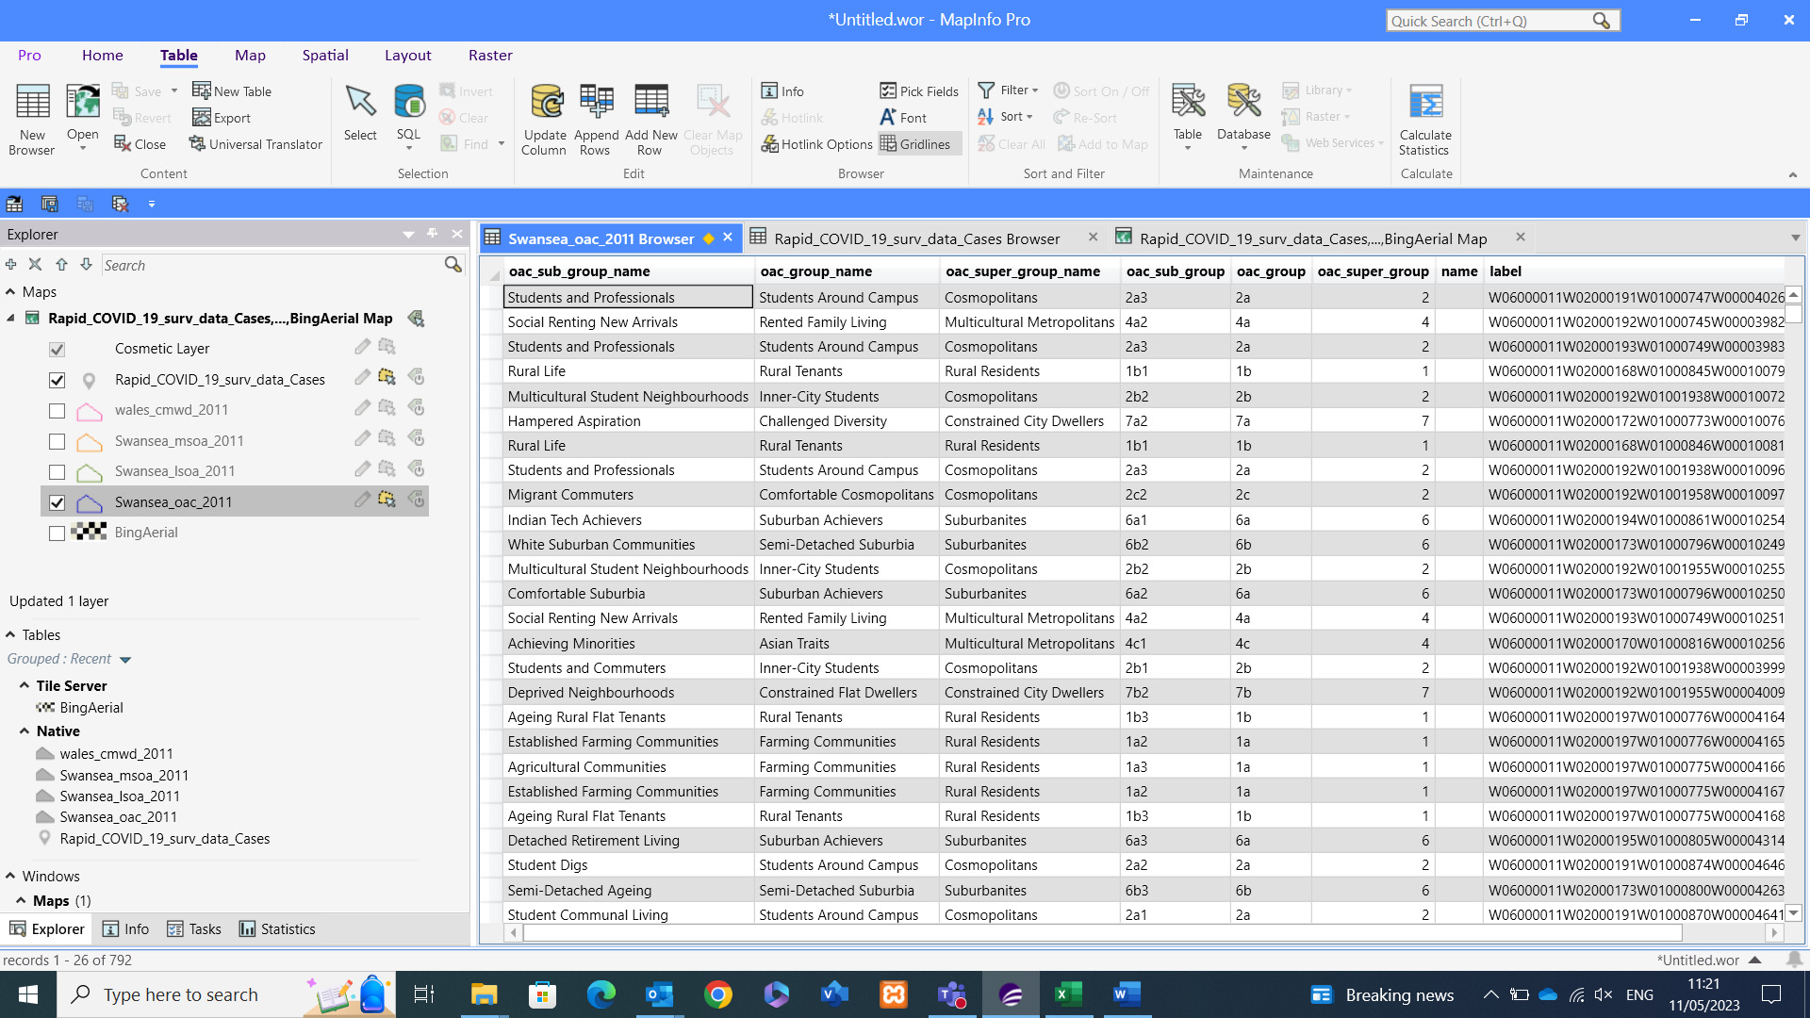
The above figure shows a socio demographic breakdown of the local population of all the LSOA and MSOA areas of Swansea. This data will allow me to compare covid findings to the population living in the area, for example an area with ageing rural population might support the suggestion that an area that experienced high mortality rate or high vaccination rates due to prioritisation of the elderly and vulnerable.

UK Data Service
UK Data Service is an online accessible database which requires a log in so that the user can obtain the data they are looking for. The service is predominantly used by those relating to educations, Students, teachers, and researchers, though it is accessible to the public if they so wish to register. The service provides a range of data, it breaks down the data by theme, type, teaching dataset, general and census specific.
Once the user reaches the data selector screen, they can break the data down further. For example, Geography data can be split by country, by date range, boundaries, and area of interest. [3]
Once the selection is made the data format needs selecting, and then the data is packaged and downloadable to the end user. MapInfo format selectable to transfer the data directly into the MapInfo software.

Figure – UK Data Service Boundary Data Selector
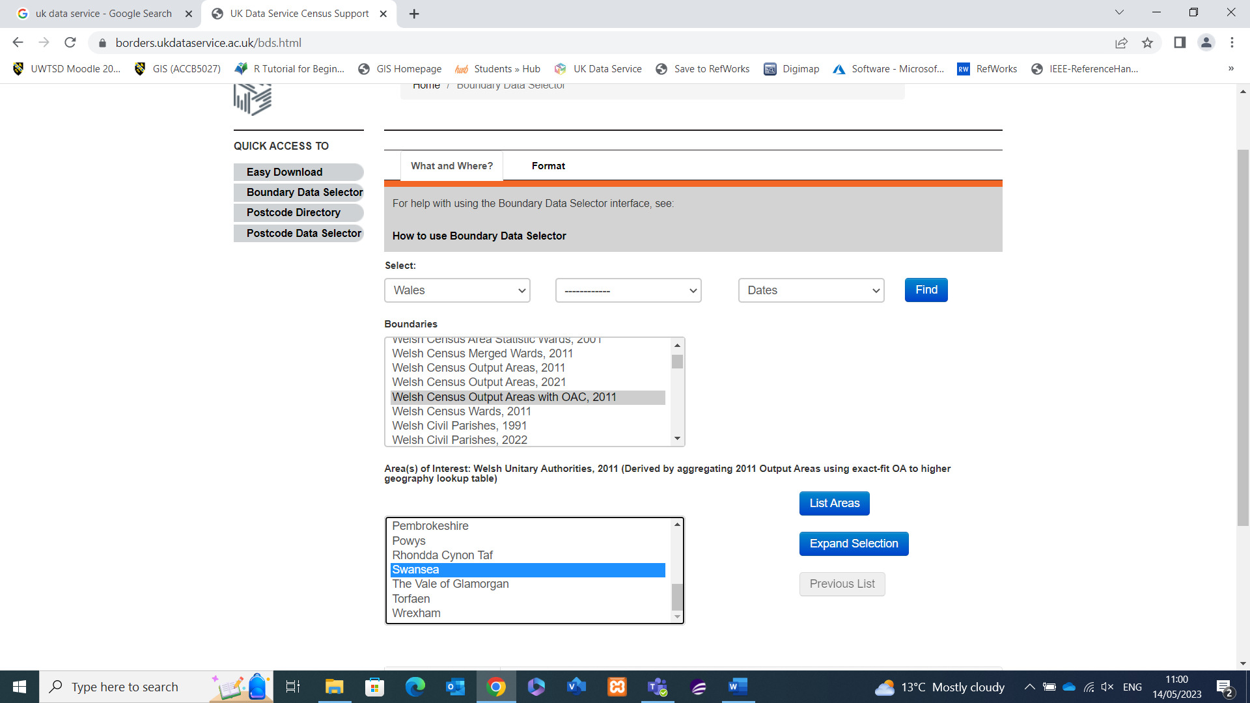
Once the data is downloaded, stored appropriately, it can be extracted into MapInfo. The below is an example of the Output Area data I have extracted to support conversations around Swansea’s performance comparable to other Counties within Wales, this dataset is fundamental to the geographical locations going forward.

Figure – Wales Output Areas dataset within MapInfo
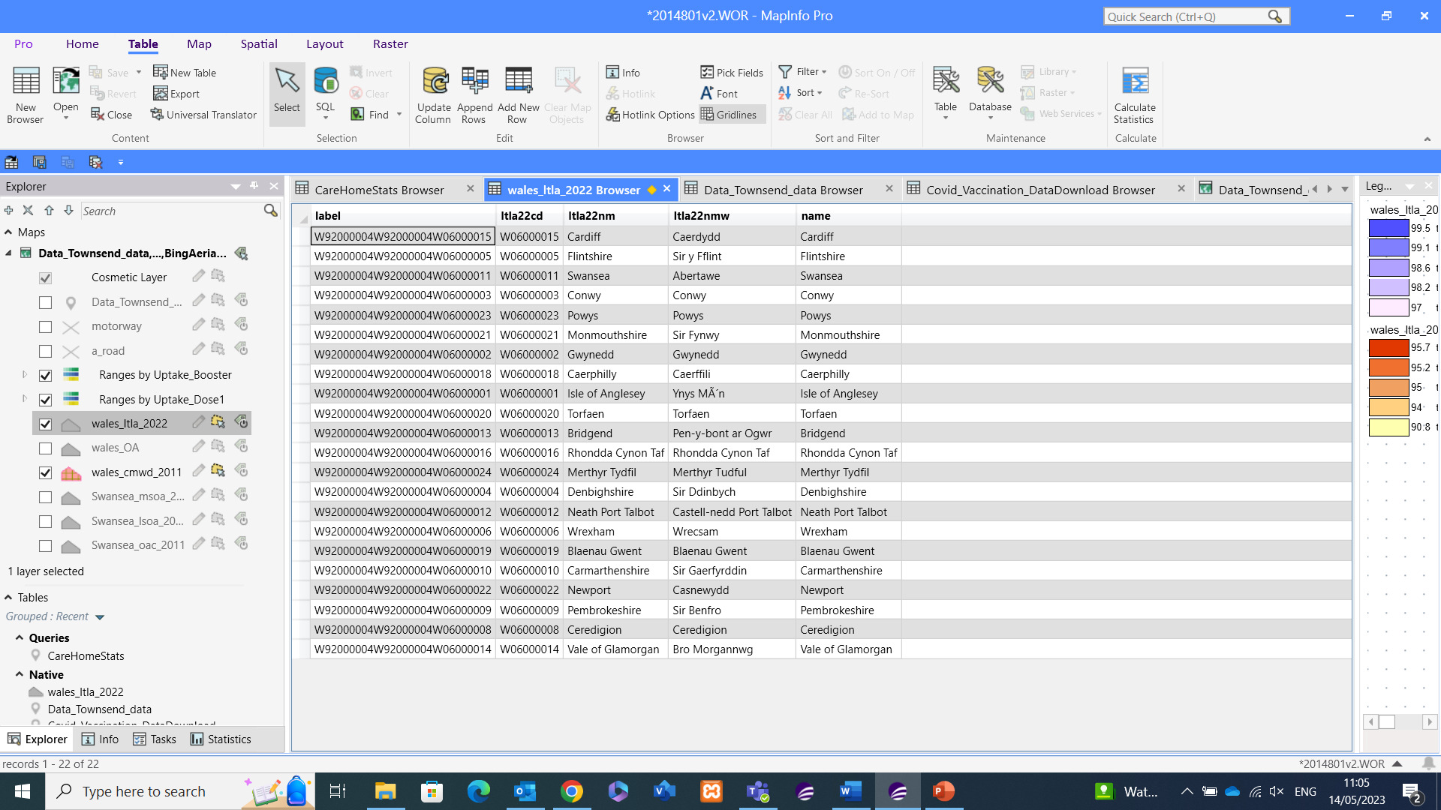

Digi Map
According to the website itself, Digi Map is “an online map and data delivery service, available by subscription to UK Higher and Further Education establishments.” [4]
Unlike the other data sources, Digi Map is only accessible via a log in that is only available to those individuals in Further education establishments. The suite of data provided by the platform is vast, it ranges from Ordnance Survey right through to Geology and Marine Data. The Ordnance Survey data is useful to create a detailed view of the case study location topography including road networks, rivers etc.
Figure – Selection of Data within DigiMap
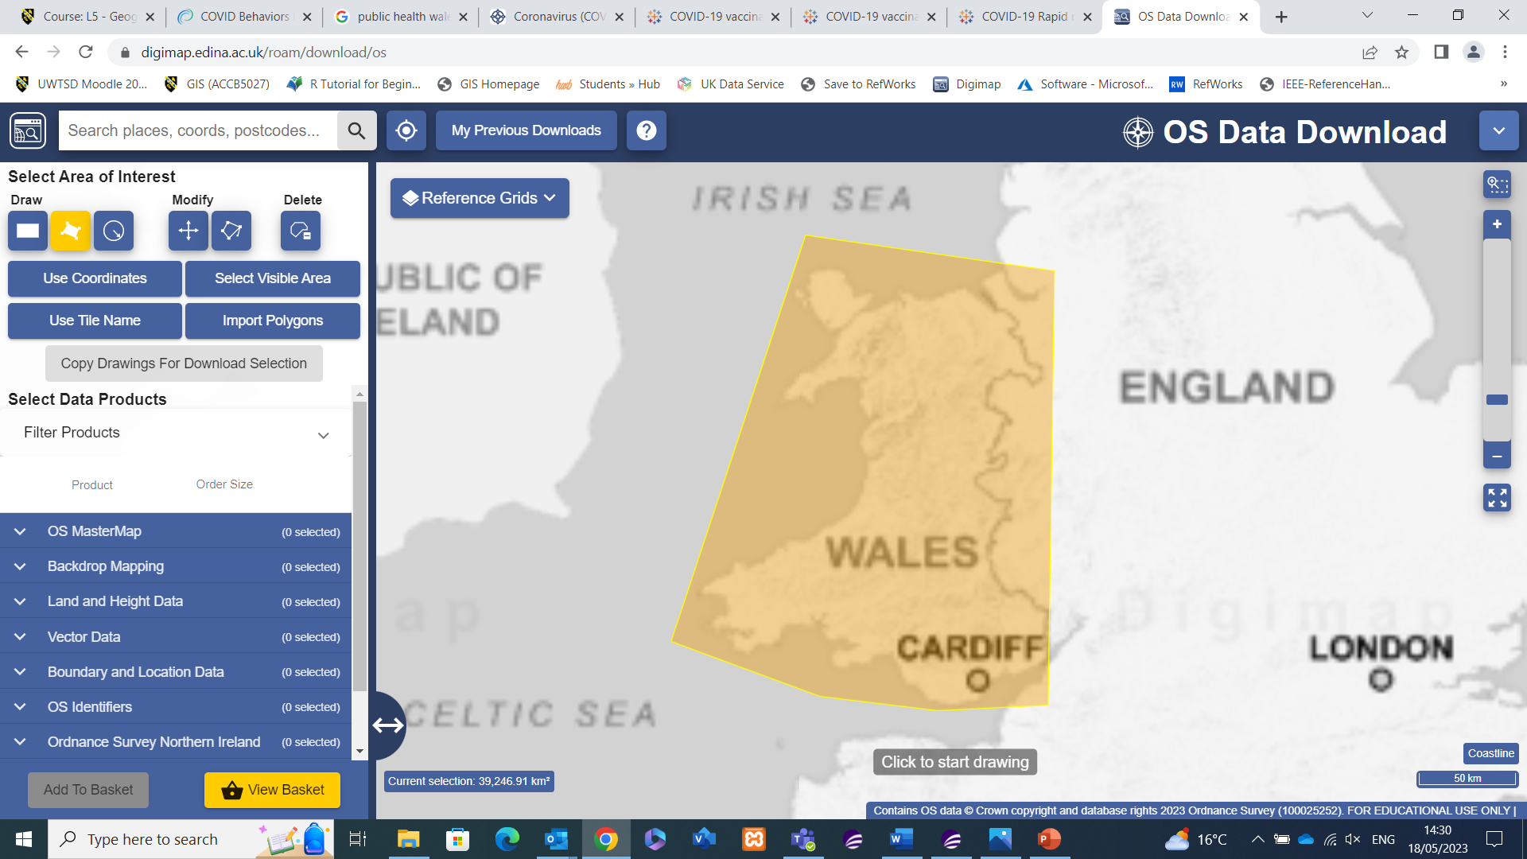
Having accessed DigiMap I am able to draw the area I require, along with selecting the strategi option to specify the type of OS visualisation I want. This will download all the attributes for the OS Map as can be seen in the next visual.

Figure – Complete Strategi OS Map
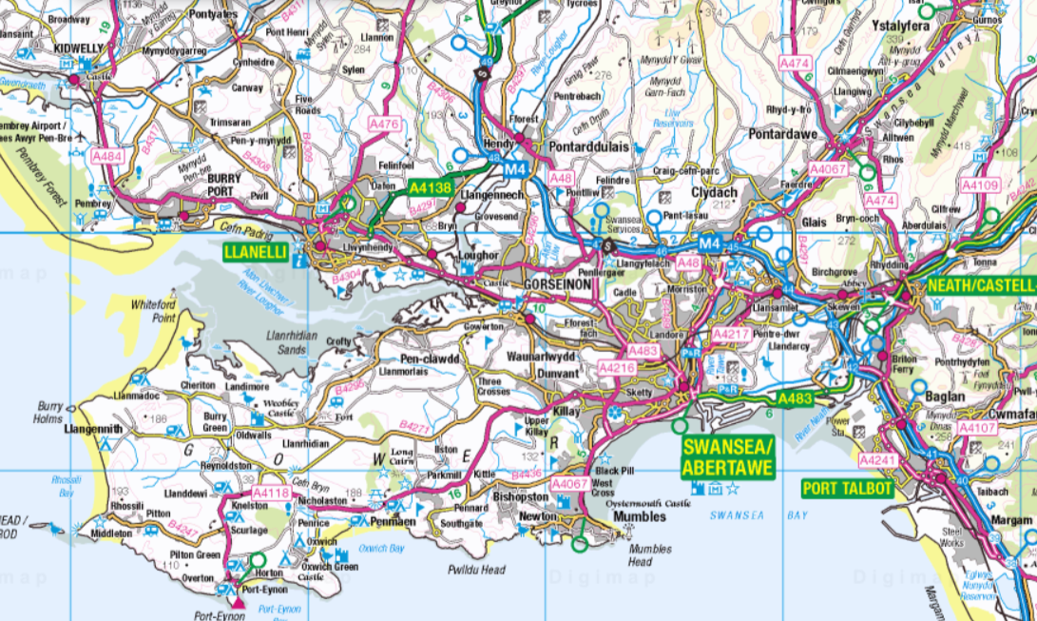
This is how my MapInfo visual would look if I opened all the strategi options, however for the purposes of keeping the workspace clutter free I’ve chose the Motorway, A road, main road, and local road options.

Creation of Layers and Maps
Within the Workspace there are multiple layers of data collated. It’s unlikely that all the tables will be required for each visual creation, however having a range of data relating to the case study saved to the workspace broadens the scope of discussion topics. Similarly, the data lingering in the background can be used to create multiple views, as will be shown by the various output layers.

Output Area Layers
Most of the base maps will be geographical and breaking an area into smaller segments. This data is gathered from the UK Data Service, to begin with I have the breakdown of Wales into its different Counties, this will allow me to compare Swansea with the rest of Wales initial discussions.

Figure - Welsh Local Authorities © Crown Boundary Data Wales
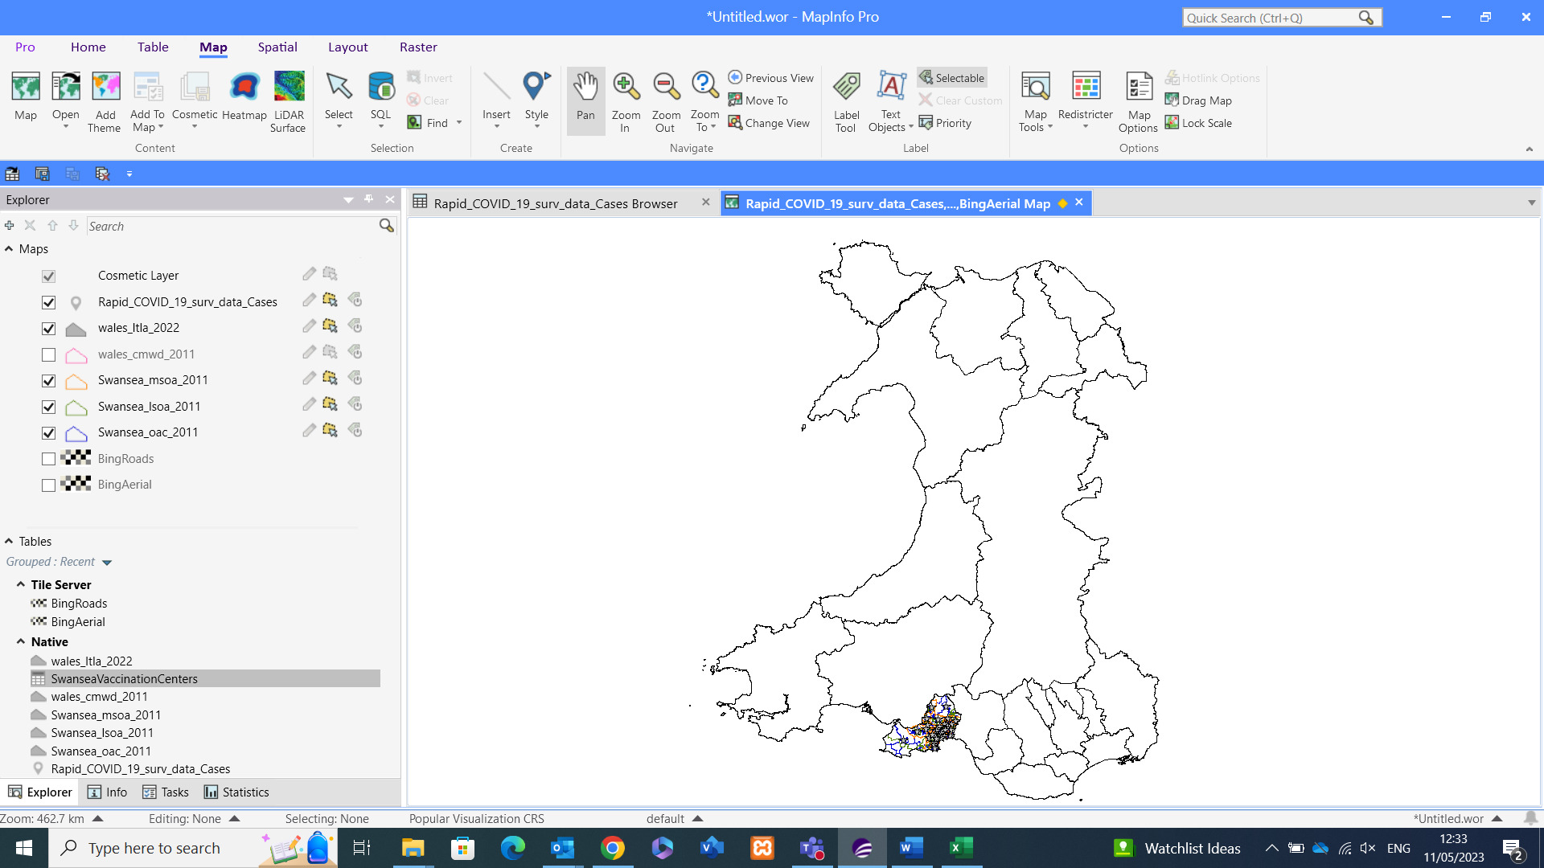
Having downloaded the Wales ward data, I can now look to break down the case study area of Swansea into smaller sections to break the figures down into further granularity.
The breakdown of a country into its counties is well known to the public from basic maps and geography within education. However, the county/wards within a country can be broken down further, which is known as output areas.
From all Wales view above, we can focus on Swansea as our case study area by Middle Layer Super Output Area (MSOA), which is made up of grouping of Lower Super Output Areas. These groupings are used by the ONS when gathering census data to drill down into differences within specific areas, as all areas will have an affluent and poorer spaces which can be comparable for a variety of reasons.
The MSOA view breaks Swansea down into smaller sections, and according to the NHS Data Dictionary MSOA’s typically have a “minimum population of 5,000 and the mean is 7,200” [5] and LSOA’s “typically contain from four to six Output Areas. The Minimum population is 1000 and the mean is 1500” [6]
The LSOA classifications for England and Wales differ to some of the other countries within the UK, focussing on Wales specifically there is usually a 1:1 relationship between a postcode and LSOA code.

Figure – MSOA Layer Data and Visual © Crown Boundary Data MSOA Swansea
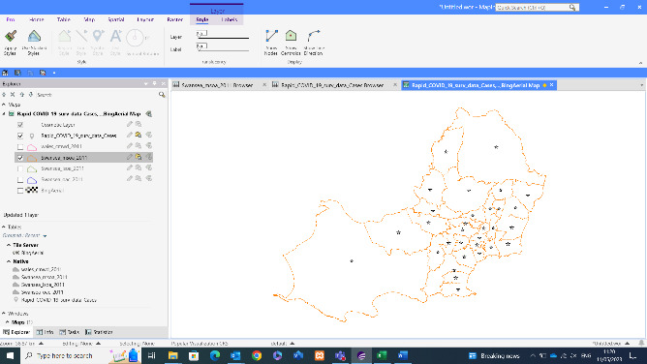
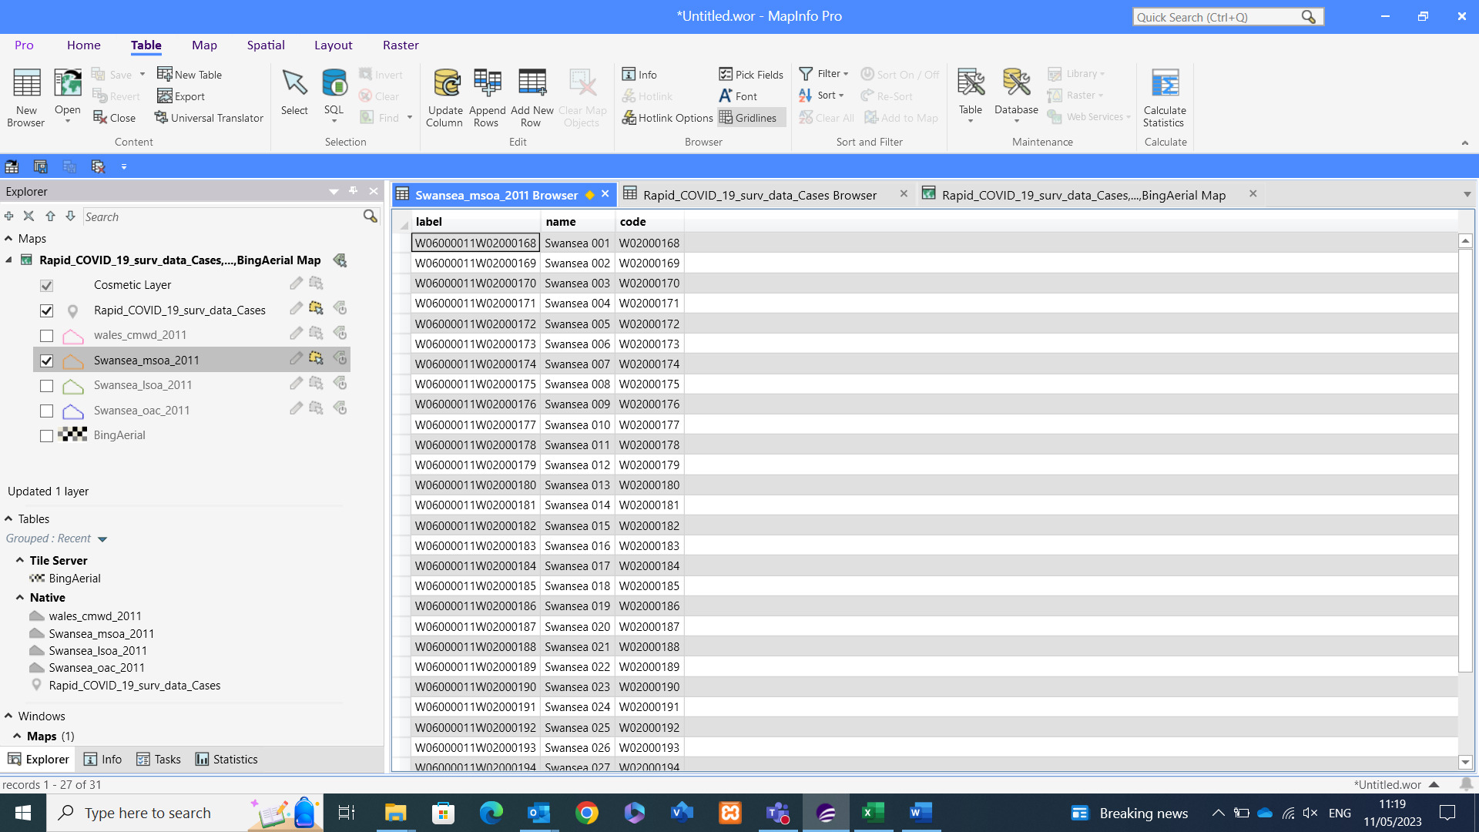
Comparing the MSOA to LSOA visuals it is easy to see especially for the Mumbles area of Swansea on the far West covers a vast area due to the lower population density, and even at LSOA the area is only split in two due to the lower population figures compared to the more central built-up areas to the Southeast.

Figure – LSOA Layer Data and Visual © Crown Boundary Data LSOA Swansea
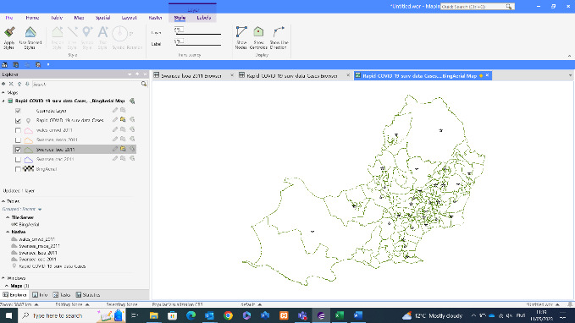
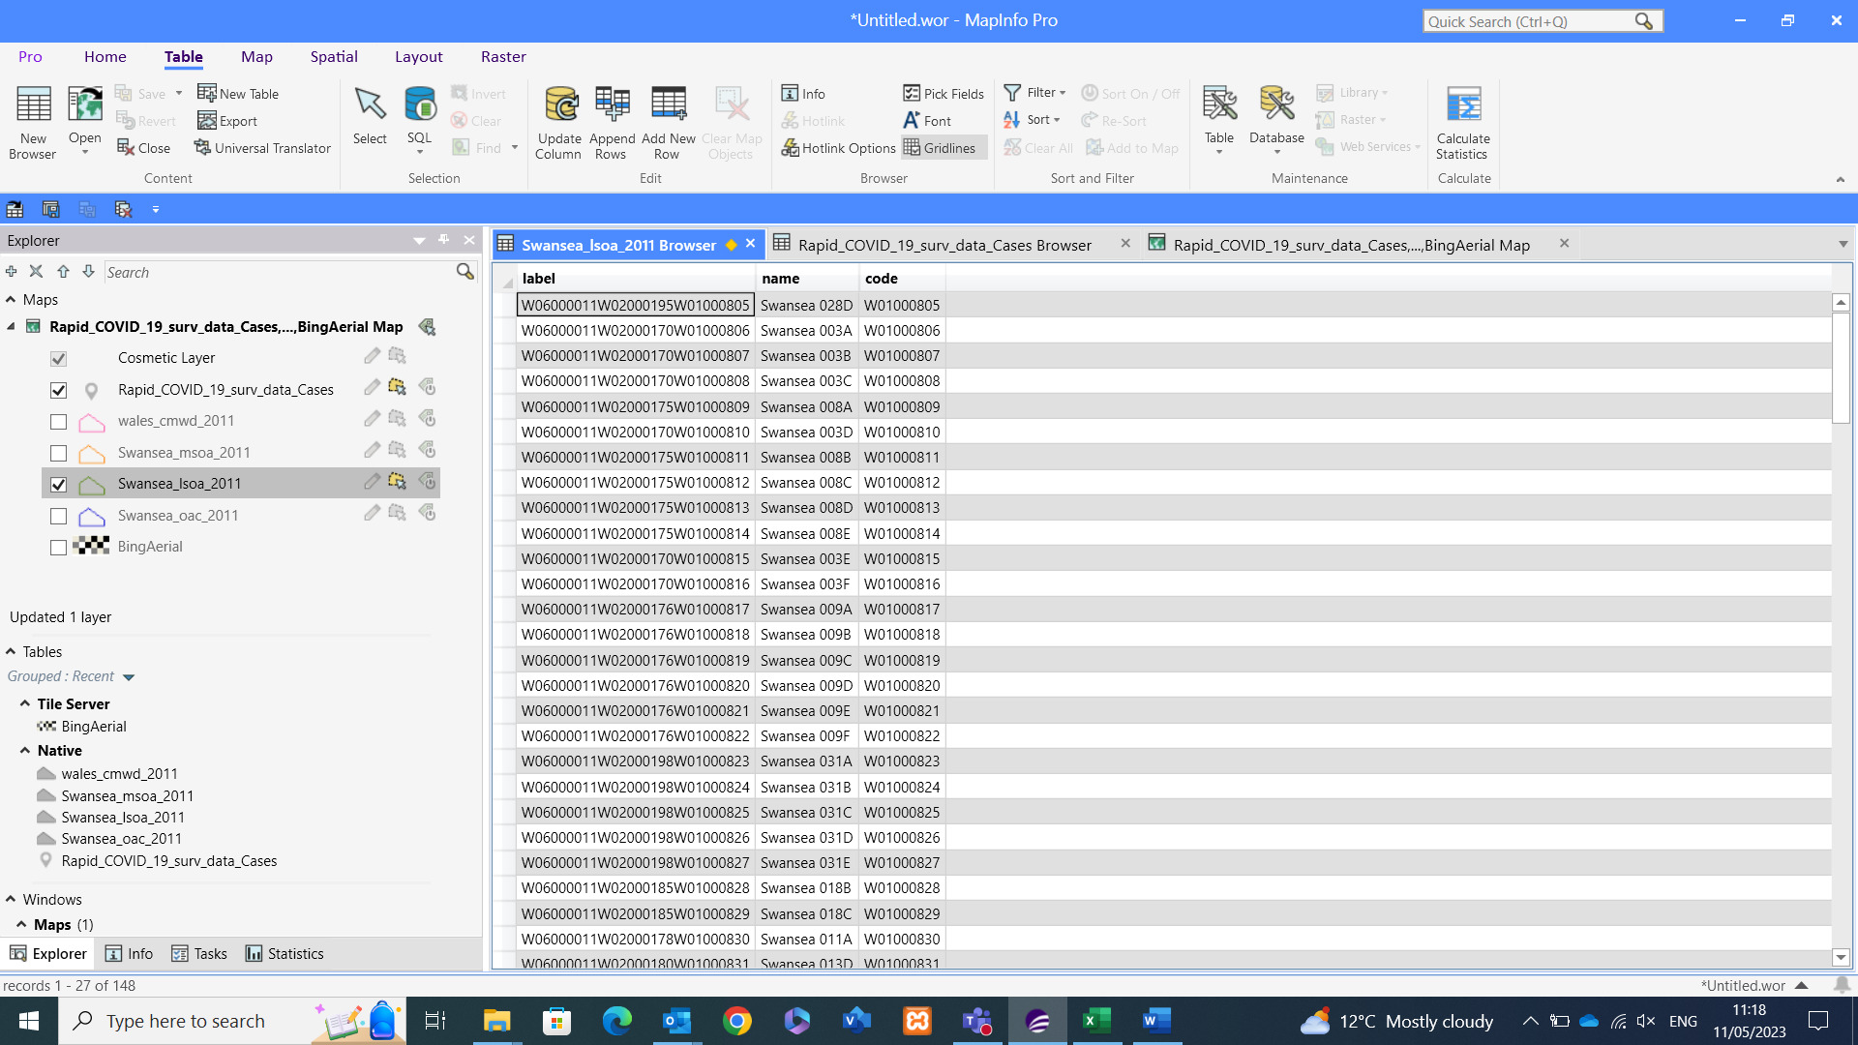
The LSOA map above can be broken down further into Output areas, which according to the NHS Data Dictionary are “built from clusters of adjacent unit POSTCODES in the United Kingdom” [7].
The Output area data is used by the ONS as the Base unit for Census data, which is then built up into LSOA, MSOA and Ward data. Like the other breakdowns, there is a visual difference between the levels, however the output area itself might be too granular a level for the visuals as even without colour and socio-demographic data added it is difficult to read visually.

Figure – Output Area Swansea © Crown Boundary Data Output Area Swansea
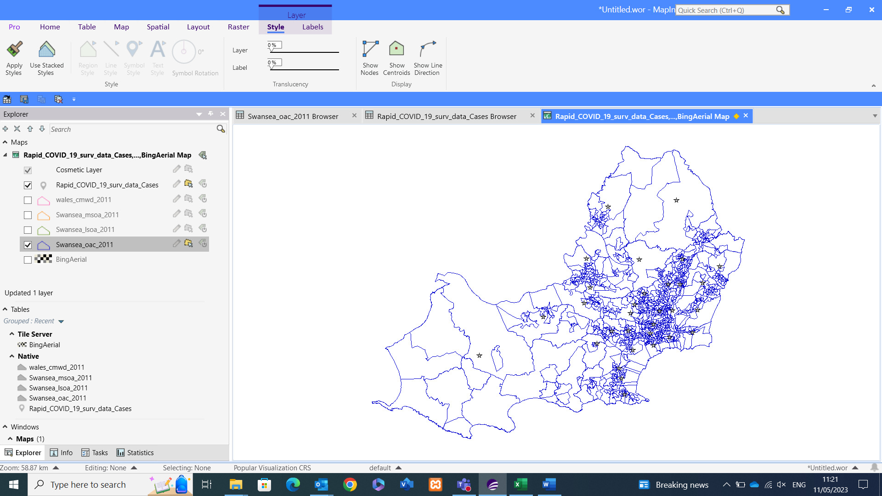

Bing Aerial Map/OS Survey Map
The Bing aerial map is like a google earth view of the world and provides a base map to add further background to the geographical data added from other sources. It was useful in testing the spatial data I added for the various output areas to confirm the data added was in the correct location. Had my Swansea data been showing over an alternative area I’d know to revisit and troubleshoot the data.

Figure – Swansea Output Area data overlapping Bing Aerial © Crown Bing Aerial Map Info Swansea
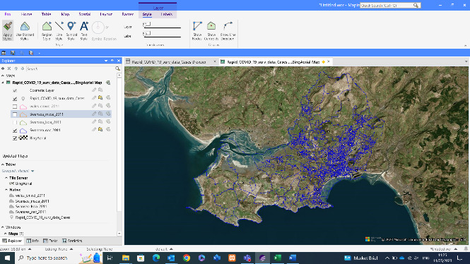
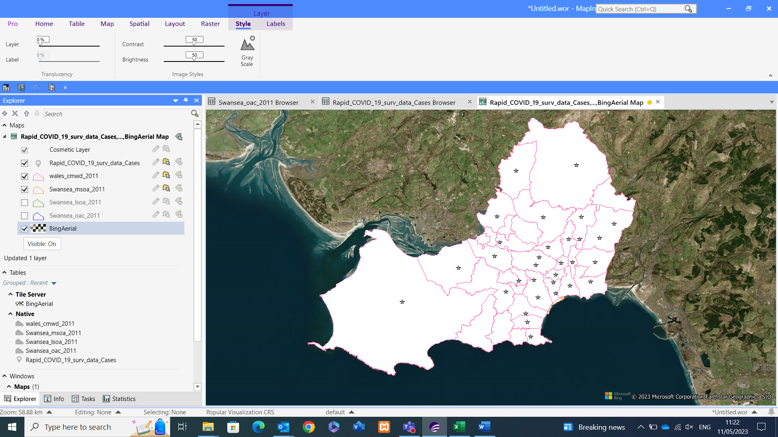
Another geographical view I can import is the OS Map data, which provides an Ordnance Survey Map view of the locational data. The OS Map will lend itself better towards one of my discussion topics around Accessibility alongside vaccination centre locations.
The figure for the OS Map view can be seen within the previous Digi Map specific section.

Roads Map
Within MapInfo there is a Roads Base Map that can be added to the suite of maps within the workspace. This base map will provide valuable information around accessibility which is a topic I can explore within the next section of the assignment. Alongside this, further detailed road mappings can be downloaded via UK Data Service to provide specific data around Motorways, A roads etc.
Below are visual representations of the road layers within my workspace. One showing the base map itself, the other is an example of the roads data taken from UK Data Service to provide the roads data without the need for a background map. The thicker darker line depicts the Motorways, whereas the thinner lighter line depicts the various A roads of the highways network. In addition to this, there’s also data provided on minor roads and primary roads.

Figure – Bing Roads compared to UK Data Service Motorway + A Roads Map © Crown Map Info Wales
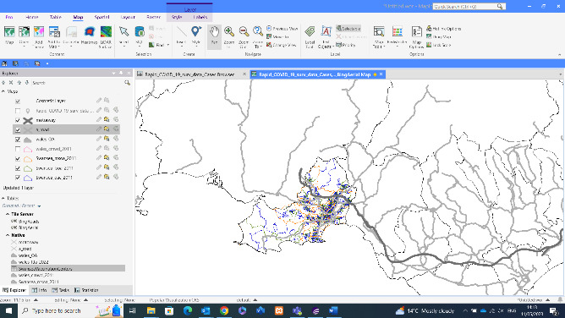
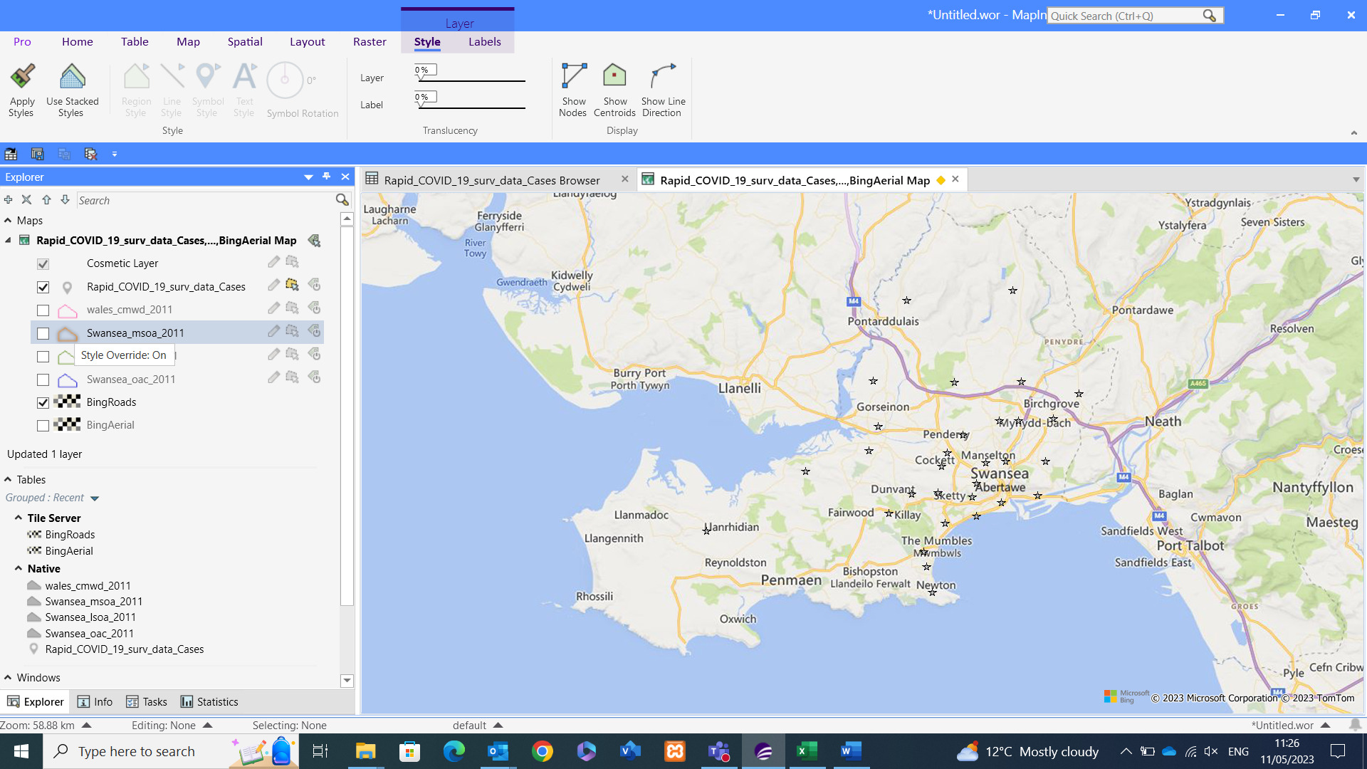

Creation of Point Data
According to GIS Lounge, point data is “used to represent nonadjacent features and to represent discrete data points.” [8] Usually, point data relates to an object/area which has zero dimensions. Example of this are schools, or even a point to identify a city on a map, as seen by a simple google maps search.

Finding of Point Data
The topic of covid data for this assignment has also sprung up point data I need to collate for my discussion topics, and that is the Vaccination centres that were created during the pandemic to facilitate the mass roll out of vaccines to combat the rising cases and deaths of Covid-19.
Finding the locations of these vaccination centres is proving difficult, as since the lockdowns of 2020 and 2021 most of these centres have since disbanded as they were temporary centres erected to get more vaccines out to the population. According to Swansea Bay University Health board [9], the only locations that currently provide a covid vaccine to the Swansea NPT area are Gorseinon Centre and the Aberfan shopping centre in Port Talbot.
However, having spoken with other students who were based in Swansea during the pandemic, I’ve managed to collate the details of multiple pop-up vaccination centres that were in operation during the height of the pandemic. Having been given the names of the centres I’ve used google to search the locations, and then collate the postcode, longitude, and latitude, collated this data within an excel document to create the required point data within MapInfo.

Adding Point Data to Dataset
Having collated the vaccination centre point data, I was then able to add this data to MapInfo and begin creating the point data to aid with my discussion topics. The below figure shows accessing the Point data tool and amending the extraction to the relevant vaccination centre table, along with the Latitude and Longitude data to create the visual.

Figure – Creation of Point Data
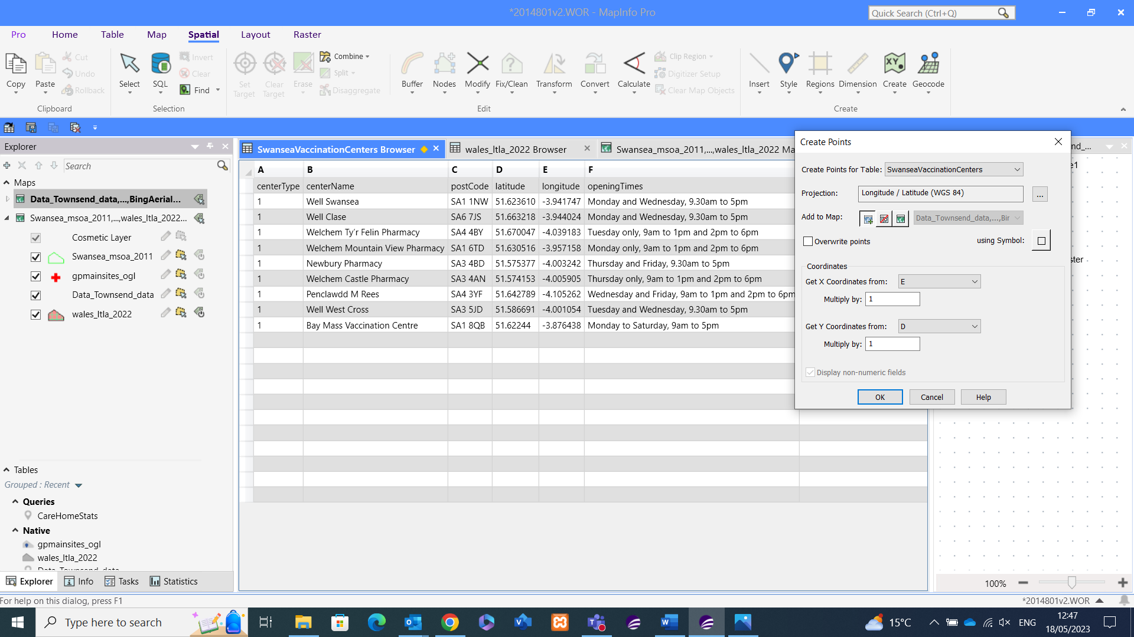
Having added the data to the browser I’m now able to use the point data within the views I’m creating. The below shows the MSOA boundary of Swansea, and the blue Diamonds show the locations of the Vaccination Centres within the area.

Figure – Vaccination Point Centre Visual © Crown Boundary Data MSOA Swansea
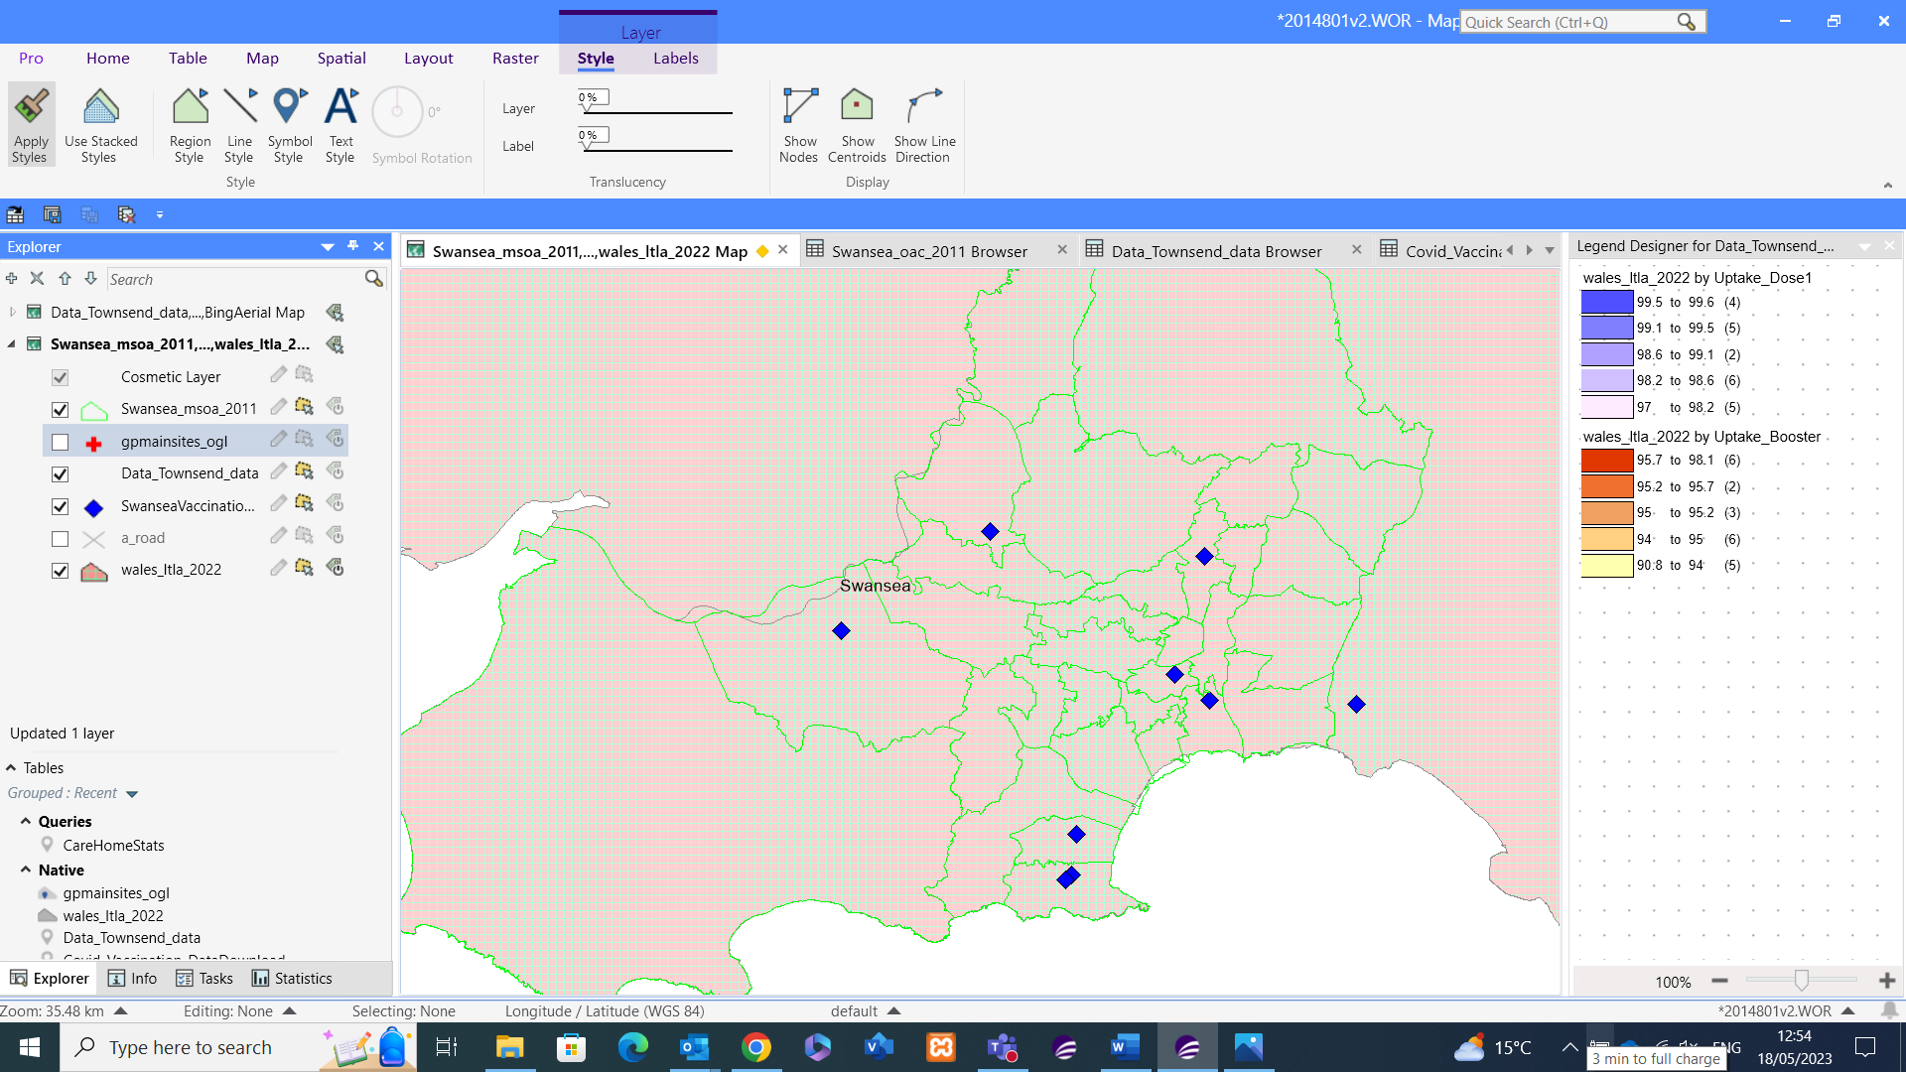
The above process I then repeated in my workspace to provide the visual locations of local GP’s for the Swansea and wider area to aid the accessibility discussion points.

Task 2

2.1. Introduction
The Covid-19 pandemic caused chaos for a couple of years, putting everyone’s life on pause and death of loved ones. This affected the overall mortality rate of the world, not just Wales or my case study area specifically. Having taken Data from Worldometers [10], I’ve been able to create the below tables to show how the UK compared in total cases, total deaths, and total deaths per 1M of the population.
As can be seen, the UK was 6th overall in the UK for total cases by country, it then ranks as the 4th highest when it comes to Deaths per 1,000,000 of the population due to Covid. Although it looks damning for the UK, it must be remembered that during the pandemic many countries didn’t report on COVID figures with such accuracy as the UK did. There are other factors that come into play like climate, average age expectancy, standard of healthcare and more. I will look to investigate some of these variables in the discussion topics to follow.

Figure – Top 10 Covid-19 Raw Data with accompanying Visuals
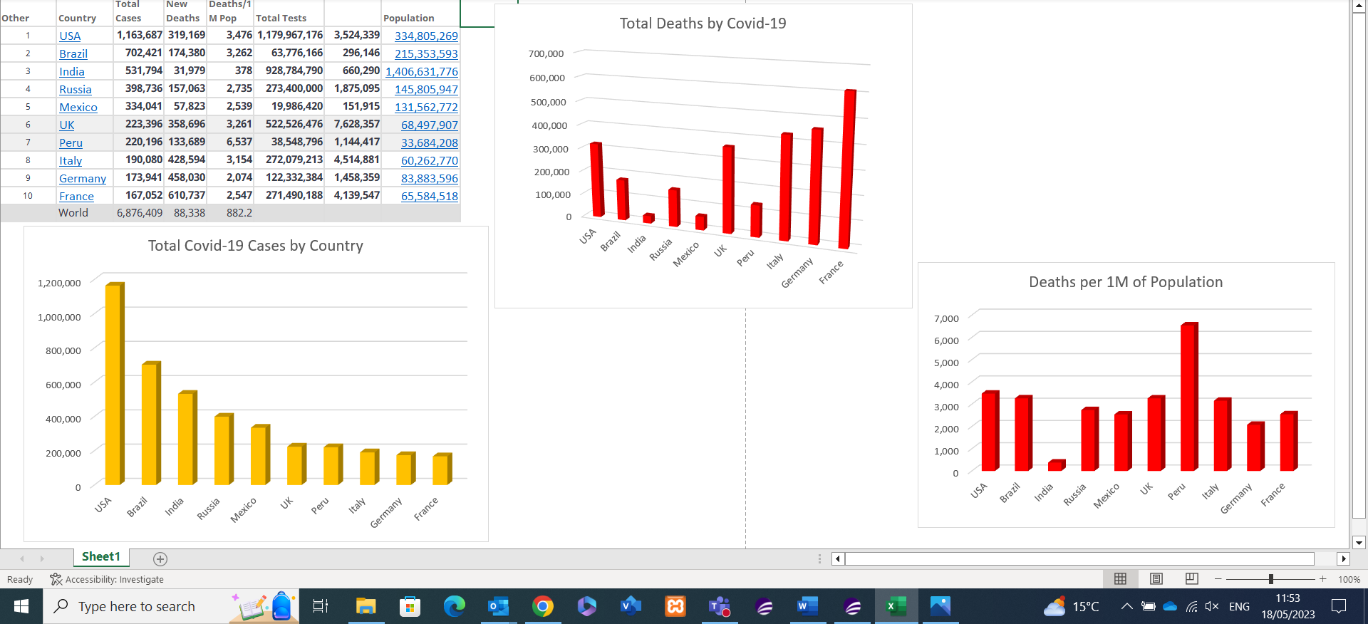

Figure – Total Cumulative deaths due to Covid © Crown Boundary Data Wales
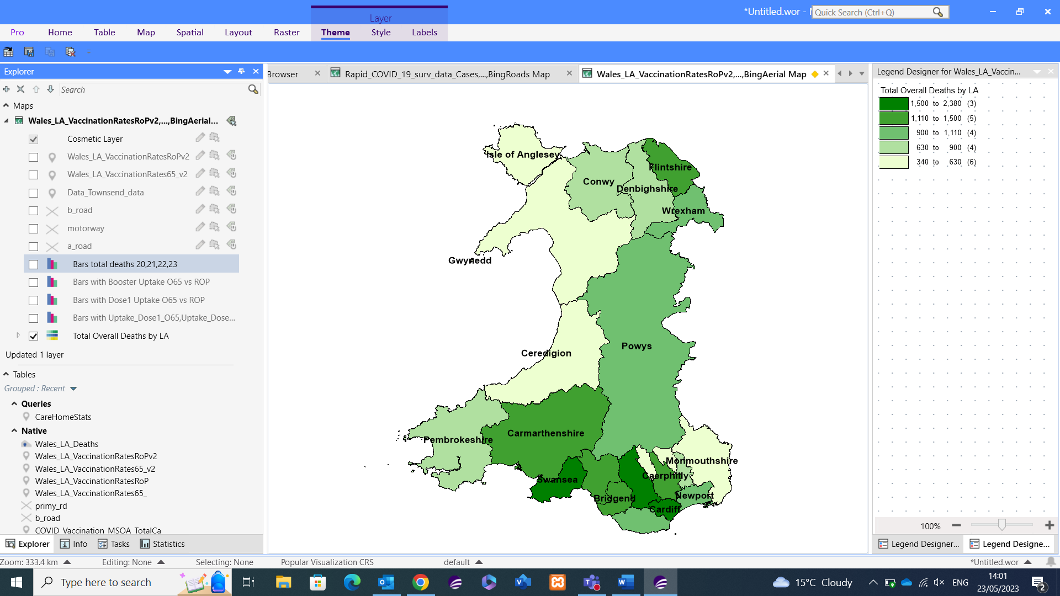
Prior to looking into the vaccination uptake against various socio-demographic factors, I thought it would be sensible to highlight the total deaths due to covid within Wales, using the cumulative total since 2020. Swansea is in fact the 3rd worst authority in Wales for total covid deaths with 1,927 and Rhondda Cynon Taff sitting at the top with 2,374 with a handful more deaths than Cardiff. Given Swansea is among the worst in Wales for total deaths, granted the total per 100,000 of the population may take away the dense population factor, it’ll be interesting to see how the vaccination rates compare.

2.2 Discussion Topic 1
The first hypothesis I will look to prove is that there is a link between poverty and high case areas. For this Hypothesis I will again utilise the GP and Vaccination centre point data, and add other socio-demographic data variables, one of which being the Townsend index which is a well-known measure of Poverty. Again, I will look to break down the Swansea Area into the MSOA level to compare the total case rates, and the case rates per 1,000 of the population to ensure a fair comparison against population density that the total case figures don’t take into consideration.
According to Local Government Associations report into deprivation, poverty, and Covid-19, “Deprivation underpins almost all inequalities.” [11] This statement not only indicates that poverty is a great indicator for this hypothesis, but also sociodemographic comparisons in general. It is a valid statement as the lower income received, the less disposable income, the decisions needing to be made between purchasing food and health care. And this was supported by data gathered by the ONS, they found that “people who live in the most deprived areas of England and Wales are around twice as likely to die after contracting COVID-19.” [12]
Income not being the only factor, standard of education levels tends to be lower in deprived areas, which is another indicator as areas with lower education levels tend to have lower immunisation rates and higher deaths.
Another key factor in the Midlands in particular, and other densely populated areas was religion, some minorities were slow in taking up the vaccines due to religious beliefs, and this had an adverse effect on immunisation rates and Morality. This point is supported by the NHS paper into Vaccination, which states “Vaccine hesitancy is highest for Black people, followed by Bangladeshi/Pakistani people.” [13] The Paper also has the below visual dataset to support this statement.

Figure – Willingness to be vaccinated by Ethnic Group
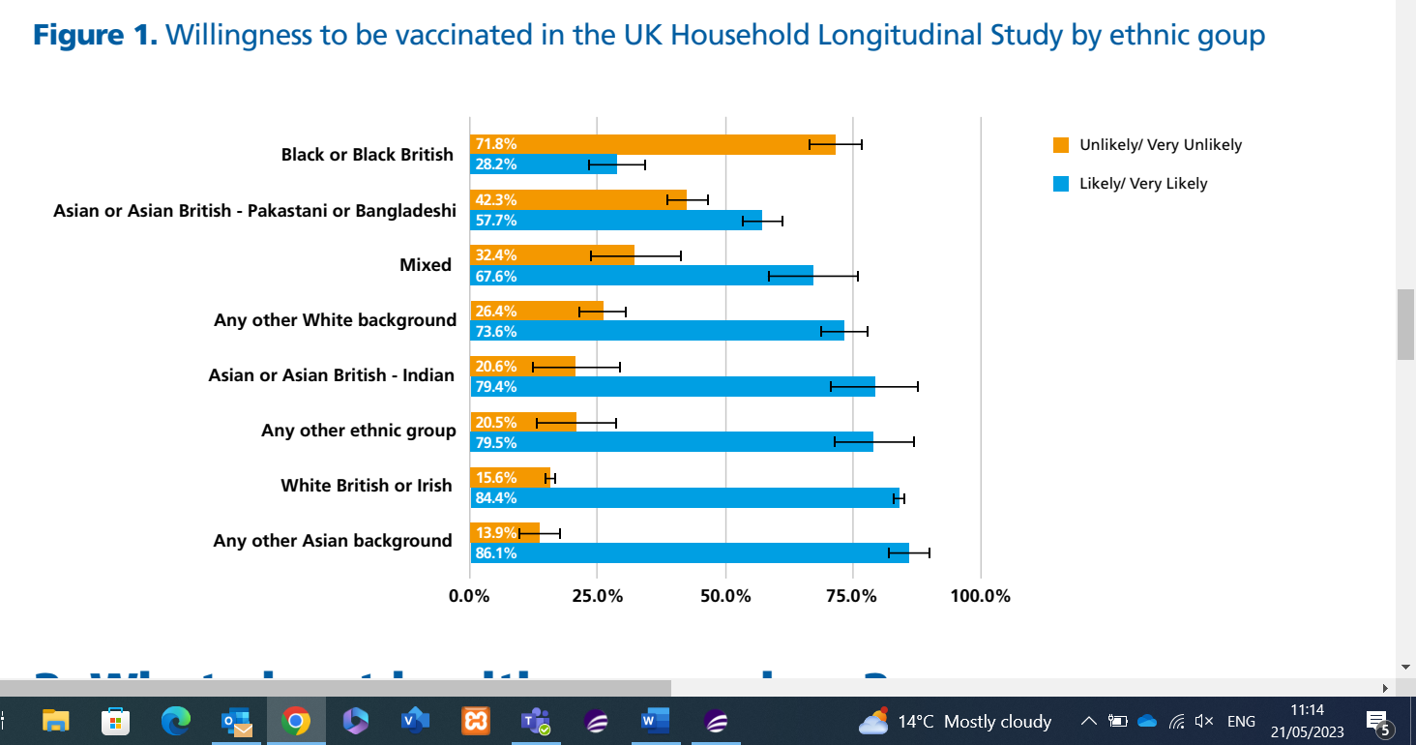
It’s clear to see that certain minorities were far more likely to be unwilling to have a vaccination. Areas that could be affected by religious beliefs in Wales would be Swansea and Cardiff.

Figure - Total Cases broken by MSOA © Crown Boundary Data Swansea
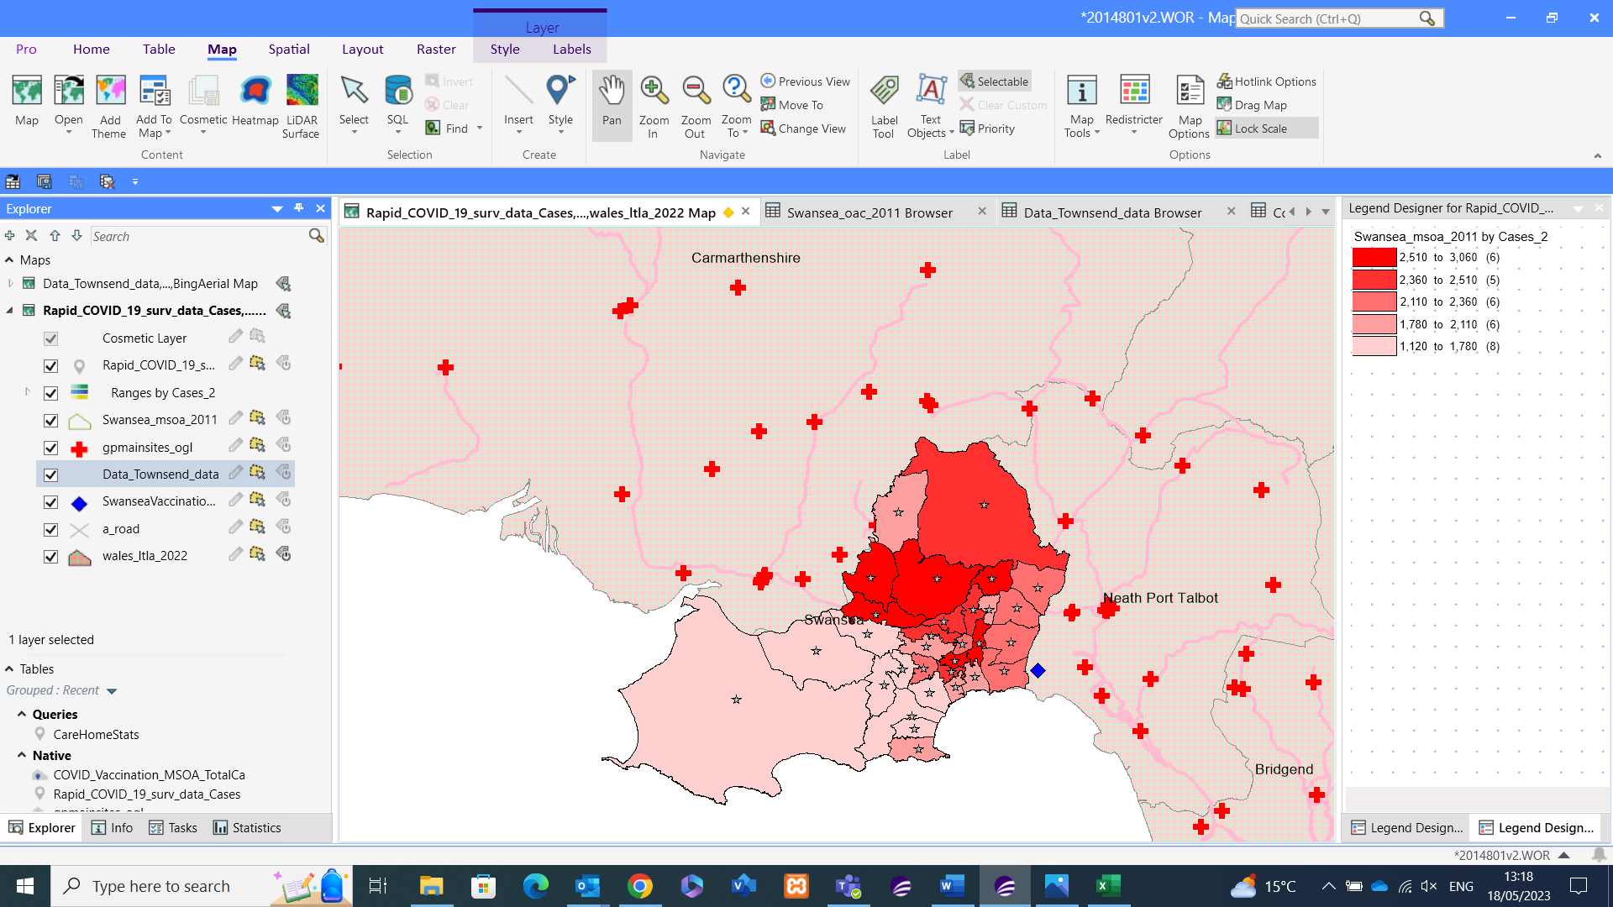
Firstly, I have a visual which shows the total cases of Covid broken down by MSOA wards within Swansea. At first glance there isn’t anything too surprising about this visual, however taking a closer look, the densely populated areas of Townhill and Uplands rank highly on the list. But so do other less densely populated areas, particularly Loughor and Llangyfelach which is are anomalies in this instance.

Figure - Total Incidents per 100,000 of Population by MSOA © Crown Boundary Data Swansea
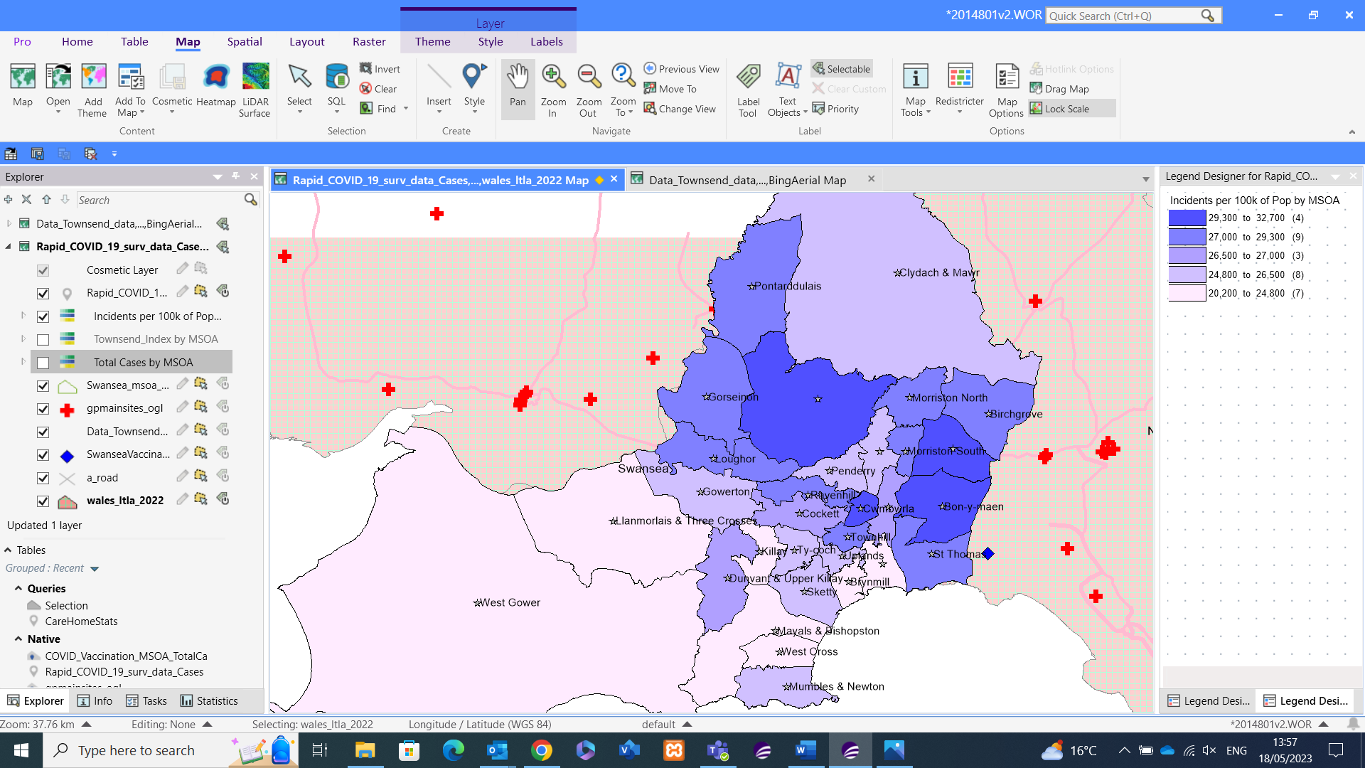
The above figure provides similar results to the total cases, however comparing to the per 100,000 of population we take away the population density factor and the results are interesting. It seems the wards to the East that had fewer total cases are in fact among the worst performing when removing the density factor. Wards like Bonymaen and Llansamlet are among the worst, but again Llangyfelach is of the worst performing wards for total and per 100,000 of population.

Figure - Townsend Index for Swansea by MSOA © Crown Boundary Data MSOA Swansea
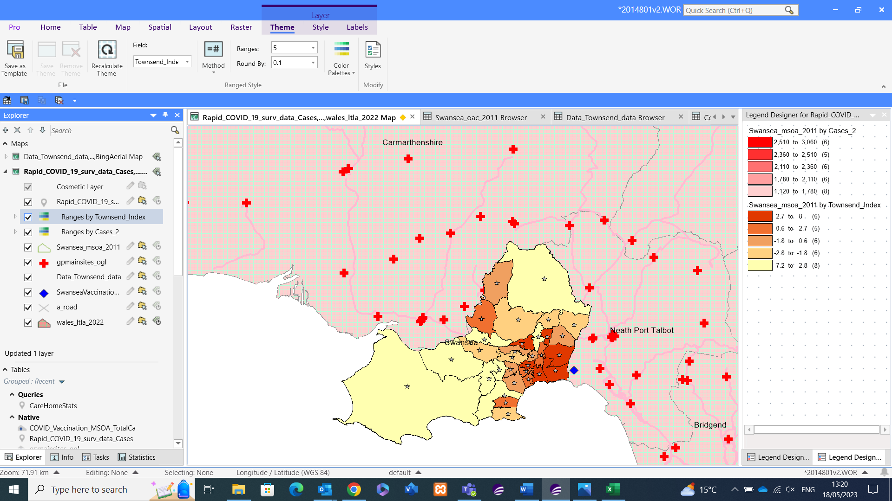
Introducing the factor of poverty to the total cases visuals gathered above there are some interesting results. Comparison of the Townsend Index to the covid case figures does support the hypothesis that there is a link between high poverty areas having high case figures. Looking at the most deprived areas firstly,

Deprived and Wealthy Areas
Townhill is a renowned area of poverty within Swansea area, unsurprisingly scored 4.6 on the Townsend Index, the second worst area for deprivation. Townhill was among the top 6 of the 31 areas for total covid cases with 2,544 cases and scoring in the top 4 of incidents per 100,000 of the population.
Like Townhill, Bonymaen follows the trend, the 4th most deprived area in Swansea has the 2nd highest figures of cases per 100,000 of the population and among the top 6 of areas by total cases.
The West of Swansea is known as a wealthy area, given its proximity to mumbles and the beaches, vast greenspace in comparison to other areas in Swansea the Gower is among the wealthiest areas due to the previous factors and others making it a desirable area. West Gower is a prime example, it scores -6.9 on the Townsend Index making it the 2nd wealthiest in the area. It also scored in the lowest scale of incidents per population and among the lowest band of total cases, which could be down to the vast green space, lower population density and a higher percentage of elderly population meaning most would’ve been self-isolating for most of the pandemic.

Anomalies/Discussion Points
It was important to include statistics for total, and total per 100,000 of the population. For example, when looking at the total case figures Swansea East looks middle of the range with total cases, but when adding population density as an indicator, Bonymaen and St Thomas are among the worst areas, Bonymaen was the 2nd worst area in this respect.
Gorseinon is also an area of interest. It scored on the poorer end of the Townsend index with a score of 1.2, putting it in the second bracket of the five, and it was the worst performing area for total cases of Covid cases with 3,054. These figures seem normal, but the area of Gorseinon has a GP and 2 Vaccination centres during the Pandemic, and so the distribution of immunisation would’ve been swift to the local area. As an area with good transport links, not as densely populated as other areas in Swansea, it being the worst area for total cases is surprising.
Compared to Gorseinon, Llangyfelach is among the wealthiest areas in Swansea scoring a -2.7 on the Townsend Index, sitting just outside the top 10 wealthy areas in Swansea. However, when it comes to Total Cases it sits within the top 5 areas in Swansea. A reason for this could be the lack of GP or Vaccination centre within the ward, and although transport links for the area appear good, the elderly population may have been forced to isolate, avoiding public transport and without a car many would’ve struggled to get vaccinated, and cases could’ve risen as a result. The Northern area of Swansea is an anomaly, as it scores very highly on the Townsend index but also scores poorly on covid case counts.
Another interesting point is Morriston South. It scores among the poorest areas on the Townsend Index, the 5th most deprived area of Swansea however it scored middle of the range of total cases with 2,544 cases and 17th overall for cases per 100,000 of the population. Some initial observations show excellent transport links, with a GP within the ward and a Vaccination centre close by in Mynydd-bach.

2.4 Discussion Topic 2
The second hypothesis, is there a link between Covid Vaccination Uptake and Age?
I believe that there is a higher percentage of elderly people immunised for the full 3 doses compared to the rest of the population aged 16-50. The rationale from my hypothesis stems from those that are older are more susceptible to illness and death due to far more factors than those aged 16-49, and as such will feel the need to get vaccinated in comparison to those of a younger age. I am indeed one of these statistics, aged 29 in good health I’ve only had the first 2 jabs and have since decided not to take up any booster jabs.
During the pandemic, and various lockdowns the elderly population were the first to be offered the jabs at each stage of immunisation. Given the increased health risks for the elderly population although it wasn’t written in law it was strongly recommended that they get immunised. The rest of the population, especially those in the 18-30 bracket were of the last to get immunised, and though there was strong recommendations this section of the population is healthier and more likely to fight off disease which lends itself to my hypothesis. Given that today the vaccine is offered to those 75+ as a seasonal vaccine, it again lends itself to the theory that immunisation rate is higher in the elderly population.
To compare the factor age has on the vaccine uptake, I have will compare the All-adults 65+ years old to the rest of the population aged 16-49 years old. There were other interesting categories like those aged 5-49 in a clinical risk group, and residents in a care home, however I felt those other age groupings were mandated and forced due to the higher risks associated to get their vaccines and were at the front of the queue. By selecting the population that are deemed without a health risk, especially those 65+ it includes the elderly in general including those without such health issues it opens the social variables to the data, personal preference, and the choice to receive the vaccine or not.

Figure – First Dose Uptake O65 vs Rest of Population © Crown Boundary Data Wales
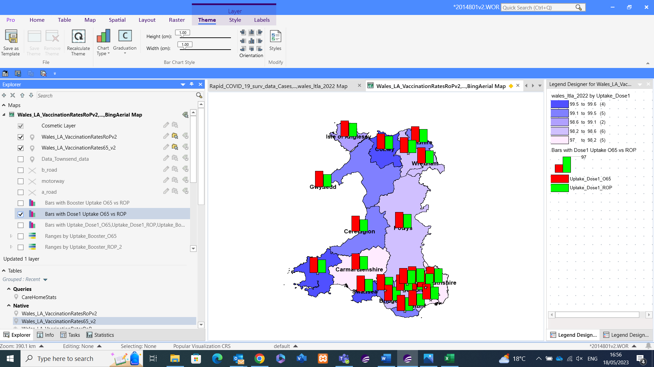
The uptake in the first dose was higher in 65+ than in the Rest of the population for all the Local Authorities. Comparing the data, the lowest uptake in the first dose was 94.3% in Cardiff but it was still almost 10% higher than the highest immunisation rate of 86.3% in Monmouthshire for the Rest of Population bracket. The average uptake of the First Dose for 65+ is 96%, compared to the 92.8% of the Rest of the Population.

Figure – Booster Uptake O65 vs Rest of Population © Crown Boundary Data Wales
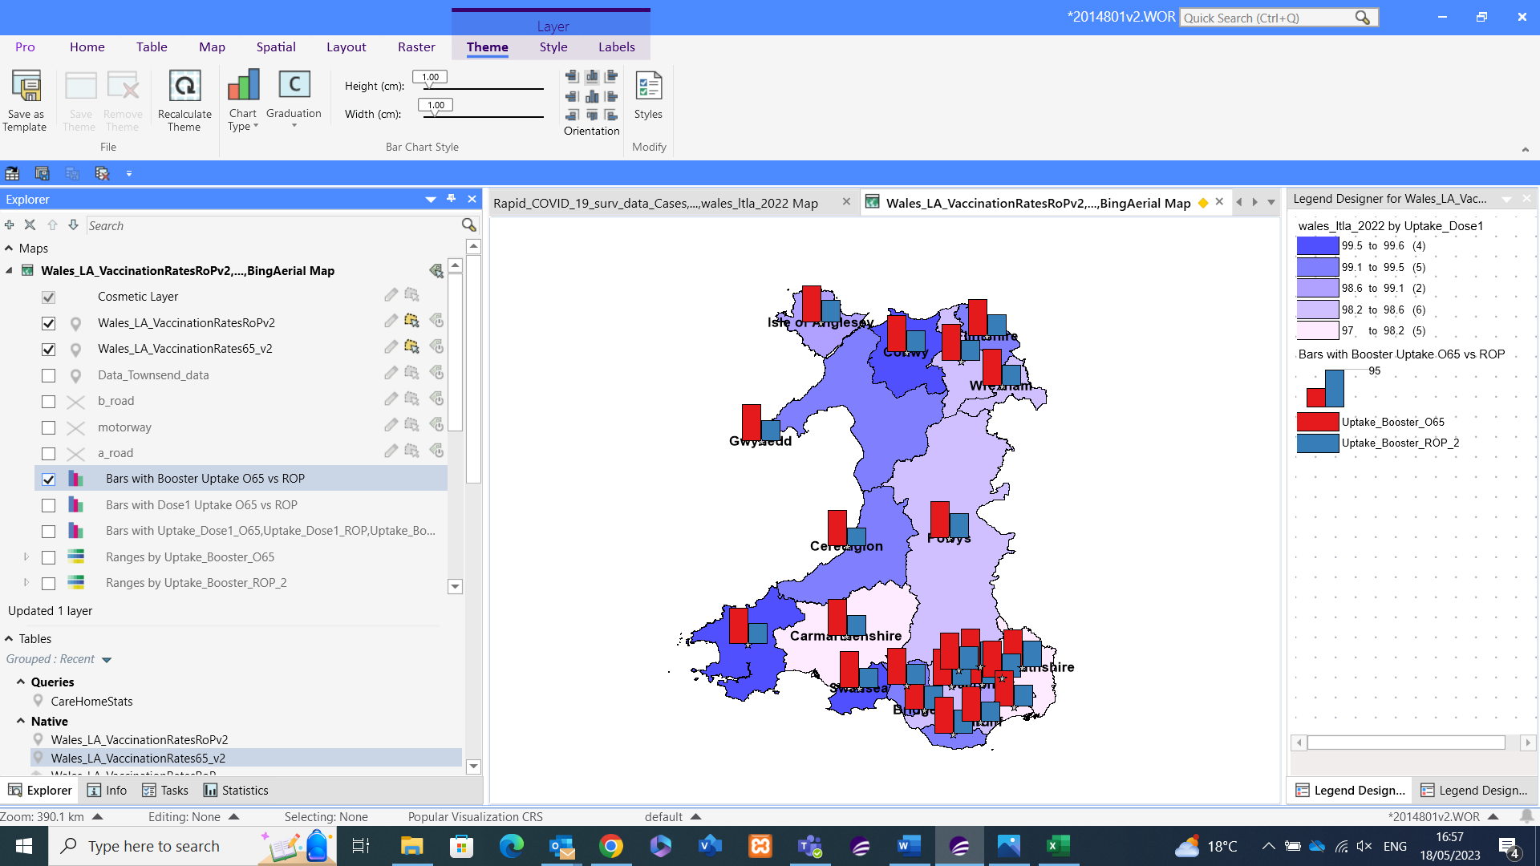
The trend set by the first dose continued to the Booster, not just continued but the gap between the two age groups increased drastically. The lowest percentage of Booster uptake was 89.9% again in Cardiff, which was far higher than the 67.3% booster uptake of Monmouthshire which was the best immunisation rate for all the Welsh counties. That lowest figure of 89.9% booster uptake of the 65+ population is almost double the lowest Rest of Population Booster uptake of 47.4% in Ceredigion.
The average uptake of the Booster jab for 65+ is 80.7%, which is a drop of 17% compared to the first jab. However, there’s a dramatic drop for the Rest of the Population, as the Booster uptake of 56.4% is over 35% less than that of the first Jab.

Figure – Combined View of First Dose and Booster Immunisation © Crown Boundary Data Wales
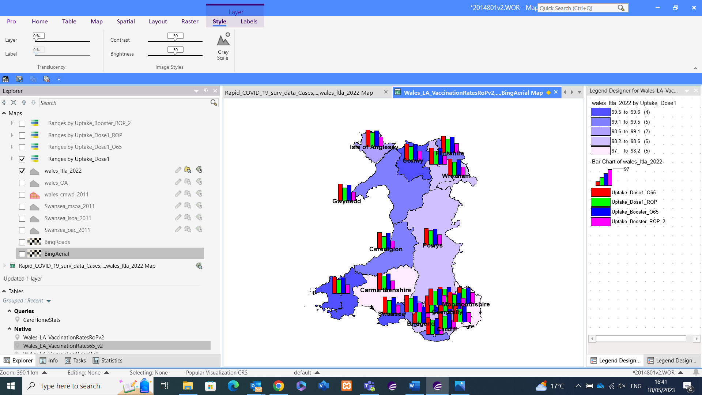
The above view combines the bar chart results from above into a singular view. Again, even though the Southeast section of Wales is rather crowded, it’s still visible that the uptake of the booster dropped significantly compared to the first dose for not just the 65+ population, but for the rest of population, as backed up by the stats mentioned for previous figures.

Figure – Swansea Specific Comparison © Crown Boundary Data Wales
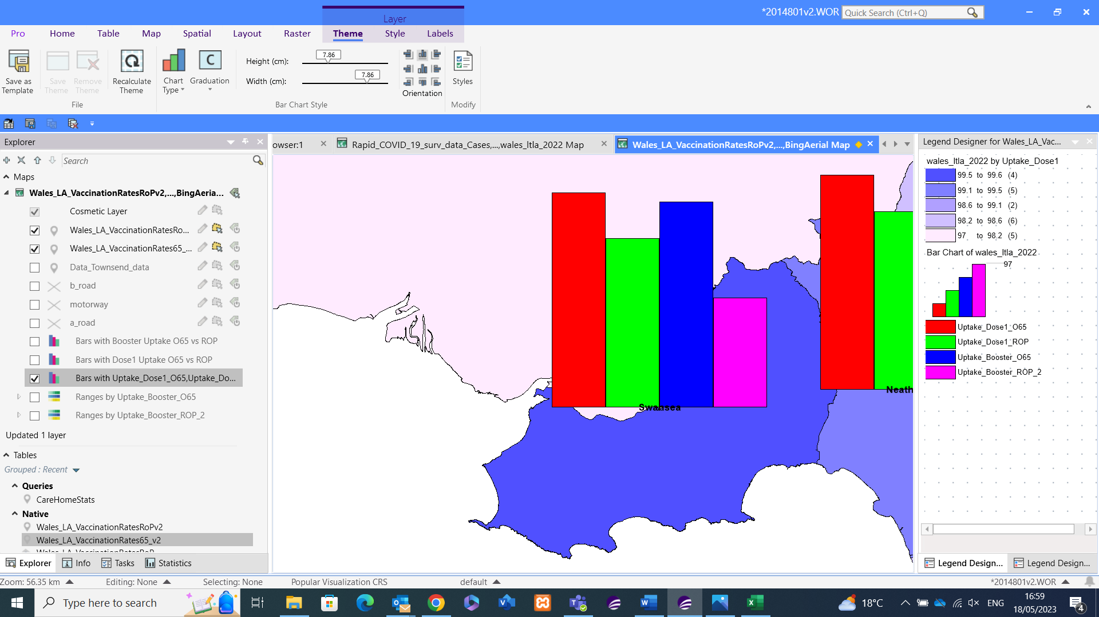
As can be seen, the immunisation rates of the 65+ Population is far better than the rest of the population. For the first Dose, there was 20% higher immunisation for the 65+ population at 97%, and although the 65+ immunisation rate was 4% lower at 93% for the Booster jab, the immunisation rate of the Rest of the population was far worse at 50%.

Figure – Covid Behaviour UK average by various filters
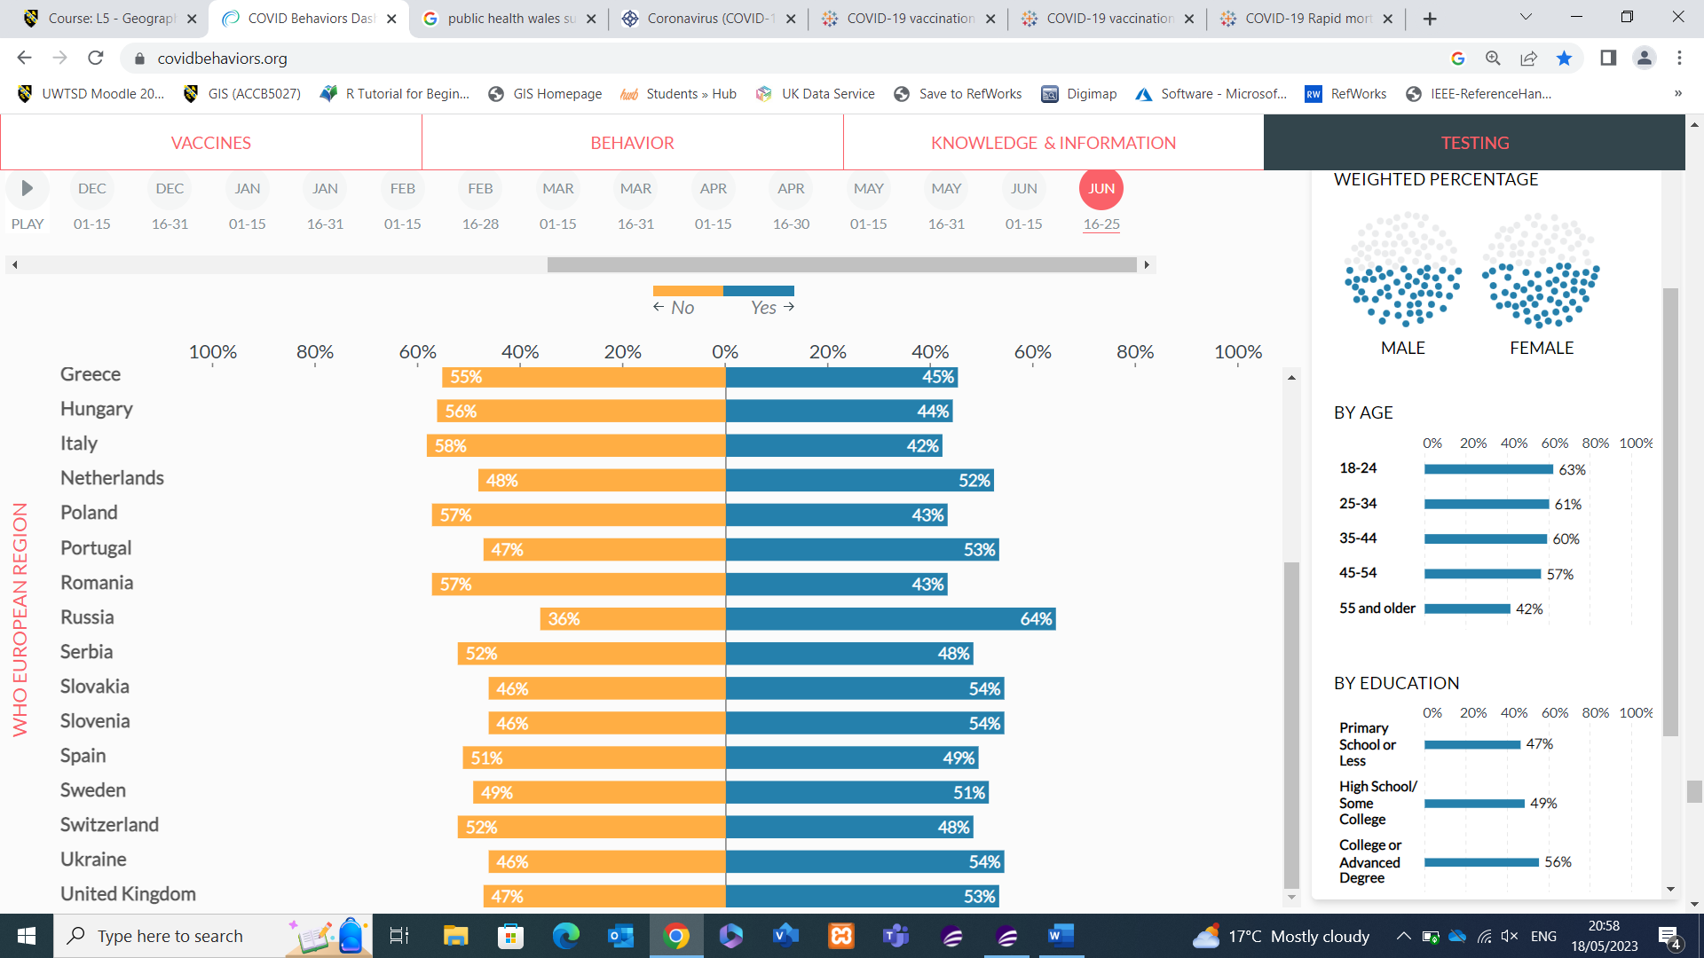
The previous figure shows the results of a survey of a random test sample conducted by CovidBehaviours [14]. The participants surveyed answered the simple question of whether they have ever had covid, whilst providing further demographic data.
The results were then broken down into different demographics. As can be seen compared to other countries, the UK participants were among the highest to answer yes to having covid, and of the lowest to answer No to having the disease. Another interesting statistic was the gender breakdown with females 5% more likely to say Yes than Females. The Age statistics show that the younger population are more likely to say Yes to catching Covid compared to the older demographic. This ties in with the statistics around immunisation, the elderly population in Wales have a better immunisation rate and less likely to catch Covid in comparison to the younger population who have a lower immunisation rate of first and booster jabs.

2.5 Discussion Topic 3
Another hypothesis I will investigate is whether there’s a link between accessibility to Covid Vaccination Centres and/or GP Surgery’s and level of cases within an area. For this I will investigate differences in the MSOA sections of Swansea.
To begin with, I have added the point data of Swansea only Vaccination centres and the GP surgery’s data for Wales to the workspace. Alongside this, for an accessibility indicator I have taken the roads data provided by the OS Strategi data.

Figure – Point data of Swansea vaccination centres and All Wales GP Surgeries © Crown Boundary
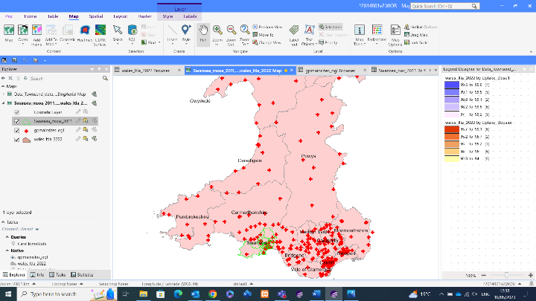
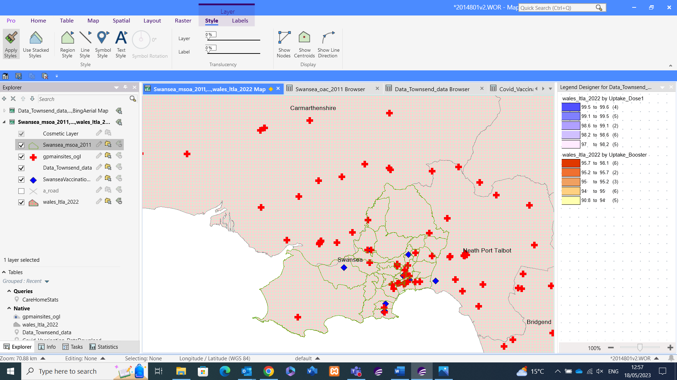
By adding the above point data, I can compare other socio-demographic data to the points of Vaccination and GP locations. Accessibility of vaccination sites can be a crucial factor in levels of immunisation and resulting case and morality figures. Having a vaccination centre in an area would help immunisation statistics but having it in an area that isn’t easily accessible to the surrounding population renders the centre obsolete as a factor.

Figure – Point Data for GP’s in Swansea © Crown Boundary Data Swansea
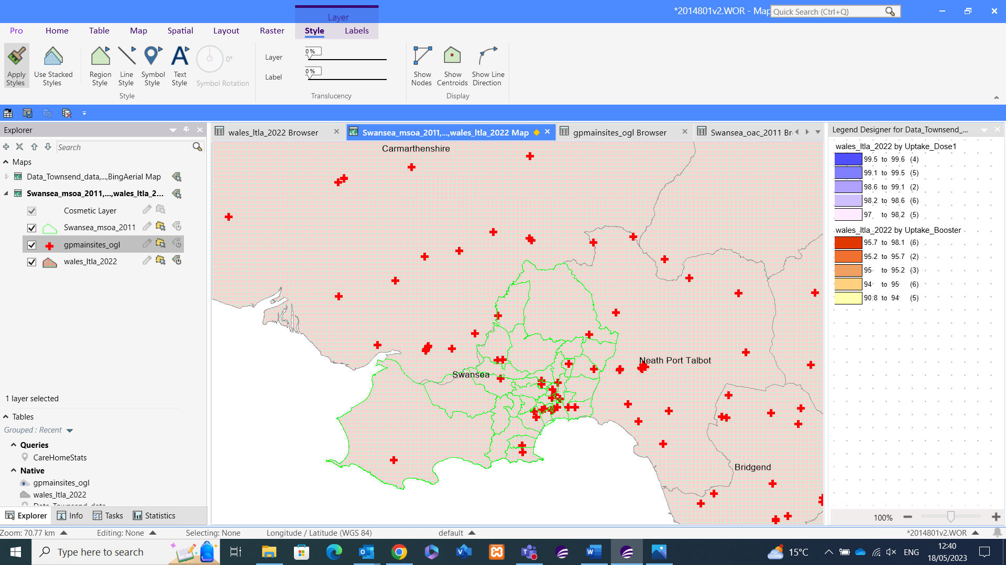
I’ve also added the point data for GPs to my data set, by adding in the GP locations it again helps measure against accessibility, given later in the pandemic some GP’s would provide Covid tests and on occasions provide vaccinations. The availability of a GP in an area can also give an indication of the general health of an area.

Figure – Point Data for Vaccination Centres against total cases © Crown Boundary Data Swansea
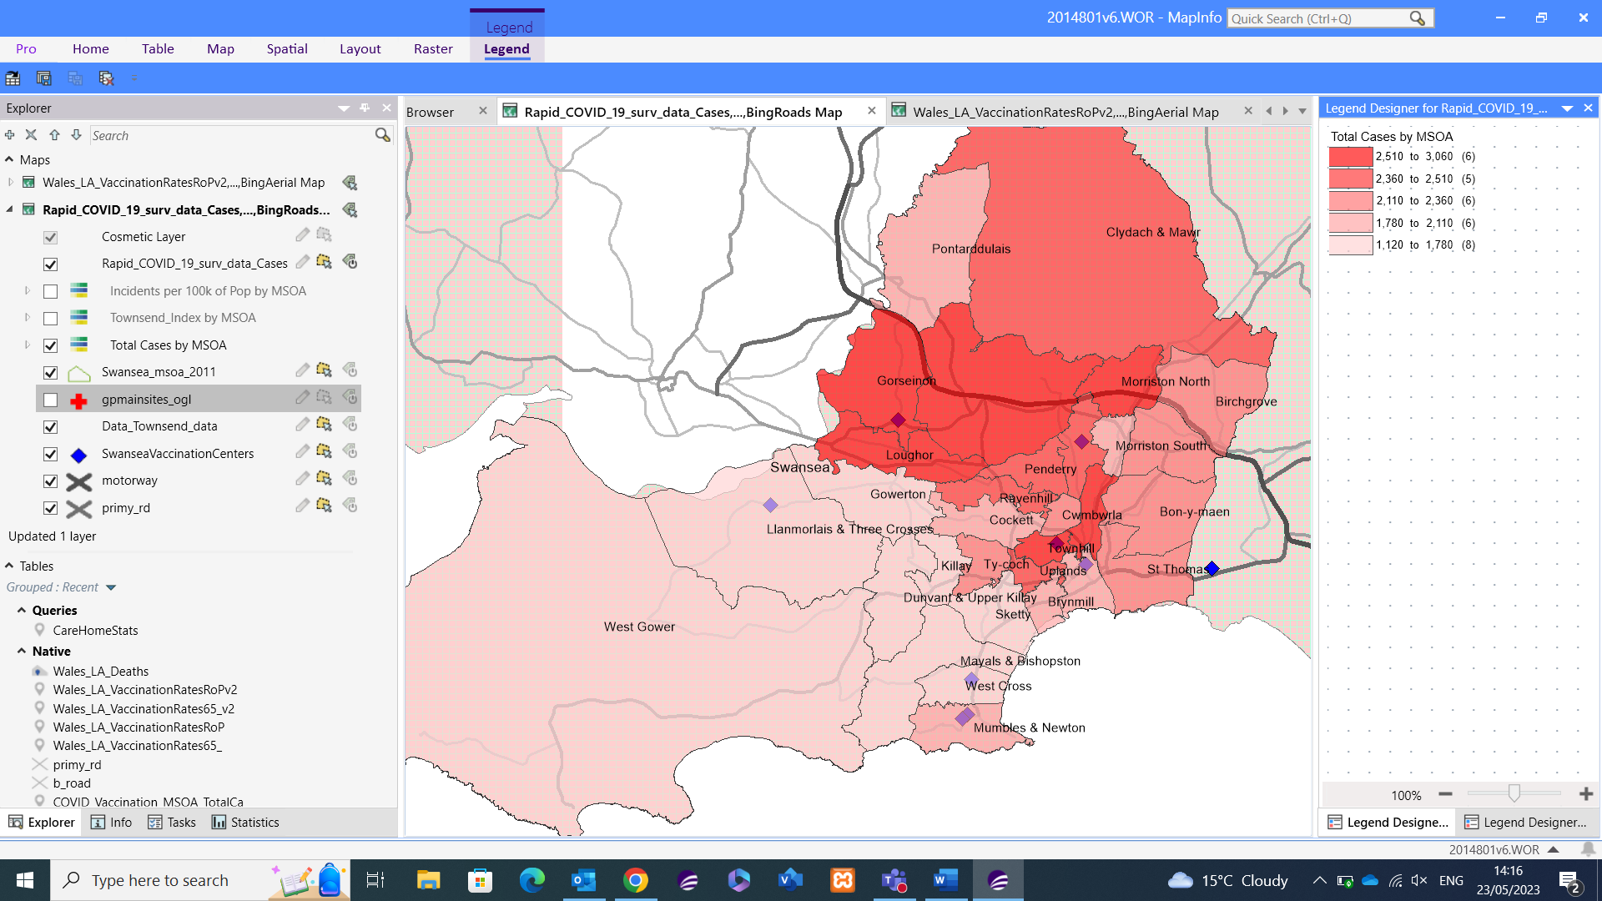
Townhill is an area of interest when looking at total case data comparable to vaccination sites. This area has a vaccination centre within the ward, yet it has a high case rate, but this could be down to the variety of social reasons including the high Townsend index score. Gorseinon is similar in that it has a vaccination centre within the Ward but has a high number of covid cases. Though some wards with a vaccination centre do have lower case numbers, due to the areas mentioned there’s no visible link between vaccination centre wards having lower case numbers.

Figure – Highest Case Number layer including local road Network © Crown Boundary Data
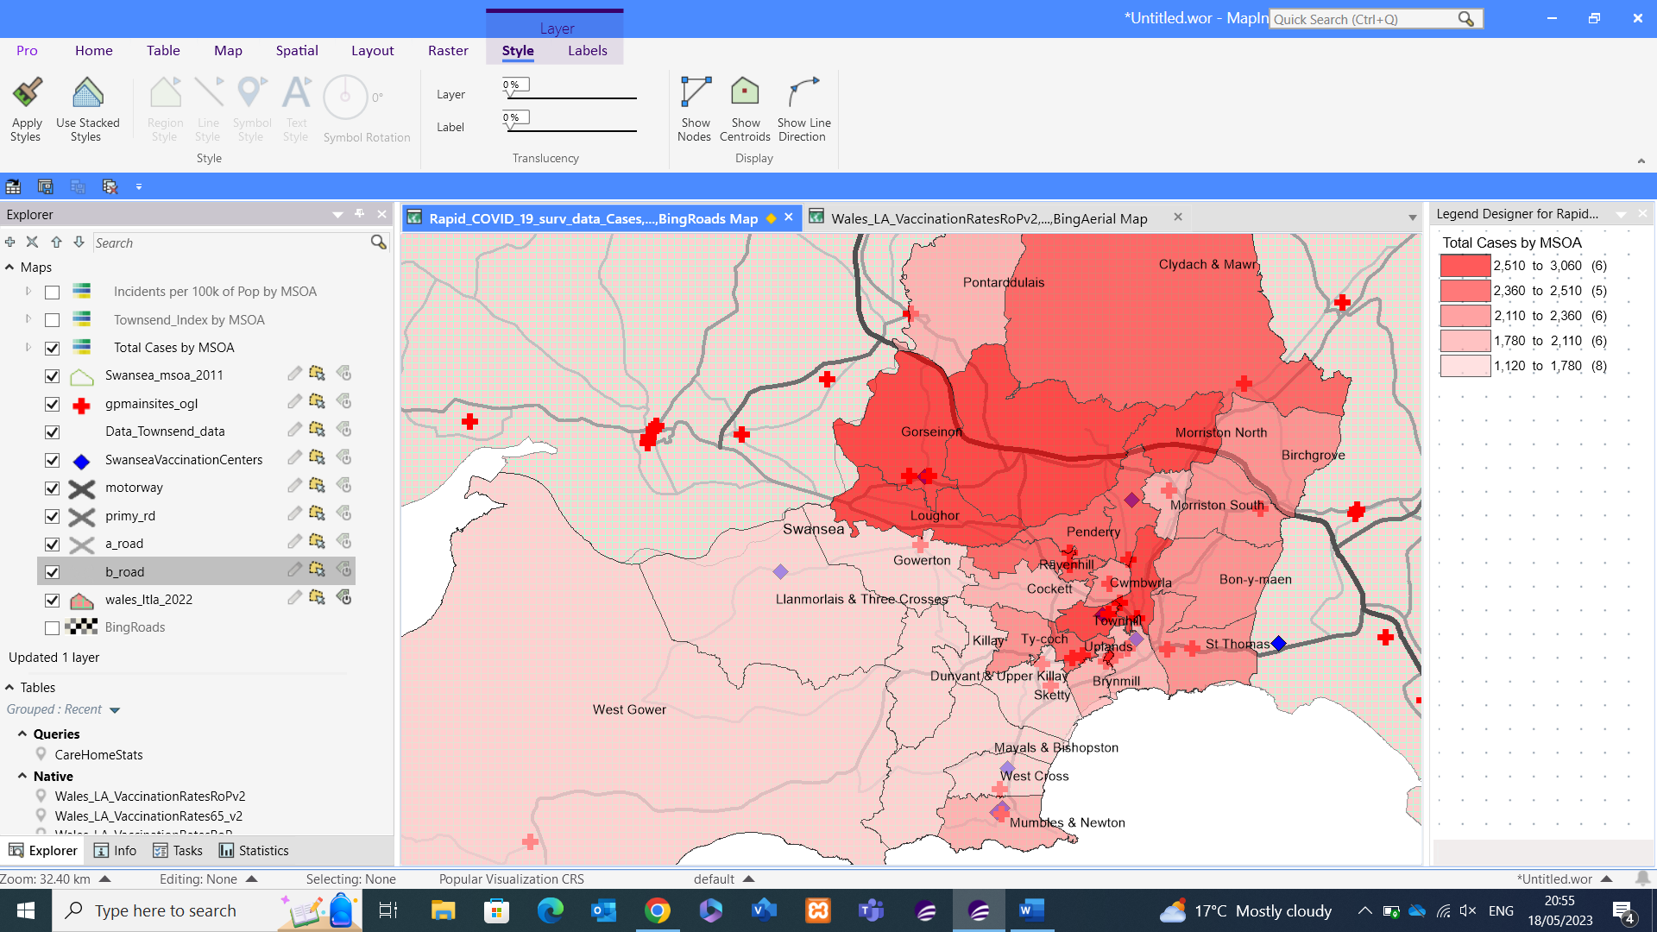
The above figure shows Loughor, Gorseinon and North Morriston block of wards as an area with high case numbers. Looking at the road network it seems strange that these areas have high case numbers given the accessibility of the motorway and various A roads. To the south of Loughor is Gowerton, there are many factors that could explain why Gowerton has lower case numbers like the improved poverty index score, but also Gowerton along with Swansea Central are the only train station locations in the area, adding the additional layer of rail travel to bus and car transport.
Figure – Traveline Cymru Bus stops in locality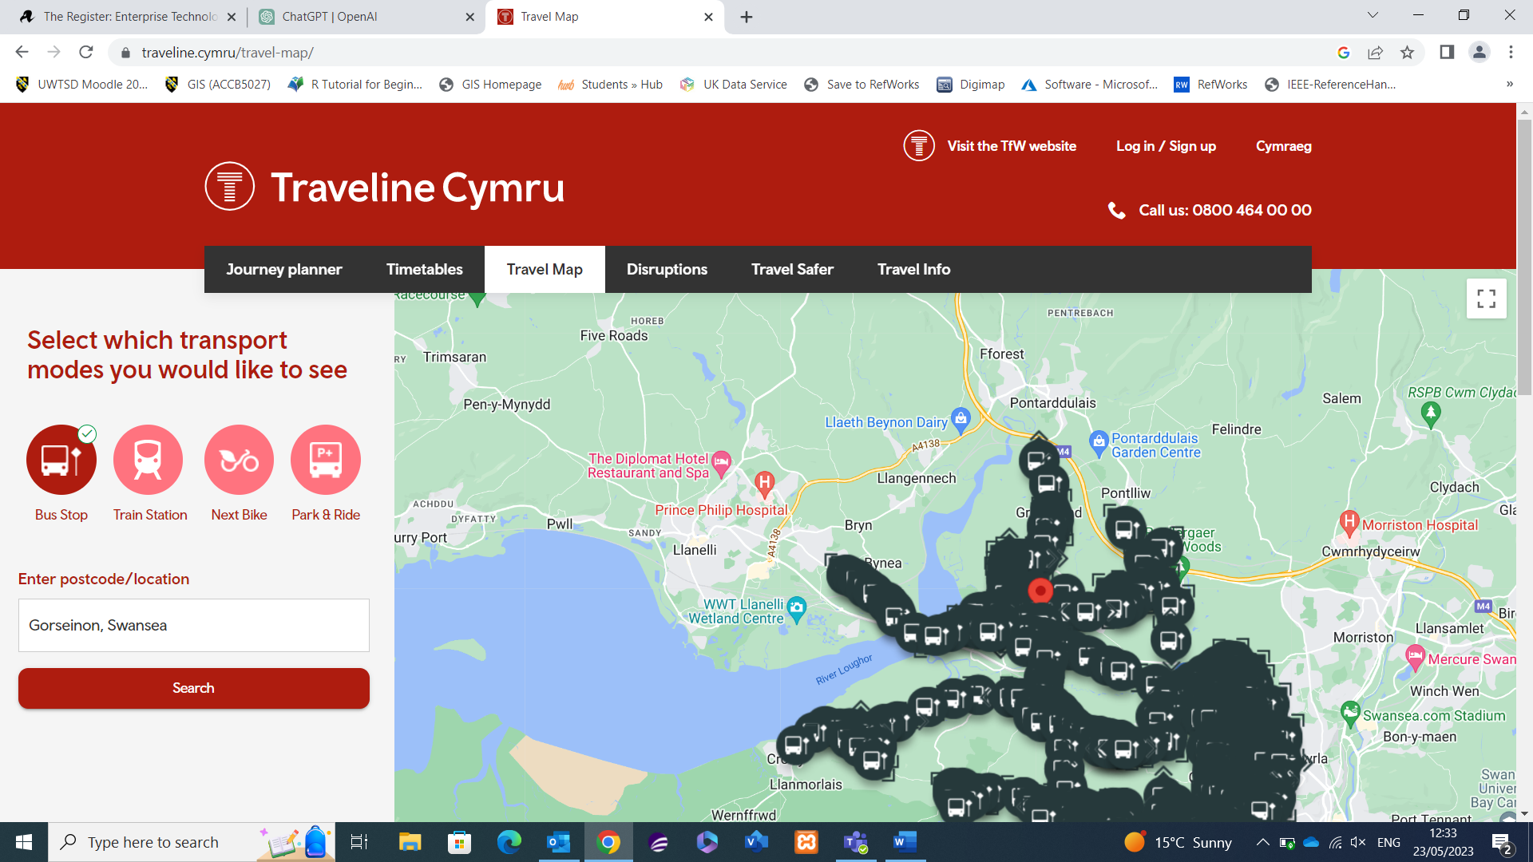
The road network immediately looks to be better than many of the other areas, similarly, looking at the below from Traveline Cymru [15] it again shows a very effective bus network which raises questions around the hypothesis. An area with such an abundance of bus stations seems to be suffering with cases, like the more populated areas, but is the effective transport route a hinderance more than a benefit? The effective transport links might encourage increased movement of people within areas and in fact has a detrimental effect to an area’s likelihood of covid cases.

Figure – Road Network view of Highest Case number MSOA’s © Crown Boundary Data Swansea
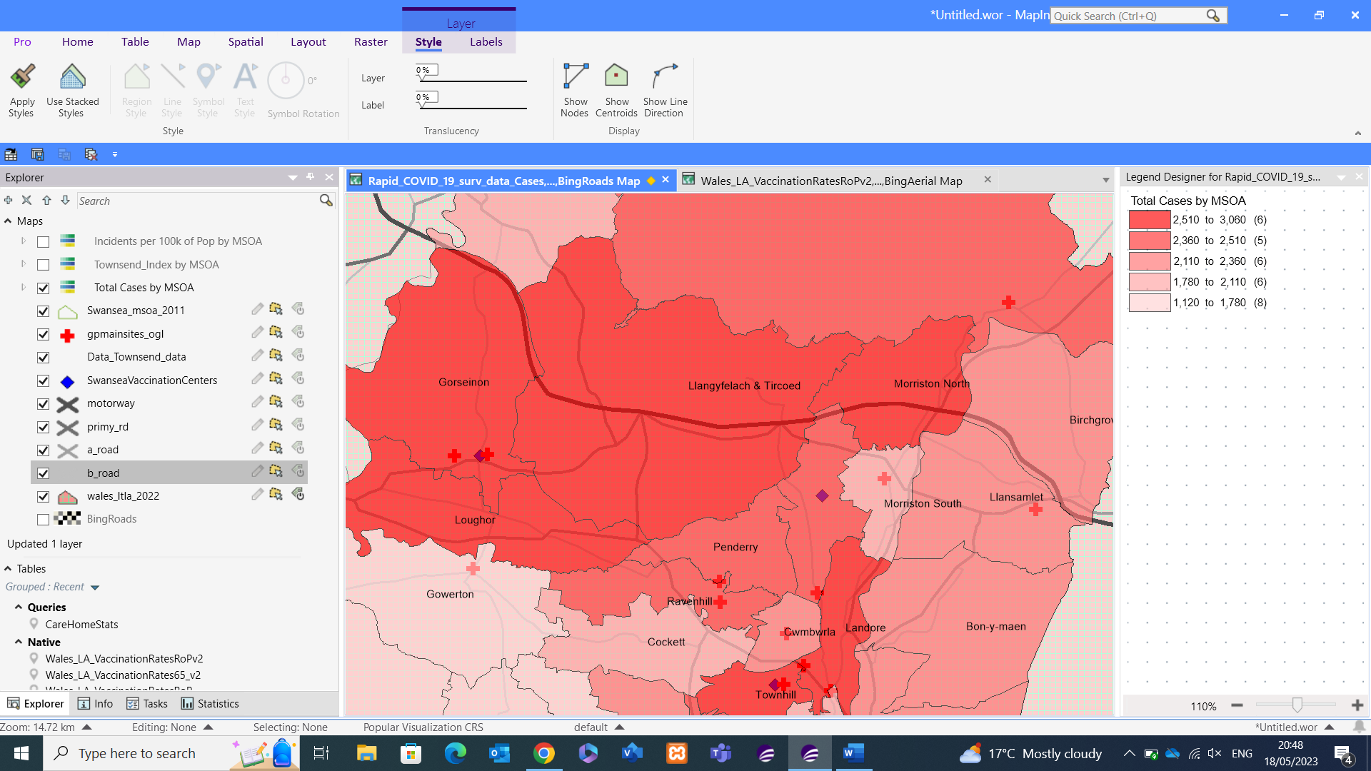
To the south of Loughor is Gowerton, there are many factors that could explain why Gowerton has lower case numbers like the improved poverty index score, but also Gowerton along with Swansea Central are the only train station locations in the area, adding the additional layer of rail travel to bus and car transport.
Alluding to the areas on the total cases map with the worst rates, I have used the Townsend index to compare against poverty however there are other indicators within the Townsend index I could test against specifically like the rate of unemployment within an area, number of households without a vehicle to get a different comparable of cases against specific poverty indicators.
With further data, I could investigate this further with the age demographics to test against areas of elderly population against total cases, along with an education variable which would allow the further exploration of poor education against total cases.

2.5 Conclusion
To conclude, I feel I have provided sufficient evidence to support my hypothesis of the link between poverty and high case areas. The use of the Townsend index data is crucial to this hypothesis; however, I feel I could get further data to further justify my hypothesis.
Similarly, for the second hypothesis I am comfortable that I can link Covid Vaccination Uptake to Age. To further justify this, I could’ve added in some further age brackets, or split the age groupings down further than the 19-49 and 65+ age groupings. Breaking the demographics into 20+ and then 10-year increments following on from this would have been far more effective.
For my third hypothesis I don’t feel I am able to completely prove or disprove it with the data I have. There are some points I have raised which are related to social aspects in some areas, but I am unable to locate the data to fully support my argument. With further data and visuals, I would be in a stronger position to answer my hypothesis.
To reach more concrete conclusions to my hypothesis I feel I require further data added to my datasets, to test further variables against my hypothesis. I would also need further references and reliable sources to back up some of the social aspects relating to the data and prove some of my local knowledge on the case study area. Further data would lead to more visuals to build a greater picture of the data than I currently have. However, I am pleased with the workspace I have created and the ability to prove a couple of my discussion topics under the circumstances faced.

3. References
Citations
[1] Anonymous, “Coronavirus (COVID-19) NHS Wales,” 2023. [Online]. Available: https://phw.nhs.wales/topics/latest-information-on-novel-coronavirus-covid-19/. [Accessed: 24-May-2023]
[2] Anonymous, “InFuse 2011,” 2023 [Online]. Available: https://infuse2011gf.ukdataservice.ac.uk/infusewizgeo.aspx. [Accessed: 24-May-2023]
[3] Anonymous, “UK Data Service Census Support,” 2018 [Online]. Available: https://borders.ukdataservice.ac.uk/bds.html. [Accessed: 24-May-2023]
[4] Anonymous, “Digimap University of Edinburgh” [Online]. Available: https://digimap.edina.ac.uk/. [Accessed: 24-May-2023]
[5] Anonymous, “Middle Layer Super Output Area,” 29-Mar-2023. [Online]. Available: https://www.datadictionary.nhs.uk/nhs_business_definitions/middle_layer_super_output_area.html. [Accessed: 24-May-2023]
[6] Anonymous, “Lower Layer Super Output Area,” 29-Mar-2023. [Online]. Available: https://www.datadictionary.nhs.uk/nhs_business_definitions/lower_layer_super_output_area.html?hl=lsoa. [Accessed: 24-May-2023]
[7] Anonymous, “Output Area,” 29-Mar-2023. [Online]. Available: https://www.datadictionary.nhs.uk/nhs_business_definitions/output_area.html. [Accessed: 24-May-2023]
[8] C. Dempsey, “Types of GIS Data Explored,” 2022. [Online]. Available: https://www.gislounge.com/geodatabases-explored-vector-and-raster-data/. [Accessed: 24-May-2023]
[9] Anonymous, “COVID vaccine in Swansea and Neath Port Talbot,” 05-May-2023. [Online]. Available: https://sbuhb.nhs.wales/coronavirus-covid-19/information/vaccine-in-swansea-and-npt/. [Accessed: 24-May-2023]

[10] Anonymous, “COVID - Coronavirus Statistics - Worldometer,” 23-May-2023. [Online]. Available: https://www.worldometers.info/coronavirus/. [Accessed: 24-May-2023]
[11] “Health inequalities: Deprivation and poverty and COVID-19 | Local Government Association,” 2023. [Online]. Available: https://www.local.gov.uk/health-inequalities-deprivation-and-poverty-and-covid-19. [Accessed: 24-May-2023]
[12] “Health inequalities: Deprivation and poverty and COVID-19 | Local Government Association,” 2023. [Online]. Available: https://www.local.gov.uk/health-inequalities-deprivation-and-poverty-and-covid-19. [Accessed: 24-May-2023]
[13] C. Cavita, “Vaccination: race and religion/belief NHS,” Feb. 2021 [Online]. Available: https://www.england.nhs.uk/south-east/wp-content/uploads/sites/45/2021/05/Vaccination-and-race-religion-and-belief-A4.pdf. [Accessed: 24-May-2023]
[14] Multiple, “COVID Behaviours Dashboard - Johns Hopkins Center for Communication Programs.,” 2021 [Online]. Available: https://covidbehaviors.org/. [Accessed: 24-May-2023]
[15] Anonymous, “Traveline Cymru Travel map,” 2023 [Online]. Available: https://www.traveline.cymru/travel-map/. [Accessed: 24-May-2023]

3.1 Table of Figures
Figure – NHS Wales Vaccination Page 4
Figure – Rapid Covid Data File and Raw Data 5
Figure – Infuse Geography Data selection. 5
Figure – Infuse Data within MapInfo 6
Figure – UK Data Service Boundary Data Selector 6
Figure – Wales Output Areas dataset within MapInfo 7
Figure – Complete Strategi OS Map 8
Figure - Welsh Local Authorities © Crown Boundary Data Wales 8
Figure – MSOA Layer Data and Visual © Crown Boundary Data MSOA Swansea 9
Figure – LSOA Layer Data and Visual © Crown Boundary Data LSOA Swansea 9
Figure – Output Area Swansea © Crown Boundary Data Output Area Swansea 10
Figure – Swansea Output Area data overlapping Bing Aerial © Crown Bing Aerial Map Info Swansea 10
Figure – Bing Roads compared to UK Data Service Motorway + A Roads Map © Crown Map Info Wales 11
Figure – Creation of Point Data 12
Figure – Vaccination Point Centre Visual © Crown Boundary Data MSOA Swansea 12
Figure – Top 10 Covid-19 Raw Data with accompanying Visuals 13
Figure – Total Cumulative deaths due to Covid © Crown Boundary Data Wales 13
Figure – Willingness to be vaccinated by Ethnic Group 14
Figure - Total Cases broken by MSOA © Crown Boundary Data Swansea 15
Figure - Total Incidents per 100,000 of Population by MSOA © Crown Boundary Data Swansea 15
Figure - Townsend Index for Swansea by MSOA © Crown Boundary Data MSOA Swansea 16
Figure – First Dose Uptake O65 vs Rest of Population © Crown Boundary Data Wales 18
Figure – Booster Uptake O65 vs Rest of Population © Crown Boundary Data Wales 18
Figure – Combined View of First Dose and Booster Immunisation © Crown Boundary Data Wales 19
Figure – Swansea Specific Comparison © Crown Boundary Data Wales 19
Figure – Covid Behaviour UK average by various filters 20
Figure – Point data of Swansea vaccination centres and All Wales GP Surgeries © Crown Boundary 20
Figure – Point Data for GP’s in Swansea © Crown Boundary Data Swansea 21
Figure – Point Data for Vaccination Centres against total cases © Crown Boundary Data Swansea 21
Figure – Highest Case Number layer including local road Network © Crown Boundary Data 22
Figure – Traveline Cymru Bus stops in locality 22
Figure – Road Network view of Highest Case number MSOA’s © Crown Boundary Data Swansea 23

