

Master of Business Administration
LCMB7002 - Financial Management
Assessment component: Financial performance and management
Student Name: Chetnaben Anilbhai Fadke
Student Number: 2430959
Lecturer Name: Shengfeng Mei
Word Count: 5153

Table of Contents
1. Introduction 2
2. Financial Health Check 2
2.1 Examination of the Company's Financial Records 2
2.2 Ratio Analysis 2
2.3 Finding Trend, Advantages, and Threats 5
2.4 Predicting Corporate Failure with the Altman Z-Score Model 7
3. Working Capital Management Analysis 8
3.1 Evaluation of Cash Operating Cycle 8
3.2 Recommended Strategies 8
3.3 A Comparison of Long-Term and Short-Term Financing Alternatives 9
4. Strategic Financial Restructuring Plan 10
4.1 Recommended Options for Financial Restructuring 10
4.2 Effect on Operational Flexibility, Shareholder Value, and Debt Structure 11
4.3 Related International and Ethical Considerations 12
5. Investment Appraisal and Capital Budgeting 13
5.1 Assess of Three Proposed Investment Projects 13
5.2 Final Investment Suggestion and Rationale 17
6. Summary 17
7. References 19
8. Appendices 24

1. Introduction
‘The examination of the business's financial performance during the last five years is the primary topic of this report, which is about a multinational corporation called General Electronics that operates in the consumer electronics market and is having financial difficulties. In this sense, the study will concentrate on identifying the company's primary financial issues and assisting in the creation of a strategic financial restructuring plan meant to address these issues and improve General Electronics' financial performance. Additionally, this study will assess three projects that have been suggested for future investment and suggest the one that would be best for the company’.

2. Financial Health Check

2.1 Examination of the Company's Financial Records
‘The 2020–2024 financial accounts demonstrate a dramatic drop in stability and performance. Operating losses increased to £15,297 million, mostly as a result of excessive costs and asset impairments, while net revenues plummeted from £614,680 million in 2020 to £394,879 million in 2024. Recent years saw a decline in net income, which reduced equity from £313,301 million to £153,105 million. Although it was much less than in previous years, cash flow from operations was nevertheless positive in 2024 at £14,822 million. Cash fell from £57,153 million to £26,783 million, indicating a weakening of liquidity. All things considered, the business has issues with profitability, efficiency, and liquidity that call for strategic restructuring.

2.2 Ratio Analysis
a. Net Profit Margin

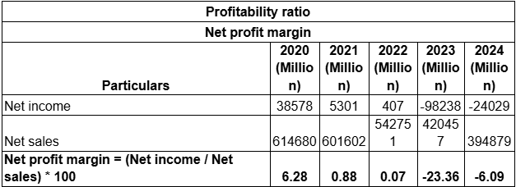
Figure 1: Net profit margin
(Source: self-report, 2025)
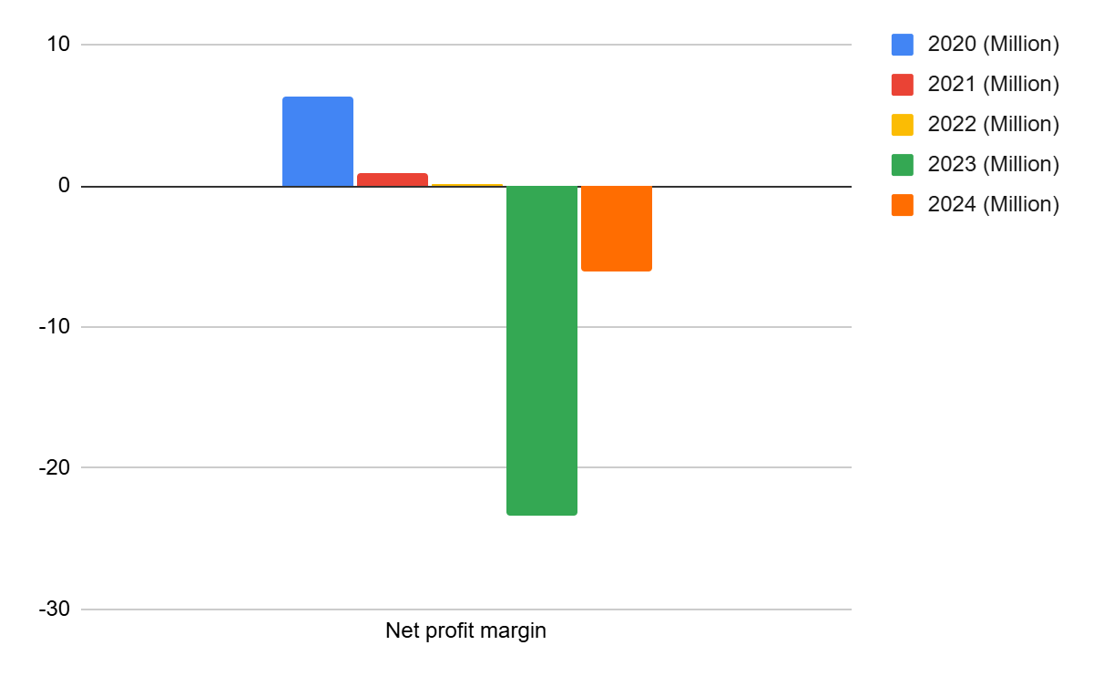
Figure 2: Net profit margin
(Source: self-report, 2025)
After taxes and costs, a company's net profit margin is used to calculate its net income per unit of sales (Corporatefinanceinstitute, 2025) (see Appendix 1, Figure 1). The margin dropped significantly, from 6.3% in 2020 to losses of 23.6% in 2023 and 2024, respectively, suggesting low profitability and inefficient costs. High expenses and subpar income performance are examples of such losses.
b. Operating Margin

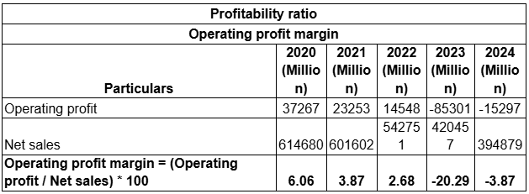
Figure 3: Operating profit margin
(Source: self-report, 2025)
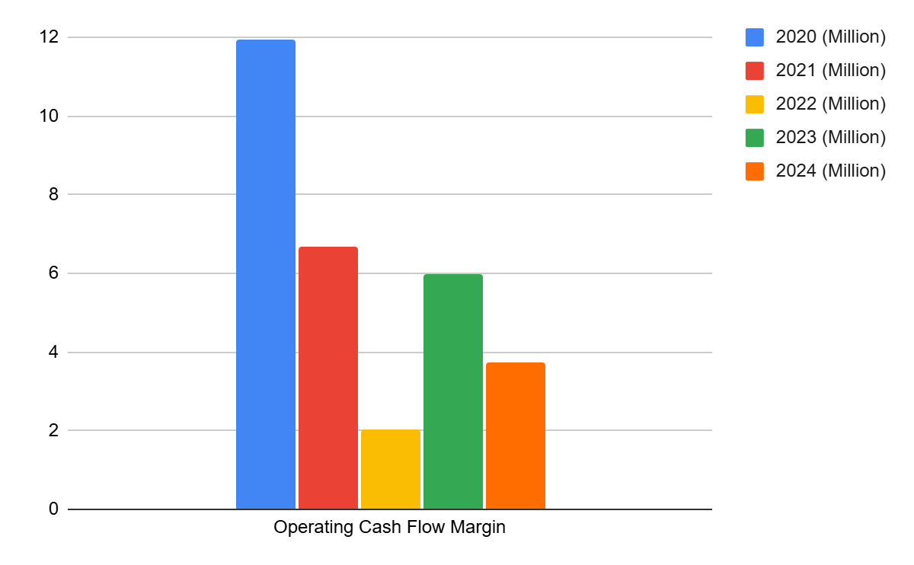
Figure 4: Operating profit margin
(Source: self-report, 2025)
operating margin is the proportion of profit from core activities that is free of interest and taxes (see Appendix 1, Figure 2). It fell as low as 6% in 2020, -20% in 2023, and -40% in 2024, indicating a substantial decline in operating efficiency. The decline was most likely brought on by higher selling and administrative expenses. The total negative margins indicate lower production and ineffective cost control.
c. Current Ratio

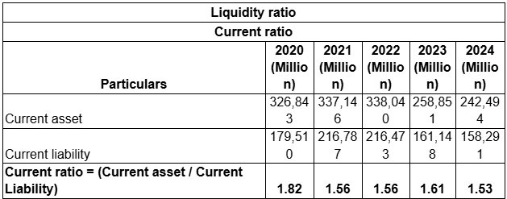
Figure 5: Current ratio
(Source: self-report, 2025)
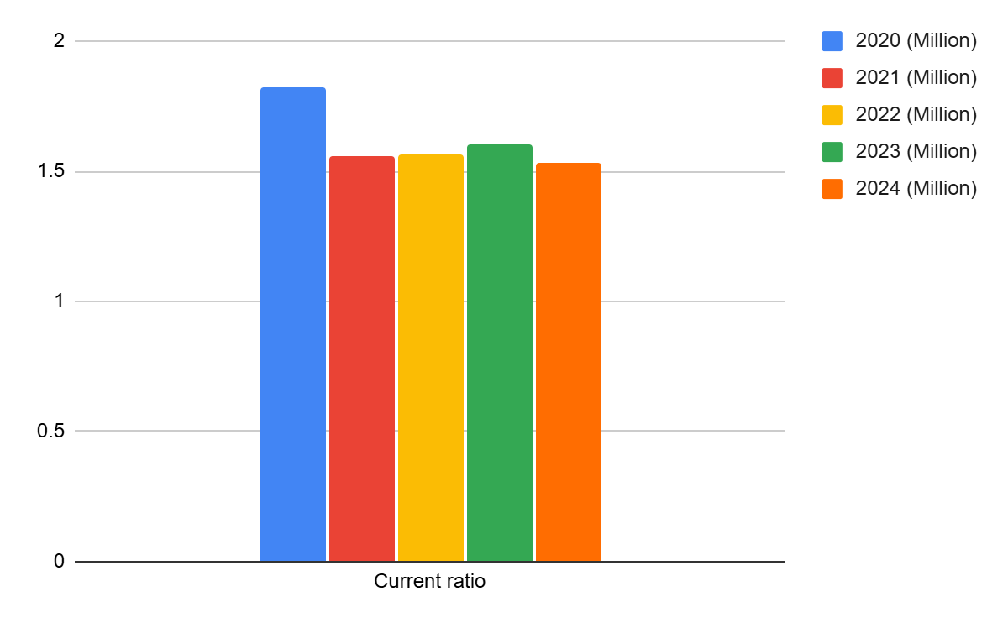
Figure 6: Current ratio
(Source: self-report, 2025)
According to Corporate Finance Institute (2024), the current ratio calculates how much of a company's current assets may be used to pay down its current obligations (see Appendix 1, Figure 3). As a sign of declining liquidity, it dropped to 1.8 in 2020 and then to 1.5 in 2024. The declining trend suggests worsening working capital, even if a ratio greater than one implies adequate short-term solvency. This suggests that the company's cash flow is limited. Shortened payment times and efficient inventory management might constrain liquidity.
d. Quick Ratio

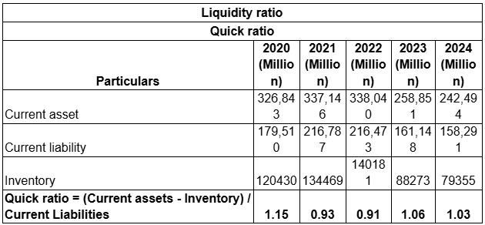
Figure 7: Quick ratio
(Source: self-report, 2025)
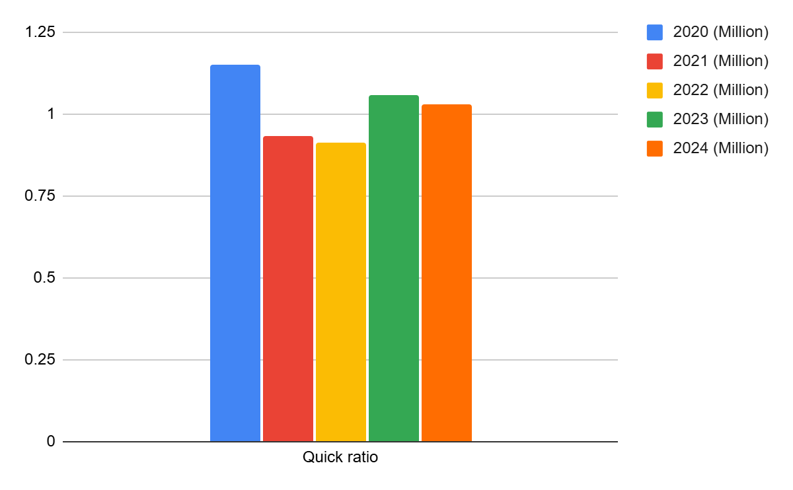
Figure 8: Quick ratio
(Source: self-report, 2025)
Using solely liquid assets and ignoring inventories, the Quick Ratio evaluates the ability to meet short-term commitments (Gunawan, 2023) (see Appendix 1, Figure 4). In 2024, it dropped to about 1.0, indicating weakened liquidity. A short time ratio of, instance, 1 indicates that the company can simply meet its responsibilities without having to liquidate any inventory. In 202122, values below 1.0 indicated that the payments were reliant on stock.
e. Inventory Turnover

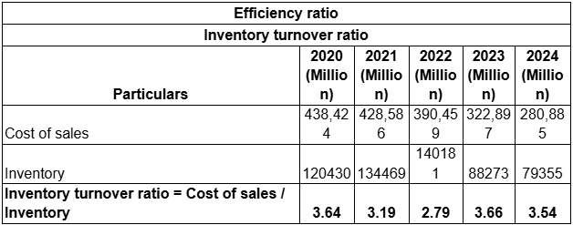
Figure 9: Inventory turnover ratio
(Source: self-report, 2025)
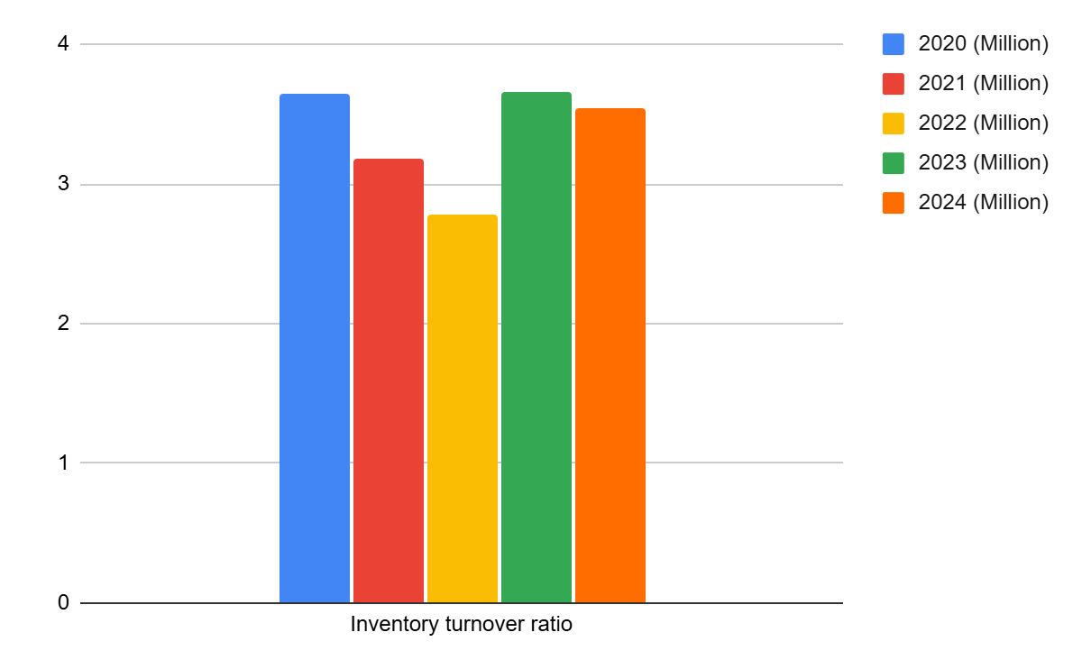
Figure 10: Inventory turnover ratio
(Source: self-report, 2025)
Inventory turnover shows how often inventory is sold and restocked over time (BDC, 2025) (see Appendix 1, Figure 5). After declining in 2022, it rose to 3.5 times in 2024, indicating better inventory control and a rebound in demand. However, the efficiency is still lower than it was before to 2021. The business should balance the cycles of sales and production.
f. Receivables Turnover

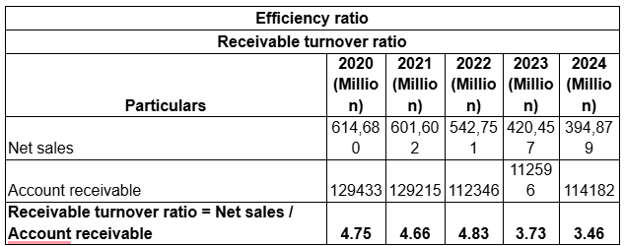
Figure 11: Receivable turnover ratio
(Source: self-report, 2025)
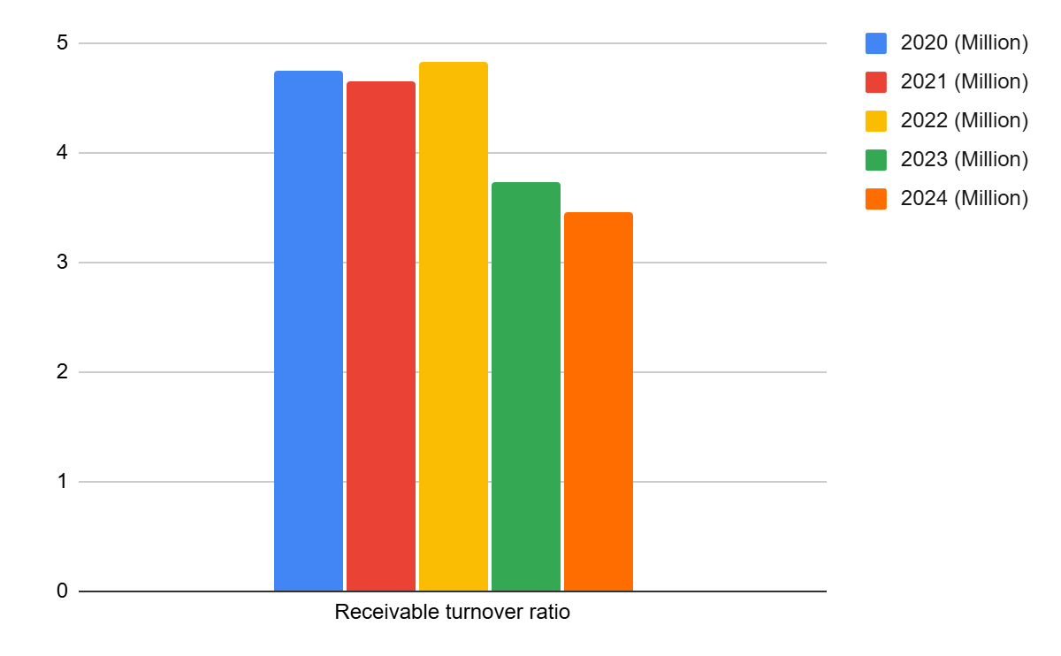
Figure 12: Receivable turnover ratio
(Source: self-report, 2025)
According to Yusup and Hariani (2023), the Receivables Turnover shows how quickly the business collects receivables from clients (see Appendix 1, Figure 6). Due to slower collections and credit risk, it decreased from 4.7 times in 2020 to 3.5 times in 2024. Soft credit policies or a decline in consumer demand might be the cause of this. Cash inflows and liquidity are reduced by the sluggish collection. It is advised that the business improve its credit management.
g. Debt to Equity Ratio
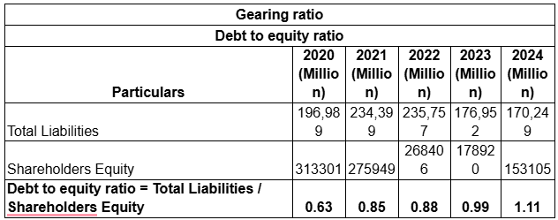
Figure 13: Debt-to-equity ratio
(Source: self-report, 2025)
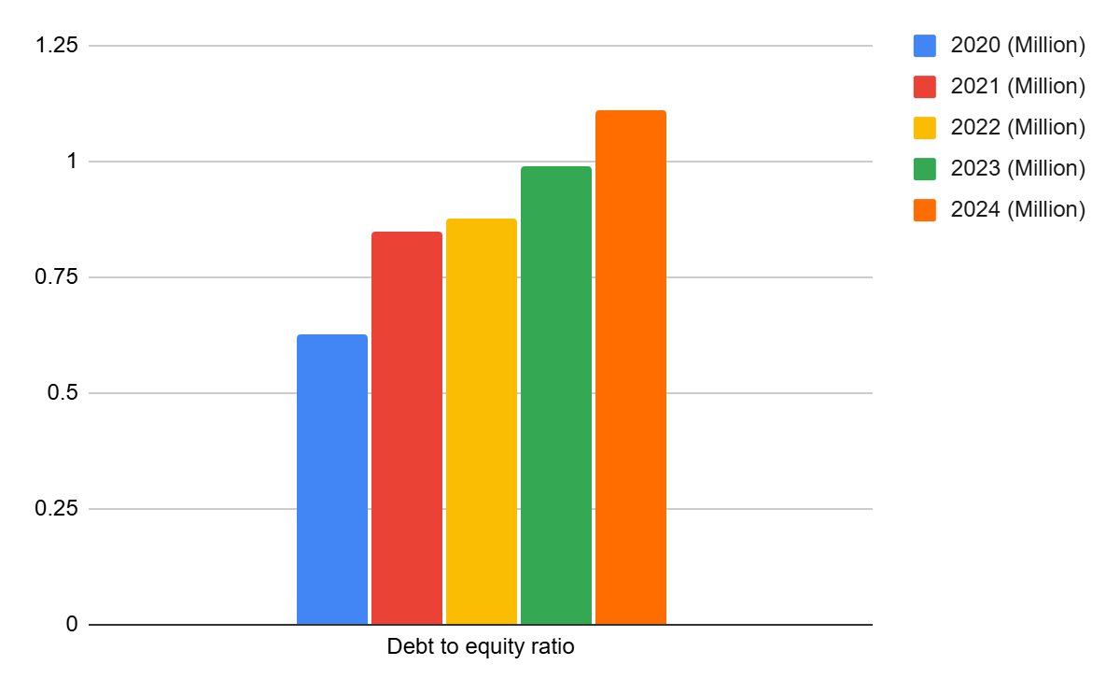
Figure 14: Debt-to-equity ratio
(Source: self-report, 2025)
To demonstrate financial leverage, a company's total debt and shareholder equity are compared using the debt to equity ratio (Corporate Finance Institute, 2023; see Appendix 1, Figure 7). It rose from 0.63 in 2020 to 1.11 in 2024, indicating a greater reliance on borrowed funds. Financial risk arises from high leverage, especially when profitability declines. Due to a protracted loss, the growth also suggests poor equity. The company should also work to rebalance its funding sources in order to restore investor trust and financial stability.
h. Interest Coverage Ratio

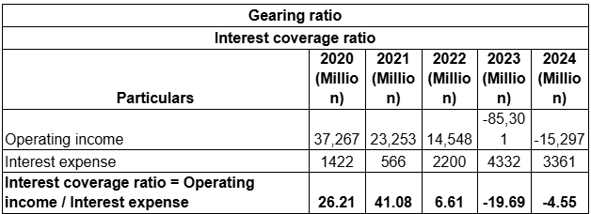
Figure 15: Interest coverage ratio
(Source: self-report, 2025)
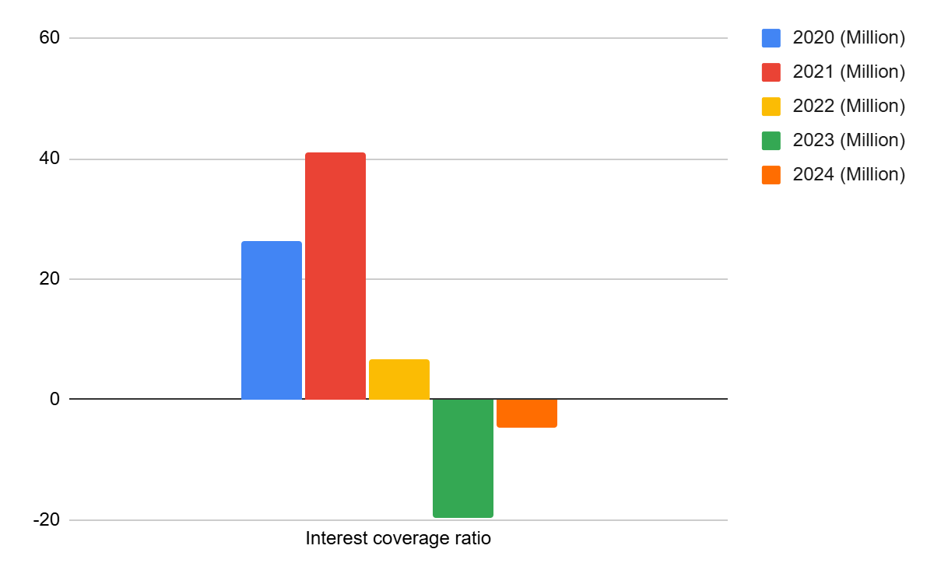
Figure 16: Interest coverage ratio
(Source: self-report, 2025)
According to Iotti et al. (2024), the Interest Coverage Ratio shows how easily a company may use its operating income to pay interest on its debt (see Appendix 1, Figure 8). It dropped from 26.1 times in 2020 to negative in 2023 and 2024, indicating that the company would not be able to use profits to pay interest costs. It is a sign of extreme financial hardship and maybe bankruptcy. Inadequate coverage would increase borrowing costs and erode lender trust. Recovering profitability and reducing debt levels are critical.
i. Return on Equity (ROE)

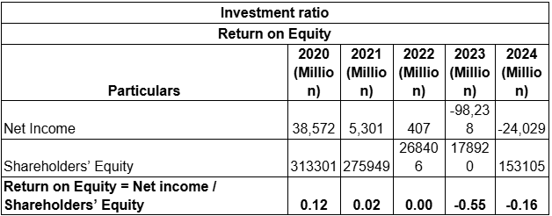
Figure 17: Return on Equity
(Source: self-report, 2025)
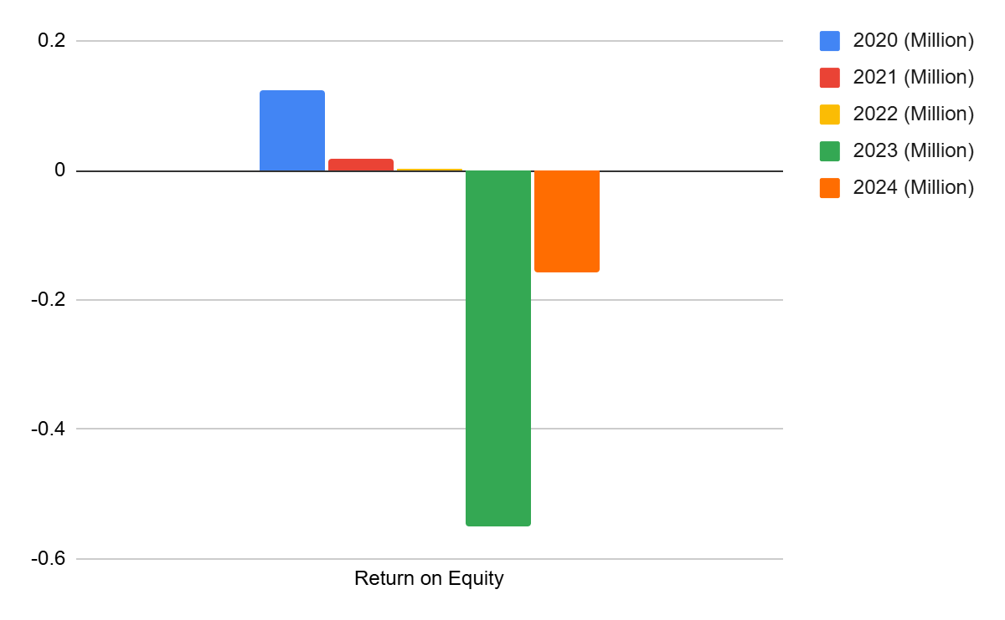
Figure 18: Return on Equity
(Source: self-report, 2025)
According to HBS (2025), ROE is a measure of how well a company uses shareholder capital to generate profits (see Appendix 1, Figure 9). With significant losses and the erosion of equity value, it dropped from 12.3% in 2020 to -54.9% in 2023 and -15.7% in 2024. The significant negative ROE suggests that rather of being yielded, the shareholders' money is being washed away. The business would need to increase operational effectiveness in order to undo this.
j. Earnings per Share (EPS)

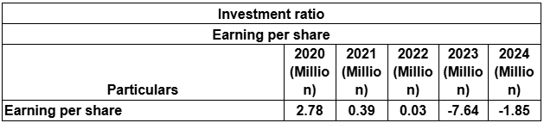
Figure 19: Earnings per share
(Source: self-report, 2025)
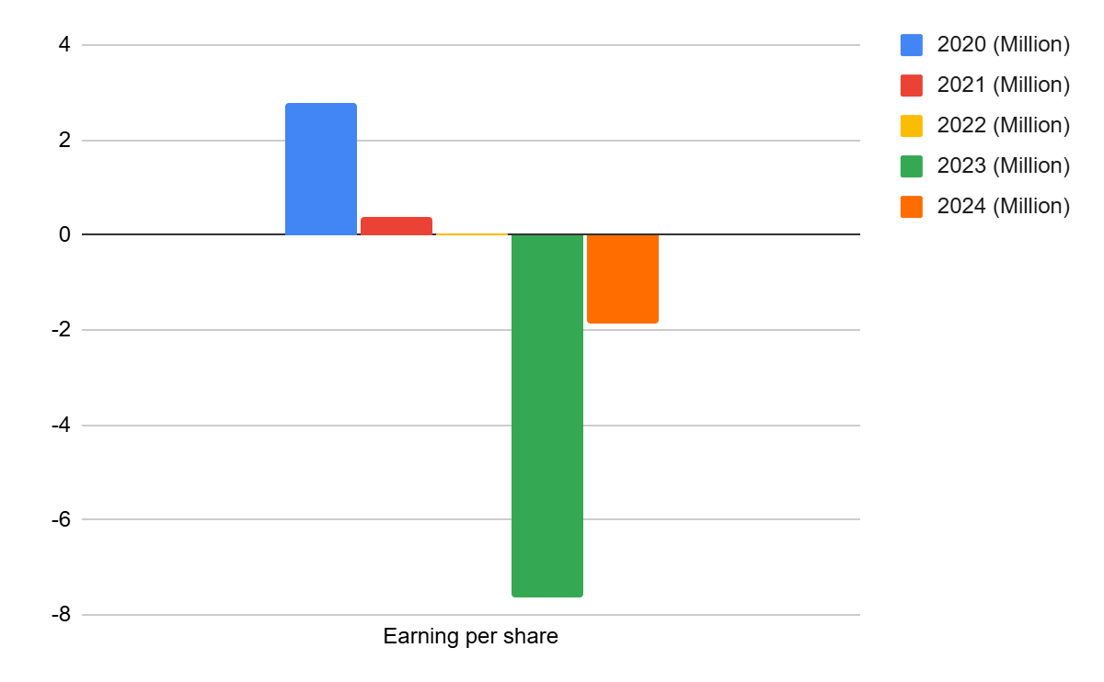
Figure 20: Earnings per share
(Source: self-report, 2025)
According to Hidayat et al. (2021), EPS is the amount of profit allocated to each outstanding share (see Appendix 1, Figure 10). With very low profits, it fell sharply in 2020, from 2.78 to -7.64 in 2023 and 2024, respectively. The overall loss of earnings and possible asset impairments are reflected in the deterioration. Market value and shareholder trust are destroyed by persistently negative EPS. Revenue must rise and expenses must be kept under control in order to regain profitability.
k. Operating Cash Flow Margin

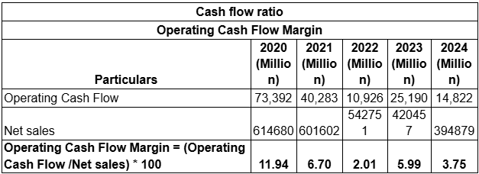
Figure 21: Operating Cash Flow Margin
(Source: self-report, 2025)
Figure 22: Operating Cash Flow Margin
(Source: self-report, 2025)
This ratio is the proportion of operating cash to total sales (Corporate Finance Institute, 2025) (See Appendix 1, Figure 11). It dropped to 3.8 in 2024 from 11.9 in 2020, but it is still positive, showing that the business can generate operational cash even when it is losing money. However, the declining margins suggest that the sales-to-cash conversion process is inefficient.
l. Free Cash Flow Margin

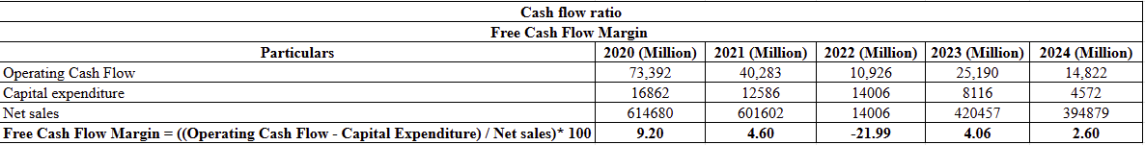
Figure 23: Free Cash Flow Margin
(Source: self-report, 2025)
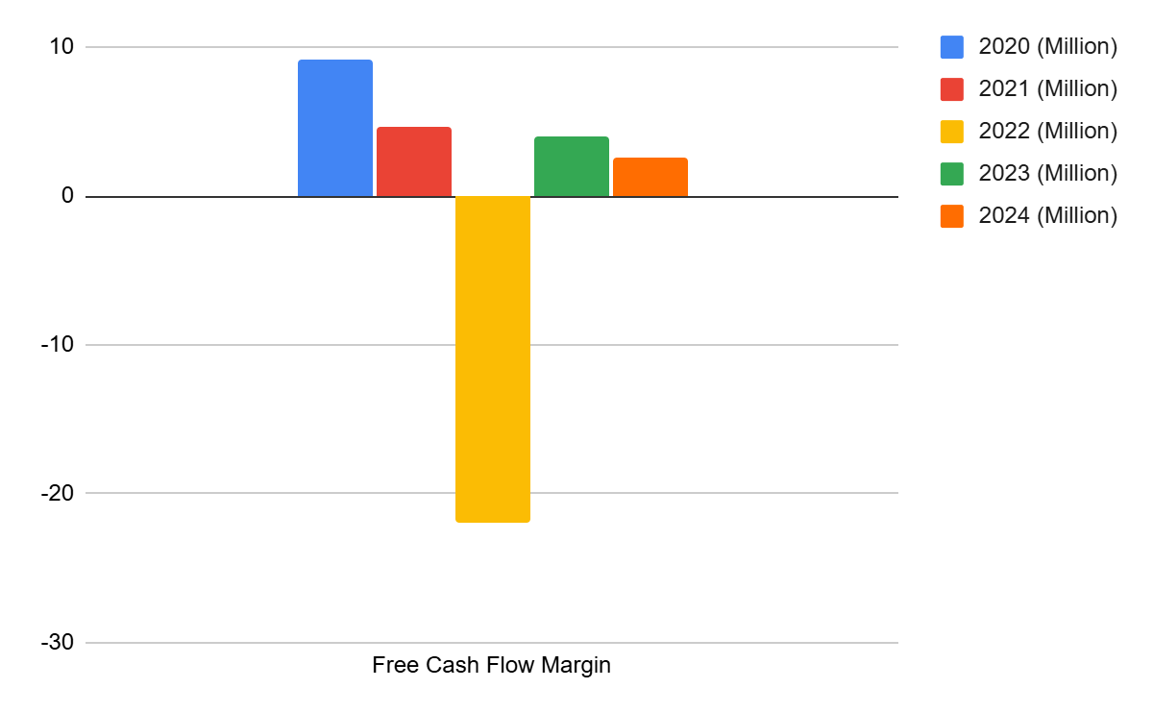
Figure 24: Free Cash Flow Margin
(Source: self-report, 2025)
The proportion of sales that remain after capital expenditures are deducted is known as the free cash flow margin (Hersi, 2021) (see Appendix 1, Figure 12). It declined to 2.2% in 2022 and 2.6% in 2024, indicating less financial flexibility. A positive but declining free cash flow (FCF) shows that cash is becoming smaller after investments. To sustain liquidity, the business should concentrate on the required capital expenditures and raise the operational cash generation rate.

2.3 Finding Trend, Advantages, and Threats
Area | Trend | Interpretation
Revenue | Sales dropped to £394,879 million in 2024 from £614,680 million in 2020. | A roughly 36% decline in sales suggests a potential loss of global market share and weakening of demand. Threat
Profitability | Between 2020 and 2024, net income decreased from £38,572 million in gains to £24,029 million in losses. | demonstrates declining profitability brought on by lower sales and higher COGS. Threat
Operating Margin | Reduction from 6.06% in 2020 to -3.87% in 2024 | decreased effectiveness in sales and a startling rise in expenses, Threat
Liquidity Ratios | As of 2024, the current ratio fluctuated between 1.82 and 1.53. | The short-term liquidity has been maintained, although it is gradually decreasing. Threat
Leverage | Between 2020 and 2024, the debt-to-equity ratio increased from 0.63 to 1.11. | demonstrates the company's growing dependence on debt and declining equity. This indicates the company's financial danger. Threat
Cash Flow | The operational cash flow decreased from 11.94% to 3.75% throughout these five years. | ineffective cash conversion from sales. This indicates a decrease in sales effectiveness. danger. As of 2024, operational cash flow of £14,822 million indicates a steady performance of core businesses. Advantage
Asset Efficiency | Between 2022 and 2024, inventory turnover increased somewhat from 2.79 to 3.54. | After experiencing losses in 2022, the corporation has improved its inventory management. Advantage
Shareholder Return | From 12%, return on equity dropped to -16%. | steady drop in the value of shares. Threat
Table: Findings from the Financial Statement and Ratio Analysis above
(Source: Self-developed)
Regarding the company's strengths, it was discovered that, in spite of the enormous losses shown in its financial statement, General Electronics' core business activities performed steadily, as seen by its operational cash flow of £14,822 million as of 2024. Additionally, the steady turnover of accounts receivable demonstrates that even in recessions, client payment cycles provide steady revenue. Additionally, the decrease in inventory levels from £140,181 million in 2022 to £79,355 million in 2024 indicates a rise in the efficiency of working capital. According to Ibrahim et al. (2021), a company's total financial performance may be enhanced by increasing the working capital cycle's efficiency. According to Wang et al. (2020), General Electronics may decrease receivables and enhance net finances available for day-to-day operations by implementing an aggressive working capital strategy.
However, in terms of risks, General Electronics may have long-term financial non-performance due to the mounting debt pressure, as seen by the growing debt-to-equity ratio. Furthermore, as the accompanying table shows, the company's costs are rising at an alarming rate. This puts the company's profitability in jeopardy. Additionally, economic unsustainability is shown by the shareholder value, which fell to -16% in 2024, endangering the exit of important shareholders.

2.4 Predicting Corporate Failure with the Altman Z-Score Model
Using financial measures, the Altman Z-Score model (Altman, 1968) is a quantitative model designed to predict a company's likelihood of filing for bankruptcy. It incorporates five weighted indicators: Market value of Equity to Total Liabilities (X 4), Earnings before Interest and Taxes to Total Assets (X 3), Working Capital to Total Assets (X 1), Retained Earnings to Total Assets (X 2), and Net Sales to Total Assets (X 5). Z = 1.2X₁ + 1.4X₂ + 3.3X₃ + 0.6X₄ + 1.0X₅ is the formula formulated.
The estimated values of this model when applied to General Electronics using the most recent data for 2024 are:
Total assets divided by working income is 0.26.
EBIT/Total Assets = -0.05 and retained earnings/Total Assets = -0.07
Sales/Total Assets = 1.22 Market Value of Equity/Total Liabilities = 0.90
Z is thus equal to (1.2×0.26) + (1.4×−0.07) + (3.3×−0.05) + (0.6×0.90) + (1.0×1.22) = 1.44.

Altman suggests that the companies that have a Z-score below 1.8 are operating in the crisis zone and have high probability of failure. General Electronics is therefore in dire financial troubles as the Z-score of 1.44 depicts in line with previous results of dwindling profitability, negative ROE, and rising debt. To re-establish solvency and investor confidence, such a foreseeable situation solidifies the need to restructure programs, which encompass divestiture of under-performing assets and enhanced working capital effectiveness.

3. Working Capital Management Analysis.
The cash operating cycle is evaluated by measuring the duration the business takes to manage current assets and settle current liabilities.

3.1 Evaluation of Cash Operating Cycle
The cash operating cycle is determined by the number of days that the business requires to use current assets and purchase current liabilities.
The period of time required to turn inventories and receivables into cash is a cash operating cycle (COC), and it demonstrates the efficiency with which the company employs its working capital (Asman et al., 2022) (See Appendix 1, Figure 13). The General Electronics inventory turnover rate improved with a rate of 2.79 in 2022 and 3.54 in 2024 which suggests a faster rate in which inventory is being cleared. Nevertheless, the decrease in the receivables turnover indicated the slower rates of customer collection as the number dropped to 4.83.
This mixture is a sign that despite the improvement of the stock management, the cash conversion period has been raised as well because of the delay in the payment of clients. Also, the business is experiencing sluggish cash collection in operations thus decreasing liquidity and making finance difficult. Also, a longer COC will mean that there is money left to repay debt or invest.

3.2 Recommended Strategies
The rising debt-to-equity ratio of General Electronics shows the necessity to enhance the liquidity through the means of working capitals usage in comparison to the outside sources.
Some of the tactics proposed include the following:
Increasing Conversion of Receivables to Cash: The organization currently has lower cash flow turnover rate which is indicated by the receivable turnover of 4.83 in 2022 and 3.46 in 2024. Bessonova et al. (2024) argue that the excessive amount of receivables restricts the liquidity of a company and reduces its profitability. Therefore, it could be recommended that the company could raise the liquidity through expediting the collection of the past sales by tightening credit standards, offering incentives to fast pay and outsourcing the collection. This was supported by Ebben and Johnson (2011) who asserted that businesses could make more liquid and profit through the proper management of cash conversion cycle.
Further Inventory Optimization: Despite the declining inventory of General Electronics whereby the inventory declined in 2022 to £140,181 million, compared to the 79,355 million in 2024, the current inventory ratio remains at 33 percent of current assets of the company. This implies that it means that inventory optimization should be further advanced by decreasing the inventory and applying leaner methods such as Just-in-Time (JIT) methods, demand forecasting tools and simplifying stock holding unit. This can also lead to an increment in the total liquid assets that are freed up by the firm, and this will raise the liquidity of the firm. This is supported by Hänninen (2024) who asserts that effective inventory management should be a priority of companies because it reduces investment in inventory, introduces new inventories, and improves liquidity. In addition, Uduehe (2025) agrees with this argument by highlighting the role inventory management plays in financial stability of a company as it could improve the financial liquidity of a firm.

3.3 A Comparison of Long-Term Financing Alternatives and Short-Term Financing Alternatives.
Short-term and long-term funding differ in terms of their length, cost and aim. Examples of financing alternatives that are short-term include credit lines, trade payables and short-term loans that are usually settled within one year (Corporatefinanceinstitute, 2024). The long-term financing will comprise bonds, debentures, and equity financed on assets or their growth and repaid in a number of years (Gupta and Chandra, 2024). General Electronics is increasingly dependent on short-term borrowing, as seen on the balance sheet: in 2020, it was dependent on short-term borrowing to the tune of 20,000 million, whereas in 2024, it has increased to 36,960 million. This demonstrates that liquidity requirements will be provided through short-term borrowing. Even though short term financing is more flexible and less expensive than long term financing, it has a liquidity risk in case of poor sales. The quick and current ratio of the business is also declining and this indicates a declining ability to meet the short-term obligation when faced with a pressure.
In contrast, long-term debt including deferred obligations, leases, has been stable. This may indicate reduced reliance on long-term financing perhaps to evade the obligation of increased rates of interest and long-term repayments.
Long-term financing, however, is reliable and allows the business to invest in profitable assets without having to make repayments right away. The company's debt-to-equity ratio has gone up, and in 2024 it will be 1.11, up from 0.63 in 2020. The business must strike a balance between the two funding streams. While excessive long-term debt may reduce financial flexibility and increase interest obligations, excessive short-term debt may place ministership on their liquidity.
To balance it, General Electronics has to focus on internal financing by improving working capital management. Reduced dependency on pricey outside sources would result from faster receivables collection and more inventory optimization. When external finance is needed, a mix of long-term loans and retained profits will ease the burden’.

4. Strategic Financial Restructuring Plan

4.1 Recommended Options for Financial Restructuring
Strategic Option 1: Selling Off Underperforming Non-Core Assets
According to study by Depecik et al. (2014), a company's value may increase if its underperforming non-core assets are sold. ‘In this sense, General Electronics' return-on-assets (ROA) has sharply decreased from 7.6% in 2020 to −7.4% in 2024, despite the fact that its asset base is still £323,354 million in 2024. This further demonstrates that, as of 2024, the company is holding onto assets that don't provide adequate returns and instead lower the company's profitability. Conversely, selling these assets will boost the company's liquid cash reserves, which will allow it to engage in the purchase of assets that will provide higher returns in the road. Therefore, in the instance of General Electronics, selling off non-core businesses that aren't functioning well is a wise strategic move.
Strategic Option 2: Injection of Equity via the Rights Issue
According to Burkart and Zhong's (2023) study, companies that are losing money often decide to increase their ownership by giving their existing shareholders rights since they are more likely to want to see the company succeed. As a result, General Electronics' shareholders will be more likely to contribute stock to the company in order to get ROE in return for a rights issue, given that the company's shareholder value has dropped to -16% as of 2024. However, Burkart and Zhong (2023) point out that companies often use finance as a last alternative when it comes to generating equity via the issuing of rights. Although equity injection is a suitable strategic alternative for General Electronics under the present circumstances, it is not a better choice than the previously mentioned divestment since it is a last resort.
Therefore, the sale of General Electronics' underperforming non-core assets is the best course of action for the company's strategic financial reorganization.

4.2 Effect on Operational Flexibility, Shareholder Value, and Debt Structure
Debt Structure: According to Feldman's (2021) study, companies employ divestitures to address internal problems, such as the underperformance of business divisions or enterprises. This is consistent with the General Electronics example. In this sense, selling off non-core assets that aren't performing well may have an impact on the company's debt structure by significantly increasing its liquidity, which makes it possible for the company to pay back its debts and lower the debt-to-equity ratio, which went from 0.63 in 2020 to 1.11 in 2024. According to their study, Naomi (2023) clarified that although interest on loans is seen as a real expenditure of a business, prompt debt repayment might improve the business's trustworthiness. In this sense, the firm's interest-based costs may be decreased by the divestment by increasing liquidity, and the firm's creditworthiness can be enhanced by repaying the loans, which will enable it to borrow money at a lower cost in the future. This demonstrates how the debt structure of General Electronics may be significantly impacted by the usage of divestiture of non-core assets that are not functioning well.
Shareholder Value: According to Osiichuk and Wnuczak's (2021) research, non-operating assets can significantly reduce a company's potential value in the absence of strict shareholder control. This is because these assets and associated activities deprive businesses of their agility, making the organizational structure as a whole needlessly opaque. Regarding General Electronics, the underperforming non-core assets are also having an impact on the company's profitability and agility by causing ROA to decline, which ultimately destroys shareholder value. As a result, selling off such assets may not only boost the company's liquid cash reserves but also decrease its debt-to-equity ratio, which lowers leverage, lowers the cost of capital, and raises shareholder equity. Therefore, General Electronics' shareholder value may be significantly increased by the divestiture of non-core, underperforming assets.
Operational Flexibility: In terms of General Electronics' operational flexibility, the company may simplify its core business operations by selling off non-core assets. This gives the company the flexibility to focus its resources and experience on enhancing its core operations. Additionally, by streamlining the company's organizational structure, this helps enhance decision-making procedures at General Electronics. According to Osiichuk and Wnuczak (2021), a company's corporate structure may become opaque due to non-operating assets. In this sense, it is evident that the sale of non-core underperforming assets may have a significant effect on General Electronics' operational flexibility. The strategic sale of non-performing assets may increase the firm's operational efficiency and, therefore, its financial returns, according to research by OSAIGBOVO and AKHIMIEN (2025).

4.3 Related International and Ethical Considerations
General Electronics must take into account several international and ethical factors, such as CSR, taxation, inflation, and currency risks, while implementing the divestiture of underperforming non-core assets as a financial restructuring plan.
Tax Liabilities: For example, in various foreign markets, the capital gains from asset sales may result in varying tax obligations. Therefore, in order to prevent problems like double taxation and non-compliance with OECD transfer pricing requirements, General Electronics must appropriately arrange the asset transactions.
CSR: Additionally, General Electronics must ethically govern the aftermath of divestment in terms of CSR via green investments, responsible layoffs, and open communication and reporting of the whole process. In this respect, Malapur (2024) went on to say that responsible staff layoffs and transparent progress reports are crucial for successfully integrating CSR into corporate restructuring initiatives of businesses during asset divestment.
Inflationary Risk: The value of the assets to be sold may fluctuate quickly in countries with significant inflation, hence General Electronics will need to conduct open reappraisals.
Currency Risk: Additionally, General Electronics' asset purchases in unstable international markets may result in a decrease in sales proceeds upon translation to the company's reporting currency. In order to avoid such losses as a result of currency depreciation, the company must establish forward contracts. This is corroborated by Ilia et al. (2019), who claim that currency risk is a significant risk for a company's equity capital depreciation’.

5. Investment Appraisal and Capital Budgeting

5.1 Assess of Three Proposed Investment Projects
NPV
Definition
‘The difference between the investment and the project's current cash inflows is known as net present value, or NPV. It is used to determine the project's overall current-worth to the company (Net present value, 2024). A positive net present value (NPV) indicates that the project is lucrative; a negative NPV suggests that the project should not be performed.
Project A
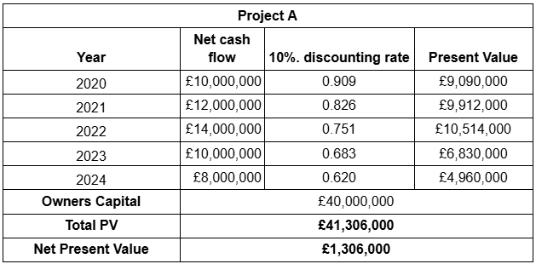
Figure 26: NPV for Project A
(Source: self-report, 2025)
In five years, Project A will have a positive cash flow with a starting capital of forty million pounds. At a 10% discount rate, the net present value (NPV) of the inflows is 1.31 million, out of a total present value of 41.31 million. This suggests that the project is cost-effective and will provide a marginal value. The payback time is steady and the rewards are modest. With a profitability index over 1, Project A will boost shareholder value and be deemed acceptable; nevertheless, its profitability is lower than Project C's and is somewhat constrained by capital efficiency.
Project B
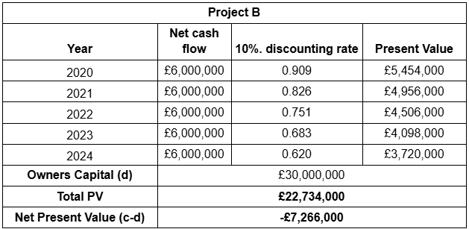
Figure 27: NPV for Project B
(Source: self-report, 2025)
Project B has an annual inflow of 6 million, but it requires a 30 million investment. At a 10% discount rate, the NPV has a negative value of 7.27 million due to its present value of 22.73 million. This suggests that the enterprise destroys value and fails to cover its cost of capital. The low and low cash flows show minimal returns and little room for expansion. It is not financially feasible, as shown by the profitability index being less than 1. In conclusion, Project B should not be approved as it does not meet the company's investment performance standards and does not provide the proper returns.
Project C
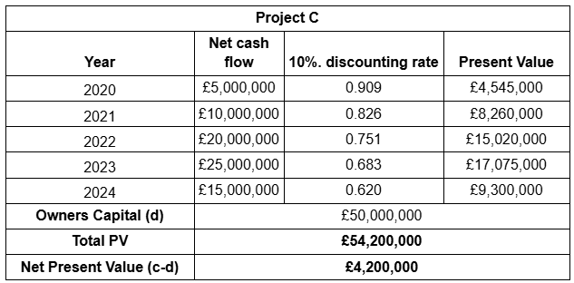
Figure 28: NPV for Project C
(Source: self-report, 2025)
In addition to requiring a substantial capital expenditure of fifty million pounds, Project C has a significant and increasing inflow during a five-year investment term. At a 10% discount, the inflows' total present value is 54.2 million, yielding an NPV of 4.2 million. Out of the three, Project C offers the most value, according to this favorable NPV. Between years one and four, the cash flows increase significantly, suggesting a great potential for profitability. The project will provide superior returns and have a profitability index greater than 1, despite its high starting cost. It must be given priority to invest in it as it has achieved higher financial performance, and it utilizes its capital properly.
IRR
Definition
The rate at which a project's net present value is regarded as zero is known as the discount rate. It is the project's projected rate of return. The project is economically viable and ought to be approved if the internal rate of return (IRR) exceeds the company's needed rate (Fregonara and Ferrando, 2023).
Project A
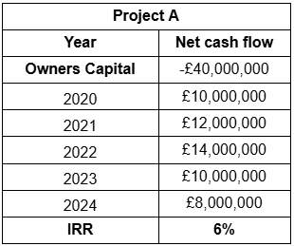
Figure 29: IRR for Project A
(Source: self-report, 2025)
After a £40 million initial investment, Project A would see increasing financial inflows over the course of five years, peaking at 14 million in the third year. The internal rate of return (IRR) is 6%, which is lower than the projected cost of capital of 10%, indicating that the project would not provide the necessary rate at the company. The project does not provide enough profitability despite the consistent inflows it generates. Project A is thus financially poor and shouldn't be approved unless it has been chosen for non-financial or strategic grounds. Its investment risk is medium and its value production is modest.
Project B
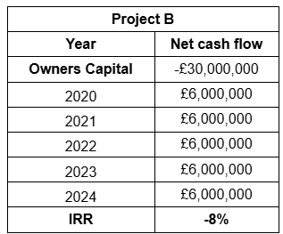
Figure 30: IRR for Project B
(Source: self-report, 2025)
A capital expenditure of thirty million pounds is needed for Project B, and the yearly inflows are equal to that amount, or six million pounds annually, over a five-year period. The project is clearly not lucrative and cannot justify its original cost, as seen by the predicted IRR of -8. Even without discounting, the return's negative value shows that total inflows are insufficient to cover the original investment. This suggests that it uses capital inefficiently and with a significant degree of financial risk. Under any reasonable cost of capital assumption, the project should be rejected right away since it destroys value and has no prospects for future expansion.
Project C
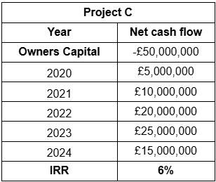
Figure 31: IRR for Project C
(Source: self-report, 2025)
With a £50 million investment, Project C's cash flows increased to a high of up to £25 million in year four before modestly declining in the final year. As with Project A, the IRR of 6 indicates poor profitability since it is less than the 10% cost of capital. However, the project offers more cash flow growth and cumulative returns, which are preferable over time. However, the investment still does not meet the required level of quality. Strictly speaking, Project C is not a wise investment endeavor; it would only be considered if there are strategic or non-financial benefits.
Profitability Index
Definition
The present value of future cash inflows relative to the original investment is known as the profitability index ratio. According to the Profitability Index (2024), it shows the value generated per pound invested. The project should be rejected if the PI is less than 1, but if it is larger than 1, it indicates that the project will provide value.
Project A
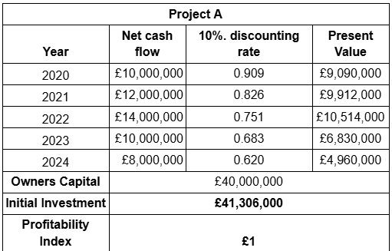
Figure 32: Profitability Index for Project A
(Source: self-report, 2025)
Project A calls for an initial investment of $40 million and a five-year cash inflow of $8–14 million annually. At a 10% discount rate, the total present value of inflows will be £41.31 million, resulting in an index of profitability (PI) of around 1.03. This indicates that the project is a source of marginal value and has already beyond the break-even point. The project seems to be quite solid, and the returns are mediocre. Cash flows are balanced, and risk is under control. As a result, Project A is a respectable but not the most lucrative option when compared to others.
Project B
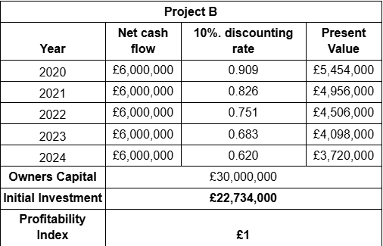
Figure 33: Profitability Index for Project B
(Source: self-report, 2025)
A £30 million initial investment is required for Project B, and over a five-year period, inflows of the same amount will total 6 million yearly. Calculating the total present value of these inflows at a 10% discount rate of 22.73 million will result in a profitability index of around 0.76 or less than 1. This suggests that if the project is carried out, value will be destroyed and the cost of capital will not be covered. Low growth rates and inefficient capital use are implied by the uniform flow of inputs. Project B is thus not financially attractive and therefore to be disregarded based on the current presumptions.
Project C
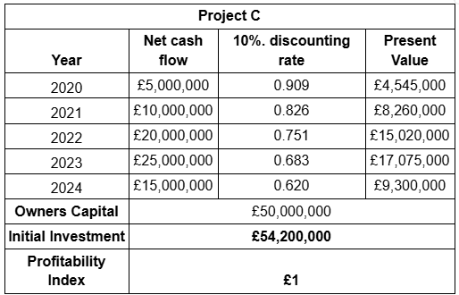
Figure 34: Profitability Index for Project C
(Source: self-report, 2025)

Payback period
Project A
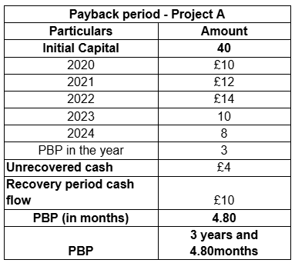
Figure 35: Payback period for Project A
(Source: self-report, 2025)
Project B
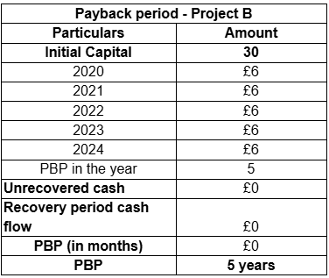
Figure 36: Payback period for Project B
(Source: self-report, 2025)
Project C
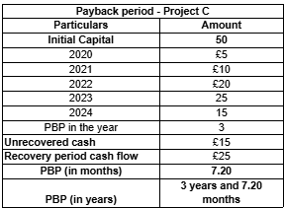
Figure 37: Payback period for Project C
(Source: self-report, 2025)

ARR
Project A
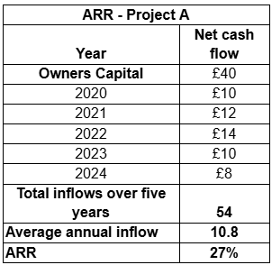
Figure 38: ARR for Project A
(Source: self-report, 2025)
Project B
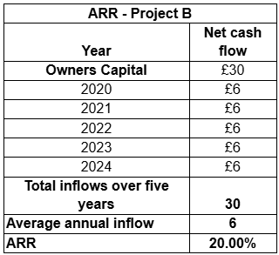
Figure 39: ARR for Project B
(Source: self-report, 2025)
Project C
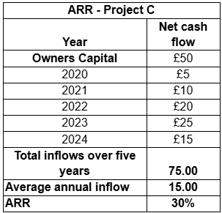
Figure 40: ARR for Project C
(Source: self-report, 2025)
In addition to requiring a larger investment of fifty million pounds, Project C will generate enormous inflows that will progressively rise over time, reaching twenty-five million pounds in the fourth year. The present value, calculated using a 10% discount rate on the inflows, equals the discounted amount of the inflows and comes to 54.2 million pounds, or around one point eight on the profitability index. This suggests that there is a high rate of value creation and strong returns relative to the cost of the investment. Despite having a higher initial investment, the project has a strong cash flow characteristic, indicating great profitability and efficient resource usage.

5.2 Final Investment Suggestion and Rationale
Project C is the most cost-effective option and should be picked for investment, according the investment appraisal study based on the NPV, IRR, and Profitability Index. With a profitability index of 1.08 and a maximum total present value of 542 million, Project C will have a positive net present value of 4.2 million. This suggests that it produces a high payout per pound invested and increases shareholder value. Even yet, the increasing cash inflows and the company's encouraging development prospects outweigh the hefty initial capital required of $50 million, making the investment worthwhile. With a PI of 1.03 and an NPV of £1.31 million, Project A is slightly profitable but less valuable than Project C. Project B is not profitable since its NPV is negative and its PI is less than 1. Since Project C produces the highest returns, it should be prioritized in a capital-rationing environment where only 60 million may be invested. Project A may be taken into consideration if there is more funding, whereas Project B would not be approved. Project C is the greatest choice to boost profitability and financial stability over the long run because of its excellent performance and higher resilience in terms of risk, as shown by rising cash flows.

6. Summary
Consequently, the financial analysis of General Electronics' accounts demonstrates that the business is now losing money, with negative shareholder values and an increasing debt-to-equity ratio. Here, it has been determined that the company may increase its liquidity by optimizing its inventory while reforming working capital and speeding up the conversion of receivables to cash. Additionally, the company has to restructure its finances by selling off non-core assets that aren't functioning well. This would enhance the company's debt load, operational flexibility, and shareholder value, as well as General Electronics' overall financial performance. Additionally, Project C is selected as suitable for General Electronics among the three strategic investment projects offered because of its high potential profitability’.

7. References
Asman, F.N., Fernandez, D., Jamaludin, N.A., Omar Zaki, H. and Ghazali, A.W., (2022). Cash conversion cycle and firm’s performance. International Journal of Academic Research in Business and Social Sciences, 12(11), pp.2682-2692.DOI:10.6007/IJARBSS/v12-i11/15276
BDC. (2025) BDC.ca. Available at: https://www.bdc.ca/en/articles-tools/entrepreneur-toolkit/financial-tools/inventory-turnover-benchmarking-tool (Accessed: 06 November 2025).
Bessonova, A., Bessonova, S. and Shevchenko, A., 2024. Optimisation of Receivables of an Enterprise as a Tool for Strengthening Financial Efficiency. Економіка розвитку систем, 6(2), pp.146-150.DOI:https://doi.org/10.32782/2707-8019/2024-2-20
Burkart, M. and Zhong, H., 2023. Equity issuance methods and dilution. The Review of Corporate Finance Studies, 12(1), pp.78-130.https://doi.org/10.1093/rcfs/cfac029
Corporate Finance Institute. (2023). Corporate Finance Institute. Available at: https://corporatefinanceinstitute.com/resources/commercial-lending/debt-to-equity-ratio-formula/ (Accessed: 06 November 2025).
Corporatefinanceinstitute. (2024) Corporate Finance Institute. Available at: https://corporatefinanceinstitute.com/resources/accounting/short-term-loan/ (Accessed: 06 November 2025).
Corporatefinanceinstitute. (2024). Corporate Finance Institute. Available at: https://corporatefinanceinstitute.com/resources/accounting/current-ratio-formula/ (Accessed: 06 November 2025).
Corporatefinanceinstitute. (2025). Corporate Finance Institute. Available at: https://corporatefinanceinstitute.com/resources/accounting/net-profit-margin-formula/ (Accessed: 06 November 2025).
Corporatefinanceinstitute. (2025). Corporate Finance Institute. Available at: https://corporatefinanceinstitute.com/resources/accounting/operating-cash-flow/ (Accessed: 06 November 2025).
Depecik, B., van Everdingen, Y.M. and van Bruggen, G.H., 2014. Firm value effects of global, regional, and local brand divestments in core and non‐core businesses. Global Strategy Journal, 4(2), pp.143-160.DOI: 10.1111/j.2042-5805.2014.1074.x
Ebben, J.J. and Johnson, A.C., 2011. Cash conversion cycle management in small firms: Relationships with liquidity, invested capital, and firm performance. Journal of small business & entrepreneurship, 24(3), pp.381-396.https://researchonline.stthomas.edu/esploro/fulltext/journalArticle/Cash-Conversion-Cycle-Management-in-Small/991015132345503691?repId=12438335950003691&mId=13439855180003691&institution=01CLIC_STTHOMAS
Feldman, E.R., 2021. Restructuring and divestitures (pp. 153-166). New York, NY: Oxford University Press.https://faculty.wharton.upenn.edu/wp-content/uploads/2016/11/Restructuring-and-Divestitures.pdf
Fregonara, E. and Ferrando, D.G., (2023). The discount rate in the evaluation of project economic-environmental sustainability. Sustainability, 15(3), p.2467.https://www.mdpi.com/2071-1050/15/3/2467.
Gunawan, E., (2023). Liquidity Ratio Analysis in Financing Short Term Liabilities. International Journal of Health, Economics, and Social Sciences (IJHESS), 5(2), pp.157-162.https://jurnal.unismuhpalu.ac.id/index.php/IJHESS/article/view/3611.
Gupta, A. and Chandra, P., (2024). TO STUDY CAPITAL STRUCTURE AND ITS RELATIONSHIP WITH FINANCIAL PERFORMANCE.https://www.researchgate.net/profile/Prakash-Chandra-23/publication/379809202_TO_STUDY_CAPITAL_STRUCTURE_AND_ITS_RELATIONSHIP_WITH_FINANCIAL_PERFORMANCE/links/661b6f2339e7641c0bbe9dba/TO-STUDY-CAPITAL-STRUCTURE-AND-ITS-RELATIONSHIP-WITH-FINANCIAL-PERFORMANCE.pdf.
Hänninen, P., 2024. Improving inventory management efficiency: the impact of optimisation.https://lutpub.lut.fi/bitstream/handle/10024/167053/Master%27s%20thesis_H%C3%A4nninen%20Pauliina.pdf?sequence=1&isAllowed=y
HBS. (2025) How & why to calculate return on equity (ROE) - HBS online. Available at: https://online.hbs.edu/blog/post/return-on-equity-formula (Accessed: 06 November 2025).
Hersi, I.A. (2021). The Relationship Between Cash Flow and Capital Expenditure of Firms Listed at the Nairobi Security Exchange (Doctoral dissertation, University of Nairobi).https://erepository.uonbi.ac.ke/handle/11295/160761.
Hidayat, R., Roespinoedji, D. and Saudi, M.H., (2021). Effect of return on assets, net profit margin and earning per share on stock prices. Turkish Journal of Computer and Mathematics Education, 12(8), pp.1388-1403.https://www.researchgate.net/profile/Rachmat-Hidayat-4/publication/356892457_Effect_of_Return_On_Assets_Net_Profit_Margin_and_Earning_Per_Share_on_Stock_Prices/links/61b19d3282a6ef0f35d3f98e/Effect-of-Return-On-Assets-Net-Profit-Margin-and-Earning-Per-Share-on-Stock-Prices.pdf.
Ibrahim, K.Y., Usaini, M. and Elijah, S., 2021. Working capital management and business performance. Nigerian Journal of Marketing (NJM) Vol. 7(1), pp.25-38.https://www.academia.edu/download/66068090/WORKING_CAPITAL_MANAGEMENT_AND_BUSINESS_PERFORMANCE.pdf
Ilia, K., Mariia, E. and Yury, D., 2019. The impact of currency risk on the value of firms in emerging countries. Корпоративные финансы, 13(1), pp.7-27.https://cyberleninka.ru/article/n/the-impact-of-currency-risk-on-the-value-of-firms-in-emerging-countries.pdf
Iotti, M., Manghi, E. and Bonazzi, G., (2024). Debt sustainability assessment in the biogas sector: Application of interest coverage ratios in a sample of agricultural firms in Italy. Energies, 17(6), p.1404.https://www.mdpi.com/1996-1073/17/6/1404.
Malapur, S.K.S., 2024. Corporate Social Responsibility Integration In Corporate Restructuring: A Pathway To Sustainable Growth.https://www.academia.edu/download/116962190/E2603083342.pdf
Naomi, I.W., 2023. Effects of Debt Financing on Financial Performance of Manufacturing Firms in Kenya. African Journal of Commercial Studies, 3(2), pp.86-95.https://ijcsacademia.com/index.php/journal/article/download/168/165
Net present value. (2024). Corporate Finance Institute. Available at: https://corporatefinanceinstitute.com/resources/valuation/net-present-value-npv/ (Accessed: 06 November 2025).
OSAIGBOVO, S. and AKHIMIEN, P.G., 2025. Organisational Downsizing and Firm Performance: The Role of Asset Reduction and Firm Competitiveness. Nigerian Journal of Management Studies, 27(2), pp.1-18.https://njms.unilag.edu.ng/article/download/2569/2075
Osiichuk, D. and Wnuczak, P., 2021. The Impact of Minority Shareholder Protection and Atomization of Shareholder Base on the Nonoperating Activities of Firms. Available at SSRN 3872957.https://papers.ssrn.com/sol3/Delivery.cfm?abstractid=3872957
Profitability index. (2024). Corporate Finance Institute. Available at: https://corporatefinanceinstitute.com/resources/accounting/profitability-index/ (Accessed: 06 November 2025).
Uduehe, E.M., 2025. LEVERAGING INVENTORY MANAGEMENT TO OPTIMIZE FINANCIAL HEALTH IN SMALL BUSINESS ENTERPRISES IN CROSS RIVER STATE, NIGERIA. International Journal of Functional Research in Arts and Humanities (IJFRAH), 4(2), pp.38-47. https://www.ijfrah.com/journal/article/download/54/55
Wang, Z., Akbar, M. and Akbar, A., 2020. The interplay between working capital management and a firm’s financial performance across the corporate life cycle. Sustainability, 12(4), p.1661.https://www.mdpi.com/2071-1050/12/4/1661
Yusup, W.E. and Hariani, S. (2023). The effect of receivables turnover, inventory turnover and current ratio on profitability. Jurnal Riset Manajemen dan Bisnis, 8(1), pp.23-32.http://www.ejournal.imperiuminstitute.org/index.php/JRMB/article/view/987.

8. Appendices

Profitability ratio
Net profit margin
Particulars | 2024 (Million) | 2023 (Million) | 2022 (Million) | 2021 (Million) | 2020 (Million)
Net income | -24029 | -98238 | 407 | 5301 | 38578
Net sales | 394879 | 420457 | 542751 | 601602 | 614680
Net profit margin = (Net income / Net sales) * 100 | -6.09 | -23.36 | 0.07 | 0.88 | 6.28
Profitability ratio
Operating profit margin
Particulars | 2024 (Million) | 2023 (Million) | 2022 (Million) | 2021 (Million) | 2020 (Million)
Operating profit | -15297 | -85301 | 14548 | 23253 | 37267
Net sales | 394879 | 420457 | 542751 | 601602 | 614680
Operating profit margin = (Operating profit / Net sales) * 100 | -3.87 | -20.29 | 2.68 | 3.87 | 6.06
Liquidity ratio
Current ratio
Particulars | 2024 (Million) | 2023 (Million) | 2022 (Million) | 2021 (Million) | 2020 (Million)
Current asset | 242,494 | 258,851 | 338,040 | 337,146 | 326,843
Current liability | 158,291 | 161,148 | 216,473 | 216,787 | 179,510
Current ratio = (Current asset / Curret Liability) | 1.53 | 1.61 | 1.56 | 1.56 | 1.82
Liquidity ratio
Quick ratio
Particulars | 2024 (Million) | 2023 (Million) | 2022 (Million) | 2021 (Million) | 2020 (Million)
Current asset | 242,494 | 258,851 | 338,040 | 337,146 | 326,843
Current liability | 158,291 | 161,148 | 216,473 | 216,787 | 179,510
Inventory | 79355 | 88273 | 140181 | 134469 | 120430
Quick ratio = (Current assets - Inventory) / Current Liabilities | 1.03 | 1.06 | 0.91 | 0.93 | 1.15
Efficiency ratio
Inventory turnover ratio
Particulars | 2024 (Million) | 2023 (Million) | 2022 (Million) | 2021 (Million) | 2020 (Million)
Cost of sales | 280,885 | 322,897 | 390,459 | 428,586 | 438,424
Inventory | 79355 | 88273 | 140181 | 134469 | 120430
Inventory turnover ratio = Cost of sales / Inventory | 3.54 | 3.66 | 2.79 | 3.19 | 3.64
Efficiency ratio
Receivable turnover ratio
Particulars | 2024 (Million) | 2023 (Million) | 2022 (Million) | 2021 (Million) | 2020 (Million)
Net sales | 394,879 | 420,457 | 542,751 | 601,602 | 614,680
Account receivable | 114182 | 112596 | 112346 | 129215 | 129433
Receivable turnover ratio = Net sales / Account receivable | 3.46 | 3.73 | 4.83 | 4.66 | 4.75
Gearing ratio
Debt to equity ratio
Particulars | 2024 (Million) | 2023 (Million) | 2022 (Million) | 2021 (Million) | 2020 (Million)
Total Liabilities | 170,249 | 176,952 | 235,757 | 234,399 | 196,989
Shareholders Equity | 153105 | 178920 | 268406 | 275949 | 313301
Debt to equity ratio = Total Liabilities / Shareholders Equity | 1.11 | 0.99 | 0.88 | 0.85 | 0.63
Gearing ratio
Interest coverage ratio
Particulars | 2024 (Million) | 2023 (Million) | 2022 (Million) | 2021 (Million) | 2020 (Million)
Operating income | -15,297 | -85,301 | 14,548 | 23,253 | 37,267
Interest expense | 3361 | 4332 | 2200 | 566 | 1422
Interest coverage ratio = Operating income / Interest expense | -4.55 | -19.69 | 6.61 | 41.08 | 26.21
Investment ratio
Return on Equity
Particulars | 2024 (Million) | 2023 (Million) | 2022 (Million) | 2021 (Million) | 2020 (Million)
Net Income | -24,029 | -98,238 | 407 | 5,301 | 38,572
Shareholders’ Equity | 153105 | 178920 | 268406 | 275949 | 313301
Return on Equity = Net income / Shareholders’ Equity | -0.16 | -0.55 | 0.00 | 0.02 | 0.12
Investment ratio
Earning per share
Particulars | 2024 (Million) | 2023 (Million) | 2022 (Million) | 2021 (Million) | 2020 (Million)
Earning per share | -1.85 | -7.64 | 0.03 | 0.39 | 2.78
Cash flow ratio
Operating Cash Flow Margin
Particulars | 2024 (Million) | 2023 (Million) | 2022 (Million) | 2021 (Million) | 2020 (Million)
Operating Cash Flow | 14,822 | 25,190 | 10,926 | 40,283 | 73,392
Net sales | 394879 | 420457 | 542751 | 601602 | 614680
Operating Cash Flow Margin = (Operating Cash Flow /Net sales) * 100 | 3.75 | 5.99 | 2.01 | 6.70 | 11.94
Cash flow ratio
Free Cash Flow Margin
Particulars | 2024 (Million) | 2023 (Million) | 2022 (Million) | 2021 (Million) | 2020 (Million)
Operating Cash Flow | 14,822 | 25,190 | 10,926 | 40,283 | 73,392
Capital expenditure | 4572 | 8116 | 14006 | 12586 | 16862
Net sales | 394879 | 420457 | 14006 | 601602 | 614680
Free Cash Flow Margin = ((Operating Cash Flow - Capital Expenditure) / Net sales)* 100 | 2.60 | 4.06 | -21.99 | 4.60 | 9.20

Particulars | 2024 (Million) | 2023 (Million) | 2022 (Million) | 2021 (Million) | 2020 (Million)
Net profit margin | -6.09 | -23.36 | 0.07 | 0.88 | 6.28
Particulars | 2024 (Million) | 2023 (Million) | 2022 (Million) | 2021 (Million) | 2020 (Million)
Operarting profit margin | -3.87 | -20.29 | 2.68 | 3.87 | 6.06
Particulars | 2024 (Million) | 2023 (Million) | 2022 (Million) | 2021 (Million) | 2020 (Million)
Current ratio | 1.53 | 1.61 | 1.56 | 1.56 | 1.82
Particulars | 2024 (Million) | 2023 (Million) | 2022 (Million) | 2021 (Million) | 2020 (Million)
Quick ratio | 1.03 | 1.06 | 0.91 | 0.93 | 1.15
Particulars | 2024 (Million) | 2023 (Million) | 2022 (Million) | 2021 (Million) | 2020 (Million)
Inventory turnover ratio | 3.54 | 3.66 | 2.79 | 3.19 | 3.64
Particulars | 2024 (Million) | 2023 (Million) | 2022 (Million) | 2021 (Million) | 2020 (Million)
Receivable turnover ratio | 3.46 | 3.73 | 4.83 | 4.66 | 4.75
Particulars | 2024 (Million) | 2023 (Million) | 2022 (Million) | 2021 (Million) | 2020 (Million)
Debt to equity ratio | 1.11 | 0.99 | 0.88 | 0.85 | 0.63
Particulars | 2024 (Million) | 2023 (Million) | 2022 (Million) | 2021 (Million) | 2020 (Million)
Interest coverage ratio | -4.55 | -19.69 | 6.61 | 41.08 | 26.21
Particulars | 2024 (Million) | 2023 (Million) | 2022 (Million) | 2021 (Million) | 2020 (Million)
Return on Equity | -0.16 | -0.55 | 0.00 | 0.02 | 0.12
Particulars | 2024 (Million) | 2023 (Million) | 2022 (Million) | 2021 (Million) | 2020 (Million)
Earning per share | -1.85 | -7.64 | 0.03 | 0.39 | 2.78
Particulars | 2024 (Million) | 2023 (Million) | 2022 (Million) | 2021 (Million) | 2020 (Million)
Operating Cash Flow Margin | 3.75 | 5.99 | 2.01 | 6.70 | 11.94
Particulars | 2024 (Million) | 2023 (Million) | 2022 (Million) | 2021 (Million) | 2020 (Million)
Free Cash Flow Margin | 2.60 | 4.06 | -21.99 | 4.60 | 9.20

Investment analysis
Net Present Value
Project A
Project A
Year | Net cash flow | 10%. discounting rate | Present Value
2020 | £10,000,000 | 0.909 | £9,090,000
2021 | £12,000,000 | 0.826 | £9,912,000
2022 | £14,000,000 | 0.751 | £10,514,000
2023 | £10,000,000 | 0.683 | £6,830,000
2024 | £8,000,000 | 0.620 | £4,960,000
Owners Capital | £40,000,000
Total PV | £41,306,000
Net Present Value | £1,306,000
Table 14: NPV for Project A
(Source: self-report, 2025)
Project B
Project B
Year | Net cash flow | 10%. discounting rate | Present Value
2020 | £6,000,000 | 0.909 | £5,454,000
2021 | £6,000,000 | 0.826 | £4,956,000
2022 | £6,000,000 | 0.751 | £4,506,000
2023 | £6,000,000 | 0.683 | £4,098,000
2024 | £6,000,000 | 0.620 | £3,720,000
Owners Capital (d) | £30,000,000
Total PV | £22,734,000
Net Present Value (c-d) | -£7,266,000
Table 15: NPV for Project B
(Source: self-report, 2025)

Project C
Project C
Year | Net cash flow | 10%. discounting rate | Present Value
2020 | £5,000,000 | 0.909 | £4,545,000
2021 | £10,000,000 | 0.826 | £8,260,000
2022 | £20,000,000 | 0.751 | £15,020,000
2023 | £25,000,000 | 0.683 | £17,075,000
2024 | £15,000,000 | 0.620 | £9,300,000
Owners Capital (d) | £50,000,000
Total PV | £54,200,000
Net Present Value (c-d) | £4,200,000
Table 16: NPV for Project C
(Source: self-report, 2025)
Internal Rate of Return
Project A
Project A
Year | Net cash flow
Owners Capital | -£40,000,000
2020 | £10,000,000
2021 | £12,000,000
2022 | £14,000,000
2023 | £10,000,000
2024 | £8,000,000
IRR | 6%
Table 17: IRR for Project A
(Source: self-report, 2025)
Project B
Project B
Year | Net cash flow
Owners Capital | -£30,000,000
2020 | £6,000,000
2021 | £6,000,000
2022 | £6,000,000
2023 | £6,000,000
2024 | £6,000,000
IRR | -8%
Table 18: IRR for Project B
(Source: self-report, 2025)
Project C
Project C
Year | Net cash flow
Owners Capital | -£50,000,000
2020 | £5,000,000
2021 | £10,000,000
2022 | £20,000,000
2023 | £25,000,000
2024 | £15,000,000
IRR | 6%
Table 19: IRR for Project C
(Source: self-report, 2025)
Profitability Index
Project A
Project A
Year | Net cash flow | 10%. discounting rate | Present Value
2020 | £10,000,000 | 0.909 | £9,090,000
2021 | £12,000,000 | 0.826 | £9,912,000
2022 | £14,000,000 | 0.751 | £10,514,000
2023 | £10,000,000 | 0.683 | £6,830,000
2024 | £8,000,000 | 0.620 | £4,960,000
Owners Capital | £40,000,000
Initial Investment | £41,306,000
Profitability Index | £1
Table 20: Profitability Index for Project A
(Source: self-report, 2025)
Project B
Project B
Year | Net cash flow | 10%. discounting rate | Present Value
2020 | £6,000,000 | 0.909 | £5,454,000
2021 | £6,000,000 | 0.826 | £4,956,000
2022 | £6,000,000 | 0.751 | £4,506,000
2023 | £6,000,000 | 0.683 | £4,098,000
2024 | £6,000,000 | 0.620 | £3,720,000
Owners Capital | £30,000,000
Initial Investment | £22,734,000
Profitability Index | £1
Table 21: Profitability Index for Project B
(Source: self-report, 2025)
Project C
Project C
Year | Net cash flow | 10%. discounting rate | Present Value
2020 | £5,000,000 | 0.909 | £4,545,000
2021 | £10,000,000 | 0.826 | £8,260,000
2022 | £20,000,000 | 0.751 | £15,020,000
2023 | £25,000,000 | 0.683 | £17,075,000
2024 | £15,000,000 | 0.620 | £9,300,000
Owners Capital | £50,000,000
Initial Investment | £54,200,000
Profitability Index | £1
Table 22: Profitability Index for Project C
(Source: self-report, 2025)
Payback period
Project A
Payback period - Project A
Particulars | Amount
Initial Capital | 40
2020 | £10
2021 | £12
2022 | £14
2023 | 10
2024 | 8
PBP in the year | 3
Unrecovered cash | £4
Recovery period cash flow | £10
PBP (in months) | 4.80
PBP | 3 years and 4.80months
Table 23: Payback period for Project A
(Source: self-report, 2025)
Project B
Payback period - Project B
Particulars | Amount
Initial Capital | 30
2020 | £6
2021 | £6
2022 | £6
2023 | £6
2024 | £6
PBP in the year | 5
Unrecovered cash | £0
Recovery period cash flow | £0
PBP (in months) | £0
PBP | 5 years
Table 24: Payback period for Project B
(Source: self-report, 2025)
Project C
Payback period - Project C
Particulars | Amount
Initial Capital | 50
2020 | £5
2021 | £10
2022 | £20
2023 | 25
2024 | 15
PBP in the year | 3
Unrecovered cash | £15
Recovery period cash flow | £25
PBP (in months) | 7.20
PBP (in years) | 3 years and 7.20 months
Table 25: Payback period for Project C
(Source: self-report, 2025)
ARR
Project A
ARR - Project A
Year | Net cash flow
Owners Capital | £40
2020 | £10
2021 | £12
2022 | £14
2023 | £10
2024 | £8
Total inflows over five years | 54
Average annual inflow | 10.8
ARR | 27%
Table 25: ARR for Project A
(Source: self-report, 2025)
Project B
ARR - Project B
Year | Net cash flow
Owners Capital | £30
2020 | £6
2021 | £6
2022 | £6
2023 | £6
2024 | £6
Total inflows over five years | 30
Average annual inflow | 6
ARR | 20.00%
Table 26: ARR for Project B
(Source: self-report, 2025)
Project C
ARR - Project C
Year | Net cash flow
Owners Capital | £50
2020 | £5
2021 | £10
2022 | £20
2023 | £25
2024 | £15
Total inflows over five years | 75.00
Average annual inflow | 15.00
ARR | 30%
Table 27: ARR for Project C
(Source: self-report, 2025)

