AI Acknowledgement

I confirm that I have not presented any AI-generated text as my own work. I confirm that I have the resources used for the research to write this assignment.

Contents
Component 1 – Development of Academic Skills 2
Evaluating Academic Sources Using the CRAAP Test 2
Synthesis of Academic Sources 3
Identifying a Key Challenge and Opportunity 3
Academic Planning for Component 2 3
Reference List – Component 1 3
Component 2 5
Introduction 5
Challenges for Students in the Digital Era 5
Opportunities in the Digital Era 5
How Students Can Adapt to Succeed 6
Conclusion 7
Reference List – Component 2 7
Component 3 – Academic Poster 8
References 11

Component 1 – Development of Academic Skills

Evaluating Academic Sources Using the CRAAP Test

Source 1: Godsk, M. and Møller, K.L., 2025 ‘Engaging students in higher education with educational technology’. Education and Information Technologies, 30(3), pp.2941-2976.
It was accessed using Google Scholar.
With the application of CRAAP test, this source represents strong Currency as it appeared in the journal’s 2025 volume although it was published online in 2024. It is currently just 2 years old, related to the topic, with open access to the link. The relevance is strong as the information answers the question directly, where the intended audience has been the students from higher education. Through educational technology, the student engagement in learning is supported by providing for their educators 61 recommendations included in eight types of educational technologies particularly relevant to university: learning management systems, discussion forums, online quizzes, social media, video, games, and virtual reality. The Authority is strong because of the academic background of the authors, namely Mikkel Godsk and Karen Louise Møller, affiliated with Aarhus University. Godsk’s university profile lists a doctorate in educational technology and learning design. Both authors are linked with recognized educational research from the Center of Educational Development. Accuracy is driven by evidence used in research. The authors present a systematic literature review guided by PRISMA, explicit stages of research, screening procedures, and coding methods. This publication is a peer-reviewed research article in Education and Information Technologies. The purpose of the source, to synthesize research and offer practical recommendations for educators, demonstrates the significance of engaging the students with technology that is needed both in learning process and in future career pathways.

Source 2: Feng, J., Yu, B., Tan, W.H., Dai, Z., and Li, Z., 2025 ‘Key factors influencing educational technology adoption in higher education: A systematic review’. PLOS Digital health, 4(4), e0000764.
I found this source on Google Scholar.
From the application of the CRAAP test, it is evident that the currency is strong as it was published recently in 2025, reviewing literature published between 2015 and 2024. Its coverage brings understanding for the adoption of educational technology in higher education researching about e-learning platforms establishment and using AI tools including ChatGPT. Its relevance comes from the fact that the students’ opportunities to use digital learning resources depend partly on accessibility and institutional support. The review discusses technological self-efficacy, digital literacy, online collaborative learning within digital academic environments, its audience includes educators, policymakers, researchers, technology developers. Authority further is attributed to the institutional affiliation of the authors, Feng, Yu, Tan and Li are working in the Department of Education at UCSI University in Malaysia. Yu also under Pingdingshan University in China. Dai is affiliated with the School of Art at Suzhou University of Science and Technology. The article appears in PLOS Digital Health, identified as a peer-reviewed research article. Accuracy is gain using evidence like 1,891 studies initially, based on systematic review process of the 39 studies selected through the PRISMA for analyse. However, using UTAUT framework could offered a narrow review perspective. The Purpose is to understand the factors that influence the adoption of technology as part of education and impact the students in higher education.

Synthesis of Academic Sources

The shared theme that both the sources do discusses is the importance of technology in the educational field and benefit the students in higher education. Godsk and Møller (2025) and (Feng, 2025)share a commune concern: effective digital learning in higher education depends on how educational technologies are implemented. The sources can be stated to complement each other, like source 1 discusses the importance of engaging students with educational technology, and source 2 addresses the factors that motivate the integration of educational technology, which makes the engagement possible. Combining the two sources thus improves the understanding of the significance of digital learning by students in higher education.
However, Godsk and Møller (2025) critically focused on the importance of some of the educational technologies that are more documented and help students engage highly both behaviourally and cognitively. Feng et al. (2025) contrastingly argue that decisive factors that influence the adoption of educational technology were highlighted and led to successful implementation, beneficial for students.
Through the synthesis of both sources, it helped in strengthening the understanding that digital learning can be effective when they are supported with purposeful teaching strategies for engaging students. Connecting adoption with engagement therefore offers a more comprehensive understanding of digital learning, universities taking in consideration in their contexts both pedagogic design and organisational readiness.

Identify a Key Challenge and Opportunity

One key challenge is how to translate technology adoption in meaningful student engagement. Godsk and Møller (2025) demonstrate that the engagement is not guaranteed by the technology itself but depends on pedagogical design and learner -centred activities, while Feng et al. (2025) describes that adoption of technology depends on individual, social, and institutional conditions. These findings suggest that without supportive teaching strategies and adequate institutional support, providing devices and platforms is insufficient.
One key opportunity is that technology can support cognitive, affective, behavioural engagement when used in interactive learning designs (Godsk and Møller, 2025). Addressing adoption conditions and engagement design together, seems more effective than addressing separately (Feng et al. 2025). Moreover, the articles discuss on the key opportunity that through educational technology, students do get access to multiple facilities like personalized learning experience, increased means of interactivity and sustainability as well (Godsk and Møller; Feng et al.2025).
The challenge and the opportunity are two sides of the same coin: adoption educational technology alone does not produce engagement, but purposeful and supported use can.

Academic Planning for Component 2

Component 2 will prioritise the challenges and the opportunities that the students encounter in the digital era. Here, the key concept like digital literacy, engagement of students, and educational technology will be expanded.
This component will be structured starting with an introduction, then mapping out the challenges and opportunities for the students in the digital era and ended with conclusion. Thus, it will suggest techniques for the students to engage in educational technology and advance in learning opportunities in the digital era.

Task | Date/ Deadline
Finish research | 30 September
Draft first section | 02 October
Complete first draft | 11 October
Final editing | 15 October

Reference List – Component 1

- Feng, J., Yu, B., Tan, W.H., Dai, Z., and Li, Z. (2025) ‘Key factors influencing educational technology adoption in higher education: A systematic review’. PLOS Digital health, 4(4), e0000764. Available at:
https://doi.org/10.1371/journal.pdig.0000764

- Godsk, M. and Møller, K.L. (2025) ‘Engaging students in higher education with educational technology’. Education and Information Technologies, 30(3), pp.2941-2976. Available at:

https://doi.org/10.1007/s10639-024-12901-x

Component 2

Introduction

Digital learning opens the scope for the students to engage in virtual tasks and upgrade their own skills and knowledge that are now required in the contemporary business world (Perrmann-Graham et al. 2025) Through online platforms, they engage in the virtual environment, gain knowledge of the process, and bust self confidence in their own abilities. However, through challenges like accessing suitable devices and software, develop confidence with unfamiliar tools, and managing the distractions, Cottrell (2024) emphasises preparation and using technology as learning support, also highlights that effective digital learning requires that students to understand technology requirements using successful online resources. The understanding of both the challenges and the opportunities expands the knowledge on the significance of digital learning and how it can be accommodated in higher education. The report thus briefs on the opportunity and the challenge that emerge from participation in the process of digital learning,

Challenges for Students in Digital Era
Digital inequality and maintaining critical engagement represent two challenges for the students in digital era. Feng et al. (2025) identifies unequal access to reliable internet, suitable devices and digital literacy training as barriers to educational technology adoption. Similarly, Mhlongo et al. (2023) highlight inequalities which may affect the effective use of digital technologies. These limitations have direct impact on students ‘access to learning materials and participation in online meetings, activities undermining academic success. This challenge connects with digital literacy: without the skills to use it efficiently, accessing technology is insufficient.
Another challenge concerns the intellectual engagement when using digital resources and generative AI. Godsk and Møller (2025) emphasise that a successful engagement depends on instructional design quality and active learning rather than technology alone. Sanz- Tejeda et al. (2026) identifies that the students relying exclusively on AI generated materials can have a reduced metacognitive engagement also can have ethical issues as plagiarism and authorship. Although AI can improve and support with writing quality, the findings above suggest that students need critical reading, ethical academic writing skills to develop their own arguments and monitor their learning, skills which support self -regulation, deeper understanding and academic integrity.

Opportunities in the Digital era

Ramdana, Munir and Furqon (2026) identify an important opportunity for students in the digital era: developing digital literacy through collaborative and technology supported learning. Through methods as flipped classrooms, creating digital content, engaging ethically online, gamification and multimodal instructions the students are enabled to participate more actively, to apply easier knowledge through practical tasks. A significant opportunity lies in the access of digital platforms, boosting the digital learning environment for institutions and learners. Digital technologies undoubtedly have opened many platforms for students to experience personalized learning programs and the use of Artificial Intelligence for gaining insights into different subjects. Chugh et al. (2023) viewed that Higher Education Institution are facing rapid changes that are driven by external factors like emerging technologies. This kind of educational technology tools are helping even instructors to engage more with the students and enhance the learning experience. Thus, a digital learning environment helps students to actively participate in courses accessible online and explore different areas of research, improving critical thinking abilities.

How students can adapt to succeed

Some strategies as to promote digital literacy a key needed in universities related to the development of students, to promote academic planning which brings changes in the learning pattern like pedagogical paradigms and learners experience, are critically appraised (Thompson and Harris, 2025). Different tools like ChatGPT or the AI tools are helpful in reconfiguring the instructional designs, the assessments integrity is protected, and academic structures are framed in lesson plans. Hence, the design of curriculum, instructors can integrate online classroom sessions and other designs for advancing the knowledge and experiences of the learners. Developing a critical evaluation strategy is another way to succeed that learners can develop through educational technology and adapt to the new environment. The online platform does offer a comprehensive opportunity for learners to engage with multiple sources and gather information and helps in framing constructive analysis (Brugliera,2024). For projects assigned or any business -related tasks given, the teachers can enhance the critical thinking skills of the learners by instructing them to conduct secondary research on the issue. It will help to engage the students more with educational technology and contribute to the learning environment.

Conclusions:

In conclusion, students’ success in the digital era depends on their ability to combine responsible strong academic skills with technology use. Digital inequality and excessive reliance on artificial intelligence present challenges to participation, critical engagement and academic integrity. However, digital platforms also offer opportunities for personalised learning, collaboration and access to educational resources. To navigate these challenges and benefit from the opportunities students must develop digital literacy, effective academic planning, critical evaluation skills. To build informed arguments and maintain intellectual independence, critical reading, ethical academic writing and independent thinking remain essential. Therefore, students can adapt successfully using digital tools to support learning while they maintain the responsibility for their own judgement, understanding, and academic work.

Referencing List – Component 2:

- Brugliera, P., 2024 ‘The effectiveness of digital learning platforms in enhancing student engagement and academic performance’. Journal of Education, Humanities, and Social Research, 1(1), pp. 26-36. Available at:
DOI:10.70088/xq3gy756

- Chugh, R., Turnbull, D., Cowling, M.A., Vanderburg, R. and Vanderburg, M.A. 2023 ‘Implementing educational technology in Higher Education Institutions: A review of technologies, stakeholder perceptions, frameworks and metrics. Education and Information Technologies, 28(12), pp. 16403-16429. Available at: https://doi.org/10.1007/s10639-023-11846-x

- Cottrell, S., 2024. The study skills handbook. 6th edn. London: Bloomsbury Academic.

- Feng, J., Yu, B., Tan, W.H., Dai, Z., and Li, Z. (2025) ‘Key factors influencing educational technology adoption in higher education: A systematic review’. PLOS Digital health, 4(4), e0000764. Available at:
https://doi.org/10.1371/journal.pdig.0000764

- Godsk, M. and Møller, K.L., 2025 ‘Engaging students in higher education with educational technology’, Education and Information Technologies, 30, pp. 2941–2976. Available at: https://doi.org/10.1007/s10639-024-12901-x

- Haleem, A., Javaid, M., Qadri, M.A. and Suman, R., 2022 ‘Understanding the role of digital technologies in education: A review’. Sustainable operations and computers, 3, pp. 275-285. Available at: 10.1016/j.susoc.2022.05.004

- Mhlongo, S., Mbatha, K., Ramatsetse, B. and Dlamini, R., 2023 ‘Challenges, opportunities, and prospects of adopting and using smart digital technologies in learning environments: An iterative review’. Heliyon, 9(6). Available at:
10.1016/j.heliyon.2023.e16348

- Perrmann-Graham, J., Peat, D.M., Christensen-Salem, A. and Walumbwa, F.O., 2025 ‘The evolution of online learning and engagement in management education during disruption: A paradoxical view’, The International Journal of Management Education, 23(2), p. 101190. Available at: 10.1016/j.ijme.2025.101190

- Ramdana, A.D., Munir and Furqon, C., 2026. Advancing digital literacy in higher education through pedagogical innovations and institutional strategies between 2014 and 2025. Discover Education, 5(1), p.227. Available at:
https://doi.org/10.1007/s44217-026-01256-9

- Sanz-Tejeda, A., Domínguez-Oller, J.C., Baldaquí-Escandell, J.M., Gómez-Díaz, R. and García-Rodríguez, A., 2025. The impact of generative AI on academic reading and writing: a synthesis of recent evidence (2023–2025). In Frontiers in Education (Vol. 10, p. 1711718). Available at: https://doi.org/10.3389/feduc.2025.1711718

- Thompson, J. and Harris, O. (2025) ‘A narrative review of educational technology in higher education’. Social Science Chronicle, 5, pp. 1-27. Available at: DOI:10.56106/ssc.2025.002

Component 3 – Academic Poster



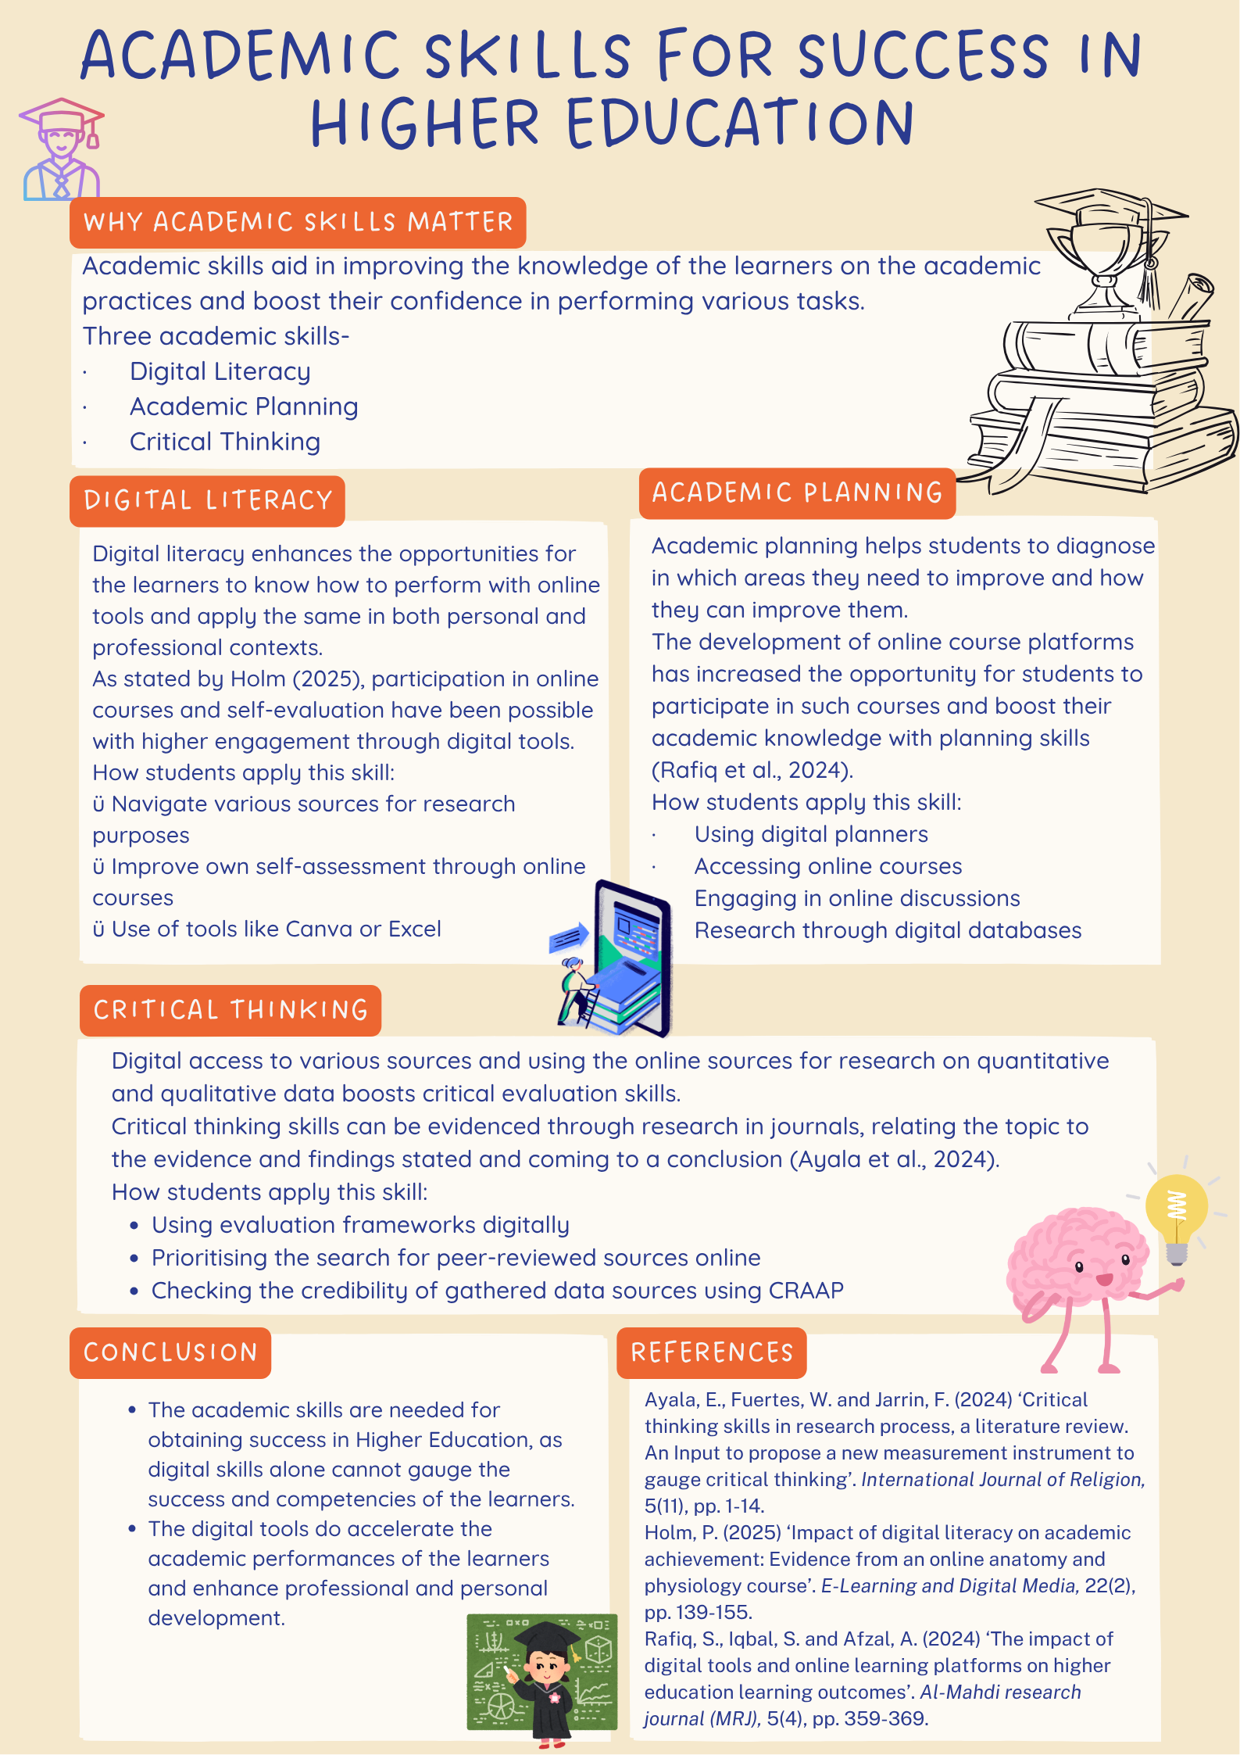

Reference List- Component 3

- Ayala, E., Fuertes, W., and Jarrin, F., 2024 ‘Critical thinking skills in research process, a literature review’. An input to propose a new measurement instrument to gauge critical thinking. International Journal of Religion, 5(11), pp. 1–14. Available at: DOI:10.61707/pwy5df19

- Holm, P., 2025 ‘Impact of digital literacy on academic achievement: Evidence from an online anatomy and physiology course’, E-Learning and Digital Media, 22(2), pp.139-155. Available at: DOI:10.1177/20427530241232489

- Rafiq, S., Iqbal, S. and Afzal, A. 2024 ‘The impact of digital tools and online learning platforms on higher education learning outcomes.’ Al-Mahdi research journal (MRJ), 5(4), pp. 359–369.

