Student name : Bruma Daniela Ionela
Student id number: 2128799
Lecturer : Jemma Smith
Module code: BMIH6007
Module title: International Meetings Management BMIH6007

Planning and Delivering an International Event

Executive Summary
This report has been a detailed description of the various factors which will affect the event which will discuss the topic ‘Technology and Innovation within the Hospitality Sector’. The event budget helped in determining that good number of profits is expected to be generated from the event. This will make sure that the people arranging the event are conscious of their actions and their main motto is to promote the growth of their society. This will be key to increasing the credibility of the event to the stakeholders and encouraging them to come again in future. The external and internal forces of the market have also been identified and analysed. The event budget helped in determining that good number of profits is expected to be generated from the event.
Table of Contents

Introduction 4
The Cycle of the Event 5
Plan 5
Organise 5
Measure 5
Analyse 5
Share 5
Concept of the Event 6
Objectives and Aim of the Event 7
Operations of the Event 8
Event Budget 9
Industry Trends and their Impacts 12
Swot Analysis 12
Pestle Analysis 13
Impact 15
Market Trends 16
Cultural and Situational Considerations 17
Conclusion 18
References 19
Appendix 22

Introduction
This is a report on the planning and organisation of the event on the discussion of ‘Technology and Innovation within the Hospitality Sector’. This has been chosen to discuss the latest technological trends seen in the hospitality industry and their impact on the same. The event will be held in London. This will be a hall, which a stage at one end of the same to be and there will be seating arrangements for about 1,000 guests. There will be arrangements for food and drinks and the guests will get brochures and copies of the discussions at the end of the event.

The Cycle of the Event
The event cycle is a model which makes sure that the events which are being planned are in a manner which will make the same successful in the context of the situation (Rahn, Wickle and Wende, 2022). This will be able to see to it that all the factors which have to be taken into consideration are highlighted and any scope for further improvement will be kept in mind.

Plan
The goal of this event is to promote the latest technologies which are being seen in the market and how the same is being applied in the context of the hospitality industry. This event will be a discussion being brought about by market leaders and technology experts on the subject (Limna, 2023).

Organise
The event will be organised offline and the same will be promoted through online channels like social media and so on. The pre-marketing budget and the event budgets will be detailed below, along with the timings for the same and the time slot for each speaker.

Measure
The success of the events can be determined based on the attendance. The event will also be live recorded and the online presence of the audience will be a good indicator of the success of the event. This will be also giving an idea of what the audience expect from managers of events in future.

Analyse
After the event is over, the KPIs will be analysed and this will be key to determining the improvements which have to be incorporated for the next event. The success of this event will also be analysed and celebrated to uphold the motivation of the people who worked to set up the event (Ali and Anwar, 2021).

Share
The documents about the success of the event will be circulated and this will be able to make sure that the same will promote the growth of the company. This will also be handed out among the people who worked hard for the success of the event to congratulate them.

Concept of the Event
The event will be a detailed discussion on the advancements which have been seen in the technologies of the hospitality industry and the ways in which it can promote higher customer satisfaction. The event will be held on the 26th of July and the same will begin at 12 noon and continue until 4 pm. The vendors will be responsible for delivering the products which will be needed for the setting up of stage, seating arrangements and so on. They will also be responsible for the development of brochures (Allen, Harris and Jago, 2022). The staff around the place will be responsible for the setting up of everything and for the helping of the guests. They will have to make sure that they are ready for any kind of changes and those they can have a good control over the progress of the event. The sponsors of the events will be rewarded with a good return on their investments by making sure that the attendees of the event are many (Li et al., 2020). The speakers will be the leaders of the industry and people who specialise in technology. This is the detailed itinerary of the things which will be needed in the event and how the same will be managed.

Objectives and Aim of the Event
The aiming of this event is to be having a detailed discussion on the technological advancements which have been seen in the industry and the ways in which it will potentially progress in future. Some of the things which will be discussed are artificial intelligence, smart homes and virtual reality. The objective is to educate the professionals about the importance of the same and how to operate them. This will be able to see to it that the audience is able to learn valuable lessons and they are willing to attend similar events again in future (Kreibich et al., 2022).
Specific | Measurable | Achievable | Relevant | Time-Bound
To be able to educate people about hospitality industry technology | Can be measured by the number of people implementing the same | Can be achieved by making the event fun as well as formal | Is relevant as this is important for the progress of the market | 1 day
To promote the hospitality industry online | Can be measured by the growth of revenue online | Can be achieved by releasing videos about the event | Is relevant as it can increase the revenue of the industry | 1 month

Table 1: SMART Objectives
(Source: Created by the Learner)

Operations of the Event
The first skill which is essential for effective event management is that of having good people skill. This is because the staff will have to interact with many people and they must make sure that no one is uncomfortable (Tan and Zhu, 2022). They must have a sense of organisation, vision and aesthetic, as this would motivate them to make sure that none of departments have flaws. They also have to see to it that they can have good communication skills and have to make sure that they are polite, courteous and empathetic to the needs of the audience.
This will be able to see to be seeing it that the audience are being able to focus on the main discussion of the event and they do not have to deal with any issues. The first and the most important resource of the event would be the budget and the financial resources (Streeck et al., 2020). This is followed by the human resources and they are followed by the marketing of the event. The materials which will be needed for the setting up of the event are also important and this will be able to see to it that the guests are comfortable. The event will also need good lighting, sound infrastructure, will have to be visually appealing and so on.

Event Budget
Breakdown of income and expenditure for the event
Income | Amount
Income from the event | £ 45,000
Donations | £ 15,000
Sponsorships | £ 70,000
Total Income | £ 130,000
Expenditure
Rent for event menu | £ 5,000
Insurance for event | £ 3,500
General and administrative expenses | £ 1,500
Marketing and advertisements | £ 3,000
Charges to hire machinery and equipment | £ 2,000
License or permit for event | £ 1,200
Professional and legal expenses | £ 1,500
Cleaning and sanitation expenses | £ 500
Telecommunication charges | £ 1,500
Stationery and other office supplies | £ 300
Event set up and decorative costs | £ 7,000
Light and sound expenses | £ 5,500
IT set up expenses | £ 5,000
Additional event volunteers | £ 3,000
Personnel costs | £ 4,500
Contingency expenses | £ 1,500
Catering expenses | £ 6,000
Transportation and travel expenses | £ 1,500
Miscellaneous expenses | £ 1,000
Total Expenditure | £ 55,000

Explanation of costs
The costs that are going to be spent for the event can be explained by categorising them into two types – fixed and variable. Fixed costs are those costs that are going to remain unchanged even if there is any change in the event activities. However, the variable costs might change as per the changes occurring in the activities of the event or the activity volume related to the event. The following is an explanation of the costs estimated for the event by categorising them as fixed and variable –
Items | Amount
Fixed Costs
Rent for event menu | £ 5,000
Insurance for event | £ 3,500
General and administrative expenses | £ 1,500
Marketing and advertisements | £ 3,000
Charges to hire machinery and equipment | £ 2,000
License or permit for event | £ 1,200
Professional and legal expenses | £ 1,500
Total Fixed Costs | £ 17,700
Variable Costs
Cleaning and sanitation expenses | £ 500
Telecommunication charges | £ 1,500
Stationery and other office supplies | £ 300
Event set up and decorative costs | £ 7,000
Light and sound expenses | £ 5,500
IT set up expenses | £ 5,000
Additional event volunteers | £ 3,000
Personnel costs | £ 4,500
Contingency expenses | £ 1,500
Catering expenses | £ 6,000
Transportation and travel expenses | £ 1,500
Miscellaneous expenses | £ 1,000
Total Variable Costs | £ 37,300
Total Costs | £ 55,000

Funding sources
The funding sources that have been decided for the event are mainly of two types – donations and sponsorships. Donations are likely to raise funds worth £15,000. On the other hand, sponsorships are expected to raise funds worth £70,000 for the event.
Income generation
The event is likely to generate a high amount of income. An amount of £130,000 is the expected income to be generated from this event. This amount involves the income that the event is going to generate along with the funds that are going to be provided by donations and sponsorships. After the reduction of the costs related to the event, the net amount of earnings that the event is likely to generate is £75,000.

Industry Trends and their Impacts

Swot Analysis
Strengths  - Experiences of the team for event planning  - Strong relationships with the vendors  - Compelling concept of the event  - Access to a big venue  - Sponsors are well-established | Weaknesses  - Limited budget  - Inexperienced volunteers  - Tightness of timelines  - Lack of the in-house resources  - Limited marketing resources
Opportunities  - Emergence of good technologies for event  - Engagement of diverse attendee  - Strategic partnerships  - Hybrid as well as virtual formats of event  - Trend of Customisation along with personalisation of experience of the attendees | Threats  - Competing ongoing events  - Technological challenges  - Budgeting constraints  - Changes in regulations  - Unpredictability of the external factors

Table 2: Swot Analysis
(Source: Created by the Learner)
This is the analysis of the internal strength, weakness, threats and opportunities which can determine the success or failure of the event.

Pestle Analysis
Factors | Impact
Political | - Recorded at 77.51 in the year 2024 (Statista, 2024), which has been a decrease from that of the previous year  - Index of the stability of the political landscape was recorded to be 0.47 (The Global Economy, 2024)  - The score of the perception of corruption in the country is noted at 71, which has been a slight decrease from that of the previous year (Statista, 2024)
Economic | - The amount of the inflation in this country have been recorded at 2.3% for the April of 2024, even though the cost of living is still high (Statista, 2024)  - The amount of growth of the GDP which is seen in the country is that of 4.35% (Statista, 2024)
Social | - The amount of the growth of the population of the country is that of -0.08% (Statista, 2024)  - The range of income which can be disposed on an average by the people of the country is 12,279-130,246 pounds (Statista, 2024)
Technological | - The amount of the UK on the Scoreboard of European Innovation is that of 114.8 (Statista, 2023)  - The rate of penetration of the internet among the audience of the UK is that of 98% (Statista, 2024)
Legal | - The event organisers will have to see to it that these employment laws are taken into consideration- National Minimum Wage and Equality Act 2010 (Citation, 2024)
Environmental | - The Environmental Act of 2021 will also have to be kept in mind by the managers of the event (Client Earth, 2022)

Table 3: Pestle Analysis
(Source: Created by the Learner)

Impact
The above discussion has been that of these internal as well as the external variables which will play an important effect in the proceedings of a successful event. One of the biggest factors which will influence the management will be the competence of the people working for them and the honesty of the channels which will be promoting the same (González-Granadillo, González-Zarzosa and Diaz, 2021). This is because the effective marketing of the event, along with the skills of the staff are some of the most important aspects of the development of the event. As the rate of innovation of the country is high, this will be a much-coveted event for the people who are a part of the market. This is because they will be able to get to know about important factors which they have to keep in mind during the development of their own hospitality brands and the knowledge will give them a competitive advantage in the market. The sustainable organisation of the event, in alliance with the Environmental Act of 2021 will increase the credibility of the same to the stakeholders. This will show that the people arranging the event are conscious of their actions and their main motto is to promote the growth of their society.

Market Trends
One of the most important market trends which have to be kept in mind is that of the digital marketing. This is a mode of the promotion of the products of an organisation through the application of the internet and the online platforms which can be operated by the same (Visser, Sikkenga and Berry, 2021). This is a form of marketing which can bring the attention of the audience to the event from anywhere in the world and at any time. This is one of the strategies and should be applied by the marketing team of the event and they should make sure that the advertisements send out the same message. Another market’s trend which needs to be kept in mind is that of the sustainable developments. The event should be organised in a manner which does not have a negative impact on the environment- pollution of the air, the water, the soil and so on (Ashby, 2022). They should also not harm any human being or animal and should make sure that the economy is supported by this event. This will be key to increasing the credibility of the event to the stakeholders and encouraging them to come again in future.

Cultural and Situational Considerations
The cultural considerations which will have to be made are that of the food, language and the music which will be played in the event (Allen, Harris and Jago, 2022). This is a formal event and there will be professionals from all backgrounds and they should all be given equal treatment and be respected for their work. This is important as otherwise; negative reviews about racism will have a negative impact on the future events which will be arranged. The food being served and the language being used should be inclusive. Both vegetarian as well as non-vegetarian meals will be served and the language which will be used will be English. The situational factor which must be considered is that the tickets should be of an optimal price, as it cannot be afforded if it is too expensive due to the economic situation of the country.

Conclusion
This report has been a careful discussion of the factors which have to be taken into consideration for the development of the event on the discussion of Technology and Innovation within the Hospitality Sector. The external and internal factors have been studied, along with the market trends which can affect the progress. The budget has been drawn up and this has been followed by the noting of the cultural considerations. The event will be planned out safely and sustainable and will be a significant addition to the professional’s experience. They will learn many new things from this event and will have a good time.

References
Ali, B.J. and Anwar, G. (2021)‘An empirical study of employees’ motivation and its influence job satisfaction. Ali, BJ, & Anwar, G.(2021). An Empirical Study of Employees’ Motivation and its Influence Job Satisfaction.’International Journal of Engineering, Business and Management, 5(2), pp.21-30.
Allen, J., Harris, R. and Jago, L. (2022) Festival & special event management. John Wiley & Sons.
Ashby, M.F. (2022) Materials and sustainable development. Butterworth-Heinemann.
Citation(2024)UK Employment Laws Explained. Available at:https://www.citation.co.uk/news/hr-and-employment-law/uk-employment-laws-explained/(Accessed: 25 May 2024).
Client Earth (2022) The UK Environment Act - what's happening now?Available at:https://www.clientearth.org/latest/news/why-the-uk-environment-bill-matters/#:~:text=What%20does%20the%20Environment%20Act,%2C%20biodiversity%2C%20and%20waste%20reduction(Accessed: 25 May 2024).
González-Granadillo, G., González-Zarzosa, S. and Diaz, R. (2021) ‘Security information and event management (SIEM): analysis, trends, and usage in critical infrastructures’. Sensors, 21(14), p.4759.
Limna, P. (2023)‘Artificial Intelligence (AI) in the hospitality industry: A review article.’ International Journal of Computing Sciences Research, 7, pp.1306-1317.
Rahn, A., Wicke, K. and Wende, G. (2022)‘Using Discrete-Event Simulation for a Holistic Aircraft Life Cycle Assessment.’ Sustainability, 14(17), p.10598.
Statista (2023)European innovation score in the United Kingdom from 2015 to 2023. Available at:https://www.statista.com/statistics/1245752/innovation-score-uk/#:~:text=According%20to%20the%20European%20Innovation,119%20in%20the%20previous%20year(Accessed: 25 May 2024).
Statista (2024)Average equivalized disposable household income in the United Kingdom in 2021/22, by decile group. Available at:https://www.statista.com/statistics/813338/average-disposable-income-per-household-uk/#:~:text=Economy-,Average%20disposable%20income%20per%20household,UK%202021%2F22%2C%20by%20decile&text=In%202021%2F22%2C%20households%20in,decile%20which%20had%20130%2C246%20pounds(Accessed: 25 May 2024).
Statista (2024)Corruption perception index score of the United Kingdom from 2012 to 2023. Available at:https://www.statista.com/statistics/868971/corruption-perception-index-in-the-uk/(Accessed: 25 May 2024).
Statista (2024)Inflation rate for the Consumer Price Index (CPI) in the United Kingdom from January 1989 to April 2024. Available at:https://www.statista.com/statistics/306648/inflation-rate-consumer-price-index-cpi-united-kingdom-uk/#:~:text=The%20UK%20inflation%20rate%20was,11.1%20percent%20in%20October%202022(Accessed: 25 May 2024).
Statista (2024) Press freedom index in the United Kingdom (UK) from 2013 to 2024. Available at: https://www.statista.com/statistics/1025956/uk-press-freedom-index/ (Accessed: 25 May 2024).
Statista (2024)Share of individuals using the internet in the United Kingdom (UK) from 2002 to 2024. Available at:https://www.statista.com/statistics/1124328/internet-penetration-uk/#:~:text=As%20of%20January%202024%2C%20nearly,United%20Kingdom%20as%20of%202023(Accessed: 25 May 2024).
Statista (2024)United Kingdom (UK): Population growth from 2012 to 2022. Available at: https://www.statista.com/statistics/270361/population-growth-in-the-united-kingdom/ (Accessed: 25 May 2024).
Statista (2024)United Kingdom: Real gross domestic product (GDP) growth rate from 2019 to 2029. Available at:https://www.statista.com/statistics/263613/gross-domestic-product-gdp-growth-rate-in-the-united-kingdom/#:~:text=Gross%20domestic%20product%20(GDP)%20growth%20rate%20in%20the%20United%20Kingdom%202029&text=The%20statistic%20shows%20the%20growth,compared%20to%20the%20previous%20year(Accessed: 25 May 2024).
Streeck, H., Schulte, B., Kümmerer, B.M., Richter, E., Höller, T., Fuhrmann, C., Bartok, E., Dolscheid-Pommerich, R., Berger, M., Wessendorf, L. and Eschbach-Bludau, M. (2020)‘Infection fatality rate of SARS-CoV2 in a super-spreading event in Germany.’ Nature communications, 11(1), p.5829.
Tan, Y. and Zhu, Z. (2022)‘The effect of ESG rating events on corporate green innovation in China: The mediating role of financial constraints and managers' environmental awareness.’ Technology in Society, 68, p.101906.
The Global Economy(2024)United Kingdom: Political stability. Available at:https://www.theglobaleconomy.com/United-Kingdom/wb_political_stability/#:~:text=Political%20stability%20index%20(%2D2.5%20weak%3B%202.5%20strong)&text=The%20latest%20value%20from%202022,to%20compare%20trends%20over%20time(Accessed: 25 May 2024).
Visser, M., Sikkenga, B. and Berry, M. (2021) Digital marketing fundamentals: From strategy to ROI. Taylor & Francis.

Appendix
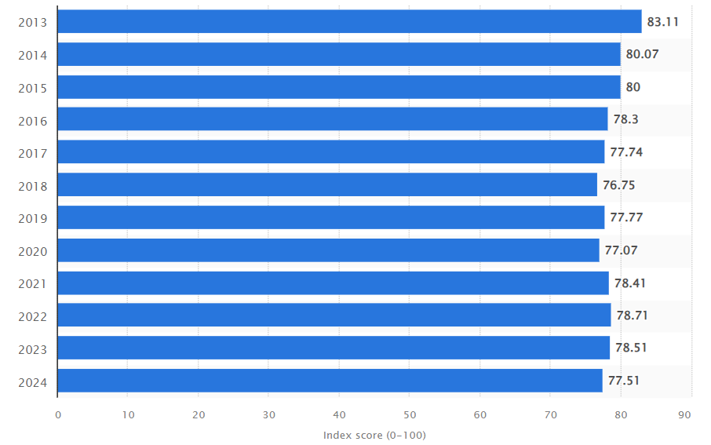
Figure 1: Press freedom index in the United Kingdom (UK) from 2013 to 2024
(Source: Statista, 2024)
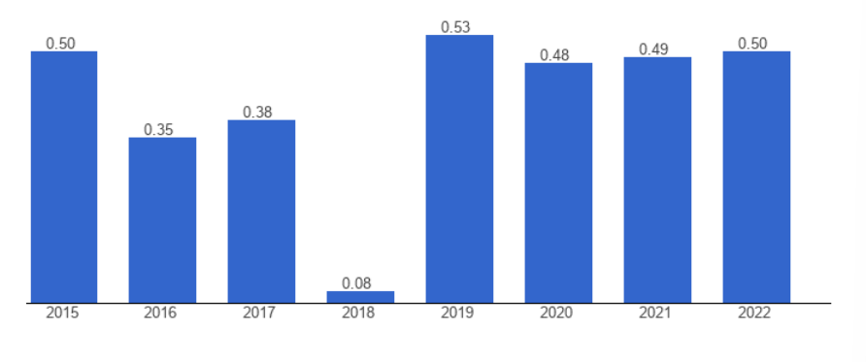
Figure 2: United Kingdom: Political stability
(Source: The Global Economy, 2024)
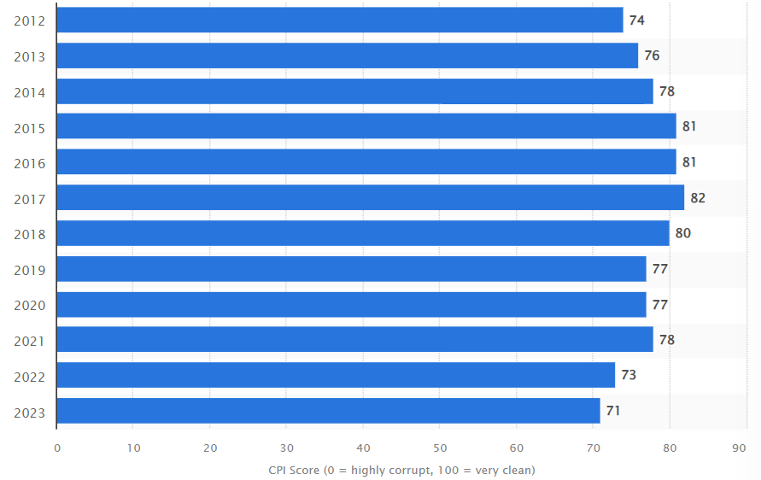
Figure 3: Corruption perception index score of the United Kingdom from 2012 to 2023
(Source: Statista, 2024)
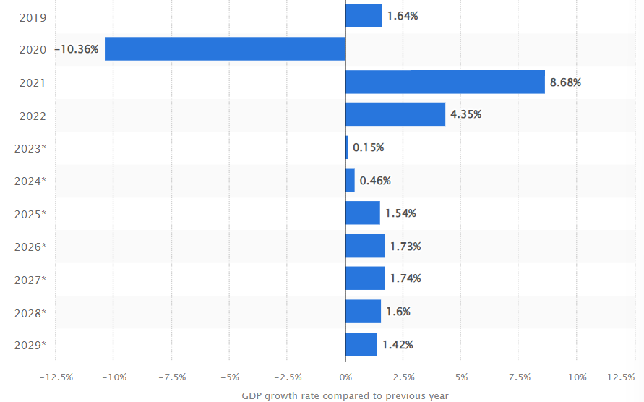
Figure 4: United Kingdom: Real gross domestic product (GDP) growth rate from 2019 to 2029
(Source: Statista, 2024)
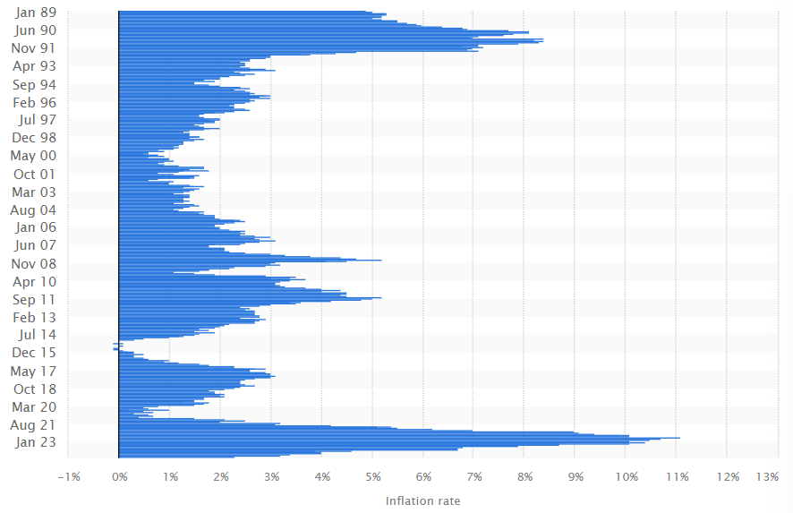
Figure 5: Inflation rate for the Consumer Price Index (CPI) in the United Kingdom from January 1989 to April 2024
(Source: Statista, 2024)
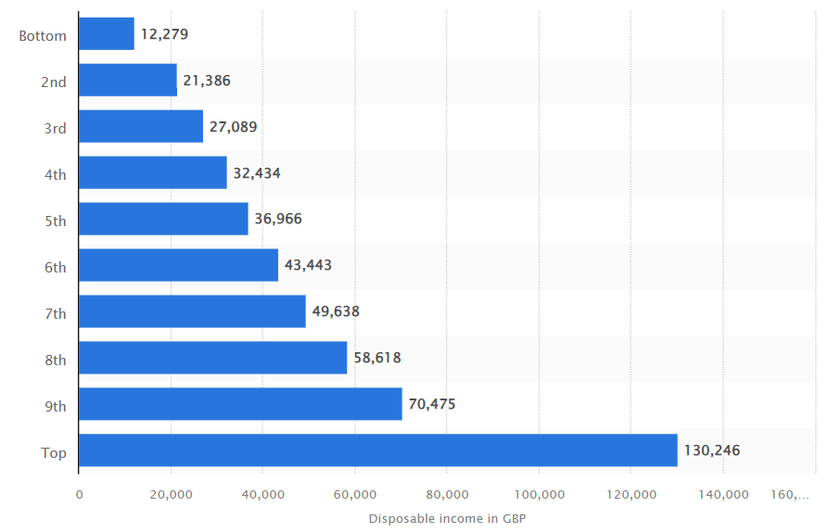
Figure 6: Average equivalised disposable household income in the United Kingdom in 2021/22, by decile group
(Source: Statista, 2024)
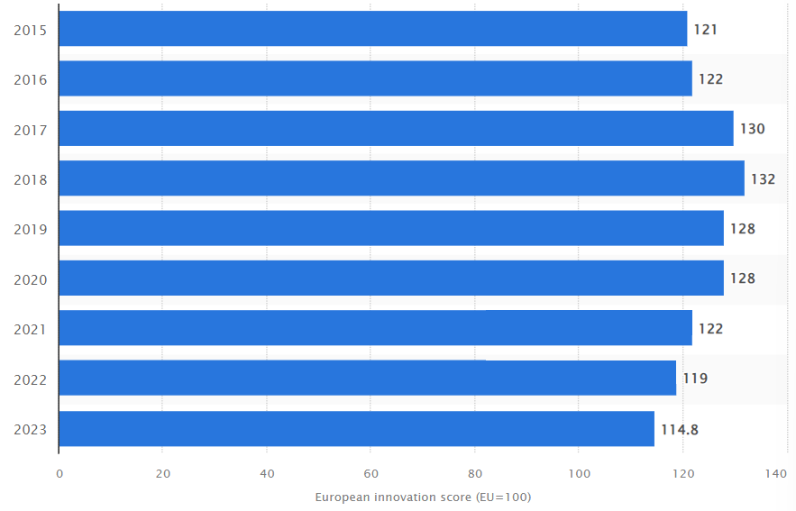
Figure 7: European innovation score in the United Kingdom from 2015 to 2023
(Source: Statista, 2024)
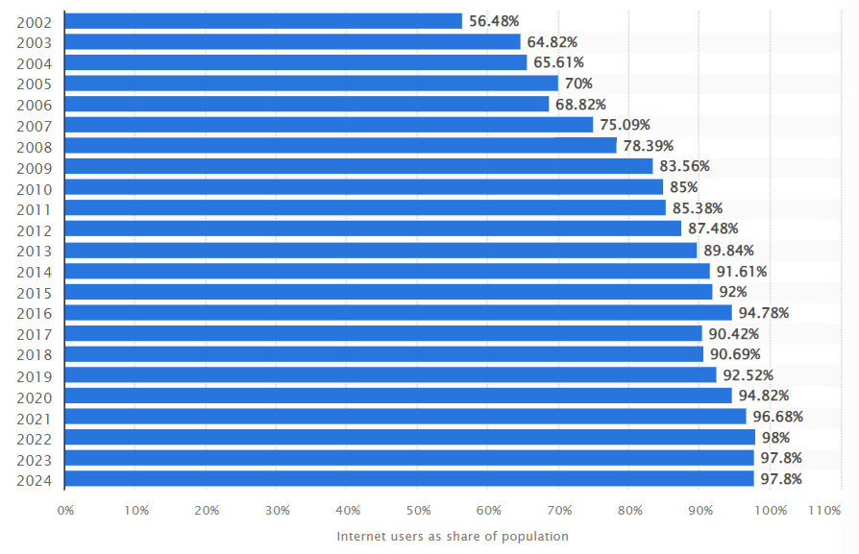
Figure 8: Share of individuals using the internet in the United Kingdom (UK) from 2002 to 2024
(Source: Statista, 2024)

