

BA International Hotel Management
BMIH5001 Entrepreneurship LEVEL 5

Essay - Individual Business Model Canvas with Entrepreneurial Reflection Using Appropriate Academic Models

Word count: 2,065
Student name: Constantin Bogdan Rusu
Student ID number:
Lecturer: Charlotte Joyner

Table of Contents
1. Part One 3
2. Part Two 8
3. References 10
4. Appendices 13
4.1. Business Model Canvas 13
4.2. Test results - Are you an entrepreneur? 14
4.3. Test results - GET2 Test Enterprise Rating 15

Figure 1. Business Model Canvas 13
Figure 2.Test results - Are you an entrepreneur? 14
Figure 3. GET2 Test Enterprise Rating 15

Part One

This essay aims to discuss and justify the proposition of an economy hotel in Ilford, in the London borough of Redbridge, using the Business Model Canvas (BMC) frame. The objectives of the essay are to outline the entrepreneurial decisions using current examples and academic and business sources related to identifying an appropriate value proposition and other components of BMC, and to justify those decisions. Please see the BMC proposal in Appendix No. 4.1.

The most common definition of entrepreneurship presents this concept as the process of starting a business based on innovative ideas to seize opportunities in the market (Hougaard, 2004). BMC (Concept Board, 2024) is a graphic framework that contains nine elements defining the business model proposal. This structured approach to planning a start-up leads to effective planning and the foundation of value creation in the context of the main relationships to the business strategy (Andreassen et al., 2018). Teece (2010) defines a business model as designing or creating the structural design of the value creation, delivery, and capture mechanisms that are employed by entrepreneurs. According to Eisenmann (2013), this process is considered critical to effectively pursuing business opportunities that are beyond entrepreneurs’ control of resources. To monetize an entrepreneurial idea, the entrepreneur needs a system to create value, deliver it, and capture it from the market (Teece, 2010). Moreover, the design must emphasise the reason for starting a new business, aiming to fulfil the needs and demands of a targeted audience (Zott and Amit, 2010).

The start-up proposed is an economy hotel in Ilford, London, borough of Redbridge, a district of Northeast London, where the main competitors are Aberdeen Guest House London, Best Inn Hotel, Lucky 8 Hotel, Britannia Inn Hotel, Cranbrook Hotel, and The Park Hotel Ilford (TravelStay.com, 2024). The business model design is based on the BMC’s nine elements: key partners, key activities and key resources, value proposition, customer relationships and channels, customer segments, cost structure, and revenue streams.

The key partners for an economy hotel include the proprietors of the building, the suppliers of goods and services (food, beverages, labour, cleaning, human resources management, accounting and audit, legal services, media and advertising services, IT services, marketplace services, etc.), investors, and banks. The building is rented, which makes the landlords important partners. The suppliers are essential for the start-up, considering that they provide food and drinks, agency employment, cleaning services, and other outsourced services such as accounting and auditing, legal services, media and advertising services, IT services, and marketplace services. The decision to outsource the management of employee relationships to a specialised provider has been made because in the hospitality industry there is a scarcity of labour (Lawson and Calverley, 2023). Moreover, outsourcing services such as cleaning, accounting and auditing, legal services, media and advertising services, IT services, and marketplace services benefit the start-up by saving costs (Bryce and Useem, 1998), having an agile organisational structure (Duc and Abrahamsson, 2017), and having the expertise and efficiency of professional services. Additionally, partnerships with investors and banks are essential for financing productive operations in hospitality (Hales, 2006). According to PwC (2023), it is recommended that hoteliers and investors strongly engage in discussions with existing financiers, keeping them knowledgeable of current performance, specifically those who will be refinancing within the next year or a year and a half, considering that the interest rate remains relatively stable at the present level.

The key activities include residential accommodation, food and drink, venue renting for events, and transportation services on request from and to airports (Evans, Stonehouse, and Campbell, 2012). Accommodation is booked in person at the reception, by phone or via Internet, on the hotel’s website, or on specialised travel platforms of online travel agencies such as Booking.com, Agoda, Lastminute.com, Expedia, Hotwire, Bookmundi, Skyscanner, and Kiwi.com (TravelPerk, 2023). Those platforms are marketplaces where customers can compare and decide where to book their accommodations in a simple and rapid manner. Additionally, these providers offer exposure to large customer pools worldwide and also offer access to other travellers’ reviews or electronic word of mouth, which can advantage non-branded hotels (Raguseo and Vitari, 2017).

The key resources include building and hotel equipment, staff, the capital, and the hotel brand. The building must be simple, attractive, and well equipped for an economy hotel, as well as the rooms, the restaurant, and the event hall (Lawson, 2018). Employees must be professional and capable of offering budget accommodation and food and drink services. Moreover, the hotel must have the capital to conduct business operations, while the brand must be built to attract cost-conscious travellers.

The value proposition is to offer quality services such as budget accommodation and food and drink to appeal to cost-sensitive travellers (Kolomoyets and Dickinger, 2023). The quality of services will enhance brand awareness and lead to financial performance, while the focus on digitalization and sustainability will enhance the customer experience.

The customer relationships and channels include in-person, over the phone, and online communication related to the portfolio of offerings, while the marketing channels include outdoor advertising, local and national newspapers, and online via corporate websites, apps, blogs, search engines, online travel agencies such as Booking.com, and social media channels such as Facebook, LinkedIn, YouTube, TikTok, and Instagram. Effective digital marketing practices in hospitality increase brand awareness, add value to the customer experience, and attract larger customer audiences (Nuseir, 2016). On the other hand, the organisation must consider the associated risks, such as cybersecurity and data privacy and protection (Sirur, Nurse, and Webb, 2018).

The customer segmentation focuses on adults with low income or who are cost-sensitive (Smith and Haughton, 2018) and who travel for pleasure or business to London. They seek basic but qualitative accommodations and catering services, as well as transportation by shuttle from or to airports in London. For this customer segment, the quality of services and amenities is critical to meeting the expectations of the targeted audience and providing an opportunity to differentiate among rivals (Bai, Ghiselli, and Pearson, 2000). Hence, maximisation of profits is derived from effective positioning and implementing low-cost solutions such as outsourcing and digital marketing, as well as by considering enhancing the sustainability of the business model to address the megatrend of increasing environmental awareness and the need for achieving the UN’s Sustainable Development Goals (Gaudig et al., 2021). Thus, the general appearance of the hotel, rooms, event space, and restaurant must be optimised, and the digital marketing practices can attract the targeted audiences at a low cost and in an effective manner. As a result, the economy hotel can capture value from low-budget travellers to London who can find basic and qualitative accommodation, food and drink, an event venue, and transportation from and to the airport at low prices.

The cost structure includes the costs related to producing and offering hospitality services, the costs associated with outsourced services and suppliers, rent, and wages. There are significant operational costs associated with renting the building, procuring food, beverages, and cleaning services, outsourcing employment management, accounting and audit, legal services, media and advertising services, IT services, marketplace services, etc. Moreover, another important cost to consider is related to investors and banks that finance the company.

The revenue streams include turnover from producing and offering hospitality services such as accommodation, food and drink, organising events, renting the space for events, and transportation from and to London airports.

It is recommended to benchmark the best budget hotel practices, such as those of Ibis Budget, Red Roof Inn, Hotel F1, Premier Inn, and Travelodge Hotels (Global Data, 2023). According to Park and Lee (2021), hotel choice is made based on the quality of the services, while customers refer to user content generated by other travellers on social media, which rates their customer experience with the brands. Hence, the convenience of transportation services, the quality of food and drink, accessibility to tourist objectives, and value for money represent the attributes most wanted by hotel guests (Park and Lee, 2021). Benchmarking can also be outsourced to global data providers for hotels to compare their performance against rivals in terms of market penetration index, average rate index, and revenue generated index based on subscription (Magnini, Crotts, and Calvert, 2020).

This essay has investigated the proposition of an economy hotel in Ilford using the BMC frame. The value proposition is to offer quality services such as budget accommodation and food and drink to appeal to cost-sensitive travellers with low incomes or who are cost-sensitive and travel for pleasure or business to London. The key partners include landlords, suppliers of goods and services, investors, and banks. The key activities include residential accommodation, food and drink, venue renting for events, and transportation services on request from and to airports. The key resources include building and hotel equipment, staff, the capital, and the hotel brand. The cost structure includes producing hospitality services, outsourced services, suppliers, rent, and wages. The revenue streams include turnover from hospitality services such as accommodation, food and drink, events, and shuttle transportation.

Part Two

The second section of the essay explores one’s entrepreneurial attributes and motivations, considering entrepreneurial theories and models aiming to develop entrepreneurial skills and behaviours. The reflective action investigates the results of entrepreneurial tests made during the module BMIH5001 Entrepreneurship and assesses them using Gibbs’ reflective cycle framework, which contains description, feelings, evaluation, analysis, conclusions, and an action plan.

The result for the test named ‘Are you an entrepreneur?’ was 38, showing that I apparently possess all of the qualities needed to be an entrepreneur. Furthermore, the results of the test ‘GET2 Test Enterprise Rating’ rank me as ‘occasionally enterprising’ with a general score of 80%, 92% for personal achievement need, 100% autonomy, 58% creativity, 58% risk taking, and 100% locus of control. Please see Appendices No. 4.2. and No. 4.3. for an illustration of the test results.

The results of the tests were both surprising and flattering, because I discovered that I have important potential to be an effective entrepreneur, but I need to develop several areas. I was happy to be considered to have all of the qualities needed to be an entrepreneur, and I have also felt intrigued and challenged to learn that I somehow lack creativity and am too cautious. I dislike the fact that currently I am content to work on a limited number of projects and may be happy to be enterprising either within employment as an intrapreneur or in my leisure time through voluntary community projects. However, considering my ambitions to have an innovative growth business, there is much to improve related to my entrepreneurial attributes. Hence, I can develop my entrepreneurial skills before starting my own business.

It is important that I scored high (92%) for personal achievement; thus, I am highly motivated to improve myself in order to be a successful entrepreneur. Moreover, I am future-oriented with a rather optimistic outlook, self-confident, task-oriented, time management skilled, results-oriented, possess strong drive and high energy, strong opinions, persistence and determination, responsibility, goal orientation, optimal prioritisation, and a willingness to work long and hard when necessary to complete tasks. Additionally, it is necessary to thoroughly investigate my strengths and weaknesses and to improve myself. Those results reflect my current status as a potential entrepreneur, and I have time to optimise my strengths during my studies. The foundation appears to be good, but there are many aspects that can be improved related to my entrepreneurial skills, with the support of my lecturers and also reading and researching in my spare time. Moreover, my personal development plan must be updated in the sense that a new goal must be added relative to developing entrepreneurial skills.

Based on the trait theory, I do possess attributes that enable me to become an effective entrepreneur. However, I need to consider the negative traits associated with entrepreneurial personalities, such as control-orientation, dependence on external recognition, and poor relationships with subordinates.

I plan to update my personal development plan in the sense that a new goal must be added relative to developing entrepreneurial skills. Additionally, it is necessary to thoroughly investigate my strengths and weaknesses and to improve myself. The foundation appears to be good, but there are many aspects that can be improved related to my entrepreneurial skills, with the support of my lecturers and also reading and researching in my spare time. Moreover, the next month I plan to enrol in a free online course to develop my entrepreneurial skills.

References

Andreassen, T.W., Lervik-Olsen, L., Snyder, H., Van Riel, A.C., Sweeney, J.C. and Van Vaerenbergh, Y. (2018) ‘Business model innovation and value-creation: the triadic way’. Journal of service management, 29(5), pp. 883-906. DOI https://doi.org/10.1108/JOSM-05-2018-0125

Bai, B., Ghiselli, R.F., and Pearson, T. (2000) ‘Market Characteristics in Economy/Budget Lodging’, Hospitality Review, 18(2), pp. 37-50. Available at: https://digitalcommons.fiu.edu/hospitalityreview/vol18/iss2/4 (Accessed: 20 January 2024)

Bryce, D.J. and Useem, M. (1998) ‘The impact of corporate outsourcing on company value’. European Management Journal, 16(6), pp. 635-643. DOI https://doi.org/10.1016/S0263-2373(98)00040-1

Concept Board (2024) 9 Sections of the Business Model Canvas: Collaborative Online Template & Guide. Available at: https://conceptboard.com/blog/business-model-canvas-free-conceptboard/ (Accessed: 20 January 2024)

Duc, A.N. and Abrahamsson, P. (2017, June) ‘Exploring the outsourcing relationship in software startups: A multiple case study’. In Proceedings of the 21st International Conference on Evaluation and Assessment in Software Engineering (pp. 134-143). DOI https://doi.org/10.1145/3084226.3084248

Eisenmann, T. (2013) ‘Entrepreneurship: A working Definition’. Harvard Business Review, 10(5), pp. 1-3. Available at: https://hbr.org/2013/01/what-is-entrepreneurship (Accessed: 20 January 2024)

Evans, N., Stonehouse, G. and Campbell, D. (2012) Strategic management for travel and tourism. London: Taylor & Francis.

Gaudig, A., Ebersberger, B. and Kuckertz, A. (2021) ‘Sustainability-Oriented Macro Trends and Innovation Types—Exploring Different Organization Types Tackling the Global Sustainability Megatrend’. Sustainability, 13(21). DOI https://www.mdpi.com/2071-1050/13/21/11583#

Global Data (2023) Budget Hotels Market Trends and Analysis by Region, Deals and Competitive Landscape. Available at: https://www.globaldata.com/store/report/budget-hotels-market-analysis/ (Accessed: 28 January 2024)

Hales, J. (2006) Accounting and financial analysis in the hospitality industry. London: Routledge.

Hougaard, S. (2004) The business idea: the early stages of entrepreneurship. Heidelberg: Springer Science & Business Media.

Kolomoyets, Y. and Dickinger, A. (2023) ‘Understanding value perceptions and propositions: A machine learning approach’. Journal of Business Research, 154. DOI https://doi.org/10.1016/j.jbusres.2022.113355

Lawson, A., and Calverley, T. (2023) Hiring boom fading but three-quarters of UK firms still struggle to find staff. Available at: https://theguardian.com/money/2023/oct/08/hiring-boom-fading-but-three-quarters-of-uk-firms-still-struggle-to-find-staff (Accessed: 26 January 2024)

Lawson, F. (2018) ‘Hotels’. In Buxton, P. (ed), Metric Handbook – Planning and Designing Data, 6th edn., London: Routledge, pp. 383-400.

Magnini, V.P., Crotts, J.C. and Calvert, E. (2020) ‘The increased importance of competitor benchmarking as a strategic management tool during COVID-19 recovery’. International Hospitality Review, 35(2), pp. 280-292. DOI https://doi.org/10.1108/IHR-08-2020-0044

Nuseir, M.T. (2021) ‘Assessing the impact of brand equity and customer experience on brand loyalty in the United Arab Emirates' hotel industry’. International Journal of Business Excellence, 25(4), pp. 459-473. DOI https://doi.org/10.1504/IJBEX.2021.119753

Park, J. and Lee, B.K. (2021) ‘An opinion-driven decision-support framework for benchmarking hotel service’. Omega, 103. DOI https://doi.org/10.1016/j.omega.2021.102415

PwC (2023) Growth in demand to stall across the UK - Hotels Forecast 2023 – 2024. Available at: https://www.pwc.co.uk/industries/hospitality-leisure/insights/uk-hotels-forecast.html (Accessed: 27 January 2024)

Raguseo, E. and Vitari, C. (2017) ‘The effect of brand on the impact of e-WOM on hotels’ financial performance’. International Journal of Electronic Commerce, 21(2), pp. 249-269. DOI https://doi.org/10.1080/10864415.2016.1234287

Sirur, S., Nurse, J.R. and Webb, H. (2018, January). ‘Are we there yet? Understanding the challenges faced in complying with the General Data Protection Regulation (GDPR)’. In MPS '18: Proceedings of the 2nd International Workshop on Multimedia Privacy and Security, Toronto, Canada, October 15 - 19, 2018, pp. 88-95.

Smith, T.A. and Haughton, S.A. (2018) ‘Segmenting Jamaica's Small Hotel Market for Better Targeting’. Social and Economic Studies, pp. 177-204. Available at: https://www.jstor.org/stable/45204458 (Accessed: 20 January 2024)

Teece, D.J. (2010) ‘Business models, business strategy and innovation’. Long range planning, 43(2-3), pp. 172-194. DOI https://doi.org/10.1016/j.lrp.2009.07.003

TravelPerk (2023) The 10 best online travel agencies in 2024. Available at: https://www.travelperk.com/blog/best-online-travel-agencies/ (Accessed: 20 January 2024)

TravelStay.com (2024) Cheap Hotels in Ilford London. Available at: https://www.travelstay.com/London_Cheap_Hotels/Cheap_Hotels_in_Ilford_LondonDeals_1.htm (Accessed: 31 January 2024)

Weil, D. (2014) The fissured workplace – Why work became so bad for so many and what can be done to improve it. London: Harvard University Press.

Zott, C. and Amit, R. (2010) ‘Business model design: An activity system perspective’. Long range planning, 43(2-3), pp. 216-226. DOI https://doi.org/10.1016/j.lrp.2009.07.004

Appendices

Business Model Canvas
Figure 1. Business Model Canvas

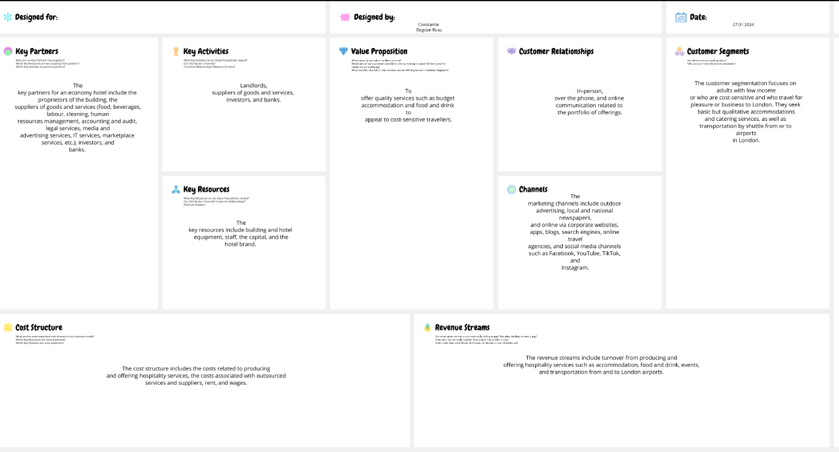

Test results - Are you an entrepreneur?

Figure 2.Test results - Are you an entrepreneur?
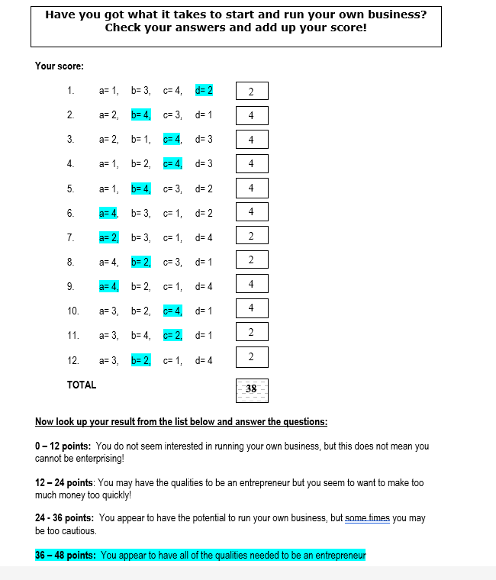

Test results - GET2 Test Enterprise Rating

Figure 3. GET2 Test Enterprise Rating


