5CO01 – Organisational performance and culture in practice - 2025
This document includes additional CIPD guidance for each question as well as the indicative content to consider from the qualification framework.
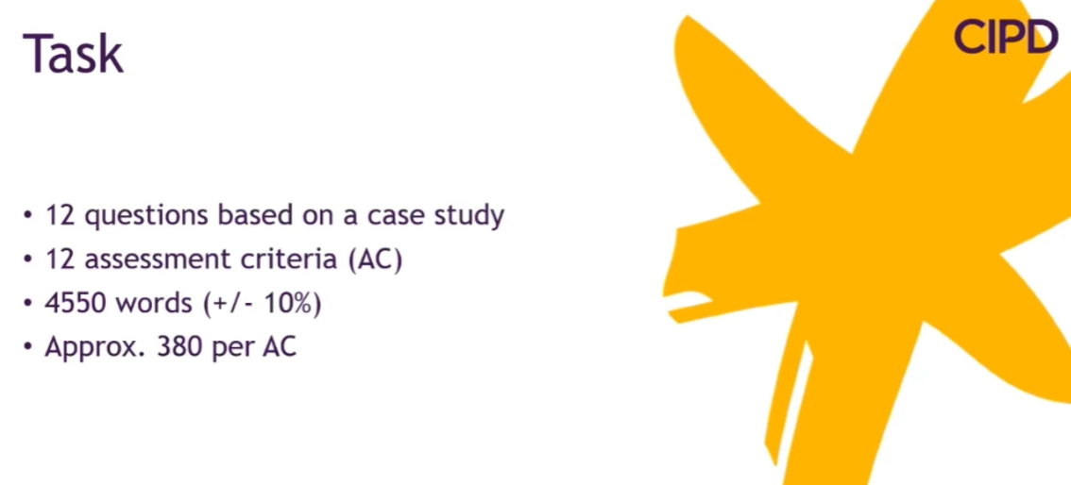
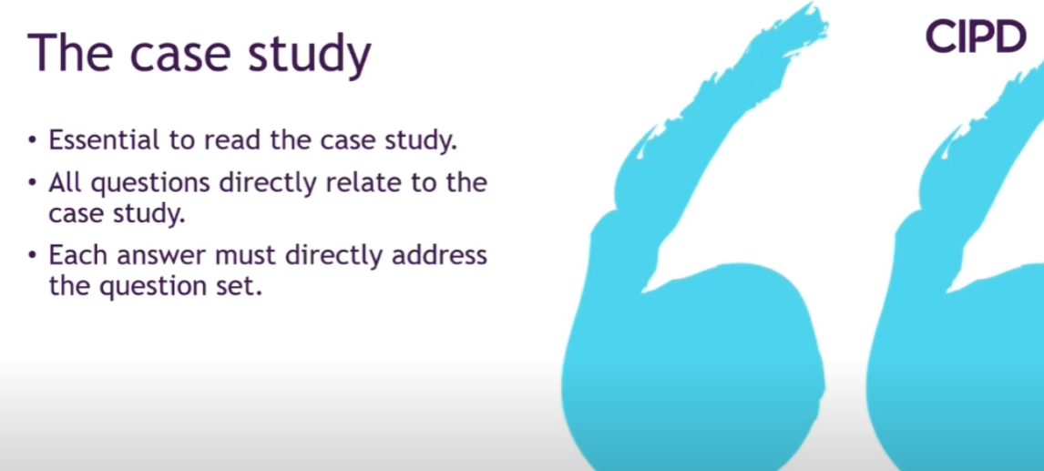
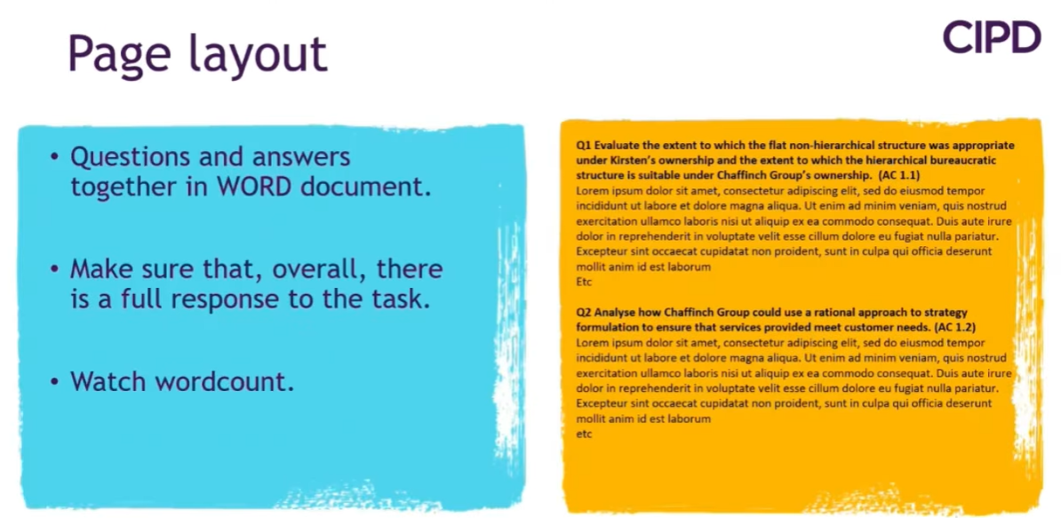

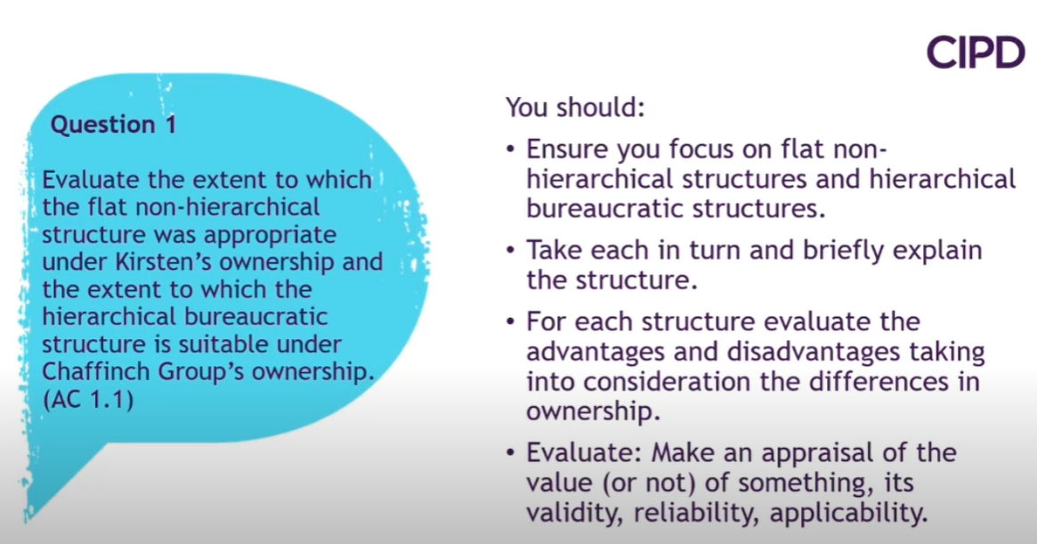
Different organisational structures, for divisional and matrix; links between structure and purpose; reasons underpinning different structures, advantages and disadvantages of different structures.
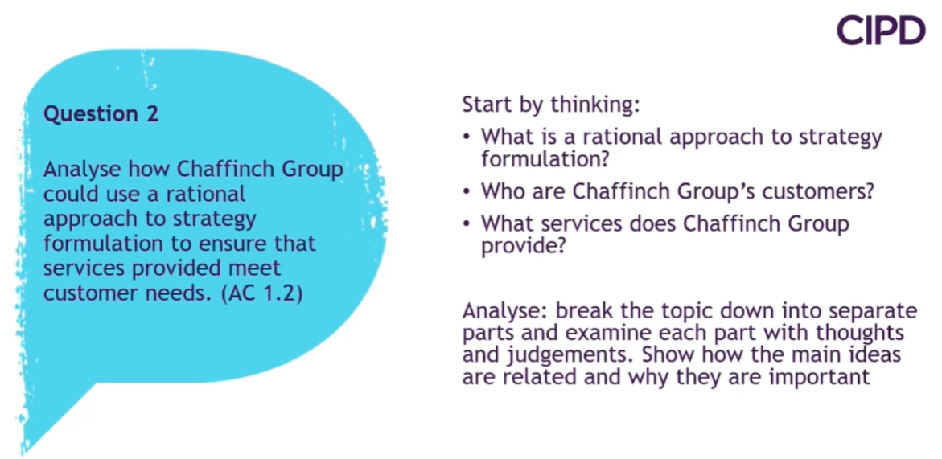
How organisational strategies are shaped by the business and external contexts; organisational insights and organisational performance; models of strategy formulation and implementation; concept of vertical and horizontal integration of strategy.
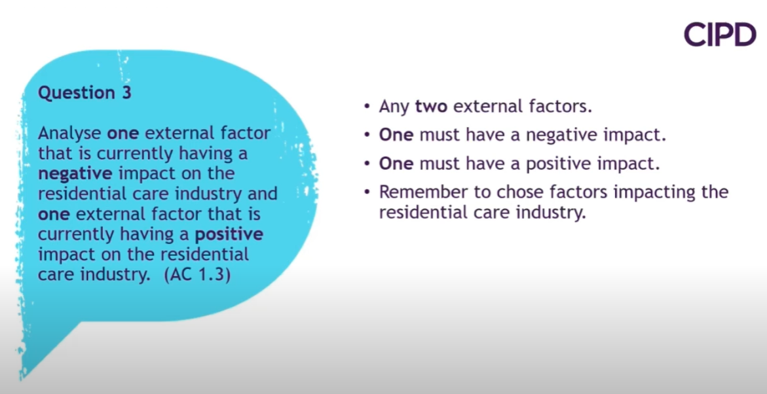
Analysis tools and approaches. Analysis of factors such as: the market and competitive contexts of organisations, principal demographic, social and technological trends, impact of technology, globalisation and international factors, government policy and legal regulation, international bodies, including the European Union. How factors/trends affect organisational priorities; impact of organisation lifecycle. Current priorities: for example expansion, contraction, restructuring, reorganisation, new product or service development, financial targets, skills shortages, labour shortages, technological developments, customer initiatives, staff initiatives, seasonal factors, remote working, shift to new product and service delivery.

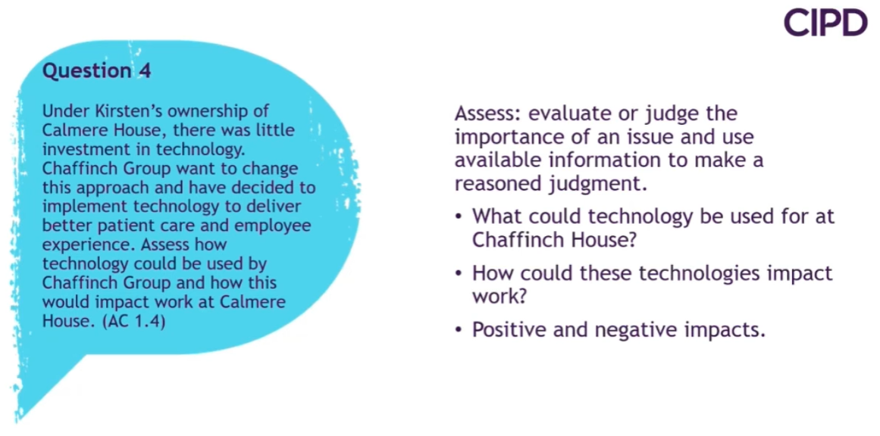
Scale of technology: work systems and ‘equipment’ in use; currency, updating and efficacy of systems; implementation of technology across the organisation and areas where technology plays a greater or lesser role; organisation spend on technology and wasted spend (‘here today gone tomorrow technology’); levels of support for using technology. Impact of technology: on different functions, products and services provided; on worker efficiency, worker wellbeing (for example remote working, ‘always-on’ technology, work-life balance, wider family issues); collaborative working (social media); worker satisfaction (automation), creativity and innovation; how the work has evolved in line with the technological timeline.
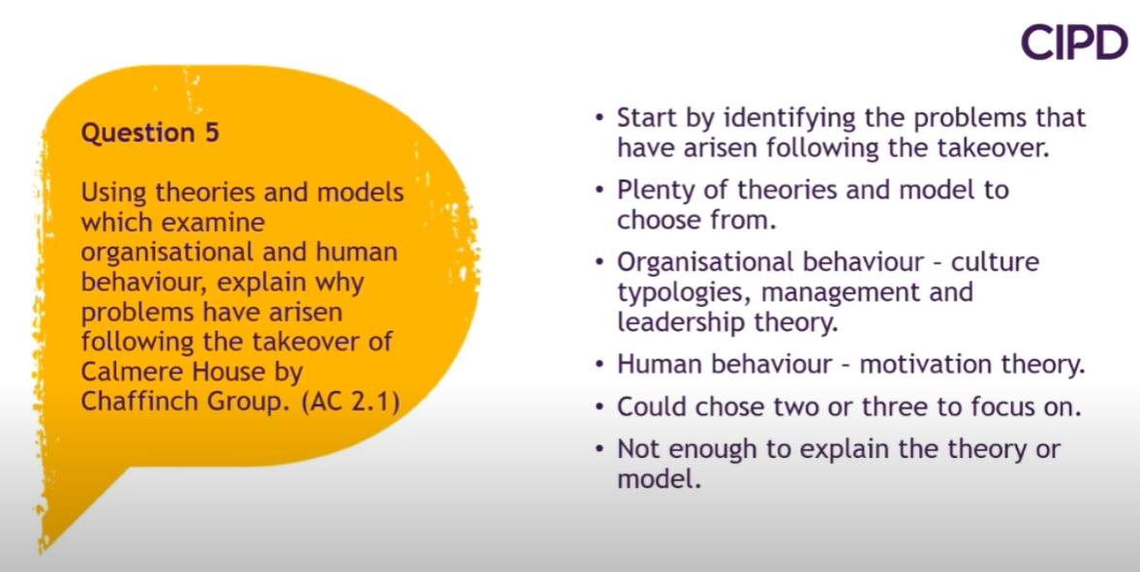
Theories and models of organisational culture; culture typologies (e.g. Schein, Hofstede, Handy). Autocratic, custodial, supportive and collegial models of organisational behaviour. Concept of Learning Organisations. Management and leadership theory and how management styles impact employee behaviour. Models of human behaviour (e.g. motivation theory).
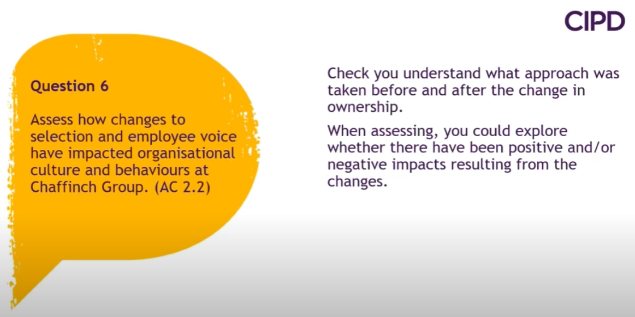
Extent of people practice influence, for example people practice’s role of ‘people champion’, setting behaviour through policy, setting behaviour through rolemodelling. Potential impact on: beliefs and values; levels of openness and trust, for example through policy development; levels of motivation, for example linked to reward, engagement, relations and equality, diversity and inclusion policies; attitude to and provisions and take-up of learning/CPD, linked to L&D policies; levels of staff wellbeing, linked to overall positioning, management and value placed on employees in the organisation.
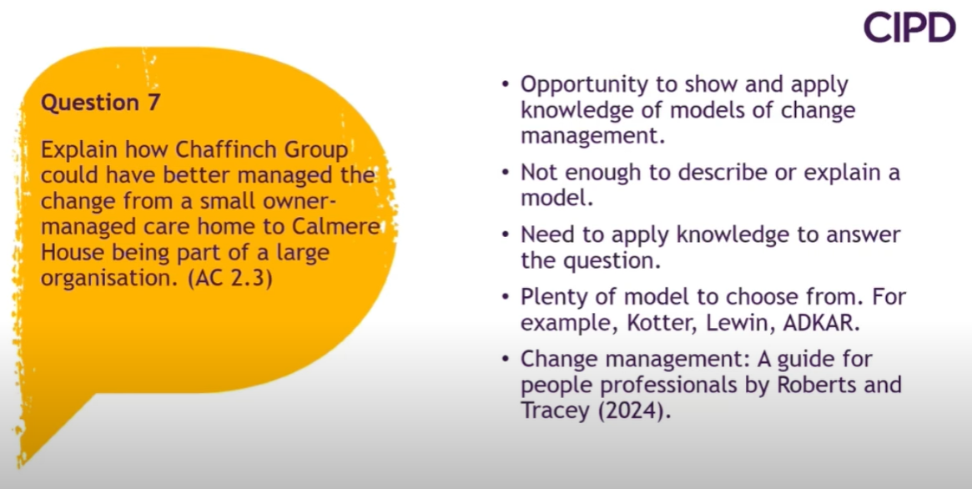
Change management approaches: for example Lewin’s three-step model of change; Kotter’s eight-stage model; reactive approaches, proactive approaches; planned change, emergent change; radical, incremental change; levers for change; drivers of change: wider environment, task environment, internal environment.
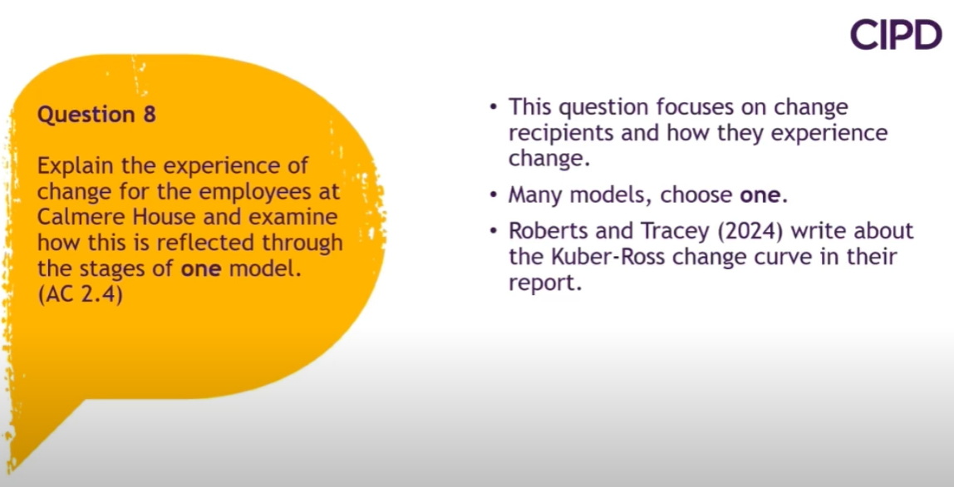
Models for how people experience change: for example Tannenbaum and Hanna three-stage model; Kubler-Ross adapted model: the coping cycle; Spencer and Adams’ seven-stage model; readiness for change and resistance to change.
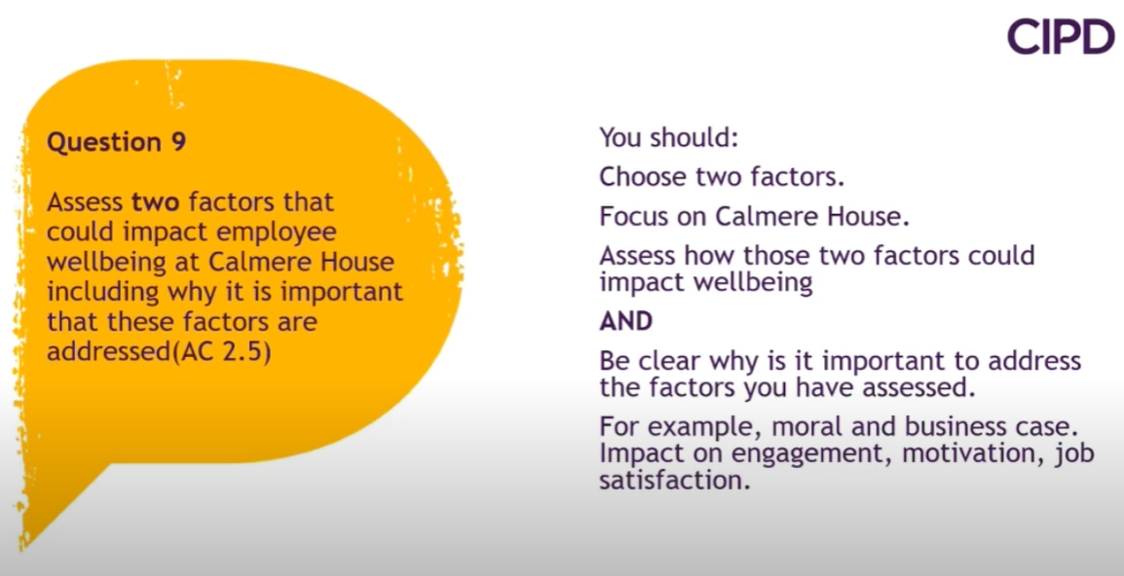
Importance of wellbeing at work: how wellbeing at work impacts on the individual: for example worker engagement; worker motivation; job satisfaction and purpose; physical and mental health; self-image and resilience. Links to psychological contract, work-life balance, wider family issues. Links to motivation, for example expectancy theory’s effort-performance-rewardengagement cycle. Impact: on levels of worker commitment and issues resulting from this for the organisation, for example issues resulting from reduced attendance, punctuality, capability and efficiency. Issues resulting from impoverished relationships and greater potential for stress and interpersonal conflict.
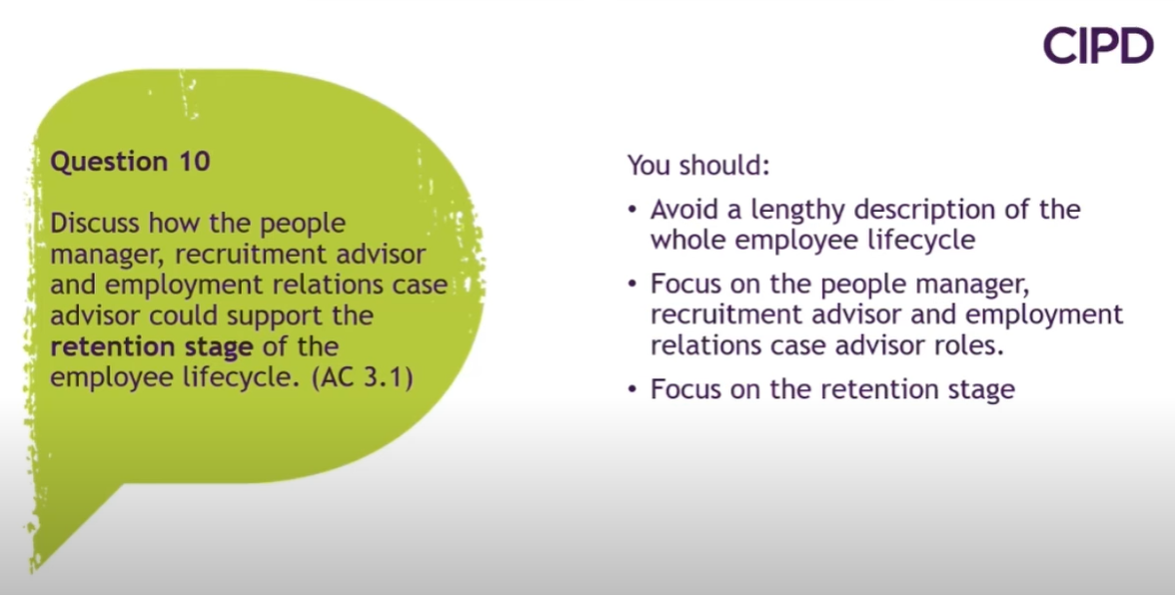
Definitions of lifecycle, for example attraction, recruitment, induction/onboarding, development, retention/engagement (including reward/relations, promotion/succession planning), exit/separation, possible post-employment connections. Overview of people practice roles at each stage and how this continues to evolve. Touch points along lifecycle for particular areas of people practice (HR, L&D, OD) and different people practice roles.
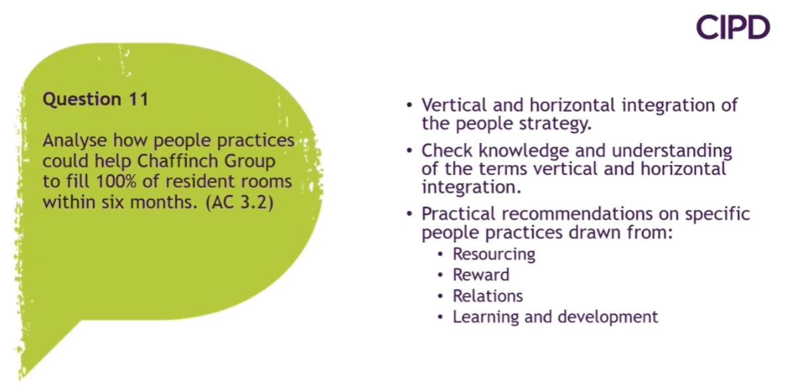
Connections: links between people practice and the strategy-making function (‘top table’); links between people practice and business/operational functions; business partnering; vertical and horizontal integration. Support: How people practice strategy is derived from and supports organisational/corporate strategy.
Services provided by different areas of people practice (for example, policy development, legislative compliance, recruitment, L&D, skills analysis, management development) and how these support the business and its employees.
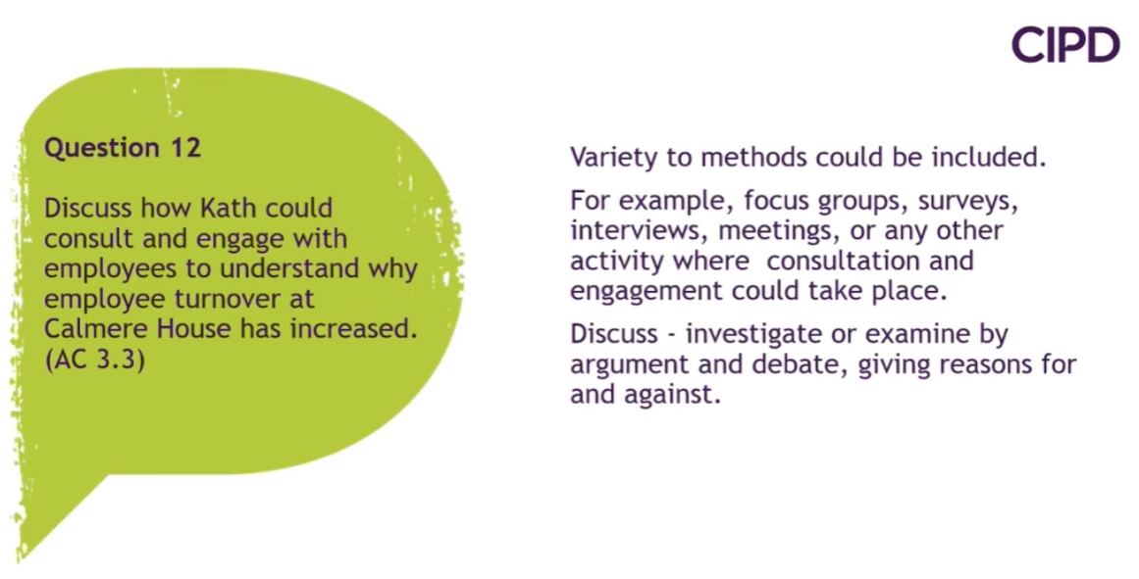
Consulting processes: how people practice liaises with and identifies internal customer needs; consultation and communication processes; stakeholder analysis; needs analysis activities. The importance of regular and effective ongoing liaison with stakeholders. Monitoring and evaluation activities

