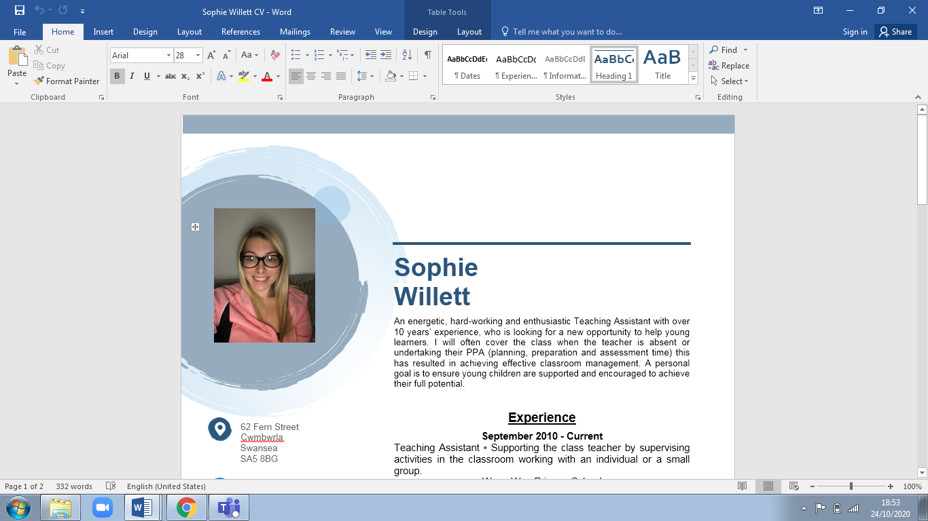

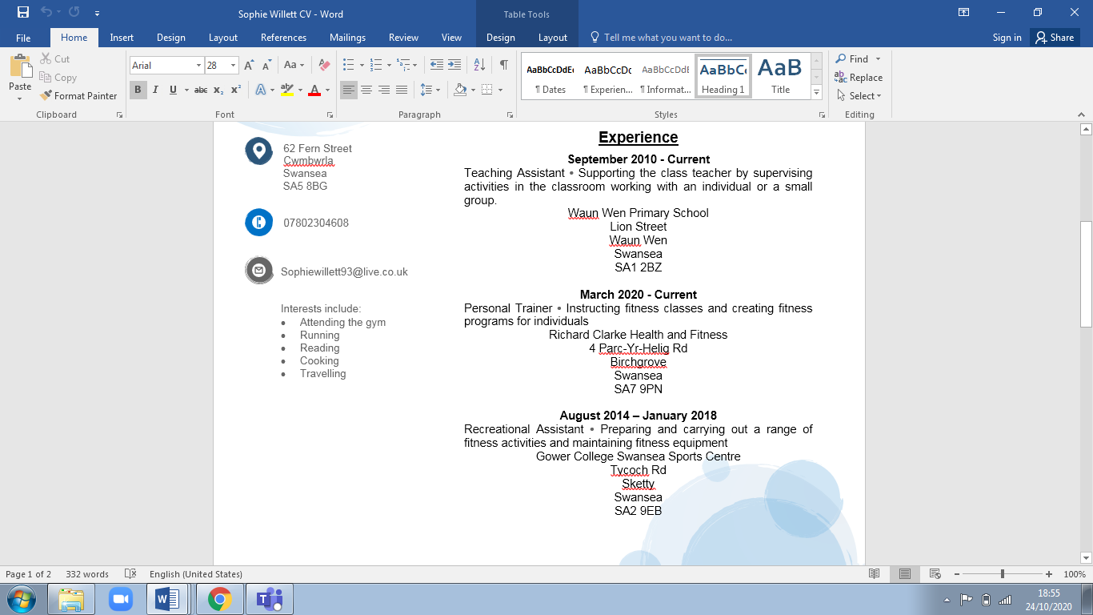
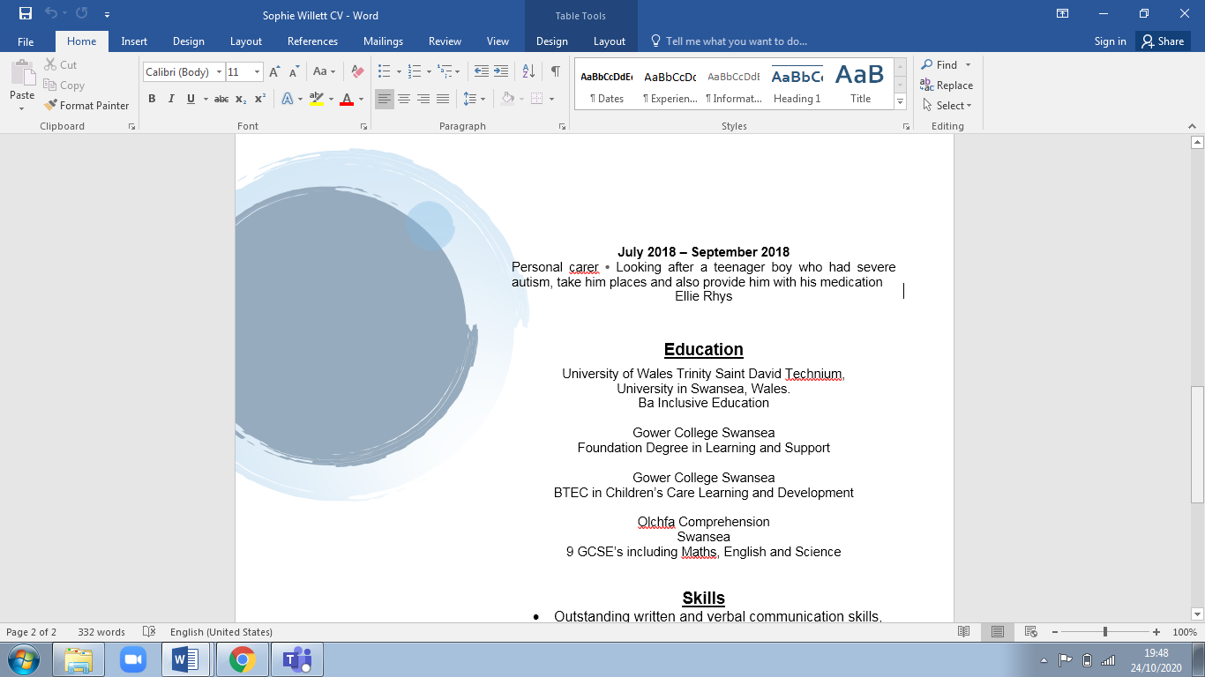

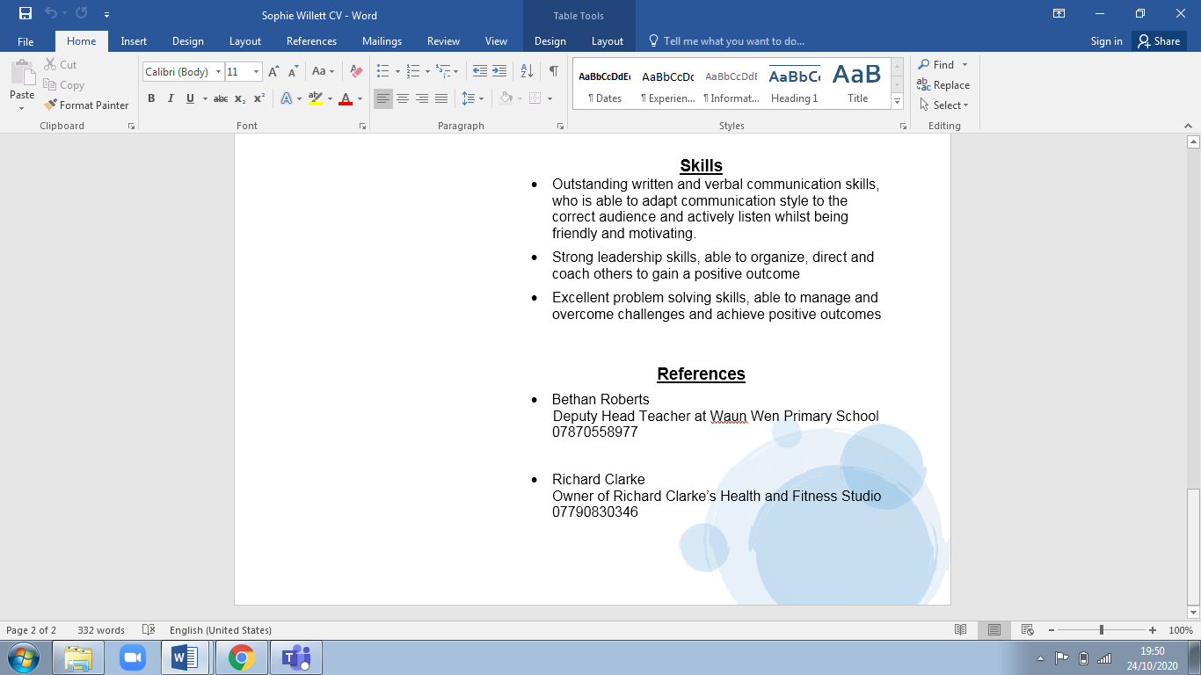

Personal Development Plan

Target for development | Why? | How? | Who/Where? | When?
Knowledge of Additional Learning Needs (ALN) | To keep up to date with new information and broaden knowledge on ALN | Undertaking the Additional Learning Needs course called ‘Special Educational Needs (SEN) – Advanced’ | Online via the website https://www.learndirect.com/course/special-educational-needs-sen-advanced | 16th November 2020
Knowledge of Additional Learning Needs (ALN) | Acquire more strategies for when working with pupils who have Additional Learning Needs | Talking to the current Special Educations Needs Co-ordinator (SENCo) | At current workplace which is at Waun Wen Primary school and the SENCo has been in her job role, for over twenty years | 30th November 2020
Real life experiences | Experiencing real life situations will increase a better understanding of a Special Teaching Facility | Volunteering in a Special Teaching Facility | A Special Teaching Facility in Swansea called Ysgul Crug Glas as I did used to work there over ten years ago | Spring 2021
Communicating in Welsh | To be able to communicate to Welsh speaking children | Undertaking a Welsh course | Online via the website https://learnwelsh.cymru/ and will undertake the ‘Improving your Welsh’ course, which is in two parts. | Spring 2021
GCSE’s | To have the appropriate requirements to be able to go onto the Postgraduate Certificate in Education (PGCE) | Undertaking weekly lessons for Mathematics, English and Science | Through Gower College Swansea as they offer part time courses for all 3 subjects.  https://www.gcs.ac.uk/a-levels-and-gcses#!pnl_all | Academic year 2021/22
PGCE | To become a teacher for primary education | Undertake the PGCE Primary course which includes; school placements and studying the theory behind teaching and learning | University of Wales Trinity Saint David  https://www.uwtsd.ac.uk/pgce-information-days/  Will attend the virtual open day on the 28th November 2020 for more information. | Academic year 2022/23

Reference list
- Cottrell, S. (2020). Skills for Success. Basingstoke: Macmillan International Higher Education
- CRAE (2020). Equality Act 2010. Available from: http://www.crae.org.uk/childrens-rights-the-law/laws-protecting-childrens-rights/equality-act-2010/ (Accessed on: 24th October 2020)
- National Careers (2020). Special educational needs (SEN) teacher. Available at: https://nationalcareers.service.gov.uk/job-profiles/special-educational-needs-(sen)-teacher (Accessed on: 24th October 2020)
- Skills You Need (2020). Available at: https://www.skillsyouneed.com/interpersonal-skills.html (Accessed on: 24th October 2020)
- Trought, F. (2017). Brilliant Employability Skills. United Kingdom: Pearson Education Limited
- Viney, D. (2019). Critical Reflection. Available at: http://davidviney.co.uk/critical-reflection (Accessed on: 22nd October 2020)
- UCAS (2020). Special Educational Needs Teacher. Available at: https://www.ucas.com/ucas/after-gcses/find-career-ideas/explore-jobs/job-profile/special-educational-needs-teacher#:~:text=Special%20educational%20needs%20(SEN)%20teachers,physical%20disabilities (Accessed on: 22nd October 2020)
- Wales. Department for Education and Skills (2015). Curriculum for Wales: revised Areas of Learning and programmes of study. Available at: https://hwb.gov.wales/storage/46382070-e563-46ee-85b5-202e41684e3b/curriculum-for-wales-revised-areas-of-learning-and-programmes-of-study.pdf (Accessed on: 24th October 2020)
- Wales. Department for Education and Skills (2015). Overview of the Draft Additional Learning Needs Code for Wales. Available from: https://gov.wales/overview-draft-additional-learning-needs-code-consultation (Accessed on: 24th October 2020)

