Buffering

Buffering is a powerful proximity analysis tool. Since buffers are regions, you can search for objects inside of them. When creating a buffer you control the size or radius of the buffer. For example, you can use MapInfo Professional to create a 15-mile buffer around all of your buildings. Then, you can select all the records from a point file that are located within the buffer (eg doctors location that are near a particular hospital).

Open up a workspace containing gp clusters and Gp locations

Add or change the symbology to look something like this:

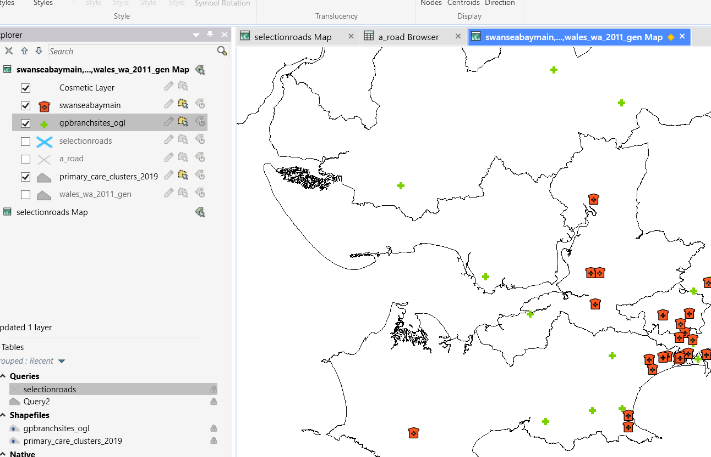

Next open a file called Strategi – you will find this in the OS digimap archived downloads. It contains some suitable road network data.

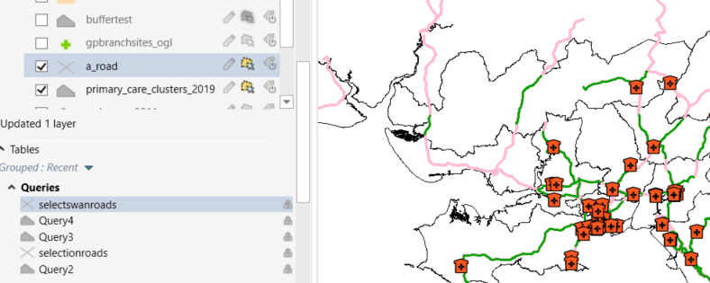

Open a roads and then perform a selection using the polygon area for Swansea Bay.

We will manually select this using the pointer arrow and holding down the shift key:

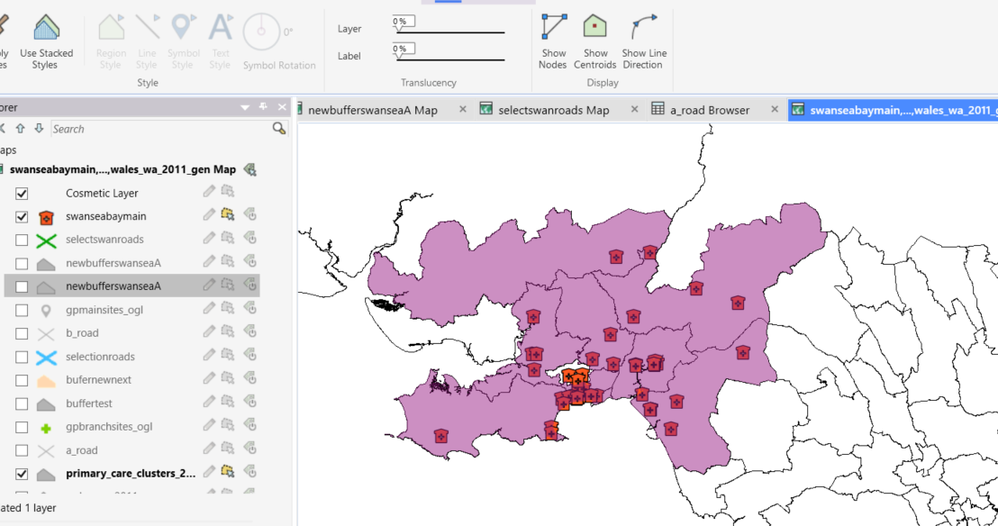

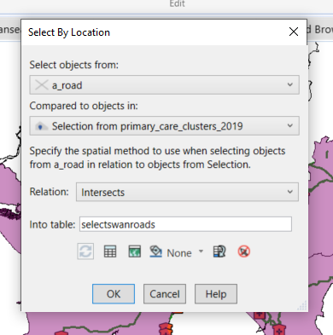

We can now create a buffer zone around the subset of Swansea roads.

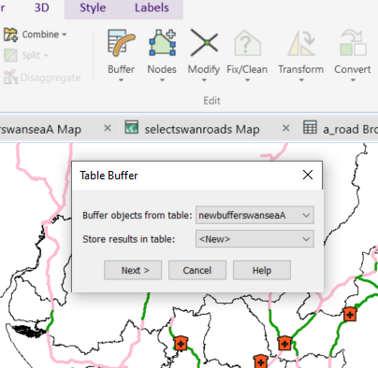

Create as a new table with a basic field structure
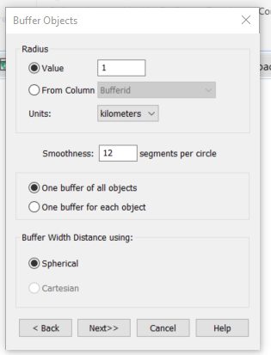

Finally, we have a picture of the zones around our road network and we can observe the GP practice distances from main roads.



