Live project report
For live project my team decided to create a series of videos that could be used in the national wool museum. These video where to be created so that if needed they could become an AR experience. My role with in the team was researcher but I lent a hand between roles though out the project as there was multiple things that needed to be done.
My duties within my role was to.
- Report to other team members with information on the client
I believe this I achieved this within the live project as I gathered information about what oshian wanted us to and what he wanted the final product to look and I reinforced this through out the project to make sure we did everything correctly
- Maintaining contact with client with regards to the facts and information about the project.
Between all of us in my group we manged to arrange a trip to the wool museum where we were shown around and shown the whole history of the museum at the end of our time at the museum one of the people who work there give me a essay that was created when the when the museum was rennervated in the early 2000's that contented a lot of information about the mill its important figures and the types of people that worked there this came in handy with regards to facts and information
- Develop ideas
I helped a lot with developing ideas as we worked together to think of ways we could make the videos the best we can in are second pitch I came up with a mock up photo of one possible Idea this idea consisted of an actor standing behind the draper shop set that was already build in the museum I created this mock up with the AR in mind and this is an idea that was favoured throughout the project and was used as one of our end videos this was a good development of ideas in my be half coz my idea became a platform for us to build off

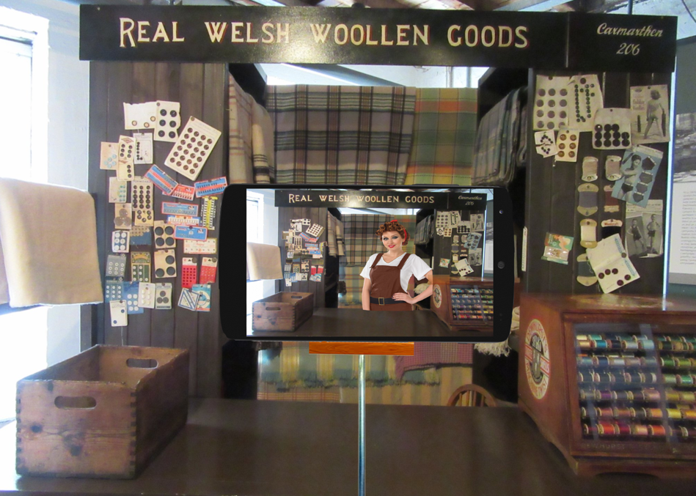

- Find out facts about the heritage site historical and practical.
This was another part where I thrived as I was able to find loads of information online and with the resources that I was given from the museum I was able to to pin point facts that would be great to put in to our final projects working closely with my team mates we where able to create a folder of information and facts about the wool museum
- Work closely with project manager to relay information
Kurtis was the production manger on are team and I worked closely with him thought the whole project relaying information checking the facts where correct working together to make sure the scripts where correct and that’s we had achieved everything this the client wanted
- Identify relevant information data
As researcher it was my job to make sure the information that where using within are films was correct and that we hadn't left no detail out I had to make your all the times where correct for our figures and that the dates that stuff would have happened where correct it was also my job the research the what life in the era that we were focusing on
- Research target audience and find ways to make the project engage with them
Whilst researching target audiences I asked family members and friends with kids the were in the target audience which was 7-11 I asked them what they would be interested in and what would make them the most entertained and willing to use I showed the older kids my mock up photo that I talked about earlier a lot of them said that that they would be interested in watching the video that way

Things I gained from this project
I gained a lot from this project as it was something that I had never done before I had worked with zinzan and Kurtis on smaller projects such as Penarth and I wasn’t sure how we would work as a team but we worked really well and I think I gained a lot of team work skills with resolving situation with in the group when things went wrong like not having enough information and keeping everyone motivated when we had to wait for replies from the client and the museum and also actors as a team we carried on working in between these brakes making sure we could use the most of our time this give me a good sense of time management and this is a skill that I have developed a lot whilst completing this project another way I made my time mangement skills better was the fact that we had to work towards a deadline and not just the final deadline but we created deadline basically each week or each time we had a meeting to make sure we kept up to date to make sure we where able to fish the project on time for the client i also had to help with the sound whilst filming and me and zininzan took it in turns to record sound this is not something that I usually do and I had only brefilly recorded sound before this I had to learn quickly how to use the htc zoom any thing I learn was organisation skills as I had to take notes on takes and plan out the filming

Somethings I thought could have been better was
That we had a an issue with actors and as are male actor backed out last minute luckily are female actor had contacts and we where able to find another actor in time

