
Applied Leadership and Management in the Workplace
Module Assignment Submission
Student Name: | Rosemarie Bennett
Student Number: | 2317081
Module No: | BMSK4011
Module Title: | Continuous Professional Development

Statement of Confirmation of Authenticity
By the act of making this, the student declares that this is the work of the student named above. The work has not, in whole or in part, been knowingly presented elsewhere for assessment, or where assessment has been built on a previous assessment, this has been identified. Where materials have been used from other sources it has been properly acknowledged. If this statement is untrue, the student acknowledges that an assessment offence has been committed.
Attention is drawn to the plagiarism and unfair practice policies of both the University and of ILM.

Table of Contents
Section 1: Know how to identify development needs 3
1.1 Identify learning styles for self and another 3
1.2 Use a simple technique for identifying development needs for self & another 5
1.3 Identify potential barriers to learning for self and another. 7
1.4 Explain how these barriers to learning can be overcome. 8
Section 2: Know how to develop self & others to achieve organisational objectives 8
2.1 Analyse learning/development options to meet needs of self & another. 8
2.2 Identify support mechanisms for the development of self & another 8
2.4 Method used to monitor the development of self & another. 12
References 13
Appendix A Curriculum Vitae 14
Appendix B Continuous Professional Development Record 15

Section 1: Know how to identify development needs

By understanding others and yourself, skills behaviours and attitudes within the team. Talking to each other will give you different development skills. Clear, systematic and ongoing identification of how learning and development (L&D) needs relate to performance gaps is key in ensuring effective learning (CIPD, 2023). Before conducting a gap, analysis there is a need to understand learning styles and identify what the development needs are using a simple SWOT analysis.

1.1 Identify learning styles for self and another

Peter Honey and Alan Mumford developed the Learning Styles Theory -- a follow up to the work of David Kolb and his Experiential Learning Theory. Honey and Mumford identified four different styles of learning: "activist," "theorist", "reflector" and "pragmatist." According to the theory, different people naturally gravitate toward a particular learning style (Watson, 2019).
I have recently completed a honey and Mumford questionnaire my results were that I am a reflector and a close pragmatist learner .being a reflector that I look at thing before making any decisions making sure that things are write before preparing, also I’m a close pragmatist which I do agree with as I do like to solve problems , with teaching methods ,looking at information in logic ways and act on it immediately , making judgments based on practicality. A pragmatist means that I am a person with strong believes in what is right and wrong I also solve problems step by step using instructions, I agree to formal procedures and policies can restrict people because there could be an easier way in solving any problems. I also believe in saying what I think directly and to the point, I like to sort my work presentation thoroughly and implement strategy, I always look for new experiences when I knew idea is I immediately start working out how to do it in principle. I am very self-disciplined as I always watching my daily diet watching what I eat, getting my steps in sticking to a regular routine. I always take pride in a job I am doing it always has to be perfect, I make discussions carefully after over thinking I do not like things to be disorganised as it makes me very anxious, so things must be in order, I always pay attention before coming to conclusion the more information I have the better. I think that some rules should be broken as some of them can be betty and they are not worth the paper they are written on sometimes I can see more practical ways in sorting thing out. reports should always be short and to the point, I will look at different information I like to try different things out, to see different ways and make my mind up. I always like to do my job correctly. A reflector means that I learn by listening and looking at the discussion first and thinking before doing, before coming to any decisions .and I’d say that this is my learning style. Also being a close pragmatist, I like to solve problems you my skills use my common sense look for logical ways to solve problems. making instinctive judgment based on practicality. This is definitely my way in doing things.

I also completed this questionnaire on an another their results were also a reflector and a close theorist(honey&mumford1992).this is a very accurate as I done this on my partner its reflects perfectly , he was also a close theorist which also is very true as he always reads everything over to make sure its correct before doing any planning organising work collecting date making notes for essays to achieve the best results.

One of the other learning styles I reached were VARK, the VARK model refers to the four sensory modalities that describe different learning preferences (Cherry, 2023).

I have researched a few different models to identify learning styles for myself and one other. I found out that I am a visual learner I like prefer to observe and look at diagrams and pictures read information and instructions and watching someone else do things first. A visual is learner is someone that observes things like pictures and diagrams handouts instructions and watching someone else first. My partner is also a visual learner style with the Honey and Munford and vac learning style. I am pragmatist and a close reflector with the VAK learning style.

1.2 Use a simple technique for identifying development needs for self & another

A simple technique to identify development needs is a SWOT analysis. A skills SWOT analysis is a simple tool to help you identify your skills and where you may lack them. It is an acronym for Strengths, Weaknesses, Opportunities and Threats. Using this analysis, you can effectively find your strengths and see where to minimise your weaknesses (wea.org, 2023).
SWOT Person 1

STRENGTHS  Working independently  Getting work done on time  Having my family believe in me.  Knowing that I can ask my tutor for advice | WEAKNESSES  My computing skills,  Me over thinking and making me think that I cannot do things.  Managing time.
OPPORTUNITIES  Being positive and believing that I will get to overcome my weaknesses. | THREATS  Negative thoughts, people not understanding, illness which could lead to me losing customers, losing money

SWOT Person 2 - Jonathan

STRENGTHS  knowing he can complete his work with no comeback.  Family and friends around.  Calm and methodical, knowing your job more through more years of experience. | WEAKNESSES  Not completing a day, due to time scale.  Illness.  Family  Pressure to achieve targets in the workplace, slower due to age.
OPPORTUNITIES  Being able to archive exams getting opportunities to better himself within the workplace and continually keeping up to the standard and changes in the workplace. I.e.  Legislation, new working practices, new Safety measures, all employees have the opportunity to climb the ladder to reach management level. | THREATS  People not doing their jobs correctly and having to re do the jobs and getting no appreciation from the company.  Negativity with family. Illness, hazards working in different premises examples are animals’ nasty dogs, drug abusers, mental health issues, violence.

Once the SWOT analysis has been completed there is a need to complete a gap analysis (also known as a needs analysis) which is the process of comparing your current performance with your desired performance (Laoyan, 2022).
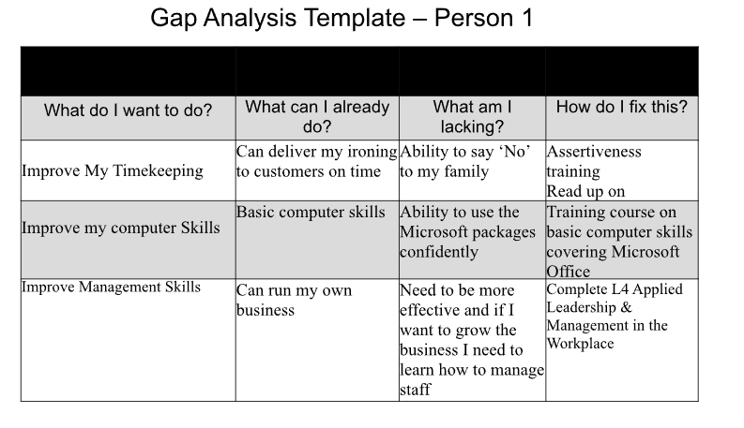
Gap Analysis person 1 if I’m ill it this would be a weakness which will affect my customers, because nobody would be able to my job, overthinking things, time management ,family bothering me all the time having to leave my work to go and do thing for family like picking up my grandchildren from school because my daughter cant because she’s in work ,but expects me to drop everything just because I work from home this is a big weakness for me because it stresses me out big time as I have commitments to for my job and my customers. The threats are that I could lose my customers due to not getting my work out to them on time and that they would go to someone else which would cost me financially. For future developments for my business are having to say no because my family need to realise that just because I work from home, I am not available twenty-four hours a day, and I feel that this will lead to my future development within my business with just a little understanding from family and friends then I will be able to develop my business in the right direction. Another weakness would be I am not very computer literate, this can be rectified by taking up a basic computing course just to get me comfortable with the software and using a computer.
Gap Analysis person 2 their weaknesses are.
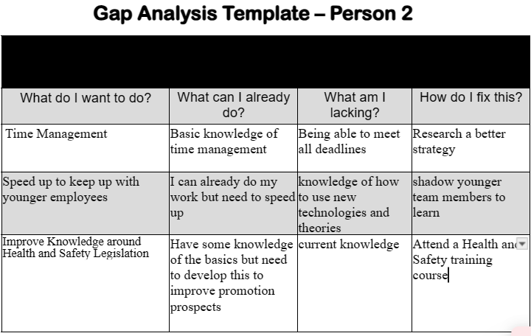
Weaknesses are illness which would stop person 2 doing the job, family ,in the work place achieving targets age could slow you down, also new people joining the company like youngsters, which are not experienced enough to do the job and rushing the job because they might do a job quicker which might look good and done on time ,figures may suggest that the targets have been achieved by the individuals where’s on the flipside a quality job may not have been carried out correctly. Which get reallocated to a more experienced engineer. Working unsocial hours can also be a weakness because your unable to commit to family and social events like Christmas birthdays all holidays.

1.3 Identify potential barriers to learning for self and another.

A barrier to learning is anything that prevents a learner from being fully engaged in the learning process (Green, 2023).
My barriers to learning include my computing skills because they are a bare minimum,
which I find is going to be a challenge if I am going to complete my assignments on
time. Further barriers include my other commitments such as my Family as I’m the sole
carer for my mum, which takes lot of my time. I also have four grandchildren which
takes up a lot of my time running back and forth doing school run and looking after the
grandchildren until they are collected. My family do not seem to understand that I have
deadlines too and my work to do get done for my business. If I can’t get my work done I
don’t get paid which will become a big problem because I have my weekly outgoings
just like everyone else has. This will lead to financial difficulty which could then prevent
me from attending classes and that could be a major barrier to learning for me as I feel I
need to be there to learn.

1.4 Explain how these barriers to learning can be overcome.

To overcome these barriers, I’ve got to make a chart for time to get everything into scale, I am going to train myself overcome the fears and be positive.
And keep learning. Also ask if I do not understand anything.to overcome these barriers ,my family need to be told that I have am only one person and that they are going to have to get thing sorted out for themselves ,I need to say NO, at times because it is going to start taking its toll, and it could start arguments which I really don’t want to happen ,getting their understanding will be really good for these barriers and for my learning.

Section 2: Know how to develop self & others to achieve organisations objectives.

Knowing what skills, I need to develop myself and others to achieve organisation and objects are by reading different newspapers articles understanding different behaviour and attitudes. What we already know and knowing how to develop in the future.

2.1 Analyse learning/development options to meet needs of self & another.

Self Directed learning – Self-directed learning can be defined as the outcome of
creating an experience that empowers learners to make decisions about the
information they want to become proficient in (Robinson &amp; Persky, 2020). For me
it is about reading and understanding to be able to learn and develop my needs.
– one of the areas where I can develop using self directed learning is reading
about time management to improve my time management skills.
On job training can be defined as the informal/practical training that can be
acquired at the job site or through workshops/seminars in order to equip
personnel with enhanced skill to provide more efficient services (Jain, 1999).
Examples of on the job training include shadowing, mentoring or short courses
but I work for myself and at the moment it is not possible to shadow or mentor to
improve efficiency as there is no one else employed in my business.
Off the job training is defined as any type of training that is not performed on the
job, that is, training which take place in a classroom and which is designed to
train groups of trainees rather than individual (UK Essays, 2015). Studying the
Cert HE in Applied Leadership &amp; Management in the Workplace is one example
of an off the job training I will be completing, another example would be attending
other courses away from workplace e.g. computer.

2.2 Identify support mechanisms for the development of self & another.

Some different support mechanisms I have research are, providing feedback in real time not just annual reviews or probational, appraisal review. However, I work for myself and there are no others in my business. To develop myself whilst completing the degree would need support from my tutor college group, family, friends. My tutor will support me through their subject knowledge and feedback, as well as answering any questions I may have. My college group will support me by answering questions and providing a listening ear when things get difficult. My family need to support me by giving me enough time to complete my assessments and accepting that sometimes I am going to have to say NO.
My partner would need support from mentoring and coaching programs to support growth within their field. Identify soft skills and personal traits or non-technical attributes that will help progression at career field. The work manager/line manager would support applications for courses and allow for time away to be able to study and gain the qualifications required e.g. Health and Safety. Colleagues would provide support by covering whilst my partner was attending the course and by discussing the content of the course and supporting the learning.
2.3 Prepare development plans for yourself and another person
Person 1
What do I want to learn? | What do I have to do? | What support and resources will I need? | How will I measure success? | Target Date for Review
Computer literacy and skills | Attend a computer course. | My tutors support. keep using my laptop | Ability to use my laptop. | 2024
Time management  course | Good attendance for my course. | Tutor support. | Time scale | April 24
Cert HE Applied Leadership and Management in the workplace | Attend  Listen  Complete assignments | Tutor  Other learners | Assignment feedback | 2 months

Personal Objectives

Short Term Goals (next 12 months)
Being able to pass 1st year course and getting assignments done on time.
Increase knowledge of computing
Medium Term Goals (2-3 years)
Being able to do more self-belief in myself
Expand my business, by advertising – using social media
By cards. Leaflets
Pass L5 Applied Leadership and Management in the Workplace
Long Term Goals (3-5 years)
Getting my degree
Managing a team. Managing a budget.
Pass L6 Applied Leadership and Management in the Workplace (achieve the degree)

Person 2
What do I want to learn? | What do I have to do? | What support and resources will I need? | How will I measure success? | Target Date for Review
How to use laptop | Keep learning | Time. | When I know that I can do thing by him myself. | March 24
Time keeping | Block my time out in sections and allocate that time for university work | Support from my university tutor and family | Hopefully see and improvement in my studies | July 2024
Health and Safety Training | Attend a relevant and current Health and safety course | Support from my line manager  Financial support and time off from the workplace  Family support  Trainer support | Passing the Health and Safety qualification | March 2024

Personal Objectives

Short Term Goals (next 12 months)
Keeping up with computer systems
Medium Term Goals (2-3 years)
Understanding different computer systems.

Long Term Goals (3-5 years)

2.4 Method used to monitor the development of self & another.

ME - Reading using computer more and being more efficient with time. Listening and being aware of my preference for visual learning means I will monitor my sessions by reflecting on what I have learned and identifying whether I have better recall if I have more opportunities to use visual learning.
I will monitor my development by listening to my tutor and asking questions if not completely sure. I will also be reading feedback on assignments and making sure I implement any advice.
Reflection on assignment – how it went, what went well and what went less well – identify areas for development. Reflection is an important part of learning through experience. By reflecting on our experiences, we maximise the potential of any new learning and we monitor any gaps in knowledge (University of Hull, 2023).
Partner – The main method my partner will use to monitor his development is his annual appraisal. The feedback he gets during his appraisal will identify development needs such as the need to develop his Health and Safety knowledge. If he attends a course then he will be able to monitor his development by passing the course, and also by getting feedback from the trainer and listening to feedback.

References

Cherry K, 2023, Overview of VARK Learning Styles, Overview of VARK Learning Styles: Definition and Types (verywellmind.com), accessed 23/11/2023
CIPD, 2023, Learning Needs Analysis Factsheet, www.cipd.org, accessed 16/11/2023
Green C, 2023, 10 Barriers to Learning and How to Overcome Them, 10 Barriers to Learning and How to Overcome Them (ispringsolutions.com), accessed 23/11/2023
Jain P, (1999), On-the-job training: a key to human resource development; Library Management, 20(5)
Laoyan S, 2022, How to use a gap analysis to achieve business goals, What is a Gap Analysis for Strategic Planning? Asana, Accessed 16/11/2023
Mozaffari H R, Janatolmakan M, Sharifi R, Ghandinejad F, Andayeshgar B & Khatony A, 2020, The Relationship Between the VARK Learning Styles and Academic Achievement in Dental Students, Advances in Medical Education and Practice, , 15-19
Robinson J D &amp; Persky A M, 2020, Developing Self-Directed Learners, Americal Journal of Pharmaceutical Education, 84 (3)
UKEssays. (November 2018). Types and importance of on the job training. Retrieved from https://www.ukessays.com/essays/management/types-and-importance-of-on-the-job-training-management-essay.
University of Hull, 2023, What is reflection? Why do it? - Reflective writing - Library at University of Hull, https://libguides.hull.ac.uk/reflectivewriting/reflection1a, accessed 23/11/23
Watson E, 2019, Honey &amp; Mumford Learning Style Theory, Honey &amp; Mumford Learning Style Theory - The Classroom, accessed 23/11/2023
WEA.Org, 2023, Assess your skills SWOT analysis, https://www.wea.org.uk/news-views/blog/assess-your-skills-swot-analysis, Accessed 23/11/23

Appendix A Curriculum Vitae
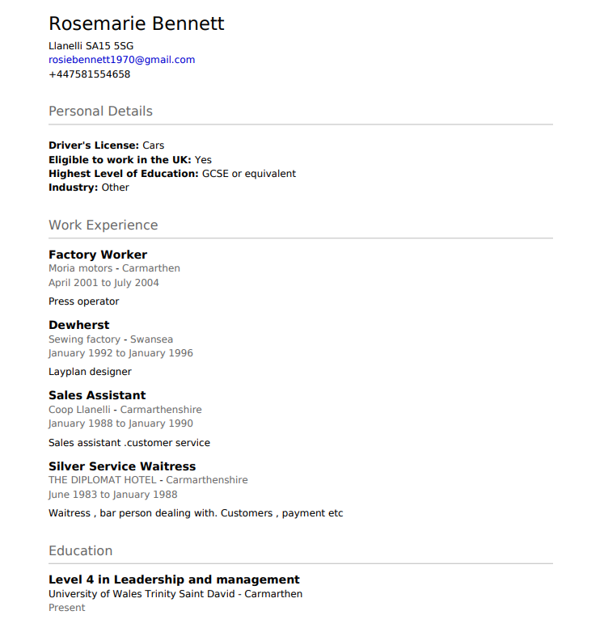

Appendix B Continuous Professional Development Record

Date | Description | Method | Learning Summary | Duration
Oct 2023-Sept 2024 | L4 Applied Leadership & Management | Face to Face delivery of first year degree | Topics include:  CPD  Professional Practice  Research Methods  Management Communication  Enterprise & Intrapreneurship  Problem Solving & Decision Making | 12 months

Until recently I have been running my own business and although I am constantly reading information to improve myself and help me understand I have not completed formal CPD as this has not been a requirement in my ironing business.

