Cover Page
Name: Sherelle Mclean
Student Number: 2407059
Module: Changemakers: Building your Personal Brand for Sustainable Employment
Module Code: BMHP5015
Lecturer: Olufemi Oluranti
Assignment Title: Component 2: Assignment (Report)

Introduction
This report explores the role of a Care Home Manager using the vacancy at Godiva Lodge in Coventry as the basis for analysis (Carehome Jobs,2026). A Care Home Manager is responsible for leading staff, ensuring high-quality person-centred care, maintain compliance with Care Quality Commission (CQC) regulations, managing budgets, and creating a safe and supportive environment for residents. I have chosen this role because it reflects my long-term career ambitions of becoming a successful care home manager before opening my own Afro-Caribbean care home. This report evaluates the skills, knowledge and experience required for the role, while identifying my strengths, areas for development and future career plans.
Job Advertisement
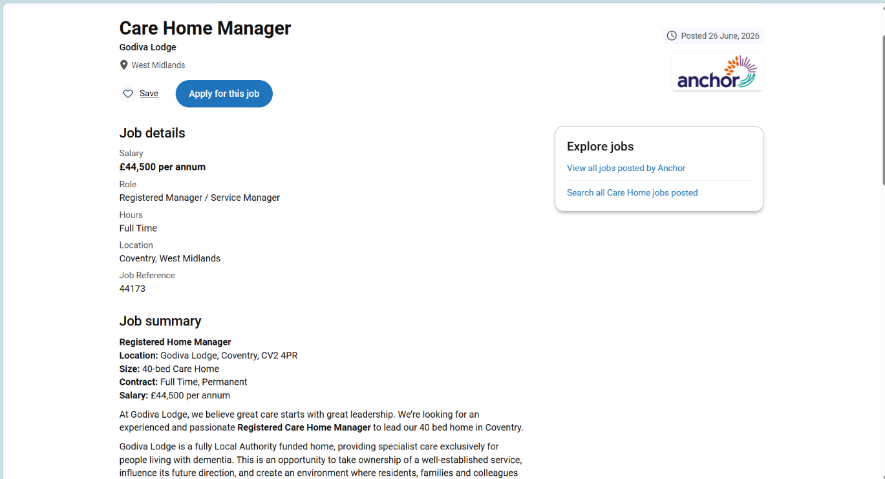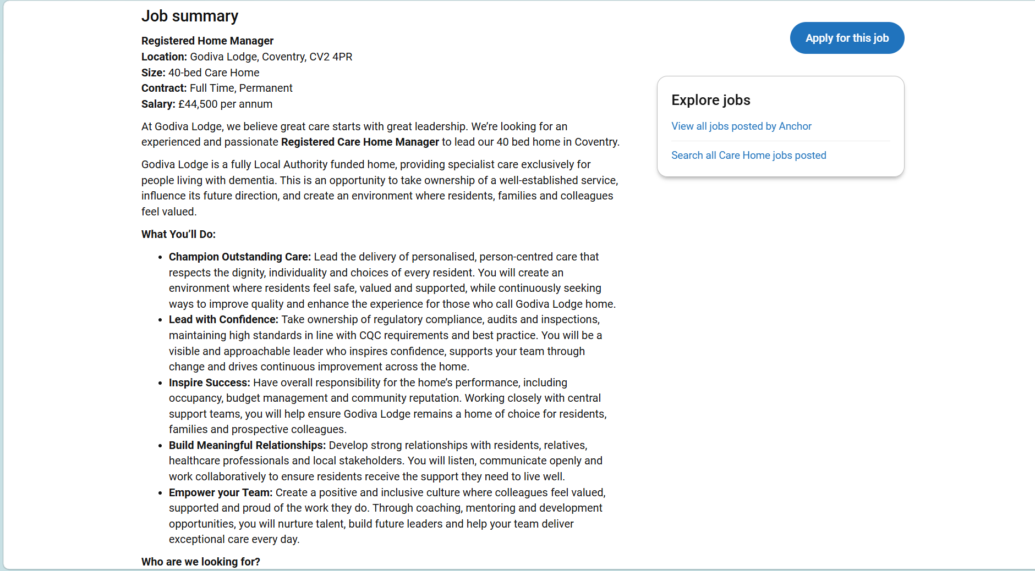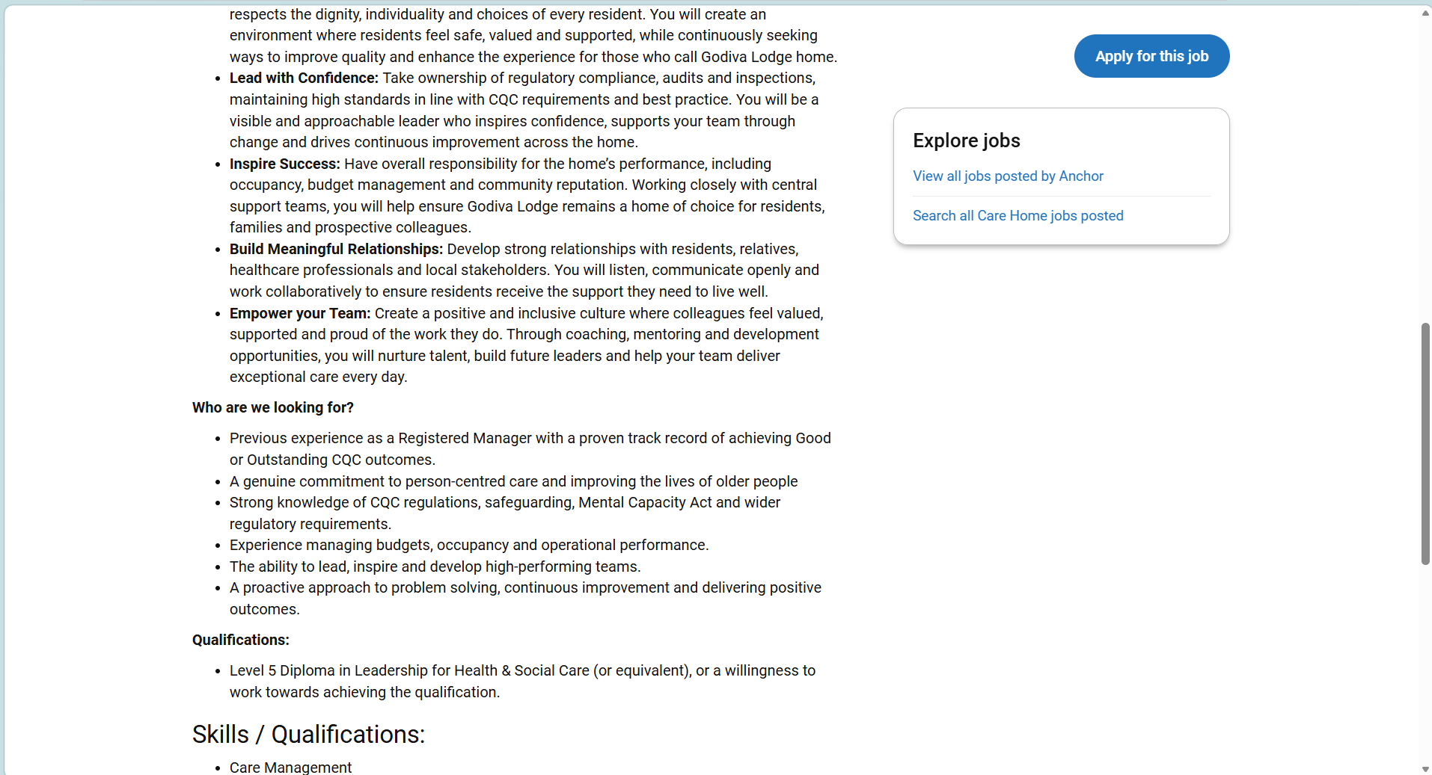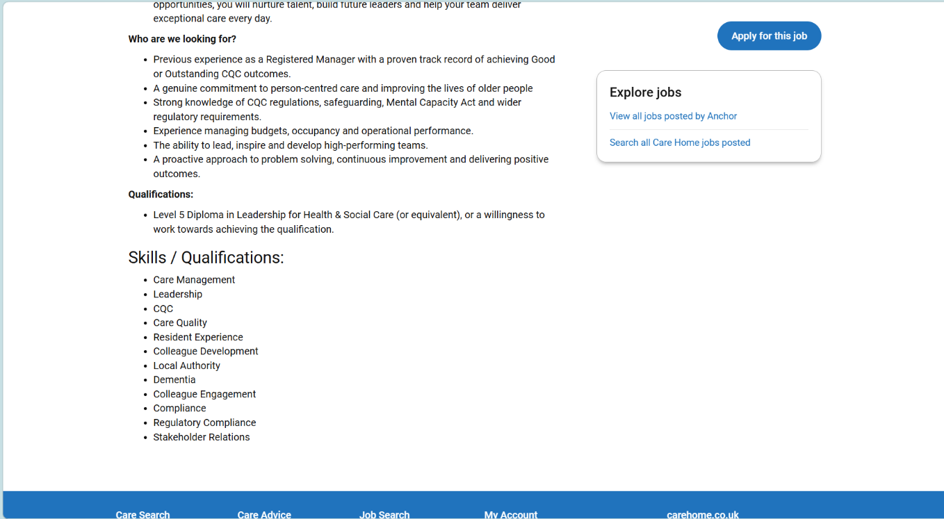

The vacancy selected for this report is for a Care Home Manager at Godiva Lodge in Coventry. The role involves leading a 40-bed residential care home specialising in dementia care. The successful candidate is expected to deliver high quality personal centred care, ensure compliance with CQC standards, manage budgets effective relationships with residents, families and healthcare professionals (Carehome jobs,2026) The employer requires previous management experience, knowledge of safeguarding legislation, the Mental Capacity Act, dementia care, and level 5 diploma in leadership for health and social care or a willingness to achieve this qualification. I selected this vacancy because it closely aligns with my long-term career goal of becoming a registered care home manager and eventually establishing my own Afro-Caribbean care home.
Job Role Employability Skills
The Care Home Manager role at Godiva Lodge requires a combination of leadership, communication, organisational and regulatory skills to ensure the delivery of safe , high-quality care. One of the most important employability skills is leadership. Effective leadership enables managers to motivate staff, promote a positive workplace culture and ensure that residents receive person-centred care. Transformational leadership also encourages staff engagement, continuous improvement and high-quality care delivery (Yukl, 2020; West et al., 2020).
Communication is another essential skill. Care home Managers must communicate effectively with residents, relatives, healthcare professionals, local authorities and members of their own team. Clear and compassionate communication helps build trust ,supports collaborative decision making and ensures that residents needs are preferences are respected (Skills for Care,2025).
The advert also highlights the importance of understanding Care Quality Commission (CQC) regulations, safeguarding procedures and the Mental Capacity Act 2005. Managers are responsible for ensuring that the service complies with legal and professional standards while protecting vulnerable adults from harm. Strong knowledge of legislation supports safe practice and helps maintain high quality care (Care Quality Commission,2025).
In addition, problem solving and decision-making skills are essential for managing complex situations, resolving staff issues and responding effectively to changing resident needs. The ability to analyse information and make informed decisions contributes to continuous improvement within the care home.
Finally, budget management and team development are key aspects of the role . Managers must use resources effectively while investing in staff training, coaching and professional development. Development a retention and enables the organisation to deliver consistently high standards of care (NHS England,2024).
Overall , these employability skills enable care managers to lead effectively , maintain regulatory compliance and deliver compassionate ,person-centred care that improves the quality of life for residents.

Evaluate Your Own Skills
After reviewing the Care Home Manager vacancy at Godiva Lodge, I believe I already possess many of the personal qualities and transferable skills needed for this role. Through my experience working in health and social care, I have developed strong communication, teamwork and interpersonal skills. These have enabled me to build positive relationships with residents, their families and colleagues while providing compassionate , person-centred care . I understand the importance of treating every individual with dignity, respect and empathy, particularly when supporting older adults and those living with dementia.
One of my greatest strengths is my commitment to continuous learning and professional development. I have successfully completed level 4 Skill for Workplace in Health and Social Care and am now coming to the end of Level 5 of my bachelor’s degree in health and social care. I am due to begin level 6 in September, bringing me closer to achieving my degree . my studies have strengthened my understanding of leadership, safeguarding ,legislations, person centred care and evidence-based practice. They have also increased my confidence in understanding the responsibilities of managing health and social care services.
I have also developed good organisational and time management skills by balancing my studies ,employment and personal responsibilities. These experiences have improved my ability to prioritise tasks, meet deadlines and remain calm under pressure, all of which are essential qualities for a Care Home Manager.
Although I have many strengths , I recognise that there are areas where I need further development before I am fully prepared for a Registered Care Home Manager Position. The vacancy requires previous experience as a registered manager , responsibility for budget management and occupancy levels, and a proven track record of achieving positive Care Quality Commission (CQC) inspection outcomes. While my degree has given me a strong theoretical understanding of these responsibilities , I need to gain more practical management experience. I also plan to complete the level 5 diploma in leadership for health and social care, as this is a recognised qualification for registered managers and will further develop my leadership and operational management skills.
Overall, I believe my compassion ,determination, resilience and willingness to learn provide a strong foundation for this career. By gaining a strong foundation for this career and completing my level 5 qualification and continuing my professional development, I am confident that I will achieve my ambition of becoming a successful Care Home Manager before opening my own Afro-Caribbean care home in the future.
Action Plan
To achieve my long-term career goal of becoming a Care Home Manager and eventually opening my own Afro-Caribbean care home, I have developed a structed action plan with clear and achievable milestones. This plan enables me to monitor my progress, identify areas for further development and ensure that continue to build the knowledge, skills and experience required for leadership within health and social care.
My immediate priority is to successfully complete Level 6 of my bachelor’s degree in health and social Care, which I will begin in September. Achieving my degree will strengthen my understanding of leadership, service improvement, healthcare policy ,safeguarding and strategic management. Continuous professional development is essential for effective leadership and maintaining high standards within health and social care services (Department of Health and Social Care, 2022). Alongside my studies, I will continue working within the health and social care sector to gain practical experience and further develop my communication, leadership and decision-making skills.
Following graduation, I plan to undertake the level 5 Diploma in leadership for Health and Social Care. This qualification is recognised within the sector and is essential for those wishing to become Registered Care Home Managers. It will develop my knowledge of regulatory compliance, quality assurance, financial management and leading high performing teams.
My next objective is to progress into a deputy care home manager or assistant manager position. This role will provide valuable experience in supervising staff, managing rotas, overseeing budgets, preparing for Care Quality Commission (CQC) inspections and supporting the overall management of care home. Developing these practical leadership skills will prepare me for the responsibilities of a Registered Care Home Manager.
Within the following few years, my aim is to secure a Registered Care Home Manager position, where I will gain experience managing a care home ,maintaining regulatory compliance and leading high-quality, person-centred services. During this time , I will continue participating in professional development, attend leadership training and build relationships with professionals across the health and social care sector.
Ultimately, my long-term ambition is to establish my own Afro Caribbean care home , providing culturally sensitive, person-centred care that reflects the needs, values and traditions of older adults from Afro-Caribbean communities. By following this action plan and regularly reviewing my progress, I am confident that I will achieve my career aspirations while making a positive contribution to adult social care.

Building Your Personal Brand
Developing a strong brand is essential for anyone aspiring to become a Care Home Manager. A personal brand reflects an individual’s values ,skills, behaviours and professional reputation, helping employers and colleagues understand what they stand for (Montoya and Vandehey,2008). As I progress in my career, I want my personal brand to be recognised for compassionate leadership, professionalism , integrity and a commitment to delivering high-quality person-centred care.
I aim to build this reputation by consistently demonstrating respect, empathy and accountability in my practice. I believe effective leaders should lead by example, continuing my professional development through higher education, leadership training and sector specific qualifications will further strengthen my knowledge and credibility within the health and social care sector.
I will also use professional platforms such as LinkedIn to showcase my qualifications, work experience and achievements, while engaging with current developments in health and social care. Maintaining a positive online presence and participating in professional discussions will help me establish valuable connections and demonstrate my commitment to lifelong learning.
By building a personal brand based on trust , leadership and excellence in care, I will increase my employability and move closer to achieving my long-term ambition of becoming a successful Care Home Manager and eventually opening my own Afro-Caribbean care home.
Promoting Your Professional Identity
Promoting a professional identity is essential in health and social care because it demonstrates competence ,credibility and a commitment to delivering high quality care. A professional identity is shaped by an individual’s knowledge, values , behaviours and adherence to professional standards, all of which influences how they are perceived by colleagues, service users and employers (Skills for Care,2025). As I work towards becoming towards becoming a Care Home Manager, I recognise the importance of maintaining a professional image that reflects integrity, compassion and accountability.
To promote my professional identity, I will continue investing in my education by completing my bachelor’s degree in health and social care and progressing to the level 5 diploma in leadership for health and social care, which is recognised as an important qualification for registered managers(Skills for Care,2025). I will also engage in continuous professional development by attending training, keeping up to date with changes in legislation and following best practice guidance published by the Care Quality Commission (CQC,2025). This will help me maintain the knowledge and skills needed to provide safe ,effective and person centre care.
In addition, I will demonstrate professionalism through respectful communication, ethical decision making, confidentiality and adherence to the value outlined in the code of conduct for adults social care workers (Skills for Care,2024). By consistently demonstrating these behaviours and building positive relationships with colleagues , residents and external professionals, I will strengthen my professional reputation and move closer to achieving my ambition of becoming a successful Care Home Manager.
Building a Professional Network
Building a professional network will support my career development by enabling me to learn from experienced professionals and stay informed about developments in health and social care(Skills for Care,2025). I will build relationships with colleagues, managers and healthcare professionals, attend relevant training events, and use LinkedIn to connect with sector leaders. Developing a strong network will enhance my knowledge, create future career opportunities and support my ambition of becoming a successful care home manager.
Conclusion
This report has explored the knowledge, skills and personal qualities required to become care home manager by analysing the vacancy at Godiva Lodge. It has highlighted the importance of effective leadership, communication, person centred care, regulatory compliance and continuous professional development in delivering high quality care. Reflecting on my own employability skills has enabled me to recognise my strengths, including my commitment to learning ,compassion and experience within health and social care, while also identifying areas for further development, such as gaining management experience and completing the level 5 diploma in leadership for health and social care. The action plan outlined in this report provides a clear pathway towards achieving my career goals. By continuing to develop my knowledge, skills and professional network, I am confident that I will become a successful care home manager and ultimately achieve my long-term ambition of opening an Afro-Caribbean care home that delivers high quality, culturally responsive .

References
Carehome.co.uk Jobs (2026) Care Home Manager – Godiva Lodge. Available at: https://www.carehome.co.uk/jobs/job.cfm/id/96009070612 (Accessed 6 July 2026).
Care Quality Commission (2025) Assessment framework. Available at: https://www.cqc.org.uk/guidance-regulation/providers/assessment/assessment-framework (Accessed 6 July 2026).
Department of Health and Social Care (2022) Health and Care Act 2022. Available at: https://www.legislation.gov.uk/ukpga/2022/31/contents (Accessed 6 July 2026).
Montoya, P. and Vandehey, T. (2008) The Brand Called You: Make Your Business Stand Out in a Crowded Marketplace. Revised and updated edn. New York: McGraw-Hill.
NHS England (2024) NHS Long Term Workforce Plan. Available at: https://www.england.nhs.uk/long-read/nhs-long-term-workforce-plan-2/ (accessed 6 July 2026).
Skills for Care (2024) Code of Conduct for Adult Social Care Workers. Available at: https://www.skillsforcare.org.uk/resources/documents/Support-for-leaders-and-managers/Managing-people/Code-of-conduct/Code-of-Conduct.pdfe of Conduct(accessed 6 July 2026).
Skills for Care (2025) The State of the Adult Social Care Sector and Workforce in England. Available at: https://www.skillsforcare.org.uk/Adult-Social-Care-Workforce-Data/workforceintelligence/resources/Reports/National/The-state-of-the-adult-social-care-sector-and-workforce-in-England-2025.pdf (Accessed 6 July 2026).
UK Government (2005) Mental Capacity Act 2005.Available at: https://www.legislation.gov.uk/ukpga/2005/9/contents (Accessed 6 July 2026).
West, M., Bailey, S. and Williams, E. (2020) The Courage of Compassion: Supporting Nurses and Midwives to Deliver High-Quality Care. Available at: https://assets.kingsfund.org.uk/f/256914/x/a8048c1365/courage_of_compassion_2020.pdf(Accessed 6 July 2026).
Yukl, G. (2020) Leadership in Organizations. 9th edn. Harlow: Pearson.

Appendix


