Rhys Hughes (2116435)
30/12/23 ACCA6011
Machine Learning

Table of Contents
Table of Contents 1
Abstract 2
Introduction 3
Related work in literature 4
Methodology 6
KNN 6
Number of Neighbours 6
P (Power parameter for the Minkowski metric) 6
Weighting 6
SVM 7
Loss 7
Penalty 7
C 7
Discussion 8
Conclusion 9
Figures 10

Abstract
This report discusses the performance of two different machine learning algorithms on the MNIST fashion image dataset. The researcher fine tunes the algorithms to get the best performance out of them and compares their results. The MNIST fashion image dataset is a more modern version of the popular MNIST benchmark dataset which used handwritten letters for testing. The fashion dataset uses 70,000 28x28 grayscale images of different fashion products from 10 different categories. The two different machine learning algorithms used are K nearest neighbours (KNN) and Support Vector Machine (SVM). After tuning the algorithms KNN was more accurate on the dataset with an accuracy of 0.861, and the tuned SVM had a lower accuracy of 0.846. It was also shown that tuning the models could have a dramatic impact on the accuracy.

Introduction
Computer vision is becoming more important as time goes on in many different industries such as cars which use cameras for both self-driving and collision detection. This means that they must be confident that the algorithms used for identifying potential risk are accurate. Therefore, investigating different machine learning algorithms on a computer vision problem and fine tuning them to view the results is important to see which algorithms cope with the specific test and how the supervisor and training can affect the outcome.
To investigate these algorithms on computer, vision the MNIST fashion data set will be used [1]. It is a modern version of the MNIST handwritten dataset which is deemed to be too simple for modern trained algorithms. Therefore, the newer dataset was created to allow for more modern testing of the algorithms. This will be a good dataset to train the algorithms on for this test.

Related work in literature
The dataset Fashion-MNIST is a dataset containing 70,000 28x28 grayscale images of 10 different fashion categories [1]. The 10 different categories are T-shirt/Top, Trouser, Pullover, Dress, Coat, Sandals, Shirt, sneaker, Bag, Ankle boots. This means there are both similar categories which could produce miss calculations by the algorithms which would be interesting to see how the algorithms differ in their accuracy. The images are taken from Zalando’s website and are edited to fit the 28x28 size and grayscale.
The creators of the dataset compared the new fashion dataset against the older handwritten dataset [2]. They used many different classifiers such as Decision trees, Gaussian Naïve Bayes, K nearest neighbour, Linear SVM and many more. They also fine-tuned the classifiers and showed all of the results of the different tunings. While certain tuned parameters did better on the fashion dataset on the whole the classifiers had a higher accuracy on the MNIST handwritten dataset. For example, for the Gradient Boosting classifier which occasionally saw accuracy on the Fashion dataset be higher, the average accuracy for the fashion dataset was 0.840 and the average accuracy for MNIST was 0.925. This story is true for the rest of the classifiers where the accuracy of the fashion dataset was all lower on average than the MNIST accuracy. The average MNIST accuracy value for the Boosting classifier also shows how close many of the classifiers have come to perfecting the dataset and why the newer fashion dataset is much more useful for modern testing.
In the report the highest accuracy achieved for KNN in the fashion dataset was 0.854 which was achieved twice with both of the weighting being set to distance, the number of neighbours set to 5 for the first and the second to 9, and the p value set to 1. The P value means that it was using Manhattan distance. The lowest accuracy was 0.838 which was achieved twice. This appears to be caused by the number of neighbours being set to 1 and using Manhattan distance. The highest accuracy in KNN is above average with some classifiers being in the 0.7s range and some as low as 0.511. The highest accuracy can be confirmed with another reporter having an average accuracy of 85% [3] (0.85). The highest accuracy in that report was 0.867 which was achieved with similar parameters of number of neighbours being 5 with Manhattan distance. These two reports will help with this implementation as it’s possible to get high accuracy with 5 neighbours with KNN. But due to Manhattan distance having both the highest and the lowest accuracy, Euclidean distance will be considered.
The Fashion dataset report doesn’t use SVM it uses SVC which while using the same algorithm it implements it in a different way. The python package that will be used uses LinearSVC with no direct SVM model. Therefore, these results can be used to help the principal researcher's models. The highest accuracy achieved was 0.836 which is lower than the lowest value from the KNN classifier. Another interesting point is the variance between the highest and the lowest accuracy with the lowest accuracy being 0.484. This means that it is possible that fine tuning the classifier will be important for finding the best result. Another report [4] used SVM with HOG (Histogram of Oriented Gradient) which is a feature descriptor. The part of the report that interests this research is the accuracy of the SVM and the confusion matrix. The accuracy of HOG + SVM was 0.865. Which is higher than KNN’s highest accuracy. The Confusion matrix is interesting as only some classes are confused with others by the SVM classifer. For example, the different types of shoes have large false positives and negatives for the other shoe classes but none for the other types of clothes. Another thing found in the confusion matrix is how the T-shirt/Top, Pullover, Coat, and Shirt classes get confused for each other by the algorithm. This will be interesting to see how the different algorithms deal with these similar classes.

Methodology
Before training the algorithm, the training data must be sanitised first. The first thing that must be done is removing any information that is not necessary for the algorithm to know. For example, index numbers that are only there for humans to understand are not necessary and could cause problems with the training. And the model should not have the labels in the training data and should be separated out. For these python packages will be used. The data will be imported using Sklearn and the data will be split into training and testing datasets using train_test_split function.

KNN

Number of Neighbours
There are various things that can affect the output from KNN [5]. The first that will be tested is the number of neighbours. For this test different amounts of neighbours were tested on the dataset from 1 to 19. With this Manhattan distance was used and the weighting was set to distance. The results can be seen in Figure 1. The results show the lowest accuracy was found with the number of neighbours being set to 1 and 2. The highest was found with the number of neighbours being set to 4 with an accuracy of 0.862. After 4 the values drop and stay around 0.85. Another interesting discovery is KNN with these parameters gets a higher accuracy with even number of neighbours numbers than odd. This differs from the research where 5 and 9 had the highest accuracy.

P (Power parameter for the Minkowski metric)
As four neighbours was found to have the highest accuracy the testing for the p number will use it as the number of neighbours. The P value is set as either 1 or 2, with 1 being Manhattan distance and 2 being Euclidean distance. As can be seen in Figure 2 Manhattan distance has a higher accuracy than Euclidean distance. The Manhattan distance had an accuracy of 0.862 and Euclidean distance had an accuracy of 0.857. This agrees with the research findings that Manhattan has a higher accuracy.

Weighting
There are two weighting options, uniform and distance. The Number of neighbours is the same as for the P metric and the P is set to 1. Figure 3 shows that the distance weighting has a higher accuracy of 0.862 compared to 0.858. The difference is very small between the two, but distance is still higher. This agrees with the research undertaken.
In conclusion, the highest accuracy was achieved with KNN was 4 neighbours, Manhattan distance, and weighting set to distance which was 0.862. It was found that the highest difference was made by changing the number of neighbours. Changing the p metric and weighting made very little difference.

SVM
In SciKit learn there are 2 different ways of calling SVM. LinearSVC and SVC. It is recommended to use LinearSVC for large datasets in the documentation therefor LinearSVC will be used [6]. This has 2 benefits, first is because it tends to be faster which is useful for doing a lot of tests and tuning and it has more flexibility for penalties and loss functions. The first test will be seeing how the untuned LinearSVC model does with the dataset. The accuracy was 0.837. This untuned model is roughly only 0.03 less than the tuned KNN model.

Loss
The loss parameter has 2 possible options hinge and squared_hinge with squared hinge being the default. Figure 4 shows the results between the 2 options. Hinge had a higher accuracy of 0.843 whereas squared_hinge had an accuracy of 0.828. This is a difference of 0.015. This means that tuning the model from its default values can see an increase in accuracy.

Penalty
Penalty has 2 possible options, l1 and l2 with the default being l2. A hinge loss parameter cannot be used with l1 therefore squared hinge will be used for this test. Another requirement is that the dual parameter needs to be false for l1 and squared hinge to work. In Figure 5 changing between l1 and l2 makes no significant difference in the final accuracy. The difference is less than 0.0001. The highest accuracy achieved is 0.846 with l1. One reason why this could be is that the max iterations is not high enough which causes it to not converge, increasing the max_iter from the default of 1000 could show different results. Another observation is that due to changing dual to false the time taken to fit and predict and give an output increased dramatically. Therefore while 0.846 is higher than the highest achieved in the loss change, the time taken means that the tests going forward will use loss parameter of hinge with the default penalty of l2.

C
The C value is the regularization parameter. It can be any positive float number. Figure 6 and 7 show the results of the test, For this dataset the lower the C value the higher the accuracy. A C value of 0.1 has an accuracy of 0.846 and C of 5 has an accuracy of 0.799, this has a difference of 0.047.
In conclusion the highest accuracy achieved was with the Loss parameter set to hinge and a C value of 0.1. This had an accuracy of 0.846. Changing the penalty appeared to make no difference but this could be for many reasons such as changing the double to false and not having enough max iterations to see a difference.

Discussion
Comparing KNN and SVM it appears that a tuned KNN has a higher accuracy than a tuned SVM model. The tuned KNN model had an accuracy of 0.861 and the tuned SVM model had an accuracy of 0.846, this is a difference of 0.015. Considering both of their accuracies stayed within the 0.8 region a difference of 0.015 is quite significant.
Looking in depth at the KNN results with the Precision, recall, F1-score, and the confusion matrix (Figures 8, 9, 10, and 11) shows some interesting findings. Firstly looking at what the model struggled to fit, it found it most difficult to label class 6 which is the shirt. The confusion matrix shows that it would often confuse it with 0,2, and 4 which are Tshirt/Top, Pullover, and Coat. This makes sense as they are similar fashion pieces. Looking at the Precision, Recall, and F1-score's it can be seen that the model having difficulty identifying 6 knocks on to those other classes, with 0 (Tshirt/top) being the most accurate out of the four and 2 (pullover) being the second worst. Another observation from the graphs is that it managed to identify class 1 which are trousers very well. This can be believed to be because of how unique it is compared to the other classes.
The SVM results (Figure 12, 13, 14, 15) show a mostly similar story to the KNN results. One difference is that it has more difficulty identifying the differences between 0, 2, 4, and 6 with 6 getting as low as 0.5 in the Recall test. The primary difference is that the class it’s able to identify second to most on average is class 9 which is the ankle boot. This is different to KNN which identifies class 8, the bag, the second to most.

Conclusion
In conclusion, it appears that KNN is able to be more accurate on this dataset than SVM but both require fine tuning to the dataset to work most reliably. An interesting note for real world use looking at the results in the confusion matrices is that while these algorithms find it difficult to differentiate similar classes such as T-shirts to shirts, they can easily distinguish between very different classes such as trousers to T-shirts. For autonomous driving for example there is a possibility that such high accuracy between similar classes might not be necessary as they could treat all cars as cars rather than differentiating them by make or size. But it can be shown that with fine tuning the algorithms can still with some confidence differentiate between similar classes with fine tuning from the ones implementing them.

References

[1] | H. Xiao, K. Rasul and R. Vollgraff, “Fashion-MNIST: a Novel Image Dataset for,” 15 September 2017. [Online]. Available: arXiv:1708.07747.
[2] | Zalando Research, “Fashion Mnist Benchmark Dashboard,” Zalando Research, 2018. [Online]. Available: http://fashion-mnist.s3-website.eu-central-1.amazonaws.com/. [Accessed 28 November 2023].
[3] | C. Edwards and A. Yen, “ Intro to Pattern Recognition: Fashion-MNIST,” University of Tennessee, Knoxville, Knoxville.
[4] | K. V. Greeshma and K. Sreekumar, “Fashion-MNIST classification based on HOG feature descriptor using SVM,” nternational Journal of Innovative Technology and Exploring Engineering, vol. 8, no. 1, pp. 960-962.
[5] | SciKit Learn, “sklearn.neighbors.KNeighborsClassifier,” SciKit Learn, [Online]. Available: https://scikit-learn.org/stable/modules/generated/sklearn.neighbors.KNeighborsClassifier.html. [Accessed 9 November 2023].
[6] | SciKit Learn, “sklearn.svm.SVC,” SciKit Learn, [Online]. Available: https://scikit-learn.org/stable/modules/generated/sklearn.svm.SVC.html. [Accessed 8 November 2023].

Figures
Figure 1
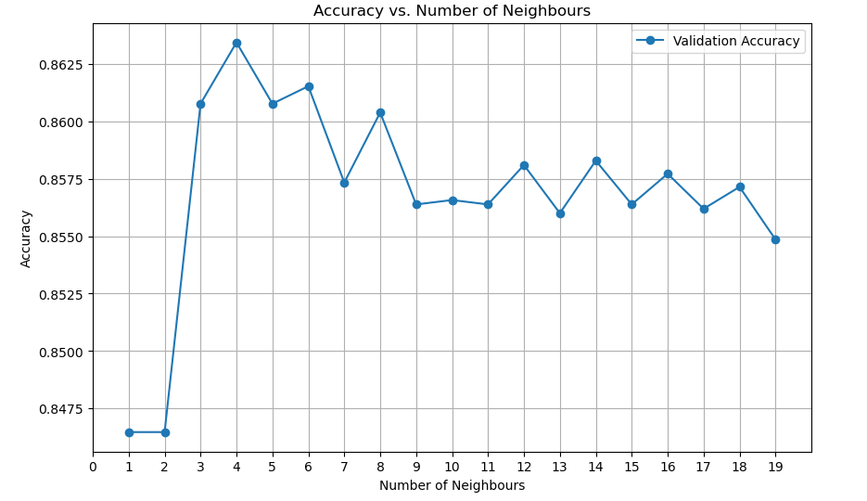

Figure 2
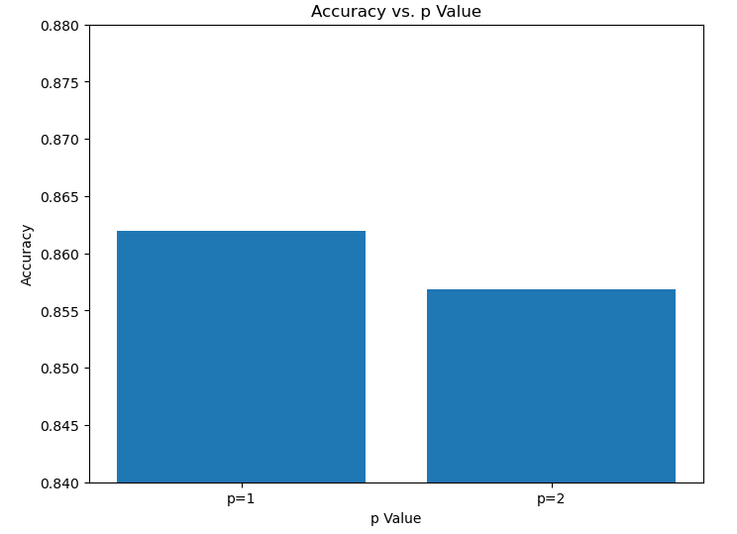

Figure 3
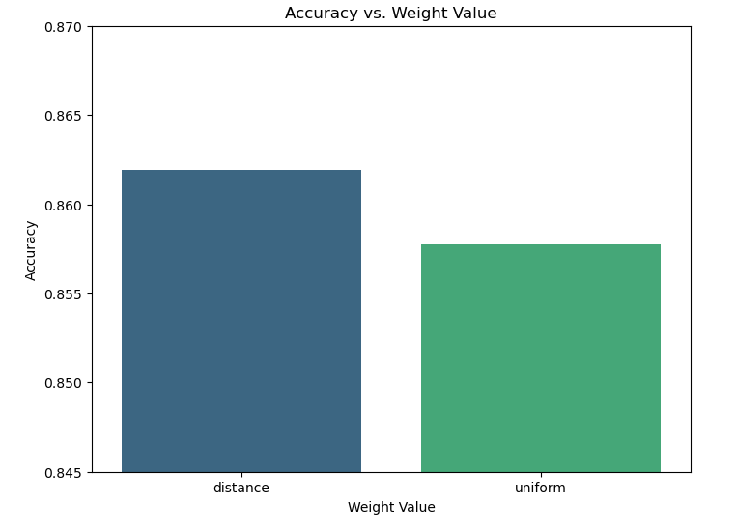

Figure 4
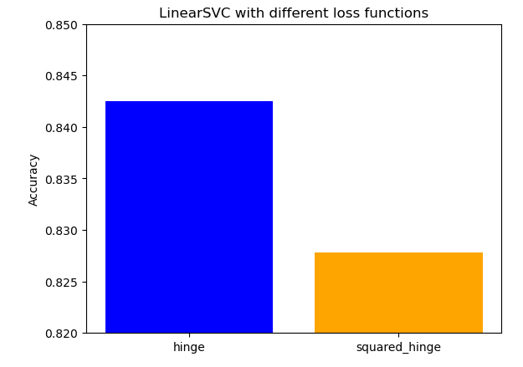

Figure 5
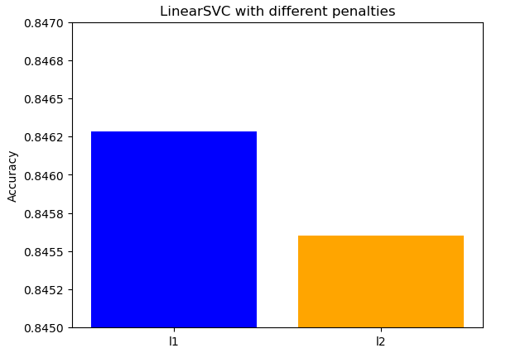

Figure 6
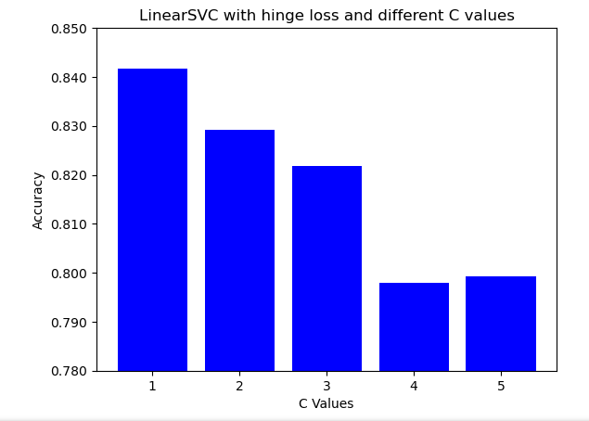

Figure 7
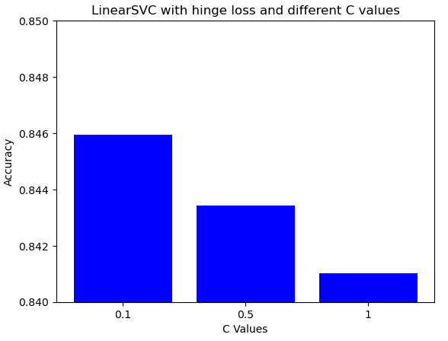

Figure 8
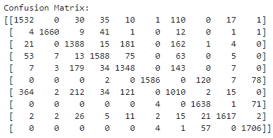

Figure 9
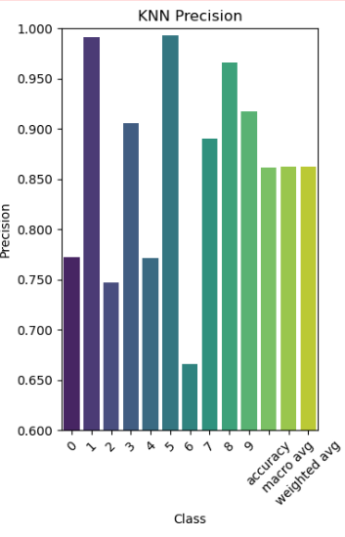

Figure 10
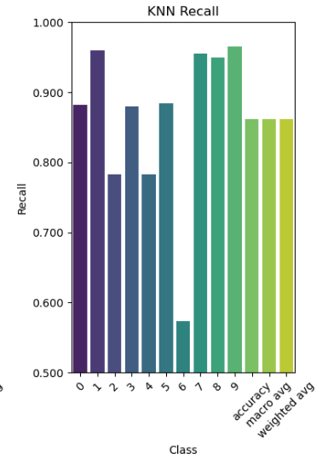

Figure 11
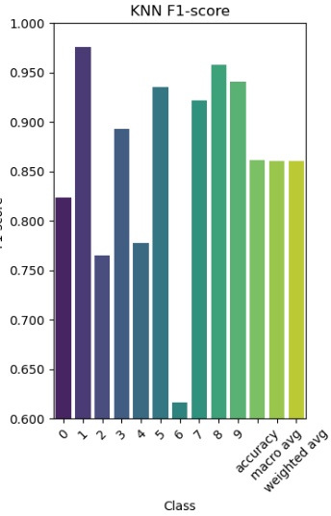

Figure 12
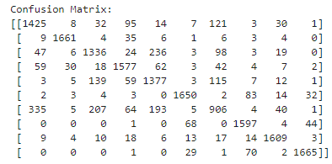

Figure 13
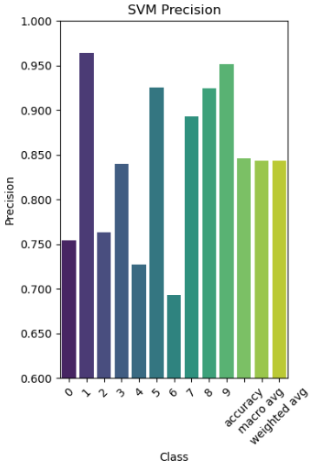

Figure 14
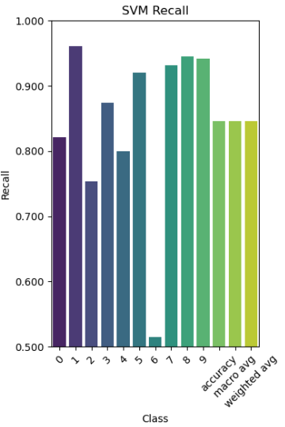

Figure 15
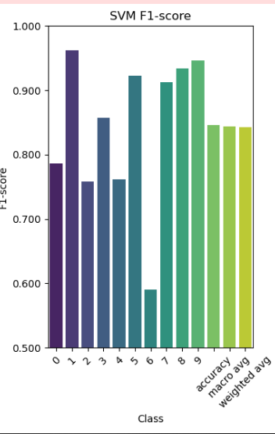

Appendix
Link to video describing code
https://youtu.be/ym9xAuI6TaA

Python code
KNN
from sklearn import neighbors, datasets, metrics
from sklearn.model_selection import train_test_split
import numpy as np
import matplotlib.pyplot as plt
import seaborn as sns
import pandas as pd

# Load Fashion-MNIST dataset
fashion_mnist = datasets.fetch_openml('Fashion-MNIST', version=1)

# Split the Fashion-MNIST data into training and testing sets
(trainData, testData, trainLabels, testLabels) = train_test_split(np.array(fashion_mnist.data),
fashion_mnist.target.astype("int"), test_size=0.25, random_state=42)

# Show the sizes of each data split
print("Training data points: {}".format(len(trainLabels)))
print("Testing data points: {}".format(len(testLabels)))
# Create a KNN model with 3 neighbors
model = neighbors.KNeighborsClassifier(n_neighbors=9, p=1, weights='distance')
# Train the model on the Fashion-MNIST training data
model.fit(trainData, trainLabels)

y_pred = model.predict(testData)
# Print the confusion matrix
print("Confusion Matrix:")
conf_matrix = metrics.confusion_matrix(testLabels, y_pred)
print(conf_matrix)

# Plot Confusion Matrix Heatmap
plt.figure(figsize=(8, 6))
sns.heatmap(conf_matrix, annot=True, fmt='d', cmap='Blues', xticklabels=fashion_mnist.target_names, yticklabels=fashion_mnist.target_names)
plt.title('Confusion Matrix')
plt.xlabel('Predicted')
plt.ylabel('True')
plt.show()

# Print the classification report
print("\nClassification Report:")
classification_rep = metrics.classification_report(testLabels, y_pred, digits=3)
print(classification_rep)

# Visualize Classification Report
report_data = metrics.classification_report(testLabels, y_pred, output_dict=True)
class_names = [str(i) for i in fashion_mnist.target_names]

# Convert report data to DataFrame for easy plotting
report_df = pd.DataFrame(report_data).transpose()

# Plot Precision
plt.figure(figsize=(12, 6))
plt.subplot(1, 3, 1)
sns.barplot(x=report_df.index, y=report_df['precision'], palette='viridis')
plt.title('KNN Precision')
plt.xlabel('Class')
plt.ylabel('Precision')
plt.xticks(rotation=45)
# Set y-axis limits to show only the range between 0.6 and 1
plt.ylim(0.6, 1)
# Format y-axis ticks to 3 decimal places
plt.gca().yaxis.set_major_formatter(plt.matplotlib.ticker.StrMethodFormatter("{x:.3f}"))

# Plot Recall
plt.subplot(1, 3, 2)
sns.barplot(x=report_df.index, y=report_df['recall'], palette='viridis')
plt.title('KNN Recall')
plt.xlabel('Class')
plt.ylabel('Recall')
plt.xticks(rotation=45)
plt.ylim(0.5, 1)
# Format y-axis ticks to 3 decimal places
plt.gca().yaxis.set_major_formatter(plt.matplotlib.ticker.StrMethodFormatter("{x:.3f}"))

# Plot F1-score
plt.subplot(1, 3, 3)
sns.barplot(x=report_df.index, y=report_df['f1-score'], palette='viridis')
plt.title('KNN F1-score')
plt.xlabel('Class')
plt.ylabel('F1-score')
plt.xticks(rotation=45)
plt.ylim(0.6, 1)
# Format y-axis ticks to 3 decimal places
plt.gca().yaxis.set_major_formatter(plt.matplotlib.ticker.StrMethodFormatter("{x:.3f}"))

plt.tight_layout()
plt.show()

SVM
import numpy as np
from sklearn import datasets, metrics, svm
from sklearn.pipeline import Pipeline
from sklearn.preprocessing import StandardScaler
from sklearn.svm import SVC
from sklearn.model_selection import train_test_split
import numpy as np
import matplotlib.pyplot as plt
import seaborn as sns
import pandas as pd

# Load Fashion-MNIST dataset
fashion_mnist = datasets.fetch_openml('Fashion-MNIST', version=1)

# Split the Fashion-MNIST data into training, validation, and testing sets
(trainData, testData, trainLabels, testLabels) = train_test_split(
np.array(fashion_mnist.data),
fashion_mnist.target.astype("int"),
test_size=0.25,
random_state=42
)
#Pipeline
scaler= StandardScaler()
trainDataScaled = scaler.fit_transform(trainData)
testDataScaled = scaler.transform(testData)

# Create an SVM model
print("running")
model = svm.LinearSVC(loss='hinge', C=0.1)

# Train the model on the Fashion-MNIST training data
model.fit(trainDataScaled, trainLabels)

# Predict on the test data
y_pred = model.predict(testDataScaled)

# Print the confusion matrix
print("Confusion Matrix:")
conf_matrix = metrics.confusion_matrix(testLabels, y_pred)
print(conf_matrix)

# Plot Confusion Matrix Heatmap
plt.figure(figsize=(8, 6))
sns.heatmap(conf_matrix, annot=True, fmt='d', cmap='Blues', xticklabels=fashion_mnist.target_names, yticklabels=fashion_mnist.target_names)
plt.title('Confusion Matrix')
plt.xlabel('Predicted')
plt.ylabel('True')
plt.show()

# Print the classification report
print("\nClassification Report:")
classification_rep = metrics.classification_report(testLabels, y_pred, digits=3)
print(classification_rep)

# Visualize Classification Report
report_data = metrics.classification_report(testLabels, y_pred, output_dict=True)
class_names = [str(i) for i in fashion_mnist.target_names]

# Convert report data to DataFrame for easy plotting
report_df = pd.DataFrame(report_data).transpose()

# Plot Precision
plt.figure(figsize=(12, 6))
plt.subplot(1, 3, 1)
sns.barplot(x=report_df.index, y=report_df['precision'], palette='viridis')
plt.title('SVM Precision')
plt.xlabel('Class')
plt.ylabel('Precision')
plt.xticks(rotation=45)
# Set y-axis limits to show only the range between 0.6 and 1
plt.ylim(0.6, 1)
# Format y-axis ticks to 3 decimal places
plt.gca().yaxis.set_major_formatter(plt.matplotlib.ticker.StrMethodFormatter("{x:.3f}"))

# Plot Recall
plt.subplot(1, 3, 2)
sns.barplot(x=report_df.index, y=report_df['recall'], palette='viridis')
plt.title('SVM Recall')
plt.xlabel('Class')
plt.ylabel('Recall')
plt.xticks(rotation=45)
plt.ylim(0.5, 1)
# Format y-axis ticks to 3 decimal places
plt.gca().yaxis.set_major_formatter(plt.matplotlib.ticker.StrMethodFormatter("{x:.3f}"))

# Plot F1-score
plt.subplot(1, 3, 3)
sns.barplot(x=report_df.index, y=report_df['f1-score'], palette='viridis')
plt.title('SVM F1-score')
plt.xlabel('Class')
plt.ylabel('F1-score')
plt.xticks(rotation=45)
plt.ylim(0.5, 1)
# Format y-axis ticks to 3 decimal places
plt.gca().yaxis.set_major_formatter(plt.matplotlib.ticker.StrMethodFormatter("{x:.3f}"))

plt.tight_layout()
plt.show()

