Module: Introduction to Web and Database Concepts.

Module code: ACCA4025.

Assignment title: Developing an MS Access database for Coastal Tourism Management.

Submission date: 8th of January, Monday.

Student name: Shaun James Davies.

Student number: 2317135.

Word Count: 2353

Table of Contents
Section A 3
Identify the different types of users who might access the Database Management System (DBMS) for Coastal Tourism Management 3
Identify various departments within coastal getaways that might require access to the CTMS. Describe the specific needs and responsibilities of each department in managing coastal tourism. 4
Database Design and Implementation 5
Create a Entity Relationship Diagram (ERD) 5
Introduction to Entity Relationship Diagrams (ERDs) 5
Relationships Between Entities 5
Entities and Attributes Explanation 5
Relational database schema 6
SECTION B 7
Explain the importance of developing an MS Access database for Coastal Tourism Management in Wales, UK. 7
How can a database improve the efficiency and effectiveness of managing coastal tourism? 7
Efficiency 7
Effectiveness 8
Discuss the potential challenges and benefits of transitioning from manual data management to a computerized system for Coastal Tourism Management. 8
How can the DBMS address these challenges? 9

Section A

Identify the different types of users who might access the Database Management System (DBMS) for Coastal Tourism Management

- Tourists Role:
Primary consumers of services.
Responsibilities: Registering, booking, providing feedback, and participating in events.
2. Customer Service Representatives Role: Interact with tourists for queries and support. Responsibilities: Handle bookings, provide information about services and events.
3. Database Administrators (DBAs) Role: Manage and maintain the DBMS. Responsibilities: Ensure system's smooth operation, security, and data integrity.
4. Marketing and Sales Team Role: Promote vacation packages and events. Responsibilities: Tailor marketing strategies including events and local services.
5. Finance and Accounting Department Role: Manage financial aspects. Responsibilities: Handle transactions related to bookings and events.
6. IT and Technical Support Staff Role: Provide technical support. Responsibilities: Maintain system, including event and service provider listings.
7. Event Coordinators Role: Manage event-related aspects. Responsibilities: Coordinate with service providers for event planning and execution.
8. Local Business Liaisons/Service Provider Coordinators Role: Bridge between Coastal Getaways and local service providers. Responsibilities: Ensure accurate service provider information, coordinate offers.
9. Management and Executives Role: Oversee business performance. Responsibilities: Strategic planning, including events and collaboration with service providers.
10. Quality Assurance and Compliance Team Role: Ensure service quality. Responsibilities: Monitor compliance, service standards in packages and events. Each user type plays a crucial role in the ecosystem of Coastal Getaways. With the addition of event coordination and service provider management, the system caters to a more dynamic range of services, enhancing the overall tourism experience.

Identify various departments within coastal getaways that might require access to the CTMS. Describe the specific needs and responsibilities of each department in managing coastal tourism.
1. Customer Service and Reservation Department Specific Needs: Access to booking and customer interaction systems. Information on current vacation packages, events, and service provider details. Responsibilities: Manage tourist inquiries and reservations. Provide information about vacation packages, events, and local services.
2. Marketing and Sales Department Specific Needs: Data on customer preferences, booking trends, and feedback. Information about upcoming events and services from local providers. Responsibilities: Promote vacation packages, events, and services. Develop marketing campaigns targeting different tourist segments.
3. Finance and Accounting Department Specific Needs: Financial transaction records, including bookings, event fees, and payments to service providers. Budgeting tools and financial reporting capabilities. Responsibilities: Manage financial transactions and bookkeeping. Budgeting and financial planning for tourism activities and events.
4. IT and System Management Department Specific Needs: Tools for maintaining the CTMS, including database management and system security. Responsibilities: Ensure the CTMS is functioning efficiently and securely. Provide technical support to other departments.
5. Event Management Department Specific Needs: Access to the event management module of the CTMS. Coordination tools for working with service providers and internal teams. Responsibilities: Plan and manage local events. Coordinate with service providers for event logistics.
6. Partnerships and Provider Relations Department Specific Needs: Database of service providers and their offerings. Tools for communication and contract management. Responsibilities: Establish and maintain relationships with local service providers. Integrate service providers' offerings into Coastal Getaways' packages.
7. Human Resources Department Specific Needs: Employee management tools, including scheduling and training modules. Responsibilities: Manage recruitment, training, and staff welfare. Ensure adequate staffing for peak tourism periods and events.
8. Quality Assurance and Compliance Department Specific Needs: Access to feedback and quality control reports. Compliance tracking tools for tourism standards and regulations. Responsibilities: Monitor service quality and customer satisfaction. Ensure compliance with tourism and safety regulations, especially for events and local services.
9. Business Development and Strategic Planning Department Specific Needs: Market analysis tools and access to performance metrics. Responsibilities: Identify new opportunities for growth, including potential events and partnerships. Develop long-term strategies for business expansion and sustainability.
These departments collectively ensure that all aspects of coastal tourism management, from customer interaction and event planning to strategic partnerships and quality assurance, are effectively addressed. The inclusion of specific departments for event management and provider relations highlights the expanded scope of Coastal Getaways' operations, ensuring a comprehensive and enjoyable tourism experience.

Database Design and Implementation

Create a Entity Relationship Diagram (ERD)

Introduction to Entity Relationship Diagrams (ERDs)
An Entity Relationship Diagram (ERD) is pivotal in visualizing and structuring the Coastal Tourism Management System's database. It serves as a blueprint, delineating relationships between various entities like tourists, reservations, vacation packages, feedback, events, and service providers. This visual representation aids in ensuring that the database structure aligns seamlessly with the operational needs of Coastal Getaways, enabling efficient data management and retrieval.

Relationships Between Entities
Tourist to Reservation: Relationship Type: One-to-Many Explanation: Allows a single tourist (identified by TouristID) to create multiple reservations. Each reservation is uniquely identified by ReservationID, offering a seamless booking experience for tourists exploring different vacation options.
Reservation to VacationPackage: Relationship Type: Many-to-One Explanation: Associates each reservation (identified by ReservationID) with a specific vacation package (identified by PackageID). This setup enables tourists to book specific packages while allowing multiple reservations for the same vacation offer.
Tourist to Feedback: Relationship Type: One-to-Many Explanation: Enables a tourist to provide multiple feedback entries (identified by FeedbackID). The feedback, comprising comments and ratings, provides valuable insights for service enhancement and quality assurance.
Event to ServiceProvider: Relationship Type: Many-to-One Explanation: Establishes that multiple events (each with its EventID) can be managed or offered by a single service provider (identified by ProviderID). This relationship aids in organizing diverse local events efficiently.
Reservation to Event (Many-to-Many): Relationship Type: Many-to-Many Explanation: Illustrates that a single reservation can encompass participation in multiple events, while each event can be part of various reservations. Typically managed through a junction table such as 'ReservationEvent,' ensuring seamless event coordination for tourists.

Entities and Attributes Explanation
Tourist: Attributes: TouristID, FirstName, LastName, Email, Phone
Explanation: Essential for personalized service and communication, allowing Coastal Getaways to cater to individual preferences and maintain direct contact for better customer service.
Reservation: Attributes: ReservationID, TouristID, PackageID, ReservationDate, TotalCost Explanation: Forms the core of the booking process, linking tourists to specific vacation packages, facilitating seamless booking management and financial transactions.
VacationPackage: Attributes: PackageID, PackageName, Price, Duration, Description
Explanation: Provides comprehensive details about vacation offers, aiding tourists in making informed decisions and selecting the most suitable packages for their preferences.
Feedback: Attributes: FeedbackID, TouristID, Comment, Rating
Explanation: A crucial tool for collecting and analyzing tourist experiences, enabling Coastal Getaways to improve services based on constructive feedback and ratings.
Event: Attributes: EventID, EventName, Date, Location, ProviderID
Explanation: Enriches the tourism experience by offering local events, providing tourists with diverse engagement opportunities during their coastal visit.
ServiceProvider: Attributes: ProviderID, Name, ServiceType, ContactInfo
Explanation: Essential for collaboration and event management, providing information about local businesses and services, enriching the tourism experience through partnerships.
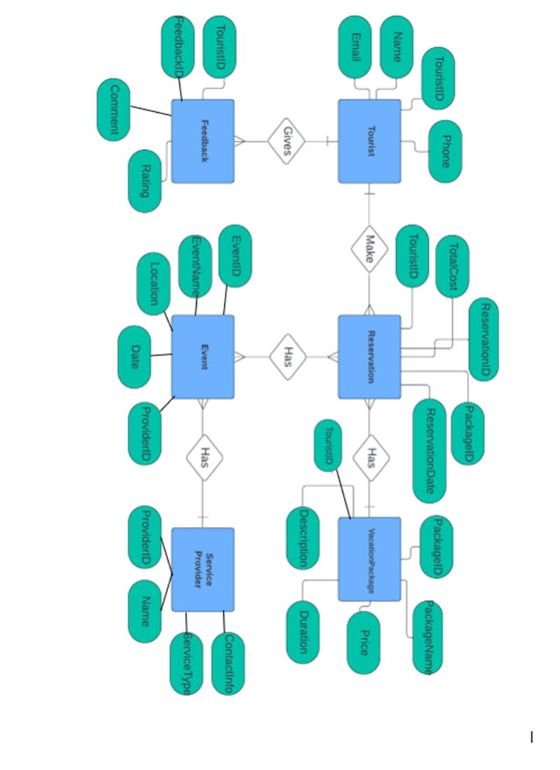
The ERD for the Coastal Tourism Management System reflects its intricate data structure, laying the groundwork for its database. It visually illustrates entity relationships, aiding efficient data flow for effective management. Beyond initial design, this diagram serves as a guide for system upgrades and integrity maintenance. More than a technical blueprint, it strategically aligns with operational goals, ensuring the system's adaptability and top-notch service for tourists.

Relational database schema
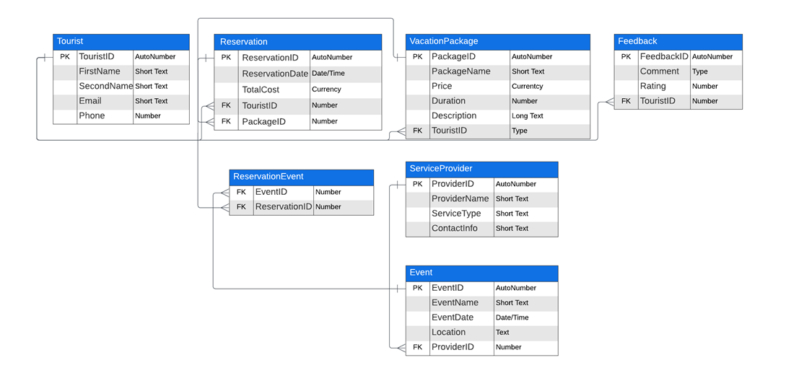

SECTION B

Explain the importance of developing an MS Access database for Coastal Tourism Management in Wales, UK.

Developing an MS Access database for Coastal Tourism Management in Wales is pivotal for efficient data handling and streamlined operations within Coastal Getaways.

This centralized platform ensures cohesive data management, facilitating the organization and accessibility of diverse information pertaining to reservations, feedback, events, and service providers. Microsoft Access's user-friendly interface allows for easy adoption by employees, while its customizable features enable tailored forms, queries, and reports to match specific operational needs.

Additionally, its scalability accommodates evolving tourism demands, and integration with other tools fosters enhanced collaboration and data analysis. The database's cost-effectiveness, coupled with its robust security measures, ensures compliance with regulations while optimizing resource allocation.

Ultimately, Microsoft Access empowers Coastal Getaways to make data-driven decisions, improve service delivery, and elevate the overall tourism experience along Wales' stunning coastlines. [2]

How can a database improve the efficiency and effectiveness of managing coastal tourism?

An effective database system plays a pivotal role in coastal tourism management, catalysing both efficiency and effectiveness in operational processes. By streamlining operations through centralized data management, automation, and swift accessibility, databases optimize resource allocation and reduce delays, enhancing overall operational efficiency[3].
Simultaneously, comprehensive data analytics [2] enable informed decision-making, personalized customer service, and continuous improvement, fostering strategic partnerships and adaptability to industry trends. This seamless integration of efficiency-driven processes and data-driven effectiveness empowers coastal tourism entities, like Coastal Getaways, to not only manage operations more efficiently but also to offer enhanced and tailored experiences to tourists, ensuring sustained growth and customer satisfaction.

Efficiency
Streamlined Operations: A database centralizes data related to reservations, feedback, events, and service providers, reducing manual handling and streamlining administrative tasks. This streamlined approach minimizes time spent on data entry and retrieval, enhancing overall operational efficiency [4].
Automated Processes: Automated functionalities within the database, such as reservation confirmations, feedback collection, and event scheduling, eliminate manual interventions. This automation reduces errors, accelerates processes, and optimizes staff productivity, leading to increased operational efficiency.
Data Accessibility and Retrieval: Quick and easy access to consolidated data allows staff to promptly retrieve information on available vacation packages, tourist preferences, and service provider details. This swift access to information eliminates delays, enabling faster decision-making and improving service response times.
Resource Optimization: By providing insights into booking trends, tourist preferences, and feedback analysis, the database enables better resource allocation. This optimization ensures that Coastal Getaways can allocate resources effectively, avoiding overbooking or underutilization of services, thereby maximizing operational efficiency. [5]
Reduced Downtime and Delays: Efficient database management minimizes downtime associated with manual paperwork or redundant processes. This reduction in delays enables Coastal Getaways to provide quicker responses to inquiries, manage bookings seamlessly, and maintain a high level of service quality, ultimately enhancing operational efficiency. [1][5]

Effectiveness
Improved Decision-Making: Access to comprehensive data and analytics within the database enables informed decision-making. Insights into tourist behaviour, feedback analysis, and service performance contribute to the development of effective strategies, leading to improved service offerings and customer satisfaction [6].
Enhanced Customer Service: The database facilitates personalized services by storing tourist preferences and feedback. This personalized approach enhances the tourist experience, fostering loyalty and positive word-of-mouth, which, in turn, contributes to the effectiveness of Coastal Getaways' service delivery.
Continuous Improvement: Feedback collection and analysis through the database enable continuous improvement. Identifying areas for enhancement based on tourist reviews and preferences helps refine services, ensuring ongoing effectiveness in meeting and exceeding customer expectations.
Adaptability to Trends and Changes: The database's flexibility and scalability allow Coastal Getaways to adapt swiftly to changing tourism trends and market demands. This adaptability ensures that the tourism management system remains effective by aligning with evolving customer needs and industry trends.
By enhancing efficiency through streamlined processes and promoting effectiveness through data-driven decision-making and continuous improvement, a well-managed database significantly contributes to Coastal Tourism Management's success and growth.[2]

Discuss the potential challenges and benefits of transitioning from manual data management to a computerized system for Coastal Tourism Management.

Transitioning from manual data management to a computerized system, like a Database Management System (DBMS), for Coastal Tourism Management comes with its own set of challenges and benefits. Let's explore them along with how a DBMS can address these challenges:
Potential Challenges:
Cost and Resource Allocation: Implementing a DBMS involves initial costs, including software purchase, hardware upgrades, and training.
DBMS Solution: Over time, a DBMS can lead to cost savings through improved efficiency and reduced paperwork.
Training and Adaptation: Staff may require training to adapt to the new system, and there might be resistance to change.
DBMS Solution: A user-friendly interface and comprehensive training sessions can ease the transition.
Data Migration: Transferring existing data into the new system can be time-consuming and prone to errors.
DBMS Solution: Automated data import tools and professional assistance can ensure accurate and efficient data migration.
System Reliability and Security: Dependence on technology raises concerns about system reliability and data security.
DBMS Solution: Regular backups, security protocols, and redundancy measures can mitigate these risks.
Maintenance and Upgrades: Continuous system maintenance and periodic upgrades are necessary.
DBMS Solution: Choosing a system with good support and update policies can help manage this challenge.
Potential Benefits:
Increased Efficiency: Automation of routine tasks reduces manual labour and errors. Real-time data processing speeds up operations.
Improved Data Organization and Accessibility: Centralized data storage makes information retrieval and management more systematic and accessible.
Enhanced Decision Making: Data analytics capabilities provide insights for informed decision-making and strategy development.
Scalability: A DBMS can grow with the business, accommodating increased data and more complex operations. Better Customer Service: Quick access to data enables more personalized and efficient customer service. Compliance and Reporting: Easier tracking and reporting for regulatory compliance.

How can the DBMS address these challenges?

How DBMS Addresses Challenges:
Cost and Resource Allocation: Long-term operational efficiencies and reduction in manual paperwork can offset initial investment costs.
Training and Adaptation: User-friendly DBMS interfaces and comprehensive training can facilitate smoother adaptation.
Data Migration: DBMS often come with tools to assist in accurate and efficient data migration.
System Reliability and Security: Modern DBMS are equipped with robust security features and backup capabilities.
Maintenance and Upgrades: Regular updates and professional support from DBMS providers can help manage maintenance needs.
In summary, while the transition to a DBMS presents challenges such as initial costs, training needs, and system reliability concerns, the long-term benefits of improved efficiency, data management, decision-making, and customer service are significant. A well-implemented DBMS can effectively address these challenges, leading to a more streamlined and effective management of Coastal Tourism.

References
[1] "chapter- 6," Accessed: Jan 7, 2024, [Online]. Available: https://paginas.fe.up.pt/~als/mis10e/ch6/chpt6-3bullettext.htm
[2] "Benefits of database development | nibusinessinfo.co.uk," Accessed: Jan 7, 2024, [Online]. Available: https://www.nibusinessinfo.co.uk/content/benefits-database-development
[3] "The Impact of ERP Systems on Operational Efficiency | AppMaster." https://appmaster.io/blog/operational-efficiency-erp-systems (accessed Jan 7,).
[4] J. Edmondson, "Understanding Computerized Databases: What Are They and How Are They Used?", Businesstechweekly.com, https://www.businesstechweekly.com/operational-efficiency/data-management/computerized-databases/ (accessed Jan 7, 2024).
[5] "7 ways a good database can improve your business", Everconnect, https://everconnectds.com/blog/7-ways-a-good-database-can-improve-your-business/ (accessed Jan 7, 2024).
[6] "How database software can improve efficiency and speed for your business." Microsoft. https://www.microsoft.com/en-ww/microsoft-365/business-insights-ideas/resources/how-database-software-can-improve-efficiency-and-speed-for-your-business (accessed Jan 7,).

