Continuing Professional Development (CPD)

The CIPD operates an outputs-based CPD policy. This means that we’re not concerned with how much time our members spend on training courses or how many boxes they tick on a form, instead our approach is focused on outcomes and results. CPD is about capturing useful experiences and assessing the practical benefits of what you have learnt.
Our Royal Charter and professional standing are dependent upon all members being able to demonstrate their commitment to CPD. Each year, the CIPD contacts a random sample of professional members to request evidence of their CPD from the past 12 months, via a set of reflective CPD questions. You may be asked to submit evidence of your CPD at any time.
Our CPD cycle

Our CPD cycle provides a clear structure for what great CPD looks like. CPD is about positioning learning in the context of evolving as a professional and applying your learning in the workplace. Use our CPD cycle to ensure you’re getting the most from your learning.
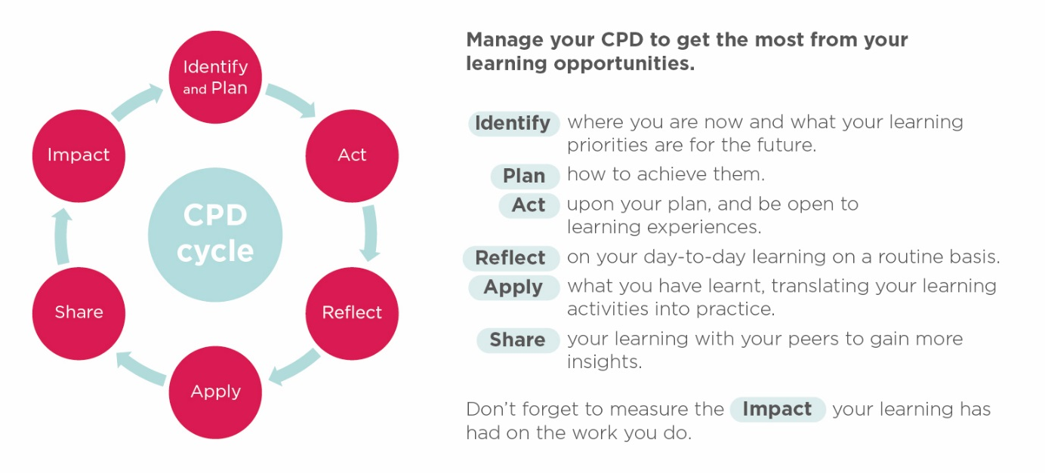

Within our qualifications, candidates will be expected to show evidence of CPD, how they have learnt, demonstrate reflection and focus on the future.
Some people find it helpful to write things down in detail, while others record 'insights and learning points' in their diaries as they go along. This helps them to assess their learning continuously. These records and logs are useful tools for planning and reflection and can be incorporated into a candidate’s portfolio of assessment evidence.
(CIPD, 2018).

