ACBA4006 Material Science and Building Services
Assignment 02 Level 4 Light and Sound
Lecturer: Allan Nantel
Author: Owen Brown (1901187)

Task A
Calculate Use the Lumen method to calculate how man lamps are required for a production area of a factory requiring a Lighting Design Lumen (LDL) output of 18,000 lumens. 200 lux is required at the working plane. The Light Loss Factor (LLF) is 0.75
Room Index.
The dimensions of the production area are 60m x 24m x 8m in height. The height of the working plane (work benches) is 1m above the floor.
The room index can be calculated using the following formula:
RI =$\frac{\left(Length × Width\right)}{Hm × (L+W)}$
RI = $\frac{60 × 24}{7 × (60+24) }$
RI = $\frac{1440}{588}$
RI = 2.448

Utilisation Factor
The reflectance’s of the room are 0.3 for the ceiling and 0.5 for the walls. Fluorescent lamps in a recessed louvre with a DLOR of 50% are specified. A utilisation factor table (Appendix 01) has been used to calculate the utilisation factor.
UF = 0.46

Number of Lamps Required
The following formula is used to calculate the number of lamps required for the production area.
N = $\frac{E×A}{F×UF×LLF}$
N = number of lamps required.
E = illuminance level required (lux).
A = area at working plane height (m²).
F = initial luminous flux output of each lamp (lm).
UF = utilisation factor.
LLF = light loss factor.
N = $\frac{200×1440}{18000×0.46×0.75}$
N = $\frac{288000}{6210}$
N = 46.376
Number of lamps required is then rounded up to 48 for even distribution.

Spacing (S) of the lamps
Next the maximum distance between the lamps is calculated using the following formula for fluorescent tubes in diffusing luminaires.
S_{max} = 1.5 x Hm
S_{max} = 1.5 x 7m
S_{max} = 10.5m

Layout
4 rows of 48 lamps gives the most even distribution of light with half spacings around the perimeter. A scale CAD drawing of the production area showing the lamp centres and spacings is available in Appendix 02.

Task B
- Calculate the sound reduction index (SRI) for a composite wall.
The brick wall has an area of 20m² containing a window of 4m². The sound reduction index of the wall is 50dB and the window is 10dB.
To calculate the SRI of the composite wall, the transmission coefficient (T) of each component needs to be calculated.
Brickwork T₁ = ?, A₁ = 20-4 = 16m², SRI = 50dB
Window T₂ = ?, A₂ = 4m², SRI = 10dB
The known SRI values are calculated using the formula 10 x (log₁₀(1/T)) which can be used to calculate the transmission coefficient values as follows:

Brickwork
SRI = 10 x (log₁₀(1/T))
50 = 10 x (log₁₀(1/T₁))
5 = log₁₀ x (1/T₁)
1/T₁ = 10⁵
T₁ = 10⁻⁵
T₁ = 0.000010

Window
SRI = 10 x (log₁₀(1/T))
10 = 10 x (log₁₀(1/T₂))
1 = log₁₀ x (1/T₂)
1/T₂ = 10¹
T₂ = 10⁻¹
T₂ = 0.10

The overall transmission coefficient (T_{o}) can now be calculated using the following formula:
T_{o} = $\frac{\left(T1xA1\right)+(T2xA2)}{A1+A2}$
T_{o} = $\frac{(0.000010x16)+(0.10x4)}{16+4}$
T_{o} = $\frac{0.00016+0.4}{20}$
T_{o} = 0.020008

The overall sound reduction index can now be calculated as follows:
SRI = 10 x (log₁₀(1/T))
SRI = 10 x (log₁₀(1/0.020008))
SRI = 10 x (log₁₀(49.980007))
SRI = 10 x 1.69
SRI = 17dB

- Internal sound management

The phenomenon that the human ear perceives as sound is an alternating wave of high and low pressure. This pressure wave travels at different speeds through different mediums depending the density and stiffness of the medium (Evans, 2016).
Sound waves have two main characteristics:
- Frequency – This is the amount of high- and low-pressure cycles per second. Each cycle is 1 hertz (Hz). Low frequency noise (20Hz to 160Hz) is typically heard as low rumbling. The longer slower wavelengths are harder to insulate against than higher frequency sounds, which have higher energy that dissipates faster.
- Sound pressure – This is the amount the air pressure is increased by the wave and is measured in pascals (Pa) and used to measure the loudness.

Sound travels around buildings and into buildings by the following mechanisms:
- Airborne transmission – Sound can enter a building through openings such as vents and ducts. It can also travel through elements of the building fabric by the soundwaves hitting one side, causing vibrations on the other. Examples include traffic, voices and musical instruments.
- Impact transmission – This happens when the fabric of the building is hit by an object, causing vibrations which create air movement in the surrounding spaces. Examples include footfall, slamming of doors and vibrations from machinery.

The Sound reduction index (SRI) is used to measure the sound level difference from airborne transmission on either side of a partition. (Welsh Government, 2010) state the amount of reduction that is mandatory, and approved methods to construct the various elements to achieve this. The frequency of the sound wave will have an impact on the amount of sound reduction achieved. (Appendix 03) Shows there is less sound reduction at lower frequencies.
The following insulation methods can be used to attenuate the transmission of sound through the building fabric:
- Mass – Sound wave energy converts to thermal energy when travelling through dense materials. Dense materials are commonly used in wall and floor construction to reduce airborne and impact sound. Mass can be achieved in framed construction by adding layers of high-density plasterboard. The sound will be reduced by 6dB if the mass of the surface area is doubled (Evans, 2016).
- Isolation – Separating the layers of a building, making them independent from each other makes the travel of sound more difficult. Timber framed party walls adopt this principle, separating the buildings by using two frames with a gap between them. Anything that links different parts of the construction (such as wall ties) will increase sound transmission. (Welsh Government, 2010) Give locations where cavities must be closed to prevent the transmission of sound.
- Rigidity – Elements that are less rigid or have a low dynamic stiffness transmit less sound. An example of this would be a resilient layer under a floating floor, that gives on impact and reduces impact transmission.
- Absorption – Fibrous insulation and other porous materials have air spaces that create friction, which converts the sound energy into thermal energy. Framed constructions often rely on insulation for the absorption of sound as they lack mass. Materials can also be selected for room surfaces that absorb sound.

Attention must be given to the sealing of any pipe or cable runs, gaps around windows, doors and partitions. If a brick wall has a hole that is 0.1% of the walls total area then the SRI reduces from 50dB to 30dB (McMullan, 2012).

References
Evans, H.M.A. (2016) How Buildings Work. Newcastle: RIBA Publishing.
McMullan, R. (2012) Environmental Science in Building. 7th Ed. Basingstoke: Palgrave Macmillan.
Welsh Government. (2010) The Building Regulations 2010 Approved Document E: Resistance to the passage of sound.

Bibliography
British Standards Institution. (2014) BS 8223:2014 Guidance on sound insulation and noise reduction for buildings. BSI Standards Publication.
Chudley, R and Greeno, R. (2016) Building Construction Handbook. 11th Ed. Abingdon: Routledge.
Reid, E. (2016) Understanding Buildings. Abingdon: Construction Press.

Appendices
Appendix 01. Utilisation factor table. McMullan, R. (2012) Environmental Science in Building. 7th Ed. Basingstoke: Palgrave Macmillan.
Appendix 02. Lighting Layout of Factory Production Area. Author.
Appendix 03. Insulation Curve for a Wall. www.customaudiodesigns.co.uk

Appendix 01. Utilisation factor table.

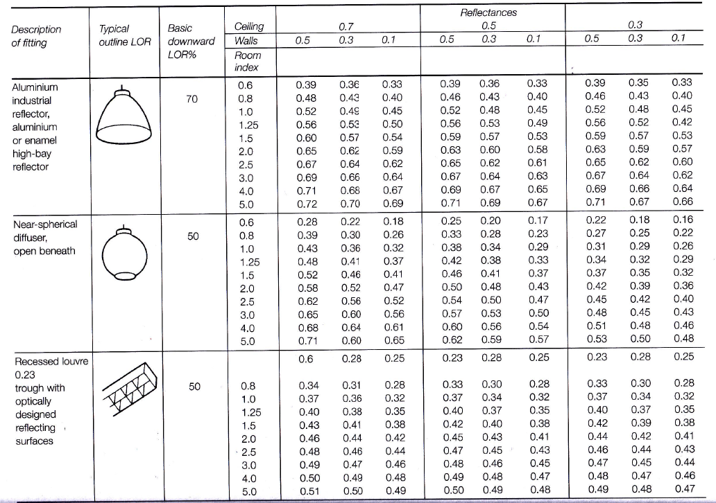
(McMullan, 2012).

Appendix 02. Lighting Layout of Factory Production Area.

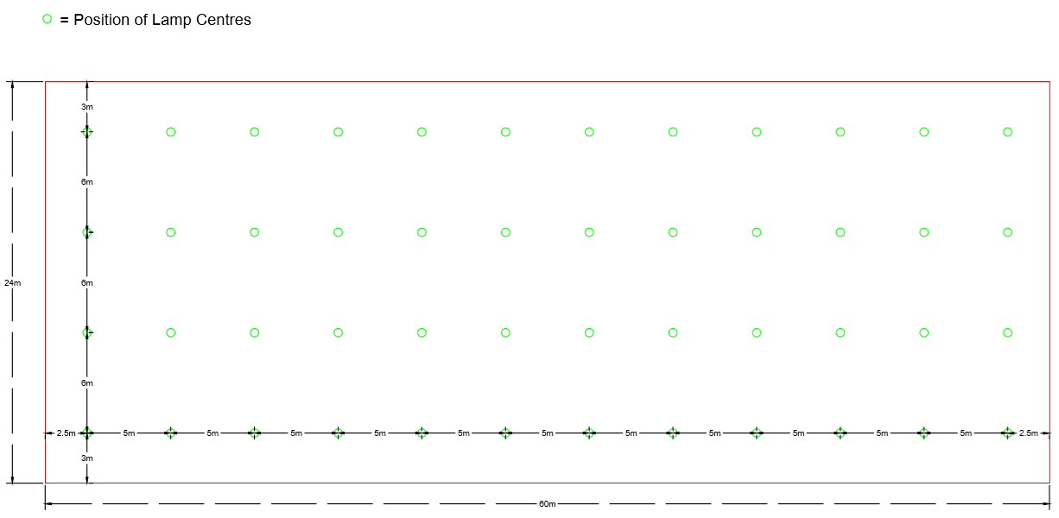
Appendix 03. Insulation Curve for a Wall.

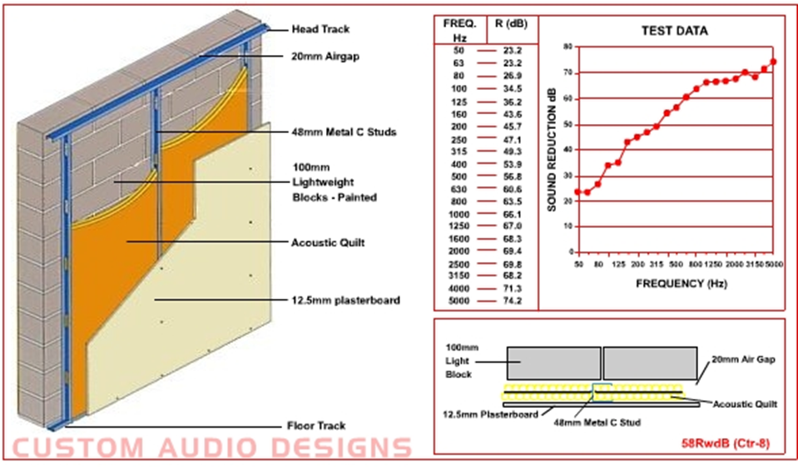
(www.customaudiodesigns.co.uk)

