MOHAMMAD ASSADUJJAMAN
STUDENT NO- 2207975
MODULE: FOREIGN LANGUAGES AND CULTURAL AWARENESS
BMIH5003
LECTURER: HEIDI PROSSER
ASSIGNMENT TITLE: PRESENTION

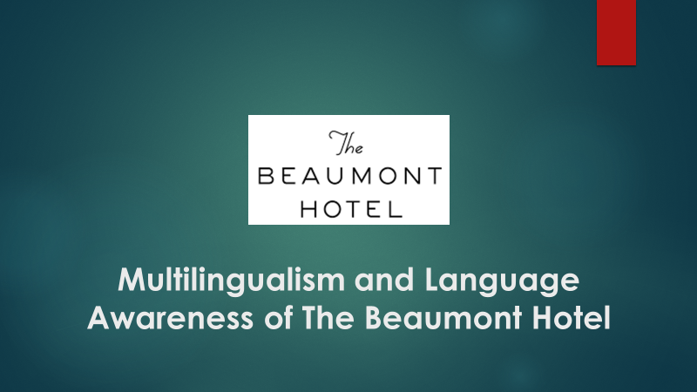
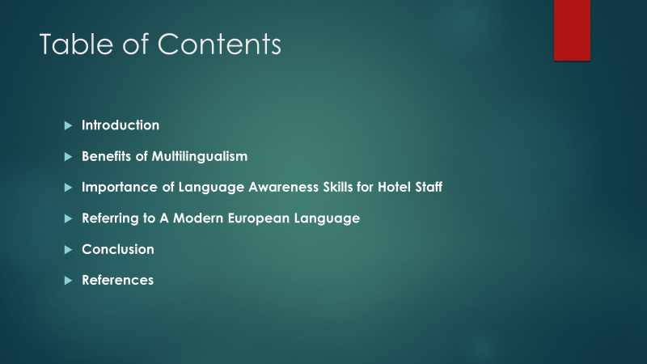

Introduction
As hotel employees need to engage with customers speaking different languages, having multilingual staff can bring numerous benefits to organizations. According to Suhaimi and Abdullah (2017), multilingualism is the capability of someone to speak more than one language. Based on the Beaumont Hotel, this presentation will showcase some topics related to multilingualism and language awareness referring to French which is a modern European language.
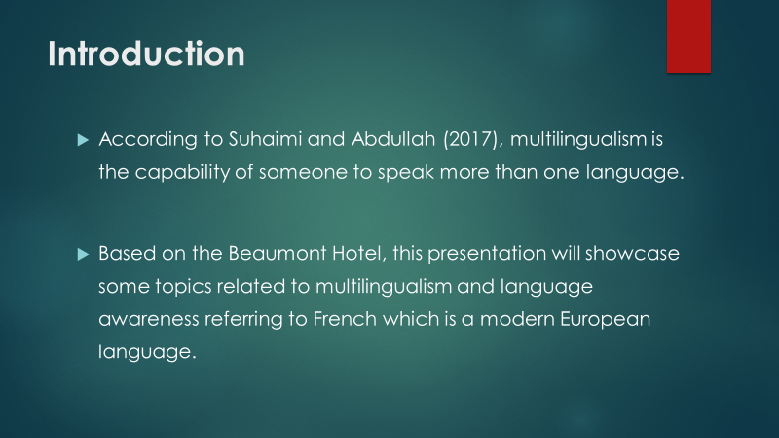

Benefits of Multilingualism
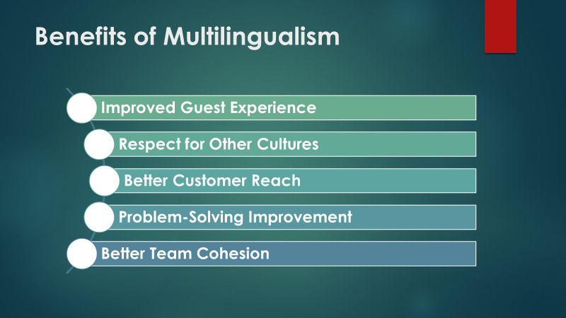
Improved Guest Experience: Staff members fluent in multiple languages are better able to cater to their visitors' individual needs and address their questions and concerns on time. Customer satisfaction is increased as a result, which is good for both word of mouth and future business (De Carlos et al., 2019).
Respect for Other Cultures: Employees who speak more than one language have a greater understanding of cultural norms and social conventions. This cultural awareness allows them to serve all customers with respect and consideration, regardless of their origins.
Better Customer Reach: If the staff speaks more than one language, the hotel can reach more people. If staffs can speak Mandarin, Spanish, or Arabic well, they can help the hotel reach new markets and make more money by bringing in people from all over the world.
Problem-Solving Improvement: Goethals (2016) says that employees who can speak more than one language are better able to handle difficult conditions. When hotel staff speak more than one language, they can talk to guests and fix problems more easily, which is good for the hotel's brand image.
Better Team Cohesion: Support for a lot of languages makes working together easier. Sharing linguistic skills among staff members makes the hotel run more smoothly overall. This builds community, encourages teamwork, and facilitates the sharing of information.

Importance of Language Awareness Skills for Hotel Staff
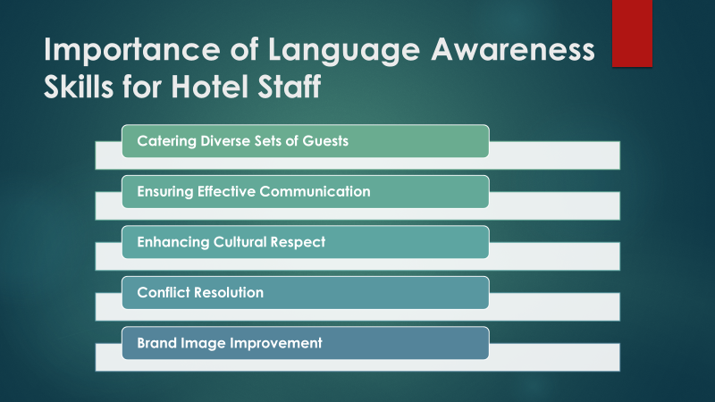
Catering Diverse Sets of Guests: Customers who do not speak English, like those who speak Mandarin, French, or Arabic, can be sure that they will get the same great service as those who do. To meet the needs of its foreign guests, the Beaumont Hotel needs to be culturally aware (Tziora et al., 2016).
Ensuring Effective Communication: Language knowledge makes it easier for staff members to understand how important it is for them to be able to communicate clearly with each other. To keep things running smoothly and give great service to guests, employees need to be able to clearly communicate.
Enhancing Cultural Respect: People who know a lot about languages like the cultural differences that come with the different languages they use. These feelings are very important for keeping guests' cultural practises pure and for making the place where everyone feels at home warm and welcoming.
Conflict Resolution: Employees who are fluent in multiple languages are better equipped to resolve disagreements by picking up on nuanced verbal cues and tones. For the sake of the hotel's reputation for excellent service and the rapid resolution of any misunderstandings or disagreements that may arise, this skill is crucial.
Brand Image Improvement: At the Beaumont Hotel, they value diversity and welcome all guests. The staff's linguistic and cultural competence contributes greatly to this impression, making the hotel a top pick among foreign visitors looking for a friendly and respectful stay.

Referring to A Modern European Language
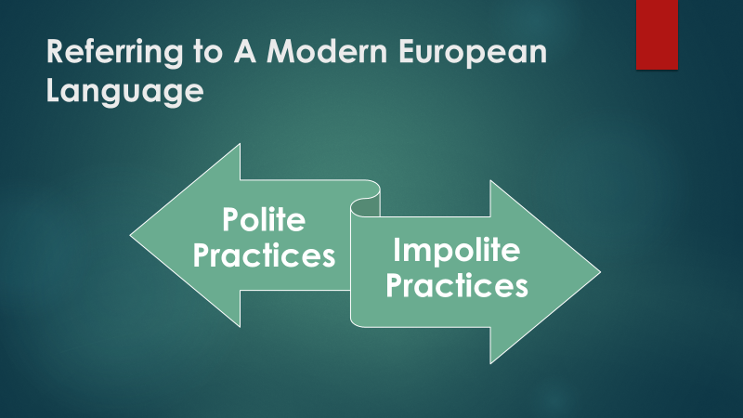
French can be a good example which is spoken throughout Europe today. French is one of the most widely spoken languages in the world, as it is not only spoken in France but also in small areas of Belgium, Switzerland, Luxembourg, Canada, and some nations in Africa.
Polite Practices: Business etiquette in the French-speaking hotel industry places a premium on civility. Addressing people formally, with appropriate titles, is essential, especially when dealing with clients. The use of "Monsieur" or "Madame" before a guest's last name is a common expression of respect and courtesy in French culture (Rusu, 2022). The use of "S'il vous plaît" (please) and "Merci beaucoup" (thank you very much) is also crucial.
Impolite Practices: Misusing formal titles or speaking too casually might give the impression of rudeness. Requesting someone's private information out of the blue is one example of unfriendly behaviour. Understanding the subtleties of French politeness, the team at the Beaumont Hotel ensures that they approach guests properly, creating a courteous and respectful ambience, which in turn increases visitor satisfaction and the hotel's reputation.

Conclusion
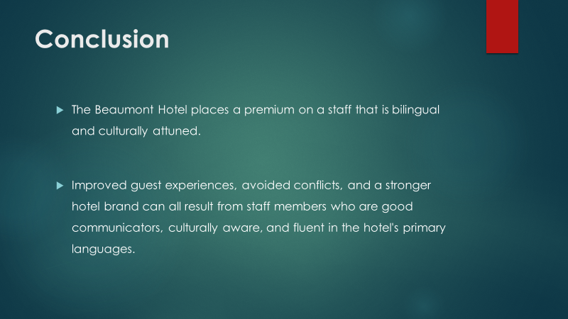
The Beaumont Hotel places a premium on a staff that is bilingual and culturally attuned. The hotel guarantees its diverse guests feel welcome by encouraging employees to become multilingual. Improved guest experiences, avoided conflicts, and a stronger hotel brand can all result from staff members who are good communicators, culturally aware, and fluent in the hotel's primary languages. In the cutthroat hospitality sector, the hotel can set itself apart from the competition by emphasising politeness, especially in business encounters. Staff morale is boosted as a result of the commitment to linguistic diversity, and customers benefit as well. The Beaumont Hotel in London is a great example of how words can bring people together, strengthen bonds, and improve service.

References
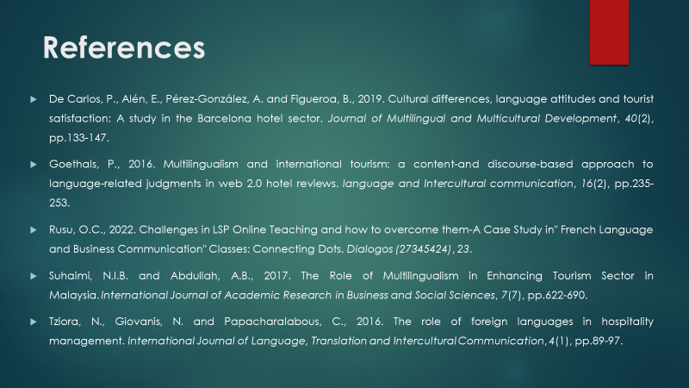
De Carlos, P., Alén, E., Pérez-González, A. and Figueroa, B., 2019. Cultural differences, language attitudes and tourist satisfaction: A study in the Barcelona hotel sector. Journal of Multilingual and Multicultural Development, 40(2), pp.133-147.
Goethals, P., 2016. Multilingualism and international tourism: a content-and discourse-based approach to language-related judgments in web 2.0 hotel reviews. language and Intercultural communication, 16(2), pp.235-253.
Rusu, O.C., 2022. Challenges in LSP Online Teaching and how to overcome them-A Case Study in" French Language and Business Communication" Classes: Connecting Dots. Dialogos (27345424), 23.
Suhaimi, N.I.B. and Abdullah, A.B., 2017. The Role of Multilingualism in Enhancing Tourism Sector in Malaysia. International Journal of Academic Research in Business and Social Sciences, 7(7), pp.622-690.
Tziora, N., Giovanis, N. and Papacharalabous, C., 2016. The role of foreign languages in hospitality management. International Journal of Language, Translation and Intercultural Communication, 4(1), pp.89-97.

