Task B
Discuss the implications of the factors of frequency and wavelength in:
- Internal sound management

Sound can become quite a nuisance and pain to people so there are many ways sound can managed internally.

In places like Music studios, they use Acoustic panelling which helps to prevent sound from escaping the room and trapping it in. As for places like this keeping the sound trapped in that location is important. As this is managed using the panelling as its designed to prevent sound from leaving as it reflects the sound back so you can hear the acoustics better.

In housing, apartments or buildings used for meeting they can be fitted with acoustic plasterboards which are more in mass than normal boards as this stops the sound from passing through and stops the noise from passing into other rooms or buildings. Also, using certain types of insulation in the walls helps prevent the passage of sound from going into other rooms.

A method which is usually used in commercial or sometimes in residential housing is using suspended flooring or ceilings. Doing this can create the air in the room to be stale so the sound vibrations won’t be able to transfer through the walls do to them being isolated from the main structure.

With sound there’s different types of it they are Airborne and Impact. Airborne is things like traffic (Horns, engines), people talking and wildlife like dogs barking and cats meowing. Impact is sound made from two forces hitting each other like footsteps hitting the floor or a falling object as when the make impact with each other it creates a sound and vibrations. The example I gave about sound management are examples of Airborne and Impact as people, as in a studio people are singing or hitting drums so a person’s voice is airborne, and the drums is impact due to the drummer hitting the drums.

Lastly, there are different methods of sound management for high and low frequencies as High Frequencies is well absorbed and poorly transmitted. While Low Frequencies are the opposite to them as they are poorly absorbed and well transmitted. So different measures are used for them because they are different to each other. So, for Low Frequencies methods like Panel Absorbers which are used to absorb the Low Frequencies and convert them into mechanical vibrations which lose their energy from it. For High Frequencies, typically used are Porous Absorbers which turn the sound energy into converted heat.

- Partition wall construction technique.

(LTD)
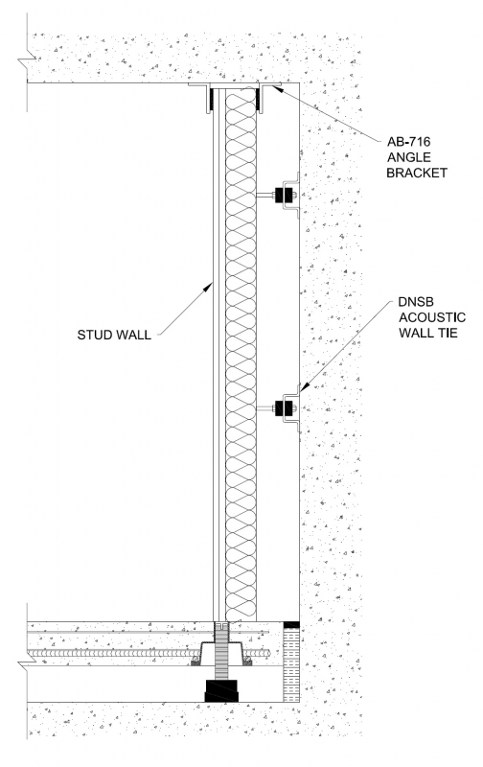
This section shows an example of absorption panelling. As the stud wall is separated from the main structure via the wall ties as the sound will hit the wall and be absorbed by it and transferred through the ties into the main structure. This is done to allow air follow too as the void in between. Also, the insulation is used as well to absorb any noise or vibrations too and dampen it. This technique would usually be found in offices, meeting rooms or classrooms as in these rooms will have large numbers of people and they’ll be talking, shouting, arguing and objects falling so this technique would help prevent nearly all sound from being transmitted.

- The Insulation material choice.

Different materials have different reactions and affects when different wavelengths or frequencies of sound hit them, transfer through or when trying to prevent it from leaving.
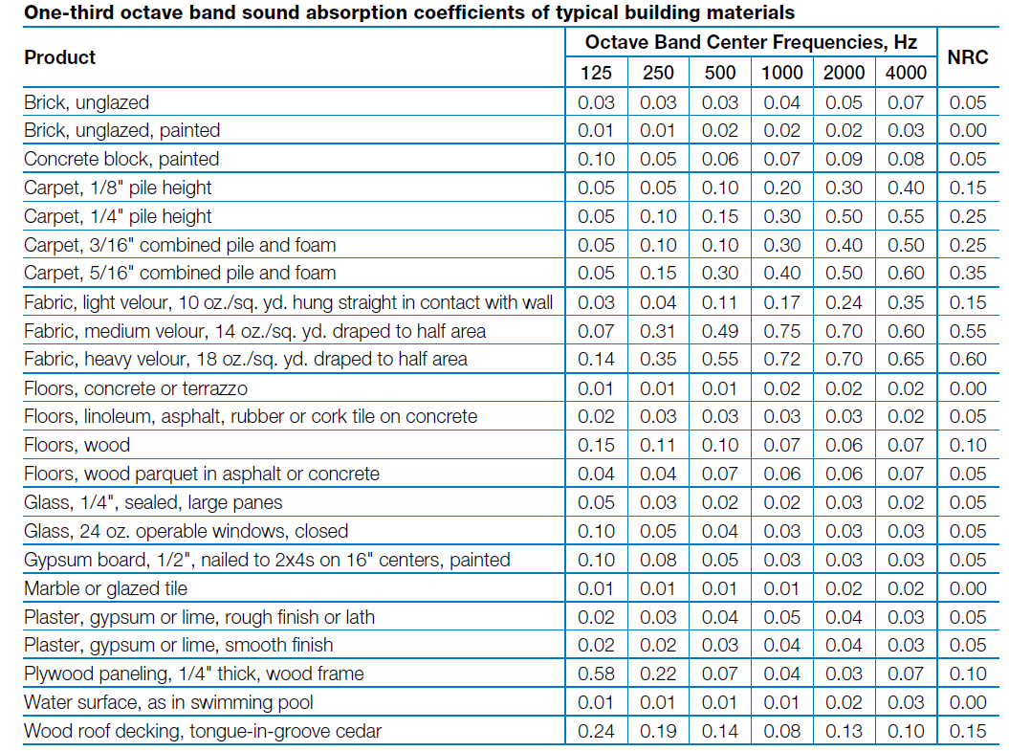
In the above table it shows the different absorption coefficients of standard buildings materials. With materials which have 0 NRC have perfect reflection while those which have 1 have perfect absorption.
Materials like timber, brick, steel, and glass are commonly used materials all have different absorptions percentages. For example, Glass is a poor absorber of sound as it’ll shatter at roughly 556 hz but is an even better reflector of sound, even better than concrete. However, materials like concrete and brick are better absorbers of sound but poor reflectors. That’s why they’re ideal for making walls out of than glass as there would be hardly any sound escaping as if it were glass walls than sound would just pass through or reflect.
Steel is very good at reflecting most high frequency sounds and a small percentage of low. This makes them ideal from places like studios are they reflect most sounds and amplify the sound waves making them better but are a poor absorber as they only absorb 0.03 NRC which is 3% of all sound that passes them.

