

Strategic Environmental Analysis of Audi
Module Code: LCLM6003
Module Name: Leading and Implementing Change (LIC)
Lecturer name: Nadeem Mirza
Student Name: Alexandru Buzatu
Student ID:2312847

Executive Summary
The key purpose of the report is to introduce an actionable strategic change plan for Audi, which is currently facing issues with data bottlenecks, intense competitive pressure, job losses among the employees and other macroeconomic issues. By responding to these issues, the major objective is to improve employee training practices, after-sales services and quality in car manufacturing, by which the Audi Group can gain an advantage to rank at the top position. Through conducting PESTLE, SWOT and Porter's five forces analysis, high bargaining power of the buyers, political and regulatory issues, availability of new entrants and employee criticisms are found as the major business problems. The application of the change management model has also been considered in this report. Lewin's three-step model reflects that, in the initial stage, Audi has focused on communicating the importance of automation. An evaluation of the McKinsey 7-S framework has also been taken into consideration in this report. The application of the ADKAR model showcases that Audi prioritises reskilling to improve change management. In order to bridge the current business gaps, Audi has future scopes for improving the service settings along with integrating blockchain, upgrading AI systems, improving training and continuous improvement in after-sales services.

Table of Contents
1. Introduction 3
2. Introduction to Audi 3
2.1 Background and History of Audi 3
2.2 Current position and strategic context 3
3. Analysis of the external and internal environment nature 4
3.1 External Environmental Analysis using PESTLE 4
3.2 Industry Analysis (External Analysis) using Porter's Five Forces 5
3.3 Internal Analysis with SWOT 8
4. Evaluation of the Change Management Models 9
4.1 Driver of Strategic Change 9
4.2 Lewin’s Three-Step Change Management Model 10
4.3 McKinsey 7-S Change Management Framework 11
4.4 ADKAR Change Management Model 11
5. Leadership and Organisational Culture 12
5.1 Managing digital transformation changes in Audi 12
5.2 Role of leadership for managing changes 13
5.3. Impacts of the organisational culture on the change management programme 14
6. Change Management Plan for Audi 14
6.1 Proposed strategic change management plan 14
6.2 Clear strategic objectives 15
6.3 Implementation Plan 16
6.4 Financial Plan 17
6.5 Communication Plan 18
6.6 Evaluation Plan 18
7. Conclusion 19
References 20

1. Introduction
In the business field, the strategic change plan is essential for organisations to implement their current operational state in association with actionable solutions, which allows for achieving their future goals. According to Trygg and Grundel (2025), strategic change planning offers a more proactive approach rather than the traditional form of business changes, as it optimises innovative thinking and drives sustainability in the ongoing service nature. At the present contemporary stage, most businesses determine strategic changes through integrating AI (Artificial Intelligence) and other cutting-edge solutions to lead automation of the service setting to improve productivity levels. This report is going to analyse the change management and impacts of the business environmental factors of the well-known automobile sector, Audi, for which a suitable change management plan is developed. The rationale behind choosing Audi is due to its strategic transformation with modern technologies, an advancing global automobile production system, rapid organisational agility and transformational leadership.

2. Introduction to Audi

2.1 Background and History of Audi
Audi is well-known as a multinational luxury car manufacturer, which was first established in Germany in 1909 (Audi, 2026a). In 1899, this company was initiated as Horch & Cie as an automotive engineering service provider, which was expanded through producing motorcycles and mid-range cars with a water-cooled four-cylinder engine. The availability of motorcycles and innovative engine-based mid-range cars allowed them to retain potential customers in the international market, which allowed them to become a successful car manufacturer. Since 1969, Audi has continued to offer automobile services in the UK market by launching 100 saloons, by which it has established itself as one of the most popular car brands and set up their future success in the country (Car Discount Ltd, 2026). By following the needs and expectations of the potential car buyers, Audi UK introduced various innovative cars like Quattro, Q3, Q5, Q7, A4, A6 and others, which are popular for high-quality features and cutting-edge solutions.

2.2 Current position and strategic context
Considering the current context, it can be stated that the automobile industry across the globe is encountering rapid changes in terms of digitalisation and automation. An increased focus on electrification and digital advancements is observed in recent times. Audi remains one of the well-recognised brands in the UK automobile industry. Audi holds approximately 5.4% of the UK new car market in recent times. Sales of 111,115 vehicles in 2025 have also been observed (Audi, 2026d). Considering the strategic context, the organisation is focusing on shifting towards electrification in accordance with the contemporary market trends. Inclusion of automation in the vehicles and manufacturing systems is also observable.

3. Analysis of the external and internal environment nature

3.1 External Environmental Analysis using PESTLE
In order to analyse the impacts of the external environmental factors on the strategic change and digitalisation of Audi UK, the PESTLE tool is applied. PESTLE is the strategic management technique applied for assessing the impacts of political, economic, social, technological, legal and environmental factors (Dalirazar and Sabzi, 2023).
PESTLE | Analysis | Impact on the strategic change practises of Audi UK
Political | Long-term existence of Brexit is the key trajectory factor for the automobile sector to manage the export and import of resources in the West Midlands and East Midlands regions of the UK (Bailey et al., 2023). | Negative
Economic | The monthly GDP (Gross Domestic Product) index of the UK is approximately 103.2 (May, 2026), which was an increase from the previous year (102.3 in December, 2025) (Clark, 2026). | Positive
Social | In the UK, the wide availability of motor vehicle insurance facilities and penetration of the multinational automobile brands have significant impacts on the growing rate of car buyers over the period (Kester, 2022). | Positive
Technological | Growing trends of using data analytics, AI, battery technologies and the wide availability of different charging stations create opportunities for most UK automobile sectors to raise innovations in car manufacturing and sustain competitive advantages (Ziegler and Abdelkafi, 2023). | Positive
Legal | Regulations like the 'Automated Vehicles Act 2024 ' are quite relevant for ensuring safety levels and managing self-driving entities in the authorised form (Legislation of the UK Government, 2026). However, amendments in sections 44, 47, 78 and others of this legislation are often found. Dynamic amendments of the regulations become critical for the automobile sectors of the UK to manage their automobile services and customer service nature. | Negative
Environmental | As per Williams and Blyth (2023), strict policies on environmental and CSR (Corporate Social Responsibility) practices have significant impacts on raising production of sustainable automobile vehicles. | Positive
Table 1: PESTLE analysis
Based on the PESTLE analysis (Table 1), geopolitical issues like BREXIT and dynamic regulatory changes are found as the major drawbacks for Audi UK to lead strategic changes with digitalisations and automations.

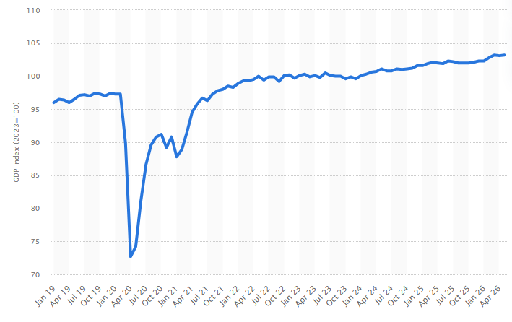
Figure 1: GDP Index rate of the UK from January 2019 to May, 2026
(Source: Clark, 2026)
However, the dynamic growth of the GDP (Figure 1) level, availability of vehicle insurance, and awareness about modern technological trends seem to be the major benefits for Audi UK, which allows them to improve their service settings along with digitalisations, AI and other cutting-edge solutions. As strong GDP growth and insurance facilities allow them to retain potential customers, manage operational costs and continue R&D operations for innovative electric vehicle production, these external environmental factors are considered key benefits for Audi UK.

3.2 Industry Analysis (External Analysis) using Porter's Five Forces
In regard to analysing the impacts of the ongoing industrial market conditions, Porter's Five Forces are applied. In the opinion of Hadjipetrou (2026), Porter's five forces model is fundamental for strategic planning to shape modern industrial organisations and improve industry profitability and attractiveness.
Porter’s five forces factors | Analysis
Competitive Rivalry | Competitive rivalry is high in the UK automobile market. As per the estimation of the number of new passenger cars sold and registrations in the UK, Volkswagen ranked in the top position (178,607) in the last year (Statista, 2026). On the other hand, Audi ranked in the fifth position for selling and registering 111,115 new vehicles in the UK, which seems quite challenging for strengthening competitive advantages.
Threats of new entrants | The threat of new entrants is high. As per Paba (2022), the penetration of Chinese electric vehicle companies becomes challenging for existing businesses to improve selling points and performance in the UK market. With reference to CarSalesBase data, SAIC (a Chinese car manufacturer) was able to sell 54,000 cars in the UK and other European markets, which was four times higher than in 2019 (Paba, 2022).
Threats of new substitutes | The threat of new substitutes is moderate in the UK. Due to the wide availability of the multinational automobile sectors and electric vehicle production in the UK, automobile sales grew by 1.94% (Pamidimukkala et al., 2024). It creates less scope for other automobile sectors to stabilise their service in this competitive market environment.
Bargaining power of the suppliers | The bargaining power of the suppliers is also low, due to the wide availability of suppliers and the massive global original equipment manufacturers in the UK automobile market.
Bargaining power of the buyers | The bargaining power of the buyers is high. As the customers are price sensitive and concerned about purchasing vehicles based on price and quality, the UK automobile sector experiences high bargaining power and challenges to sustain competitive advantages (Ramjaun et al., 2024).
Table 2: Porter’s five forces analysis
As shown in Porter's five forces analysis (Table 2), low bargaining power of the suppliers and low threats of new substitutes seem the key benefits for Audi to continue transitioning from traditional business services to modern digital solutions.
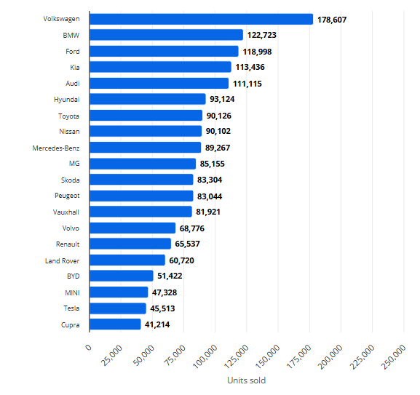
Figure 2: Number of new passenger cars sold and registered of different brands in the UK
(Source: Statista, 2026)
In contrast, the high competitiveness of Volkswagen, BMW, Ford and Kia, as well as their high selling rate, becomes critical for the Audi group to stabilise their service and market attractiveness with their electric motor vehicles and modern car ranges (Figure 2). Besides this, threats from new Chinese automobile businesses and high bargaining power of the customers are also challenging for the Audi group.

3.3 Internal Analysis with SWOT
In association with SWOT analysis, the effectiveness of the internal factors is evaluated for the case of Audi. SWOT analysis is useful for examining possible strengths and weaknesses behind implementing particular services, which is helpful for leading strategic directions (Goldberg and Sinatra, 2023).
Strength | Weaknesses
- High popularity as the world-renowned luxury brand of Audi is the key strength.  - Currently, more than 88,000 employees are working in Audi across 100 markets (Audi, 2026b). | - Recently, over 6,000 Audi workers criticised and protested against this automobile manufacturer for causing thousands of job losses after the closure of the Neckarsulm plant (Simon and Bureger, 2026).
Opportunities | Threats
- The wide extension of the automobile service and employee training facilities creates opportunities for the Audi group to improve the brand image, customer satisfaction and maintain quality in the after-sales service (AhmadzadehGhomi et al., 2025). | - Job cuts and closure of the automobile manufacturing plant are responsible for causing threats of high employee turnover and poor availability of skilled professionals for driving digital transformation and the formation of modern electric vehicles.
Table 3: SWOT analysis of Audi
As shown in the SWOT analysis (Table 3), the availability of a strong brand reputation and expansion of the workforce are advantages for the Audi group to stabilise their automobile services along with the strategic changes. Alternatively, the case scenario of Audi Neckarsulm plant closure indicates possible threats of job losses and limited professionals to raise innovations.

4. Evaluation of the Change Management Models

4.1 Driver of Strategic Change
Considering the contemporary context, the strategic change within the automobile industry is driven by the focus on sustainable and digitally advanced automobile solutions. One of the key drivers of strategic change within Audi is the shifted focus from traditional automobile services to electrification. The organisation has focused on shifting from internal-combustion engines towards EVs For instance, the organisation has a significant range of EV models, such as the A2 e-tron and the Q6 e-tron SUV (Audi, 2026e). A rapid increase in digitalisation and AI usage is worth mentioning as other drivers of strategic changes within the organisation. In accordance with these industry trends, the organisation has introduced AI-driven car technologies and digital services. Similarly, environmental pressure has also encouraged Audi to implement strategic changes. The organisation has considered the climate change adversities associated with the automobile industry. In this respect, the organisation has reduced vehicle and manufacturing emissions as a part of its responsible business practices. Moreover, the changing customer preferences towards sustainable brands in this industry have also been another factor in strategic changes. As per this statistical data, 49% of UK consumers consider purchasing digitally integrated and electric-driven vehicles (Motor Finance Online, 2026). In this respect, Audi also focuses on incorporating digital advances in their cars.

4.2 Lewin’s Three-Step Change Management Model
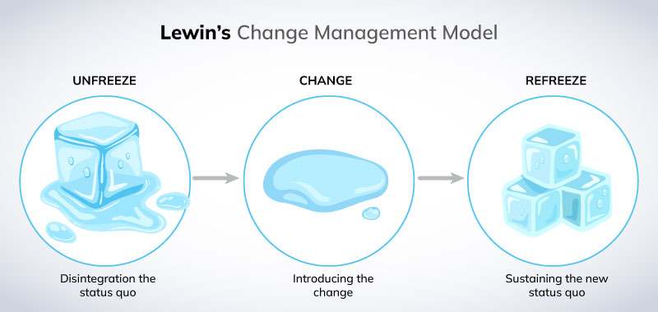
Figure 3: Lewin’s Three-Step Change Management Model
(Source: Miller, 2022)
Lewin's three-step model is one of the well-recognised frameworks for understanding the change management process within an organisation. This framework was developed by Kurt Lewin during the 1940s. This framework incorporates three distinctive components, such as unfreeze, change and refreeze (Sorensen, 2023). In the unfreeze stage, an organisation is required to communicate the need for change among the stakeholders. Thus, in the initial stage, Audi focuses on communicating the importance of automation, digitalisation and electrification. The second stage involved in this framework is associated with the actual implementation of the change strategies. During the change stage, Audi has introduced EV technologies, automated manufacturing processes, and the inclusion of AI into the vehicles. The final stage included in this framework is refreeze, which focuses on stabilising the organisation in the new state.
A few issues associated with the strategic changes can be identified within the business context of Audi. For instance, in the initial and change stages, employee skill gaps can be noted as an issue for the organisation. Audi addressed this issue by providing training to the workforce. The organisation arranged approximately 20 vocational training sessions (Audi, 2026f). These training sessions are focused on enhancing the digital skills of the employees to contribute to change management.

4.3 McKinsey 7-S Change Management Framework
McKinsey 7-S model is another distinctive framework associated with change management practices (Boakye, 2024). Seven key components are included in this framework to evaluate change management. Strategy is one of the key components in this framework that helps in understanding the long-term plan of an organisation. The long-term strategy of Audi is to enhance automation and sustainability in its business practices. Structure is the second stage in this framework, reflecting the way reporting lines are managed. In alignment with this component, Audi has focused on automation and digitalisation in different departments, including production. For instance, Audi has implemented smart production through an Automated Guided Vehicle (AGV) approach (Audi, 2022). The formal and informal procedures associated with a change are reflected through the component of the system. Digital manufacturing and AI-integrated data analysis approaches have been considered by the organisation. In alignment with the component of shared values in this framework, Audi has emphasised innovation and sustainability, while maintaining high quality. Focusing on the component of skills in this model, this automobile organisation focuses on technological skills and AI system management expertise. As part of the style component, Audi has prioritised a transformational leadership approach in the change management environment. In the context of staff, the organisation has focused on investing in existing staff for skill development, while hiring specialists in digitalisation and automation.
However, a few issues within Audi in accordance with this framework can also be identified. For instance, integration of the advanced technologies with the legacy system can be noted as an issue for the organisation. In order to address this issue, Audi has considered incorporating a digital transformation approach. The organisation collaborates with institutions, such as the Fraunhofer Institutes and IPAI (Audi, 2025). This approach contributes to the digital transformation.

4.4 ADKAR Change Management Model
ADKAR is also a commonly used framework for understanding the change management process within an organisation. The key components of this framework are awareness, desire, knowledge, ability and reinforcement (Mazariego et al., 2026). During the initial stage, the employees are required to understand the need for change within the organisation. Audi has emphasised the importance of automation and digitalisation in the contemporary market. In the stage of desire, enhancing employee motivation to participate in the change is considered. Audi has reflected on the scope for developing new skills and performance excellence to improve employee motivation. In terms of knowledge, employees are required to enhance their skills and knowledge in advanced automation and digital technologies. Considering the component of ability, employees should focus on applying the knowledge in manufacturing and similar practices. The reinforcement aspect reflects that new behaviours are required to be adequately implemented within the organisation. Audi has focused on integrating the innovative strategies into their corporate goals.
One of the key issues encountered by the organisation during change management was the fear of job loss among the employees. The focus on modern approaches regarding automation may have caused job insecurity among the traditional workers. In order to address this issue, Audi has prioritised career development practices, reskilling and providing incentives (Audi, 2023). These initiatives have allowed for improving employee knowledge in accordance with the contemporary market needs.

5. Leadership and Organisational Culture

5.1 Managing digital transformation changes in Audi
Instead of using local computers and traditional digital network settings, Audi management group manage regular business operations in association with AI and other cutting-edge technologies through the 360factory strategy. According to the 360factory strategy, Audi group strengthened the virtual assembly planning for manufacturing a diverse range of innovative vehicles through integrating the Edge Cloud 4 Production solutions and AI tools (Audi, 2023). It is effective for the internal workforce team to estimate ongoing market demands, plan sustainable ways of production and strengthen a resource-efficient design of the manufacturing plant infrastructure. It allows them to meet the demands of the future. On the other hand, Vasile et al. (2025) argued that integration of smart and modern digital objectives creates obstacles for automobile businesses in securing financial resources, data privacy and security levels, as systematic glitches and algorithmic issues adversely trigger them to implement the service settings. It becomes a complex hurdle for modern technology usage and leading vehicle software integrations for offering self-automated driving cars and driver-assistance features.

5.2 Role of leadership for managing changes
The Audi leadership team enhances the holistic production and manufacturing aspects in relation to digitalisation for leading highly flexible and sustainable electric vehicle production by adopting a transformational leadership style.
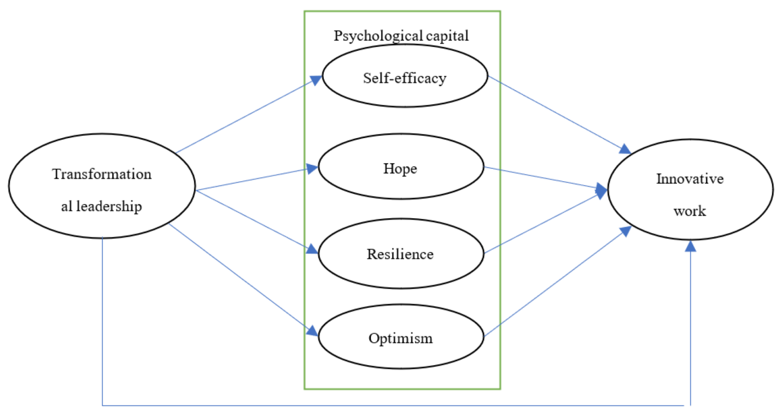
Figure 4: Impacts of transformational leadership on innovative work behaviour among employees
(Source: Karimi et al., 2023)
As shown in Figure 4, Karimi et al. (2023) revealed that transformational leaders are responsible for engaging employees, prioritising their needs, and empowering them to develop their creativity and innovative behaviour, which acts as the mediating role for psychological capital through the lens of 'Social Exchange Theory’. Gernot Dollner, who is the CEO (Chief Executive Officer) of Audi, prioritised strategic and well-orchestrated personnel changes to shape their future as the technology-driven supercar brand (Audi Communications, 2026). Through offering training facilities and engaging professional workers, the Audi brand became capable of expanding the production of the Audi E5 Sportsback, Audi E7X and others by advancing electrification strategies, which was significant to expand their service settings across worldwide zones. However, limited availability of the necessary competencies and professional workforce team seems less appropriate for the transformational leaders to boost innovation in the workplace (Pigola et al., 2024). Linking with the case scenario of Audi Neckarsulm plant, initiatives of implementing the workforce setup with the digitalisations and closure of this car manufacturing plant for alterations become critical for the transformational leaders of Audi to achieve the goals of digitalisations.

5.3. Impacts of the organisational culture on the change management programme
The organisational culture of Audi is engineering-driven, quality-focused, high-performance, and focused on electrification, which is responsible for managing a structured governance and leading a change management programme. In 2021, the Audi board of management team was responsible for setting up a new change management programme, 'Vorsprung 2030', for which they equipped the organisational team with training, improved the onboarding system and accelerated digital transformations (Audi, 2026c). Wide availability of professional engineers and structured governance allows the Audi group to achieve the goals and objectives of Vorsprung 2030, like reduction of combustion engine production, an extensive ecosystem for electric cars, an after-sales offering with intelligent hardware and predictive services and growing productivity. However, Wynn and Felser (2023) argued that although the availability of software expertise is the central competency of automotive companies for expanding autonomous driving-based car production and innovative designs, limitations of digital resources, economic volatility and dynamic changes in customers' trends seem the key changes for the automobile sector to sustain change management programmes.

6. Change Management Plan for Audi

6.1 Proposed strategic change management plan
Through responding to possible gaps of Audi found in the previous sections, this automobile sector needs to focus on developing an ecosystem-wide agile change management plan. In order to improve competitive advantages, address employees' criticisms and address data-driven issues, the Audi group needs to replace the rigid and linear rollout system with modern decentralised solutions for real-time sentiment analysis, predictive risk modelling, scaling transformation smoothly and hyper-personalised employee training. In order to reduce operational inefficiencies and costs for digital sources, proper collaboration and partnership with low-cost suppliers is relevant for saving investment levels, accessing real-time information on inventory levels and procurement procedures and improving shipment levels effectively (Joeaneke et al., 2024). Moreover, companies like Tesla strongly prioritise the integration of blockchain technologies for improving data integrity, verification, and data confidentiality across the car manufacturing system (Eledlebi et al., 2024). As this technology acts as a fully symmetric lightweight authentication protocol for improving the data management level, Audi transformational leaders are proposed to improve data privacy in the data-driven networking system, similar to Tesla.
However, Ren et al. (2024) revealed that proper fixations of the privacy-enhancing technologies (like Internet-of-Things and Industrial 4.0) allow for strengthening the security patches against the identified unauthorised access in the digital networking system. This proposed technique will be effective for preserving privacy without significantly affecting the utility of the user data, for which Audi should be concerned with securing a huge volume and variety of data. From the case scenario of Volkswagen, Velinov (2023) argued that the implementation of the training and awareness programme is effective for maintaining fair workforce setups, effective diversity management practices, improving innovative practices and enhancing corporate culture. Although the differentiations of the employees' needs may be critical for the Audi leadership team to improve continuous training practices, this hyper-personalised training will be relevant to mitigate possible biases of job losses and improve productivity levels.

6.2 Clear strategic objectives
Strategic Objectives | Performance Target | Timeline
To avoid over-costing the digitalisations by prioritising low-cost suppliers and technology providers from different country zones. | Increase cost saving rate by 20% | Within 2 years
To mitigate the data privacy issues with integrating a blockchain system | Reduce the threats of data privacy by 30% | Within 3 years
To improve the security level in the automobiles through enhancing data minimisation and anonymisation (privacy by design) | Increase the security level by 50% | Within 3 years
To expand the digital training to reduce the possibilities of employee criticisms | Improve the workforce productivity and competencies by 70% | Within 2 years
To develop the vehicle quality and after-sales service settings for improving selling rate and competitive advantages. | Optimise the selling rate by 60% | Within 3 years
Table 4: Strategic objectives of the change management plan for Audi

6.3 Implementation Plan
Phase | Key Activities | Timeline | Stakeholders responsible
1 | Proper collaboration with the international partners to find out relevant suppliers for low-cost-based technologies | 1-3 months | Transformational leaders and board management group
2 | Expand and integrate newly upgraded blockchain technologies with the data-driven network settings across the manufacturing zones. | 18-20 months | IT team and operational team
3 | Strengthening privacy by design for improving security level | 5-6 months | IT management team, customer service group
4 | Implementing employee training, onboarding and continuous monitoring of employee feedbacks | 20-25 months | HR management, operational team
5 | Upgrading existing digital infrastructure and real-time assessment solutions | 5 months | Customer service team
Table 5: Proposed roadmap for implementation and change management for Audi

6.4 Financial Plan
Investment Area | Year 1 (£m) | Year 2 (£m) | Year 3 (£m) | Total (£m) | Expected outcomes
Upgrading AI-based data-driven infrastructure | 70 | 50 | 50 | 170 | Boost data authenticity and manufacturing processes with proper decision-making and automation (Pang et al., 2025)
Sourcing newly upgraded blockchain technologies | 50 | 40 | 40 | 130 | Relevant for optimising security level (Modares et al., 2025)
Developing privacy by design | 70 | 60 | 70 | 200 | Improving customers' satisfaction level
Cloud infrastructure and cybersecurity | 80 | 70 | 50 | 200 | Effective for strengthening the network settings for data management
Training setups | 60 | 40 | 30 | 130 | Relevant for employee productivity nature
Monitoring, continuous improvement and maintenance | 50 | 70 | 80 | 200 | Improving customers’ satisfaction nature
Improving technical support and system integrations | 30 | 40 | 50 | 120 | Mitigating the biases in quality management
Total investment | 430 | 370 | 370 | 1,150
Table 6: Financial Plan

6.5 Communication Plan
During the implementation of the internal service settings based on the implementation plan (Table 5), all stakeholders will be involved in the virtual meetings conducted on the Google Meet platform. As per Glazunova et al. (2023), Google Meet is user-friendly and relevant for communicating with a wide range of individuals through representing the datasets along with the Google Workspace tools. It will be relevant for discussing and analysing the ongoing performance nature from the progress report and feedback to examine the areas of improvement, which will be effective for implementing in the resource planning, financing and decisions taken under the board management of Audi.

6.6 Evaluation Plan
After three months of implementing the change management and service setting nature, the performance areas are measured using the quantitative KPI factors. By examining the progress report, the proposed plan will be implemented to fulfil clear strategic objectives given in Table 4. Below, an estimated progress report is developed showcasing KPI factors and key targets (Table 7).
Performance Area | Key Performance Indicator (KPI) | Target
Improving financial efficiency | Profitability rate | Increasing by 20%
Raising user satisfactions | User satisfaction rate | Increasing by 40%
Avoiding data bottleneck | Data security rate | Improving by 70%
Improving employee satisfaction | Employee retention rate | Accelerating by 50%
Improving competitive advantages in the UK market | Selling rate | 30% growth
Table 7: Key Performance Indicators

7. Conclusion
Hence, it can be concluded that initiatives of the 360factory strategy and prioritisation of the AI-based solutions will be significant for Audi to strengthen itself as the most sustainable and high-selling automobile brand in future. Although the case of Audi Neckarsulm Plant, data bottleneck issues, poor security and low selling points are found as the major drawbacks, the proposed strategic change management plan will be effective for achieving future goals of competitive advantages and sustainability. Strategic interventions for integrating blockchain devices, training opportunities and implementing after-sales services will lead to positive outcomes for customer retention level, profitability and employee productivity rate in the upcoming period.

References
AhmadzadehGhomi, M. Qorugchi, E.H. Mohebbi, S. and Bagheri, M. (2025) ‘Factors Affecting Brand Image Improvement in the Automotive Industry’, Journal of Management and Business Solutions, pp. 1-17.
Audi (2022) Smart Production: How Audi Is Designing the Production of the Future. Available at: https://www.audi.com/en/press-releases/smart-production-how-audi-is-designing-the-production-of-the-future-14786 (Accessed: 6 August, 2026).
Audi (2023) Audi 360factory. Available at: https://www.audi.com/en/presskits/smart-production-14757 (Accessed: 6 August, 2026).
Audi (2025) Audi develops the picking process of the future. Available at: https://www.audi.com/en/press-releases/audi-develops-the-picking-process-of-the-future-16681 (Accessed: 6 August, 2026).
Audi (2026a) Company history. Available at: https://www.audi.com/en/company-history-17227 (Accessed: 6 Aug, 2026).
Audi (2026b) Employees & corporate culture. Available at: https://www.audi.com/en/employees-and-corporate-culture-17203 (Accessed: 6 August, 2026).
Audi (2026c) Audi accelerating transformation: "Vorsprung 2030". Available at: https://press.audi.co.uk/releases/269 (Accessed: 6 August, 2026).
Audi (2026d) Audi delivers 1.6 million vehicles in 2025 as strong fourth quarter ends challenging year. Available at: https://press.audi.co.uk/releases/941 (Accessed: 6 August, 2026).
Audi (2026e) Our fully electric (EV) cars. Available at: https://www.audi.co.uk/en/electric/e-tron/ (Accessed: 6 August, 2026).
Audi (2026f) Audi starts the training year 2023 with more than 700 young talents. Available at: https://www.audi.com/en/press-releases/audi-starts-the-training-year-2023-with-more-than-700-young-talents-15574 (Accessed: 6 August, 2026).
Audi Communications (2026) Audi Group strengthens international leadership team. Available at: https://www.audi.com/en/press-releases/audi-group-strengthens-international-leadership-team-17114 (Accessed: 5 August, 2026).
Bailey, D. De Ruyter, A. Hearne, D. and Ortega-Argilés, R. (2023) ‘Shocks, resilience and regional industry policy: Brexit and the automotive sector in two Midlands regions’, Regional Studies, 57(6), pp. 1141-1155.
Boakye, M. (2024) ‘Leadership and strategic change management in organizations’, International Journal of Applied and Advanced Scientific Research, 9(1), pp.1-10.
Car Discount Ltd (2026) A Century of Audi in the UK: From Innovation to Electric Revolution. Available at: https://www.uk-car-discount.com/news/audi-uk-innovating-electrifying-a-century (Accessed: 7 August, 2026).
Clark, D. (2026) Monthly index of gross domestic product in the United Kingdom from January 2019 to May 2026. Available at: https://www.statista.com/statistics/1175538/monthly-gdp-uk/?srsltid=AfmBOooImJskFJHnbVA6P0B0nR7736STUpmh6afDeZmkxzVmgek7Ph4T (Accessed: 8 August, 2026).
Dalirazar, S. and Sabzi, Z. (2023) ‘Strategic analysis of barriers and solutions to development of sustainable buildings using PESTLE technique’, International Journal of Construction Management, 23(1), pp. 167-181.
Eledlebi, K. Alzubaidi, A. Damiani, E. Puthal, D. Mateu, V. Zemerly, M.J. Al-Hammadi, Y. and Yeun, C.Y. (2024) ‘Bio-integrated hybrid TESLA: A fully symmetric lightweight authentication protocol’, IEEE Internet of Things Journal, 11(23), pp. 37421-37436.
Glazunova, O. Gurzhii, A.N. Korolchuk, V. and Voloshyna, T. (2023) ‘Selection of digital tools for organizing students' group work in distance education’, Information Technologies and Learning Tools, 2(94), pp. 87-101.
Goldberg, B. and Sinatra, A.M. (2023) ‘TUTORING (GIFT) SWOT ANALYSIS’, Design Recommendations for Intelligent Tutoring Systems: Volume 10-Strengths, Weaknesses, Opportunities and Threats (SWOT) Analysis of Intelligent Tutoring Systems, p. 9.
Hadjipetrou, I.P. (2026) ‘Awareness of Porter’s Five Forces Framework: A Research Paper’, Journal of Emerging Markets and Management, 2(2).
Joeaneke, P. Kolade, T.M. Obioha Val, O. Olisa, A.O. Joseph, S. and Olaniyi, O.O. (2024) ‘Enhancing security and traceability in aerospace supply chains through block chain technology’, 26(10), pp. 114-135.
Karimi, S. Ahmadi Malek, F. Yaghoubi Farani, A. and Liobikienė, G. (2023) ‘The role of transformational leadership in developing innovative work behaviors: The mediating role of employees’ psychological capital’, Sustainability, 15(2), p. 1267.
Kester, J. (2022) ‘Insuring future automobility: A qualitative discussion of British and Dutch car insurer's responses to connected and automated vehicles’, Research in Transportation Business & Management, 45, p. 100903.
Legislation of the UK Government (2026) Automated Vehicles Act (2024). Available at: https://www.legislation.gov.uk/ukpga/2024/10/contents (Accessed: 3 August, 2026).
Mazariego, C. Williamson, K. McCarthy, K. Gazzard, A. Stuart, K. Leon, S. Taylor, N. Rushton, S. and O’Brien, T. (2026) ‘Driving statewide digital transformation in oncology care: a change management case study using ADKAR methodology for the implementation of patient-reported outcomes in cancer clinical care’, JBI Evidence Implementation, pp.10-1097.
Miller, K. (2022) A Practical Explanation of Lewin’s Change Management Model. Available at: https://crowjack.com/strategy/change-management-models/lewins-model (Accessed: 6 August, 2026).
Modares, A. Emroozi, V.B. Roozkhosh, P. and Modares, A. (2025) ‘A Bayesian best-worst approach with blockchain integration for optimizing supply chain efficiency through supplier selection’, Supply Chain Analytics, 9, p. 100100.
Motor Finance Online (2026) UK consumers show gradual shift towards EVs: Deloitte study. Available at: https://www.motorfinanceonline.com/news/uk-consumers-show-gradual-shift-towards-evs-deloitte-study/ (Accessed: 6 August, 2026).
Paba, S. (2022) ‘The Chinese automotive industry at a turning point’, An Overview. DEMB WORKING PAPER SERIES, pp. 1-36.
Pamidimukkala, A. Kermanshachi, S. Rosenberger, J.M. and Hladik, G. (2024) ‘Barriers and motivators to the adoption of electric vehicles: A global review’, Green Energy and Intelligent Transportation, 3(2), p. 100153.
Pang, Y. Huang, T. and Wang, Q. (2025) ‘AI and data-driven advancements in Industry 4.0’, Sensors, 25(7), p. 2249.
Pigola, A. de Moraes, G.H.S.M. do Prado, N.B. Lucas, A.C. Sigahi, T.F.A.C. and Anholon, R. (2024) ‘Transformational leadership addressing team performance: situational challenges in corporate settings’, Journal of Work-Applied Management. pp. 1-16.
Ramjaun, T.I. Rodrigues, V.S. and Kumar, M. (2024) ‘Horizontal supply chain collaboration amongst small enterprises: insights from UK brewery networks’, Production Planning & Control, 35(2), pp. 206-224.
Ren, W. Tong, X., Du, J. Wang, N., Li, S. Min, G. and Zhao, Z. (2024) ‘Privacy enhancing techniques in the internet of things using data anonymisation’, Information systems frontiers, 26(6), pp. 2227-2238.
Simon, F. and Bureger, A. (2026) Thousands of Audi workers protest over threatened plant closure. Available at: https://www.reuters.com/business/world-at-work/thousands-audi-workers-protest-over-threatened-plant-closure-2026-07-29/ (Accessed: 7 August, 2026).
Sorensen, S.E. (2023) An examination of leading through change using Snyder’s hope theory and Lewin’s 3-step model, Pepperdine University.
Statista (2026) Number of new passenger car registrations in the United Kingdom (UK) in 2025, by brand. Available at: https://www.statista.com/statistics/300305/number-of-new-car-registrations-in-the-united-kingdom/?srsltid=AfmBOoqsNu_Fx8gCIIGRkM6yBjHhS9Y6TrYQtpbX1KcJHoxkxP1rbrDe (Accessed: 7 August, 2026).
Trygg, K. and Grundel, I. (2025) ‘Strategic spatial planning in the implementation of mobility hubs’, Journal of Urban Mobility, 7, p. 100105.
Vasile, A. Burtea, A.M. and Ghiculescu, L.D. (2025) ‘The Development of Digitalization Management in the Automotive Industry: Processes and Challenges’, In International Conference of Management and Industrial Engineering (Vol. 12, pp. 193-198).
Velinov, E. (2023) ‘Top management team diversity impact on financial performance: Evidence from VW Group affiliated firms’, Financial Internet Quarterly, 19(3), pp. 1-15.
Williams, I.D. and Blyth, M. (2023) ‘Autogeddon or autoheaven: Environmental and social effects of the automotive industry from launch to present’, Science of the Total Environment, 858, p. 159987.
Wynn, M. and Felser, K. (2023) ‘Digitalisation and Change in the Management of IT’, Computers, 12(12), p. 251.
Ziegler, D. and Abdelkafi, N. (2023) ‘Exploring the automotive transition: A technological and business model perspective’, Journal of cleaner production, 421, p. 138562.

