
Learning Log
Hotel Placement – Managing Guest Service Operations


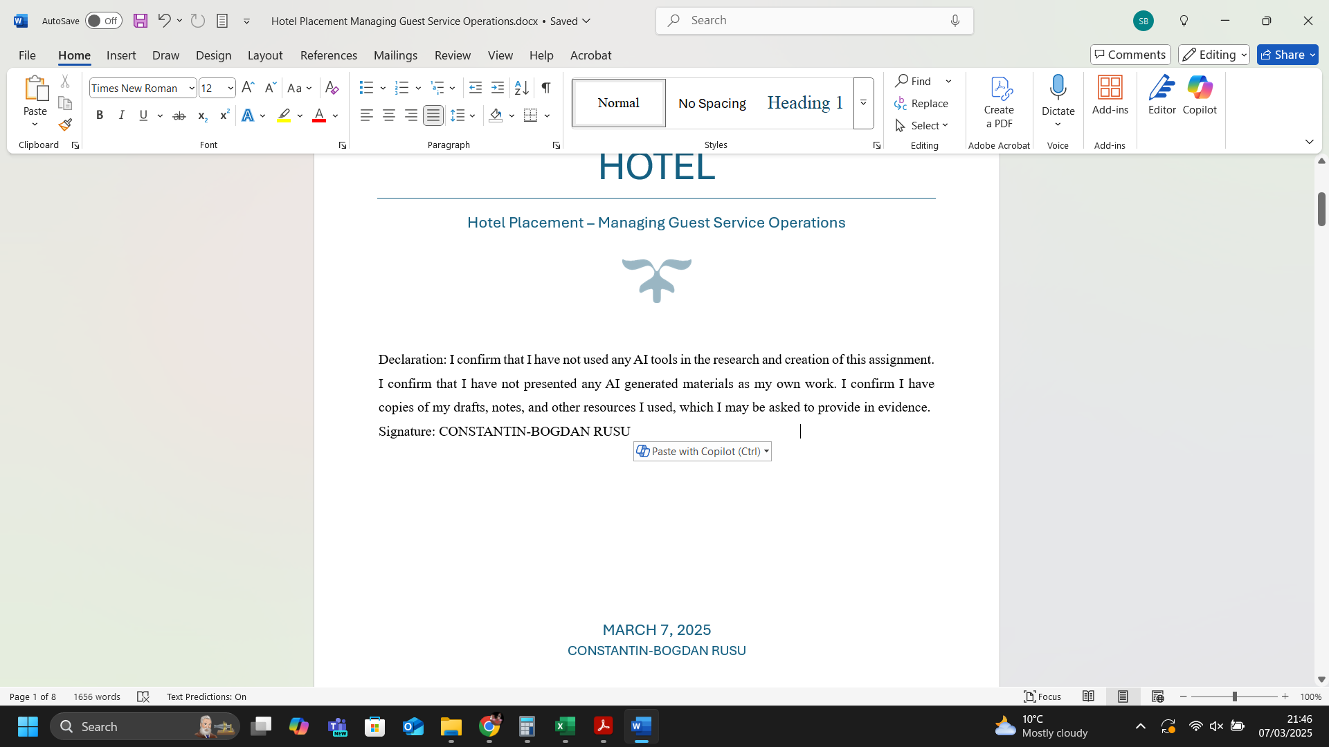
Table of Contents
I. Introduction 2
II. Reflection – Gibbs’ Reflective Cycle 2
III. Analysis 4
IV. Organisational Issues ​ 4
V. Conclusion and Action Plan ​ 5
References 6

Figure 1. Gibbs’ Reflective Cycle 2

Introduction
This report aims to provide a comprehensive reflection on my experiences during a 10-week Level 6 hotel placement as part of the "Managing Guest Service Operations" module in the BA International Hotel Management program. The primary objective of this report is to document and critically analyse the practical and managerial aspects of guest service operations within various hotel departments, including housekeeping, maintenance, etc. ​Managing guest service operations is crucial in the hospitality industry as it directly impacts the guest experience and satisfaction (Manhas and Tukamushaba, 2015). Effective management in this area ensures that guests receive high-quality service, which is essential for maintaining a positive reputation and achieving business success (Luo and Qu, 2016)). This report will highlight the significance of enhancing key skills such as communication, teamwork, task management, and problem-solving, which are vital for delivering exceptional guest service and achieving operational excellence (Vallen and Vallen, 2014).​

Reflection – Gibbs’ Reflective Cycle
The subsequent section reflects on the experiences encountered and to assess my progress through Gibbs' reflective cycle which comprises six stages designed to thoroughly examine one’s learning experience: description, feelings, evaluation, analysis, conclusion, and action plan (Gibbs, 1988).
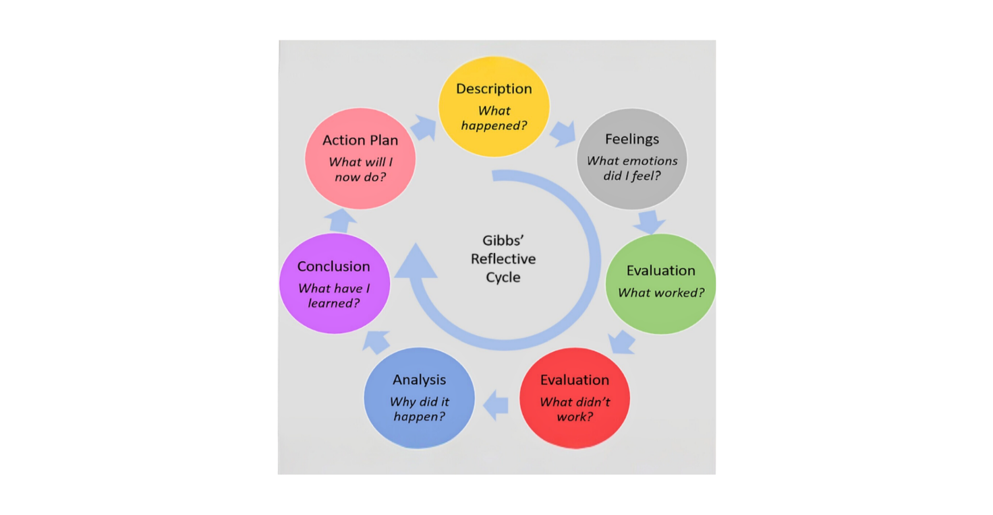
Figure 1. Gibbs’ Reflective Cycle
Source: Gibbs, 1988

Description
During my 10-week placement at Premier Inn Stansted Airport, I shadowed a supervisory position within various departments, including Housekeeping, Maintenance, Leisure Club, and Meetings/Events. ​ My tasks included managing operations such as changing sheets and linen, serving breakfast, and handling customer complaints at the reception. For instance, I dealt with complaints about parking charges, room conditions, and food quality. ​
Feelings
At first, I experienced both excitement and nervousness. I was enthusiastic about gaining new knowledge, yet apprehensive about addressing real-time guest service concerns. ​ As I became more familiar with the environment and tasks, my confidence grew. ​ Positive interactions with guests and effective teamwork with hotel staff made me feel valued and part of the team. ​ However, dealing with complaints was challenging and sometimes stressful. ​​
Evaluation
The experience was largely positive. ​ I gained practical skills in guest service operations and learned the importance of effective communication and teamwork (Vallen and Vallen, 2014). ​ Handling complaints, although challenging, provided valuable lessons in problem-solving and customer service (Ro and Wong, 2012). ​ The supportive environment and guidance from my mentor were significant contributors to my positive experience.
Analysis
This placement underscored the importance of work-based skills and technical expertise in effectively managing guest service operations (Felce, Perks, and Roberts, 2016). Effective communication, teamwork, and problem-solving are fundamental for meeting and managing guest expectations. ​ For example, resolving a complaint about room conditions required not only understanding the issue but also coordinating with housekeeping and maintenance to address it promptly. ​
Conclusion
Although I effectively handled most tasks and gained substantial knowledge, there are areas for improvement. I should have been more proactive in seeking feedback and identifying opportunities for further development. Additionally, developing better strategies for handling complaints would enhance my ability to manage guest service operations effectively (Vallen and Vallen, 2014). ​
Action Plan ​
In future roles, I will seek regular feedback from supervisors to ensure continuous improvement and alignment with organizational goals. Additionally, adopting a proactive approach to learning and skill development will be a priority, allowing me to stay updated with industry trends and enhance my competencies. I plan to enhance my problem-solving strategies specifically to address guest complaints effectively and efficiently. Building on my communication and teamwork skills will also be crucial to providing quality guest service and fostering a collaborative work environment (Tewan, 2009). Reflecting with Gibbs' Cycle has provided valuable insights for my growth in the hospitality industry, helping me identify areas of improvement and setting clear goals for my professional development.

Analysis
In the housekeeping department, work-based skills such as task management, attention to detail, and problem-solving are crucial. Managing operations like changing sheets and linen requires efficient task management to ensure rooms are prepared on time for new guests. Attention to detail is essential to maintaining cleanliness and order in guest rooms and common areas while meeting the hotel's standards. Problem-solving skills are necessary to address guest complaints (Tewan, 2009) about room conditions, such as noise and temperature issues, promptly and effectively. Technical knowledge in this department includes understanding and applying the hotel's cleaning protocols and standards to maintain hygiene and guest satisfaction. Additionally, knowledge of inventory management for housekeeping supplies ensures that the department is always well-stocked and operational. The maintenance department demands technical proficiency, safety awareness, and problem-solving skills. Handling maintenance tasks requires technical skills to address issues such as plumbing, electrical, and HVAC systems (Wolny, 2013). Ensuring that all maintenance activities comply with health and safety regulations is crucial to prevent accidents and ensure a safe environment for guests and staff (Chan and Lam, 2013). Technical knowledge in this department includes familiarity with the operation and maintenance of various hotel equipment and systems, which is necessary to perform repairs and maintenance efficiently.

Organisational Issues ​

During my placement, I encountered several organisational issues that impacted guest service operations within the housekeeping and maintenance departments. One significant issue was related to guest complaints about room conditions, which highlighted the importance of effective communication and problem-solving skills in maintaining guest satisfaction (Tewan, 2009).In the maintenance department, addressing guest complaints about room conditions was a recurring challenge. For instance, during Week 1, a couple complained about their room being cold and noisy. ​This issue required quick and effective problem-solving skills to ensure that the guests' concerns were addressed promptly. Similarly, during Week 5, another couple complained about the heating in their room being noisy and the room being cold. These experiences highlighted the importance of technical proficiency and safety awareness in the maintenance department to prevent and resolve such issues.One particular situation that stood out was a guest complaint about booking an accessible room but receiving an ordinary room instead. This incident occurred during Week 5 and involved a guest who also complained about waiting 10 minutes at reception and the bathroom in the accessible room having a bath instead of an accessible shower. This situation impacted the guest's experience negatively and highlighted the need for accurate booking systems and effective communication between departments to ensure that guest needs are met (Melián-González and Bulchand-Gidumal, 2016).To address these issues, it is essential to implement practical solutions that enhance guest service operations (Wood, 2013).​ For example, regular training sessions for housekeeping and maintenance staff can improve their technical skills and problem-solving abilities. Additionally, implementing preventive maintenance schedules can help reduce the likelihood of equipment failures and ensure smooth operations. Effective communication between departments is also crucial to ensure that guest needs are accurately recorded and addressed promptly.

Conclusion and Action Plan ​
In conclusion, my 10-week placement at Premier Inn Stansted Airport provided invaluable insights into the practical and managerial aspects of guest service operations within the Housekeeping and Maintenance departments. The experience underscored the importance of work-based skills such as problem-solving, task management, attention to detail, and efficient communication. The placement also highlighted the significance of technical knowledge in managing housekeeping protocols, maintenance tasks, and addressing guest complaints efficiently. Moving forward, my action plan includes several key steps to enhance my professional development in the hospitality industry. Firstly, I will seek regular feedback from supervisors to ensure continuous improvement and alignment with organisational goals. This will help me identify areas for further development and stay updated with industry trends. Secondly, I will adopt a proactive approach to learning and skill development, focusing on enhancing my problem-solving strategies specifically to address guest complaints effectively and efficiently. Additionally, I will continue to build on my communication and teamwork skills to provide quality guest service and foster a collaborative work environment.

References
Chan, E.S. and Lam, D. (2013) ‘Hotel safety and security systems: Bridging the gap between managers and guests’. International Journal of Hospitality Management, 32, pp. 202-216. Available at: https://doi.org/10.1016/j.ijhm.2012.05.010
Felce, A., Perks, S. and Roberts, D. (2016) ‘Work-based skills development: a context-engaged approach’. Higher Education, Skills and Work-Based Learning, 6(3), pp. 261-276. Available at: https://doi.org/10.1108/HESWBL-12-2015-0058
Gibbs, G. (1988) Learning by doing: A guide to teaching and learning methods. London: Further Education Unit.
Luo, Z. and Qu, H. (2016) ‘Guest-defined hotel service quality and its impacts on guest loyalty’. Journal of Quality Assurance in Hospitality & Tourism, 17(3), pp. 311-332. Available at: https://doi.org/10.1080/1528008X.2015.1077185
Manhas, P.S. and Tukamushaba, E.K. (2015) ‘Understanding service experience and its impact on brand image in hospitality sector’. International Journal of Hospitality Management, 45, pp. 77-87. Available at: https://doi.org/10.1016/j.ijhm.2014.11.010
Melián-González, S. and Bulchand-Gidumal, J. (2016) ‘A model that connects information technology and hotel performance’. Tourism management, 53, pp. 30-37. Available at: https://doi.org/10.1016/j.tourman.2015.09.005
Ro, H. and Wong, J. (2012) ‘Customer opportunistic complaints management: A critical incident approach’. International Journal of Hospitality Management, 31(2), pp. 419-427. Available at: https://doi.org/10.1016/j.ijhm.2011.06.017
Tewan, J. ​ (2009) Hotel Front Office: Operations and Management. ​ Oxford: Higher Education Press.
Vallen, G.K. and Vallen, Jerome J. ​ (2014) Check-In Check-Out: Managing Hotel Operations. ​ 9th Ed. ​ Harlow: Pearson Education Limited.
Wolny, P. (2013) Getting a Job in Building Maintenance. The Rosen Publishing Group, Inc.
Wood, R.C. (2013) Key Concepts in Hospitality Management. London: SAGE Publications Ltd.

