STUDENT NAME: JANEPHER NAMITALA
STUDENT ID NUMBER: 2030084
PROGRAMME: BSc HEALTH & SOCIAL CARE
MODULE: CHANGEMAKERS: CREATIVITY & VALUE CREATION
MODULE CODE: BMHP5014_BIRM
LECTURER: ROBERT NARTOWSKI
ASSIGNMENT TITLE: E- PORTFOLIO EVIDENCE OF LEARNING COMPRISING OF 2 SEPARATE ARTEFACT ITEMS

Table of Content

Contents
Introduction 1
ARTEFACT TASK 1 (MIND MAP) 2
ARTEFACT TASK 3: ELEVATOR PITCH 4
WHAT IS THE PURPOSE OF MY WHOLE CAMPAIGN? 6
References 8

Introduction
In this assignment, the project plan will focus on starting a charitable organisation to reduce the number of people with obesity in the UK by creating awareness and understanding through the education of individuals. The E-portfolio items that I will use include a mind map and an elevated pitch that will advocate for the organisation's mission.

ARTEFACT TASK 1 (MIND MAP)
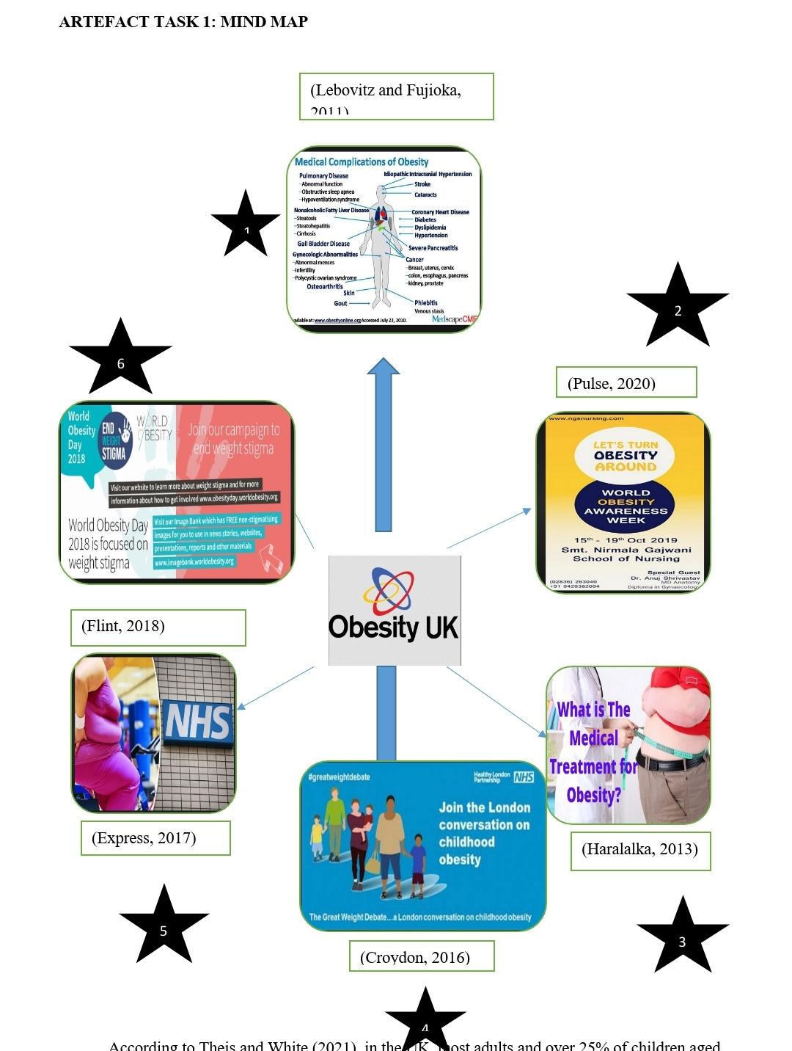
According to Theis and White (2021), in the UK, most adults and over 25% of children aged between 2 and 15 years live with obesity, reducing their life expectancy and increasing their likelihood of contracting serious illnesses such as cancer, type 2 diabetes and heart diseases. In their study, Theis and White note that the reason for high obesity prevalence rates could be due to policy failures in implementation and evaluation or weaknesses in the policies due to their design that hinders their effectiveness. However, since obesity was considered a health challenge in 1991, four governments in power put in place national policy measures to tackle obesity. They include ending the promotion of products that are high in fat, sugar and salt; calorie labelling of foods by large restaurants; and banning the advertisement of products with high fat, sugar and salt content before 9 p.m. (Department of Health and Social Care, 2020).
Despite having national policies in place to tackle obesity, the number of people with obesity continues to skyrocket, necessitating the need to address the problem by starting a charitable organisation with the mission of ensuring that the population of the UK lead healthier lives and reducing the prevalence rate of obesity. The mind map above shows how the ideas and concepts that, if well undertaken, would help reduce the number of individuals with obesity.
Firstly, there is a need to create awareness and understanding through education so that citizens can know about obesity well. Several people opine that treating obesity involves moving about more and eating less, which is not true as the disease requires lifelong and comprehensive care (Haralalka, 2013). Furthermore, organising international conferences where people can debate about the disease will be vital in helping the population understand the disease better.
Secondly, ObesityUK will work with national, regional and local organisations to ensure people reduce excess weight. For instance, the organisation can work with the local authorities to increase their weight management services and provide GPs through the National Health Service (NHS) to advise people on eating healthy and exercising regularly (Express, 2017).
Thirdly, the organisation will ensure that patients obtain advice and get access to treatment in the health facilities. ObesityUK has volunteers whom it trains and develops so that they can offer assistance to parents and guardians of children with obesity who cannot access medical assistance. The volunteers include online administrators and health practitioners (ObesityUK, 2010).
Fourthly, there is a need to recognise obesity as a disease. Obesity is a health condition that involves more than the idea of “calories in" and "calories out", as some doctors have discovered that some genes may increase a person's hunger levels leading them to gain excess weight. Also, disorders such as polycystic ovary syndrome, hypothyroidism and Cushing’s disease can lead to an individual being obese (Lebovitz and Fujioka, 2011).
Lastly, the last two concepts that entail reducing weight stigma and discrimination and providing a safe community for people with obesity to have a voice go hand in hand. According to Flint (2018), the organisation can ensure that there is the protection of health statuses of persons at all costs from discrimination and stigma, regardless of the notion that obesity is a controllable health concern.


ARTEFACT TASK 3: ELEVATOR PITCH
The organisation’s logo
Source (ObesityUK, 2010)

Hi everyone, and welcome to the launch of ObesityUK. It is a charitable organisation that seeks to reduce the number of people with obesity in the UK. Obesity is a health challenge that can reduce individuals' life expectancy and increase their chances of contracting severe illnesses such as cancer, type 2 diabetes and heart diseases. For most people, obesity involves the idea of "calories in" and "calories out", and treating it requires eating less and moving about more which is false as the disease requires lifelong and comprehensive care.
Currently, most adults and over 25% of children aged between 2 years and 15 years live with obesity.
The high prevalence rates could be because of policy failure in implementation and evaluation or weaknesses in the policies due to their design that hinders their effectiveness. Despite the government formulating national policies to try and tackle obesity, the number of people continues to rise daily. I believe this charitable organisation will endear to support people with obesity to get medical assistance from their local healthcare facilities.
How ObesityUk will work is that it will create awareness and understanding through education so that individuals can know the disease well and have conferences in which they can debate on the disease. They will also recognise obesity as a disease in which the cause may be a result of genes increasing a person's hunger level, leading to excess weight or disorders such as polycystic ovary syndrome, hypothyroidism and Cushing’s disease. The organisations will work with the national, regional and local organisations to ensure that people eat a balanced diet and regular exercise and work with the local authorities to increase their weight management services. Furthermore, ObesityUK will ensure that patients obtain advice and get access to treatment in the health facilities. The organisation has volunteers such as online administrators, which it trains and develops to assist parents and guardians of children with obesity who do not have access to medical assistance. In cases of reducing weight stigma and discrimination, the organisations will ensure the protection of the health status of individuals regardless of the notion that obesity is a controllable health concern. More importantly, ObesityUK will aim to provide a safe community for people with obesity to have a voice.

What I am looking for in this room is your support through membership and enrolment of more volunteers that will assist in the daily operations of the organisations in supporting people living with obesity. You can check our social media pages for more information about the organisations. Thank you so much for creating time this morning, and I will open the floor to any questions.

WHAT IS THE PURPOSE OF MY WHOLE CAMPAIGN?
This essay aims to explain what I did in artefacts tasks one and three and demonstrate how we will campaign. It will also describe the whole idea's purpose and the things the organisation will need. Besides that, the essay will show how the organisation will make money and its use.
Artefact one required that I develop an idea of a gap in service and use a mind map to show how the other ideas interlink with the main idea. The main idea was to start a charitable organisation in the UK to reduce the number of people living with obesity. The organisation was at the centre of the mind map interconnecting with its functions as the other ideas. The ideas surrounding the central idea include; creating awareness and understanding through education, working with other organisations, and ensuring that patients obtain advice and access treatment facilities. Other ideas include spearheading efforts that will recognise obesity as a disease, protecting the health statuses of people with obesity from discrimination and stigma, and providing a safe community for people with obesity to have a voice.
Artefact three required that I formulate an elevator pitch to present to an imaginary audience who could be investors to obtain support or funding for the charitable organisation. I had to consider several aspects to make the pitch more persuasive and positive. I had to greet everyone and welcome them to the organisation's launch. I smiled, made eye contact with the audience and shook hands in appropriate cases. The introductory part of the gap in service is experienced, i.e., obesity, with a summary of what ObesityUK will be doing to ensure that it reduces the number of people living with obesity in the UK. The functions are in the order of priority from those that are more pressing to less pressing. Later, I called the audience into action by telling them what I would like to happen next. I summarised my desires, told them how they could progress if they wanted and showed them a proposal on how they could initiate contact. In my pitch, I indicated that I needed their support through membership and enrolment of more volunteers that will assist in the organisation's daily operations in supporting people living with obesity. Furthermore, I notified the audience of the organisation's social media pages so they could know about the organisation and initiate contact.
The purpose of creating the artefacts is to promote healthy living habits in the UK so that they do not become obese and reduce the number of people living with obesity in the UK. Theis and White (2021) indicate that most adults and over 25% of children between 2 and 15 years live with obesity, reducing their life expectancy and increasing their likelihood of contracting serious illnesses. Furthermore, the artefacts will aid in promoting the campaign for the organisation to make money or get support to run its day-day operations.
There are several ways to promote the organisation and its campaign, which include alerting close associates and friends, use of social media, engaging with people, and working with other organisations. Close associates, family and friends will be the first people we will make aware of the campaign; we will encourage them to become promoters by asking them to make other people aware of the campaign and, more importantly, thank them.
Social media would be one of the favourite ways to promote the campaign, as it would reach a larger audience. Social media tools like Twitter, Facebook, Instagram, and YouTube offer a platform for the campaign to go viral by using hashtags and engaging more with followers. Also, social media tools will facilitate the posting of new content, relevant news and links to other sources of information on obesity.
Engaging people would involve holding conferences to promote the campaign and conducting door-to-door campaigns to make people aware of what the organisation will be doing to tackle obesity. Conferences will offer a room in which people are likely to debate and ask questions about the reasons for the campaign and why the organisation wants to tackle obesity. Engaging people will offer more insight into the campaign as there is the likelihood of getting new ideas and affirming people that the campaign is for their good.

Working with other organisations implies that it can bring on board other players that will enable the organisation to attain its objectives. The other players could be the media, the government of the UK and other non-governmental organisations (NGOs). For instance, the media could provide coverage on obesity campaigns, and the government can offer financial aid for the organisation to conduct its activities since it is responsible for ensuring universal health coverage. Partnering with other organisations will make the campaign more known, and the organisation will be able to get more membership and enrolment of volunteers, which is what it needs.
The money from the campaign activities of the organisation would serve to train and develop volunteers who will act as online administrators, with their work being to assist parents and guardians of children with obesity that cannot access medical assistance. The money will also aid in increasing weight management services and providing more GPs advising people on the need to eat healthily and exercise regularly. In addition, the money will help to bring and conduct awareness and understanding campaigns on obesity as it will facilitate the movement of campaigners like charities and the designing of flyers, conference posters and leaflets.

References
Croydon (2016). Talk to Us about Childhood Obesity. [online] Newsroom. Available at: https://news.croydon.gov.uk/talk-to-us-about-childhood-obesity/ [Accessed 4 Oct. 2022].
Department of Health and Social Care (2020). Tackling obesity: Empowering Adults and Children to Live Healthier Lives. [online] GOV.UK. Available at: https://www.gov.uk/government/publications/tackling-obesity-government-strategy/tackling-obesity-empowering-adults-and-children-to-live-healthier-lives.
Express (2017). Fat People Are ‘not going to Bankrupt NHS’ Because They Will Die Earlier Says New Report. [online] Express.co.uk. Available at: https://www.express.co.uk/life-style/health/757582/Obesity-NHS-premature-death-healthcare.
Flint, S. (2018). Ending Weight Stigma and discrimination; a Priority for All. [online] NCD Alliance. Available at: https://ncdalliance.org/news-events/blog/weight-stigma-and-discrimination-a-priority-for-public-health [Accessed 4 Oct. 2022].
Haralalka, R. (2013). Top 5 Treatment Options for Obesity - Best Tips | AyurvedicCure.com. [online] Ayurvediccure. Available at: https://ayurvediccure.com/top-5-treatments-for-obesity/ [Accessed 4 Oct. 2022].
Lebovitz, H. and Fujioka, K. (2011). Obesity: Why Don’t We Recognize It as a Treatable Disease? [online] Medscape. Available at: https://www.medscape.org/viewarticle/725826_transcript [Accessed 4 Oct. 2022].
ObesityUK (2010). Obesity UK. [online] Obesity UK. Available at: https://www.obesityuk.org.uk/.

Pulse (2020). National Obesity Awareness Week 2021. [online] Pulse Insurance. Available at: https://pulse-insurance.co.uk/news/national-obesity-awareness-week-2021/ [Accessed 4 Oct. 2022].
Theis, D.R.Z. and White, M. (2021). Is Obesity Policy in England Fit for Purpose? Analysis of Government Strategies and Policies, 1992–2020. The Milbank Quarterly, [online] 99(1). www.doi:10.1111/1468-0009.12498.

