MODULE CODE: LCMB7034
MODULE TITLE: INTERNATIONAL BUSINESS CONCEPTS
ASSIGNMENT TITLE: REPORT
STUDENT NAME: Nicolae Mihai
STUDENT ID:2124103
Professor : Dr Robert Ejike Udeogu

Executive Summary
This report analyses the viability of a possible market penetration of Unilever in North Korea. Unilever is a large British multinational company dealing in consumer goods with more than 190 operations in various countries with a diversified collection of products in Beauty and Wellbeing, Personal Care, Home Care, Nutrition and Ice Cream. The target market is North Korea because currently this firm is not dominant in the market. The evaluation used the Bartlett and Ghoshal Model in the analysis, PEST Analysis, Dunning OLI Framework, and the Entry Mode Theory in evaluating the strategic suitability. The findings indicate that Unilever can be best characterised as a transnational company with of strong global brand services and international experience of carrying out supply chain. However, North Korea is a significant political, legal and economic hurdle posing bans, regulatory, insufficient infrastructures and a purchasing power. Therefore, it is not advisable to enter the market immediately. Exporting will be considered the most appropriate preliminary entry mode in case the favourable business condition could be raised in the future because it is the least risky entry mode and can be implemented with minimal costs.

Table of Contents
Section 1 5
Introduction 5
Background of Unilever 5
Purpose of the Report 5
Organisational Classification and Global Strategy 6
Strategic Categorisation Using Bartlett and Ghoshal Model 6
Global Configuration and Competitive Advantage 7
Macro-Environmental Appraisal and Market Attractiveness 8
Political Environment Analysis 8
Economic Environment Analysis 9
Culture Environment Analysis 10
Legal Environment Analysis 11
Overall Market Attractiveness Assessment 12
Market Entry Analysis Using Dunning's OLI Framework 13
Ownership Advantages (O) 13
Location Advantages and Disadvantages (L) 14
Internalisation Advantages (I) 14
Entry Mode Strategy and Strategic Synthesis 15
Historical Pattern Recognition 15
Strategic Fit and Entry Mode Evaluation 16
Comparative Analysis 17
Final Recommendation and Strategic Conclusion 18
Recommendation 18
Conclusion 18
Section 2 19
Introduction 19
Description 19
Feelings 19
Evaluation 20
Analysis 20
Conclusion 21
Action Plan 21
References 23

Section 1

Introduction

Background of Unilever
Unilever is a multinational consumer goods manufacturing enterprise, which is based at London, United Kingdom, but with the headquarters in the United Kingdom. It started its operation in 1929 and is present in more than 190 countries around the world and has a consumer base of billions of customers carrying a wide array of brands, which are familiar all over the globe. Unilever has its major business divisions such as Beauty and Wellbeing, and Personal Care, Home Care, Nutrition and Ice Cream. The company has already covenanted strong presence in the world in relation to massive-manufacturing plants, supply pipelines and its channels of distribution both in the developed and emerging markets. Unilever is a global company based on innovation, brand strength and sustainability-focused approaches and strategies, and it has one of the most popular companies in the fast-moving consumer goods (FMCG) industry in the world.
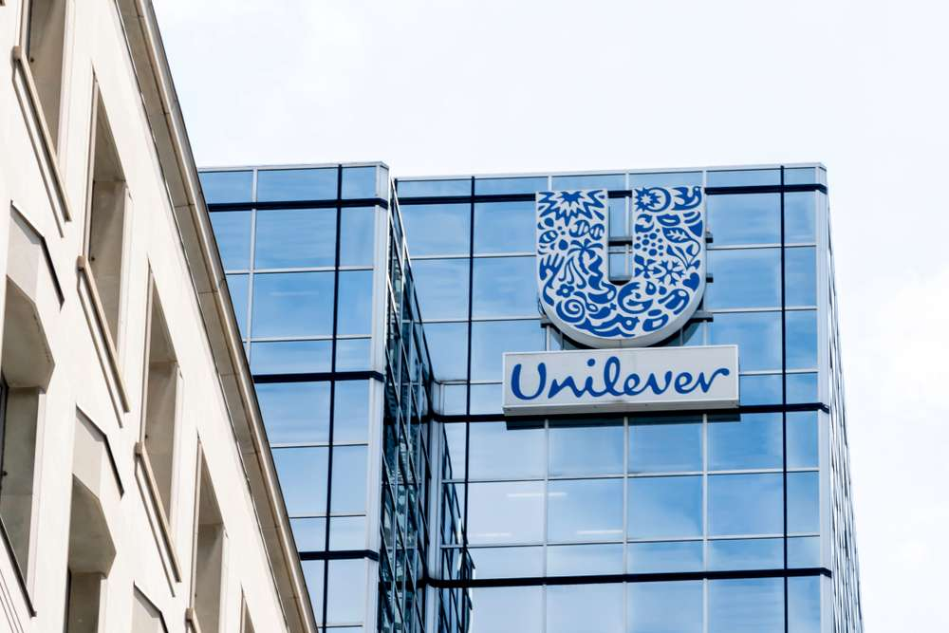
Figure 1: Unilever Plc
(Source: Unilever, 2026)

Purpose of the Report
This report is to determine the feasibility of the potential entry of the Unilever firm in North Korea which is a market where the organization has not operated any lucrative business in the market. The analysis utilizes the Model of Bartlett and Ghoshal to assess the international strategy, PEST analysis, to assess the external environment and Dunning OLI Framework to assess the attractiveness of the potential market entry and business success. Furthermore, the report implements Entry Mode Theory to assess the most appropriate choice should there be potential market entry and business success.

Organisational Classification and Global Strategy

Strategic Categorisation Using Bartlett and Ghoshal Model
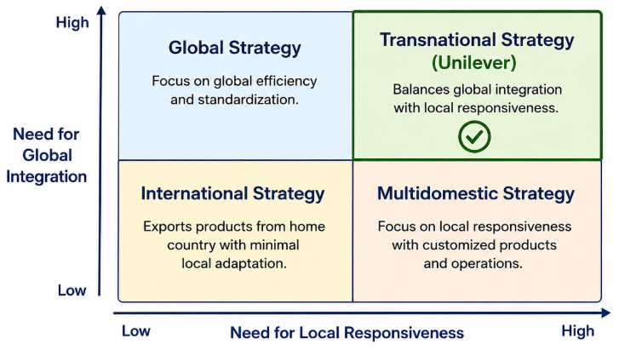
Figure 2: Bartlett & Ghoshal strategy model
(Source: Learner)
The model developed by Bartlett and Ghoshal recognises the four international strategies adopted by multinational companies including international, multidomestic, global and transnational strategies. The international strategy entails exportation of knowledge and products manufactured in the mother country to the overseas markets with a low localization. The overemphasis on high local responsiveness which involves customising products and operations by country is a feature of multidomestic strategy. Global strategy in contrast, is more concentrated on global standardization and cost efficiencies through centralization of decision making (Benito et al., 2022). International effectiveness, domestic currency, and learning are some of the elements that are interwoven in the transnational approach in the using operations of the organization.
The most suitable type of Unilever company is a transnational one as it can preserve the balance between the worldwide integration and local adaptation to the market. Its centralized procurement, research and development and supply chain management can help the company to generate economies of scale and minimise costs because it is economically efficient across the world. Simultaneously, Unilever is extremely local receptive in terms of how it modifies products and packs, pricing and promotion policies to meet the various consumer preferences in the various countries (Jadhav et al., 2023). In addition, the organisation promotes the exchange of knowledge amongst the subsidiaries, by exporting best practices, innovations and sustainability initiatives in the global network.

Global Configuration and Competitive Advantage
Unilever has a strong presence in the world market with its presence spread throughout Europe, Asia, Africa, North America, South America, and the Middle East. The company boasts of a comprehensive network of manufacturing and supply chain which makes it effective in producing and distributing products all over the world. Its diversified brand portfolio encompasses international brand portfolio in the divisions of Beauty and Wellbeing, personal care, Home Care, Nutrition and Ice creams that enables the company to cater to diverse consumer segments across global geographical markets (Kang, Lee, and Choi, 2023). Processes in the company which are related internationally generate value, that is, economies of scale which enables it to achieve cost efficiency in production, procurement and distribution.
The other strength to Unilever is that its products are as well uniformised to the company worldwide; hence the quality and reputation of the product is standardised however the brand operates at a level that suits the local consumption preference. This will be a localized way of adaptation, which will culminate to better customer satisfaction and competitiveness in the market. In addition, company sustainability, such as responsible sourcing, environmental stewardship and social impact programmes, add to value creation in the long run and corporate reputation (Ardiansyah, 2024). These are the international capabilities that can support a future growth of North Korea whereby it has positive brand capabilities, operation framework and supply chain experience

Macro-Environmental Appraisal and Market Attractiveness

Political Environment Analysis
North Koreans have a highly centralized political system, a one-party political system and high rates of state regulation of the economy and social life. The government exercises incredible dominion on production, commerce, investments and resources distribution and provides very little room on the input of the private sector. This is a very difficult political climate to multinational corporations such as Unilever as most aspects of business are usually addressed by governments due to their priority rather than the market. The wide spread international sanctions on the state of North Korea by the United Nations, the American United States, the European Union and a few other states is one of the most crucial areas of concern (Ballbach, 2022). These are sanctions which curtail international trade, financial service, transfer of technology and foreign investments.
Because of this, foreign companies face a lot of problems when it comes to establishing business vehicles or even making business deals in the country. Furthermore, political segregation of North Korea towards world economy hampers access to the markets, financial institutions and trade systems (Jwa, 2025). Market entry is complicated by foreign investment restrictions to further. Investment opportunities are closely controlled and dependent on the government approvals even though North Korea has opened special economic zones whereby it is hoping the foreign investors will invest in it. The foreign firms are more restrictive in regard to the right of ownership, transfer of earnings, and the liberty of operation. These limitations make the areas doubtful in addition to rendering the environment hostile to investments.
Trade barriers also exist that present considerable barriers. State authorities are very strict in importation and exportation of goods and services and customs are not transparent as compared to those of the global standards. The low availability of goods can have serious effects on Unilever ability to import goods and distribute products effectively and as well secure a consistent supply chain process (Shaoping, 2023). These political factors to Unilever have a direct impact on the availability of the market. The regulatory uncertainty and Government intervention would make the company to have difficulties in establishing manufacturing, distribution channel or structure or partnership with retailers. Politics is another aspect, which carries the highest risk as the sudden change of the policies, geopolitical or any other sanctions would disrupt the business operations and investment projections.

Economic Environment Analysis
North Korea has one of the most insulated economies, which is centrally planned, in the world. Trustworthy economic statistics is limited since the transparency is limited, but it is estimated by international organizations that the gross domestic product (GDP) in North Korea is around the US$20-30 billion and GDP per capita is below US$1,500 per annum (Sokolin, and Kim, 2025). Economy is so dependent on agriculture, mining, military related industries and manufacturing activities being operated by state. The existence of sanctions and limited foreign investments, as well as inefficient production systems, have ensured that the economic growth remains in very low levels.
The consumer purchasing power is still relative with that of the neighbouring countries like South Korea and China. The factors that further restricted the high-end consumer goods market, is the percentage of the population that earns a very low disposable income (Wang, 2022). Even though the basic household and personal care goods are essential goods, affordability is a significant issue. Thus, the majority of the foreign labels of Unilever may fulfil the role of being expensive to the general population unless cleverly adjusted, to correspond with the level of income of a particular area. The infrastructure in terms of distribution is another large issue. There is poor development of logistics system, transportation and retail channels in line with international standards (Judijanto et al., 2024). Retailing has limited networks of roads, warehouses and modern outlets that make distribution of the products very costly and ineffective. Such infrastructural weaknesses would increase operation and supply chain efficiencies to Unilever.
The finances also pose problems within the country. The currency in use in North Korea is not a free exchangeable currency nor is there weakening of the foreign exchange control (Irwin, 2025). Sanctions to international banking transactions are still limiting the access to international financial services. These stipulations may make it difficult to have payments processed, profit repatriation and funding investment by overseas companies. The demand potential in the FMCG industry would exist in that the consumers will require soaps, detergents, shampoos and food products everyday (Helen, and Darling, 2022). However, the overall market is low due to the low income and low consumer purchasing power. The issue of affordability of some of its products can compel Unilever to launch less expensive variants of the products in the event it gets to the market in future.
The economic attractiveness of North Korea is very low in the long-run. Poor infrastructure, low purchasing power, financial limitations and low economic isolation are very significant phenomena that decrease market potentials (Sharma et al., 2023). Whereas the country has a population of approximately 26 million people and the multinationals in the global FMCG industry have not fully explored the country (Lee, and Lee, 2022). The opportunities might arise in the future as long as economic reforms and international contact may increase.

Culture Environment Analysis
The cultural environment within North Korea is unique with a definite sense of nationalism, collectivism, state ideology and minimal foreign influence exposure. Consumer behaviour is not the same as what is experienced in open-market economies since the decisions to purchase are exposed to the individual preferences, as well as to the government regulation and availability of products (Chekol et al., 2022). As a result, it would become obligatory to obtain the knowledge of the peculiarities of the local culture before entering in the market any multinational company. Ordinary virtues emphasized in social values include the common good, nationalism, discipline and obedience to the society. They influence consumption behavior and the attitude towards foreign products. Although consumers might be willing to purchase foreign products that are of a high quality there are limited opportunities of accessing these products. As such, the consumption tends to be based on necessity and rather on consumer luxury.
The consumption patterns are also affected by income and range of products as well as the lack of variety. Most consumers have basic needs such as food, household goods and personal hygiene products as priorities (Herjanto, and Amin, 2022). This would open prospective success of Unilever in their core FMCG segments, and this is especially on the part of soaps, detergents, toothpaste as well as nutrition products. The luxury brands however are unlikely to have a high demand in terms of affordability. Perceptions of foreign brands are complex with regards to culture. On the one hand, the foreign products can be viewed as superior and more innovative as compared to the domestic ones. On the other hand, it is possible to discourage a vigorous promotion of foreign brands by means of government policies and domestic ideology. Foreign firms must therefore be challenged to create brand recognition and customer loyalty with the traditional methods of marketing.
Major product customization would probably be needed in case of Unilever. The packaging, pricing, product size and product formulations must be changed to suit the local purchasing power and consumer tastes (Deng, 2024). There would also be limited marketing activities due to the highly regulated advertising and promotion. Conventional branding measures that are applied mostly in the international market may not also work. The government would be the biggest determiner of whether the brands would be accepted or not, whether it is affordable and whether it is perceived to be useful (Li et al., 2024). Hygiene and daily living necessities that bring about hygiene and standards that are essential may be more acceptable than premium and lifestyle branded products.

Legal Environment Analysis
North Korea is a nation that has a difficult legal landscape, as far as entry to the market by multinational companies is concerned. The policies on foreign direct investment are too restrictive and they were subjected to substantial control by the government. Although some laws have been established to encourage foreign investment within designated economic zones, the issue has not been imposed across board but it is a political issue that has dominated. In this regard, there is not a lot of predictability in the law, as compared to developed and emerging market economies. One of the biggest impediments on foreign firms is restriction of ownership. In the majority of circumstances foreign investors are not given a complete ownership of a business and they can be under compulsion to collaborate with government operated companies (Van Assche et al., 2024).
These restrictions decrease the management control and increase the dependence with the government partners. The ownership restriction would be of high concern to Unilever bearing in mind that the organisation typically requires a high level of operational control to improve product quality, brand reputation and realisation of economies of scale among other aspects in the supply chain (Hu, and Zeng, 2024). Another issue of concern is intellectual property protection. Proper security of trademarks, patents, copyrights and brand property is not guaranteed. The weak systems of enforcement make the imitation products, the illegal usage of brand names, and the lack of any legal repercussions in case of conflict more probable (Hasan et al., 2025). Since the world has become weary of the brands and some of the formulae that Unilever boasts of as its competitive advantage, the lack of intellectual property protection can very well impact the business negatively.
There are further complications by international compliance requirements. Unilever has extremely strict guidelines on international corporate governance, sustainability and ethical standards. The company must adhere to sanctions regulations set by the United Nations, European Union, United Kingdom as well as the United States. The possible effect of doing business in North Korea can land in compliance risks, litigation, loss of reputation, and even sanctions by the international regulating bodies (Raynor, 2022). The legal environment has also led to the operation risks being high. It becomes more uncertain to foreign investors because of poor enforcement of contracts process, low judicial independence, and lack of proper mechanisms of dispute resolution. Procurement, employment, distribution and financial dealings including, legal barriers might also be involved.

Overall Market Attractiveness Assessment
Factor | Opportunity Level | Risk Level | Impact on Entry
Political Environment | Low | Very High | Market entry is highly inhibited by international sanctions, government control and political uncertainty.
Economic Environment | Medium-Low | High | Streamline Consumer market has not been utilized fully, because there is low purchasing power, and infrastructure is poor which limits further developments of this market.
Legal Environment | Low | Very High | Ownership is also risky, compliance is also a problem as well as weak legal protection which enhance risk in investments.
Cultural Environment | Medium | Medium | Demand of necessary FMCG products is present but the products must be adapted and restricted in their marketing.
Overall Market Potential | Medium-Low | Very High | They are characterized by long term opportunities in case of reforms, and current conditions are extremely difficult.
Table 1: Overall Market Attractiveness Assessment table
(Source: learner)

Market Entry Analysis Using Dunning's OLI Framework
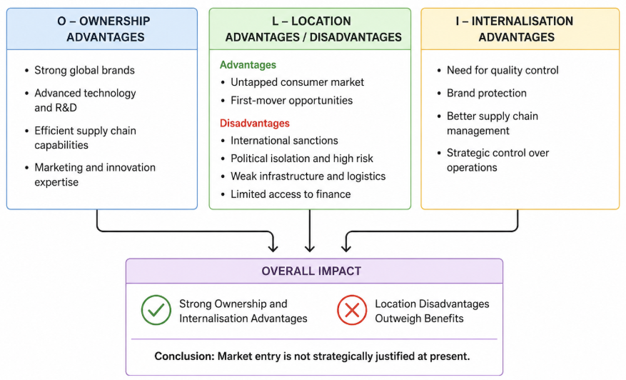
Figure 3: OLI framework: Unilever in North Korea
(Source: Learner)

Ownership Advantages (O)
The special resources and capabilities that help a firm to take a competitive advantage in the process of expanding to other countries are known as ownership advantages. Unilever boasts of several key ownership advantages, which can be utilized to support a shift to Korea. Initially, the business has a portfolio of brands that is internationally known in such spheres as personal care, home care, nutrition and ice cream. These brands have the merits of a high level of consumer confidence and reputation of quality. Second, Unilever has come up with technology in product development, manufacturing, and research and development that by means of unrelenting innovation and operational efficiency enabled the continuous development (Suthar, Kumar, and Joshi, 2026).
In addition to this, Unilever has also achieved state-of-the-art global supply chain management that has contributed towards sourcing, production, distribution and inventory management in most of the international markets (Chandratreya, 2023). The firm is also well endowed with immense marketing experience because of its operation in the multi-cultural environments around the world. Through such knowledge, Unilever has a chance of a preview of the needs of consumers and the necessary changes of the products to their local needs. Those ownership advantages would work in favour of any potential entry into North Korea as it would provide the resources to enable the gain of competitive operation and to offer quality consumer products.

Location Advantages and Disadvantages (L)
Three aspects in a host country can be said to be location advantages and which can render investment attractive to foreign firms. The opportunity of North Korea that can be exploited is the high untapped consumer market. This would occur because of the low number of international players in the FMCG sector, Unilever would have a modest competitive edge and a big potential consumer with an unmet demand on the personal care, hygiene and home products (Akter, and Kabir, 2025). This is also because by successfully entering the market, the Unilever would have benefited in a first-mover advantage and this would help the company to win the brand recognition and market share before entering the market. Despite these opportunities, some big demerits exist.
International community sanctions hugely bring trade, finances and foreign investments to a halt. Isolation in politics constrains incorporation into the world markets and levels of escapism in the foreign business (Osabuohien, and Drapkin, 2022). Poor existence of infrastructure such as poor transportation, poor logistics, poor communication and poor retail system, would make the operation costly and make the supply chain inefficient.

Internalisation Advantages (I)
The benefits of internalisation are reasons why a company may be willing to be in full control of the business processes as opposed to licensing or outsourcing business processes. In the case of Unilever, quality control is a crucial factor to ensure the safety of product quality and consumer confidence in worldwide markets (Shaoping, 2023). Direct control additionally assists in brand protection which minimizes any chances of copying the product or misuse of intellectual property. Further, sourcing, production and distribution processes should be closely associated with each other in the supply chain management. Direct control of information would be more likely in Unilever rather than licensing because licensing would pose more risks in its operation, lack of capacity to deal with quality and strategic decision making, and the selflessness of the absence of the company to establish brand consistency (Laursen, and Andersen, 2023).

Entry Mode Strategy and Strategic Synthesis

Historical Pattern Recognition
Unilever has over the years used diverse market entry modes, in support of its global expansion strategy which are acquisitions, joint ventures, wholly owned subsidiaries and strategic alliances. The most popular entry mode has been acquisitions because they assist in quick penetration of the market, facilitate entry of an already established network of distribution and provision of information on the local market (Kormakova et al., 2023). These include the purchase of domestic consumer goods companies in emerging markets in order to improve the market share as well as brand image within the portfolio. Joint venture has been provided in the markets where they felt the need to have local partners to overcome the fluctuations in the regulations or to comprehend their markets (Moschieri, Ravasi, and Huy, 2024). Increasing its operations with local companies in limited Asian markets has helped Unilever to get information on consumer preference and channel of distribution.
Wholly owned subsidiaries have been established in markets that are of strategic significance and where the company must have a total control of the operations including manufacturing, marketing and supply chain operations. In addition, strategic alliances have also enabled innovation and sustainability activities, as well as supply chain building within different territories (Lobo et al., 2025). Unilever has been acquiring and creating wholly owned subsidiaries in the emerging African and Asian markets in order to enhance its competitiveness.

Strategic Fit and Entry Mode Evaluation
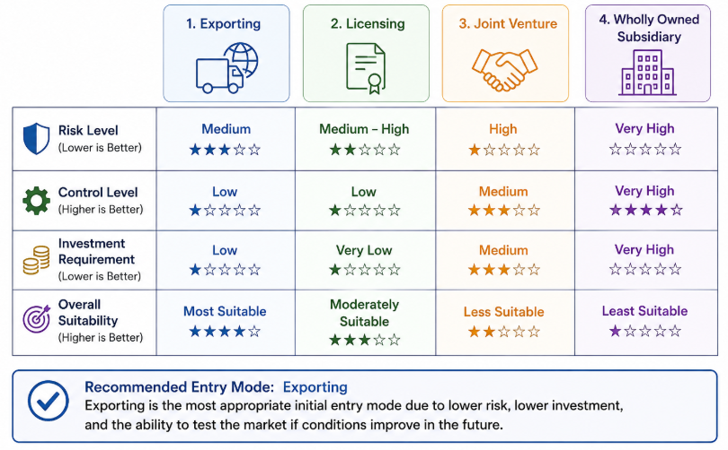
Figure 4: Strategic entry mode evaluation for Unilever
(Source: Learner)
Option 1: Exporting
Exporting would entail the supply of Unilever products in North Korea using manufacturing plants that are in other countries. The most significant advantage of this approach is that it only requires relatively low level of investment which will reduce the financial exposure and stand of the operations. Exporting would also allow Unilever to test the market to ensure it has checked the demand and would be able to commit itself to intensive resources. Nevertheless, the drawbacks are huge such as other countries can impose sanctions, trade and customs restrictions and transport orchestrates, which could have a profound effect on the supply of products (Zahra, 2025). In addition to this it would have a deficiency in distribution infrastructure and so restrict access to the market hence the logistics would be costly.
Option 2: Licensing
The licensing would allow a local organization to manufacture or sell Unilever products instead of paying royalty. The advantages of this strategy include small capital demand and less operation liability and entry into the market with local enterprises. Nonetheless, licensing has great disadvantages to Unilever. There would have been reduced control quality of products, brand management, and operational standards by the company. Lack of strong protection of intellectual property in North Korea may only serve to create a higher likelihood of brand abuse, counterfeits, and negative image (Chimvula, 2026).
Option 3: Joint Venture
The joint venture will involve collaborating with a local partner in Unilever. The advantages are that the investment costs are shared, the familiarity of the local market and also they can move freely in the government regulations (Guo, and Li, 2024). The mode can also enhance rapport with the state authorities, gain access to local channels of distribution. However, there are weaknesses such as potential partner conflicts, less managerial control and difficulty in doing business goals alignment. The partnership arrangements might be threatened by political intervention and uncertainty about regulations as well.
Option 4: Wholly Owned Subsidiary
In a completely owned subsidiary, Unilever will have complete ownership and control over operations, product quality, branding and supply chain operations. It is the most strategic mode that has the greatest potential of growth in the long term. It is, however, costly in terms of financial input and the company faces a lot of political, legal and economic risk. Because of the limitations on investment, sanctions and regulatory restrictions by North Korea, it would be quite hard and risky to establish a wholly owned subsidiary (Jon, Park, and Singh, 2024).

Comparative Analysis
Entry Mode | Risk | Control | Investment | Suitability
Exporting | Medium | Low | Low | Most suitable because degree of commitment is not so high and the risk of having political and legal interference is low.
Licensing | Medium-High | Low | Very Low | The presence of relatively appropriate but inadequate control and poor intellectual property protection is highly worrying.
Joint Venture | High | Medium | Medium | It may be somewhat suitable in learning about the local markets, but there are threats of political interference and conflict between partners.
Wholly Owned Subsidiary | Very High | Very High | Very High | Inappropriate to the largest extent due to sanction, investment restrictions and colossal political, legal and economic risks.
Table 2: Comparative Analysis of Entry Modes for Unilever in North Korea
(Source: Learner)

Final Recommendation and Strategic Conclusion

Recommendation
Based on the findings of the PEST analysis, the OLI framework that has been developed by Dunning, the past politics of market entry and the overall analysis of risk, it is recommended that Unilever does not venture into North Korea up to this day. Irrespective of the firm having good ownership strengths and a global working experience, political, legal, and economic obstacles are major impediments to market appeal. In case there is a political change in the future so that sanctions can be relaxed and offer a better environment to invest, exporting is the most desirable form of entry mode since it is characterized by low amounts of investment and risk exposures.

Conclusion
Currently, North Korea is not a feasible market to pursue Unilever international expansion strategy. The potential opportunities are less than the high levels of political risk in the country, a legal environment is restrictive, and the economy is weak. Nevertheless, it stands a chance in the long-term bearing in mind that its untapped customer base is likely to have long-term prospects in case they become economically liberalised and incorporated into the global market.

Section 2

Introduction
Reflective practice is one of the important features of international business studies which enable the students to examine the experiences, uncover the lessons and improve their decision-making in the future. This reflection implements Irving Gibbs Reflective Cycle to examine the process involved in coming up with the analysis on the implementation of a market entry analysis of Unilever in North Korea. By giving a thoughtful consideration, one can learn valuable information that can lead to development of both a personal and also a professional growth.

Description
The assignment entailed the analysis of the prospects of Unilever expanding into North Korea, and the market where the company is completely absent. The primary objective was to determine the viability of an entry into market in a strategic and friendly manner. The report integrates, several international business models were adopted including Model created by Bartlett and Ghoshal, PEST Analysis, Dunning OLI Framework and the Entry Mode Theory. The following were the instruments that were used to assess the international strategy of Unilever, the external environment of North Korea, ownership and location advantages plus market entry strategies. This discussion has established that North Korea already presents a variety of political, legal and economic risks that are more than any advantages that can accrue to Unilever.

Feelings
I was interested and motivated at the outset of the assignment since Unilever is a globally known multinational that has many activities internationally. The choice of North Korea to target market was initially strange because of its political isolation and inaccessibility. After further analysing, I realised that it was not going to be easily analysed as a simple and politically sensitive market as I believed. There were some occasions that I was lost since I could not locate dictatorial information as there was limited economic and business information (Schlumberger et al., 2024). Special attention had to be paid to analysing political risks and sanctions. Through the application of the theories and models of international business I got confidence, however. The frameworks aided me in making a proper arrangement of information and had a more critical view towards international decisions to enter a market.

Evaluation
There were a number of positive issues that were gained out of this project. First, the assignment greatly enhanced my knowledge of the international market entry strategy, and the determinants of the multinational business expansion. The use of theoretical models in a real business situation billed my analytical and critical thinking skills. The gathering and reviewing information on various scholarly and business sources were also another way my research skills developed with regards to the project (Dziubaniuk, Ivanova, and Nyholm, 2023). Moreover, I also learned more about the risks that multinational corporations assume when entering into the market that is politically and economically unfavourable.
However, challenges such as getting valid and recent information about North Korea was especially difficult due to lack of transparency and access to information. The other challenge was the need to strike a balance between the market attractiveness, and the high risks during the assessment of the opportunities (Fitri, 2024). Using several school of thoughts, such as Bartlett and Ghoshal Model, PEST analysis, OLI theory and Entry Mode Theory, integration was also complicated with each school of thought emphasizing the various facets of the international business decision-making.

Analysis
The project was quite instructive in that it offered some valuable learning experiences on international business strategy. Bartlett and Ghoshal helped me in their model in determining why Unilever would be regarded as a transnational corporation. The structure revealed how the company portrays the compatibility of the global efficiency, and the local responsiveness across the different markets. The PEST analysis also implied that political, economic, legal and cultural factors were areas that would be of interest in the analysis before consideration is made on the international expansion (Sun et al., 2024). Under this framework, I realised that the external environmental conditions could have a considerable effect (positive or negative) on the success or failure of business.
The OLI Framework was an improvement on my concept of foreign markets entry decision as it further defines the influence of benefits of ownership, location and internalisation on investment decision (Batschauer, Eliete, and Amal, 2022). Entry mode analysis displayed that entry mode has frequently been a decision of balancing opportunities and big uncertainties and dangers. The connection between theory and businesses as it relates to business decision-making was championed by this discussion. It also highlighted on the need to perform environmental scanning, risk assessment and strategic planning before venturing into foreign markets.

Conclusion
The project has exposed me to the international business strategy, market entry analysis and the risk assessment. I have also been told that only the organisational strengths and the correct external conditions can enable a successful international expansion. The experience has demonstrated the utility of theoretical concepts of business to real business and the possible importance of critical and evidence-based decision making in evaluating opportunities and threats in global business practices.

Action Plan
Specific | Measurable | Achievable | Relevant | Time-bound
Improve research skills by using a wider range of academic journals, industry reports, and international business databases for future projects. | Review and utilise at least 15 academic and professional sources for each international business assignment. | Access to university library resources and online databases makes this achievable. | Strong research skills improve the quality and credibility of business analysis. | Achieve this in all future assignments over the next 6 months.
Strengthen critical analysis by evaluating opportunities, risks, and strategic alternatives more comprehensively. | Apply at least three strategic frameworks and provide critical comparisons in future reports. | Regular practice and feedback from lecturers will support development. | Critical thinking is essential for international business decision-making. | Implement within the next academic semester.
Enhance knowledge of global market risk assessment and international expansion strategies. | Complete two online courses or professional workshops on international business strategy. | Courses are widely available through online learning platforms. | Supports future career development in international business and strategic management. | Complete within the next 12 months.
Table 3: SMART action plan
(Source: Learner)

References
Akter, M.S.B. and Kabir, T., (2025). Exploring the Impact of Sustainable Packaging on Brand Value and Consumer Loyalty FMCG Sector: Insights from Unilever.
Ardiansyah, M., (2024). Integrating corporate social responsibility into business strategy: creating sustainable value. Involvement International Journal of Business, 1(1), pp.29-42.
Ballbach, E.J., (2022). Moving beyond targeted sanctions: The sanctions regime of the European Union against North Korea (No. 4/(2022)). SWP Research Paper.
Batschauer da Cruz, C.B., Eliete Floriani, D. and Amal, M., (2022). The OLI Paradigm as a comprehensive model of FDI determinants: a sub-national approach. International Journal of Emerging Markets, 17(1), pp.145-176.
Benito, G.R., Cuervo‐Cazurra, A., Mudambi, R., Pedersen, T. and Tallman, S., (2022). The future of global strategy. Global Strategy Journal, 12(3), pp.421-450.
Chandratreya, A., (2023). Implementation of green supply chain management practices. Korea Review of International Studies, 16(50).
Chekol, F., Hiruy, M., Tsegaye, A., Mazengia, T. and Alimaw, Y., (2022). Consumers’ frequency of purchasing behavior of organic honey and butter foods from the farmers’ food product market in Northwest, Ethiopia: A poisson regression approach. Cogent Social Sciences, 8(1), p.2144871.
Chimvula, G.A., (2026). Leveraging Intellectual Property for Development: Insights from South Korea for Developing Countries. Cybaris®, 17(2), p.1.
Deng, H., (2024). Formulation of agricultural product marketing strategies based on the analysis of customer value perception and demand. Journal of System and Management Sciences, 14(4), pp.363-379.
Dziubaniuk, O., Ivanova-Gongne, M. and Nyholm, M., (2023). Learning and teaching sustainable business in the digital era: a connectivism theory approach. International Journal of Educational Technology in Higher Education, 20(1), p.20.
Fitri, S., (2024). Evaluation of compensation policies and their impact on employee retention in the food industry. Involvement International Journal of Business, 1(1), pp.43-59.
Guo, Z. and Li, Y., (2024). Analysis of the decisive factors of government attracting tourists in public management from the perspective of environmental protection. Problemy Ekorozwoju, 19(1), pp.285-295.
Hasan, Y.S., Ela, S.R., Yulifwi, N., Musa, S. and Macmud, A.S., (2025). Trademark Counterfeiting: A Legal Review and Its Implications for Consumer Protection. Indonesian Civil Law Review, 1(2), pp.18-40.
Helen, J. and Darling Selvi, V., (2022). Consumer behavior on fast-moving consumer goods. International Journal of Management (IJM), 13(3), p.214.
Herjanto, H. and Amin, M., (2022). Customer personal values of hygiene product consumption: a means-end analytic approach. Young Consumers, 23(1), pp.112-128.
Hu, Y. and Zeng, Y., (2024). Achieving sustainable operations: Challenges, countermeasures, and the case of Unilever. In SHS Web of Conferences (Vol. 181, p. 01036). EDP Sciences.
Irwin, D.A., (2025). Trade Policy, Exchange Rates, and the Globalization Surge of the 1990s. The Journal of Economic History, 85(2), pp.303-335.
Jadhav, H.B., Sablani, S., Gogate, P., Annapure, U., Casanova, F., Nayik, G.A., Alaskar, K., Sarwar, N., Raina, I.A., Ramniwas, S. and Mousavi Khaneghah, A., (2023). Factors governing consumers buying behavior concerning nutraceutical product. Food Science & Nutrition, 11(9), pp.4988-5003.
Jon, W., Park, T.J. and Singh, A., (2024). Benefits of North Korea's Membership in the New York and ICSID Conventions. Pacific Focus, 39(2), pp.234-275.
Judijanto, L., Asniar, N., Kushariyadi, K., Utami, E.Y. and Telaumbanua, E., (2024). Application of integrated logistics networks in improving the efficiency of distribution and delivery of goods in indonesia a literature review. Sciences du Nord Economics and Business, 1(01), pp.01-10.
Jwa, S.H., (2025). Why the Democracy-Market System Fails: A New Development Economics Perspective.
Kang, J., Lee, S. and Choi, S., (2023). Asymmetric Vacillation in the FMCG Industry: A Case Comparison of Procter & Gamble and Unilever. Administrative Sciences, 13(8), p.187.
Kormakova, I., Kruhlyanko, A., Peniuk, V., Ursakii, Y. and Verstiak, O., (2023). Actual strategies for businesses penetrating foreign markets in the modern economy: Globalisation aspect. International Journal of Professional Business Review: Int. J. Prof. Bus. Rev., 8(5), p.117.
Laursen, L.N. and Andersen, P.H., (2023). Resource and supplier interaction in network innovation governance: the case of innovating at Unilever. Journal of business research, 156, p.113465.
Lee, S. and Lee, S., (2022). Industries and enterprises of North Korea: Facts, concepts, and trends. KDI Dialogue on the North Korea Economy.
Li, P., Castelo, N., Katona, Z. and Sarvary, M., (2024). Frontiers: Determining the validity of large language models for automated perceptual analysis. Marketing Science, 43(2), pp.254-266.
Lobo, C.A., Marinho, A., Santos Pereira, C., Azevedo, M. and Moreira, F., (2025). The role of leadership and strategic alliances in innovation and digital transformation for sustainable entrepreneurial ecosystems: A comprehensive analysis of the existing literature. Sustainability, 17(13), p.6182.
Moschieri, C., Ravasi, D. and Huy, Q., (2024). Why do some multinational firms respond better than others to the hostility of host governments? Proximal embedding and the side effects of local partnerships. Journal of Management Studies, 61(2), pp.627-685.
Osabuohien-Irabor, O. and Drapkin, I.M., (2022). FDI Escapism: the effect of home country risks on outbound investment in the global economy. Quantitative Finance and Economics, 6(1), p.113.
Raynor, B., (2022). The shadow of sanctions: reputational risk, financial reintegration, and the political economy of sanctions relief. European Journal of International Relations, 28(3), pp.696-721.
Schlumberger, O., Edel, M., Maati, A. and Saglam, K., (2024). How authoritarianism transforms: A framework for the study of digital dictatorship. Government and Opposition, 59(3), pp.761-783.
Shaoping, L., (2023). Unilever Global Sourcing and Purchasing Strategies: A Case Study of Trade and Logistics between the EU and UK Post-Brexit. Industrial Engineering and Innovation Management, 6(10), pp.124-131.
Sharma, G.D., Kraus, S., Talan, A., Srivastava, M. and Theodoraki, C., (2023). Navigating the storm: the SME way of tackling the pandemic crisis. Small Business Economics, 63(1), pp.221-241.
Sokolin, A and Kim, J, (2025). North Korea’s economy grows at fastest pace in eight years: BOK report. Available at: https://www.nknews.org/2025/08/north-koreas-economy-grows-at-fastest-pace-in-eight-years-bok-report/ (Accessed on: 15 June 2026)
Sun, Z., Tavakoli, S., Khalilpour, K., Voinov, A. and Marshall, J.P., (2024). Barriers to peer-to-peer energy trading networks: a multi-dimensional PESTLE analysis. Sustainability, 16(4), p.1517.
Suthar, N., Kumar, D. and Joshi, A., (2026). Strategic Innovation Management Using Emerging Technologies for Building Resilience in Competitive Scenarios. Innovation Management for Disruptive Maturity in Competitive Scenarios, pp.537-566.
Unilever, (2026). Available at: https://www.unilever.co.uk/ (Accessed on: 15 June 2026)
Van Assche, A., Pasha, A.A., Cernat, L. and Voss, H., (2024). From the editor–Governments as buyers: The international business implications of public procurement. Journal of International Business Policy, 7(2), pp.133-146.
Wang, X., (2022). Application of internet of things technology to promote high‐quality development of resource‐based city industrial transformation and upgrading demonstration areas. Mobile Information Systems, (2022)(1), p.9263632.
Zahra, S.S., (2025). The Impact of Trade Sanctions and Export Control Laws on Global Business Operations. ASSAJ, 4(02), pp.952-963.

