

Software Development
Assessment2

Georgiana Ramona Anghel (1914799) | Software Development | 05.05.2022

1. a) Which variable type would be most suitable to store each of the following values?
G Single

2112 Long-priods.

Sarah Type

3.21 SINGLE- PRECISION

H2 Double-Precision

-34.62 Single .

What errors are present in the following code for welcoming a user to a program? Line numbers are included for easy reference

1 print(Welcome to my program")
2
- print("Please enter your name: ")
- myName = int(input())
5
6 print("Welcome, " myName)
8 print("I shall say hello to you 10 times: ")
9
- for counter in range(0, 11)
- print("Hello")

In first line are missing “ and :
- Int(input - is wrong
5. In this line of code is missing , and “ myName ”
6
This is the correct option:
print("Welcome to my program: ")
print("Please enter your name: ")
myName = input()
print("Welcome, ", "myName")
print("I shall say hello to you 10 times: ")
for i in range(0,11):
print(i)
print("Hello")

C:\Users\Georgiana\PycharmProjects\pythonProject\venv\Scripts\python.exe C:/Users/Georgiana/AppData/Roaming/JetBrains/PyCharmCE2021.3/scratches/test.py
Welcome to my program:
Please enter your name:
Hello, Georgiana
Welcome, myName
I shall say hello to you 10 times:
0
1
2
3
4
5
6
7
8
9
10
Hello

Process finished with exit code 0

- C) How many iterations do the following loops have?

for i in range(1, 9, 1): 10
print("Hello")

for i in range(0, 8, 2): 8
print("Hello")

1. d) What is the value of the integer variable total after the following code is executed?

total = 1

for x in range(0, 8, 1):
total = total + x
if x == 5: total = 0

1 e) Logic

- Given the following values x=5, y=3, z=12 is the statement below true or false?
x==y
true

- Given the following values x=5, y=3, z=12 is the statement below true or false?
x < z/y
False

- Calculating the volume of a square-based pyramid

The volume of a square-based pyramid is calculated using the formula shown below:
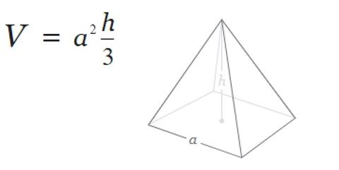

Task:
Write a program to calculate the volume of the pyramid using the above formula.

Allow the user to enter the measurements for a and h. Both a and h should be positive numbers.

Print the volume on the screen to 2 decimal places

print("Enter the base: ")
base = float(input())
print("Enter the slant height: ")
sh = float(input())
total = (2 * base * sh) + (base ** 2)
print("The surface area is: ", total)

C:\Users\Georgiana\PycharmProjects\pythonProject\venv\Scripts\python.exe C:/Users/Georgiana/AppData/Roaming/JetBrains/PyCharmCE2021.3/scratches/scratch_2.py
Enter the base:
2
Enter the slant height:
3
The surface area is: 16.0

Process finished with exit code 0

- Using lists (Python) or arrays (C etc)

Task:
Write a program designed to calculate the average age of some people in a room. There are 6 people in the room. Start by declaring an empty list eg
ages = []
- Prompt the user to enter the six ages (these should be within normal human lifespan!).
- After the ages have been entered, print each of them on the screen.
- Calculate the average age of the people in the room (to 2 decimal places) and print it on the screen.
Use loops where appropriate
Sample output:
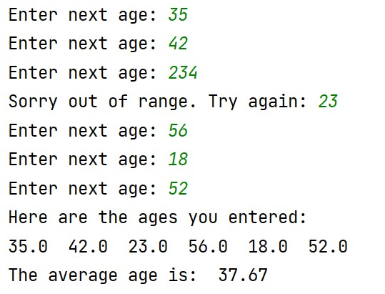

temps = []
for counter in range(0,6):
print("Enter your age: ")
temps.append(float(input()))
print("Sorry out of range. Try again ")
choice = int(input())
if 13<choice or choice >100:
print("Sorry out of the range!")
else:
print("Try again!:")
print("The average age is:", choice)

C:\Users\Georgiana\PycharmProjects\pythonProject\venv\Scripts\python.exe C:/Users/Georgiana/AppData/Roaming/JetBrains/PyCharmCE2021.3/scratches/scratch.py
Enter your age:
45
Enter your age:
54
Enter your age:
34
Enter your age:
23
Enter your age:
54
Enter your age:
34
Sorry out of range. Try again
5
Try again!:
The average age is: 5

Process finished with exit code 0

- Using Functions

Task:
Write a function called entername() to allow the user to enter the name of a conference delegate.
The function should be called 3 times, once for each of 3 conference delegates, and the (local scope) name entered returned to the main program.
Print the names entered from the main program, then calculate the total bill for attending the conference (£65 per person) and print it on the screen Sample output:
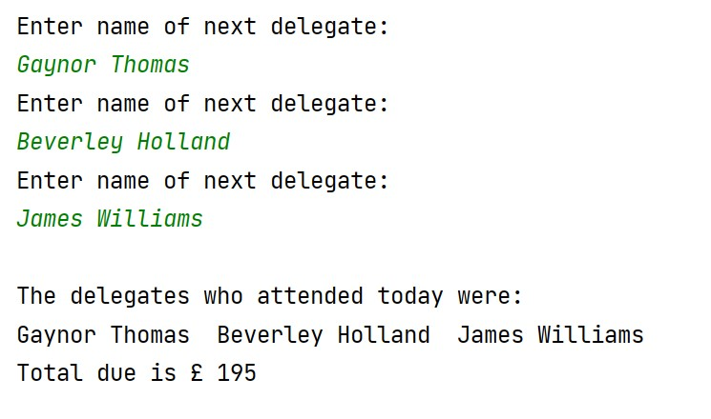

  - marks total for Question 4]

name1 = input("Enter name of next delegate: ")
name2 = input("Enter name of next delegate: ")
name3 = input("Enter name of next delegate: ")
print("The delegates who attended today were: " + name1, name2, name3)
print("Total due is : £", input())

C:\Users\Georgiana\PycharmProjects\pythonProject\venv\Scripts\python.exe "C:/Users/Georgiana/AppData/Roaming/JetBrains/PyCharmCE2021.3/scratches/TEST 22.py"
Enter name of next delegate: Georgiana Anghel
Enter name of next delegate: Andreea Rossi
Enter name of next delegate: Cristina Viga
The delegates who attended today were: Georgiana Anghel Andreea Rossi Cristina Viga
145
Total due is : £ 145

Process finished with exit code 0

Diwedd/End

