University of Wales Trinity Saint David
Wales Institute of Science and Art


Vehicle Electronics

Vehicle Electronics (ACHA4031)

1103 Words
Alexander King
2501127
4/2026
Contents
1 Task 3 1
1.1 Scope Time Division Calculations (6) 1
1.2 Function Generator output square wave (6) 1
1.3 Capacitor charge and discharge wave marked at correct points. (6) 1
1.4 Basic Capacitor Calculations (6) 1
1.5 Capacitor discharge table (5) 1
1.6 Plot log(V) Gradient (5) 1
1.7 Gradient Calculations and Compare(8) 1
1.7.1 Gradient Calculations 1
1.7.2 Comparison table 1
1.8 Capacitor Uses (5) 1
1.9 Inaccuracies Question (4) 1
1.10 Risk Question (10) 1
2 References 2

Task 3

Scope Time Division Calculations (6)
The clock period of the oscilloscope is set at 500μs per sample as seen in the square and capacitor text files, and the horizontal axis is split over 10 divisions. The square wave repeats every 40 samples as seen in the data. Using this information, the following calculation can be made:
Time Division: 40 samples x 0.0005 s = 0.02 s for one full cycle.

Function Generator output square wave (6)
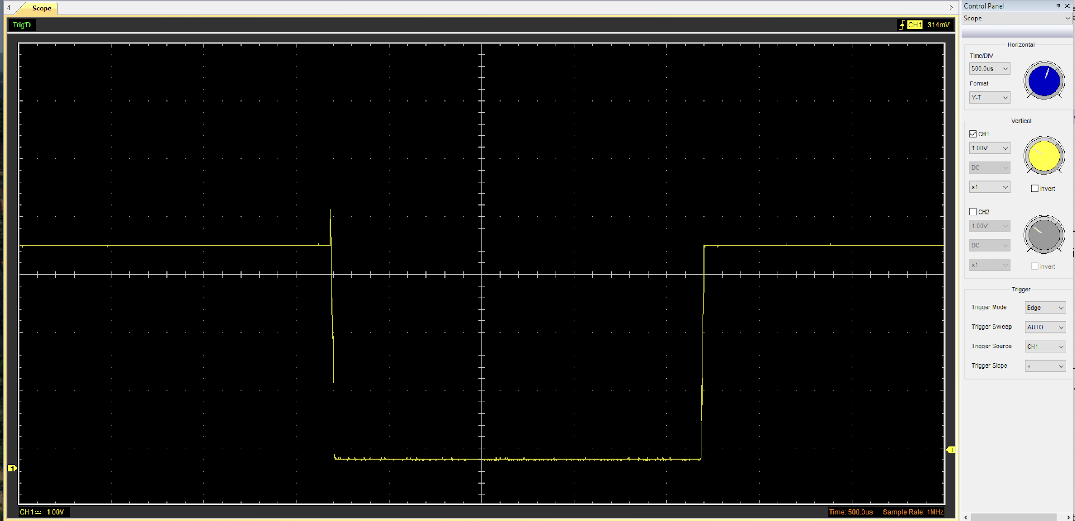
Output Wave 1 - Square Wave

The wave produced by the function generator was analysed to decide the input parameters for the RC circuit.

Voltage Peak: 3.8588V
Voltage Minimum: 0.1569V
Vpp = 3.8588 – 0.1569 = 3.7019V

Capacitor charge and discharge wave marked at correct points. (6)
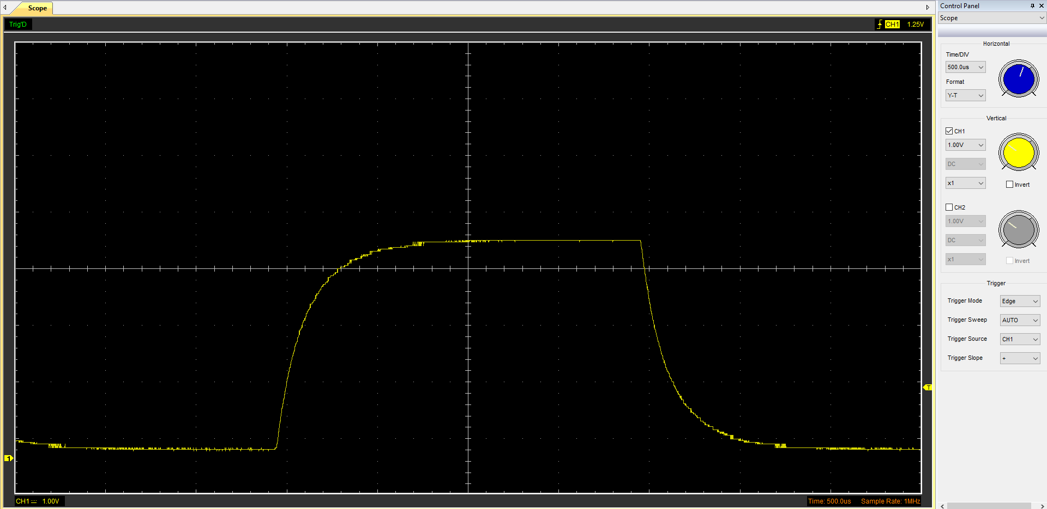
Charging
Discharging
Output Wave 2 - Capacitor Charge Cycle

Basic Capacitor Calculations (6)
Formula: τ = R x C
Initial Voltage = 3.85V
Target Voltage = 3.85 x 0.368 = 1.41V
It takes approximately 14 samples to drop from 1.41V
τ = 14 x 0.0005s = 0.007s (7ms)

Capacitor discharge table (5)
Table 1 - Capacitor Discharge
Time (s) | Voltage (V) | ln (V) | dy = y2 – y1  dy = ln(V)2-ln(V)1 | dx = x2- x1  dx = Time2 – Time1 | dy/dx
0.000 | 3.8588 | 1.350 | x | x | x
0.005 | 2.0500 | 0.717 | -0.633 | 0.005 | -126.6
0.010 | 1.0800 | 0.076 | -0.641 | 0.005 | -128.2
0.015 | 0.5700 | -0.562 | -0.638 | 0.005 | -127.6

Plot log(V) Gradient (5)

Graph 1 - Time vs log

Gradient Calculations and Compare(8)

Gradient Calculations
$$τ=-\frac{1}{-127.47}≈0.007845 s \left(7.845ms\right)$$
$$C=\frac{τ}{R}=\frac{0.007845}{8200}≈0.957μF$$

Comparison table
Table 2 - Gradient Comparison
 | Capacitance | Delta | Percentage difference
Actual | 1 µF | x | X
Marker Calculation | 0.98µF | 0.02µF | 2%
Gradient Calculation | 0.96µF | 0.04µF | 4%

Capacitor Uses (5)
Capacitors are common components used in electronic circuits for many different purposes such as:
Timing – capacitors can be paired with resistors to produce precise time delays that are used in timers, clocks and oscillators.
Energy Storage – Camera flashes use capacitors to release a large amount of energy in a short blast.
Filtering – Capacitors are often used to rectify voltage fluctuations.
Tuning – Radio receivers use capacitors to tune in to specific frequencies.
Coupling – Capacitors can be used to block DC signals and allow AC signal to pass in audio circuits.
Decoupling – Capacitors can be used near integrated circuits to provide instant current to prevent voltage drops on the main power rail.
Starting motors – Capacitors provide a phase shift to create enough torque to start an AC motor.
Sensors – In touchscreens and proximity sensors such as parking sensors, capacitors are used to measure changes in capacitance.

Inaccuracies Question (4)
Instrument-related inaccuracies combine with component tolerances to produce measurement discrepancies when testing electronics. Standard carbon-film resistors and electrolytic capacitors have a tolerance of ±5% to ±20% (Bird, 2017). Therefore, the actual time constant may not be equal to the nominal values specified in design as a result of the physical nature of the hardware. The internal resistance of a digital multimeter or oscilloscope, can change the circuit play during measurement by pulling current from the circuit thus reducing voltages (Tooley, 2020). Digital sampling errors cause errors in the data (Hughes, 2016). Finally, environmental factors like ambient temperature can alter resistance in conductors and dielectric stability in capacitors, widening the gap between empirical and theoretical calculations (Storey, 2021).

Risk Question (10)
ISO/SAE 2134:2021 provides a rigid guide for cybersecurity in regard to road going vehicles. As the Controller Area Network (CAN bus) was built for efficiency instead of security, there is little authentication or encryption so to satisfy ISO/SAE 21434 standards, cybersecurity defence must focus on reducing the feasibility of threats through multi-layered defence as listed below:
Risk-Based Engineering (TARA) – Threat Analysis and Risk Assessment begins by setting Cybersecurity Goals for the CAN bus. Engineers prioritize crucial areas of the vehicle such as steering or braking as these areas contribute heavily to the safety of the vehicle.
Network Segmentation and Gateway Isolation – Attackers can target low-security systems such as the infotainment system in order to gain access to other systems within the vehicle. This is prevented via 2 defences, security gateways that filter traffic between domains, and domain isolation which segments each network meaning a weakness in defence in one area is less likely to affect other systems.
Secure Onboard Communication – As the CAN bus lacks authentication, designs often implement Secure Onboard Communication (SecOC) in order to comply with SO/SAE 21434 standards. This adds a layer of protection that authenticates each “message” ensuring it comes from a legitimate source.
Intrusion Detection and Prevention Systems (IDPS) – This system monitors the CAN bus for anomalies such as Frequency Anomalies such as DoS attacks and Payload Anomalies which are values outside of pre-defined limits.
Hardware Security Modules (HSM) – Secure hardware is crucial in order to utilize modern ECUs as the ECUs use the hardware to store keys and encrypt data in an isolated environment.

References
Bird, J. (2017) Electrical and Electronic Principles and Technology. 6th edn. London: Routledge.
Grimm, D., Lautenbach, A., Almgren, M., Olovsson, T. and Sax, E. (2023) ‘Gap Analysis of ISO/SAE 21434 – Improving the Automotive Cybersecurity Engineering Life Cycle’, 2023 IEEE 26th International Conference on Intelligent Transportation Systems (ITSC), pp. 1904-1911.
Hughes, E. (2016) Electrical and Electronic Technology. 12th edn. Harlow: Pearson Education.
ISO/SAE 21434:2021 (2021) Road vehicles — Cybersecurity engineering. Geneva: International Organization for Standardization / Warrendale: SAE International.
Kifor, C. V. and Popescu, A. (2024) ‘Automotive Cybersecurity: A Survey on Frameworks, Standards, and Testing and Monitoring Technologies’, Sensors, 24(18), p. 6139.
Machado, A., Ferreira, J. and Silva, J. (2023) ‘Security Challenges and Mitigation Strategies in Automotive CAN Bus Systems’, Journal of Automotive Cybersecurity, 4(2), pp. 112–128.
Nilsson, J.W. and Riedel, S.A. (2019) Electric Circuits. 11th edn. London: Pearson Education.
Smith, R. and Jones, L. (2022) Automotive Ethernet and CAN Bus Security: A Practical Guide to ISO/SAE 21434. 2nd edn. London: Engineering Press.
Storey, N. (2021) Electronics: A Systems Approach. 6th edn. London: Pearson.
Tooley, M. (2020) Electronic Circuits: Fundamentals and Applications. 5th edn. London: Routledge.
Wang, H., Chen, Y. and Liu, X. (2024) ‘Implementing SecOC in CAN FD Networks for Enhanced Vehicle Security’, IEEE Transactions on Vehicular Technology, 73(1), pp. 45–59.

