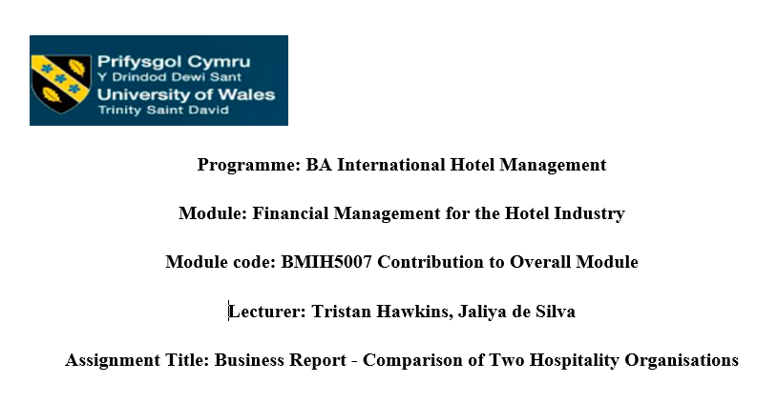
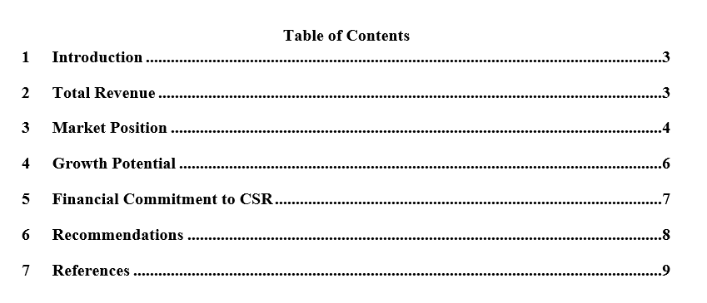

Introduction
The hotels that will primarily be compared in this study are Mandarin Oriental Hotel Group and Premier Inn. In order to highlight Asian history, local culture, and distinctive style, Mandarin Oriental Hotel Group manages 37 properties in 25 countries (Mandarin Oriental Hotel, 2023). As a result, Premier Inn boasts 800 hotels with comfortable beds, bathrooms, TVs, and views throughout the UK. As a result, it offers excellent lodging at reasonable costs in nearly 83,500 rooms located in exotic locales (Premier Inn, 2023). Therefore, the hotels mainly consider different hotel industries, such as premium and affordable.

Total Revenue
Primarily with regards to Premier Inn, it increased its yearly dividend at the beginning of 2023 by £413 million tax-free. As a result, the UK's sales accommodations grew along with the income. As a result, the company's sales of beverages and nutrition products increased 40% over the previous year. Therefore, in terms of rooms, 27% of profit before the pandemic was accessible in 2020 (Anil Kumar, 2023). In comparison to sales, the profit increased in 2021 and 2022. Substantial financial success by Premier Inn UK in 2023 resulted in a 27% rise in revenue. The profit adjusted in 2022 was £2,625 million, up 12% from the same year in 2020. With a 24% increase in revenue at the beginning of February 2020, £58 million was regarded as the key sales figure for 2022. Investors are pleased with the outcome because the hotel's yearly earnings climbed by 544%, which also helped to boost the share price of the hotel on the market. Due to inflation, the corporation raised the hotel rate in 2022. Due to the high occupancy rate, food and beverage sales increased by 40% year over year (Sweney, 2023).
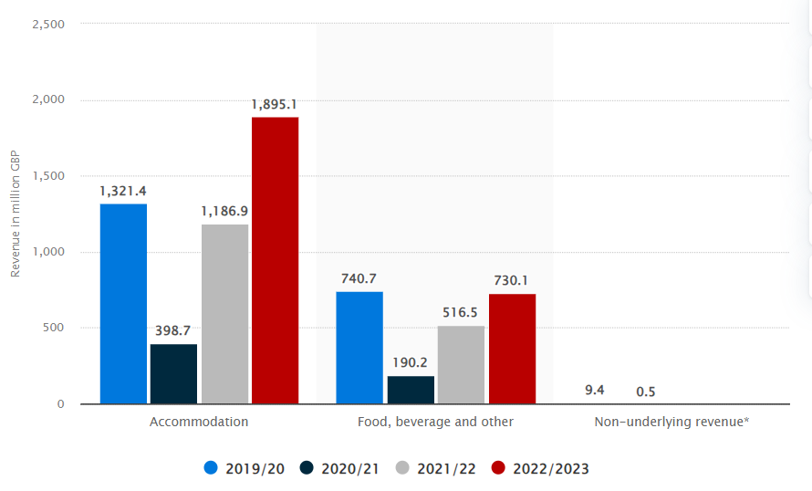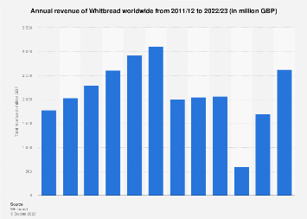
Figure 1: Financial performance of Premier Inn
Soruce: Statista, 2023a; Statista, 2023b
In terms of the MOHG, the hotel's total revenue is expected to be $454.1 million in 2022 compared to a lower $316.9 million in 2021. In comparison to 2021, 2022 saw a rise in sales. As a result, the hotel's primary source of income is $454.1 million, while its primary source of loss is $49.5 million. In order to make a profit, the hotel is now run in the critical three regions of Asia, Europe, the Middle East, and Africa. In the aftermath of the pandemic, sales also fell by 68% in 2021 to $183.7 million (Mandarin Oriental Hotel Group, 2022a).
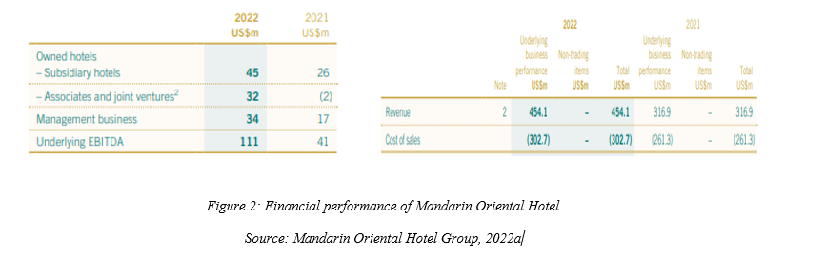

Market Position
The Premier Inn Hotel's position in the market is seen as One of the most significant hotel chains in the UK owned by The Whitbread Group, of which Premier Inn is a part. A robust commercial presence across the country. It is well known for providing inexpensive rooms and dominates the mid-range and low-cost hotel markets. However, market positions change over time due to a variety of factors, including competition, evolving consumer preferences, and general economic conditions. As a result, Premier Inn holds 12% of the hotel's Whitbread market share. As a result, Premier Inn offers premium facilities at reasonable rates. As a result, the hotel primarily targets new clients in the family category to preserve customer loyalty through the conducting of various events and festivities. It uses many marketing channels to draw in and entice more clients while also enabling same-day reservations in order to reach the goal. In the hotel industry, the hotel has a competitive edge. Regarding expanding long-term networks and collaboration in the UK, the hotel has 12% of the market (George, 2021).
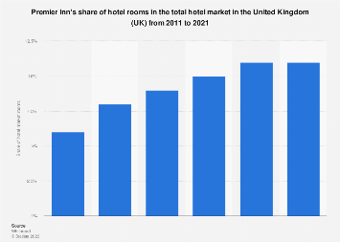
Figure 3: Market Share
Source: Statista, 2023c
The market share for the Mandarin Oriental Hotel Group is international chain of extravagant hotels that is well-known for its sumptuous apartments in a number of places. The primary competitors of this MOHG include Shangri-La Asia, Harbour Plaza, Marriot, Regal, and The Hong Kong Hotel with Shanghai Hotels. This hotel offers 5-star service, features opulent suites and rooms, and was built with modern infrastructure. The hotel was primarily founded in Bermuda, and it is listed there as well as in London and Singapore. The market value of the hotel is $1.97 billion. The addition of presently committed facilities in early 2021 further bolstered the hotel's strong liquidity position, which was already in place by 2020. Hence, this hotel have good market share in regard to luxury hotel industry. EBITDA was US$74 million in 2018, as opposed to US$155 million in positive EBITDA in 2019. Thus, the overall loss was $206 million, of which $175 million was attributable to operating losses and US$31 million was attributable to a post-tax damage of the carrying worth of the Geneva hotel as a outcome of a sharp decrease in the market worth of the leasehold interest. 2019 had earnings of $41M USD (Mandarin Oriental Hotel Group, 2022a).

Growth Potential
The growth of Premier Inn had been targeted both nationally and globally in terms of growth potential. Hotels have been remodelling and constructing new premises in order to maintain and increase their market share in the UK. The hotel has also researched prospective markets in other countries, including the Middle East and Germany. Hence, in regard to preserving and developing this reputation, loyal customers can return and recommend the brand to others, which might lead to increased sales. Therefore, the hotel is mainly famous among the customers in regard to its marketing strategies. The Premier Inn is known for offering luxurious accommodations at reasonable costs. Growth in the hotel industry may be possible through partnerships and acquisitions. Whitbread, the company that owns Premier Inn, should have investigated strategic partnerships or alliances to promote expansion. Premier Inn may broaden its product line by including more services or concentrating on other client groups. Businesses might invest in eco-friendly accommodations, extended-stay options, or boutique hotels to attract a more comprehensive customer. Modern developments in reservation techniques, smartphone applications, and smart hotel amenities have enhanced the consumer experience. The hotel industry is thus highly vulnerable to the influences of the economy, travel preferences, and regulatory regulations. Therefore, these adjustments and suitably changing the business model are essential for the hotel's success (George, 2021).
The MOHG oversees a group of luxury hotels and resorts in popular tourist destinations throughout the globe. They may be found throughout the Americas, Europe, Asia, and the Middle East. Mandarin Oriental is known for offering its guests luxury, opulent experiences. Their hotels are typically associated with outstanding service, exquisite design, and a commitment to creating sumptuous, peaceful environments. Along with accommodation, Mandarin Oriental hotels frequently provide a range of extras, including fine dining restaurants, spas, wellness centres, event and meeting facilities, and specialised concierge services. The business is well known for appreciating the local culture and history in the places where its properties are located. Local traditions and artwork are typically incorporated into hotel architecture and tourist experiences. Because of this, Mandarin Oriental places a high value on client loyalty. The expansion of Mandarin Oriental's global presence will involve both the construction of new properties and the purchase of premium hotels and resorts that already exist. This tactic may help them increase brand recognition and reach new consumers. The market for luxury hotels is fiercely competitive and susceptible to overall economic conditions. Furthermore, it is influenced by global events, travel trends, and changing consumer preferences (Pang, 2020).

Financial Commitment to CSR
Regarding its monetary commitment to CSR, Premier Inn supports energy saving and invests in programmes that help the environment by reducing carbon emissions and conserving water. For this, significant capital investments are needed. Examples of financial commitments to community participation include funding for local projects, educational programmes, and support for charity groups in the locations where Premier Inn operates. The Premier Inn allocates funds to promote diversity and inclusion throughout the organisation. Over 500,000 meals' worth of leftover food were donated to charities by the company in 2020. One hundred forty tonnes of food were provided by The Real Junk Food Project and FareShare combined. The goal of Whitbread company is to enhance people, societies, and the environment. The Great Ormond Street Hospital Children's Charity (GOSH Charity), which supports fundraising for very ill children from throughout the UK, has hosted the event since 2012. Over the next five years, the hotel committed to giving £20 million to the GOSH Charity Build It. For our milk, the hotel employed British farms that had been qualified by the Red Tractor Standard. The first hotel and restaurant chain in the UK to sustainably acquire all seafood in line with MSC certification standards. Additionally, the hotel served beef from the UK and Ireland that, was Farm Assured (Premier Inn, 2023a).

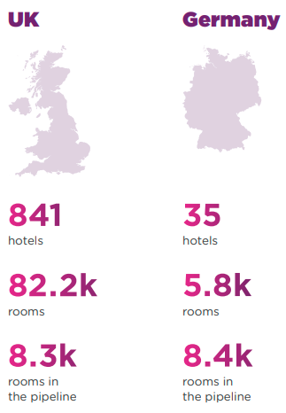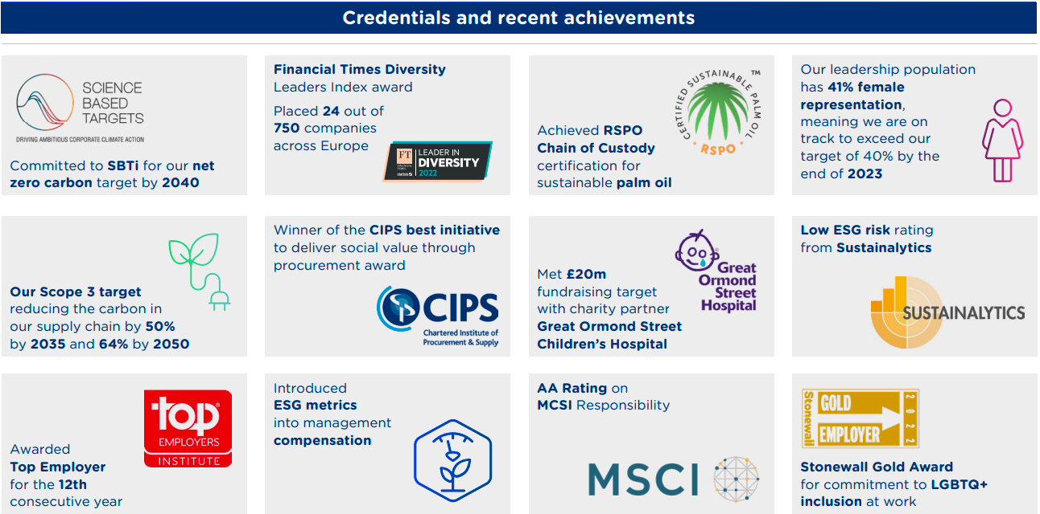
Figure 4: CSR
Source: Premier Inn, 2022b
Mandarin Oriental is committed to return to societies in which the hotel is mainly committed in harmonizing society and surrounding with reference to The Mandarin Oriental Hotel Group's CSR. Being upfront and honest about our progress in all areas will help raise the bar for upscale hospitality. The underlying aim of expressing all of our views in our pursuit of climate-friendly operations is to make even the most complicated aspects of our business as comprehensible to a broad audience as possible. The Kuala Lumpur Mandarin Oriental donates at least 35 food packages in regard to hungry people three times in a week with collaboration with Reach Out. Therefore, Mandarin Oriental in Shanghai offers fully-funded French baking and pastry training to young people from disadvantaged backgrounds, enabling them to get qualifications that will allow them to escape poverty is mainly through gainful employment. The Christmas Charity Sales donated $10,000 and 3,000 volunteer hours to Taiwan Pawprint K9 Rescue and Taipei Stray Cats Protection Association in support of sheltering stray animals in need. The running team participated in the 6 km event and gave the German AIDS Foundation €28,600. For the last five years, the hotel has offered alignment and training chances to help inmates from Milan Bollate Prison with their rehabilitation (Mandarin Oriental Hotel Group, 2022b).
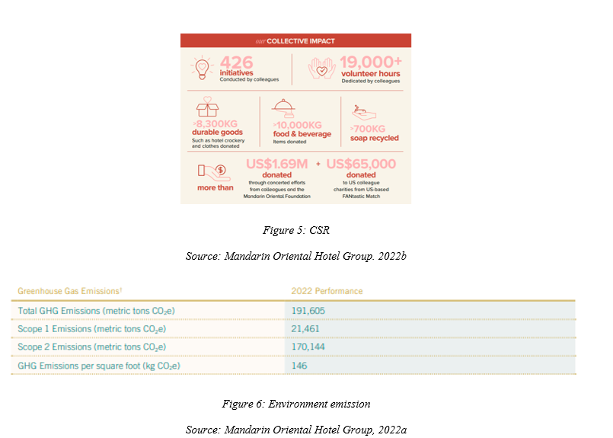

Recommendations
The global footprint of the MOHG has been expanding, and this trend is likely to continue. As a result, establishing new hotels in prime locations can promote growth, especially in developing communities with a booming, affluent clients. As a form of diversification, the company could look at market segmentation within the luxury hotel industry. Hence, the hotel should offer services to those with an interest in wellness and spas, business travellers, or cultural events should be part of this. By offering distinctive and customised experiences tailored to the requirements and interests of its guests, the Mandarin Oriental Hotel Group can stand out and attract a high-end clientele. Therefore, personalised packages for each person should be offered in relation to Premier Inn Hotel, principally. As a result, it should offer a means of highlighting and identifying the market sector. Therefore, it is essential to concern about educating the staff to provide guests with a good impression of the hotel. Thus, training the workers is necessary to sustain loyalty and deliver high-quality services. Additionally, educating the personnel mainly demonstrates the hotel's reputation, which primarily addresses the hotel's image and market loyalty.

Conclusion
The Mandarin Oriental and Premier Inn Hotels are the critical selections for this report. In light of growth, revenue, and CSR, along with market position, both hotels are picked. Therefore, when comparing the two hotels, discrepancies are evident. Due to its reputation and image, The Mandarin Oriental Hotel Group is regarded as a premium hotel. Because of its price policies, Premier Inn is regarded as an economical hotel. As a result, both enterprises are seen as different in terms of the market's location and pricing. As a result, the hospitality industry is very competitive; therefore, it is essential to stay current.

References
Anil Kumar. R. 2023. Premier Inn owner Whitbread profit beats expectations, raises dividend. [Online]. Available at: https://www.reuters.com/business/retail-consumer/premier-inn-owner-whitbread-posts-annual-profit-above-pre-pandemic-levels-2023-04-25/ [Accessed on October 23, 2023].
George, R., 2021. Tourism and Hospitality Marketing Principles. In Marketing Tourism and Hospitality: Concepts and Cases (pp. 3-31). Cham: Springer International Publishing.
Mandarin Oriental Hotel Group. 2022a. Annual Report 2022. [Online]. Available at: https://photos.mandarinoriental.com/is/content/MandarinOriental/corporate-22arMOIL [Accessed on October 23, 2023].
Mandarin Oriental Hotel Group. 2022b. SUSTAINABILITY REPORT 2022. https://photos.mandarinoriental.com/is/content/MandarinOriental/_Corporate/PDFs/mandarin-oriental-sustainability-report-2022.pdf [Accessed on October 23, 2023].
Mandarin Oriental Hotel. 2023. Our Company. [Online]. Available at: https://www.mandarinoriental.com/en/our-company [Accessed on October 23, 2023].
Pang, J.M., 2020. Adopting “East Asian” cultures and themes in hotel branding: a study of the M. Mandarin. Asia Pacific Journal of Tourism Research, 25(10), pp.1085-1097.
Premier Inn. 2023. [Online]. Like the view? [Online]. Available at: https://www.premierinn.com/gb/en/home.html [Accessed on October 23, 2023].
Premier Inn. 2023a. We are a Force for Good. [Online]. Available at: https://www.premierinn.com/gb/en/why/force-for-good.html [Accessed on October 23, 2023].
Premier Inn. 2023b. ENVIRONMENTAL, SOCIAL AND GOVERNANCE REPORT. [Online]. Available at: https://www.premierinn.com/content/dam/pi/websites/desktop/why/force%20for%20good/final-esg-report-2021-2022.pdf [Accessed on October 23, 2023].
Statista. 2023a. Revenue of Whitbread worldwide from 2019/21 to 2022/23, by segment. [Online]. Available at: https://www.statista.com/statistics/739891/revenue-whitbread-united-kingdom-uk-by-segment/ [Accessed on October 23, 2023].
Statista. 2023b. Whitbread: total revenue 2022. [Online]. Available at: https://www.statista.com/statistics/511372/total-revenue-whitbread-united-kingdom-uk/ [Accessed on October 23, 2023].
Statista. 2023c. Premier Inn's share of hotel rooms in the total hotel market in the United Kingdom (UK) from 2011 to 2021. [Online]. Available at: https://www.statista.com/statistics/755691/premier-inn-share-of-hotel-market-rooms-united-kingdom-uk/ [Accessed on October 23, 2023].
Sweney. M. 2023. Premier Inn owner surpasses pre-Covid profits as travellers seek deals. [Online]. Available at: https://www.theguardian.com/business/2023/apr/25/premier-inn-whitbread-pre-covid-profits-deals [Accessed on October 23, 2023].

